COEPD – Traditional Development

Capstone Project1 – Part -3

**DINESH KULKARNI**

Online Agriculture Products Store

**Question 1** – Functional Requirements - 15 Marks

Identify minimum 20 functional requirements

Example:

Functional requirement: When an order is fulfilled, the local printer shall print a packing slip.

Non-Functional Requirement: Packing slips shall be printed on both sides of 4”x 6” white paper, the standard size for packing slips used by local printers.

***Answer***

**Functional Requirement: -**It is type of solution requirement, it describes the behaviour and information the solution will manage. They describe capabilities the system will be able to perform in terms of behaviours or operation-specific information technology application actions or responses. (FRS document).

**Non-Functional requirement: -**It captures that do not directly relate to the behaviour or functionality of the solution, but rather describe environmental conditions under which the solution must remain effective or qualities that the system must have. They are also known as quality or supplementary requirement. These can include requirements related to capacity, speed, security, availability and information architecture and presentation of the user interface. (SSD Document).

|  |  |  |  |
| --- | --- | --- | --- |
| Req ID | Req Name | Requirement description | Priority |
| FR0001 | Farmer Registration | Farmers should be able to register with the application | 8 |
| FR0002 | Farmer Search for Products | Farmers should be able to search for available products in fertilizers, seeds, pesticides | 8 |
| FR0003 | Role based login | Farmers and Manufactures should have separate login | 8 |
| FR0004 | New user Registration | New user should be able to register using email ID and password | 9 |
| FR0005 | Catalog search | System should be displaying the product catalog | 7 |
| FR0006 | Navigation product | Product category navigation should be available | 7 |
| FR0007 | Detailed product description | Product detail description should be available for search | 8 |
| FR0008 | Advanced filter option | Farmer should be able to search product by its attribute | 6 |
| FR0009 | Add to cart | Farmers should be able to add the product to cart | 9 |
| FR0010 | Multiple payment options | Farmers should be able to purchase the product by different payment options | 8 |
| FR0011 | Order tracking | Farmers should be able to track the orders after purchase the product | 7 |
| FR0012 | Notification | Farmers should be able to get notification of orders shipment after confirmation of order | 7 |
| FR0013 | User profile | Farmers and manufacturers should be allowed to modify the profile | 7 |
| FR0014 | Password recovery | Farmers and manufacturers should allow to recovery of login password | 8 |
| FR0015 | Manage product listing | Manufactures are allowed to manage the list of products | 7 |
| FR0016 | Customer support | Farmers should get the assistance for purchasing the products | 7 |
| FR0017 | Ratings and feedback | Users should, be able to write feedback and give ratings in app | 6 |
| FR0018 | Report generation | System should be able to generate report for product sales | 8 |
| FR0019 | Multiple language | Application should support local language for farmers | 5 |
| FR0020 | Social media integration | Application should allow user to integrate social media platform for registration and marketing | 5 |
| NFR0101 | Page Loading Time | Each Page should load within 2 seconds time | 9 |
| NFR0102 | WCAG 2.1. | The system must meet Web Content Accessibility Guidelines WCAG 2.1. | 8 |
| NFR0103 | Data security | System must ensure data encryption for all payment transaction | 9 |
| NFR0104 | Data protection | System must compliance with password and data protection | 9 |
| NFR0105 | Quick response time | System should respond <500ms for API call | 8 |
| NFR0106 | Scalability | Application must support for rapid growing users, Products, and transactions | 8 |
| NFR0107 | Responsive design for all device | Application must be compatible for all devices | 8 |
| NFR0108 | Reliability | Application must be available all time for users | 9 |
| NFR0109 | Maintainability | Application must be modular for easy updates and code fixes | 7 |
| NFR0110 | Schedule maintenance | Application should give notification to user for schedule maintenance | 6 |
| NFR0111 | Integration | Application must be integrated with other applications such logistics, payment gateway, weather conditions | 6 |
| NFR0112 | Testability | Application must be easily testable for any changes | 7 |
| NFR0113 | Response time | Application should respond to user input within 2 sec | 7 |

**Question 2–**Minimum 5-page designs - 15 Marks

Make wireframe and prototypes

***Answer***

**Wireframe: -**It is visual representation or blueprint of webpage or application. It outlines the basic structure and layout of the interface focusing on the arrangement of elements, navigation pathways and how different components interact with each other. Wireframes are typically low fidelity means they are not detail in terms of designs or graphics but rather emphasize functionality and user experience. They serve as a guide for developers, designers, and stakeholders to understand the project scope and ensure that every one is aligned before proceeding with more details design and development phase.

**Prototypes: -**They are early models or simulations of product used to visualise and test its functionality before full scale development begins. They help stakeholders to understand how final system will work and allow feedback, revisions, and improvements in early process.

**How prototypes are prepared?**

1.Requirement gathering: - Understand user needs, project goal, key functionalities

2.Wireframing: -Create rough layout sketches (wireframes) to define the structure and elements of each screen and page.

3.Choose prototyping tool: -Use tools like Figma, Adobe, Sketch, Axure, Invision, Balsamiq.

4.Build prototype: - Start with simple mock ups low fidelity to detail version.

5.Tests and review: -Share with end user for feedback.

6.Iterate: -Repeat above process.

**Axure: -**It is powerful wireframing, prototyping and documentation tool used to design interactive and high-fidelity prototypes for websites, apps, and software system. Unlike Balsmiq Axure offer advanced capabilities including dynamic content, conditional logic, animations, and data driven interface.

**Why BA use Axure?**

1.Interactive prototyping: -BA use Axure to create clickable, functional prototypes that simulate user interaction helping stakeholder understand how the final product will behave.

2.Requirements documentations: -Axure allows BA to attach detailed annotations and specifications directly to UI components making it easier to communicate requirements to developers and designers.

3.Scenario simulations: -With support of logic, variable and dynamic contents BA can model user flow, decision tree and system behaviour without writing code.

4.Stakeholder communication: -A working prototype with interaction helps in gathering feedback and validate the requirements early in the SDLC.

**Advantage of Axure**

1.High fidelity prototypes: -Create realistic and functional UI prototype closely mimicking the actual application

2.Advanced interaction: -Support conditions, logic, dynamic panels, variable and more.

3.Built in documentation: -Automatically generate specification and notes associated with UI.

4.Team collaboration: -Axure cloud allows real time collaboration

**Disadvantage of Axure**

1.Steep learning curve: -It can be complex for beginner and non-technical users

2.Performance issue: -Prototypes with too many elements will lag or load slowly

3.Cost: -More expensive than other tools like Balsmiq

4.Overkill for simple project: -If only basic wireframes are needed then Axure’s powerful features are excessive.

1. **Home Page**

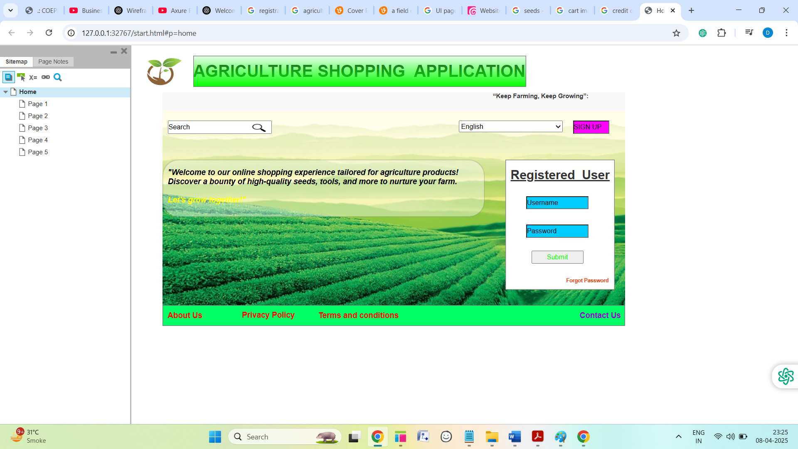

**2.Registration Page**

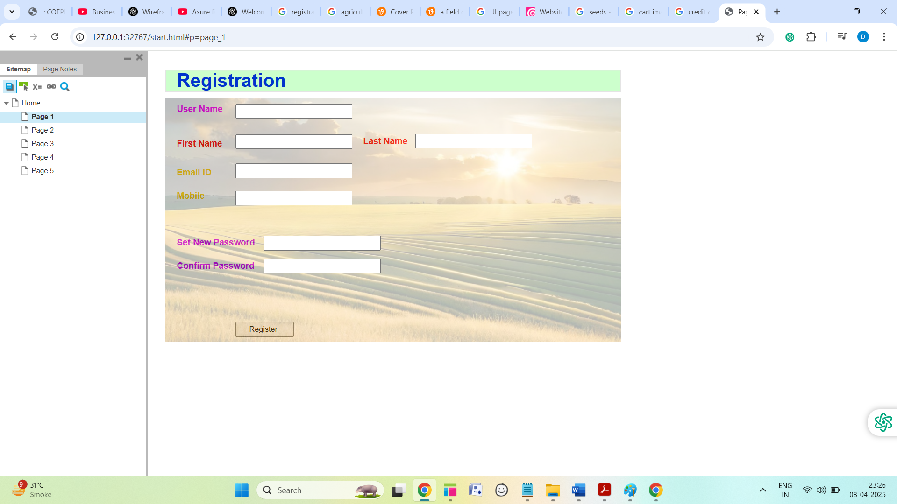

**3.Shopping Page**

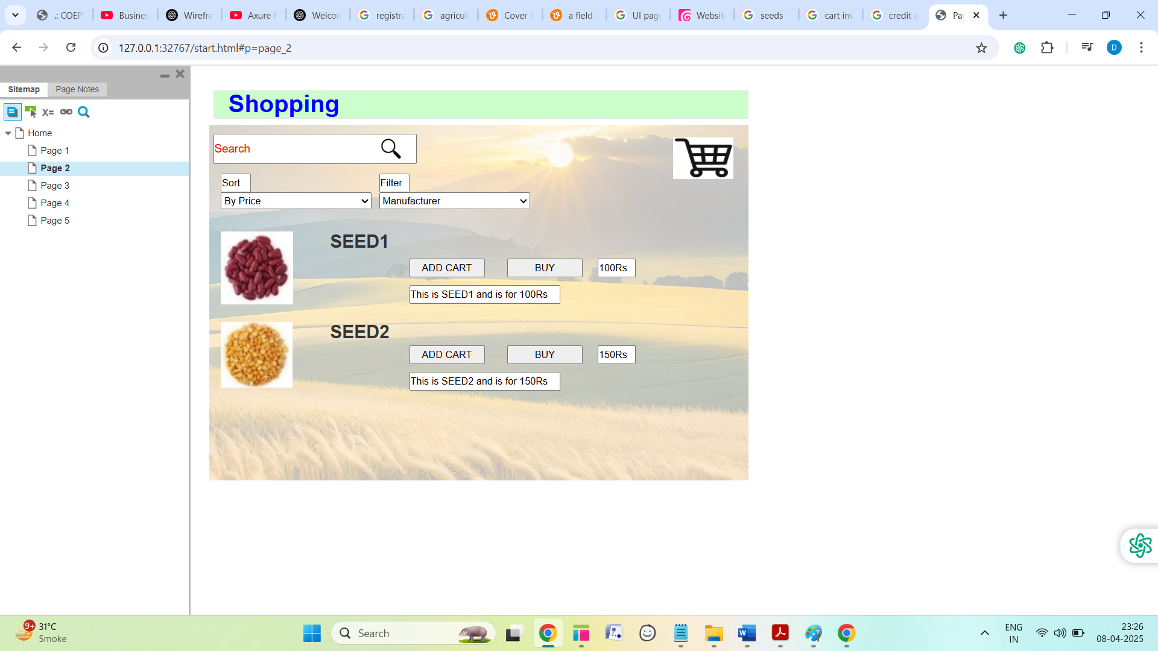

**4.Payment Page**

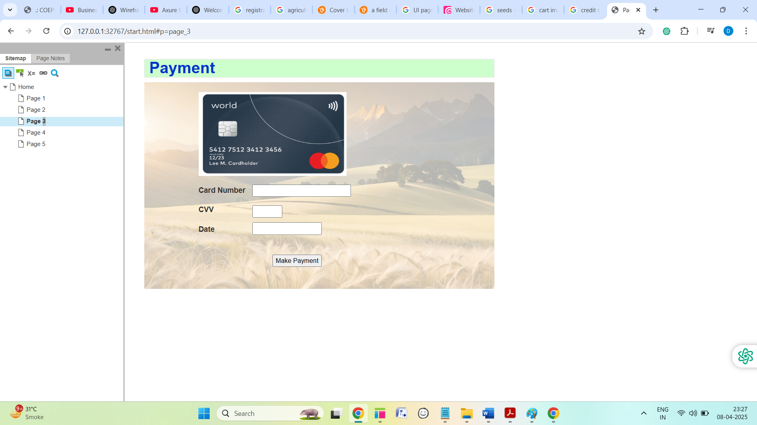

**5.Order Page**

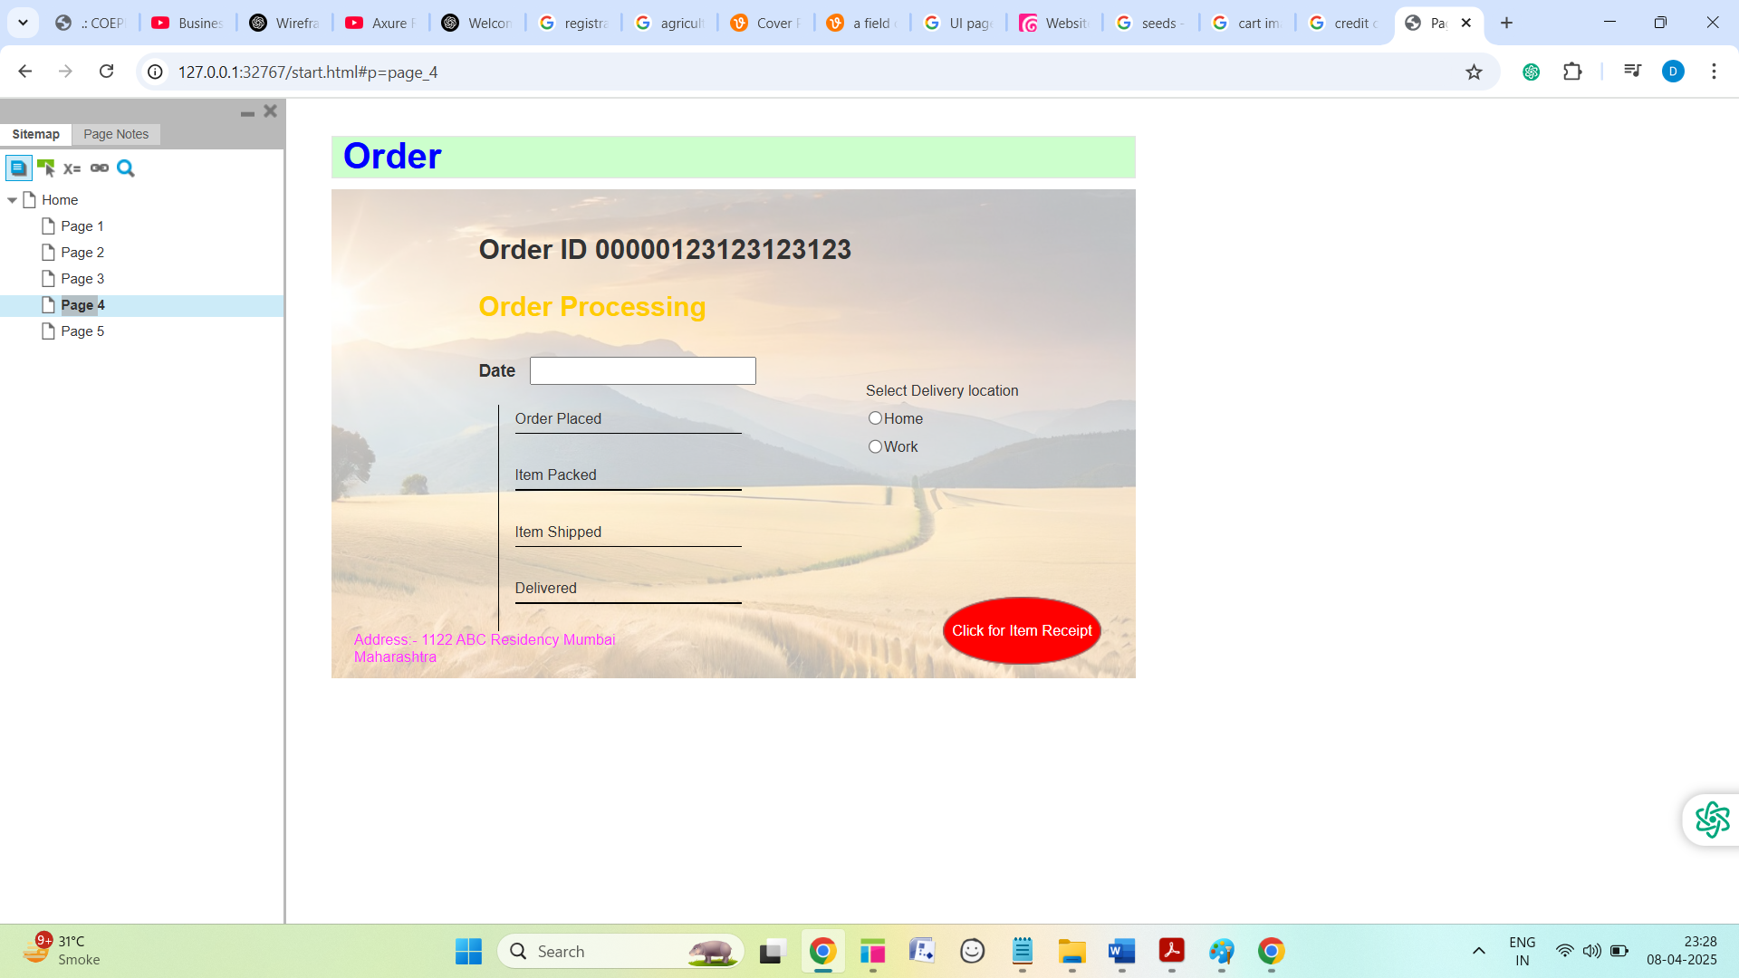

**Question 3** – Tools (Visio, Balsamiq) - 15 Marks

Make a note of the Tools, which you are using for above concepts.

***Answer***

The main responsibility of BA is

1.Requirement gathering

2.Documenting the requirement

3.Model the requirement

1.UML

2.Axure

3.Balsmiq

**Microsoft visio: -**It is a diagramming and vector graphics applications used to create diagrams, flowcharts, and other visual representation of complex information.

**Balsmiq: -**It is rapid wireframing tool used to create mock-ups and prototypes of user interface

**Axure: -**It is more advanced prototyping tool used to create high fidelity, interactive wireframes and prototypes for web and mobile applications.

**Balsmiq: -**It is tool to create wireframes / mock-ups: -Showing the front end or UI of application in simple manner

Dummy model-Representation of pages showing basic and essential features in Balsmiq.

**Here we used Balsmiq tool**

Balsmiq is rapid wireframing tool used primarily by business analysts, designers, and developers to create low fidelity mock-ups and wireframes of software applications and websites. These wireframes are essentially visual representations of the layout and structure of product’s user interface.

**Why Balsmiq is used?**

1.Rapid prototyping: -It allows quick and easy creation of wireframes, enabling BA to iterate and experiment with different design ideas efficiently

2.Visualization: -It helps stakeholder visualize early-stage concepts and functionality of a product before significant resources are committed to development

3.Collabration: -It facilitates collaboration among teams by providing a clear, visual reference that all stake holders can understand and provide feedback on

**Advantages of Balsmiq**

1.User friendly interface: -It has simple drag and drop interface

2.Speed: -Rapidly creating wireframes

3.Low fidelity: -Focuses on functionality and structure

4.Cost effective: -More budget friendly

So Balsmiq consider as valuable tool for BA by enabling them to quickly sketch out ideas and collaborate effectively during the early stage of software development.

**1.Home Page**

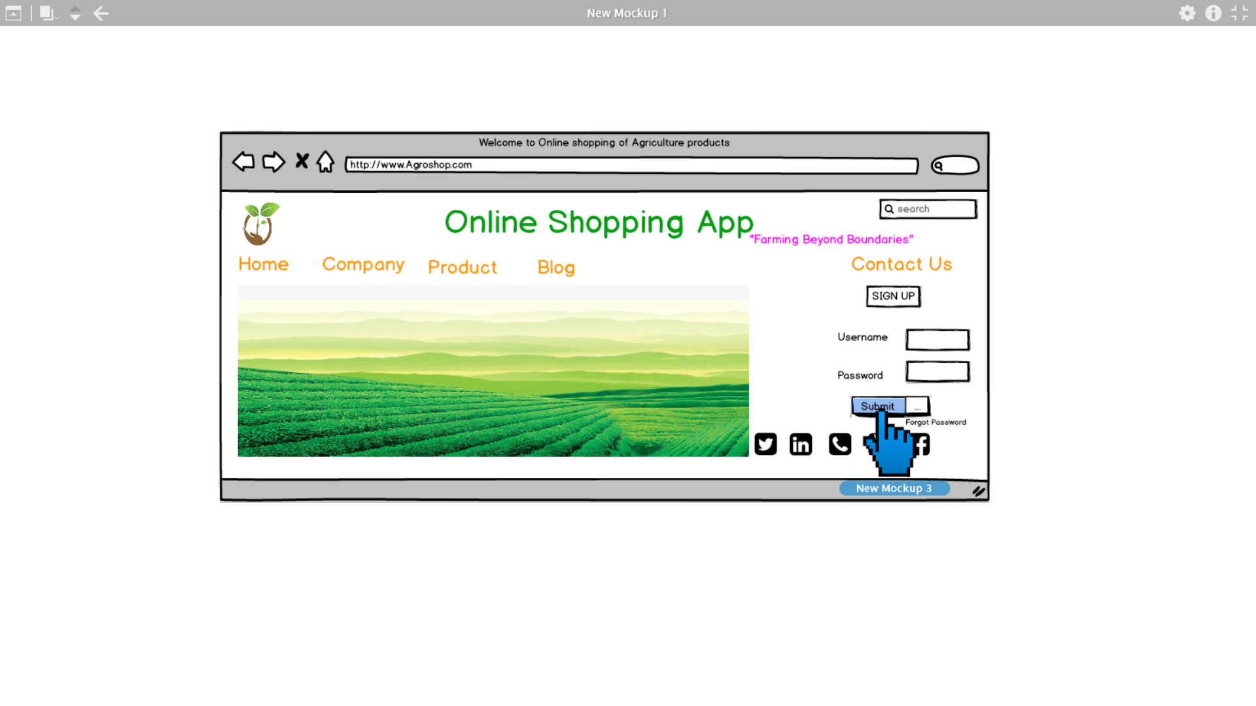

**2.Registration Page**

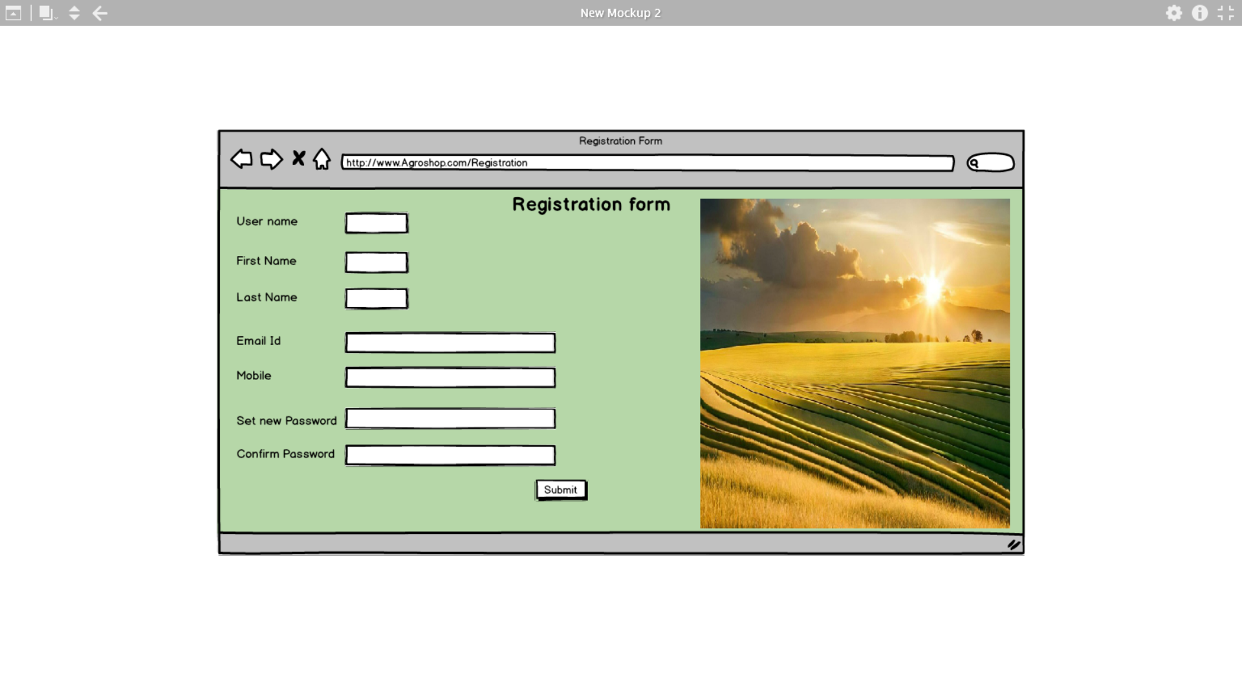

**3.Shopping Page**

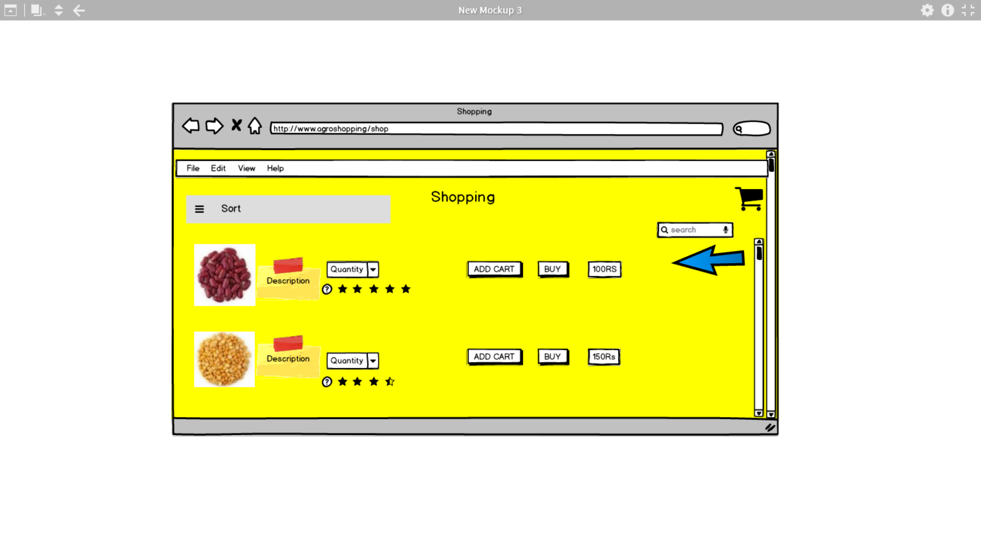

**4.Payment Page**

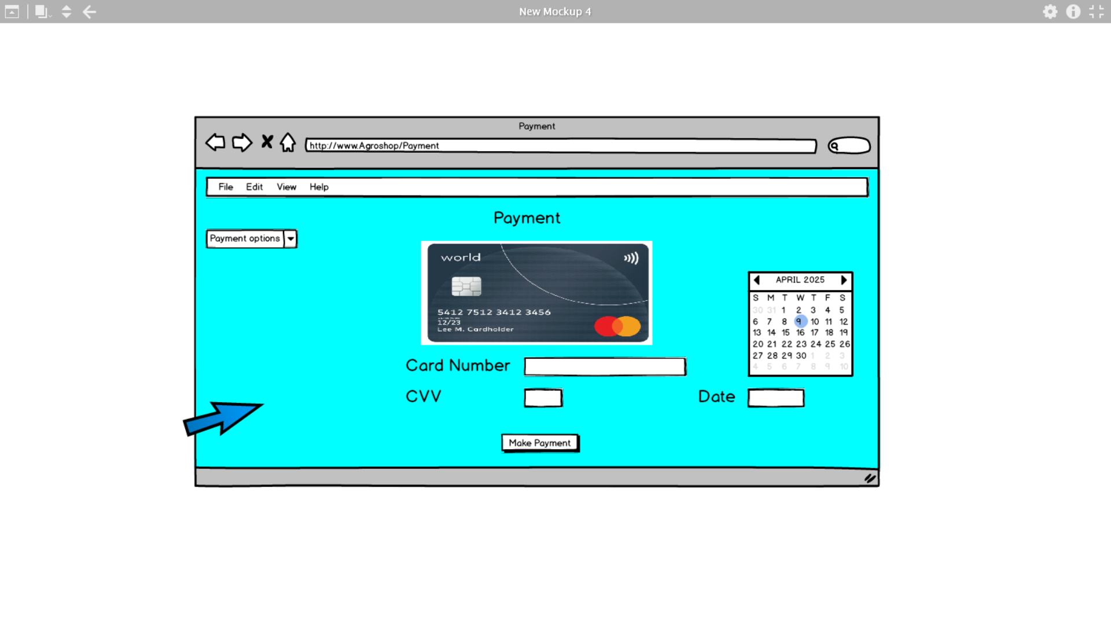

**5.Order page**

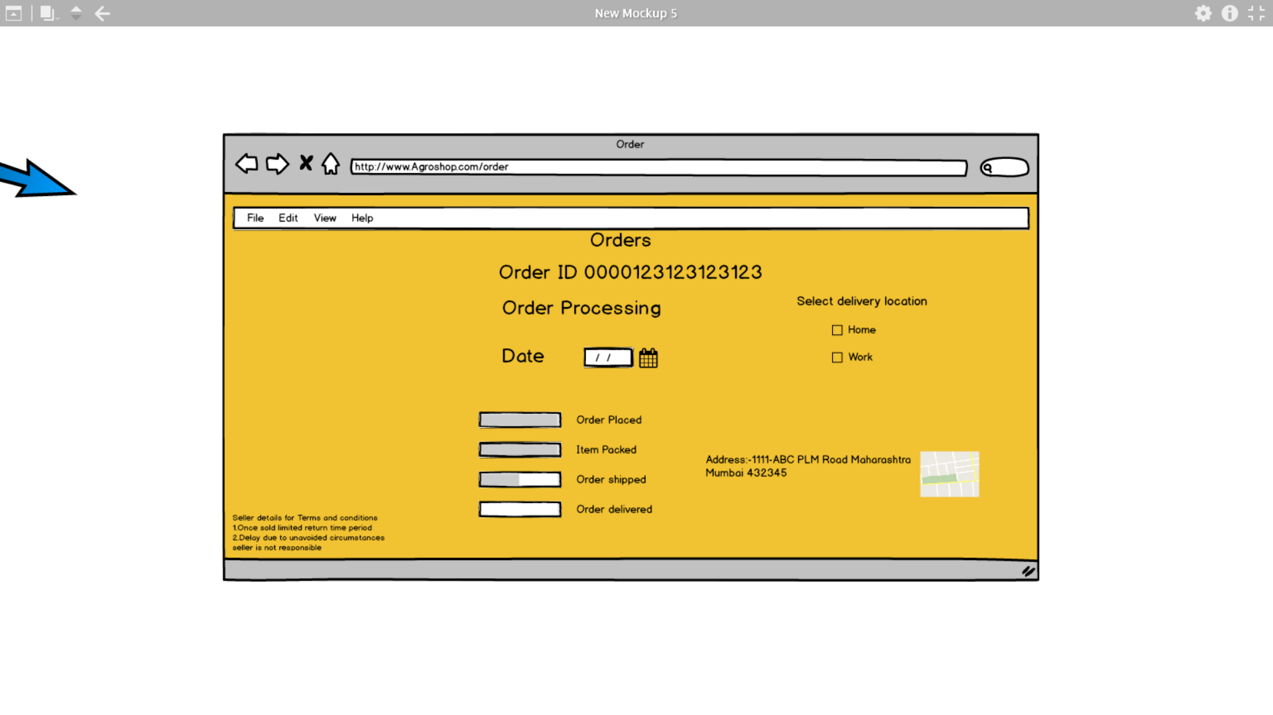

**Question 4** – RTM - 6 Marks

A business analyst’s key responsibilities are to keep track of the requirements and make sure that no requirement is missed.

Mr. Henry and peter have approached you regarding the current status of the project. How will you tackle this situation?

Prepare RTM

***Answer***

**RTM: -**Requirement traceability matrix is a document that maps the user requirement with status and activity of project. It is very crucial for any project. BA should be responsible for any requirement should not miss in SDLC.

|  |  |  |  |  |  |  |  |
| --- | --- | --- | --- | --- | --- | --- | --- |
| Req ID | Req Name | Requirement description | Design | T1 | T2 | T4 | UAT |
| FR0001 | Farmer Registration | Farmers should be able to register with the application | Completed | Pass | Pass | Pass | Accepted |
| FR0002 | Farmer Search for Products | Farmers should be able to search for available products in fertilizers, seeds, pesticides | Completed | Pass | Pass | Pending | Pending |
| FR0003 | Role based login | Farmers and Manufactures should have separate login | Completed | Pass | Pass | Pass | Pending |
| FR0004 | New user Registration | New user should be able to register using email ID and password | Completed | Pass | Pass | Pass | Accepted |
| FR0005 | Catalog search | System should be displaying the product catalog | Completed | Pass | Pass | Pending | Pending |
| FR0006 | Navigation product | Product category navigation should be available | Completed | Pass | Pass | Fail | Pending |
| FR0007 | Detailed product description | Product detail description should be available for search | In progress | Pending | Pending | Pending | Pending |
| FR0008 | Advanced filter option | Farmer should be able to search product by its attribute | In progress | Pending | Pending | Pending | Pending |
| FR0009 | Add to cart | Farmers should be able to add the product to cart | Completed | Fail | Pending | Pending | Pending |
| FR0010 | Multiple payment options | Farmers should be able to purchase the product by different payment options | Completed | Pass | Pass | Pass | Accepted |
| FR0011 | Order tracking | Farmers should be able to track the orders after purchase the product | Completed | Pass | Fail | Pending | Pending |
| FR0012 | Notification | Farmers should be able to get notification of orders shipment after confirmation of order | In progress | Pending | Pending | Pending | Pending |
| FR0013 | User profile | Farmers and manufacturers should be allowed to modify the profile | Completed | Fail | Pending | Pending | Pending |
| FR0014 | Password recovery | Farmers and manufacturers should allow to recovery of login password | Completed | Pass | Pass | Pass | Accepted |
| FR0015 | Manage product listing | Manufactures are allowed to manage the list of products | Completed | Pass | Pass | Pass | Accepted |
| FR0016 | Customer support | Farmers should get the assistance for purchasing the products | Pending | Pending | Pending | Pending | Pending |
| FR0017 | Ratings and feedback | Users should, be able to write feedback and give ratings in app | Pending | Pending | Pending | Pending | Pending |
| FR0018 | Report generation | System should be able to generate report for product sales | Pending | Pending | Pending | Pending | Pending |
| FR0019 | Multiple language | Application should support local language for farmers | Completed | Pass | Pass | Pass | Accepted |
| FR0020 | Social media integration | Application should allow user to integrate social media platform for registration and marketing | Completed | Pass | Fail | Pending | Pending |
| NFR0101 | Page Loading Time | Each Page should load within 2 seconds time | Completed | Pass | Pass | Pass | Not started |
| NFR0102 | WCAG 2.1. | The system must meet Web Content Accessibility Guidelines WCAG 2.1. | In progress | Pending | Pending | Pending | Pending |
| NFR0103 | Data security | System must ensure data encryption for all payment transaction | Completed | Pass | Pass | Pass | Not Started |
| NFR0104 | Data protection | System must compliance with password and data protection | Completed | Pass | Pass | Pass | Accepted |
| NFR0105 | Quick response time | System should respond <500ms for API call | Completed | Pass | Pass | Fail | Pending |
| NFR0106 | Scalability | Application must support for rapid growing users, Products, and transactions | Completed | Pass | Pass | Pass | Accepted |
| NFR0107 | Responsive design for all device | Application must be compatible for all devices | Completed | Pass | Pass | Pass | Not started |
| NFR0108 | Reliability | Application must be available all time for users | Completed | Pass | Pass | Pass | Accepted |
| NFR0109 | Maintainability | Application must be modular for easy updates and code fixes | Completed | Pass | Pass | Pass | Accepted |
| NFR0110 | Schedule maintenance | Application should give notification to user for schedule maintenance | Completed | Pass | Pass | Pass | Accepted |
| NFR0111 | Integration | Application must be integrated with other applications such logistics, payment gateway, weather conditions | Completed | Pass | Pass | Pass | Accepted |
| NFR0112 | Testability | Application must be easily testable for any changes | Completed | Pass | Pass | Pass | Accepted |

**Question 5** – 10 Test Case Documents - 10 Marks

Prepare 10 Test Case Documents

***Answer***

**Test case document: -**It is detail and structured document that describe a specific set of conditions and steps to verify that a feature or function of a software application works as intended. It is a key component in the software testing process and ensures requirements are met, bugs are caught early and quality is maintained.

**Test case 1: - Farmers Registration**

|  |  |
| --- | --- |
| Project ID | P00OAPS001 |
| Project Name | Online Agriculture Product Shopping App |
| Project Manager Name | Mr. Vandanam |
| Field | Example |
| Test Case ID | TC-001 |
| Test Scenario | Verify farmer’s registration functionality |
| Description | Verify that farmer can register successfully using valid inputs |
| Pre-condition | User should be on registration page |
| Test steps | 1.Enter Name  2.Enter valid email id  3.Enter password  4.Click on registered button |
| Test Data | Name: -Dinesh  Email: -dineshkul1@gmail.com  Password: -ABC123 |
| Expected Result | Registration successful message displayed and user redirected to login screen |
| Actual Result | Registration successful |
| Status | Pass |
| Remarks | NA |
| Tested By | Jason |
| Date | 09/04/2025 |

**Test case 2: - Farmer Search for Products**

|  |  |
| --- | --- |
| Project ID | P00OAPS001 |
| Project Name | Online Agriculture Product Shopping App |
| Project Manager Name | Mr. Vandanam |
| Field | Example |
| Test Case ID | TC-002 |
| Test Scenario | Verify farmers can search products |
| Description | Validate the product search functionality with keyword input |
| Pre-condition | Farmer is logged in application and should be on home page |
| Test steps | 1.Click on search bar  2.Type seed  3.Press enter or click on search icon |
| Test Data | Search keyword: - seed |
| Expected Result | A list of products related to seeds is displayed with images, names |
| Actual Result | Search product is displayed on screen |
| Status | Pass |
| Remarks | NA |
| Tested By | Jason |
| Date | 09/04/2025 |

**Test case 3: - Role based login**

|  |  |
| --- | --- |
| Project ID | P00OAPS001 |
| Project Name | Online Agriculture Product Shopping App |
| Project Manager Name | Mr. Vandanam |
| Field | Example |
| Test Case ID | TC-003 |
| Test Scenario | Verify login functionality for different roles |
| Description | Validate that user must redirected to correct dashboard after login |
| Pre-condition | User must register either Farmar or manufacturer |
| Test steps | 1.Navigate to login page  2.Enter Email id  3.Enter password  4.Click on login button |
| Test Data | Email: -dineshkul1@gmail.com  Password: -ABC123 |
| Expected Result | User should be login in application based on user role |
| Actual Result | User is able to login as per their role and corresponding screens are available |
| Status | Pass |
| Remarks | NA |
| Tested By | Jason |
| Date | 09/04/2025 |

**Test case 4: - Catalog search**

|  |  |
| --- | --- |
| Project ID | P00OAPS001 |
| Project Name | Online Agriculture Product Shopping App |
| Project Manager Name | Mr. Vandanam |
| Field | Example |
| Test Case ID | TC-004 |
| Test Scenario | Verify product catalog is displayed correctly to user |
| Description | Validate that all product categories and listings appear in catalog section |
| Pre-condition | User is logged in and on home page |
| Test steps | 1.Nevigate to catalog page  2.Browse through the listed category  3.Click on category  4.View listed product |
| Test Data | NA |
| Expected Result | Product catalog should be displayed with all active categories and product listing |
| Actual Result | Product catalog is displayed to user |
| Status | Pass |
| Remarks | Prices not showing |
| Tested By | Jason |
| Date | 09/04/2025 |

**Test case 5: - Product Category Navigation**

|  |  |
| --- | --- |
| Project ID | P00OAPS001 |
| Project Name | Online Agriculture Product Shopping App |
| Project Manager Name | Mr. Vandanam |
| Field | Example |
| Test Case ID | TC-005 |
| Test Scenario | Verify user can navigate through different product category |
| Description | Ensure that category navigation should work |
| Pre-condition | User is logged in and on home page |
| Test steps | 1.Click on product menu  2.Select category  3.Browse listed product  4.Click on back or on category |
| Test Data | Category names: -Seed, fertilizers |
| Expected Result | User should navigate through different product category |
| Actual Result | User can navigate through different product category |
| Status | Pass |
| Remarks | NA |
| Tested By | Jason |
| Date | 09/04/2025 |

**Test case 6: - Advanced Filter Search**

|  |  |
| --- | --- |
| Project ID | P00OAPS001 |
| Project Name | Online Agriculture Product Shopping App |
| Project Manager Name | Mr. Vandanam |
| Field | Example |
| Test Case ID | TC-006 |
| Test Scenario | Verify that farmers can filter products based on attributes like price, brand, type etc... |
| Description | Validate that applying multiple filters return accurate product result |
| Pre-condition | User should be login and on search screen |
| Test steps | 1.Go to search  2.Select filter option  3.Select attribute  4.Click on search option |
| Test Data | Attribute like brand, price |
| Expected Result | Only product matching the filters should be displayed |
| Actual Result | Farmers can filter by advance filter option |
| Status | Pass |
| Remarks | NA |
| Tested By | Jason |
| Date | 09/04/2025 |

**Test case 7: - Add to Cart**

|  |  |
| --- | --- |
| Project ID | P00OAPS001 |
| Project Name | Online Agriculture Product Shopping App |
| Project Manager Name | Mr. Vandanam |
| Field | Example |
| Test Case ID | TC-007 |
| Test Scenario | Verify Farmers can add the product to their shopping cart |
| Description | Ensure the selected product is correctly added to shopping cart |
| Pre-condition | User is login and on product detail screen |
| Test steps | 1.Nevigate to product  2.Click adds to cart  3.Open the cart to verify item  4.Update the cart  5.Proceed to check out |
| Test Data | Product name and Quantity |
| Expected Result | Product is added to cart |
| Actual Result | User is able to add the product |
| Status | Pass |
| Remarks | NA |
| Tested By | Jason |
| Date | 09/04/2025 |

**Test case 8: - Multiple payment options**

|  |  |
| --- | --- |
| Project ID | P00OAPS001 |
| Project Name | Online Agriculture Product Shopping App |
| Project Manager Name | Mr. Vandanam |
| Field | Example |
| Test Case ID | TC-008 |
| Test Scenario | Verify that farmers can purchase the product by different payment options |
| Description | Validate that all payment options are available |
| Pre-condition | User has at least one product in cart and proceeds for check out |
| Test steps | 1.Add product to cart  2.Proceed for check out  3.Select payment method  4.Enter valid payment details  5.Confirm payments |
| Test Data | Payment information, card details |
| Expected Result | Payment is successfully processed and confirmation message is displayed |
| Actual Result | Farmers can make payment with different payment options |
| Status | Pass |
| Remarks | NA |
| Tested By | Jason |
| Date | 09/04/2025 |

**Test case 9: - Order Tracking**

|  |  |
| --- | --- |
| Project ID | P00OAPS001 |
| Project Name | Online Agriculture Product Shopping App |
| Project Manager Name | Mr. Vandanam |
| Field | Example |
| Test Case ID | TC-009 |
| Test Scenario | Verify farmer’s can track their orders after purchase |
| Description | Verify that order status updates correctly at every stage |
| Pre-condition | User should be login and has placed orders |
| Test steps | 1.Login as farmer  2.Nevigate to My Order section  3.Select an order  4.View tracking status |
| Test Data | Order ID-000123123 |
| Expected Result | System displays the order status |
| Actual Result | Farmer is able to track the order after successfully purchase the items |
| Status | Pass |
| Remarks | NA |
| Tested By | Jason |
| Date | 09/04/2025 |

**Test case 10: - Notification**

|  |  |
| --- | --- |
| Project ID | P00OAPS001 |
| Project Name | Online Agriculture Product Shopping App |
| Project Manager Name | Mr. Vandanam |
| Field | Example |
| Test Case ID | TC-010 |
| Test Scenario | Verify user receive notification of order update |
| Description | Verify that user must get timely notification of his order |
| Pre-condition | User is login and has placed order |
| Test steps | 1.Place an order  2.Wait for order confirmation  3.Check notification panel for any pop up  4.Monitor notification updates |
| Test Data | Order id: -000123123 |
| Expected Result | User should receive notification for  Order confirmation  Order shipped  Order delivered |
| Actual Result | User is able to see the notification for his order |
| Status | Pass |
| Remarks | NA |
| Tested By | Jason |
| Date | 09/04/2025 |

**Question 6** – DB Design – 8 Marks

After the requirements are thoroughly explained to the entire project team by business analyst, the Database architects have decided to do the database design and also to represent the in-flow and out-flow of data.

Draw database schema and ER diagram

***Answer***

**DB Schema: -**It is blue print that outlines the structure of database, including its tables, fields, relationships, constraints, and other characteristics.

**An ER diagram (Entity relationship diagram): -**It is a visual representation of the relationships between entities in a database. It depicts the entities such as table, attributes (properties or fields) and relationships between them.

**Entities and table**

1.Users

|  |  |  |
| --- | --- | --- |
| Field Name | Data type | Description |
| user_id (PK) | INT | Unique user id |
| name | VARCHAR | Full Name |
| email | VARCHAR | unique |
| password | VARCHAR | Encrypted password |
| user_type | ENUM | ‘farmer’, ‘manufacturer’ |
| phone | VARCHAR | Contact number |

2.Products

|  |  |  |
| --- | --- | --- |
| Field Name | Data type | Description |
| product_id (PK) | INT | Unique product id |
| name | VARCHAR | Product Name |
| description | TEXT | Product description |
| category_id (FK) | INT | Link to product category |
| price | DECIMAL | Product price |
| stock | INT | Available quantity |
| manufacture_id | INT | Link to user table |

3.Category

|  |  |  |
| --- | --- | --- |
| Field Name | Data type | Description |
| category_id (PK) | INT | Unique category id |
| category_name | VARCHAR | Name like seeds, fertilizers |

4.Orders

|  |  |  |
| --- | --- | --- |
| Field Name | Data type | Description |
| order_id (PK) | INT | Unique order id |
| user_id (FK) | INT | Link to user table |
| order_date | DATETIME | Date of order |
| status | VARCHAR | Order status |
| total_amount | DECIMAL | Total order cost |

5.Order items

|  |  |  |
| --- | --- | --- |
| Field Name | Data type | Description |
| item_id (PK) | INT | Unique item id |
| order_id (FK) | INT | Link to order |
| product_id (FK) | INT | Link to product |
| quantity | INT | Number of units |
| price_at_order | DECIMAL | Price at the time of order |

6.Payments

|  |  |  |
| --- | --- | --- |
| Field Name | Data type | Description |
| payment_id (PK) | INT | Unique payment id |
| order_id (FK) | INT | Links to orders |
| payment_type | VARCHAR | UPI, COD, CARD |
| payment_status | VARCHAR | Paid, Pending |
| payment_date | DATETIME | When payment was made |

7.Ratings and Feedback

|  |  |  |
| --- | --- | --- |
| Field Name | Data type | Description |
| feedback_id (PK) | INT | Unique feedback id |
| user_id (FK) | INT | Link to user |
| product_id (FK) | INT | Link to product |
| rating | INT | 1 to 5 |
| comment | TEXT | User feedback |
| created_at | DATETIME | Feedback time stamp |

DB SCHEMA

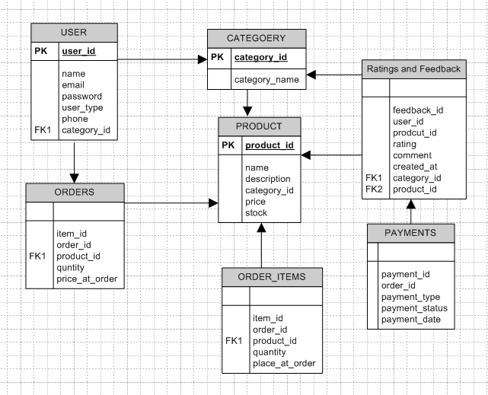

**ER diagram**



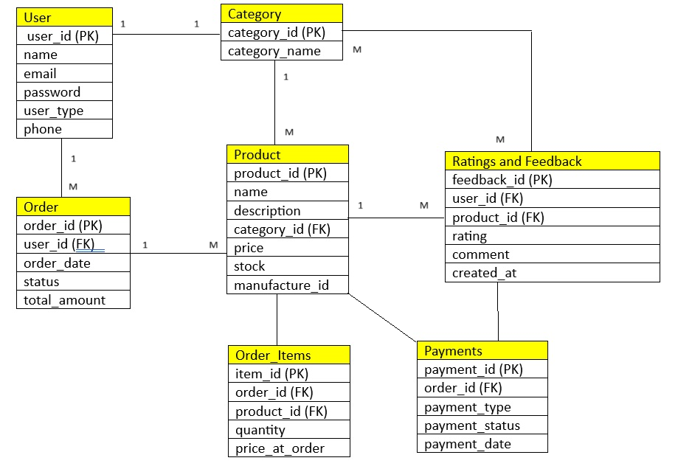

**Question 7** – Data Flow Diagram - 3 Marks

What is a data flow diagram? Draw a data flow diagram to represent the in-flow and out-flow of data when a Farmer is placing an order for the product

***Answer***

**Data flow diagram: -**DFD is a graphical representation of the flow of data within a system. It visually shows how data moves from one process to another, how it is stored and where it is end up.

It helps analyst and designer understand the flow of data within a system, identify potential bottlenecks or inefficiency and communicate system requirement to stakeholders.

**Farmer placing the order**

Key components

1.Farmer

2.Process

1.Browse the product

2.Add to cart

3.Select the payment

4.Confirm order

3.Data store

1.Product catalog D1

2.Cart D2

3.Payment information D3

4.Order database D4

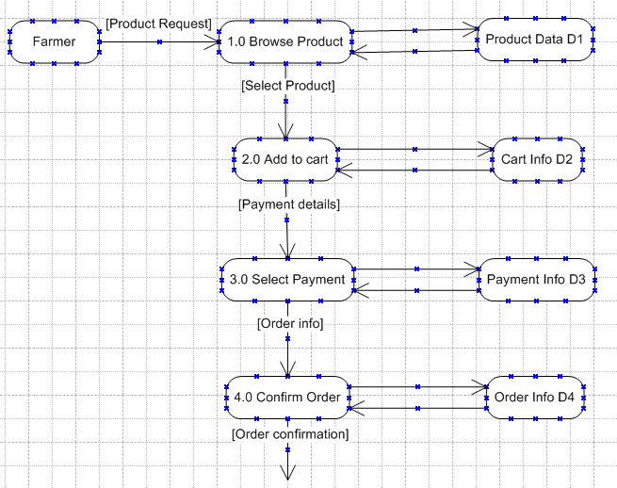

**Question 8** – Change Request - 10 Marks

Due to change in the Government Taxation structure. we should change the Tax structure How do you handle change requests in a project?

***Answer***

A change request is a formal proposal to alter a system, product, project.

**Steps to handle the change request**

Step 1 Receive the change request

1.Offical request submitted by stakeholder (Project sponsor, client, legal team)

2.Document the request Update tax calculation logic as per new governmental taxation rules

Step 2 Log the change

1.Record it in the change request log with ID, Description, Date received, Requester name

Step 3 Perform Impact Analysis

1.Business Impact: -How it is affecting pricing, invoice generation, customer experience

2.Technical Impact: -Which module need to update (check out, billing engine)

3.Time and Cost: -Estimate time and resources needed and potential cost

4.Regulatory compliance: -Ensure legal accuracy of implementation

Step 4 Review and Approval

1.Present change to change control board CCB or project leadership

2.Include analysis report

3.Await approval or Rejection

Step 5 Plan the Implementation

1.Update project timeline

2.Assign task to developers, testers, and project team

3.Update project documentation and requirements (BRD, RTM etc.)

Step 6 Implement the change

1.Developer update the tax logic in code

2.QA test the scenarios under new tax rules

3.UAT to validate real world use cases with new tax rules

Step 7 Deploy the change

1.Deploy to production after UAT

2.Notify stakeholders

Step 8 Post change review

1.Confirm the change works as expected

2.Update user manual, helps guides and training material

**Question 9** – Change Request Vs an Enhancement - 5 Marks

As the project is in process, Ben and Kevin have contacted you. The reason is to inform you that they want the Farmers to sell their crop yields through this application i.e. Farmers should be able to add their crop yields or products and display to public and should be able to sell them. They also want to introduce Auction system for their Crop yields. As a BA, what will be your response?

Is this a change request or an enhancement???

***Answer***

**1.Change Request CR**

1.A change request typically refers to a formal request to modify a product or service to correct a defect, address an issue, or change an existing functionality

2. It often arises when there is a need to fix something that is not working as intended or adjust a feature to meet specific requirement

**2.Enhancment**

1.An enhancement on the other hand involves improving or adding new features to a product or service that already functions correctly

2.It aims to enhance the capabilities or user experience beyond the current state often driven by new customer needs, market trends, or technological advancements

|  |  |  |
| --- | --- | --- |
| Aspect | Change Request | Enhancement |
| Definition | A formal request to alter existing functionality or fix an issue | A request to improve or add new functionality |
| Purpose | To correct problems | To improve performance |
| Trigger | Found bugs, user issue, unexpected behaviour | User feedback, market trends, innovation opportunities |
| System status | Usually for systems already in use but need changes | For system that work as intended but could be improved |
| Nature of work | Modification or Correction | Addition or Upgrade |
| Impact on existing feature | Changes or fixes existing functionalities | Introduces new or improved features |
| Examples | Fixing calculator error | Improving the UI of calculator |

In our case study this request is not about modifying an existing functionality but about introducing entirely new capabilities to the system.

It introduces new features farmer market place and auction system that were not part of original system.

**There for it is clearly ENHANCMENT.**

**Why it is enhancement?**

1.New functionality: -The current system supports buying the products not selling

2.Scope Expansion: -Adds a whole new seller module and auction mechanism not originally planned

3.Involves multiple module: -Farmer profile, product listing, pricing, public view, bidding logic

4.Technical architecture impact: -May required backend service for auction timing, bidding logic, buyer alert

**BA role for above enhancement**

1.Document the enhancement

1.In product backlog or Enhancement request log

2.Gather detail requirement from Ben and Kevin

1.How will farmer list the crop?

2.Will bidding be time bound?

3.Payment and delivery mechanism

3.Do feasibility and Impact analysis

1.Time, Cost, Architecture

4.Colabrate with technical team to estimate effort and impact

5.Present to stakeholder or change control board CCB for approval

**Question 10** – Estimations - 6 Marks

Come up with estimations – How many Manhours required

***Answer***

Man hours are the required effort of the resources to complete the project.

**There are three types of projects**

1.Small-upto 500 hours

2.Medium-upto 1000 hours

3.Large-upto 1500 hours

**Analysis**

1.Project Duration: -18 months

2.Budget: -2Cr

3.Team members: -Total 12 including stakeholder

4.Wroking days/ Month: -22

5.Working hours / day: -8 hours

6.Project scope include

1.Product listing and management by manufacturer

2.Browsing, selecting, and ordering product by farmers

3.Admin and user management

4.Delivery address collection

5.Order tracking

6.Secure Authentication

7.Basic dashboard and reports

8.Mobile and web interface

9.Testing

10.Deployment

11.Support and documentation

|  |  |  |  |  |  |
| --- | --- | --- | --- | --- | --- |
| Role | Number of people | % Involvement | Months active | Total hours | Total |
| Project Manager | 1 | 80% | 18 | 18*22*8*0.8*1 | 2535 hours |
| BA | 1 | 80% | 10 | 10*22*8*0.8*1 | 1232 hours |
| Senior JAVA Dev | 1 | 100% | 14 | 14*22*8*1*1 | 2464 hours |
| JAVA Developer | 4 | 100% | 12 | 12*22*8*1*4 | 8448 hours |
| DB Admin | 1 | 50% | 8 | 8*22*8*0.5*1 | 704 hours |
| Network Admin | 1 | 30% | 6 | 6*22*8*0.3*1 | 317 hours |
| Testers | 2 | 100% | 6 | 6*22*8*1*2 | 2112 hours |

Total manhours required to complete the project is **17812 hours**

We can round up the 18000 hours for planning and buffer time for any unplanned events or rework

**Question 11** – UAT – 6 Marks

Project has finally completed all the stages i.e., design, development, testing etc. Now, it is the role of a business analyst to contact the client for testing of the final product and must successfully complete it. How are you going to handle this situation? And once it is done, what will be the process to close the project?

Explain UAT Acceptance process

***Answer***

BA acts as bridge between the development team and the client, ensuring the product is tested and accepted as per original business requirements.

**Steps for UAT and closure**

Step1 Preparation for UAT

1.Confirm readiness with internal team (PM, Developer, Tester)

2.Ensure the UAT environment is deployed and stable

3.Prepare and share UAT plan includes scope, entry and exit criteria, timelines

4.Review the test cases for business requirements

5.Create user login for client (Kevin, Peter, and Ben)

Step2 Communicate with client and stakeholder

1.Contact client (Kevin, Peter, and Ben) via mail or phone

2.Explain system is ready for UAT and required their feedback

3.Share UAT plan, test cases, timelines, and instructions

4. Schedule UAT kick off meeting to explain instructions and process

Step3 Facilitate UAT execution

1.Be available to support user during testing to collect feedback

2.Track issue raised during UAT in BUG sheet

3.Ensure all bugs are categorised as critical, major, and minor

4.Coordinate with developer and tester to fix UAT issues quickly

Step 4 UAT sign off Acceptance

1.Once UAT is complete conduct UAT closure meeting with stakeholders

2.Share summary, test reports, fixes, feedback

3.Get formal Sign off by email or sign document

**Once UAT is accepted follow these steps to close the project officially**

1.Final deployment: -Move the system to production or live environment

2.Documentation hand over: -Share user manuals, admin guide, training documents

3.Training session: -Train end user if needed

4.Client handover: -Handover credentials, URLs, backups, support contacts

5.Project review meeting: -Conduct project retrospective with internal team and stakeholder

6.Final invoicing and sign off: -Ensure client approve final invoice and sign off contractually

7.Archival: -Store all the data for future project reference

**Question 12** – Project Closure Document - 6 Marks

Explain Project closure document

***Answer***

Project closure document is also known as project closure report is a formal document that summarizes the key outcomes, lesson learned and final details of completed project

It serves as a comprehensive record of the project’s accomplishment, challenges, and overall performance providing valuable insights for stakeholders and future products.

Project closure document is formal report that signals the official end of the project. It confirms that all deliverables have been completed the client has accepted the final product and all contractual obligations are fulfilled.

**Key components of project closure document**

1.Project overview: -Summary of project, objectives, scope, start and end dates, and stakeholders

2.Deliverable summary: -List of final deliverables submitted and accepted by client

3.UAT signoff confirmation: -Evidence of user acceptance testing completion and client approvals

4.Budget summary: -Final financial estimated vs actual budget any revenue or saving

5.Final millstone status: -Status of key millstone and whether they were archived

6.Open issues and resolutions: -Any remaining issues, how they were handled or differed

7.Lesson learned: -Key insight, challenges faced, and what can be improved in future project

8.Resource released: -Confirmation that project resources are released

9.Client signoff: -Formal signoff from the client that project is completed

10.Attachment: -Supporting documents invoices or reports any pending

**Purpose of project closure document**

1.Officially ends the project

2.Confirms client satisfaction

3.Provides reference to future projects

4.Ensure lessons are documented

5.Release resources and budget

**When is it used?**

1.After UAT is completed and signoff

2.Before final invoice submission and payment

3.During the final project review or retrospective meeting

**Example of closure document**

All deliverables have been met as per the agreed scope and have been accepted by the client. The project is now formally closed as of (Date).

----------------------*-----------------------------*------------------------------*-----------------------*-----------------------