***Question 1: Audits – 5 marks***

Four quarterly audits are planned Q1, Q2, Q3, and Q4 for this project. What is your knowledge on how these audits will happen for a BA?

|  |  |
| --- | --- |
| Stage | Quarter 1 – requirement validation and documentation review |
| Completed | Week 1 to Week 20 |
| Checklist | * Business requirement document (BRD) * System requirement specifications (SRS) * UML Diagrams * Business to functional requirements mapping * Email communication list: To, CC and BCC * Client sign off documents * RTM document version control * Email communications – To, CC and BCC |
| BA Responsibilities | * Ensure all requirements are well documented. * Align with SOONY and development team. * Identify missing requirements or risks. |

|  |  |
| --- | --- |
| Stage | Quarter 2 – design and initial development audit |
| Completed | Week 30 to Week 37 |
| Checklist | * Utilization of tools * Documented evidence on client communication * Stakeholder MOM * UI / UX design compliance * Data flow and process flow audit * Development milestone check * Review changes and impact analysis |
| BA Responsibilities | * Validate process models and wireframes. * Ensure developers align with the requirements. * Monitor scope changes. * Update traceability matrix. |

|  |  |
| --- | --- |
| Stage | Quarter 3 – development and testing compliance audit |
| Completed | Week 40 to Week 60 |
| Checklist | * JAD Sessions report * End user-manual preparation * BA and developer MOM * Code review and compliance with requirements * Functional and integration testing review * Defect management and risk assessment |
| BA Responsibilities | * Track requirement to test case coverage * Verify defect resolution alignment with requirements * Assess system performance and usability issues. |

|  |  |
| --- | --- |
| Stage | Quarter 4 – UAT & Deployment Readiness Audit |
| Completed | Week 58 to Week 78 |
| Checklist | * User Acceptance Testing (UAT) Report * Stakeholder Feedback Review * Final Documentation Review * Deployment & Post-Launch Plan Verification |
| BA Responsibilities | * Ensure all UAT feedback is addressed * Validate training materials for farmers/suppliers * Prepare business impact analysis for SOONY |

***Question 2: BA Approach Strategy – 6 marks***

What elicitation techniques to apply in this project?

|  |  |
| --- | --- |
| Technique | Why to use? |
| Interviews | Directly gather insights from key stakeholders on project goals, expectations, and pain points. |
| Workshops | Collaborative discussions to refine system workflows, payment processes, and logistics. |
| Observation | Understand how farmers currently procure products and the challenges they face. |
| Surveys & Questionnaires | Collect large-scale feedback from farmers on digital platform usability, preferences, and features. |
| Focus Groups | Gather qualitative feedback from select farmers and suppliers on pricing, order processing, and ease of use. |
| Document Analysis | Study existing procurement policies, government agricultural schemes, and competitor platforms. |
| Prototyping | Provide a mock-up of the online store to validate usability before development. |
| Brainstorming | Generate new ideas for platform features and business model innovations. |

How to do stakeholder analysis RACI?

|  |  |  |  |  |  |  |  |  |
| --- | --- | --- | --- | --- | --- | --- | --- | --- |
| Project Activity | Sponsor (Mr. Henry) | SOONY Finance (Mr. Pandu) | Project Manager | BA | Developers | Testers | Farmers & Suppliers | Customer Support |
| Requirement Gathering | A | C | R | R | I | I | C | I |
| Business Model Finalization | A | R | C | C | I | I | C | I |
| System Design & Architecture | I | I | A | R | R | I | C | I |
| Development | I | I | A | C | R | I | I | I |
| Testing & Quality Assurance | I | I | A | C | C | R | C | I |
| User Acceptance Testing (UAT) | I | I | A | R | C | R | C | I |
| Deployment & Go-Live | A | I | R | C | R | C | I | C |
| Post-Launch Support & Maintenance | I | I | A | C | R | R | I | R |

What documents to write?

1. Business Case Document: Justifies why the project is initiated (problem, solution, benefits, ROI, risks).
2. Project Charter: Defines project scope, objectives, stakeholders, budget, and timeline.
3. Stakeholder Analysis & RACI Matrix: Identifies key stakeholders and assigns roles/responsibilities.
4. Requirement Elicitation Report: Summarizes findings from interviews, surveys, and workshops.
5. Business Requirements Document (BRD): Defines business needs, goals, and high-level requirements.
6. Software Requirements Specification (SRS): Detailed functional & non-functional system requirements.
7. Use Case Document: Describes system interactions between users and the platform.
8. Process Flow Diagrams (UML, BPMN): Visualizes workflows for purchasing, payment, order tracking, etc.
9. Data Flow Diagrams (DFD): Shows how data moves within the system (users, products, transactions).
10. User Interface Wireframes & Prototypes: Initial screen designs to validate UI/UX before development.
11. Functional Specification Document (FSD): Maps functional requirements to system design.
12. Technical Specification Document (TSD): Defines architecture, database, APIs, and security standards.
13. Traceability Matrix (RTM): Links requirements to test cases for validation.
14. Test Plan & Test Cases: Defines testing strategy, test cases, expected results.
15. Defect Log: Tracks and documents bugs/issues found during testing.
16. User Acceptance Testing (UAT) Plan: Defines UAT process, participants, and success criteria.
17. Training Manuals & User Guides: Guides for farmers, suppliers, and support teams.
18. Deployment Plan: Steps for migrating system from test to production.
19. Change Management Plan: Handles process transitions & minimizes user resistance.
20. Post-Launch Support Plan: Defines issue resolution, monitoring, and system updates.
21. Quarterly Audit Reports (Q1, Q2, Q3, Q4): Ensures compliance, tracks issues, and process improvements.
22. Lessons Learned Document: Captures successes, failures, and recommendations for future projects.

What process to follow to sign off on documents?

* Step 1: Identify Required Signatories
  + Determine who must approve the document based on the RACI Matrix.
  + Common signatories include:
    - Business Sponsor (Mr. Henry)
    - Financial Head (Mr. Pandu)
    - Project Manager (Mr. Vandanam)
    - Developers (for technical documents)
    - Testers (for QA-related documents)
    - End-Users (Farmers & Suppliers for UAT documents)
* Step 2: Draft & Review the Document
  + Prepare the first draft based on stakeholder requirements.
  + Conduct internal reviews with relevant teams (e.g., Developers, Testers, Architects).
  + Address feedback before sending it for formal approval
* Step 3: Distribute for Review & Approval
  + Send the document to all stakeholders for review.
  + Use email, document management tools (SharePoint, Confluence, Google Docs), or project management software (JIRA, Trello).
  + Set a deadline for review and response.
* Step 4: Address Feedback & Make Revisions
  + Gather feedback via meetings, email comments, or collaborative tools.
  + Make necessary changes and update the document version.
  + Maintain a version history to track updates.
* Step 5: Formal Approval & Sign-Off
  + Once all feedback is incorporated, request final approval.
  + Obtain written confirmation via email or digital signatures (DocuSign, Adobe Sign).
  + Store the approved version in a centralized repository for future reference.
* Step 6: Communicate Final Sign-Off
  + Inform all relevant stakeholders that the document is finalized and approved.
  + Update the traceability matrix to ensure alignment with project phases.
  + Restrict further edits unless a formal change request is raised.

How to take approvals from the client?

Identify What Needs Approval:

* Key documents include BRD, SRS, Design Prototypes, UAT Results, and Deployment Plan.

Prepare & Share the Document:

* Ensure clarity, accuracy, and completeness.
* Send via email, project management tools (JIRA, SharePoint), or cloud storage (Google Drive).
* Specify approval deadline and key highlights for easy review.

Conduct a Review Meeting (If Needed):

* Walk the client (Mr. Henry & SOONY team) through the document.
* Address questions, concerns, and requested changes.

Revise & Finalize:

* Incorporate feedback and maintain version control.
* Send the final version for confirmation.

Obtain Formal Approval:

* Request written approval via email or digital signature (DocuSign, Adobe Sign).
* Store signed copies for future reference.

What communication channels to establish?

Emails & Official Documents – For approvals, formal updates, and sign-offs.  
Meetings (Zoom, MS Teams, Google Meet) – For stakeholder discussions, requirement gathering, and status updates.  
Project Management Tools (JIRA, Trello, Asana) – For task tracking and issue management.  
Instant Messaging (Slack, Microsoft Teams, WhatsApp Groups) – For quick clarifications and team coordination.  
Shared Repositories (Google Drive, SharePoint, Confluence) – For document storage and version control.

How to handle change requests?

Receive & Document: Capture requests via emails, meetings, or JIRA, detailing the reason and urgency.  
Analyse Impact: Assess effects on scope, timeline, budget, and resources with developers and testers.  
Seek Approval: Present impact analysis to SOONY leadership for decision-making.  
Implement & Test: Update requirements, modify the system, and conduct regression testing to ensure stability.  
Communicate & Document: Inform stakeholders of changes and update the traceability matrix.

How to update project progress to stakeholders?

To update project progress to stakeholders:

* Send regular emails and official documents for approvals, formal updates, and sign-offs.
* Schedule meetings via Zoom, MS Teams, or Google Meet for stakeholder discussions, requirement gathering, and status updates.
* Utilize project management tools like JIRA, Trello, or Asana for task tracking and issue management.
* Use instant messaging platforms such as Slack, Microsoft Teams, or WhatsApp Groups for quick clarifications and team coordination.
* Regularly update shared repositories like Google Drive, SharePoint, or Confluence with the latest project documents and version control records.

How to take sign off on the UAT – client project acceptance form?

Step 1: Conduct UAT Sessions

* Facilitate hands-on testing with the client (Mr. Henry & SOONY team).
* Document test results, feedback, and defects.

Step 2: Resolve Issues

* Fix critical bugs and conduct retesting.
* Ensure the system meets agreed requirements.

Step 3: Present UAT Report & Acceptance Form

* Share UAT summary, defect resolutions, and final test results.
* Attach the Client Project Acceptance Form for approval.

Step 4: Obtain Formal Sign-Off

* Request written approval via email or digital signature (DocuSign, Adobe Sign).
* Store signed forms for compliance and future reference.

***Question 3: explain and illustrate 3 tier architecture***

Application layer: Top most layer of the application, also called as the presentation layer – it handles the user interface (UI) components such as screens and pages.

Business Logic Layer: Middle layer of the architecture – acts as the intermediatory between presentation layer and the data storage layer. This layer contains the core logic of the application.

Database Layer: Bottom most layer of the architecture – responsible for storing and retrieving data.



***Application Layer***  
UI Components displayed in the client computers are handled here.



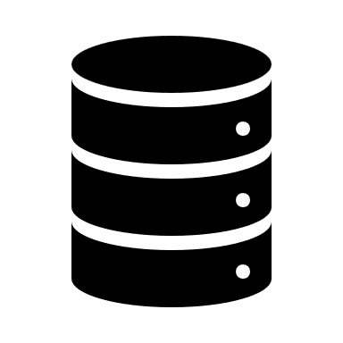

***Database Layer***Responsible for storing and retrieving data

***Business Logic Layer***  
Core logic of the application is stored in the application servers here.

***Question 4 – BA Approach Strategy for Framing Questions***

1. 5W 1H (Who, What, When, Where, Why, How)

* Who will use the system? (Farmers, suppliers, SOONY team)
* What are the key pain points and expectations?
* When should each feature be available? (Timelines)
* Where will the platform be accessed? (Web/Mobile)
* Why is the requirement necessary? (Business impact)
* How will it be implemented? (Technical feasibility)

2. SMART Approach *(Specific, Measurable, Achievable, Relevant, Time-bound)*

1. Questions should be specific & measurable (e.g., "How many suppliers should be onboarded initially?")
2. Requirements should be achievable & relevant to business needs.
3. Ensure a time-bound scope to avoid delays.

3. RACI Framework (Responsible, Accountable, Consulted, Informed)

1. Identify which stakeholders are Responsible (R), Accountable (A), Consulted (C), and Informed (I) before questioning.
2. Example: Farmers & suppliers consulted on usability, while SOONY’s finance team is accountable for pricing models.

4. 3-Tier Architecture Awareness

1. Ensure clarity on UI (Frontend), Business Logic (Backend), and Database (Data Storage).
2. Example: "How should product categories be structured for easy navigation?"

5. Use Cases, Models & Diagrams

* Frame questions around Use Cases, Use Case Specs, Activity Diagrams, and UI Page Designs.
* Example: “What happens if a farmer cancels an order? Should refunds be automated?”

***Question 5 – Elicitation Techniques - 6 Marks***

As a Business Analyst, What Elicitation Techniques you are aware of?

|  |  |
| --- | --- |
| Technique | Definition |
| Brainstorming | A group discussion technique to generate innovative ideas and solutions. |
| Document Analysis | Reviewing existing documents to gather system requirements and business rules. |
| Reverse Engineering | Analysing an existing system to understand its functionality and derive requirements. |
| Focus Groups | A guided discussion with selected stakeholders to gather feedback and insights. |
| Observation | Watching users interact with a system or process to understand workflows and challenges. |
| Workshops | Interactive sessions with stakeholders to collaboratively define requirements and solutions. |
| JAD (Joint Application Development) | A structured workshop involving users, developers, and business teams for rapid requirement gathering. |
| Interview | A one-on-one or group discussion to collect detailed stakeholder requirements. |
| Prototype | A visual or interactive mock-up of a system to validate requirements before development. |
| Questionnaire | A structured set of questions to collect quantitative or qualitative data from stakeholders. |
| Use Case Specs | Detailed descriptions of system interactions between users and functionalities. |

***Question 6 – This project Elicitation Techniques - 5 Marks***

1. Interviews*(For Stakeholder Alignment)*

Why?

* Helps gather detailed business requirements from Mr. Henry, SOONY’s leadership, farmers, and suppliers.
* Allows one-on-one discussions to understand key pain points and expectations.

2. Workshops *(For Requirement Finalization & Consensus)*

Why?

* Facilitates collaborative requirement gathering among stakeholders.
* Ensures faster decision-making for system workflows and pricing models.

3. Document Analysis *(For Understanding Existing Processes & Compliance)*

Why?

* Helps analyse government agricultural policies, existing procurement methods, and competitor platforms.
* Ensures legal and regulatory compliance in the platform’s design.

4. Prototyping *(For UI/UX Validation & User Experience Testing)*

Why?

* Helps stakeholders visualize the platform (order placement, payments, delivery tracking).
* Ensures usability before full-scale development.

5. Observation (Job Shadowing) *(For Understanding Farmer Challenges)*

Why?

* Provides real-world insights into how farmers currently purchase seeds, fertilizers, and pesticides.
* Helps design a user-friendly digital experience for first-time users.

6. Focus Groups *(For Gathering User Preferences & Expectations)*

Why?

* Engages multiple farmers/suppliers in a structured discussion about product selection, pricing, and payment options.
* Helps understand common challenges and feature priorities.

7. Questionnaires & Surveys *(For Large-Scale Input Collection)*

Why?

* Helps collect quantitative & qualitative feedback from farmers on preferred payment modes, order volumes, and logistics expectations.
* Useful for assessing digital literacy levels of end-users.

***Question 7 – 10 Business Requirements- 10 Marks***

BR001: The system shall allow farmers to browse and purchase agricultural products (fertilizers, seeds, pesticides) from multiple suppliers.

BR002: The platform shall support multiple payment methods, including UPI, debit/credit cards, net banking, and cash on delivery (COD).

BR003: The system shall enable order tracking functionality, allowing farmers to check delivery status in real time.

BR004: Suppliers shall be able to list, update, and manage their products, inventory, and pricing dynamically.

BR005: The platform shall provide multilingual support (English, Hindi, and regional languages) to accommodate farmers across different regions.

BR006: The system shall allow farmers to rate and review products to enhance transparency and trust.

BR007: The platform shall include a dashboard for SOONY and suppliers to track sales, revenue, and customer orders.

BR008: The system shall integrate with logistics partners for delivery management, including estimated delivery timelines and tracking.

BR009: The platform shall comply with government agricultural regulations and allow for subsidy-based pricing when applicable.

BR010: The system shall provide customer support via live chat, email, and phone assistance to help farmers navigate the platform.

***Question 8 –Assumptions- 5 Marks***

Target Users: The platform will primarily serve farmers in remote areas and agricultural suppliers (fertilizer, seed, pesticide manufacturers).

Platform Accessibility: The system will be available on both web and mobile (Android & iOS) for ease of access.

User Digital Literacy: Farmers may have limited technical knowledge, so the platform must be user-friendly with simple navigation and multilingual support.

Payment Methods: The platform will support UPI, debit/credit cards, net banking, and cash-on-delivery (COD).

Order Management: Farmers should be able to track orders in real time, and suppliers should manage inventory and product availability dynamically.

Product Transparency: Product ratings and reviews will be available for farmers to make informed decisions.

Logistics & Delivery: The system will integrate with third-party delivery partners for seamless transportation of goods.

Government Regulations: The platform must comply with agricultural and e-commerce regulations, including potential subsidy integrations for farmers.

Customer Support: Farmers and suppliers will have access to live chat, email, and phone support for issue resolution.

Performance & Scalability: The system must handle a large number of concurrent users and scale as adoption increases.

***Question 9 – This project Requirements Priority - 8 Marks***

|  |  |  |  |
| --- | --- | --- | --- |
| Req ID | Req Name | Req Description | Priority (1-10) |
| BR001 | Product Browsing & Purchase | The system shall allow farmers to browse and purchase agricultural products (fertilizers, seeds, pesticides) from multiple suppliers. | 10 |
| BR002 | Payment Methods Integration | The platform shall support multiple payment methods, including UPI, debit/credit cards, net banking, and cash on delivery (COD). | 9 |
| BR003 | Order Tracking | The system shall enable order tracking functionality, allowing farmers to check delivery status in real time. | 8 |
| BR004 | Supplier Product Management | Suppliers shall be able to list, update, and manage their products, inventory, and pricing dynamically. | 9 |
| BR005 | Multilingual Support | The platform shall provide multilingual support (English, Hindi, and regional languages) to accommodate farmers across different regions. | 8 |
| BR006 | Product Reviews & Ratings | The system shall allow farmers to rate and review products to enhance transparency and trust. | 7 |
| BR007 | Sales & Order Dashboard | The platform shall include a dashboard for SOONY and suppliers to track sales, revenue, and customer orders. | 8 |
| BR008 | Logistics & Delivery Integration | The system shall integrate with logistics partners for delivery management, including estimated delivery timelines and tracking. | 9 |
| BR009 | Government Compliance & Subsidy Integration | The platform shall comply with government agricultural regulations and allow for subsidy-based pricing when applicable. | 7 |
| BR010 | Customer Support Services | The system shall provide customer support via live chat, email, and phone assistance to help farmers navigate the platform. | 9 |

***Question 10 – Use Case Diagram - 10 Marks***

***Question 11 – (minimum 5) Use Case Specs - 15 Marks***

***Use Case Name: Browse & Select Products  
Use Case ID: UC001***

***Brief Description:***

This use case describes how a farmer logs into the online agriculture store, browses through various agricultural products, views detailed product information, and adds desired items into shopping cart in preparation for purchase.

***Actors:***

* 1. Primary actor: Farmer
  2. Secondary actor: Product Catalogue System

***Preconditions:***

1. Farmer is registered and successfully logged into the platform.
2. The system has product listings uploaded by suppliers.

***Basic flow path:***

1. Farmer logs into the agriculture store platform.
2. Farmer navigates to product categories.
3. System displays the list of available products in the selected category.
4. Farmer uses filters or search bar to narrow down the results.
5. Farmer clicks on the products to views detailed information.
6. Farmer selects the desired quantity.
7. Farmer clicks add to cart.
8. System confirms that the product has been added to the shopping cart.
9. Farmer may continue shopping or proceed to checkout.

***Alternative flow:***

1. Alternative flow 1: No Products found:
   1. After step 4, if no products match the search, the system displays, “No products available for selected filter.
2. Alternative flow 2: Out of stock product:
   1. After step 6, if the product is out of stock, the “add to cart” button is disabled and message is shown, “Currently unavailable”.
3. Alternative flow 3: Session Timeout:
   1. After step 6, if the farmer’s session expires before adding to the cart, the system prompts for re-login.

***Key scenarios:***

1. Item added to cart not available in stock anymore.

***Special request:***

1. The system should support multilingual display of product names and description.
2. Provide voice search functionality for ease of access.
3. Show suggested / related products after adding an item to the cart.

***Use Case Name: Place an Order  
Use Case ID: UC002***

Brief Description:   
This use case describes how a farmer places an order for the products added to the cart by providing the delivery address, selecting a payment method, and confirming the order. It also includes handling payment success or failure.

Actors:

1. Primary actor:
   1. Farmer
2. Supporting actors:
   1. Payment gateway (External System)
   2. Inventory
   3. Order Management System

Preconditions:

1. Farmer is logged into the system.
2. The cart contains at least one product.
3. All selected items are available in stock.

Basic flow path:

1. Farmer navigates to the cart.
2. System displays all added items with total price.
3. Farmer clicks on proceed to check out.
4. System prompts the farmer to enter or confirm delivery address.
5. Farmer selects delivery method – UPI, card or COD.
6. System checks stock availability.
7. System redirects to payment gateway.
8. Payment is successfully processed.
9. System generates unique order ID and confirms the order.
10. Confirmation is sent to farmer via notification / SMS / email.

Alternative flows:

1. Payment failure: after step 8, if payment fails, the system displays an error and offers retry or alternative payment method.
2. Out of stock item at checkout: after step 6, if an item becomes unavailable before checkout, the system notifies the farmer about it.
3. Invalid address: after step 4, if the address is incomplete or invalid, the system prompts for correction.

Key scenarios:

1. Farmer adds seeds and fertilisers to the cart, selects UPI as payment and completes the order.
2. Farmer selects cash on delivery, receives confirmation, and prepares to accept the order in the farm.

Post condition:

1. Confirmed order is created with unique ID.
2. Payment is recorded (if online).
3. Order status is set to “processing”.

Special requests:

1. Display estimated delivery date before processing order.
2. Show a summary page for final review before payment.
3. Enable order confirmation via SMS in regional language.

***Use case name: Make Payment  
Use Case ID: UC003***

Brief Description:   
This use case describes how a farmer selects a payment method and completes the transaction using the platform’s integrated payment gateway to finalise a product order.

Actors:

1. Primary actor: farmer.
2. Supporting actor:
   1. Payment gateway (external system).
   2. Order management system.

Preconditions:

1. Farmer has items ready for checkout.
2. Order has been reviewed and confirmed by farmer.
3. A valid delivery address has been provided.

Basic flow path:

1. Farmer selects a preferred payment method (UPI, card, net banking, COD).
2. If online payment is selected, the system redirects to the payment gateway.
3. Farmer enters payment credentials.
4. Payment gateway authenticates and authorises the transaction.
5. Upon successful payment, the system updates the order status to paid.
6. Farmer receives a payment confirmation message via email / SMS / app notifications.
7. The system proceeds to order processing.

Alternative flows:

1. Payment failure: if the payment fails, the system displays an error message and offers options to retry or change the payment method.
2. Interrupted payment session: if the session times out or the farmer closes the window, the system makes the order as pending payment and allows resumption.
3. Choosing cash on delivery: if the farmer chooses cash on delivery, payment is deferred to the time of delivery and order is marked as payment on delivery.

Key scenarios:

1. A farmer pays for seeds via UPI, receives an instant confirmation, and proceeds to track the order.
2. A card transaction failed, and the farmer switches to cash on delivery to complete the purchase.

Post conditions:

1. Payment is successfully recorded and linked to the order.
2. Order status is updated accordingly.
3. A digital receipt is generated.

Special requests:

1. Show QR Code for UPI payments.
2. Allow partial payments for bulk payments.
3. Include support for regional payment wallets in future.

***Use case name: Track Order  
Use case ID: UC004***

Brief Description:   
This use case describes how a farmer can track the status of an order placed through the online agriculture store, using real time updates provided by the logistics partner through system integration.

Actors:

1. Primary actor:
   1. Farmer.
2. Supporting actor:
   1. Logistics partner.
   2. Order management system.

Preconditions:

1. The farmer has successfully placed and confirmed the order.
2. The order has been accepted by the supplier and dispatched.

Basic flow path:

1. Farmer logs into the online agriculture store.
2. Navigates to the my order section.
3. Selects the relevant order.
4. System fetches the real time tracking data from the logistics partner.
5. System displays the current status.
6. Farmer views estimated delivery date and tracking details.

Alternative flow:

1. Order not shipped yet:
   1. If the supplier hasn’t dispatched the order, the system shows status processing with an estimated dispatch date.
2. Tracking order not available:
   1. If the tracking data is unavailable due to connectivity, or system error the system displays, “tracking information not available at the moment”.
3. Delayed delivery:
   1. If the logistics partner flags a delay, the system updates the delivery date and notifies the farmer.

Key scenario:

1. A farmer tracks an order of pesticides marks as “out for delivery” and prepares to receive it.
2. The tracking shows “delayed” due to weather conditions, and the system automatically sends an SMS update.

Post conditions:

1. The farmer has successfully viewed the current status and the delivery details of the order.
2. The system logs the tracking request for future reference.

Special requests:

1. Include push notification alerts for each change in the order status.
2. Display the delivery map or timeline bar for visual clarity.
3. Offer support for SMS tracking for low internet regions.

***Use case: Supplier manages inventory  
Use Case ID: UC005***

Brief Description: This use case describes how a supplier logs into the online agriculture store to add, update, or remove the product listings, adjust stock levels, and manage pricing of the agricultural products such as fertilisers, seeds and pesticides.

Actors:

1. Primary actor: Supplier.
2. Supporting actors:
   1. Product catalogue system
   2. Inventory management system
   3. Admin (monitoring role)

Pre Conditions:

1. The supplier must be registered and logged into the system.
2. Supplier has access to the supplier dashboard.
3. Products have been previously approved for listing.

Basic Flow Path:

1. Supplier logs into the online agriculture store.
2. Navigates to the inventory and product management section.
3. Supplier selects the product to update and clicks “Add New Product”.
4. Enters / updates the product details (name, price, quantity, description, image).
5. Clicks Save to submit the update.
6. System validates the data and updates the inventory records.
7. The changes are reflected in the product catalogue visible to farmers.
8. Admin is notified if approval workflow is required.

Alternative flow:

1. Validation Failure:
   1. If required fields (eg: product name or price) are missing, the system prompts the supplier to complete them.
2. Product listing rejected:
   1. If admin rejects the new product or change, the system sends a rejection reason and disables the listing.
3. Session timeout:
   1. If the supplier is inactive for a long period of time, the system logs out the session for security.

Key scenarios:

1. A supplier adds a new organic fertiliser product with stock of 100 units.
2. The supplier reduces the inventory for a pesticide after a bulk offline sale.
3. A supplier updates the price of a seed pack based on market changes.

Post conditions:

1. Product details are successfully added or updated in the catalogue.
2. Inventory levels reflect accurate stock quantities.
3. Admin is notified for changes if approval is required.

Special requests:

1. Allow bulk upload of products via excel or csv.
2. Provide low stock alerts to suppliers.
3. Include version history and audit logs for each product change.

***Use case: Supplier processes orders  
Use case ID: UC006***

Brief Description:   
This use case describes how a supplier processes new orders received from the farmers by verifying the product availability, preparing the items, marking them ready for pickup, and coordinating with the logistics partner for dispatch.

Actors:

* 1. Primary actor:
     + Supplier
  2. Supporting actors:
     + Order management system
     + Logistics partner
     + Inventory management system

Precondition:

1. Supplier is logged into the platform.
2. There are confirmed orders placed by farmers awaiting processing.
3. Inventory is updated and accurately reflects stock.

Basic flow path:

1. Supplier logs into online agriculture store.
2. Navigates to the orders section in the supplier dashboard.
3. Views a list of new and pending orders.
4. Selects an order and verifies the product availability in inventory.
5. Confirms the order and updates the status to processing.
6. Picks and packs the products for delivery.
7. Updates the status to ready for pickup.
8. System notifies the logistics partner.
9. Logistics partner schedules and confirms pickup.
10. System confirms the order status to shipped.

Alternative flow:

1. Item out of stock:
   1. If inventory is insufficient, the supplier marks the item out of stock, and system notifies the farmer for cancellation or waitlist.
2. Logistics delay:
   1. If the logistics partner fails to pick up on time, the supplier may reschedule the pick up and contact support.
3. Order cancellation by farmer:
   1. If the farmer cancels the order before dispatch, the system updates the status to cancelled and inventory is restored.

Key scenarios:

1. Supplier processes a bulk order of seeds, schedules pick up, and dispatches within 24 hours.
2. A supplier partially fulfils an order due to stock limitations and updates the system accordingly.

Post conditions:

1. The order is marked as shipped and is en route to the farmer.
2. Inventory is reduced based on fulfilled quantity.
3. Logistics partner is officially assigned for delivery.

Special requests:

1. Enable auto alerts to suppliers for new orders.
2. Provide printable packing slips with farmer details.
3. Allow suppliers to reschedule pickups in coordination with logistics.

***Use case: Customer Support Handling Complaints  
Use case ID: UC007***

Brief Description:   
This use case describes how a Farmer submits a complaint regarding an order or product, and how the Customer Support Team receives, reviews, resolves, and communicates the status of that complaint through the Online Agriculture Store system.

Actors:

1. Primary Actors:
   1. Farmer
2. Supporting actors:
   1. Customer Support Executive
   2. Admin (for escalated issues)
   3. Order Management System

Preconditions:

1. The farmer is logged into the system.
2. The complaint is related to a past or current order.

Basic flow path:

1. Farmer logs into the system.
2. Navigates to “My Orders” and selects an order.
3. Clicks on “Raise a Complaint.”
4. Fills in the complaint form with details and optionally attaches images.
5. Submits the complaint.
6. System generates a Complaint Ticket ID and notifies the support team.
7. Customer Support reviews the complaint and contacts the farmer if needed.
8. Issue is resolved (refund, replacement, clarification).
9. Complaint is marked as “Resolved,” and the farmer is notified.

Alternative flows:

1. Invalid Complaint Submission:
   1. If mandatory fields are missing, the system prompts the farmer to complete them.
2. Complaint Escalated
   1. If the issue cannot be resolved at the support level, it is escalated to the Admin for further action.
3. No Response from Farmer:
   1. If the farmer doesn’t respond to support queries within a defined time, the complaint is put on hold with notification.

Key scenarios:

1. A farmer receives a damaged product and raises a complaint with photos. Support processes a return and refund.
2. A farmer is charged incorrectly, and the support team clarifies the pricing issue.

Post conditions:

1. Complaint is either resolved or escalated.
2. Farmer receives notification of the resolution status.
3. Complaint record is stored for audit and reporting.

Special Requests:

1. Enable multi-language support for complaint submission.
2. Allow voice message attachment for low-literacy users.
3. Include an auto-acknowledgment email/SMS upon complaint submission.

***Use case: Product Reviews and Ratings  
Use Case ID: UC008***

Brief Description:  
This use case describes how a Farmer provides feedback on a purchased product by submitting a star rating and a written review. The reviews help other farmers make informed decisions and allow suppliers to improve their offerings.

Actors:

1. Primary Actor:
   1. Farmer
2. Supporting Actors:
   1. Product Catalog System
   2. Admin (for moderation)

Pre Conditions:

1. The farmer is logged into the system.
2. The product has been successfully delivered and marked as "Received."
3. Review period (e.g., within 15 days of delivery) is still valid.

Basic Flow Path:

1. Farmer logs into the Online Agriculture Store.
2. Navigates to “My Orders.”
3. Selects the product from the delivered orders list.
4. Clicks “Rate & Review” option.
5. Selects a star rating (1 to 5 stars).
6. Enters a text review describing the experience.
7. Submits the review.
8. System validates and publishes the review under the product.
9. Admin is notified for moderation (if needed).

Alternative flows:

1. Review Already Submitted:
   1. If the farmer tries to submit a second review for the same product, the system restricts it or allows editing only.
2. Inappropriate Content:
   1. If the review contains abusive or flagged words, the system either auto-blocks or sends it to the admin for moderation.
3. Anonymous Review Option:
   1. The farmer may choose to hide their name from the public review listing.

Key Scenarios:

1. A farmer rates a pesticide 4 stars and comments that it worked effectively within two days.
2. A farmer posts a 2-star review stating the fertilizer package was damaged, helping others be aware.

Post Conditions:

1. The review and rating are published under the product page.
2. Review data contributes to the product’s average rating.
3. Suppliers and other farmers can view the feedback.

Special requests:

1. Enable image upload in reviews for proof or clarity.
2. Add filters to sort reviews by rating or usefulness.
3. Allow admin to respond to reviews for service recovery.

***Use case name: Generate Sales and Order Reports  
Use Case ID: UC009***

Brief Description:  
This use case describes how Admin or Supplier generates reports related to sales performance, order volume, product-wise sales, and customer trends using the reporting features of the Online Agriculture Store system.

Actors:

1. Primary Actors:
   1. Admin
   2. Supplier
2. Supporting Actor:
   1. Reporting System / Database

Preconditions:

1. The actor (admin or supplier) must be authenticated and logged in.
2. Sales and order data must be available in the system for the selected date range.

Basic Flow Path:

1. Actor logs into the platform and navigates to the Reports section.
2. Selects the type of report to generate (e.g., Sales by Product, Daily Orders, Revenue Summary).
3. Enters filters such as date range, product category, or region.
4. Clicks on “Generate Report.”
5. System queries the database and compiles the requested report.
6. System displays the report on-screen and offers download in PDF/Excel format.
7. Actor saves or prints the report for record-keeping or decision-making.

Alternative Flows:

1. No Data Found:
   1. If no data is found for the selected filters, the system shows: “No records available for the selected criteria.”
2. Report Generation Timeout
   1. If the report takes too long to generate, the system shows a message and suggests refining the filters.
3. Permission Denied
   1. If a supplier tries to access admin-level reports, the system restricts access and shows a permissions error.

Key Scenarios:

1. Admin generates a monthly summary report to analyze supplier performance.
2. A supplier downloads a sales report for their own listed products to assess revenue for the quarter.

Post Conditions:

1. Report is successfully generated and downloaded (if needed).
2. Data may be exported, printed, or emailed.
3. The system logs report generation for audit purposes.

Special Requests:

1. Enable scheduled reports to be emailed automatically.
2. Include graphical dashboards for visual analytics.
3. Allow role-based report templates for Admins, Suppliers, and Finance teams.

***Question 12 – (minimum 5) Activity Diagrams - 15 Marks***

Activity – farmer buying process:

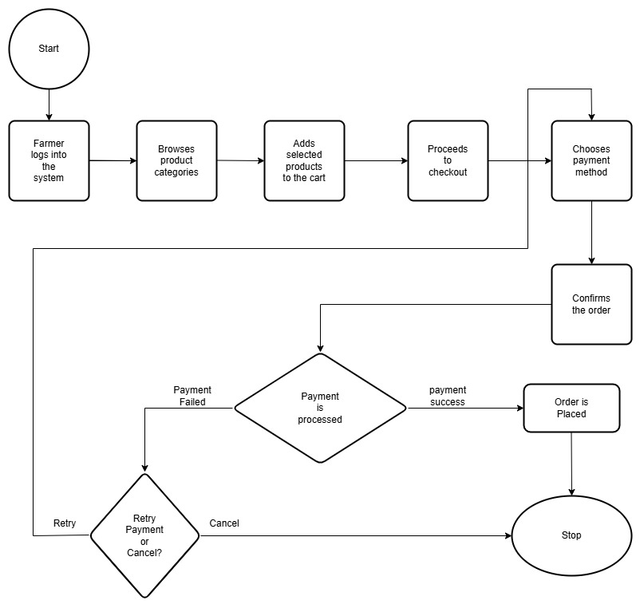

Activity – Order Processing by Supplier

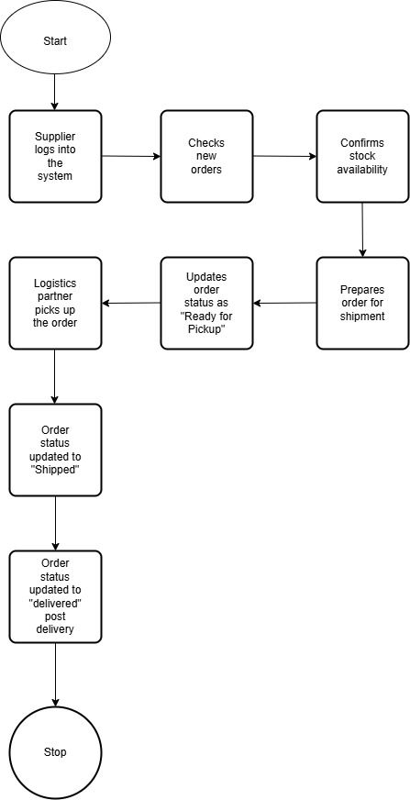

Activity Diagram: Order Tracking

Activity Diagram: Customer Support Request

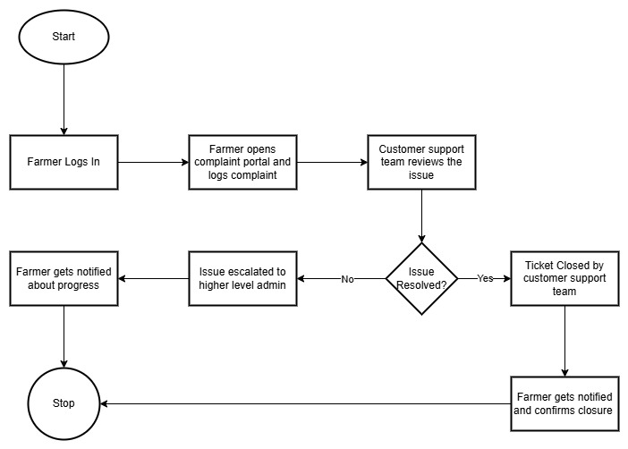

Activity Diagram: Product information request

