**Case study 3/3**

Question 1 – Functional Requirements - 15 Marks Identify minimum 20 functional requirements Example : Functional requirement: When an order is fulfilled, the local printer shall print a packing slip. Non-Functional Requirement: Packing slips shall be printed on both sides of 4”x 6” white paper, the standard size for packing slips used by local printers.

Answer: -

| **Req ID** | **Type** | **Req Name** | **Req Description** | **Priority** |
| --- | --- | --- | --- | --- |
| FR0001 | Functional | Farmer Registration | Farmers should be able to register with the application. | 8 |
| FR0002 | Functional | Farmer Search for Products | Farmers should be able to search for available products in fertilizers, seeds, and pesticides. | 8 |
| FR0003 | Functional | Farmer Login | Farmers must log in with valid credentials (email and password). | 9 |
| FR0004 | Functional | Manufacturer Registration | Manufacturers should be able to register on the platform. | 7 |
| FR0005 | Functional | Upload Product Info | Manufacturers should be able to upload product details including price, quantity, and image. | 8 |
| FR0006 | Functional | Add to Cart | Farmers should be able to add selected products to their shopping cart. | 9 |
| FR0007 | Functional | Place Order | Farmers should be able to place an order for selected items in the cart. | 10 |
| FR0008 | Functional | Payment via UPI | Farmers should be able to make payments using UPI. | 10 |
| FR0009 | Functional | Delivery Tracking | Farmers should be able to track their order delivery status. | 8 |
| FR0010 | Functional | Email Order Confirmation | The system should send a confirmation email once the order is placed. | 7 |
| NFR0101 | Non-Functional | Page Loading Time | Each page should load within 2 seconds under standard network conditions. | 9 |
| NFR0102 | Non-Functional | Accessibility Compliance | The system must comply with Web Content Accessibility Guidelines (WCAG) 2.1. | 8 |
| NFR0103 | Non-Functional | System Availability | The system should be available 99.9% of the time during business hours (24/7 for farmers). | 10 |
| NFR0104 | Non-Functional | Data Encryption | Sensitive data (e.g., passwords, payment info) must be encrypted using industry standards. | 10 |
| NFR0105 | Non-Functional | Mobile Responsiveness | The application must be responsive and accessible on mobile devices and tablets. | 9 |
| NFR0106 | Non-Functional | Browser Compatibility | The application should support Chrome, Firefox, Edge, and Safari. | 7 |
| NFR0107 | Non-Functional | Scalability | The system should support up to 1 million concurrent users without performance degradation. | 8 |
| NFR0108 | Non-Functional | Backup and Recovery | Daily data backups must be taken and stored securely. System must support quick recovery. | 8 |
| NFR0109 | Non-Functional | User Friendliness | The user interface should be intuitive and easy to navigate for non-technical users. | 9 |
| NFR0110 | Non-Functional | Security Compliance | The system should adhere to OWASP Top 10 security standards to prevent common vulnerabilities. | 10 |

2. Question 2–Minimum 5 page designs - 15 Marks Make wireframe and prototypes

Wireframe

1. LOGIN/REGISTRATION PAGE WIREFRAME

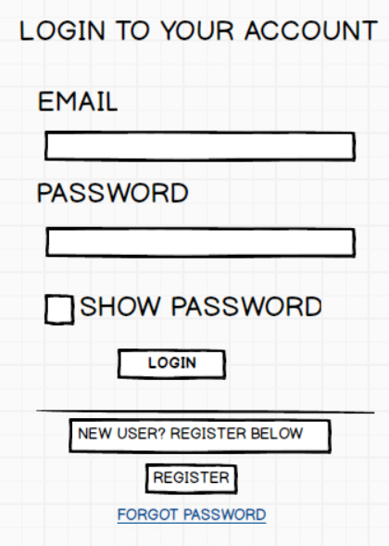

1. Product catalog page

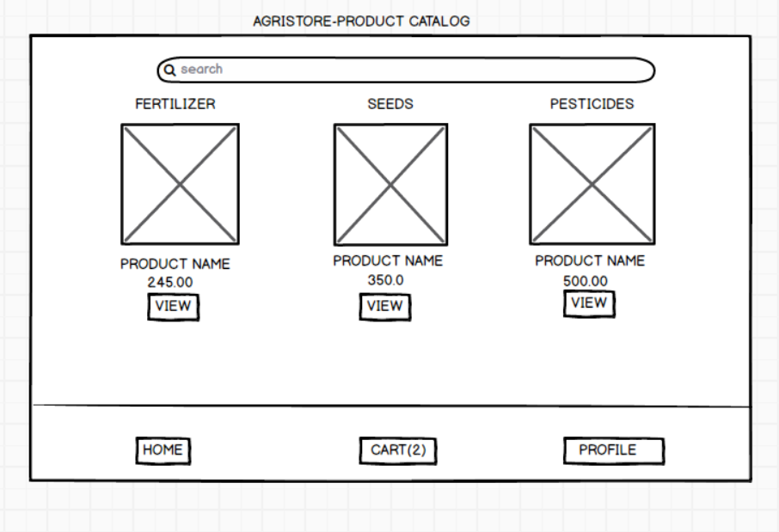

1. Payment Page

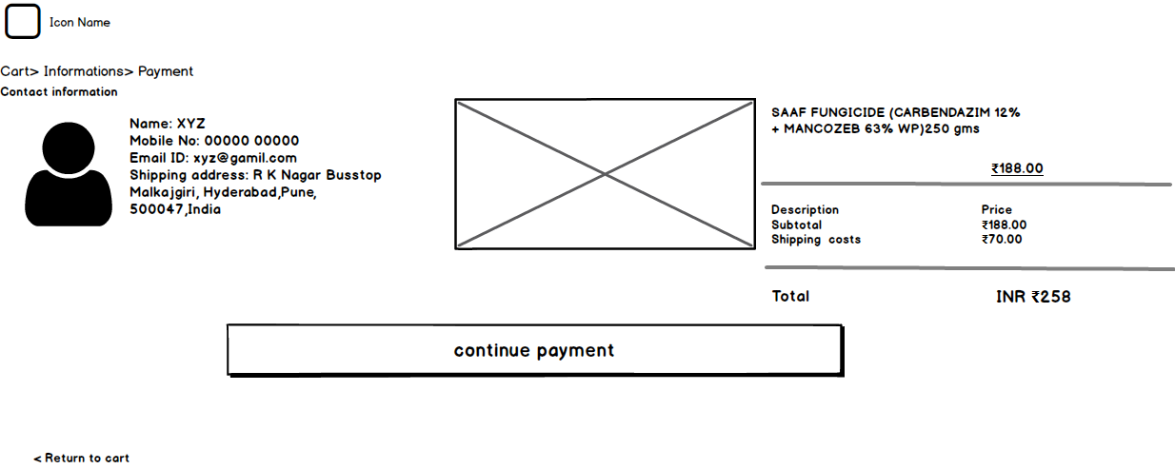

1. Product detail page

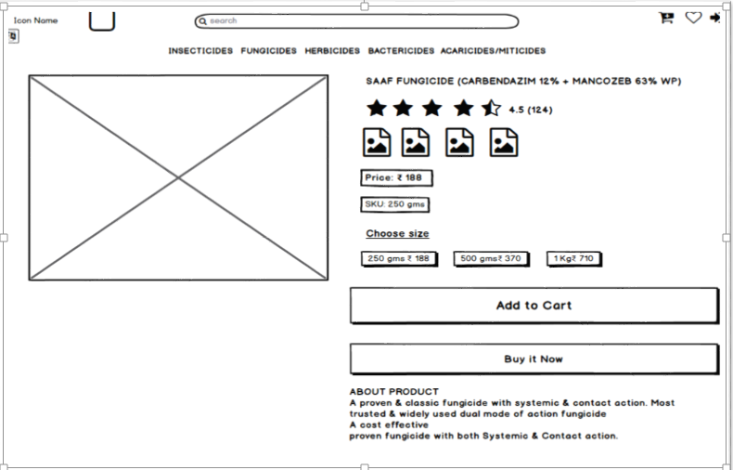

1. ORDER TRACKING PAGE

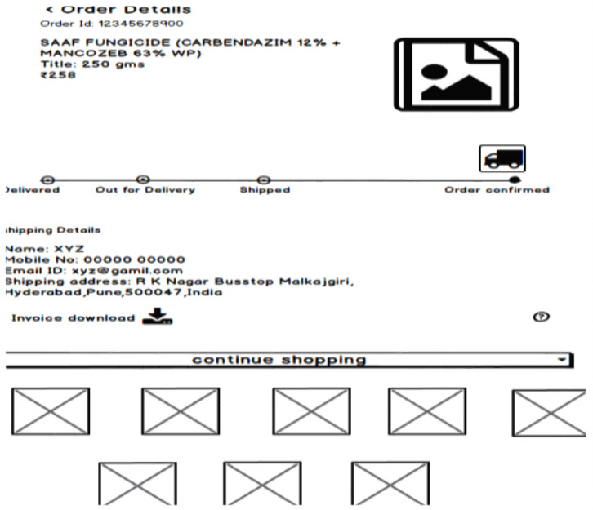

Question 3 – Tools (Visio, Balsamiq) - 15 Marks Make a note of the Tools, which you are using for above concepts.

Answer:

**Microsoft Visio**

Microsoft Visio is a powerful diagramming and vector graphics application developed by Microsoft. It allows users to create a wide range of diagrams, charts, and visual representations of information. Here are a few key points about Microsoft Visio:

1. Purpose: Microsoft Visio is primarily used for creating diagrams and visualizing complex information. It provides a variety of templates and shapes to design flowcharts, organizational charts, network diagrams, floor plans, and more.

2. User-friendly Interface: Visio features an intuitive interface with a drag-and-drop functionality, making it easy for users to create and edit diagrams. It offers a wide range of formatting options, themes, and styles to customize the appearance of diagrams.

3. Collaboration: Visio enables collaboration by allowing multiple users to work on diagrams simultaneously. It integrates with other Microsoft applications such as Microsoft Teams and SharePoint, making it easy to share and collaborate on diagrams with team members.

4. Data Linking: One of the standout features of Visio is its ability to link diagrams with external data sources, such as Excel spreadsheets or databases. This allows for automatic updating of diagrams when the underlying data changes, ensuring accuracy and consistency.

5. Integration with Other Tools: Visio seamlessly integrates with other Microsoft Office applications, allowing users to embed Visio diagrams into Word documents, PowerPoint presentations, or Excel workbooks. This enhances the overall productivity and communication capabilities.

6. Extensibility: Visio supports custom extensions and add-ons, providing the flexibility to extend its functionality. It allows developers to create custom templates, shapes, and solutions to meet specific requirements.

**Balsamiq**

Balsamiq is a rapid wireframing and prototyping tool used for creating low-fidelity mockups and sketches of user interfaces. It provides a simple and intuitive interface that allows users to quickly create visual representations of their ideas. Here are some key points about Balsamiq:

1. Purpose: Balsamiq is specifically designed for wireframing and prototyping, which is an essential step in the design process. It helps designers, developers, and product managers to quickly iterate and communicate their ideas visually.
2. Sketch-like Interface: Balsamiq uses a sketch-like interface with hand-drawn elements and rough aesthetics. This intentional low-fidelity approach encourages a focus on the structure and functionality of the design rather than intricate visual details.
3. Rapid Iteration: The primary goal of Balsamiq is to enable rapid iteration and feedback. Its drag-and-drop functionality allows users to quickly create and modify wireframes, making it easy to experiment with different layouts and ideas.
4. Pre-built Components: Balsamiq offers a wide range of pre-built UI components such as buttons, input fields, menus, and icons. These components can be easily customized and arranged to create wireframes that closely resemble the intended user interface.
5. Collaboration and Sharing: Balsamiq supports collaboration by allowing multiple users to work on the same project simultaneously. It also provides options for sharing wireframes with team members or stakeholders, either by exporting them as PDFs or by using online collaboration features.
6. Integrations: Balsamiq integrates with popular project management and design tools, allowing seamless workflow integration. It can be used alongside tools like Jira, Confluence, and Sketch to streamline the design and development process.
7. Cross-platform Compatibility: Balsamiq is available for Windows, macOS, and web platforms, making it accessible to a wide range of users. The web version allows for easy collaboration and sharing across different operating systems.

Question 4 – RTM - 6 Marks A business analyst’s key responsibilities are to keep track of the requirements and make sure that no requirement is missed. Mr. Henry and peter have approached you regarding the current status of the project. How will you tackle this situation?

Answer:-

|  |  |  |  |  |  |  |
| --- | --- | --- | --- | --- | --- | --- |
| **Req ID** | **Req name** | **Req description** | **Category** | **Sub category** | **Design** | **Code** |
| **FR001** | Login For the user | user can able to login the application for purchasing the product | Login | email id and page | Pass | Pass |
| **FR002** | Search for product | User can search the product as per requirement | Search | Pesticides,seeds,fertilizer | Pass | Pass |
| **FR003** | Payment process | Allow user to do the secure payment either from debit/credit/cod or other payment method | Payment | Credit/debit/UPI/COD | Pass | Pass |
| **FR004** | Delivery tracking | Post order farmers can able to track the delivery of the product | Delivery | Product | Pass | Pass |
| **FR005** | Browse of product | user can explore the more category from this function | Browse | product | Pass | Pass |
| **FR006** | New user registration | User must use the email id and password for registration of application | Registration | email id and password | Pass | Pass |
| **FR007** | Mail confirmation post order | User will get the mail confirmation post order of the product | Mail | email | Pass | Pass |
| **FRO8** | Product Reviews | User can leave reviews and rating for the products they have purchased | Reviews | Rating user experience | pass | pass |
| **FRO9** | Order history | User can view their past order details | Order management | User interface | pass | pass |
| **FR10** | Add to cart | User can add products to their cart for future purchases | Cart Management | user interface | pass | pass |

Question 5 – 10 Test Case Documents - 10 Marks Prepare 10 Test Case Documents Answer:-

|  |  |  |  |  |  |
| --- | --- | --- | --- | --- | --- |
| **Test case ID** | TC001 | **Test case Name** | Log In page | | |
| **Project ID** | OAP002236 | **Project Name** | Agriculture Products Store |  |  |
| **PM ID** | PM202320 | **PM Name** | Mr Vandanam |  |  |
| **Test strategy ID** | STRAT789 | **Tester ID** | SSS203610 |  |  |
| **Test plan ID** | PLAN321 | **Tester Name** | Mr Jason |  |  |
| **Test schedule ID** | SCHEDULE987 | **Date of Test** | 07-06-2023 |  |  |
| **Scenario** | Log In page |  |  |  |  |
| **Link to that page:** |  |  |  |  |  |
| **Input Data** | **Set1 Valid username Valid password** | **set2 Empty username Valid password** | **set3 Invalid username Invalid password** | **set4 Valid username Invalid password** | **set5 Locked account username Valid password** |
| **Expected behaviour** | User should be able to log in successfully | User should receive an error message indicating that the username is required | User should receive an error message indicating that the username is invalid. | User should receive an error message indicating that the password is invalid | User should receive an error message indicating that the account is locked. |
| **Actual behaviour** | User successfully logs in. | User receives an error message indicating that the username is required | User receives an error message indicating that the username is invalid | User receives an error message indicating that the password is invalid. | User receives an error message indicating that the account is locked |
| **Comments** |  |  |  |  |  |
| **Result (Pass/Fail)** | Pass | Pass | Pass | Pass | Pass |

|  |  |  |  |  |  |
| --- | --- | --- | --- | --- | --- |
| **Test case ID** | TC001 | **Test case Name** | User buys two products from their cart | | |
| **Project ID** | OAP002236 | **Project Name** | Agriculture Products Store |  |  |
| **PM ID** | PM202320 | **PM Name** | Mr Vandanam |  |  |
| **Test strategy ID** | STRAT789 | **Tester ID** | SSS203610 |  |  |
| **Test plan ID** | PLAN321 | **Tester Name** | Mr Jason |  |  |
| **Test schedule ID** | SCHEDULE987 | **Date of Test** | 07-06-2023 |  |  |
| **Scenario** | User buys two products from their cart |  |  |  |  |
| **Link to that page:** |  |  |  |  |  |
| **Input Data : Products** | **Set1 Fertilizer 1kg, Seeds** | **set2 Tools, Pesticide** | **set3 Organic Vegetable Kit** | **set4 Fertilizer 500g, Gloves** | **set5 Irrigation, Seeds (Pack of 100)** |
| **Expected behaviour** | The app should allow the user to successfully purchase both the "Fertilizer 1kg" and "Seeds" products | The app should allow the user to successfully purchase both the "Tools" and "Pesticides" products | The app should allow the user to successfully purchase the "Organic Vegetable Kit" product | The app should allow the user to successfully purchase both the "Fertilizer 500g" and "Gloves" products. | The app should allow the user to successfully purchase both the "Irrigation" and "Seeds (Pack of 100)" product |
| **Actual behaviour** | The app allows the user to successfully purchase both the "Fertilizer 1kg" and "Seeds" products. | The app allows the user to successfully purchase both the "Tools" and "Pesticides" products | The app allows the user to successfully purchase the "Organic Vegetable Kit" product. | The app allows the user to successfully purchase both the "Fertilizer 500g" and "Gloves" products | The app allows the user to successfully purchase both the "Irrigation" and "Seeds (Pack of 100)" products |
| **Comments** |  |  |  |  |  |
| **Result (Pass/Fail)** | Pass | Pass | Pass | Pass | Pass |

|  |  |  |  |  |  |  |  |  |  |  |
| --- | --- | --- | --- | --- | --- | --- | --- | --- | --- | --- |
| **Test case ID** | TC001 | | **Test case Name** | | search agriculture products | | | | | |
| **Project ID** | OAP002236 | | **Project Name** | | Agriculture Products Store | |  | |  | |
| **PM ID** | PM202320 | | **PM Name** | | Mr Vandanam | |  | |  | |
| **Test strategy ID** | STRAT789 | | **Tester ID** | | SSS203610 | |  | |  | |
| **Test plan ID** | PLAN321 | | **Tester Name** | | Mr Jason | |  | |  | |
| **Test schedule ID** | SCHEDULE987 | | **Date of Test** | | 07-06-2023 | |  | |  | |
| **Scenario** | search agriculture products | |  | |  | |  | |  | |
| **Link to that page:** |  | |  | |  | |  | |  | |
| **Input Data** | **Set1 Fertilizer** | | **set2 Seeds** | | **set3 Pesticides** | | **set4 Invalid product** | | **set5 Organic vegetables** | |
| **Expected behaviour** | The app should display a list of fertilizer products matching the search query | | The app should display a list of seed products matching the search query | | The app should display a list of pesticide products matching the search query | | The app should display an error message indicating that no matching product was found | | The app should display a list of organic vegetable products matching the search query | |
| **Actual behaviour** | The app correctly displays a list of fertilizer products. | | The app correctly displays a list of seed products | | The app correctly displays a list of pesticide products | | The app displays an error message indicating no matching product was found. | | The app correctly displays a list of organic vegetable products | |
| **Comments** |  | |  | |  | |  | |  | |
| **Result (Pass/Fail)** | Pass | | Pass | | Pass | | Pass | | Pass | |
| **Test case ID** | | TC001 | | **Test case Name** | | User requests to return a product. | | | | | |
| **Project ID** | | OAP002236 | | **Project Name** | | Agriculture Products Store | |  | |  | |
| **PM ID** | | PM202320 | | **PM Name** | | Mr Vandanam | |  | |  | |
| **Test strategy ID** | | STRAT789 | | **Tester ID** | | SSS203610 | |  | |  | |
| **Test plan ID** | | PLAN321 | | **Tester Name** | | Mr Jason | |  | |  | |
| **Test schedule ID** | | SCHEDULE987 | | **Date of Test** | | 07-06-2023 | |  | |  | |
| **Scenario** | | User requests to return a product. | |  | |  | |  | |  | |
| **Link to that page:** | |  | |  | |  | |  | |  | |
| **Input Data: Order ID Product Reason** | | **Set1 ORD123456 Fertilizer 1kg Product arrived damaged** | | **set2 ORD789012 Seeds (Pack of 100) Wrong product delivered** | | **set3 ORD345678 Pesticides (500ml) Product not as described** | | **set4 ORD901234 Tools Changed my mind** | | **set5 ORD567890 Irrigation Product expired** | |
| **Expected behaviour** | | The app should allow the user to request a return for the "Fertilizer 1kg" product and select "Product arrived damaged" as the reason. | | The app should allow the user to request a return for the "Seeds (Pack of 100)" product and select "Wrong product delivered" as the reason. | | The app should allow the user to request a return for the "Pesticides (500ml)" product and select "Product not as described" as the reaso | | The app should allow the user to request a return for the "Tools" product and select "Changed my mind" as the reason. | | The app should allow the user to request a return for the "Irrigation" product and select "Product expired" as the reason | |
| **Actual behaviour** | | The app allows the user to request a return for the "Fertilizer 1kg" product and select "Product arrived damaged" as the reason | | The app allows the user to request a return for the "Seeds (Pack of 100)" product and select "Wrong product delivered" as the reason | | The app allows the user to request a return for the "Pesticides (500ml)" product and select "Product not as described" as the reason | | The app allows the user to request a return for the "Tools" product and select "Changed my mind" as the reason | | The app allows the user to request a return for the "Irrigation" product and select "Product expired" as the reason. | |
| **Comments** | |  | |  | |  | |  | |  | |
| **Result (Pass/Fail)** | | Pass | | Pass | | Pass | | Pass | | Pass | |

|  |  |  |  |  |  |
| --- | --- | --- | --- | --- | --- |
| **Test case ID** | TC001 | **Test case Name** | User adds a valid product to the cart. | | |
| **Project ID** | OAP002236 | **Project Name** | Agriculture Products Store |  |  |
| **PM ID** | PM202320 | **PM Name** | Mr Vandanam |  |  |
| **Test strategy ID** | STRAT789 | **Tester ID** | SSS203610 |  |  |
| **Test plan ID** | PLAN321 | **Tester Name** | Mr Jason |  |  |
| **Test schedule ID** | SCHEDULE987 | **Date of Test** | 07-06-2023 |  |  |
| **Scenario** | User adds a valid product to the cart. |  |  |  |  |
| **Link to that page:** |  |  |  |  |  |
| **Input Data** | **Set1 Fertilizer 1kg** | **set2 Seeds (Pack of 100)** | **Pesticides (500ml)** | **Organic Vegetable Kit** | **InvalidProduct123** |
| **Expected behaviour** | The app should add the fertilizer 1kg product to the user's cart successfully | The app should add the seeds (pack of 100) product to the user's cart successfully | The app should add the pesticides (500ml) product to the user's cart successfully | The app should not add the organic vegetable kit to the cart as it is not available for purchase | The app should display an error message indicating that the product is invalid and cannot be added to the cart |
| **Actual behaviour** | The app adds the fertilizer 1kg product to the user's cart successfully | The app adds the seeds (pack of 100) product to the user's cart successfully | The app adds the pesticides (500ml) product to the user's cart successfully | The app correctly does not add the organic vegetable kit to the cart. | The app displays an error message indicating that the product is invalid and cannot be added to the cart |
| **Comments** |  |  |  |  | Test case passed as the app correctly handled the attempt to add an invalid product to the cart |
| **Result (Pass/Fail)** | Pass | Pass | Pass | Pass | Pass |

|  |  |  |  |  |  |
| --- | --- | --- | --- | --- | --- |
| **Test case ID** | TC001 | **Test case Name** | User successfully completes the sign-up process. | | |
| **Project ID** | OAP002236 | **Project Name** | Agriculture Products Store |  |  |
| **PM ID** | PM202320 | **PM Name** | Mr Vandanam |  |  |
| **Test strategy ID** | STRAT789 | **Tester ID** | SSS203610 |  |  |
| **Test plan ID** | PLAN321 | **Tester Name** | Mr Jason |  |  |
| **Test schedule ID** | SCHEDULE987 | **Date of Test** | 07-06-2023 |  |  |
| **Scenario : User successfully completes the sign-up process.** |  |  |  |  |  |
| **Link to that page:** |  |  |  |  |  |
| **Input Data : First Name Last Name Email Password** | **Set1 John Smith john@example.com Passw0rd123** | **set2 Emma Johnson emma@example.com Pa$$word456** | **set3 Michael Davis michael@example.com P@ssw0rd789** | **set4 Sophia Wilson sophia@example.com P@ssword!234** | **set5 William Brown william@example.com Password123!** |
| **Expected behaviour** | User should be able to successfully register with the provided first name, last name, email, and password | User should be able to successfully register with the provided first name, last name, email, and password | User should be able to successfully register with the provided first name, last name, email, and password. | User should be able to successfully register with the provided first name, last name, email, and password. | User should be able to successfully register with the provided first name, last name, email, and password |
| **Actual behaviour** | User is successfully registered with the provided first name, last name, email, and password | User is successfully registered with the provided first name, last name, email, and password | User is successfully registered with the provided first name, last name, email, and password | User is successfully registered with the provided first name, last name, email, and password | User is successfully registered with the provided first name, last name, email, and password |
| **Comments** |  |  |  |  |  |
| **Result (Pass/Fail)** | Pass | Pass | Pass | Pass | Pass |

|  |  |  |  |  |  |  |  |  |  |  |
| --- | --- | --- | --- | --- | --- | --- | --- | --- | --- | --- |
| **Test case ID** | TC001 | | **Test case Name** | | User applies a price range filter on a category page | | | | | |
| **Project ID** | OAP002236 | | **Project Name** | | Agriculture Products Store | |  | |  | |
| **PM ID** | PM202320 | | **PM Name** | | Mr Vandanam | |  | |  | |
| **Test strategy ID** | STRAT789 | | **Tester ID** | | SSS203610 | |  | |  | |
| **Test plan ID** | PLAN321 | | **Tester Name** | | Mr Jason | |  | |  | |
| **Test schedule ID** | SCHEDULE987 | | **Date of Test** | | 07-06-2023 | |  | |  | |
| **Scenario** | User applies a price range filter on a category page | |  | |  | |  | |  | |
| **Link to that page:** |  | |  | |  | |  | |  | |
| **Input Data : Category Price Range** | **Set1 Fertilizers 50 - 1000** | | **set2 Seeds 100 - 2500** | | **set3 Pesticides 2000 - 9000** | | **set4 Tools 30000 - 100000** | | **set5 Irrigation 40+** | |
| **Expected behaviour** | The app should display products in the "Fertilizers" category with prices ranging from 50 to 1000. | | The app should display products in the "Seeds" category with prices ranging from 100 to 2500. | | The app should display products in the "Pesticides" category with prices ranging from 2000 to 902000 to 9000 | | The app should display products in the "Tools" category with prices ranging from 30000 to 100000. | | The app should display products in the "Irrigation" category with prices greater than 40+. | |
| **Actual behaviour** | The app correctly displays products in the "Fertilizers" category with prices ranging from 50 to 1000 | | The app correctly displays products in the "Seeds" category with prices ranging from 100 to 2500. | | The app correctly displays products in the "Pesticides" category with prices ranging from 2000 to 9000. | | The app correctly displays products in the "Tools" category with prices ranging from 30000 to 100000.. | | The app correctly displays products in the "Irrigation" category with prices greater than 40+. | |
| **Comments** |  | |  | |  | |  | |  | |
| **Result (Pass/Fail)** | Pass | | Pass | | Pass | | Pass | | Pass | |
| **Test case ID** | | TC001 | | **Test case Name** | | : User successfully completes the checkout process  and places an order. | | | | | |
| **Project ID** | | OAP002236 | | **Project Name** | | Agriculture Products Store | |  | |  | |
| **PM ID** | | PM202320 | | **PM Name** | | Mr Vandanam | |  | |  | |
| **Test strategy ID** | | STRAT789 | | **Tester ID** | | SSS203610 | |  | |  | |
| **Test plan ID** | | PLAN321 | | **Tester Name** | | Mr Jason | |  | |  | |
| **Test schedule ID** | | SCHEDULE987 | | **Date of Test** | | 07-06-2023 | |  | |  | |
| **Scenario** | | : User successfully completes the checkout process and places an order. | |  | |  | |  | |  | |
| **Link to that page:** | |  | |  | |  | |  | |  | |
| **Input Data: Product Quantity Shipping Address Payment Method** | | **Set1 Tomato Seeds 2 Main St Credit Card** | | **set2 Organic Fertilizer 1 Elm St PayPal** | | **set3 Garden Tools 3 Oak St Cash on Delivery** | | **set4 Plant Pots 4 Pine St Credit Card** | | **set5 Irrigation System 2 Maple St PayPal** | |
| **Expected behaviour** | | User should be able to successfully place an order for tomato seeds with a quantity of 2, provide the shipping address, and select credit card as the payment method | | User should be able to successfully place an order for organic fertilizer with a quantity of 1, provide the shipping address, and select PayPal as the payment method | | User should be able to successfully place an order for garden tools with a quantity of 3, provide the shipping address, and select cash on delivery as the payment method | | User should be able to successfully place an order for plant pots with a quantity of 4, provide the shipping address, and select credit card as the payment method | | User should be able to successfully place an order for an irrigation system with a quantity of 2, provide the shipping address, and select PayPal as the payment method | |
| **Actual behaviour** | | User is able to successfully place an order for tomato seeds with a quantity of 2, provide the shipping address, and select credit card as the payment method | | User is able to successfully place an order for organic fertilizer with a quantity of 1, provide the shipping address, and select PayPal as the payment method | | User is able to successfully place an order for garden tools with a quantity of 3, provide the shipping address, and select cash on delivery as the payment method | | User is able to successfully place an order for plant pots with a quantity of 4, provide the shipping address, and select credit card as the payment method | | User is able to successfully place an order for an irrigation system with a quantity of 2, provide the shipping address, and select PayPal as the payment method | |
| **Comments** | |  | |  | |  | |  | |  | |
| **Result (Pass/Fail)** | | Pass | | Pass | | Pass | | Pass | | Pass | |

|  |  |  |  |  |  |
| --- | --- | --- | --- | --- | --- |
| **Test case ID** | TC001 | **Test case Name** | User wants to track the status of their order | | |
| **Project ID** | OAP002236 | **Project Name** | Agriculture Products Store |  |  |
| **PM ID** | PM202320 | **PM Name** | Mr Vandanam |  |  |
| **Test strategy ID** | STRAT789 | **Tester ID** | SSS203610 |  |  |
| **Test plan ID** | PLAN321 | **Tester Name** | Mr Jason |  |  |
| **Test schedule ID** | SCHEDULE987 | **Date of Test** | 07-06-2023 |  |  |
| **Scenario** | User wants to track the status of their order |  |  |  |  |
| **Link to that page:** |  |  |  |  |  |
| **Input Data: Order ID** | **Set1 123456** | **set2 789012** | **set3 456123** | **set4 963255** | **set5 789123** |
| **Expected behaviour** | User should be able to track the order with the order ID "123456" and view the current status | User should be able to track the order with the order ID "789012" and view the current status | User should be able to track the order with the order ID "345678" and view the current status | User should be able to track the order with the order ID "901234" and view the current status | User should be able to track the order with the order ID "567890" and view the current status |
| **Actual behaviour** | User is able to track the order with the order ID "123456" and view the current status | User is able to track the order with the order ID "789012" and view the current status. | User is able to track the order with the order ID "345678" and view the current status | User is able to track the order with the order ID "901234" and view the current status | User is able to track the order with the order ID "567890" and view the current status |
| **Comments** |  |  |  |  |  |
| **Result (Pass/Fail)** | Pass | Pass | Pass | Pass | Pass |

|  |  |  |  |  |  |
| --- | --- | --- | --- | --- | --- |
| **Test case ID** | TC001 | **Test case Name** | User wants to submit a review and feedback for a completed order. | | |
| **Project ID** | OAP002236 | **Project Name** | Agriculture Products Store |  |  |
| **PM ID** | PM202320 | **PM Name** | Mr Vandanam |  |  |
| **Test strategy ID** | STRAT789 | **Tester ID** | SSS203610 |  |  |
| **Test plan ID** | PLAN321 | **Tester Name** | Mr Jason |  |  |
| **Test schedule ID** | SCHEDULE987 | **Date of Test** | 07-06-2023 |  |  |
| **Scenario** | User wants to submit a review and feedback for a completed order. |  |  |  |  |
| **Link to that page:** |  |  |  |  |  |
| **Input Data : Order ID Rating Comments** | **Set1 123456 4 out of 5 "Great product!"** | **set2 789012 5 out of 5 "Excellent service!"** | **set3 345678 3 out of 5 "Average quality."** | **set4 901234 4 out of 5 "Fast delivery."** | **set5 567890 2 out of 5 "Disappointed with packaging."** |
| **Expected behaviour** | User should be able to submit a review and feedback for the order with the order ID "123456" with a rating of 4 out of 5 and a positive comment. | User should be able to submit a review and feedback for the order with the order ID "789012" with a rating of 5 out of 5 and a positive comment | User should be able to submit a review and feedback for the order with the order ID "345678" with a rating of 3 out of 5 and a neutral comment | User should be able to submit a review and feedback for the order with the order ID "901234" with a rating of 4 out of 5 and a positive comment | User should be able to submit a review and feedback for the order with the order ID "567890" with a rating of 2 out of 5 and a negative comment |
| **Actual behaviour** | User is able to submit a review and feedback for the order with the order ID "123456" with a rating of 4 out of 5 and a positive comment. | User is able to submit a review and feedback for the order with the order ID "789012" with a rating of 5 out of 5 and a positive comment. | User is able to submit a review and feedback for the order with the order ID "345678" with a rating of 3 out of 5 and a neutral comment | User is able to submit a review and feedback for the order with the order ID "901234" with a rating of 4 out of 5 and a positive comment. | User is able to submit a review and feedback for the order with the order ID "567890" with a rating of 2 out of 5 and a negative comment. |
| **Comments** |  |  |  |  |  |
| **Result (Pass/Fail)** | Pass | Pass | Pass | Pass | Pass |

Question 6 – DB Design – 8 Marks After the requirements are thoroughly explained to the entire project team by business analyst, the Database architects have decided to do the database design and also to represent the in-flow and out-flow of data. Draw database schema and ER diagram

DB DESIGN:

|  |
| --- |
| **Customers** |
| ID  Email ID  Password  Full Name  Billing Address  Mobile Number |

|  |
| --- |
| **Products** |
| Product ID  Name  Price  Weight  Descriptions  Image  Category  Stock |

|  |
| --- |
| **Categories** |
| ID  Name  Descriptions |

|  |
| --- |
| **Orders** |
| Order ID  Customer ID  Amount ID  Shipping Address  Order Address  Order Email  Order Date  Order Status |

|  |
| --- |
| **Order Items** |
| Order ID  Product ID  Price  Quantity |

ER DIAGRAM

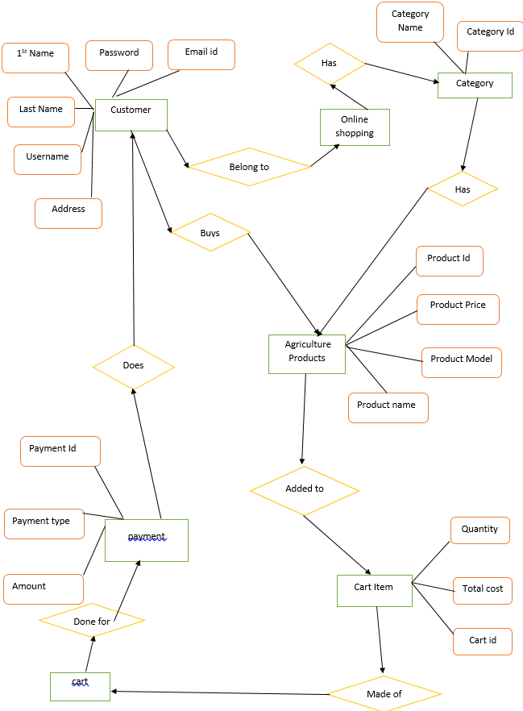

Question 7 – Data Flow Diagram - 3 Marks What is a data flow diagram? Draw a data flow diagram to represent the in-flow and out-flow of data when a Farmer is placing an order for the product

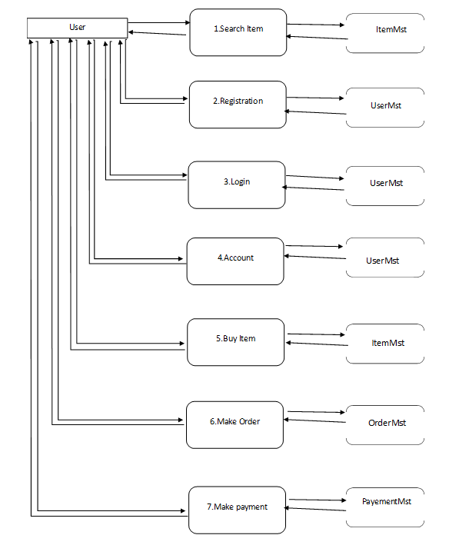

Question 8 – Change Request - 10 Marks Due to change in the Government Taxation structure . we should change the Tax structure How do you handle change requests in a project?

Answer:

Definition of a “Change”

For the purposes of this document, a Change is defined as the addition, modification, or removal of a configuration item (CI), service, or service component, and/or its associated elements. When as a I receives a request of change from the client Due to change in government taxation structure, I will analyse the request and clarifies exactly what the request is asking me to do in that agriculture product store. I will perform some activities to improvise and change the project as per the Clients Requirement

1. Evaluate the change request: Firstly, I would assess the change request to understand the impact of the new taxation structure on the project. I would examine the specifics of the new tax structure and assess how it might affect the project budget, timeline, and requirements.
2. Impact Analysis: Once the change request has been assessed, I would perform an impact analysis. This would involve evaluating the impact of the new tax structure on the project's cost, schedule, and scope. I would also identify any potential risks associated with implementing the change request.
3. Feasibility Study: Next, I would conduct a feasibility study to evaluate whether it is possible to implement the change request. This would involve considering factors such as the availability of resources, technical feasibility, and potential legal or regulatory issues that may arise due to the change.
4. Effort Estimation: Based on the results of the impact analysis and feasibility study, I would estimate the effort required to implement the change request. This would involve estimating the time, cost, and resources required to implement the changes in the project.
5. Approval: After completing the above steps, I would present the results to the project stakeholders for review and approval. If the change request is approved, I would update the project plan accordingly and communicate the changes to the development team.

When a change is requested, as a Business Analyst I should follow the following steps. In simple terms,

1. Firstly, I need to documents the change requests.
2. BA identifies whether the change in the ongoing project is really worth it or not. The taxation structure change by government is priority to consider point according to that I need to develop documents and into on-going sprint.
3. Project Manager should approve the change requests. If yes, the project will move furtherly. As a BA I will Take Approval from PM and PO on Email and forward this mail to all team and done this change on priority Bases.
4. Business Analyst along with the Project Manager ensure whether the change is a minor or a major change. If the policy change by government the it is major change request according to the government instruction, we need to make change with a given time.
5. If the new requirement is a major change, they make sure that it should not impact the delivery date of the project or any changes in the project scope.
6. Also try to help the other stakeholders to understand the importance of change requests which helps to reduce the negative impact of the project.
7. As the project is in process, Ben and Kevin have contacted you. The reason is to inform you that they want the Farmers to sell their crop yields through this application i.e. Farmers should be able to add their crop yields or products and display to general public and should be able to sell them. They also want to introduce Auction system for their Crop yields. As a BA, what will be your response? Is this a change request or an enhancement???

Answer:-

According to my understanding change Request mean in any IT project we can change all process ore add new process or system instance of old remove. Enhancement is a part of change request. For example, we provide only service through web and we are not available at application services and we lunch new application at android platform that change request Enhancement means add something new in existing process or system for example if farmer can process payment by only UPI and Debit card and now, we add new feature farmer can pay payment by credit card and online banking.

“According to IBM.com A change request is a proposal from a stakeholder in the software

development process to change something in a product or in a product process”.

“According to IBM.com Common change requests include defects and requests for product

enhancements or new features”.

As the project is in process, Ben and Kevin have contacted you. The reason is to inform you that they want the Farmers to sell their crop yields through this application i.e., Farmers should be able to add their crop yields or products and display to general public and should be able to sell them. They also want to introduce Auction system for their Crop yields.

As a BA, what will be your response?

As BA I will check introduce new link in online product store Buy and sale product from farmers. And in that add auction link also farmers can able to sale their agricultural product to other farmers by location wise we are already into delivery service of small amount of agricultural product is sale by farmer then can choose delivery service through application also

**It is a Change request**.

Question 10 – Estimations - 6 Marks Come up with estimations – How many Manhours required

Answer:

Estimating the number of man-hours required for the Online Agriculture Products Store project depends on various factors such as the scope of work, complexity of features, team efficiency, and individual productivity. However, I can provide a rough estimation based on the information provided.

1. Project Manager (Mr. Vandanam): Assuming full-time involvement throughout the project, an average of 8 hours per day, 5 days a week, for 18 months. Total man-hours: 8 hours/day * 5 days/week * 18 months.
2. Senior Java Developer (Ms. Juhi): Assuming full-time involvement throughout the project, an average of 8 hours per day, 5 days a week, for 18 months. Total man-hours: 8 hours/day * 5 days/week * 18 months.
3. Java Developers (Mr. Teyson, Ms. Lucie, Mr. Tucker, Mr. Bravo): Assuming full-time involvement throughout the project, an average of 8 hours per day, 5 days a week, for 18 months. Total man-hours per developer: 8 hours/day * 5 days/week * 18 months. Multiply this by the number of Java Developers.
4. Network Admin (Mr. Mike): Assuming part-time involvement, an average of 4 hours per day, 5 days a week, for 18 months. Total man-hours: 4 hours/day * 5 days/week * 18 months.
5. DB Admin (Mr. John): Assuming part-time involvement, an average of 4 hours per day, 5 days a week, for 18 months. Total man-hours: 4 hours/day * 5 days/week * 18 months.
6. Tester (Mr. Jason, Ms. Alekya): Assuming full-time involvement throughout the project, an average of 8 hours per day, 5 days a week, for 18 months. Total man-hours per tester: 8 hours/day * 5 days/week * 18 months. Multiply this by the number of Testers.

**Analysis**

* As per the case study, the duration of the project is 18 months and the current team size is around 15. This will come under medium project.
* As the trained resources are available, trainers are not required.
* As the structure of the project is available, New and enhanced infrastructure is not required.

Question 11 – UAT – 6 Marks Project has finally completed all the stages i.e., design, development, testing etc. Now, it is the roleof a business analyst to contact the client for testing of the final product and have to successfully complete it. How are you going to handle this situation? And once it is done, what will be the process to close the project? Explain UAT Acceptance process

Answer:

* **Planning:** In this step, Blue Prints are made to implement UAT testing for every feature that needs to test and minimum standards for accepting the test.
* **Designing:** Here the Test cases are designed to hide all the possibilities of software packages in a real-world environment.
* **UAT Testers:** A Testing team consists of a end users that meet the criteria for implementing testing. The end user must have expertise in subject matter, the ability to report the problems.
* **Bug Fixing:** Whatever Bugs are found in the UAT Testing, the development team should work on them and make it software error free.
* **Sign Off:** After removing all the bugs, the testing team indicates acceptance of the completion of the bugs. In this phase, all the stakeholders come to conclusion that the software is ready to GO LIVE and sign it off

Question 12 – Project Closure Document - 6 Marks Explain Project closure document

Answer:

A project closure document is a formal report that summarizes the outcomes, activities, and lessons learned from a completed project. It serves as a record of the project's completion and provides important information for future reference. The project closure document is typically prepared by the project manager or project team and is shared with relevant stakeholders, including project sponsors, senior management, and other interested parties. It serves as a comprehensive record of the project's outcomes, lessons learned, and recommendations for future projects, facilitating knowledge transfer and continuous improvement within the organization

|  |  |  |  |
| --- | --- | --- | --- |
| **Sr.No** | **Points to include** | **Details** | **Reference link** |
| 1 | **Did the client signed off on the UAT Testing** |  |  |
|  | Date of the signoff: | 15-07-2024 | Business Scope Document.docx |
|  | Name of the resource: |  |  |
| 2 | **Objectives of the project** |  |  |
|  | User friendliness | Achieved |  |
|  | Customer satisfaction |  |  |
|  | More categories | Achieved |  |
| 3 | **Functionalities worked on** |  |  |
|  | Secure payment processing | Achieved |  |
|  | Categories | Achieved |  |
| 4 | **Infrastructure** |  |  |
|  | Software's Installed | Achieved |  |
|  | Laptops purchased | Achieved |  |
| 5 | **Funding** |  | Financial Breakdown.docx |
|  | Amount approved | Rs.2Cr |  |
|  | Amount used | Rs.1.90Cr |  |
| 6 | **Overall project Information** |  |  |
|  | Escalations | 50 |  |
|  | Customer satisfaction | High |  |
| 7 | **Value to the company** |  |  |
|  | Positive/Negative | Positive-90%   * Company has gained an edge over the competitors * Increased clients * Trained employees * New project in pipeline |  |