**CAPSTONE PROJECT 1**

**PART 2**

**Question 1 – Audits**

4 Quarterly Audits are planned Q1 , Q2, Q3, Q4 for this Project What is your knowledge on how these Audits will happen for a BA ?

**Answer -**

Quarterly audits for a Business Analyst (BA) are structured reviews that assess project progress, performance, and alignment with business objectives. These audits help ensure that projects stay on track, meet stakeholder expectations, and comply with relevant standards. Below is a breakdown of how these audits might occur:

* **Quarter 1 -**

|  |  |  |  |  |
| --- | --- | --- | --- | --- |
| **Quarter** | **Task** | **Description** | **Audit Points** | **Remarks/Observation** |
| Q1 | Identify the Stakeholders | Identifying the stakeholders | Were all stakeholders were identified | Pass |
| Q1 | Conduct Interview | Conducting interview with stakeholders | Was interview conducted with all the stakeholders | Pass |
| Q1 | Review existing documents | Reviewing existing documents | Were the existing documents reviewed | Pass |
| Q1 | Define Scope | Clearly define the scope | Was the scope of the project clear | Pass |
| Q1 | Define Functional & Non-functional requirements | Defining all the requirements | Were all requirements defined | Pass |
| Q1 | Prioritize Requirements | Prioritizing Requirements | Were all requirements prioritized | Pass |
| Q1 | Validate Requirements | Validating Requirements | Were all requirements validated | Pass |
| Q1 | Obtain Sign off | Obtaining Sign off | Was sign off taken | Pass |

* **Quarter 2 –**

|  |  |  |  |  |
| --- | --- | --- | --- | --- |
| **Quarter** | **Task** | **Description** | **Audit Points** | **Remarks/Observation** |
| Q2 | Solution Design | Designing Solution | Was solution decided | Pass |
| Q2 | Prototype Development | Developing prototype | Was prototype developed | Pass |
| Q2 | Code Development | Developing Code | Were codes developed correctly | Pass |
| Q2 | Unit Testing | Testing units | Was unit testing done | Pass |

* **Quarter 3 –**

|  |  |  |  |  |
| --- | --- | --- | --- | --- |
| **Quarter** | **Task** | **Description** | **Audit Points** | **Remarks/Observation** |
| Q3 | Integrated Testing | Testing Multiple modules | Was integrated testing done | Pass |
| Q3 | Security Testing | Testing Security Features | Were security features tested | Pass |
| Q3 | System Testing | Testing the system as a whole | Was system testing done | Pass |
| Q3 | Bug Fixing | Fixing the errors | Was debugging done | Pass |

* **Quarter 4 –**

|  |  |  |  |  |
| --- | --- | --- | --- | --- |
| **Quarter** | **Task** | **Description** | **Audit Points** | **Remarks/Observation** |
| Q4 | Regression Testing | Regression Testing | Was regression testing done | Pass |
| Q4 | UAT | User Acceptance Testing | Was UAT Performed | Pass |
| Q4 | Test Report | Preparing Test Report | Was Test Report Published | Pass |
| Q4 | Obtain Sign off | Obtaining Sign off | Was Sign off taken | Pass |

**Question 2 – BA Approach Strategy**

Before the Project is going to Kick Start, The Committee asked Mr Karthik to submit BA Approach Strategy

Write BA Approach strategy (As a business analyst, what are the steps that you would need to follow to complete a project – What Elicitation Techniques to apply, how to do Stakeholder Analysis RACI/ILS, What Documents to Write, What process to follow to Sign off on the Documents, How to take Approvals from the Client, What Communication Channels to establish n implement, How to Handle Change Requests, How to update the progress of the project to the Stakeholders, How to take signoff on the UAT- Client Project Acceptance Form )

Your Team

Project Manager - Mr Vandanam

Senior Java Developer - Ms. Juhi

Java Developers - Mr Teyson, Ms Lucie, Mr Tucker, Mr Bravo

Network Admin - Mr Mike

DB Admin - Mr John.

Testers - Mr Jason and Ms Alekya

BA - You

Technical Team have assembled to discuss on the Project approach and have finalised to follow 3-tier architecture for this project.

**Answer -**

This is a comprehensive strategy for a Business Analyst (BA) approach in a project. It outlines key steps such as requirement elicitation, stakeholder evaluation, documentation, effective communication, managing change requests, and obtaining approvals.

***BA APPROACH STRATEGY***

**1. Elicitation Techniques**

* **Objective:** Collect detailed requirements from stakeholders to gain a clear understanding of their needs and expectations.
* **Methods to Use:**
* **Interviews:** Engage in one-on-one or group discussions with key stakeholders to obtain in-depth insights.
* **Workshops:** Conduct collaborative sessions with stakeholders to encourage idea sharing and discussion.
* **Surveys/Questionnaires:** Distribute structured forms to collect quantitative data from a broader audience.
* **Document Analysis:** Examine existing materials, such as business process guides, system specifications, and past project reports.
* **Observation:** Monitor end-users in their work environment to better understand their tasks and potential challenges.
* **Prototyping:** Create preliminary models to gather user feedback and refine requirements accordingly.

**2. Stakeholder Analysis**

* ***Objective:*** Identify and evaluate stakeholders to assess their impact, level of interest, and specific needs.
* ***Approach:***
* **Stakeholder Identification:** Compile a list of all relevant stakeholders, including clients, end-users, and internal team members.
* **Influence & Interest Analysis:** Assess each stakeholder’s role in the project, their level of influence, and their engagement.
* **Stakeholder Mapping:** Utilize frameworks like power-interest grids to categorize stakeholders based on their involvement and impact.
* **RACI Matrix Development:** Define roles and responsibilities using the RACI model:
  + **R (Responsible):** The individual executing the task.
  + **A (Accountable):** The person with ultimate responsibility for task completion.
  + **C (Consulted):** Those providing input and expertise.
  + **I (Informed):** Individuals who need updates on progress.
* ***RACI MATRIX:***

|  |  |  |  |  |  |  |  |
| --- | --- | --- | --- | --- | --- | --- | --- |
| ACTIVITY | PROJECT MANAGER | SENIOR JAVA DEVELOPER | JAVA DEVELOPER | NETWORK ADMIN | DB ADMIN | TESTER | BA |
| REQUIREMENT ELICITATION | I |  |  |  |  |  | A |
|  | C | A | C | C | C | C | R |
| IMPLEMENTATION | I | R | R | I | I | I | C |
| TESTING | I |  |  |  |  | R | C |
| DEPLOYMENT | I |  |  | A | A | I | C |

**3. Documentation:**

* ***Objective***

Develop and maintain key project documents to promote clarity and alignment.

* ***Documents to write***
* **Business Requirements Document (BRD):** Outlines the overarching business needs.
* **Functional Requirements Document (FRD):** Specifies detailed functional requirements.
* **Use Cases/User Stories:** Describes user interactions with the system.
* **Process Flows/Diagrams:** Provides visual representations of workflows and business processes.
* **Change Request Form:** Records and manages modifications to the project scope.
* **Test Plan and Test Cases:** Ensures compliance with requirements through testing.

**4. Sign-off Process:**

* ***Objective***

Obtain official stakeholder approval for critical project documents.

* ***Steps***
* **Document Review:** Verify completeness and accuracy of all project documents.
* **Stakeholder Review:** Distribute documents for stakeholder input and feedback.
* **Feedback Integration:** Revise documents as needed based on stakeholder suggestions.
* **Final Approval:** Secure stakeholder sign-off, either through signatures or electronic approval.

**5. Client Approvals:**

* ***Objective***

Obtain formal client approval at key project milestones to ensure alignment and acceptance.

* ***Steps***
* **Review Meetings:** Schedule sessions with the client to assess key deliverables.
* **Deliverable Presentation:** Clearly showcase requirements, designs, and relevant documents.
* **Feedback Collection:** Gather client input and resolve any concerns.
* **Formal Approval:** Secure client sign-off through a formal document or email confirmation.

**6. Communication Channels:**

* ***Objective***

Set up clear communication channels to facilitate continuous project updates and stakeholder interactions.

* ***Channels to Establish***
* **Email:** Use for formal communication and document sharing.
* **Project Management Tools:** Utilize platforms like Jira or Trello to track progress and tasks.
* **Instant Messaging:** Enable quick discussions via Slack, Microsoft Teams, or similar tools.
* **Regular Meetings:** Conduct scheduled status meetings to review progress, address issues, and discuss changes.

**7. Handling Change Request:**

* ***Objective***

Handle changes to project scope or requirements in a structured and organized manner.

* ***Steps***
* **Change Request Documentation:** Record proposed changes using a Change Request Form.
* **Impact Assessment:** Analyse the effects on scope, timeline, and resources.
* **Stakeholder Review & Approval:** Submit the request for evaluation and approval.
* **Documentation Update:** Incorporate approved changes into project plans and documentation.

**8. Updating Project Progress:**

* ***Objective***

Regularly update stakeholders on the project's progress and status.

* ***Steps***
* **Status Reports:** Share weekly or bi-weekly updates on progress, risks, and issues.
* **Project Dashboard:** Utilize a management tool to showcase real-time project status.
* **Stakeholder Meetings:** Hold regular discussions to review progress and address necessary actions.

**9. Sign-off On UAT (User Acceptance Test):**

* ***Objective***

Obtain formal client approval for the final project deliverables.

* ***Steps***
* **User Acceptance Testing (UAT):** Conduct UAT with the client to verify the system meets their requirements.
* **Feedback Collection:** Gather client feedback and resolve any identified issues.
* **Acceptance Form Preparation:** Draft the Client Project Acceptance Form for final approval.
* **Final Sign-off:** Secure formal client approval by obtaining their signature on the acceptance form.

By adopting this Business Analysis Approach Strategy, you will be well-equipped to oversee and implement the project effectively, ensuring all requirements are fulfilled and stakeholders remain informed and engaged throughout the project's duration.

**Question 3 – 3-Tier Architecture**

Explain and illustrate 3-tier architecture?

**Answer –**

A 3-tier application is a software architecture structured into three distinct layers: the data access tier at the base, the application tier (business logic) in the middle, and the client tier (presentation) at the top. Each layer operates independently and can be distributed across different locations within a network. However, these tiers represent logical divisions of the application rather than specific physical locations on separate machines.



**Layers of the 3-Tier Architecture**

The **3-tier architecture** is structured into the following three layers:

* **Presentation Layer (Client Layer):** Also known as the **front-end layer**, this layer includes the user interface, allowing users to interact with the system. Its primary function is to communicate with the application layer.
* **Application Layer (Business Logic Layer):** Acting as the **middleware**, this layer processes business logic and facilitates data exchange between the client and the database server. It manages data flow and partially processes the retrieved data.
* **Database Layer:** This layer is responsible for **data storage and management**. It handles essential operations such as inserting, updating, and deleting records in the database.

**Layer Functions & Examples**

* **Application Layer:** Displays user interface elements such as **application name, member login, product listings, new user registration, and featured items**.
* **Business Logic Layer:** Contains **rules, regulations, and reusable components** such as **GST calculations, multiple payment options (card, cash, UPI), and business logic updates**.
* **Database Layer:** Serves as a **storage hub for product-related data**, including **product prices, quality, quantity, and inventory details**.

**Question 4 – BA Approach Strategy for Framing Questions**

Business Analyst should keep What points in his/her mind before he frames a Question to ask to the Stakeholder

(5W 1H – SMART – RACI – 3 Tier Architecture – Use Cases, Use case Specs, Activity Diagrams, Models, Page designs)

**Answer -**

As a Business Analyst, asking well-structured questions is essential for gathering precise and complete requirements from stakeholders. Keeping key principles in mind ensures that your questions are clear, relevant, and aligned with project goals. Below is a structured approach incorporating the 5W 1H framework, SMART criteria, RACI model, 3-Tier Architecture, and other essential elements to enhance the elicitation process.

***1. 5W 1H Framework (Who, What, When, Where, Why, How)***

* Who:
  + Who are the primary users or stakeholders?
  + Who will be affected by this requirement?
* What:
  + What specific need or functionality is required?
  + What are the expected deliverables or outcomes?
* When:
  + When is this requirement needed?
  + When should the feature or change be implemented?
* Where:
  + Where will this requirement be applied within the system or business process?
  + Where does the data or functionality integrate within the application architecture?
* Why:
  + Why is this requirement important to the business?
  + Why was this issue or need identified?
* How:
  + How should this requirement be implemented?
  + How will success be measured?

***2. SMART Criteria for Question Framing***

* Specific: Ensure precision in your questions.
  + Example: Instead of *"What do you need?"*, ask *"Which specific features should be included in the user interface?"*
* Measurable: Gather information that defines success.
  + Example: *"How will you evaluate the effectiveness of this new feature?"*
* Achievable: Ensure requirements are realistic given constraints.
  + Example: *"What limitations or resource constraints should we consider?"*
* Relevant: Focus on project-related goals.
  + Example: *"How does this requirement contribute to the project's objectives?"*
* Time-bound: Identify deadlines and time constraints.
  + Example: *"By when is this feature expected to be delivered?"*

***3. RACI Model for Stakeholder Roles***

* Responsible: Determine who is in charge of executing the task.
  + Example: *"Who is responsible for defining the detailed requirements?"*
* Accountable: Identify the individual approving the requirement.
  + Example: *"Who will be accountable for finalizing this requirement?"*
* Consulted: Recognize key stakeholders involved in decision-making.
  + Example: *"Which stakeholders should we consult for validation?"*
* Informed: Ensure necessary updates are communicated.
  + Example: *"Who should be kept informed about requirement updates?"*

***4. 3-Tier Architecture Considerations***

* Presentation Layer:
  + *"How will this requirement influence the user interface and experience?"*
* Application Layer:
  + *"How does this requirement impact business logic and processing rules?"*
* Data Layer:
  + *"What data needs to be stored and managed for this requirement?"*

***5. Use Cases, Models, and Page Design Considerations***

* Use Cases:
  + *"Can you describe a typical use case for this feature?"*
* Use Case Specifications:
  + *"What are the preconditions and expected results of this use case?"*
* Activity Diagrams:
  + *"How does this requirement modify existing process flows?"*
* Models:
  + *"Do we need additional models or diagrams to represent this requirement?"*
* Page Designs:
  + *"What elements should be included in the page design to meet this requirement?"*

***Summary of Best Practices***

* Clarity: Questions should be direct and unambiguous.
* Relevance: Ensure alignment with project goals and stakeholder needs.
* Detail: Gather sufficient information to understand the full impact.
* Consistency: Maintain coherence with existing documentation and scope.

By integrating these techniques, Business Analysts can structure questions that drive meaningful discussions, ensuring all aspects of the project are clearly defined and well-documented.

**Question 5 – Elicitation Techniques**

As a Business Analyst, What Elicitation Techniques you are aware of? ( BDRFOWJIPQU)

**Answer –**

As a Business Analyst, it is essential to be well-versed in various elicitation techniques to effectively gather and understand stakeholder requirements. Below is a structured list of techniques, categorized using the acronym **BDRFOWJIPQU**:

**Key Elicitation Techniques**

* **B – Brainstorming**
  + **Overview:** A collaborative approach where stakeholders and team members engage in open discussions to generate ideas and solutions.
  + **Application:** Ideal for quickly generating a wide range of innovative ideas and potential solutions.
* **D – Document Analysis**
  + **Overview:** Examining existing documentation, including business process guides, reports, and past project records, to extract valuable information.
  + **Application:** Useful for understanding current workflows, system functionalities, and previous project decisions.
* **R – Requirements Workshops**
  + **Overview:** Structured sessions where stakeholders come together to discuss and define requirements.
  + **Application:** Effective for capturing detailed requirements and ensuring stakeholder alignment.
* **F – Focus Groups**
  + **Overview:** Engaging a selected group of stakeholders in structured discussions to gather insights on specific topics.
  + **Application:** Provides diverse perspectives and collective feedback on a particular subject.
* **O – Observations**
  + **Overview:** Directly monitoring end-users as they perform tasks or interact with a system to identify their needs and challenges.
  + **Application:** Offers a real-world understanding of user behavior and system usability.
* **W – Formal Workshops**
  + **Overview:** Organized meetings with a predefined agenda to gather requirements and discuss project specifics.
  + **Application:** Useful for in-depth discussions and resolving complex project-related concerns.
* **J – Joint Application Development (JAD) Sessions**
  + **Overview:** Collaborative meetings involving stakeholders and developers to refine requirements and solutions.
  + **Application:** Facilitates consensus-building between business and technical teams.
* **I – Interviews**
  + **Overview:** One-on-one or group discussions with stakeholders to gather detailed insights into their needs and pain points.
  + **Application:** Helps obtain in-depth information while fostering relationships with stakeholders.
* **P – Prototyping**
  + **Overview:** Developing initial versions or models of a system or feature to gather user feedback.
  + **Application:** Allows stakeholders to visualize requirements early in the development process, leading to iterative improvements.
* **Q – Questionnaires/Surveys**
  + **Overview:** Distributing structured forms to collect quantitative data and opinions from stakeholders.
  + **Application:** Efficient for gathering input from a large audience quickly.
* **U – Use Case Modelling**
  + **Overview:** Creating diagrams and scenarios that illustrate functional requirements from a user’s perspective.
  + **Application:** Helps define system functionalities and user interactions clearly.

**Additional Techniques**

* **User Stories:** Capturing requirements in a simple format that focuses on user needs, often used in Agile methodologies.
* **Contextual Inquiry:** A mix of observation and interviews to understand user behavior in their natural working environment.

**Summary**

Each elicitation method has its unique advantages and is suited for different phases of the requirements-gathering process. Using a combination of these techniques ensures a thorough and accurate collection of requirements, aligning the final solution with stakeholder expectations and project objectives.

**Question 6 – This project Elicitation Techniques**

Which Elicitation Techniques can be used in this Project and Justify your selection of Elicitation Techniques?

Prototyping

Use case Specs

Document Analysis

Brainstorming

Fertilizers, seeds, pesticides details from the manufacturers and should be able to display them to the Farmers.

To gather the business requirements from the client, you went to SOONY and met Mr. Henry. When Mr. Henry was asked about the project and what are they expecting from the project, Mr. Henry stated that he is expecting to have a login for all its users (fertilizers, seeds, pesticides manufacturers and Farmers), a product catalogue of fertilizers, seeds, pesticides, a search option to search for products, payment process, and delivery tracking.

After doing the stakeholder analysis, you have found out that Peter, Kevin, Ben are the key stakeholders and you have scheduled an appointment to meet them. After meeting with them and trying to gather the stakeholder requirements, Kevin said that, a Farmer should be able to browse through the products catalogue once they visit the website and need to have a search option so that they can search for any product they need. Peter said that, if a farmer wants to buy any product or add them to buy-later list, they need to login first using their email id and password. If it is a new user, then they can create a new account by submitting their email ID and creating a secure password. Ben added saying that, Farmers needs to have an easy-to-use payment gateway which should include cash-on-delivery (COD), Credit/Debit card and UPI options so that the user’s experience should be better. Kevin mentioned that, a user gets an email confirmation regarding their order status. A delivery tracker to track the whereabouts of their order.

Identify Business Requirements (which includes Stakeholder Requirements)

BR001 – Farmers should be able to search for available products in fertilizers, seeds, pesticides

BR002 – Manufacturers should be able to upload and display their products in the application

**Answer –**

***Preferred Elicitation Techniques for This Project & Justification***

***1. Prototyping***

Prototyping involves creating a visual representation of ideas, allowing users to test concepts before full-scale development. A prototype is essentially a scaled-down version of the final product.

For this online agricultural product store, as a Business Analyst, I would use prototyping to illustrate ideas on paper and validate them with both internal and external stakeholders before launching the product. Since this is a new project with no existing market reference, prototyping helps assess feasibility. Additionally, it enables us to answer critical questions and refine the concept before making significant financial investments in development.

***2. Brainstorming***

Brainstorming is a technique that can be conducted individually or in groups to gather and evaluate user ideas. It involves collecting input from stakeholders, analyzing their suggestions, and determining which ideas should be incorporated into the system requirements.

For this project, brainstorming would be beneficial because:

* It encourages innovation, allowing users and stakeholders to contribute creative ideas.
* A group of 8 to 12 participants typically ensures a diverse set of suggestions.
* It helps identify all possible solutions to potential challenges.
* It provides insight into new opportunities that might otherwise be overlooked.

By utilizing prototyping and brainstorming, the project can be designed with a user-centric approach, ensuring alignment with stakeholder expectations and market needs.

**Question 7 – 10 Business Requirements**

Make suitable Assumptions and identify at least 10 Business Requirements.

**Answer –**

* **BR001** – Farmers should be able to search for available products, including fertilizers, seeds, and pesticides.
* **BR002** – Manufacturers should have the ability to upload and showcase their products on the application.
* **BR003** – All users, including farmers and manufacturers of fertilizers, seeds, and pesticides, should be able to log in.
* **BR004** – The online web or mobile application should feature a product catalog for fertilizers, seeds, and pesticides, along with a search function for easy product discovery.
* **BR005** – Farmers should be able to browse the product catalog upon visiting the website.
* **BR006** – A search feature should be available for farmers to quickly find the products they need.
* **BR007** – Farmers should be able to purchase products or add them to a buy-later list.
* **BR008** – New users should be able to create an account by providing their email ID and setting up a secure password.
* **BR009** – The application should provide an easy-to-use payment gateway, supporting options such as cash-on-delivery (COD), credit/debit cards, and UPI for a seamless user experience.
* **BR010** – Users should receive an email confirmation regarding their order status.
* **BR011** – Farmers should be able to track their deliveries using a delivery tracking feature.
* **BR012** – The online web or mobile application should include a feedback section for all users, including farmers and manufacturers of fertilizers, seeds, and pesticides.
* **BR013** – Farmers should have the ability to rate agricultural product manufacturing companies.
* **BR014** – All users, including farmers and manufacturers, should be able to log in using their email ID and password.

**Question 8 –Assumptions**

List your assumptions

**Answer –**

* Farmers should have access to at least an Android mobile device, laptop, or computer, and a valid email ID.
* The mobile application or website should be capable of displaying the stock of agricultural products for farmers.
* The application or website should offer a guest access feature for certain farmers.
* The application should display recently searched agricultural products on the homepage for easy access.
* Users should be able to create a new account using their mobile number and password.
* The application should include an alert system to send SMS notifications to farmers for tracking product deliveries.
* Farmers should have access to a user-friendly payment gateway that supports mobile banking and offline payment options to enhance their experience.
* Farmers should have the ability to cancel orders when needed.
* The application should include a chat feature to facilitate communication between manufacturers and farmers for resolving queries.
* A monsoon update feature should be integrated into the application.
* The application should also provide information about government schemes and facilities for farmers.

**Question 9 – This project Requirements Priority**

Give Priority 1 to 10 numbers ( 1 being low priority – 10 being high priority) to these Requirements after discussions with the stakeholders

|  |  |  |  |
| --- | --- | --- | --- |
| **Req ID** | **Req Name** | **Req Description** | **Priority** |
| BR001 | Farmer Search for Products | Farmers should be able to search for available products in fertilizers, seeds, pesticides | 8 |
| BR002 | Manufacturers upload their Products | Manufacturers should be able to upload and display their products in the application | 8 |

Once the requirements are finalized, as a business analyst, one of the major roles is to act as a liaison between the client and the project team. To gather the requirements correctly from the client side and then to deliver those requirements to the project team in a way they understand.

To make the project team understand the requirements, you need to convert those requirements into UML diagrams and screen mock-ups.

**Answer –**

|  |  |  |  |
| --- | --- | --- | --- |
| **Req ID** | **Req Name** | **Req Description** | **Priority** |
| BR001 | Farmer Search For Products | Farmers Should Be Able To Search For Available Products In Fertilizers, Seeds, Pesticides | 9 |
| BR002 | Manufacturers Upload Their Products | Manufacturers Should Be Able To Upload And Display Their Products In The Application | 8 |
| BR003 | All Users Login | All Users (Fertilizers, Seeds, Pesticides Manufacturers And Farmers) Should Be Able To Log In. | 9 |
| BR004 | Display Product Catalogue | Online Web / Mobile Application Should Display Product Catalogue Of Fertilizers, Seeds, Pesticides, A Search Option To Search For Products. | 7 |
| BR005 | Browse Through The Website | Farmer Should Be Able To Browse Through The Products Catalogue Once They Visit The Website. | 6 |
| BR006 | Search For Any Products | Have A Search Option So That Farmer Can Search For Any Product They Need | 8 |
| BR007 | Buy-Later List | Farmer Should Able To Buy Product Or Add Them To Buy-Later List. | 8 |
| BR008 | Create A New Account | A Fresh User Should Able To Create A New Account By Submitting Their Email Id And Creating A Secure Password. | 9 |
| BR009 | Easy-To-Use Payment Gateway | Farmers Needs To Have An Easy-To-Use Payment Gateway Which Should Include Cash-On-Delivery (Cod), Credit/Debit Card And Upi Options So That The User’S Experience Should Be Better | 9 |
| BR010 | Email Confirmation | User Should Get An Email Confirmation Regarding Their Order Status | 6 |
| BR011 | Track Delivery | Farmer Should Able To Track Delivery From Delivery Tracker. | 6 |
| BR012 | Have Feedback Option | Online Web / Mobile Application Should Have Feedback Option For All Users (Fertilizers, Seeds, Pesticides Manufacturers And Farmers) | 6 |
| BR013 | Rating Of Agricultural Product | Farmers Should Have Platform To Do Rating Of Agricultural Product Manufacture Company | 7 |
| BR014 | Log In By Submitting Their Email ID And Password | All Users (Fertilizers, Seeds, Pesticides Manufacturers And Farmers) Should Be Able To Log In By Submitting Their Email ID And Password. | 8 |

**Question 10 – Use Case Diagram**

Draw use case diagram

**Answer-**

* ***Use Case Diagram of Online Agricultural Store***



* ***Use Case Diagram of Seller or Manufacturer***



**Question 11 – (minimum 5) Use Case Specs**

**Answer –**

* ***Use Case 1***

|  |  |
| --- | --- |
| Use Case ID | Ucfff1 |
| Case Name | New User Registration |
| Created by | BA |
| Date Created | 09/02/2025 |
| Last updated | 25/02/2025 |
| Actor | Farmers |
| Description | New farmers can register into apps |
| Pre & Post Condition | User need to have a valid mobile number or email id to register |
| Flow | * User will click on register * User will enter the mobile number or email id * User will receive an OTP * User will be able to login and create their profile |
| Alternate flow | Click on forgot password link |

* ***Use Case 2***

|  |  |
| --- | --- |
| Use Case ID | Ucfff2 |
| Case Name | Choose from the list of Available products |
| Created by | BA |
| Date Created | 09/02/2025 |
| Last updated | 25/02/2025 |
| Actor | Farmers |
| Description | Registered user would be able to select and add the desired product to the cart |
| Pre & Post Condition | User must be registered |
| Flow | * Registered user will be able to search for the product * Able to select the product from the list * User able to add the item to their cart or Wishlist |
| Alternate flow | NA |

* ***Use Case 3***

|  |  |
| --- | --- |
| Use Case ID | Ucfff3 |
| Case Name | Check out and Payments |
| Created by | BA |
| Date Created | 09/02/2025 |
| Last updated | 25/02/2025 |
| Actor | Farmers |
| Description | Registered user would be able to make the payments and place the order |
| Pre & Post Condition | User must be registered |
| Flow | * Select address for the shipment * User will select the payment mode * User will enter will Banking credentials * User will receive OTP from Bank |
| Alternate flow | NA |

* ***Use Case 4***

|  |  |
| --- | --- |
| Use Case ID | Ucfff4 |
| Case Name | Cancel the order |
| Created by | BA |
| Date Created | 09/02/2025 |
| Last updated | 25/02/2025 |
| Actor | Farmers |
| Description | Users will be able to cancel the order |
| Pre & Post Condition | User must be registered |
| Flow | * User will click on My Account * Click on order history * Select the order to be cancelled * Selected order will show as cancelled * Refund will be initiated |
| Alternate flow | NA |

* ***Use Case 5***

|  |  |
| --- | --- |
| Use Case ID | Ucfff5 |
| Case Name | Track the order |
| Created by | BA |
| Date Created | 09/02/2025 |
| Last updated | 25/02/2025 |
| Actor | Farmers |
| Description | Users will be able to Track the Order |
| Pre & Post Condition | User must be registered |
| Flow | * Click on order history * Click on Track order * User will be able to check their order that where it is and what is the estimated time off delivery * User will be able to contact customer care and also chat options are available for further query or concern |
| Alternate flow | NA |

**Question 12 – (minimum 5) Activity Diagrams**

Activity Diagram

**Answer –**

***1, New User Registration –***

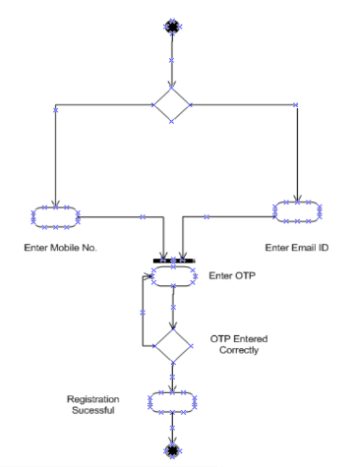

***2. Placing Order –***

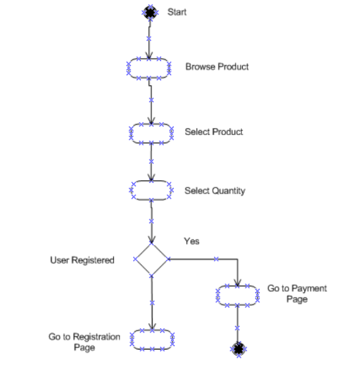

***3. Order Cancellation –***

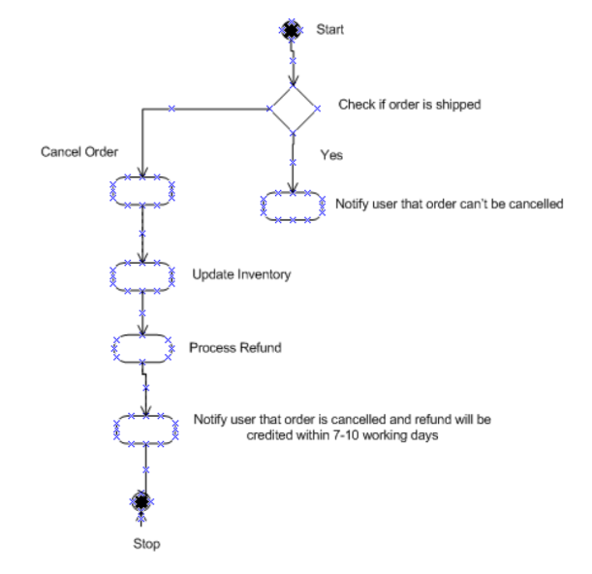

***4. Payment –***

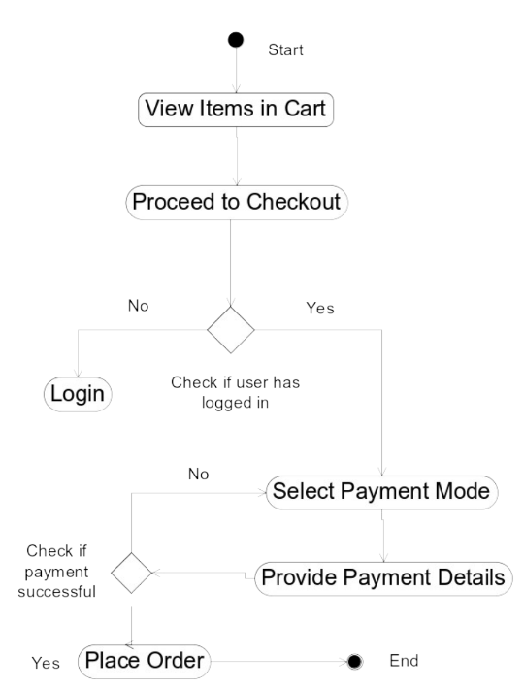

***5. Delivery –***

