**Assignment 1**

**Business Requirement Document**

**Project Name: Ice N Milk Pvt Ltd**

**Project ID: 2025- Ice N Milk – 001**

**Version ID: 3.0**

**Author: Rohit Salvi**

1. **Document Revision**

|  |  |  |
| --- | --- | --- |
| **Date** | **Version Number** | **Document Changes** |
| 01.01.2025 | 1.0 | Initial Draft |
| 15.02.2025 | 2.0 | Development and Coding |
| 30.03.2025 | 3.0 | Testing |

1. **Approvals**

|  |  |  |  |  |
| --- | --- | --- | --- | --- |
| **Role** | **Name** | **Title** | **Signature** | **Date** |
| **Project Head** | Ms. Priyanka | SOW |  |  |
| **Project Leader** | Mr. Hanumant | Project sign-off sheet |  |  |
| **Development Lead** | Mr. Gajanan | Coding |  |  |
| **Quality Lead** | Ms. Madhuri | Testing |  |  |
| **Content Lead** | Ms. Sneha | Content Strategy |  |  |

1. **RACI Chart**

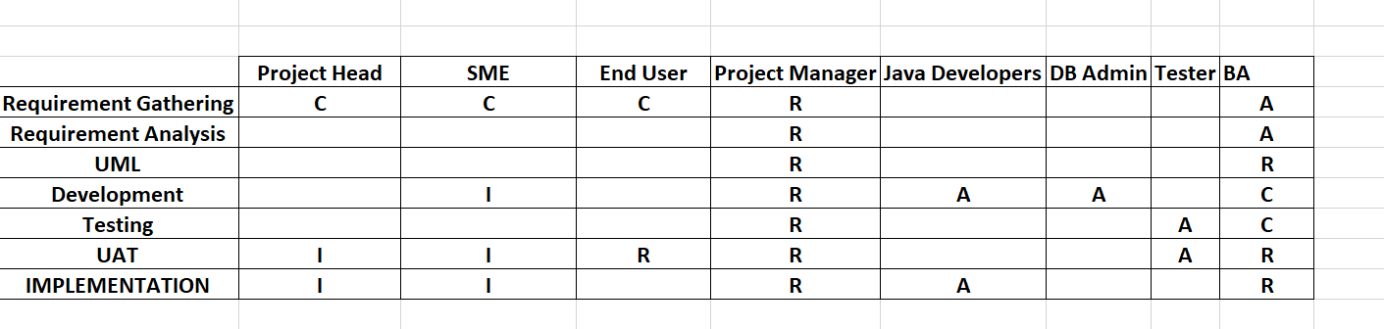

1. **Introduction**
   1. **Business Goals**

This document outlines the requirements for developing software for Ice N Milk Pvt Ltd, a manufacturer of ice cream and milk products with a network of manufacturing plants and warehouses across the country. The proposed system will focus on two primary objectives: effective inventory management and enabling the quickest delivery to customers. By achieving these goals, the company aims to enhance operational efficiency, minimize waste, and improve customer satisfaction.

* **Streamlined Inventory Management:** Ensure real-time monitoring of inventory

levels across all warehouses and plants to reduce spoilage and optimize stock levels.

* **Enhanced Delivery Efficiency:** Implement a system to identify the fastest delivery

routes and automate order allocation based on proximity and inventory availability.

* **Improved Customer Satisfaction:** Minimize order fulfilment time and ensure

product freshness at delivery.

* 1. **Business Objectives**

1. Develop a centralized system to track and manage inventory across all locations.

2. Automate order processing, allocation, and dispatch based on inventory and location.

3. Integrate delivery route optimization with real-time traffic and weather data.

4. Reduce inventory wastage by implementing an expiry-date tracking mechanism.

5. Enable reporting and analytics for better decision-making and demand forecasting.

* 1. **Business Rules**

1. Inventory must be updated in real-time upon receipt, dispatch, or adjustment.

2. Orders should only be fulfilled if the inventory is available and meets the required shelf-life criteria.

3. Delivery routes must prioritize freshness while minimizing transportation costs.

4. Customer priority orders (e.g., bulk orders) must be flagged for immediate action.

1. **Project Goal**

* Real Time inventory tracking across the locations
* Bulk Order prioritization
* Instant Re-routing in case of delays
* Dashboards / Reports for inventory levels, Order Patterns and Delivery accuracy.

1. **Project Scope**

Software to be developed to manage the inventory and quickest delivery to the customer.

**6.1. In Scope Functionality**

* Inventory tracking at manufacturing plants and warehouses.
* Order management and allocation.
* Delivery route optimization.
* Analytics and reporting dashboards

**6.2. Out Scope Functionality**

* Manufacturing Process and Management
* Customer Relationship Management

1. **Assumptions**
2. All warehouses and plants have internet connectivity for real-time updates.
3. 2. Delivery vehicles are GPS-enabled to support route optimization.
4. 3. Data from external sources (e.g., traffic, weather) is available via APIs.

All warehouses and plants have internet connectivity for real-time updates.

2. Delivery vehicles are GPS-enabled to support route optimization.

3. Data from external sources (e.g., traffic, weather) is available via APIs.

* All warehouses and plants have internet connectivity for real-time updates.
* Delivery vehicles are GPS-enabled to support route optimization.
* Data from external sources (e.g., traffic, weather) is available via APIs

1. **Constraints**

* Budget limitations may restrict the scope of features.
* Integration with legacy systems may pose technical challenges.
* Project timelines must align with the company’s peak season schedules.

1. **Risks**

* Users knowledge expertise
* Resource availability risk
* Improper requirements gathering
* Improper planning
* Scope Creep
* System Integration
* Employees Resistance

1. Improper planning**ss Process Overview**

**10. Legacy System (AS IS)**

* Inventories are managed manually or using isolated systems.
* Order allocation is manually determined, leading to inefficiencies
* Delivery routes are planned based on experience, not optimized

**Proposed Recommendations (To Be)**

* A centralized system enables automated inventory management.
* Orders are allocated and dispatched through a well-integrated API.
* Delivery routes are optimized dynamically for speed and cost.

1. **Development and Resource Plan**

**Development Strategy**:

**Phase 1:** Requirement gathering, stakeholder workshops, and system design (2 weeks).

**Phase 2:** Development of core modules (Inventory, Order, Delivery) (8 weeks)

**Phase 3:** Integration with external systems (APIs, GPS) and legacy systems (4 weeks)

**Phase 4:** Testing and quality assurance (3 weeks).

**Phase 5:** Deployment, training, and support (3 weeks).

**Resource Count:**

Project Head – 1

Project Manager -1

Business Analyst -1

SME – 1

Developers - 3

1. **Appendices**
   1. **List Of Acronyms**
   2. **Glossary Of Terms**
   3. **Related Documents**

* Market Research for Ice Cream \ Milk Products Industry
* Feasibility Study Report
* Stakeholder requirement documents

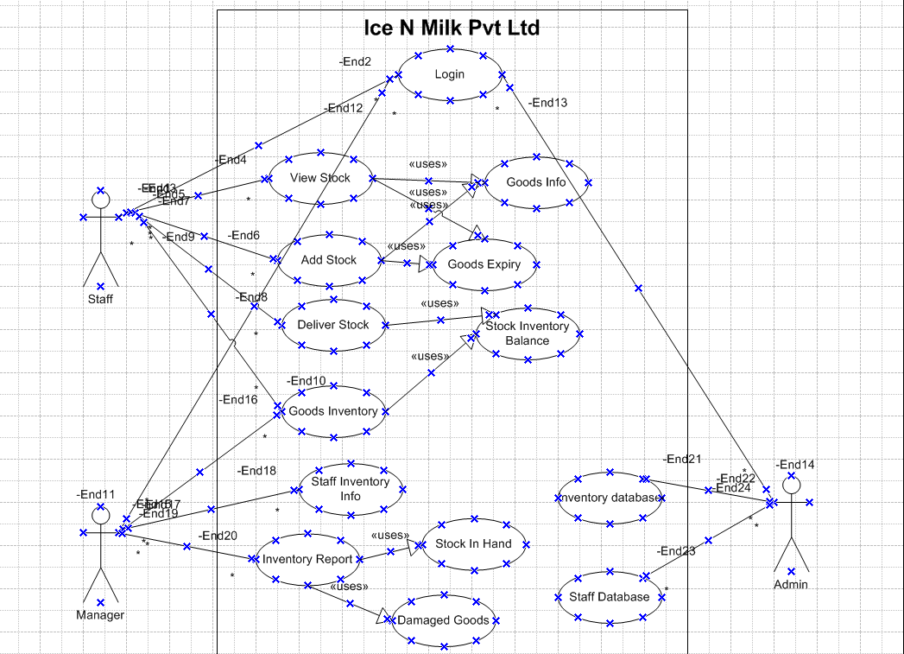

**Assignment 2**

1. **Introduction Letter**

To,

Ice N Milk Pvt Ltd

Dear Sir/Madam,

Warm Greetings!

My self Rohit Salvi working as a Business Analyst who has been assigned to work with your esteemed organization and team for this exciting project.

I bring expertise in warehousing and logistics sector domain concentrating on exceptional customer service, which aligns with your requirements.

With your vision of managing inventory and ensuring the quickest delivery of your ice cream and milk products, I have been assigned the task to shape your goals into realistic and well-curated software application.

I have done an extensive research on your current processes, challenges and futures aspirations regarding your products and customer reach. As a team, I would be delighted to understand your requirements and create a strategic plan to meet your goals and objectives. Your insights and feedback would be very essential to make this software application practical and scalable to match your needs.

I would also be looking forward to meet your team to discuss the requirements in details and gather inputs accordingly. I would also request you to share documents, processes or initial walk through to help us start this journey.

I sincerely appreciate for providing me this opportunity to collaborate on this project and I am confident that I would be able to curate a perfect software application that adds value to your business goals.

Please let me know convenient time for further discussion.

Thanks and Regards,

Rohit Salvi

(989031954)

**Business Requirement Document**

**Project Name: Online Store**

**Project ID: 2025- Online Store – 001**

**Version ID: 3.0**

**Author: Rohit Salvi**

1. **Document Revision**

|  |  |  |
| --- | --- | --- |
| **Date** | **Version Number** | **Document Changes** |
| 01.01.2025 | 1.0 | Initial Draft |
| 15.02.2025 | 2.0 | Development and Coding |
| 30.03.2025 | 3.0 | Testing |

1. **Approvals**

|  |  |  |  |  |
| --- | --- | --- | --- | --- |
| **Role** | **Name** | **Title** | **Signature** | **Date** |
| **Project Head** | Ms. Priyanka | SOW |  |  |
| **Project Leader** | Mr. Hanumant | Project sign-off sheet |  |  |
| **Development Lead** | Mr. Gajanan | Coding |  |  |
| **Quality Lead** | Ms. Madhuri | Testing |  |  |
| **Content Lead** | Ms. Sneha | Content Strategy |  |  |

1. **RACI Chart**



1. **Introduction**
   1. **Business Goals**

The goal of the project is to develop an online store platform that allows customers to browse, purchase products, and interact with the store via a secure and user-friendly website. The online store will handle user authentication, product management, payments, order processing, and customer support features.

* 1. **Business Objectives**
* To provide an easy-to-use online platform for users to shop from a variety of product categories.
* To offer an intuitive interface for browsing products and managing orders.
* To integrate with a payment gateway for secure transactions.
* To enhance customer satisfaction with order tracking, returns, and responsive support.
  1. **Business Rules**
* Only available products to be reflected on website
* Pre-booking option to made available
* Discounts to applied at check out
* Products to be available in specific currency only
* Minimum predefined quantity / price should be eligible for free shipping

1. **Project Goal**

To develop an e-commerce platform where customers can browse products, add them to the cart, purchase, and track orders.

1. **Project Scope**

Software to be developed to manage an online store with convenience to customer and profitability to vendors.

**6.1. In Scope Functionality**

* User registration and login
* Adding, editing, and deleting product listings
* Add to cart, view cart, and modify cart.
* Secure checkout process.
* Multiple payment gateways (credit card, PayPal, etc.).
* Order tracking (via email, customer portal).
* Status updates (processing, shipped, delivered).
* Order cancellation and returns.
* Contact form or live chat support.

**6.2. Out Scope Functionality**

* Currency Conversion
* Voice Search
* Referrals Loyalty Program
* International Shipping

1. **Assumptions**

* The platform will initially support web access but may expand to mobile applications in the future.
* All products are stored in the company’s warehouses.
* The business will handle inventory management manually or through an integrated system.

1. All warehouses and plants have internet connectivity for real-time updates.
2. 2. Delivery vehicles are GPS-enabled to support route optimization.
3. 3. Data from external sources (e.g., traffic, weather) is available via APIs.

All warehouses and plants have internet connectivity for real-time updates.

2. Delivery vehicles are GPS-enabled to support route optimization.

3. Data from external sources (e.g., traffic, weather) is available via APIs.

1. **Constraints**

* Budget limitations may restrict the scope of features.
* Integration with legacy systems may pose technical challenges.
* Project timelines must align with the company’s peak season schedules.

1. **Risks**

* Users knowledge expertise
* Resource availability risk
* Improper requirements gathering
* Improper planning
* Scope Creep
* System Integration
* Employees Resistance

1. Improper planning**ss Process Overview**

**10. Legacy System (AS IS)**

* Outdated Platform.
* These systems might struggle to integrate with modern third-party services such as payment gateways, shipping providers, or CRM solutions.
* A legacy system may not be optimized for speed, leading to longer page load times, which can negatively affect conversion rates,
* Legacy systems may still rely on manual processes for order fulfillment, customer support, and inventory management, which can slow down operations and increase human error.

**Proposed Recommendations (To Be)**

* Migrate to a modern, scalable e-commerce platform. These platforms offer improved flexibility, speed, and integrations with third-party services.
* Redesign the website with a mobile-first approach to ensure a seamless experience across all devices.
* Integrate automated order fulfilment systems and real-time inventory tracking to reduce manual work and improve accuracy.
* Use modern APIs to integrate with third-party services like CRM ,payment gateways and shipping providers

1. **Development and Resource Plan**

**Development Strategy**:

**Phase 1:** Requirement gathering, stakeholder workshops, and system design (2 weeks).

**Phase 2:** Development of core modules (Inventory, Order, Delivery) (8 weeks)

**Phase 3:** Integration with external systems (APIs, GPS) and legacy systems (4 weeks)

**Phase 4:** Testing and quality assurance (3 weeks).

**Phase 5:** Deployment, training, and support (3 weeks).

**Resource Count:**

Project Head – 1

Project Manager -1

Business Analyst -1

SME – 1

Developers – 3

1. **Appendices**
   1. **List Of Acronyms**
   2. **Glossary Of Terms**
   3. **Related Documents**

* Feasibility Study Report
* Stakeholder requirement documents

**Functional Specifications**

|  |  |
| --- | --- |
| **Project Name** | Online Booking Store |
| **Client Name** | Dmart |
| **Project Version** | 1.0 |
| **Project Sponsor** | Ms. Priyanka – Project Head |
| **Project Initiation Date** | 01.01.2025 |

**Functional Requirement Specifications**

|  |  |  |  |
| --- | --- | --- | --- |
| **Requirement ID** | **Requirement Name** | **Requirement Description** | **Priority** |
| **FR001** | Account Creation | Users must be able to create an account using an email address, username, and password. | 10 |
| **FR002** | Login / Logout | Users should be able to log in using their credentials and log out of their accounts | 10 |
| **FR003** | Password Recovery | Users should be able to reset their passwords through an email link if forgotten. | 10 |
| **FR004** | Product Catalogue | The system must display a list of products that users can browse, categorized by type, price, or other criteria | 10 |
| **FR005** | Product Reviews | Users must be able to leave reviews and rate products they have purchased. | 10 |
| **FR006** | Add to Cart | Users should be able to add products to their shopping cart | 5 |
| **FR007** | View Cart | Users must be able to view the contents of their shopping cart (product name, quantity, price). | 5 |
| **FR008** | Order Summary | Users should be able to review a summary of their order before proceeding to payment. | 5 |
| **FR009** | Order Confirmation | Users should receive an order confirmation email with details of the products purchased, shipping information, and estimated delivery date | 5 |
| **FR010** | Multiple Payment Methods | The system should support multiple payment methods (credit/debit card, PayPal, etc.). | 5 |
| **FR011** | Checker Name - Mandatory | Checker Name to auto fetch details post inputting Name and Surname | 1 |
| **FR012** | Save Tab - Mandatory | Save Tab to be enable incase all mandatory fields are updated by maker and checker | 1 |
| **FR013** | Term Deposit – Documents Page | E-checklist to be saved in Pdf format only | 2 |

**Non - Functional Requirement Specifications**

|  |  |  |
| --- | --- | --- |
| **Requirement ID** | **Requirement Name** | **Requirement Description** |
| **NFR001** | Usability | Application should be user friendly |
| **NFR002** | Performance | Application should load pages within 5 secs |
| **NFR003** | Security | Application must ensure secure user authentication |

**5. Order Management**

* **Order History**: Users should be able to view their past orders and track their status (e.g., pending, shipped, delivered).
* **Order Cancellation**: Users should be able to cancel an order within a certain time frame after purchase.
* **Refunds/Returns**: Users should be able to initiate returns or request a refund within the store’s return policy period.

**6. Shipping and Delivery**

* **Shipping Options**: Users must be able to choose from different shipping methods (standard, expedited, international).
* **Shipping Costs**: The system should calculate shipping costs based on the user’s location and chosen shipping method.
* **Order Tracking**: Users should be able to track the status of their shipped orders with a tracking number.

**7. Admin Panel**

* **Product Management**: Admins must be able to add, edit, or delete products from the catalog.
* **Order Management**: Admins should be able to view all orders, update order statuses, and handle cancellations or refunds.
* **User Management**: Admins must be able to manage user accounts (block/unblock, update roles).
* **Reporting and Analytics**: Admins should have access to sales reports, inventory reports, and customer data analytics.

**8. Security Features**

* **Data Encryption**: All sensitive user data (e.g., payment information, passwords) should be encrypted.
* **Secure Checkout**: The checkout process should be secured using SSL/TLS encryption.
* **Fraud Prevention**: The system should include fraud detection mechanisms, such as payment fraud checks and address verification.

**9. Notifications and Alerts**

* **Email Notifications**: Users should receive notifications about order confirmations, shipping updates, and delivery status.
* **Push Notifications**: If applicable, the system should send push notifications to users about promotions or new arrivals.
* **Out of Stock Alerts**: Users should be notified when a product they are interested in is back in stock.

**10. Customer Support**

* **Live Chat**: The system should support live chat functionality for real-time customer assistance.
* **Contact Forms**: Users should be able to contact the support team via a form or email.
* **Help Center/FAQ**: The system should provide users with a self-service help center or FAQ section.

**11. Promotions and Discounts**

* **Coupon Codes**: Users should be able to apply discount or promotional codes during checkout.
* **Sale Events**: Admins should be able to schedule sales or offer seasonal promotions.

**12. SEO and Marketing**

* **SEO-Friendly URLs**: Product and category URLs should be optimized for search engines.
* **Email Marketing Integration**: The system should integrate with email marketing tools to send newsletters, promotions, or product recommendations to customers.
* **Social Media Integration**: The online store should allow easy sharing of products on social media platforms.

**13. Mobile Compatibility**

* **Responsive Design**: The online store must be optimized for mobile and tablet devices.
* **Mobile App Integration (Optional)**: If applicable, users should be able to access the store through a dedicated mobile app.