**Nurturing Process – Waterfall Deliverables – Part -2/2**

**Document 6** - Please prepare a Use case diagram, Activity diagram and a Use case specification document.

1. **Use Case Diagram:**

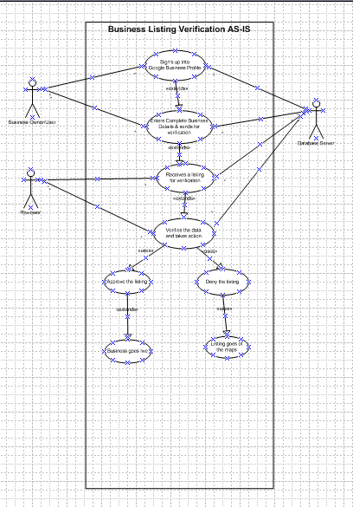

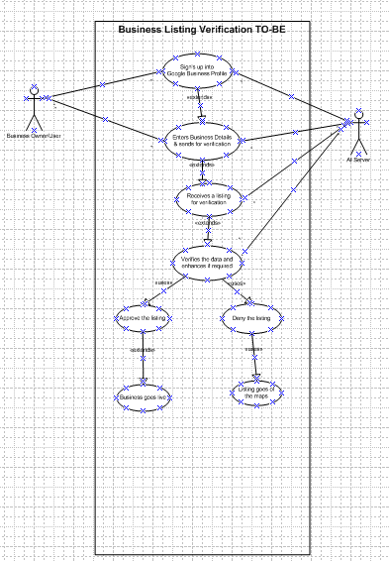

1. **Activity Diagram:**

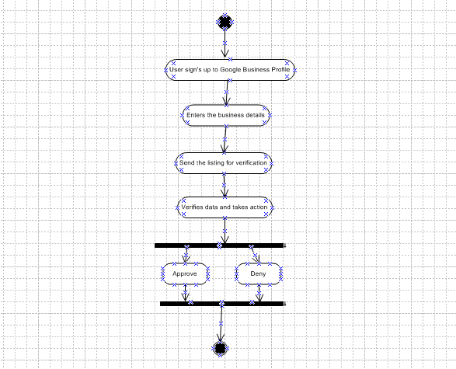

1. **Use Case Specification Document**

|  |  |
| --- | --- |
| **Use Case Id:** UC001 |  |
| **Created by**: Sirisha | **References**: Project Requirements Document |
| 1. **Use Case Name** | Verify Business Listing |
| 1. **Use Case Description** | This use case describes the process where a business listing submitted by a user is verified by the AI/ML system, reviewed by an admin, and either approved or rejected based on defined business rules. |
| 1. **Actors** | Business User, Verification Admin, AI/ML Verification Engine, Database System |
| 1. **Pre-Conditions** | * User is authenticated * Listing is submitted in the required format |
| 1. **Basic Flow** | * Business user submits a new listing. * AI/ML engine automatically analyzes the listing for validity. * Admin receives flagged listings for manual review. * Admin verifies and approves/rejects the listing. * Status is updated and the user is notified. |
| 1. **Alternative Flow** | * If listing is auto-verified with high confidence, it bypasses manual review. * If the listing has missing fields, system prompts the user to complete data. |
| 1. **Exceptional Flow** | * System downtime leads to queueing of submissions. * AI engine fails to process — admin manually handles it. |
| 1. **Post-conditions** | Listing is either approved and published or rejected with reason provided. |
| 1. **Assumptions** | * Admin has access to the verification dashboard. * AI engine is trained on appropriate datasets. |
| 1. **Constraints** | * Response time for listing decision should not exceed 24 hours. * Listing must comply with local legal and business policies. |
| 1. **Dependencies** | * AI/ML model performance. * Admin availability. * Database storage and retrieval systems. |
| 1. **Input & Outputs** | * **Inputs**: Business listing form (name, category, location, documents) * **Outputs**: Approval/rejection notification; listing visibility on the map |
| 1. **Business Rules** | * Listings with 95% AI confidence score are auto-approved. * Listings flagged require dual-admin confirmation before rejection. |
| 1. **Miscellaneous Information** | * All decisions logged with timestamps for audit. * GDPR compliance for data handling is mandatory. |

**Document 7- Screens and Pages**

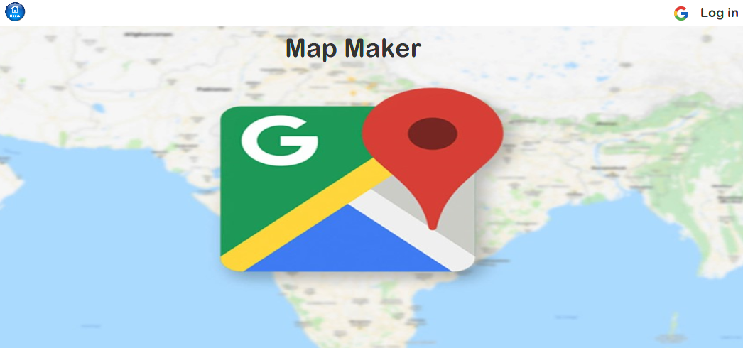

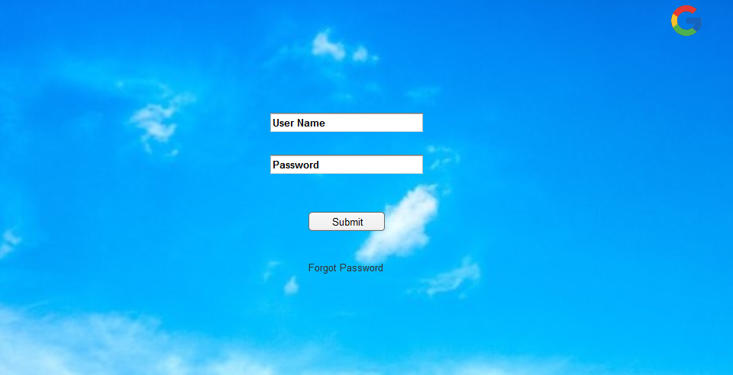

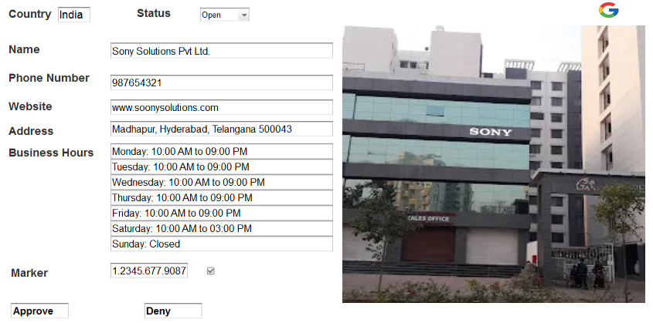

**Document 8** - **Tools-Visio and Axure**

Write a paragraph on your experience using Visio and Axure for the project.

Answer) During the AccuMap project, I extensively utilized **Microsoft Visio** and **Axure RP** to support visual Modeling and prototyping activities. **Visio** proved highly effective for creating clear and professional **use case diagrams, activity diagrams**, and **process flows** that communicated system behaviour and user interactions to both technical and non-technical stakeholders. It helped streamline validation during stakeholder reviews.

On the other hand, **Axure** was instrumental in developing interactive **wireframes and prototypes** for user interface elements. It enabled us to simulate user journeys and receive early feedback, reducing rework during development. The combined use of Visio and Axure enhanced overall collaboration, clarity, and efficiency throughout the requirements and design phases of the AccuMap Project.

**Document 9 - BA experience**

**My experience as BA in following phases:**

**1. Requirement Gathering**

* Applied the **MoSCoW technique** to prioritize and classify business requirements.
* Handled client unavailability by identifying alternate **Points of Contact (POCs)** to gather critical inputs quickly.
* Validated and refined requirements using the **FURPS model** (Functionality, Usability, Reliability, Performance, Supportability).
* Identified and eliminated duplicate or redundant requirements to maintain clarity and accuracy.
* Utilized **Prototyping** to help stakeholders provide more precise and concrete requirements.

**2. Requirement Analysis**

* Created detailed **UML diagrams** to visually represent system functionalities and interactions.
* Designed **activity diagrams** to depict process flows and operational sequences.
* Conducted regular walkthroughs with the team to communicate visual artifacts.
* Incorporated feedback and concerns from team members, updating diagrams and documentation accordingly.
* Prepared both **Business Requirements Specification (BRS)** and **System Requirements Specification (SRS)** documents.

**3. Design Phase**

* Developed **test cases** directly from **use case diagrams**, ensuring traceability.
* Collaborated with the client to validate **design and solution documents**.
* Documented both **positive and negative test scenarios** to ensure comprehensive coverage.
* Ensured **no test case was overlooked**, understanding its potential downstream impact on development.
* Created **test data** sets aligned with real-world scenarios.
* Updated the **Requirements Traceability Matrix (RTM)** to ensure all business needs were addressed.

**4. Development Phase**

* Facilitated **JAD (Joint Application Development)** sessions to enhance collaboration between business and technical teams.
* Acted as the point of contact for clarifying developer queries during the coding phase.
* Addressed resistance or lack of cooperation within the team through **one-on-one discussions**, fostering a supportive work environment.
* Shared **UML and process diagrams** to guide unit development.
* Scheduled and led **regular sync-up meetings** with both the client and development teams.
* Recorded meetings and followed up individually with members who were absent, ensuring continuity.

**5. Testing Phase**

* Derived **test cases from use cases** and business scenarios.
* Conducted **high-level system testing** to validate critical functionality.
* Coordinated with the client to acquire realistic **test data**.
* Maintained and updated the **RTM** to align with testing outcomes.
* Collected **client sign-off** after successful test cycle completion.
* Prepared the client team for **User Acceptance Testing (UAT)** by providing necessary support and documentation.

**6. Deployment Phase**

* Shared the finalized **RTM** with the client as part of the **project closure documentation**.
* Assisted in the preparation and distribution of **end-user manuals** and training materials.
* Organized and conducted **training sessions** for the client's operational team.
* Ensured full attendance in training sessions through proactive coordination and communication.