**Online Agricultural Store Capstone-1 Prep-3**

**1.Functional Requirements**

|  |  |  |  |
| --- | --- | --- | --- |
| **Requirement ID** | **Requirement Name** | **Requirement Description** | **Priority** |
| FR0001 | Farmer Registration | Farmers able to register with Email ID & Password with the application | 9 |
| FR0002 | Farmers Login | Farmers able to login with Email ID & Password | 9 |
| FR0003 | Search | Farmers able to search the Products | 8 |
| FR0004 | Filter | Farmers able to filter products biased on category, Price, Size | 5 |
| FR0004 | Product Selection | Farmers able to select the Products biased on usage | 6 |
| FR0005 | Product Description | Farmers able to see the product description and for type of the crop | 5 |
| FR0007 | Add to cart | Farmers are able to add their Products in cart for shopping | 8 |
| FR0008 | Quantity | Farmers able to Modify the Quantity of products before buying | 7 |
| FR0009 | Checkout Process | Farmers are able to check out in the app to initiate the Purchase Process | 7 |
| FR0010 | Payment | Farmers should have various option to make Payment i.e. UPI/Cards/COD | 9 |
| FR0011 | Order Confirmation | Farmers should receive the conformation about the order and Expected delivery date | 7 |
| FR0012 | Order Shipping | Farmers able to receive the shipping details to track the order | 7 |
| FR0013 | Order Status | Farmers should receive the delivery conformation through SMS, Email ID, App Notification | 7 |
| FR0014 | Manufacturer Registration | Manufacturer Should register | 9 |
| FR0015 | Manufacturer Login | Manufacturer Should login | 9 |
| FR0016 | Manufacturer Upload Product Details | Manufacturer able to upload their Product Details with clear description | 8 |
| FR0017 | Manufacture Payment Details | Manufacture are able to see the payment details | 8 |
| FR0018 | Inventory | Manufactures are able manage the inventory | 6 |
| FR0019 | Delivery Boy Login/ registration | Delivery boy able to login or register in the app | 9 |
| FR0020 | Delivery Details | Delivery boy able to see the farmer Details and Delivery location | 7 |
| FR0021 | Transaction happens through Delivery Boy on COD Orders | Delivery boy has to collect the Payment through farmer on COD Orders | 8 |

**Non- Functional Requirement**

|  |  |  |  |
| --- | --- | --- | --- |
| **NFR ID** | **NFR Name** | **Description** | **Priority** |
| NFR001 | Registration Process Time | The system should register a farmer within 3 seconds of submitting the Details | 9 |
| NFR002 | Productivity of the system | The system should perform seamlessly even after large number of users user the application at a time | 7 |
| NFR003 | Password Security | The system should ensure that passwords meet complexity requirements | 8 |
| NFR004 | Data Validation | The system should verify the details of the user | 8 |
| NFR005 | Error Handling | The system should provide the user-friendly message if there are any inputs Error | 7 |
| NFR006 | Availability | The Service Should be available 24/7 | 9 |

**2–Minimum 5-page designs**

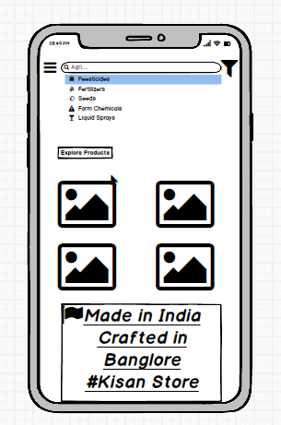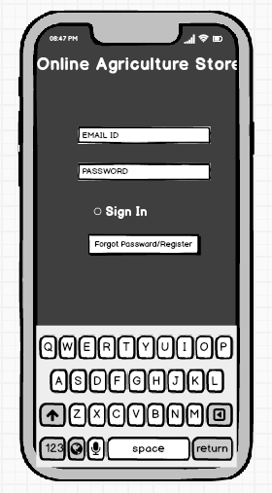

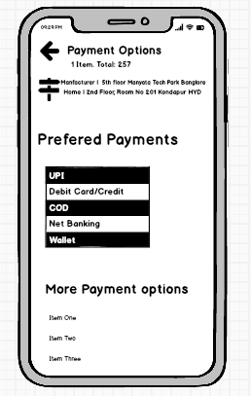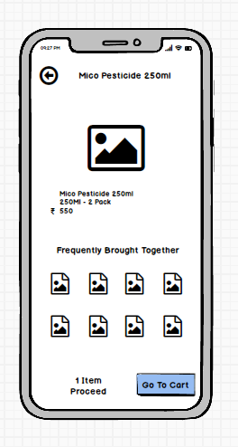

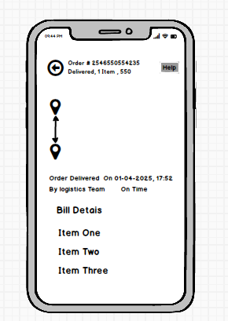

**3 – Tools**

**Balsamiq**

Balsamiq Mock-ups is an effective tool for presenting the software requirements in the form of   
wireframes. This helps the software development team to visualize how the software project will look like in the very early stages of development. This is a small tutorial where we will cover all the  
basic steps needed to start with Balsamiq Mock-ups.

**Ms Viso**

Microsoft Visio is a diagramming and visualization tool that allows users to create a variety of diagrams, including flowcharts, organization charts, network diagrams, and floor plans, using a range of shapes, templates, and connectors

**4. RTM**

RTM is a documentation tools it helps mapping the requirements with the test cases. This Tools help to track the requirements to check the current project requirements are Met

**Why**

To link requirements to test cases and defect accurately

We can prevention in defect leakages

To ensure good quality Application

|  |  |  |  |  |  |  |  |  |  |
| --- | --- | --- | --- | --- | --- | --- | --- | --- | --- |
| **Req ID** | **Req Name** | **Req Description** | **Design** | **D1** | **T1** | **T2** | **T3** | **T4** | **UAT** |
| FR0001 | Farmer Registration | Farmers able to register with Email ID & Password | Completed | In Progress | In Progress | Pending | Not Started | Not Started | Not Started |
| FR0002 | Farmer Login | Farmers able to log in with Email ID & Password | Completed | In Progress | In Progress | Pending | Not Started | Not Started | Not Started |
| FR0003 | Search | Farmers able to search the Products | Completed | In Progress | In Progress | Pending | Not Started | Not Started | Not Started |
| FR0004 | Filter | Farmers able to filter products based on category, Price, Size | Completed | Not Started | Not Started | Pending | Not Started | Not Started | Not Started |
| FR0005 | Product Selection | Farmers able to select the products based on usage | Completed | Not Started | Not Started | Pending | Not Started | Not Started | Not Started |
| FR0006 | Product Description | Farmers able to see product descriptions and crop suitability | Completed | Not Started | Not Started | Pending | Not Started | Not Started | Not Started |
| FR0007 | Add to Cart | Farmers can add products to the cart for shopping | Completed | In Progress | In Progress | Pending | Not Started | Not Started | Not Started |
| FR0008 | Quantity | Farmers able to modify product quantity before purchasing | Completed | Not Started | Not Started | Pending | Not Started | Not Started | Not Started |
| FR0009 | Checkout Process | Farmers can check out to initiate the purchase process | Completed | Not Started | Not Started | Pending | Not Started | Not Started | Not Started |
| FR0010 | Payment | Farmers should have multiple payment options (UPI, Cards, COD) | Completed | In Progress | In Progress | Pending | Not Started | Not Started | Not Started |
| FR0011 | Order Confirmation | Farmers receive order confirmation and expected delivery date | Completed | Not Started | Not Started | Pending | Not Started | Not Started | Not Started |
| FR0012 | Order Shipping | Farmers receive shipping details for order tracking | Completed | Not Started | Not Started | Pending | Not Started | Not Started | Not Started |
| FR0013 | Order Status | Farmers receive delivery confirmation via SMS, Email, App | Completed | Not Started | Not Started | Pending | Not Started | Not Started | Not Started |
| FR0014 | Manufacturer Registration | Manufacturers should register | Completed | In Progress | In Progress | Pending | Not Started | Not Started | Not Started |
| FR0015 | Manufacturer Login | Manufacturers should log in | Completed | In Progress | In Progress | Pending | Not Started | Not Started | Not Started |
| FR0016 | Manufacturer Upload Product Details | Manufacturers can upload product details with descriptions | Completed | Not Started | Not Started | Pending | Not Started | Not Started | Not Started |
| FR0017 | Manufacturer Payment Details | Manufacturers can view payment details | Completed | Not Started | Not Started | Pending | Not Started | Not Started | Not Started |
| FR0018 | Inventory | Manufacturers can manage inventory | Completed | Not Started | Not Started | Pending | Not Started | Not Started | Not Started |
| FR0019 | Delivery Boy Login/Registration | Delivery personnel can log in or register | Completed | In Progress | In Progress | Pending | Not Started | Not Started | Not Started |
| FR0020 | Delivery Details | Delivery personnel can see farmer details and delivery location | Completed | Not Started | Not Started | Pending | Not Started | Not Started | Not Started |
| FR0021 | Transaction via Delivery Boy (COD) | Delivery personnel collect payment for COD orders | Completed | Not Started | Not Started | Pending | Not Started | Not Started | Not Started |

|  |  |  |  |  |  |  |  |  |  |
| --- | --- | --- | --- | --- | --- | --- | --- | --- | --- |
| **Req ID** | **Req Name** | **Req Description** | **Design** | **D1** | **T1** | **T2** | **T3** | **T4** | **UAT** |
| NFR001 | Registration Process Time | The system should register a farmer within 3 seconds of submitting the Details | Completed | In Progress | In Progress | Pending | Not Started | Not Started | Not Started |
| NFR002 | Productivity of the system | The system should perform seamlessly even after large number of users user the application at a time | Completed | In Progress | Not Started | Pending | Not Started | Not Started | Not Started |
| NFR003 | Password Security | The system should ensure that passwords meet complexity requirements | Completed | In Progress | Not Started | Pending | Not Started | Not Started | Not Started |
| NFR004 | Data Validation | The system should verify the details of the user | Completed | Not Started | Not Started | Pending | Not Started | Not Started | Not Started |
| NFR005 | Error Handling | The system should provide the user-friendly message if there are any inputs Error | Completed | Not Started | Not Started | Pending | Not Started | Not Started | Not Started |
| NFR006 | Availability | The Service Should be available 24/7 | Completed | Not Started | Not Started | Pending | Not Started | Not Started | Not Started |

**5. Test Case Document**

**1.https://docs.google.com/spreadsheets/d/1TxFtfq27xa_eutLUdM0jzIPAsClddcmXkmCqehGJUXg/edit?usp=sharing**

2.[**Test Case Document .xlsx**](https://1drv.ms/x/c/c4d2bb5cc67aee6c/EVi7U45qLe5Fih9KYNLPahgBVwzbMZaf0Gh4kNCjf8pGoA?e=zkQGaK)

**6.DB Design**

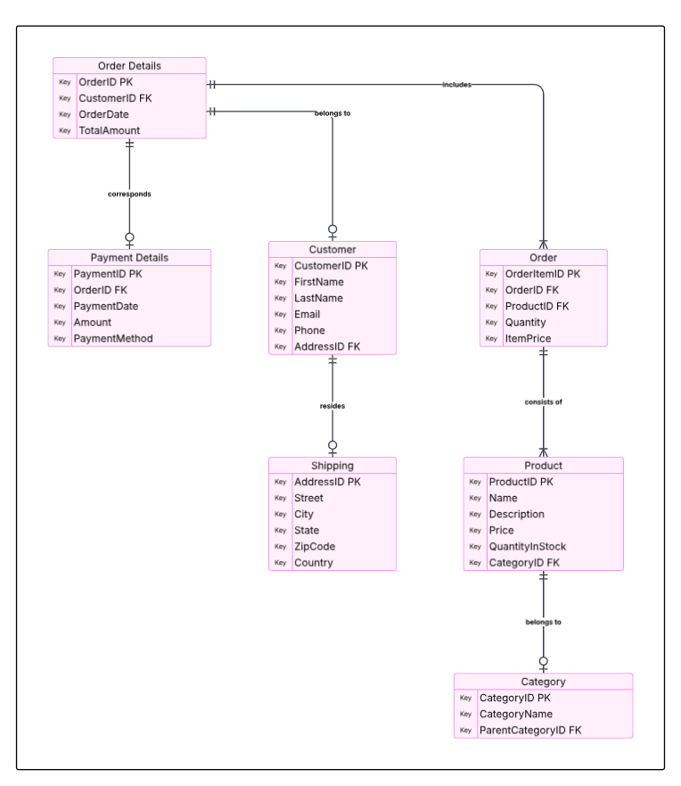  
https://lucid.app/lucidspark/35130ad8-e1a0-40a2-aa6b-b93498d69a34/edit?invitationId=inv_d289911b-c9ca-446c-a4ad-1da41193724e

**ER Diagram**

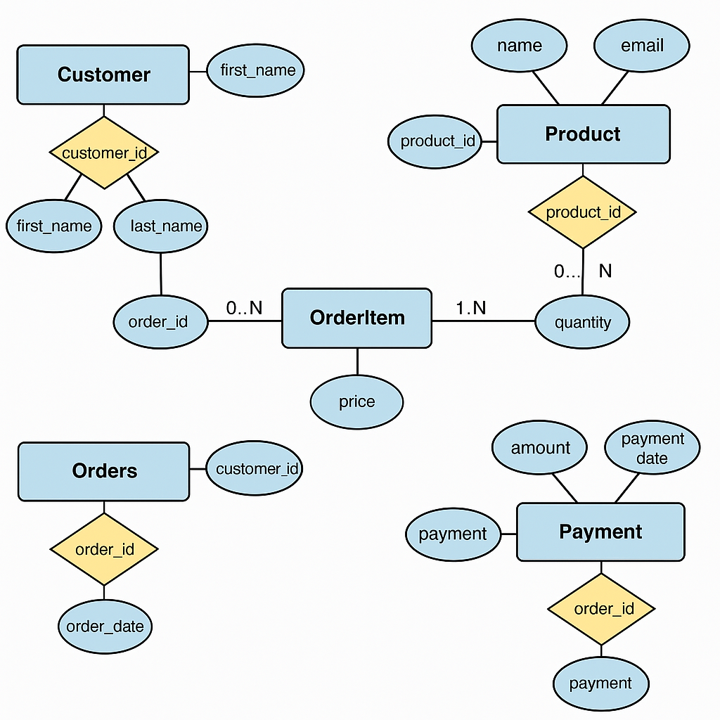

**7.What is a Data Flow Diagram (DFD)?**

A Data Flow Diagram (DFD) is a graphical representation of the flow of data in a system. It shows how input data is transformed into output data through a process and where the data is stored.  
  
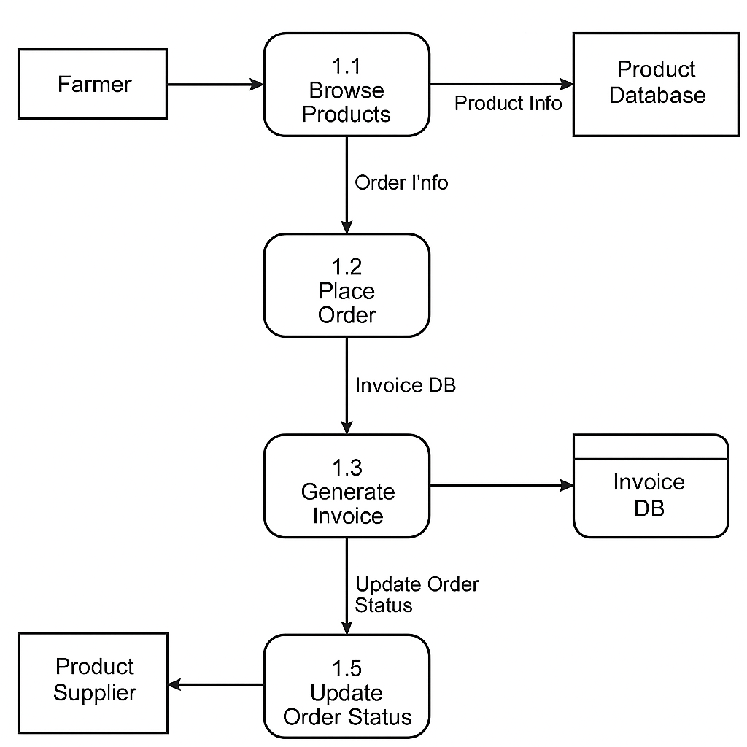

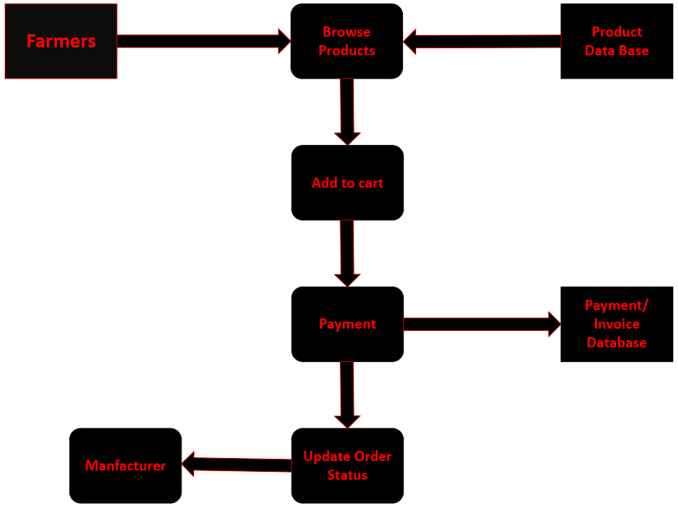  
[Drawing 1.vsdx](https://analyticalassprent-my.sharepoint.com/:u:/g/personal/harishnallamothu_analyticalassprent_onmicrosoft_com/EQ1r8kT_e6RIsktMuHXy_1sBWbAUKnH5sulccLWG7VHKsg?e=Pzg1IH)

**8 – Change Request**

A change request is a formal proposal to modify a project or system. It may involve changes in functionality, performance, or compliance with new regulations.

In this scenario, the Government has changed the taxation structure, which impacts the pricing and financial calculations within the online agriculture products store.

Steps to Handle the Change Request:

1. Identify the Impact:
   * Analyze how the new taxation structure affects pricing, invoicing, and payment processing.
   * Identify which modules of the system require modification (e.g., billing, checkout, financial reports).
2. Document the Change Request:
   * Record details like the reason for the change, affected areas, and expected outcomes.
   * Include stakeholders involved, such as finance teams and developers.
3. Assess Feasibility and Risk:
   * Conduct an impact analysis to determine the effort required for implementation.
   * Assess risks such as compliance issues, data integrity, and timeline constraints.
4. Seek Approval from Stakeholders:
   * Present the change request to Mr. Henry and the project team.
   * Obtain approval from financial and legal teams to ensure compliance.
5. Plan and Implement the Change:
   * Update the taxation logic in the database and application.
   * Modify invoices and receipts to reflect the new tax rates.
   * Update reports and dashboards to align with revised tax policies.
6. Test the Changes:
   * Conduct unit testing, system testing, and regression testing.
   * Validate calculations to ensure tax amounts are correctly applied.
7. Deploy the Changes:
   * Roll out the update in a controlled manner (e.g., staging environment first, then production).
   * Provide training or communication to users about the new tax structure.
8. Monitor and Validate:
   * Ensure there are no discrepancies in tax calculations post-implementation.
   * Gather feedback from users to address any issues.

**9: Change Request vs Enhancement**

As per the scenario described, Ben and Kevin have requested **new functionalities** to be introduced in the application. These include:

1. Allowing Farmers to sell their crop yields through the application
2. Enabling display of those products to the general public
3. Introducing an Auction system for the crop yields

**Is this a Change Request or an Enhancement?**

This is an Enhancement.

**Reason:**

An enhancement refers to adding new features or capabilities to an existing system that were not originally part of the scope. In this case:

* The initial scope was limited to farmers buying fertilizers, seeds, and pesticides.
* The ability for farmers to sell their own crop yields and the introduction of an auction system represents additional functionality aimed at expanding the application’s purpose and value proposition.
* It does not change or modify any existing requirement—it simply extends the capabilities.

**BA’s Response:**

As a Business Analyst, I would first document the new requirements and assess the impact of this enhancement on the system architecture, UI, database design, security considerations, and timeline. I would then:

1. Arrange a stakeholder meeting to clarify objectives and expected features.
2. Conduct feasibility analysis with the technical and project team.
3. Update the BRD (Business Requirement Document) and obtain approvals.
4. Work with the Project Manager to re-estimate timelines, costs, and resource allocation.
5. Log this enhancement in the change log and update all relevant documentation.

**10.Estimations**

**Estimated Man-Hours Per Role**

|  |  |  |  |  |
| --- | --- | --- | --- | --- |
| **Role** | **No. of People** | **Hours/Month/Person** | **Months** | **Total Hours** |
| Project Manager | 1 | 176 (22×8) | 18 | 3,168 |
| Business Analyst | 1 | 176 | 6 | 1,056 |
| Senior Developer | 1 | 176 | 12 | 2,112 |
| Developers | 4 | 176 | 12 | 8,448 |
| Network Admin | 1 | 176 | 2 | 352 |
| DB Admin | 1 | 176 | 3 | 528 |
| Testers | 2 | 176 | 6 | 2,112 |

**11. UAT – User Acceptance Testing**

**Step 1: UAT Planning and Preparation**

As a Business Analyst (BA), I will initiate the UAT process after the internal QA testing is complete and all the major defects are resolved. First, I’ll:

* Identify UAT stakeholders (e.g., Mr. Henry, Peter, Kevin, Ben).
* Finalize the UAT test environment (which should closely resemble the production environment).
* Prepare and review the UAT Test Plan, including:
* Scope of testing
* Roles and responsibilities
* Entry and exit criteria
* Test scenarios and cases
* Schedule UAT cycles with stakeholders.

**Step 2: UAT Execution**

Share UAT credentials and documentation (Test Cases and Instructions).

Observe or assist stakeholders as they execute test cases like:

* Registering a farmer account
* Searching for products
* Placing an order
* Making payments using different methods
* Receiving confirmation emails
* Using the delivery tracker
* Log any bugs or feedback from stakeholders into a defect tracking tool.

**Step 3: UAT Sign-off Process**

Once all critical issues are resolved and the stakeholders confirm that the application meets the agreed business requirements, I will:

* Conduct a UAT Closure Meeting
* Prepare a UAT Sign-off Document including:
* List of executed test cases
* Final approval by stakeholders
* Summary of issues encountered and resolutions

**Step 4: Project Closure Process**

After UAT sign-off:

Conduct a Project Closure Meeting with the client and internal teams.

Handover project deliverables like:

* Source code
* Technical and user documentation
* Admin credentials
* Release final invoice or payment request (if applicable).
* Archive project documents for future reference.
* Capture lessons learned and document best practices.

**12.Project Closure Document**

A Project Closure Document is an official document that formally signals the end of a project. It summarizes the project outcomes, evaluates its success against the defined objectives, documents any learnings or issues, and secures final sign-off from stakeholders. It ensures that all aspects of the project are complete and provides a reference for future projects.

**Key Components of a Project Closure Document**

1. **Project Overview:**
   * Brief summary of the project objective (e.g., to create an online agriculture products store for farmers and manufacturers).
   * Start and end dates.
   * Stakeholders and teams involved.
2. **Objectives and Deliverables Review:**
   * Lists all agreed deliverables and verifies their completion.
   * Compares initial scope with final outcomes.
3. **Milestone Achievements:**
   * Documents key phases like Requirement Gathering, Design, Development, Testing, UAT, and Deployment.
4. **UAT and Final Acceptance:**
   * Captures user acceptance test results.
   * Includes client approval and acceptance signature (e.g., from Mr. Henry or Mr. Pandu).
5. **Open Issues/Outstanding Items:**
   * Lists any pending tasks, bugs, or requests that might be moved to maintenance or future enhancements.
6. **Lessons Learned:**
   * Highlights what went well and what could have been improved.
   * Feedback from all teams (BA, Dev, QA, Client).
7. **Change Log Summary:**
   * Overview of all approved changes and their impact on scope, time, or cost (e.g., tax structure change request).
8. **Resource Release Statement:**
   * Confirms that all resources (developers, testers, etc.) are released from the project.
9. **Financial Summary:**
   * Budgeted vs. actual cost (e.g., Budget: ₹2 Crores under CSR).
10. **Sign-Off and Closure:**

* Formal sign-off by stakeholders confirming the project is complete.
* Official date of closure.