Question 1) Identify minimum 20 functional requirements.

Answer) Functional Requirements: The approach through which functionality is achieved is known as Functional Requirement. It helps understand what the system should do to achieve the functionality.

|  |  |  |  |
| --- | --- | --- | --- |
| **Req. ID** | **Req. Name** | **Req Description** | **Priority** |
| **FR0001** | Farmer Registration | Farmers should be able to register with the application. |  |
| **FR0002** | Farmer Search for Products | |  | | --- | | Farmers should be able to search for available products in fertilizers, seeds, pesticides. |  |  | | --- | |  | | 8 |
| **FR0003** | Farmer Login | |  | | --- | | Farmers should be able to log in using their email ID and password. |  |  | | --- | |  | | 8 |
| **FR0004** | New Farmer Registration | |  | | --- | | New users should be able to create an account using their email ID and password. |  |  | | --- | |  | | 8 |
| **FR0005** | Product Catalog Display | |  | | --- | | The system should display a product catalog containing fertilizers, seeds, and pesticides. |  |  | | --- | |  | | 8 |
| **FR0006** | Product details view | |  | | --- | | Farmers should be able to view detailed information about selected products. |  |  | | --- | |  | | 8 |
| **FR0007** | Add to Cart | |  | | --- | | Farmers should be able to add selected products to their cart for purchase. |  |  | | --- | |  | | 8 |
| **FR0008** | Buy Later Option | |  | | --- | | Farmers should be able to add products to a "Buy Later" list. |  |  | | --- | |  | | 7 |
| **FR0009** | Order Placement | |  | | --- | | Farmers should be able to place an order for selected products. |  |  | | --- | |  | | 8 |
| **FR0010** | Payment Gateway Integration | |  | | --- | | Farmers should be able to make payments using COD, Credit/Debit card, and UPI. |  |  | | --- | |  | | 9 |
| **FR0011** | Order Confirmation email | |  | | --- | | Farmers should receive an email confirmation after placing an order. |  |  | | --- | |  | | 7 |
| **FR0012** | Delivery Tracker | Farmers should be able to track their order status | 8 |
| **FR0013** | Manufacturer Registration | Manufacturers should be able to register in the application. | 7 |
| **FR0014** | Manufacturer Login | Manufacturer should be able to login using their credentials. | 7 |
| **FR0015** | Product Addition by Manfacturers | Manufacturers should be able to add their products | 8 |
| **FR0016** | Product Management | Manufacturers should be able to update or remove their listed Products. | 7 |
| **FR0017** | Order Management by Manufacturer | Manufacturers should be able to view and manage received orders. | 7 |
| **FR0018** | Admin Dashboard | Admin should have access to manage users products and transactions. | 9 |
| **FR0019** | Reports and Analytics | Admin Should be able to generate sales report and User activitity analytics. | 6 |
| **FR0020** | Customer Support Request | Farmers should be able to rasie queries related to orders and payments. | 7 |

Non Functional Requirements: They will describe the qualities and attributes of a system focusing on how the system performs. Integration of external Peripherals with the system along with quality requirements are called as Non-Functional Requirements.

|  |  |  |
| --- | --- | --- |
| **Req. ID** | **Req. Name** | **Req Description** |
| **NFR0001** | Page loading time | Each page should load within 2 seconds. |
| **NFR0002** | WCAG 2.1 Compliance | |  | | --- | | The system must meet Web Content Accessibility Guidelines WCAG 2.1. |  |  | | --- | |  | |
| **NFR0003** | System Availability | The Application should be available 99.9% of the time (24/7 uptime) |
| **NFR0004** | Scalability | The system should support upto 10,00,000 concurrent users without performance degradation. |
| **NFR0005** | Security Standards | The Application should comply with security standards to prevent vulnerabilities |
| **NFR0006** | Data backup and Recovery | The system should perform automatic daily backups and support recovery within 1 hour in case of failure. |
| **NFR0007** | Mobile Responsiveness | The web application should be fully responsive and work seamlessly on mobile devices. |
| **NFR0008** | Payment Security | Payment transactions must be encrypted. |
| **NFR0009** | User Friendly interface | The Application should have an easy to use interface for Farmers and Manufacturers. |
| **NFR0010** | Browser Compatibility | The Application should be compatible with Chrome, Firefox & Other latest versions. |

Question 2) Wireframes and Prototypes.

Answer) Wireframes:

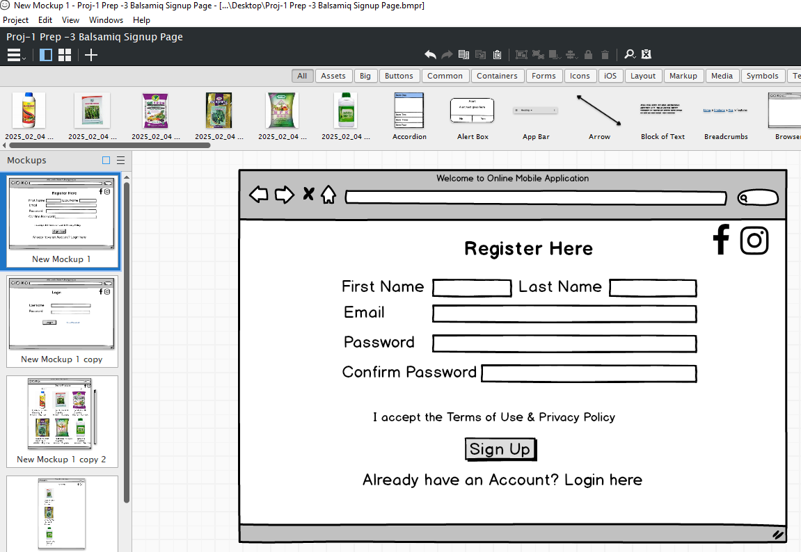

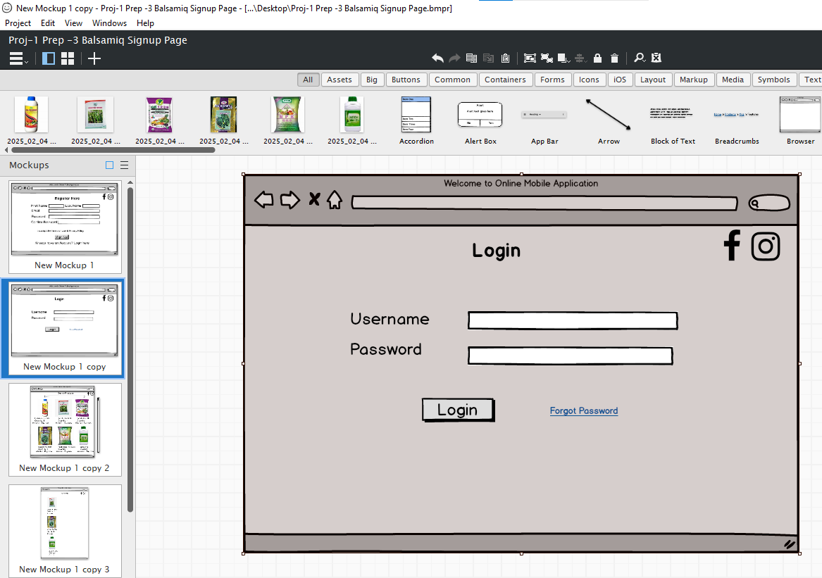

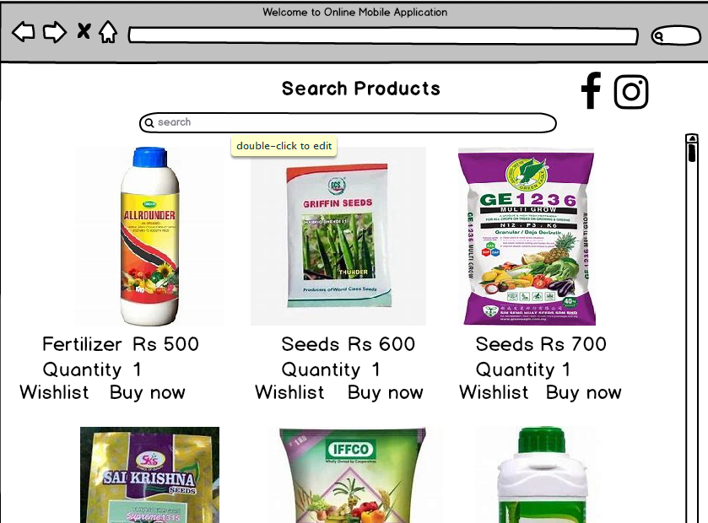

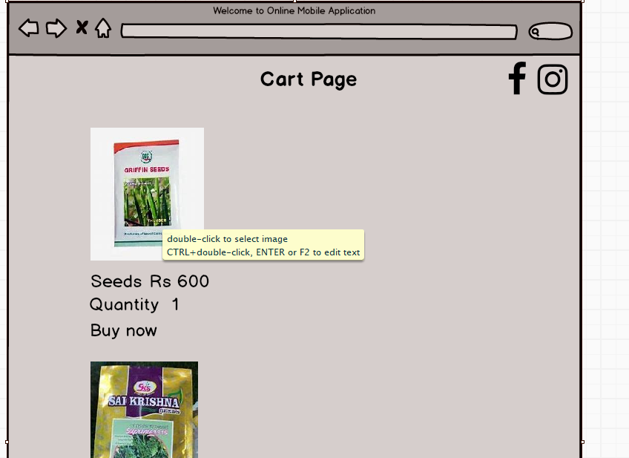

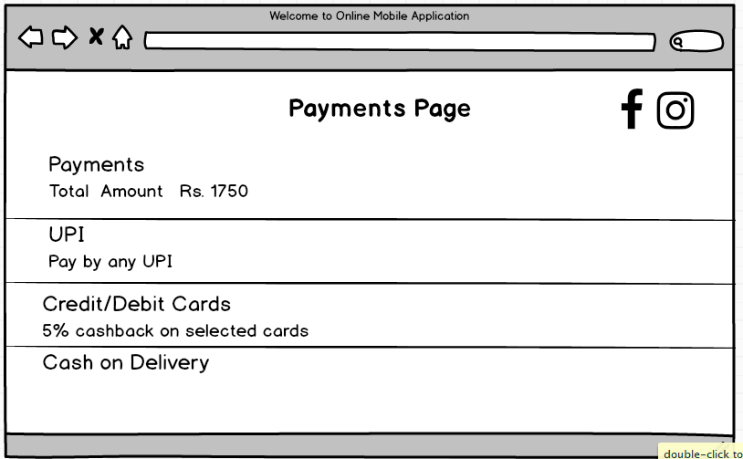

Prototypes:

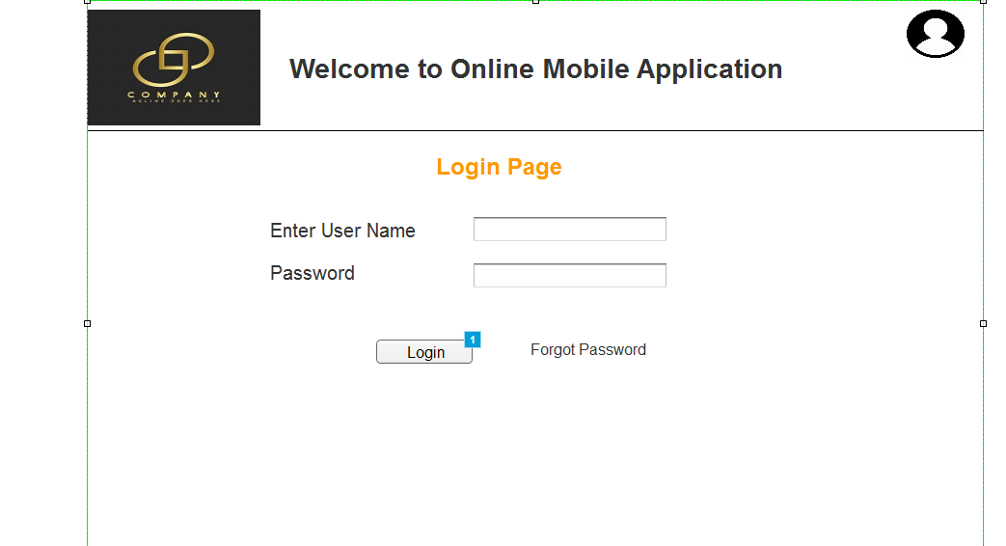

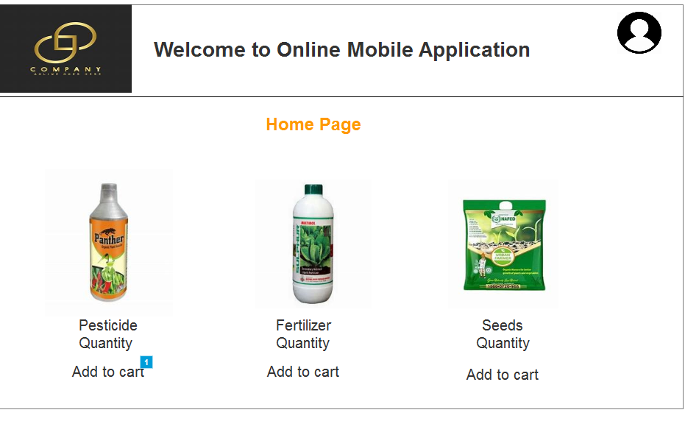

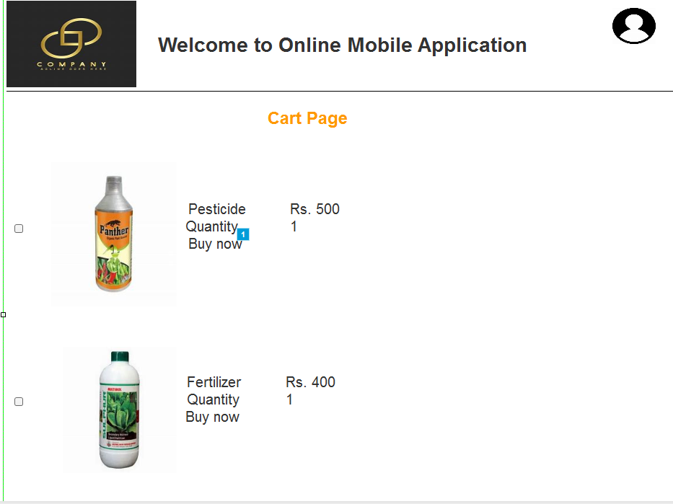

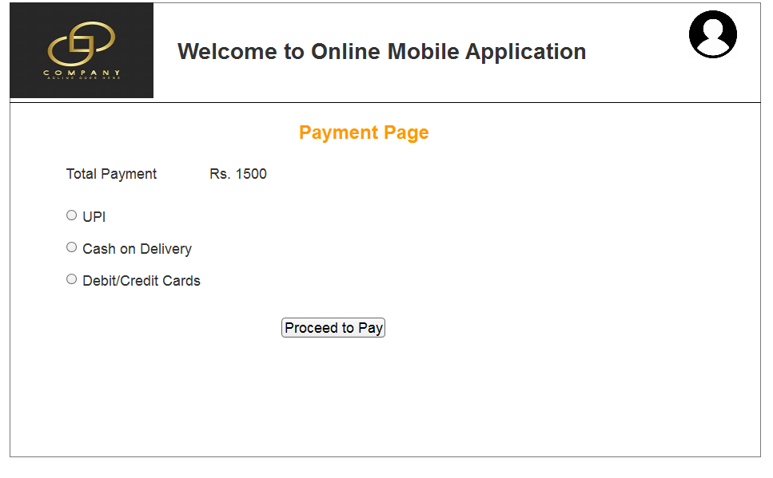

Question 3) Make a note of the Tools, which you are using for above concepts.

Answer) Microsoft Visio: It’s a diagramming and vector graphics application used to create diagrams, flowcharts and other visual representations of complex information. Used to draw Use Case Diagrams & Activity Diagrams.

Balsamiq: It’s a rapid wireframing tool used to create Mockups and Prototypes of User Interfaces.

Axure: It’s a more advanced Prototyping tool used to create high fidelity interactive wireframes and Prototypes for web and mobile applications.

Question 4) Prepare RTM

Answer) RTM is a document to track the requirements of the Project throughout the Project Lifecycle it ensures that all the requirements are met and none have been missed.

|  |  |  |  |  |  |  |  |  |  |
| --- | --- | --- | --- | --- | --- | --- | --- | --- | --- |
| **Req ID** | **Req Name** | **Req Description** | **Design** | **Code** | **Unit Testing** | **Component Testing** | **System testing** | **SIT** | **UAT** |
| **FR001** | User Registration | User should register themselves | C | C | C | C | C | C | C |
| **FR002** | Search Product | User should be able to search product | C | C | C | C | Incomplete | I | I |
| **FR003** | User request for detailed Products | User should be able to request for details of the Project | C | C | C | C | Incomplete | I | I |
| **FR004** | Add Products to Cart | User should be able to add the products to the cart | C | C | C | Complete | Incomplete | C | I |
| **FR005** | Buy the Product | User should be able to buy the Product. | C | C | C | Complete | Incomplete | I | I |

Question 5) Prepare Test Case Documents

Answer) Test case Document is a detailed outline used by the testers to ensure that a software application or a system is working as expected.

|  |  |  |  |  |  |
| --- | --- | --- | --- | --- | --- |
| **Test Case ID** | | TC001 | **Test Case Name** | | Farmer Registration |
| **Project ID** | | P001 | **Project Name** | | Online Agriculture Store |
| **PM ID** | | PM001 | **PM Name** | | Mr. Vandanam |
| **Test Strategy ID** | | TS001 | **Tester ID** | | T001 |
| **Test Plan ID** | | TP001 | **Tester Name** | | Mr. Jason |
| **Test Schedule ID** | | TS001 | **Date of Test** | | 08-Feb-2025 |
| **Scenario** | | Farmer Registration |  | |  |
| **Link to that page:** | | https://register.com |  | |  |
| **Input Data** | Set 1  Valid Email & Password | Set 2  Missing Password | Set 3  Invalid email format | Set 4  Duplicate email | Set 5  Weak Password |
| **Expected Behaviour** | Registration Successful |  |  |  |  |
| **Actual Behaviour** | User should be registered and should receive confirmation email |  |  |  |  |
| **Comments** | N/A |  |  |  |  |
| **Result (Pass/Fail)** | Pass |  |  |  |  |

|  |  |  |  |  |  |
| --- | --- | --- | --- | --- | --- |
| **Test Case ID** | | TC002 | **Test Case Name** | | Login with valid credentials |
| **Project ID** | | P001 | **Project Name** | | Online Agriculture Store |
| **PM ID** | | PM001 | **PM Name** | | Mr. Vandanam |
| **Test Strategy ID** | | TS001 | **Tester ID** | | T002 |
| **Test Plan ID** | | TP001 | **Tester Name** | | Ms. Alekhya |
| **Test Schedule ID** | | TS001 | **Date of Test** | | 08-Feb-2025 |
| **Scenario** | | Login |  | |  |
| **Link to that page:** | | https://login.com |  | |  |
| **Input Data** | Set 1 email password | Set 2 Valid Credentials | Set 3 Wrong password | Set 4 Unregistered Email | Set 5 Blank Fields |
| **Expected Behaviour** | User Should be logged in and redirected to dashboard |  |  |  |  |
| **Actual Behaviour** | Login failed with valid credentials |  |  |  |  |
| **Comments** | Bug found in authentication |  |  |  |  |
| **Result (Pass/Fail)** | Fail |  |  |  |  |

|  |  |  |  |  |  |
| --- | --- | --- | --- | --- | --- |
| **Test Case ID** | | TC003 | **Test Case Name** | | Product search functionality |
| **Project ID** | | P001 | **Project Name** | | Online Agriculture Store |
| **PM ID** | | PM001 | **PM Name** | | Mr. Vandanam |
| **Test Strategy ID** | | TS001 | **Tester ID** | | T003 |
| **Test Plan ID** | | TP001 | **Tester Name** | | Mr. Jason |
| **Test Schedule ID** | | TS001 | **Date of Test** | | 08-Feb-2025 |
| **Scenario** | | Product Search |  | |  |
| **Link to that page:** | | https://searchproducts.com |  | |  |
| **Input Data** | Set 1 Product name | Set 2 fertilizer A | Set 3 Seed X | Set 4 Pesticide Z | Set 5 Invalid product |
| **Expected Behaviour** | Relevant products should be displayed |  |  |  |  |
| **Actual Behaviour** | Works correctly for all products |  |  |  |  |
| **Comments** | N/A |  |  |  |  |
| **Result (Pass/Fail)** | Pass |  |  |  |  |

|  |  |  |  |  |  |
| --- | --- | --- | --- | --- | --- |
| **Test Case ID** | | TC004 | **Test Case Name** | | Add Products to cart |
| **Project ID** | | P001 | **Project Name** | | Online Agriculture Store |
| **PM ID** | | PM001 | **PM Name** | | Mr. Vandanam |
| **Test Strategy ID** | | TS001 | **Tester ID** | | T002 |
| **Test Plan ID** | | TP001 | **Tester Name** | | Ms. Alekhya |
| **Test Schedule ID** | | TS001 | **Date of Test** | | 08-Feb-2025 |
| **Scenario** | | Add to cart/Product Selection |  | |  |
| **Link to that page:** | | https://cart.com |  | |  |
| **Input Data** | Set 1 Select product A | Set 2  Select product B | Set 3  Select multiple Products | Set 4  Remove item from cart | Set 5  Empty cart |
| **Expected Behaviour** | Product should be added to cart Successfully |  |  |  |  |
| **Actual Behaviour** | Works fine |  |  |  |  |
| **Comments** | N/A |  |  |  |  |
| **Result (Pass/Fail)** | Pass |  |  |  |  |

|  |  |  |  |  |  |
| --- | --- | --- | --- | --- | --- |
| **Test Case ID** | | TC005 | **Test Case Name** | | Payment Processing |
| **Project ID** | | P001 | **Project Name** | | Online Agricultural Store |
| **PM ID** | | PM001 | **PM Name** | | Mr. Vandanam |
| **Test Strategy ID** | | TS001 | **Tester ID** | | T001 |
| **Test Plan ID** | | TP001 | **Tester Name** | | Mr. Jason |
| **Test Schedule ID** | | TS001 | **Date of Test** | | 08-Feb-2025 |
| **Scenario** | | Payment |  | |  |
| **Link to that page:** | | https://payments.com |  | |  |
| **Input Data** | Set 1  Payment details Credit Card | Set 2  Debit card | Set 3  UPI | Set 4  Cash on delivery | Set 5  Invalid Payment |
| **Expected Behaviour** | Payment should be processed succesfully |  |  |  |  |
| **Actual Behaviour** | Payment gateway issue observed |  |  |  |  |
| **Comments** | Needs investigation |  |  |  |  |
| **Result (Pass/Fail)** | Fail |  |  |  |  |

Question 6) Draw Database Schema and ER Diagram.

Answer) Database Schema: Database Schema is a blueprint that outlines the structure of the database including its tables, fields, relationships, constraints and other characteristics.

Entity Relationship Diagram: It is a visual representation of the relationships between entities and database. It depicts the entities (such as tables), attributes (properties or fields) and relationships between them.

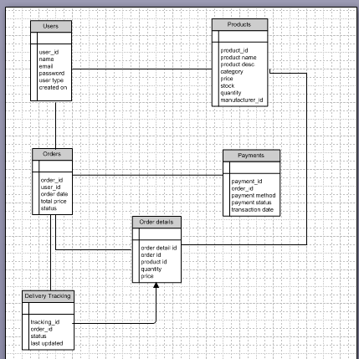

Question 7) What is a data flow diagram? Draw a data flow diagram to represent the in-flow and out-flow of data when a Farmer is placing an order for the product.

Answer) A Data Flow Diagram is a graphical representation of the flow of data within a system. It visually shows how data moves from one process to another, how its stored and where it ends up.

It helps Analysts and Designers to understand the flow of data within a system identify potential bottlenecks or inefficiencies and communicate system requirements to Stakeholders.

Update order status

Send order confirmation

Store Payment info

Confirm Payment

Save Cart details

Proceed to Payment

Select products

Send product details

Request Products Data

Search Products

Send confirmation message

Order Database

Payment Records

Products database

Farmer

Question 8) How should a BA handle Change requests?

Answer)

1. Initially, the BA documents the Change requests.
2. The BA will analyse the Change request is really a change or a defect from the previous need communications.
3. The Change manager or the Project Manager must provide an initial approval if the business Analyst needs to move further in analyzing the change requested.
4. When it comes to Change management whether or not to incorporate the changes, depends on yet another important factor which is for the BA as well as the PM to ensure whether the requested change is a complex one or just a minor change.
5. In case the change is complex, it will not only expand the scope of the Project drastically which in turn leads to increase the delivery time.
6. Business Analysts will help the Stakeholders to understand the impact, the change request will have on the organization and to help minimize negative impact that results from that particular change.
7. Successful change efforts necessitate the Business Analyst to articulate a realistic or convincing vision that appeals to both internal and external Stakeholders.

Question 9) As the project is in process, Ben and Kevin have contacted you. The reason is to inform you that they want the Farmers to sell their crop yields through this application i.e. Farmers should be able to add their crop yields or products and display to general public and should be able to sell them. They also want to introduce Auction system for their Crop yields. As a BA, what will be your response? Is this a change request or an enhancement???

Answer) In this case it would be considered as an Enhancement as it involves adding new features to the system.

As a BA I need to document the requirements and work with the development team to determine the feasibility and Impact of the new features we’re also supposed to consider the potential benefits, risks and costs associated with the enhancements before making any recommendations to the Client.

Question 10) Come up with estimations – How many Manhours required?

Answer) Man hours are the required effort of the resources to complete a Project. There are three types of Projects:

Small: Upto 500 hours, Medium: Upto 1000 hours, Large: Upto 1500 hours.

As per the case study the duration of the Project is 18 months and the current team size is around 15. This will come under Medium Project.

As the trained resources are already available, trainers are not required.

As the structure of the Project is available, new and enhanced infrastructure is not required.

Question 11) Explain UAT Acceptance process.

Answer) User Acceptance Testing (UAT) is the final phase of testing before the application is deployed. It ensures that the system meets business requirements and is ready for production.

Steps in UAT Acceptance Process:

1. Requirement Validation
   * Ensure all functional and non-functional requirements are documented and agreed upon.
   * Review the Change Request Document (CRD) if applicable.
2. UAT Planning
   * Define UAT scope, objectives, and entry/exit criteria.
   * Identify UAT testers (typically business users, stakeholders, or end-users).
   * Prepare a UAT environment (separate from development and testing environments).
3. Test Case Preparation
   * Create UAT test cases based on business scenarios.
   * Define test data, expected results, and acceptance criteria.
4. UAT Execution
   * Testers execute test cases and log defects.
   * Record actual results vs. expected results.
   * Defects are reported to the development team for resolution.
5. Defect Resolution & Retesting
   * Developers fix reported defects.
   * Testers retest the fixes to verify the resolution.
6. Final Sign-Off & Approval
   * If all critical defects are fixed, testers provide a UAT Sign-Off.
   * Business users approve the system for Go-Live.
7. Go-Live & Post-UAT Support
   * Deploy the system to production.
   * Provide post-UAT support for a smooth transition.

Question 12) Explain Project closure document

Answer) A Project Closure Document also known as the project Closure Report is a formal document that summarizes the key outcomes, lessons learned and final details of a completed Project.

It Serves as a comprehensive record of the Project’s accomplishments, Challenges and overall performance providing valuable insights for stakeholders and future projects.

Points to be included in the Project Closure document are:

Project Overview Risk Management

Achievements Challenges

Lessons Learned Resources Utilization

Quality Assurance