# Waterfall Deliverables – Part -1/2

**Document 1-** Business case document template

➢ Why is this project initiated?

*This project is initiated to automate and integrate the processing of TruTime (no. of hours worked in a project, break time etc.) capturing accurate Login & logout for WFH (Work from Home) and Hybrid working professionals, updating leave requests thru automated portal and submit the timesheet by aligning all the data (by auto capturing the TruTime and leave time of employees). This will later integrate with HR systems immediately with zero or minuscule error and updates the employee database instantly. This helps in timely release of salary and improve employee satisfaction.*

➢ What are the current problems?

*Manual process of collating the TruTime by POCs (Project Manager), Requesting for leave thru email and submitting timesheet in excel is time consuming with multiple emails trails & discussions which leads to multiple errors in data capture. We also have multiple POCs involvement leading to delay in aligning the data as well. This impacts the employee satisfaction and high probabilities of missing project timelines.*

➢ With this project how many problems could be solved?

*With this project, we have planned to automate end to end process of TruTime submission, requesting leave and timesheet submission with ease of use (user friendly GUI) portals/applications and operate operations with error free transaction with system integration across organization. This also ensues the privacy of all the employees with robust system design and security adhering to all the privacy policy.*

➢ What are the resources required?

*To successfully complete this project, a well-coordinated team consisting of both client community members and IT Services professionals. We would need a team of 10-12 members with specific proficiency in respective system development like below:*

|  |  |
| --- | --- |
| **Client Members** | **IT Services Members** |
| Project Sponsor | Project Manager |
| Subject Matter Experts (SMEs) | Business Analyst |
| End Users (PMOs and Associates) | Software Developers (2-3 FTEs) |
|  | Quality Assurance (QA) Engineers (1-2 FTEs) |
|  | UI/UX Designer (1 FTE) |
|  | System Administrator/DevOps Engineer (1 FTE) |
|  | Training and Support Specialist (1 FTE) |

➢ How much organizational change is required to adopt this technology?

*There will be a very minimal Organization change to adept this technology as it is already a technology driven company, all of our employees will be proficient enough to adopt this change and be more welcoming.*

➢ Time frame to recover ROI?

*We have fixed the project timeline for completion by 11 – 12 months, post this we will implement the new portal to the entire organization. This would take a minimum of 1 to 2 years for ROI after implementation.*

➢ How to identify Stakeholders?

*We will identify the stakeholders with RACI matrix.*

**Document 2:** BA Strategy

As a business analyst, we would take certain steps as part of the strategy approach to achieve the goal for this project. To achieve that, below ones to be followed diligently without any deviation.

1. **Elicitation Technique:**

We in this project will follow brainstorming technique. We will schedule a formal meeting with the key responsible stakeholders with employees of the organisation like Project Manager for the to understand the flow of approval and exception handling, few tenured employees to get the ease of use and user-friendly UI and HR group to understand the system integration and data flow and generate the idea based on each category for automation. We will document all the points discussed and later, we shall rephrase the ideas as requirement from top priority to the least and eliminate duplicate or non-value-added idea.

1. **Stakeholder Analysis:**

The stakeholder analysis with RACI matrix is here. Identifying key members for the projects and their POC details as below:

|  |  |  |  |  |  |  |  |
| --- | --- | --- | --- | --- | --- | --- | --- |
| **RACI MATRIX** | **Client** | **Project Manager** | **BA** | **Developers** | **UI/UX Designers** | **Testers** | **System Admin** |
| **Requirement Gathering & Analysis** | C | A | R | I | I | I | I |
| **Design** | I | A | R | C | R | I | C |
| **Coding** | I | C | I | R | A | I | C |
| **Testing** | I | A | C | C | I | R | I |
| **UAT** | A | C | R | C | I | I | I |
| **Deployment** | I | A | C | R | R | R | I |

All member prefer email for any updates/clarification except in urgent situation. Only PM and BA allowed to call the stakeholders directly.

|  |  |  |  |
| --- | --- | --- | --- |
|  | **Name** | **Contact No.** | **Email** |
| Client | ABC | 12343 | [ABC@ABC.com](mailto:ABC@ABC.com) |
| Project Manager | XXX | 128678 | [XXX@Cognizant.com](mailto:XXX@Cognizant.com) |
| BA | Arihant | 9884014825 | Arihant@cognizant.com |
| Developers | XXY | 563734314 | XXY@cognizant.com |
| UI/UX Designers | XYX & YXY | 132459843 & 232352566 | XYX@cognizant.com & YXY@cognizant.com |
| Testers | XXYY | 3234635254 | XXYY@cognizant.com |
| System Admin | XYXY & XXXY | 23446456 & 2323452352 | XYXY@Cognizant.com & XXXY@cognizant.com |

1. **Documents to Write:**

We have few documents to write in regards to this project. Some of them are BRD, SRD, FRD/FRS, SRS, use case, test case documents etc. each have their own specifics as per the requirement is defined.

1. **Process to follow to Sign off on the Documents:**

Once the documents are ready and reviewed by all the internal team including PM, BA and delivery lead, we can fix the call with the client on requirement document and specification document. We will discuss the document in detail with them and seek if they have any clarification. If no questions asked, then delivery lead or BA will formally send email with the MOM to the client and take his concurrence. If questions raised by the client, we will try to clarify with answers on the same call or work on the answers and reschedule the meeting for sign off.

1. **How to take Approvals from the Client**

For Client sign off - Client prefers the signoff via email and only from 1 POC which would be BA/PM, and can call him if no response received in 24 hours. So, any sign off on the documents will be generated at first, schedule meeting to discuss in detail about the documents and finalise it. This will be sent to client email and wait for the approval. In case of no response within 24 hours, BA will call the client seeking approval.

For internal sign off – Project Manager can review any internal matters and send it to delivery lead for review or if low in priority, PM can itself approve. We can fix the meeting involving the corresponding stakeholders specific to that document and discuss with the lead on sign off.

1. **Communication channel:**

We will establish 2 common communication channels

1. *Internal communication*

Any internal meeting, brainstorming or KT, review meeting, weekly call, process update or anything related to the project, we can block the meeting room at a specific location where we have majority of the project headcount and discuss face to face constructively. Write down the action pointers and notes updates for the next meet.

1. *Client or external communication*
   1. *For monthly update*

we can fix the meeting with the client online and communicate the status on the project and discuss on the future plan and the timelines on the project.

* 1. *For formalizing the client about the status of the project if client requested in office meeting*

PM and the BA (if required we will add members as per the circumstance) will visit the client office and update the status along with meet and greet.

1. **Handling Change Request:**

At any point in time, when client is requesting for any change in the process flow. This has to be documented in CR Tracker with the date, no. of CRs, Type of CR and detailed description as below. We will study the CR and analyse the risk and other findings and fix the meeting with the stake holders for sign off confirmation from client as well as PM.

|  |  |  |  |  |  |  |  |
| --- | --- | --- | --- | --- | --- | --- | --- |
| **Date** | **CR No.** | **CR Type** | **Detailed Description** | **Expected Closure date** | **Priority** | **Client Signoff** | **PM signoff** |
|  |  |  |  |  |  |  |  |

1. **Updating progress of the project to client:**

We must maintain the transparency throughout the project with the client and ensure their satisfaction is met in all the terms. To keep updated on the project status, we will follow RTM (Requirement Traceability Matrix) sheet/chart throughout and update the client monthly on its status. We will send a clear sheet to the client via email and update the status and if client requires any meeting for understanding the progress, we will do so otherwise not required We internally can have this RTM call weekly or bi weekly.

1. **Sign off on UAT:**

Once all our testing phase of the project is completed with 100% accuracy. We will formally request the client for UAT. We will prepare the UAT documents and request the client to perform the UAT. Some of our designer, testers and other team would be available at that point in time for any clarification from client user end. We need to sort out things at the same time. In case of any CRs raised, we will follow CR procedure.

Once client has successfully completed UAT, we will formalize a meeting in person and have a final review meeting and take signoff from the client by filling the UAT form.

**Document 3**- Functional Specifications

|  |  |
| --- | --- |
| Project Name | OneCognizant (1C) |
| Customer Name | Cognizant India Pvt LTD. |
| Project Version | 1.0 |
| Project sponsor | Cognizant Application Development Group |
| Project Manager | Mr. Vijay Kumar |
| Project Initiation Date | 03-01-2025 |

**Functional Requirement specifications:**

1. TruTime Capturing

|  |  |  |  |
| --- | --- | --- | --- |
| **Req ID** | **Requirement Name** | **Requirement Description** | **Priority** |
| FR001 | Portal Login | All User of the company must be able to login the 1C Application | 1 |
| FR002 | TruTime Login | User to click the Login Button whenever he/she is logging in | 2 |
| FR003 | TruTime Break Checkin | User will click in the break time/lunch time button accordingly as per the requirement | 3 |
| FR004 | TruTime Break Checkout | User will click out the break time/lunch time button accordingly as per the requirement after completing the break/lunch | 3 |
| FR005 | TruTime Logout | User to click the Logout Button whenever he/she is logging out | 2 |

1. Applying Leave

|  |  |  |  |
| --- | --- | --- | --- |
| **Req ID** | **Requirement Name** | **Requirement Description** | **Priority** |
| FR006 | Apply Leave Screen | User to click on Leave Request Button enabled at the top of the page | 1 |
| FR007 | Leave Submission Page | User will select the date planned for leave (from date and to Date) | 2 |
| FR007.1 | Half Day Leave Submission Checkin box | If user is planning for half day leave, then radio button to be clicked for half day leave update | 2 |
| FR008 | Leave confirmation page | User will get pop up screen to confirm the leave applied, user must click Confirm/Cancel button after the message is read | 3 |

1. Timesheet submission

|  |  |  |  |
| --- | --- | --- | --- |
| **Req ID** | **Req Name** | **Req Description** | **Priority** |
| FR009 | Timesheet page creation | User will Click on Timesheet option from the header of the application | 1 |
| FR010 | Choose from dropdown on Project info | User should choose the project he/she currently working and select the appropriate name from the project Name dropdown | 2 |
| FR011 | Billability Selection | User must select the billable type (whether he will be billed or working as NBL (buffer resource of the project)) | 3 |
| FR012 | Working Hours Update in the Date Box | User will update the no. of hours worked each day under date box and should not exceed more than 9 hours | 4 |
| FR013 | Submit Filled timesheet | User can finally submit the timesheet filled | 5 |
| FR014 | Timesheet update confirmation | User will look at the timesheet confirmation popup and click proceed to submit / cancel for corrections | 6 |
| FR015 | Corrections in Timesheet | If user cancels the timesheet for correction, then the process repeats from the FR010 | 7 |

**Document 4** - Requirement Traceability Matrix

|  |  |  |  |  |  |  |  |  |  |  |  |
| --- | --- | --- | --- | --- | --- | --- | --- | --- | --- | --- | --- |
| **Req ID** | **Requirement Name** | **Requirement Description** | **Priority** | **Design** | **Development 1** | **Testing 1** | **Development 2** | **Testing 2** | **Delivery lead sign off** | **UAT** | **Client Signoff** |
| FR001 | Portal Login | All User of the company must be able to login the 1C Application | 1 | Complete | Complete | Complete | Complete | Complete | Complete | Complete | Pending |
| FR002 | TruTime Login | User to click the Login Button whenever he/she is logging in | 2 | Complete | Complete | Complete | Complete | Complete | Pending | Not Started | Not Started |
| FR003 | TruTime Break Checkin | User will click in the break time/lunch time button accordingly as per the requirement | 3 | Complete | Complete | Complete | Complete | Started | Not Started | Not Started | Not Started |
| FR004 | TruTime Break Checkout | User will click out the break time/lunch time button accordingly as per the requirement after completing the break/lunch | 3 | Complete | Complete | Complete | Complete | Started | Not Started | Not Started | Not Started |
| FR005 | TruTime Logout | User to click the Logout Button whenever he/she is logging out | 2 | Complete | Complete | Complete | Complete | Complete | Pending | Not Started | Not Started |
|  |  |  |  |  |  |  |  |  |  |  |  |
| FR006 | Apply Leave Screen | User to click on Leave Request Button enabled at the top of the page | 1 | Complete | Complete | Complete | Complete | Complete | Complete | Pending | Not Started |
| FR007 | Leave Submission Page | User will select the date planned for leave (from date and to Date) | 2 | Complete | Complete | Complete | Complete | Complete | Pending | Not Started | Not Started |
| FR007.1 | Half Day Leave Submission Checkin box | If user is planning for half day leave, then radio button to be clicked for half day leave update | 2 | Complete | Complete | Complete | Complete | Complete | Pending | Not Started | Not Started |
| FR008 | Leave confirmation page | User will get pop up screen to confirm the leave applied, user must click Confirm/Cancel button after the message is read | 3 | Complete | Complete | Started | Started | Not Started | Not Started | Not Started | Not Started |
| FR009 | Timesheet page creation | User will Click on Timesheet option from the header of the application | 1 | Complete | Complete | Complete | Complete | Complete | Complete | Complete | Complete |
| FR010 | Choose from dropdown on Project info | User should choose the project he/she currently working and select the appropriate name from the project Name dropdown | 2 | Complete | Complete | Complete | Complete | Complete | Complete | Complete | Complete |
| FR011 | Billability Selection | User must select the billable type (whether he will be billed or working as NBL (buffer resource of the project)) | 2 | Complete | Complete | Complete | Started | Complete | Complete | Complete | Complete |
| FR012 | Working Hours Update in the Date Box | User will update the no. of hours worked each day under date box and should not exceed more than 9 hours | 2 | Complete | Complete | Complete | Complete | Started | Not Started | Not Started | Not Started |
| FR013 | Submit Filled timesheet | User can finally submit the timesheet filled | 2 | Complete | Complete | Complete | Complete | Pending | Not Started | Not Started | Not Started |
| FR014 | Timesheet update confirmation | User will look at the timesheet confirmation popup and click proceed to submit / cancel for corrections | 3 | Complete | Complete | Started | Started | Not Started | Not Started | Not Started | Not Started |
| FR015 | Corrections in Timesheet | If user cancels the timesheet for correction, then the process repeats from the FR010 | 3 | Complete | Complete | Started | Started | Not Started | Not Started | Not Started | Not Started |

**Legends:**

Complete – The Task is fully completed

Started – the task is under construction stage

Pending – Pending approval/signoff

Not started – work is not yet started

**Document 5** - BRD Template

# **One Cognizant**

# **100005346**

# **V 1.1**

# **Arihant Jamed**

**Table of Contents:**

|  |  |  |
| --- | --- | --- |
| **Topic** | **Name** | **Page Number** |
| 1 | Document Revision | 7 |
| 2 | Approvals | 7 |
| 3 | RACI Chart for This Document | 7 |
| 4 | Introduction | 8 |
|  | 4.1. Business Goals | 8 |
|  | 4.2. Business Objectives | 8 |
|  | 4.3. Business Rules | 8 |
|  | 4.4. Background | 9 |
|  | 4.5. Project Objective | 10 |
|  | 4.6. Project Scope | 10 |
|  | 4.6.1. In Scope Functionality | 10 |
|  | 4.6.2. Out Scope Functionality | 11 |
| 5 | Assumption | 11 |
| 6 | Constraints | 11 |
| 7 | Risks | 12 |
|  | 7.1. Technological Risk | 12 |
|  | 7.2. Skill Risks | 13 |
|  | 7.3. Political Risks | 13 |
|  | 7.4. Business Risks | 14 |
|  | 7.5. Requirements Risks | 14 |
|  | 7.6. Other Risks | 15 |
| 8 | Business Process Overview | 15 |
|  | 8.1. Legacy System (AS-IS) | 15 |
|  | 8.2. Proposed Recommendations (TO-BE) | 17 |
| 9 | Business Requirements | 18 |
| 10 | Appendices | 21 |
|  | 10.1. List of Acronyms | 21 |
|  | 10.2. Glossary of Terms | 21 |
|  | 10.3. Related document | 21 |

# **Document Revision:**

|  |  |  |
| --- | --- | --- |
| **Date** | **Version** | **Document Changes** |
| 01-03-2025 | 1.0 | Initial Draft |
| 01-04-2025 | 1.1 | Draft modification on privacy policy |
| 12-01-2025 | 2.0 | Draft Completed for client review |
| 19-01-2025 | 2.1 | Changes on Conditional values |
| 03-02-2025 | 2.2 | Minor demographical changes |
| 19-02-2025 | 2.3 | Security Updates |
| 03-01-2025 | 3.0 | Final Draft |

# **Approvals:**

|  |  |  |  |  |
| --- | --- | --- | --- | --- |
| **Role** | **Name** | **Title** | **Signature** | **Date** |
| Project Sponsor | Rajesh Khanna | AVP | Signed | 03-02-2025 |
| Business Owner | Sailaja Josyula | SD | Signed | 03-02-2025 |
| Project Manager | Ravi Kumar | AD | Signed | 03-01-2025 |
| System Architect | Anand Joshi | M | Signed | 28-02-2025 |
| Development Lead | Mathew Jose | SM | Signed | 28-02-2025 |
| User Experience Lead | Mahalakshmi | SA | Signed | 28-02-2025 |
| Quality Lead | Mohd Ibrahim | SA | Signed | 27-02-2025 |
| Content Lead | Savitha Kumari | M | Signed | 27-02-2025 |

# **RACI Chart for This Document:**

|  |  |  |  |  |  |  |
| --- | --- | --- | --- | --- | --- | --- |
| **Name** | **Position** | **\*** | **R** | **A** | **C** | **I** |
| Arihant Jamed | Business Analyst | Signing authority | Yes | Yes |  |  |
| Rajesh Khanna | Project Sponsor | Signing authority |  | Yes |  |  |
| Sailaja Josyula | Business Owner | Signing authority | Yes | Yes |  |  |
| Ravi Kumar | Project Manager |  |  |  | Yes |  |
| Anand Joshi | System Architect |  |  |  | Yes |  |
| Mathew Jose | Development Lead |  |  |  | Yes |  |
| Mahalakshmi | User Experience Lead |  |  |  |  | Yes |
| Mohd Ibrahim | Quality Lead |  |  |  |  | Yes |
| Savitha Kumari | Content Lead |  |  |  |  | Yes |

# **Introduction:**

# **4.1. Business Goals:**

Ability to update TruTime, submit Leave request and submit timesheet online in a web application across the organization and eradicate the manual processes. This will increase employee satisfaction and reduce manual hours of PMOs and HR. This web application will integrate with HR management system for faster processing of salaries.

# **4.2. Business Objectives:**

We will provide an IT solution with easy usage of web application, Mobile apps for Android and iOS. This will ultimately reach the goals of the business and improve satisfaction among employees. We will develop all in one application,

1. Web application enabled with login and logout. Along with the organizational lunch break policy. This will capture the accurate date and time of employees working from home/hybrid. We will also develop mobile application once the web application is deployed in production.
2. The same web application will have a leave request tab where associate can apply their leaves accordingly.
3. Submitting timesheet within the same application choosing the project and its corresponding time employee has worked on.
4. All these functionalities will integrate real time updates to the HR management system. This will be superfast like a lightning speed.
5. We will also provide FAQs on the web application navigation for any clarification in real time use.

# **4.3. Business Rules:**

**Organization Policies**

1. **Code of Conduct:** Guidelines on ethical behaviour, professionalism, conflicts of interest, and respect for colleagues and clients.
2. **Equal Employment Opportunity:** Prohibits discrimination based on race, gender, age, religion, disability, or other protected characteristics.
3. **Attendance and Punctuality:** Policies on clock-in/clock-out procedures, reporting absences, and consequences for tardiness or absenteeism.
4. **Information Technology (IT) and Data Security:** Guidelines on the use of company computers, internet, and email, password policies, data protection measures, and reporting of security incidents.
5. **Remote Work:** Expectations for remote work, communication procedures, use of technology, and accountability measures.
6. **Grievance and Disciplinary Procedures:** Steps for filing a grievance, investigation procedures, and disciplinary measures for policy violations.

**Procedures**

1. Identifying the need
2. Drafting the policy
3. Review and approve
4. Communication and training
5. Implementation
6. Evaluation & Revision

**Rules& Regulations**

1. **Workplace Conduct:** Employees must treat colleagues, clients, and partners with respect and professionalism at all times.
2. **Dress Code:** Adhere to the organization’s dress code, which may vary based on the role and department.
3. **Harassment Policy:** Zero tolerance for any form of harassment, bullying, or discrimination.
4. **Conflict of Interest:** Disclose any potential conflicts of interest and avoid situations that could compromise impartiality.
5. **Attendance and Time Management:** Employees are expected to arrive on time and adhere to their scheduled working hours.
6. **Leave Requests:** Follow the established procedure for requesting leave and provide adequate notice.
7. **Breaks:** Take breaks as specified by the organization, ensuring minimal disruption to work.
8. **Health and Safety:** Follow all safety guidelines and protocols to ensure a safe working environment.
9. **Incident Reporting:** Report any accidents, injuries, or unsafe conditions immediately.
10. **Emergency Procedures:** Be familiar with and follow emergency evacuation procedures.
11. **Use of Company Resources:** Use company equipment and resources responsibly and for work-related purposes only.
12. **Internet and Email:** Adhere to the organization’s internet and email usage policy, avoiding inappropriate or unauthorized use.
13. **Confidential Information:** Protect sensitive and confidential information from unauthorized access or disclosure.
14. **Compliance and Ethics:** Comply with all applicable laws and regulations relevant to the organization’s operations.
15. **Ethical Behaviours:** Conduct business with integrity, honesty, and in accordance with ethical standards.
16. **Reporting Violations:** Report any violations of policies, rules, or regulations through the appropriate channels.

# **4.4. Background:**

The Organization employs manual process of updating TruTime (login and logout of associates WFH/Hybrid), applying for leave and filling the timesheets week on week in MS excel. These are controlled by existing PMOs as part of their additional roles and responsibility of their own projects.

***Current Scenario:***

* PMO manually collates the TruTime information of all employees working from home/hybrid which includes their login and logout time including their project spent time and break time.
* Employees update their leave request to respective PMOs thru email and PMO manually track these leave requests in excel
* PMO send out excel sheet in share path that all employees update their timesheets accordingly every week and ensure that their leaves and their login logout time align properly
* HR will verify all these details and approve / reject incase of any errors.

***Impact:***

* **Time Wastage –** PMOs take significant amount of time to update all the information in excel as it depends on employee's responses and post which they verify each data manually.
* **Error –** increased risks of human error in data entry and calculations which may lead to discrepancies
* **Delays –** processing leave requests, TruTime or Timesheets manually can be slow which can affect employees and project timelines.

***Root Cause:***

* Lack of automation and integration of internal systems
* Dependence on manual data and communication over email
* Limited visibility and real time tracking of TruTime, Leaves and timesheets update

***Opportunities Identified:***

* **Automation –** Implementation of automation systems for TruTime Tracking, Applying Leave and Submitting Timesheets
* **Integration –** Integrating the system with existing HR with project management system for seamless data flow
* **Real Time Tracking –** enhancing real-time visibility and tracking of data and its updates

# **4.5. Project Objective:**

The overall goal is to Eliminate manual data entry and reduce the processing time spent by 80-90% thru end to end automation which minimise the errors by less than 1% and streamline the approval process for increased employee satisfaction. Enhance operation efficiency and lower the Burden of PMOs with accurate and timely data.

The web application enables the client requirement into automated process along with the system integration adhering to their privacy and other policies which will align to their needs with seamless operations.

# **4.6. Project Scope:**

This scope is to develop a simple ease of use web application for employees in the organization to punch in Login/Logout time, Apply leave and submit timesheets.

# **4.6.1. In Scope Functionality:**

* All User of the company must be able to login the 1C Application
* User to click the Login Button whenever he/she is logging in
* User will click in the break time/lunch time button accordingly as per the requirement
* User will click out the break time/lunch time button accordingly as per the requirement after completing the break/lunch
* User to click the logout Button whenever he/she is logging out
* User to click on Leave Request Button enabled at the top of the page
* User will select the date planned for leave (from date and to Date)
* If user is planning for half day leave, then radio button to be clicked for half day leave update
* User will get pop up screen to confirm the leave applied, user must click Confirm/Cancel button after the message is read
* User will Click on Timesheet option from the header of the application
* User should choose the project he/she currently working and select the appropriate name from the project Name dropdown
* User must select the billable type (whether he will be billed or working as NBL (buffer resource of the project))
* User will update the no. of hours worked each day under date box and should not exceed more than 9 hours
* User can finally submit the timesheet filled
* User will look at the timesheet confirmation popup and click proceed to submit / cancel for corrections
* If user cancels the timesheet for correction, then the process repeats from the Click on Timesheet step

# **4.6.2. Out Scope Functionality:**

* Must be existing Employee, new Employee ID cannot be generated
* Employees working from office for all days have automated punch in / punch out time.
* Cannot past date/time for Non-Adherence of Login Logout
* Missing of check-in/check-out of Break or lunch time will not recapture the actual time taken
* Any incorrect leave cannot be recalled. This will be part of future sprints
* Non-Adherence will lead to compliance as per HR policy
* Cannot exceed more than 9 hours per day. Incorrect hour capture will not undo after submission in the current sprint
* Autofill of previous data will be in next sprint not available currently.

# **5. Assumption:**

* Valid Employee ID and Password as SSO login to the portal
* Employee must visit the application to update their login logout time daily without fail
* Employees take breaks as per allowable policy in the organization
* Employee submit leave request as per their leave availability
* Employee submit leave request at least 1 week before it is planned
* Employee aware of choosing the correct Projects while submitting the timesheets
* Employee is aware on billability and roles in the project they submit
* All the time captured in the local time zone

# **6. Constraints:**

* **Resource Constraints** - Conflicts in resource allocation due to multiple projects or competing priorities
* **Stakeholder Constraints** - Ensuring consistent and effective communication and engagement with all stakeholders
* **Technological Constraints** - Keeping up with rapidly changing technology and implementing new solutions
* **Regulatory Constraints** - Meeting industry-specific regulations, standards, and legal requirements
* **Cultural Constraints** - Aligning the project with the organization's culture and values
* **Geographical Constraints** - Coordinating project activities across different time zones
* **Financial Constraints** - Dealing with cost fluctuations for materials, labour, and other expenses

# **7. Risks:**

We may have risk factor while the project progress and we need to ensure that these risks are identified early and action them accordingly. Some of the risks that could slow down the timelines are:

# **7.1. Technological Risk:**

Technological risks are challenges and potential threats associated with the use of technology in projects or operations.

**Risk:**

* Technology becomes outdated or incompatible with new systems
* Difficulties in integrating new technology with existing systems
* Hardware/Software failures
* Data breaches, cyberattacks, and unauthorized access
* Technology not performing as expected, leading to inefficiencies.
* Losing critical data due to system failures or errors

**Avoid:**

* Regularly update and upgrade technology to stay current
* Choose technology that is compatible with existing systems
* Choose reliable and well-supported technology solutions
* Conduct thorough research and performance testing before adoption
* Implement robust data backup and recovery solutions

**Mitigate:**

* Adopt flexible and scalable solutions that can adapt to future changes
* Conduct thorough testing and pilot programs before full implementation
* Regularly update security protocols, conduct audits, and provide employee training
* Implement redundancy and failover mechanisms, and perform regular maintenance
* Monitor performance continuously and address issues promptly
* Regularly test backup and recovery processes to ensure effectiveness

**Transfer:**

* Outsource technology management to vendors who stay updated with the latest advancements
* Engage third-party experts to manage integration tasks
* Obtain cyber insurance to cover potential losses from security breaches
* Use managed services or cloud providers with robust uptime guarantees
* Use service-level agreements (SLAs) with vendors to ensure performance standards
* Use cloud storage solutions with built-in redundancy and data protection

**Accept:**

* Plan for periodic reviews and updates, acknowledging that some degree of obsolescence is inevitable
* Develop contingency plans for potential integration challenges
* Prepare an incident response plan to address security incidents promptly
* Maintain a disaster recovery plan to minimize downtime and data loss
* Develop performance improvement plans and address issues as they arise
* Establish data retention policies and ensure critical data is backed up frequently

# **7.2. Skill Risks:**

Skill risks refer to the potential challenges and threats associated with the skills and expertise needed to complete a project successfully. These risks can impact the project's timeline, quality, and overall success. Here are some common skill risks and strategies to address them:

* **Skill Gaps:** Lack of necessary skills or expertise within the project team
* **Turnover:** Loss of key personnel with critical skills
* **Training Needs:** Insufficient training for team members to perform their tasks effectively
* **Dependency on Key Personnel:** Over-reliance on a few individuals with specialized skills
* **Evolving Technology:** Rapid changes in technology that require new skills and knowledge
* **Performance Variability:** Inconsistent performance levels among team members

**Avoid:** Conduct thorough skills assessment during the project planning phase to identify any skill gaps and ensure the team has the necessary expertise

**Mitigate:** Provide ongoing training and professional development opportunities to ensure team members have the skills required for the project

**Transfer:** Outsource specific tasks or functions that require specialized skills to external experts or consultants

**Accept:** Acknowledge that some level of performance variability is inevitable and plan for it by setting realistic performance expectations and providing additional support where needed

# **7.3. Political Risks:**

Political risks refer to potential challenges and threats arising from political decisions, events, or conditions that can impact an organization's operations, profitability, and strategic goals

* **Regulatory Changes:** New laws, regulations, or policies that may affect business operations.
* **Political Instability:** Unrest, conflict, or changes in government that can disrupt business activities.
* **Expropriation:** Government takeover or seizure of private assets and property.
* **Trade Restrictions:** Tariffs, import/export controls, and trade barriers that impact global operations.
* **Corruption:** Unethical practices, bribery, and corruption within political and governmental institutions.
* **Taxation Changes:** Changes in tax laws or rates that affect financial planning and profitability.
* **Sanctions:** Economic or political sanctions imposed on specific countries or entities.
* **Policy Uncertainty:** Unpredictable policy decisions that create uncertainty for businesses.

**Avoid:** Refrain from entering markets with high political instability or significant regulatory challenges.

**Mitigate:** Monitor political developments and engage in active lobbying or advocacy to influence policy decisions.

**Transfer:** Obtain political risk insurance to cover potential losses from expropriation or government seizure.

**Accept:** Acknowledge that some level of policy uncertainty is inherent in international operations and develop flexible strategies to adapt to changing conditions.

# **7.4. Business Risks:**

Business risks are uncertainties or potential threats that can negatively impact an organization's operations, profitability, and strategic goals. Here are some common business risks and strategies to address them:

* **Market Risk:** Changes in market conditions, competition, and customer preferences.
* **Operational Risk:** Internal processes, systems, or events that disrupt business operations.
* **Financial Risk:** Risks related to financial management, such as liquidity, credit, and interest rate risks.
* **Strategic Risk:** Risks associated with long-term strategic decisions and planning.
* **Compliance Risk:** Non-compliance with laws, regulations, and industry standards.
* **Reputation Risk:** Damage to the organization's reputation due to negative events or publicity.
* **Technological Risk:** Rapid changes in technology and potential technological failures.
* **Supply Chain Risk:** Disruptions in the supply chain that affect production and delivery.
* **Human Resource Risk:** Challenges related to employee recruitment, retention, and performance.
* **Environmental Risk:** Environmental factors that can impact the business, such as natural disasters and climate change.

**Avoid:** Refrain from entering markets with high volatility or significant regulatory challenges.

**Mitigate:** Implement robust business continuity and disaster recovery plans to minimize the impact of disruptions.

**Transfer:** Obtain insurance coverage for property damage, business interruption, and other potential losses.

**Accept:** Acknowledge that market fluctuations are inherent to business operations and develop flexible strategies to adapt.

# **7.5. Requirements Risks:**

Requirement risks are potential issues and uncertainties associated with gathering, defining, and managing project requirements. These risks can lead to project delays, cost overruns, and failure to meet stakeholder expectations.

* **Incomplete Requirements:** Critical requirements are missed or not fully defined.
* **Changing Requirements:** Requirements change frequently during the project lifecycle.
* **Ambiguous Requirements:** Requirements are unclear or open to interpretation.
* **Unprioritized Requirements:** Lack of clear prioritization of requirements leads to confusion and delays.
* **Unvalidated Requirements:** Requirements are not validated with stakeholders, leading to incorrect assumptions.
* **Scope Creep:** Uncontrolled changes or additions to the project scope.
* **Stakeholder Misalignment:** Misalignment between stakeholders on project requirements.

**Avoid:** Conduct thorough requirements gathering sessions with all relevant stakeholders to ensure completeness.

**Mitigate:** Implement a formal change control process to manage and approve changes to requirements.

**Mitigate:** Conduct regular reviews and validation sessions with stakeholders to ensure requirements accurately reflect their needs.

**Transfer:** Engage external consultants or experts to help prioritize requirements based on business value and impact.

# **7.6. Other Risks:**

Some additional types of risks that organizations and projects might encounter.

* Reputation Risks
* Supply Chain Risks
* Human Resource Risks
* Project Management Risks

# **8. Business Process Overview:**

The current and thew future state of the process is depicted below.

# **8.1. Legacy System (AS-IS):**

* PMO manually collates the TruTime information of all employees working from home/hybrid which includes their login and logout time including their project spent time and break time.
* Employees update their leave request to respective PMOs thru email and PMO manually track these leave requests in excel
* PMO send out excel sheet in share path that all employees update their timesheets accordingly every week and ensure that their leaves and their login logout time align properly
* HR will verify all these details and approve / reject in case of any errors.

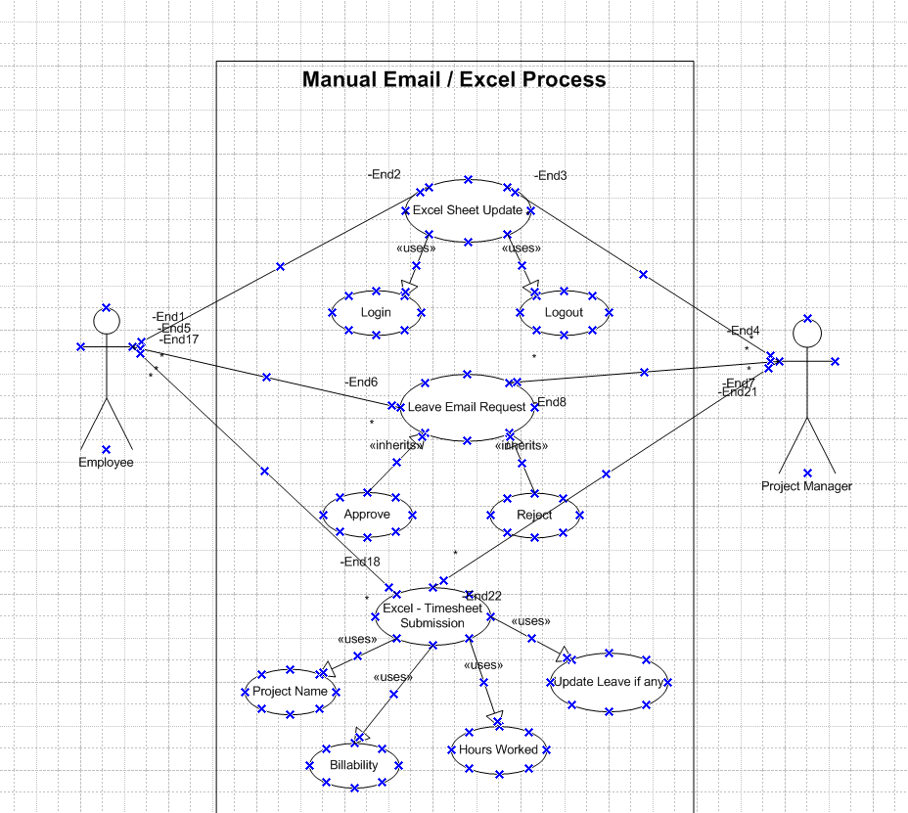

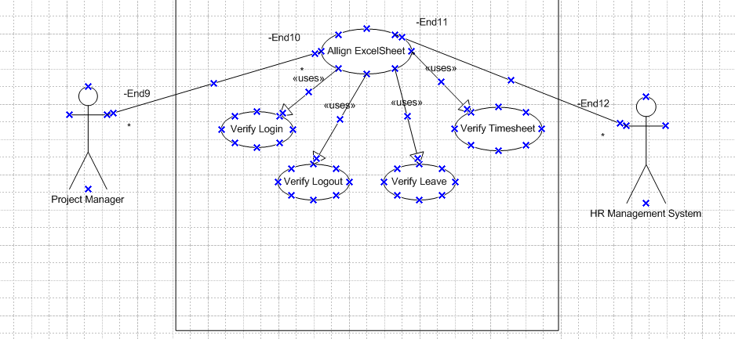

# **8.2. Proposed Recommendations (TO-BE):**

* **Automation –** Implementation of automation systems for TruTime Tracking, Applying Leave and Submitting Timesheets
* **Integration –** Integrating the system with existing HR with project management system for seamless data flow
* **Real Time Tracking –** enhancing real-time visibility and tracking of data and its updates
* **Improve Efficiency** 
  + Reduce time spent on manual data entry and processing by 50% at the 1st phase and reduce to 90% later on.
  + Automate repetitive tasks related to TruTime, Applying Leave and submitting timesheets.
* **Enhance Data Accuracy**
  + Achieve a 95% reduction in errors in Trutime, leave, and timesheet data by implementing automated validation and data entry.
  + Ensure real-time updates and synchronization across all related systems to maintain data integrity.
* **Increase Visibility and Reporting**
  + Implement real-time tracking and reporting features to provide better insights into employee time management and project progress.
  + Enable automated generation of reports for Trutime, leave balances, and timesheets, reducing the need for manual report preparation.
* **Ensure Data Security, Compliance and System Integration**
  + Implement robust security measures to protect sensitive employee data and ensure compliance with data protection regulations.
  + Ensure the automated system meets all relevant industry standards and company policies for data security and privacy.
  + Integrate the new automated system with existing HR and project management systems to ensure seamless data flow and eliminate data storage.
  + Achieve full system integration within the first 7 months of the project.

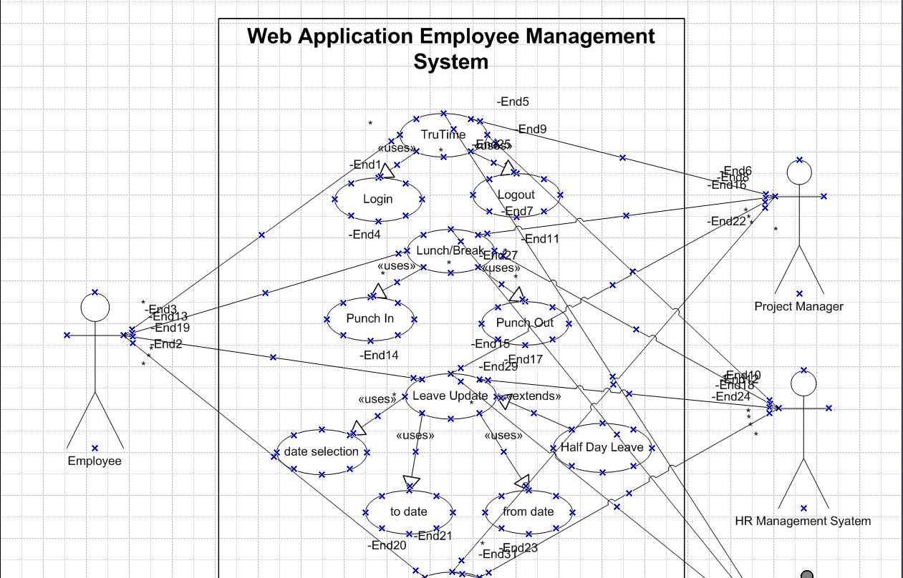

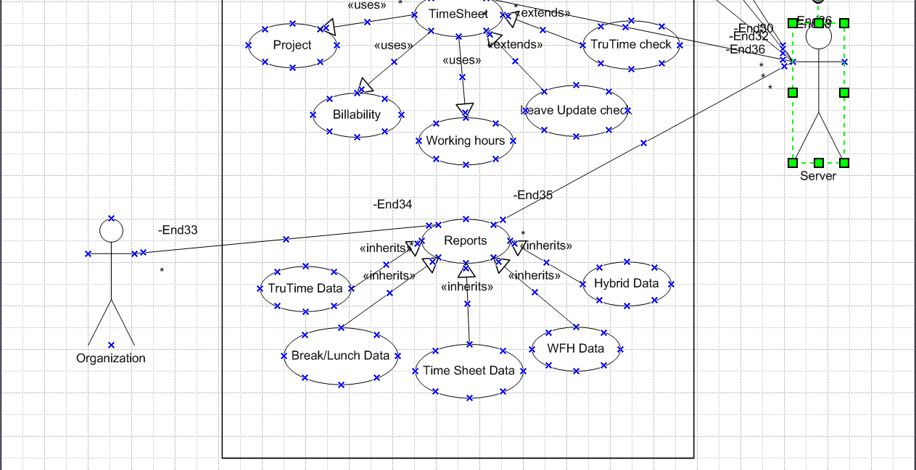

# **Business Requirements:**

**The primary business requirement:**

|  |  |  |  |  |  |
| --- | --- | --- | --- | --- | --- |
| **Req ID** | **Requirement Name** | **Requirement Description** | **Function Area** | **Priority** | **Status** |
| REQ 1 | Web Application | The Functional and Nonfunctional Requirements are explained separately | Developing Team | 2 | Started |
| REQ 2 | System Integration | Full integration of web application to the organization server | Developing Team | 3 | Not Started |
| REQ 3 | Real Time Tracking | All the inputs form employees to flow real time to the server instantly | Database Team | 4 | Not Started |
| REQ 4 | Data Accuracy | The system flow on data should be accurate | Database Team | 5 | Not Started |
| REQ 5 | Reports | Reports of multiple operation to be available for downloads | Reporting Team | 6 | Not Started |
| REQ 6 | Data Privacy & Security | Fully encrypted and data policy privacy adherence | Legal Team | 1 | Started |

**REQ 1: Functional Requirement:**

|  |  |  |  |
| --- | --- | --- | --- |
| **Req ID** | **Requirement Name** | **Requirement Description** | **Priority** |
| FR001 | Portal Login | All User of the company must be able to login the 1C Application | 1 |
| FR002 | TruTime Login | User to click the Login Button whenever he/she is logging in | 2 |
| FR003 | TruTime Break Checkin | User will click in the break time/lunch time button accordingly as per the requirement | 3 |
| FR004 | TruTime Break Checkout | User will click out the break time/lunch time button accordingly as per the requirement after completing the break/lunch | 3 |
| FR005 | TruTime Logout | User to click the checkout Button whenever he/she is logging out | 2 |
|  |  |  |  |
| **Req ID** | **Requirement Name** | **Requirement Description** | **Priority** |
| FR006 | Apply Leave Screen | User to click on Leave Request Button enabled at the top of the page | 1 |
| FR007 | Leave Submission Page | User will select the date planned for leave (from date and to Date) | 2 |
| FR007.1 | Half Day Leave Submission Checkin box | If user is planning for half day leave, then radio button to be clicked for half day leave update | 2 |
| FR008 | Leave confirmation page | User will get pop up screen to confirm the leave applied, user must click Confirm/Cancel button after the message is read | 3 |
|  |  |  |  |
| **Req ID** | **Requirement Name** | **Requirement Description** | **Priority** |
| FR009 | Timesheet page creation | User will Click on Timesheet option from the header of the application | 1 |
| FR010 | Choose from dropdown on Project info | User should choose the project he/she currently working and select the appropriate name from the project Name dropdown | 2 |
| FR011 | Billability Selection | User must select the billable type (whether he will be billed or working as NBL (buffer resource of the project)) | 2 |
| FR012 | Working Hours Update in the Date Box | User will update the no. of hours worked each day under date box and should not exceed more than 9 hours | 2 |
| FR013 | Submit Filled timesheet | User can finally submit the timesheet filled | 2 |
| FR014 | Timesheet update confirmation | User will look at the timesheet confirmation popup and click proceed to submit / cancel for corrections | 3 |
| FR015 | Corrections in Timesheet | If user cancels the timesheet for correction, then the process repeats from the FR010 | 3 |

**REQ 1: Non-Functional Requirement:**

|  |  |  |  |
| --- | --- | --- | --- |
| **Req ID** | **Requirement Name** | **Requirement Description** | **Priority** |
| NFR001 | Employee ID & Password Check | Once user updates credentials to Login the 1C application, the User ID and Password SSO will be verified backend with organization server | 1 |
| NFR002 | Clocking Time | Once user Login, the Timer will start that User know their hours of work per day. It will also update the present time as well. All these will run automatically in local time zone User login's | 2 |
| NFR003 | Break Time | Once User clicks on break/Lunch, the Timer from 0 seconds will start up to the time of allowance on each break as per HR policy and User goes beyond the permissible time will be highlighted in Aber until checkout the break time | 3 |
| NFR004 | Email Notification | An email will be sent to immediate manager if any User have exceeded their break/Lunch time at end of the day | 10 |
| NFR005 | Weekly TruTime Summary | A Summary of TruTime with date and time of login logout along with lunch/break will be sent to User to track or just for reference | 11 |
| NFR006 | Leave Balance Popup | User leave balance will be shown in the frontend page to know their leave balance | 3 |
| NFR007 | No. Of leave Days | When User chooses from date and to date while applying leave, it will auto populate the number of days the system is considering based on the input | 4 |
| NFR008 | Leave Request Notification | Once User submits leave request, an email will be sent to immediate supervisor of the User along with the User in the CC for approval | 12 |
| NFR009 | Leave approval | If supervisor approves leave, an email notification will be sent to User and deduct the leave balance from backend | 5 |
| NFR010 | Leave Rejection | If supervisor rejects leave, an email notification will be sent to User and cancels the leave request from backend | 6 |
| NFR011 | Weekly Timesheet | User project name dropdown will auto populate only the lists of projects they are allocated to not all | 7 |
| NFR012 | Applied leave in Timesheet page | If user have any leaves approved, the timesheet page will auto populate that day as leave and the text box will be disabled | 9 |
| NFR013 | TruTime Updates in Timesheet page | Login Logout time for the current week will be auto populated in the timesheet summary page so that user can see out of 45 working hours how much time they have TruTime. | 8 |

**RTM Matrix:**

This RTM will help you track the requirements throughout the project lifecycle and ensure that all the requirements are tested and verified.

***RTM matrix is explained in detail above in Document – 4***

# **Appendices:**

# **10.1. List of Acronyms:**

|  |  |
| --- | --- |
| **Short Form** | **Acronyms** |
| BRD | Business Requirement Document |
| PMO | Project Management Operations |
| HR | Human Resources |
| iOS | iPhone Operating System |
| FAQ | Frequently Asked Questions |
| WFH | Work From Home |
| SSO | Single Sign On |
| REQ | Requirement |
| NBL | Non-Billable |
| FR | Functional Requirement |
| NFR | Non-Functional Requirement |
| RTM | Requirement Traceability Matrix |

# **10.2. Glossary of Terms:**

|  |  |
| --- | --- |
| **Glossary** | **Terms** |
| TruTime | Capturing Employee's login and Logout time is termed as TruTime |
| Billability | Billing of an Employee to the client for the work done |
| Hybrid | Employees working 3 days at office and 2 days from home |
| Buffer Resource | They are additional resource to the project. They engage in work at the time of shrinkage for the day. |

# **10.3. Related document:**

|  |
| --- |
| [Project Charter](mailto:Sample) |
| Use Case Documentation |
| Stakeholder Analysis |
| Functional Requirements Specification |
| Nonfunctional Requirements Specification |
| Traceability Matrix |
| Risk Management Plan |