COEPD – Traditional Development

Capstone Project1 – Part -2/3 – 100 Marks - Pass 60 % 12 Questions

Instructions to follow:

1. Copy paste (either image, diagram or text) is not entertained. If done, the document will not be evaluated.
2. After submission of the answers of this prep exam, You should be prepared to attend viva and justify your answers in the prep exams. If in Viva, participant is NOT justifying the answers, Viva will be repeated until Candidates justify 60% correctness.
3. Mentor calls are scheduled only if the participant have submitted their task at least for one time. (should apply their knowledge in this task first)
4. For attempting prep exams participant should be thorough on the topics using their references.
5. Please format the document properly (Always have a question no., question and answer).
6. Have a consistent format (Font name: Arial/ Calibri -Font size 12, Font Color: Black ).
7. Few Questions are related to the case study, if check Questions thoroughly before you answer.
8. Answers should be elaborated in detail(*not as per the allotted marks).
9. Please focus on learning and applying the knowledge as this knowledge will be helpful in contributing at your BA job.
10. In the evaluation, students must answer all questions and should be able to justify at least 60% content and correctness of each answer.

Online Agriculture Products Store

Mr. Henry, after being successful as a businessman and has become one of the wealthiest persons in the city. Now, Mr. Henry wants to help others to fulfil their dreams. One day, Mr. Henry went to meet his childhood friends Peter, Kevin and Ben. They live in a remote village and do farming. Mr. Henry asked his friends if they are facing any difficulties in their day-to-day work.

Peter told Mr. Henry that he is facing difficulties in procuring fertilizers which are very important for farm. Kevin said that he is also facing the same problem in-case of buying seeds for farming certain crops. Ben raised his concern on lack of pesticides which could help in greatly reducing pests in crops.

After listening to all his friends’ problems, Mr. Henry thought that this is a crucial problem faced not only by his friends but also by so many other farmers. So, Mr. Henry decided to make an online agriculture product store to facilitate remote area farmers to buy agriculture products. Through this Online Web / mobile Application, Farmers and Companies (Fertilizers, seeds and pesticides manufacturing Companies) can communicate directly with each other.

The main purpose to build this online store is to facilitate farmers to buy seeds, pesticides, and fertilizers from anywhere through internet connectivity. Since new users are involved, Application should be user friendly.

This new application should be able to accept the product (fertilizers, seeds, pesticides) details from the manufacturers and should be able to display them to the Farmers. Farmers will browse through these products and select the products what they need and request to buy them and deliver them to farmers location.

Mr. Henry has given this project through his Company SOONY. In SOONY Company, Mr Pandu is Financial Head and Mr Dooku is Project Coordinator. Mr. Henry , Mr Pandu , and Mr Dooku formed one Committee and gave this project to APT IT SOLUTIONS company for Budget 2 Crores INR and

18 months Duration under CSR initiative. Peter, Kevin and Ben are helping the Committee and can be considered as Stakeholders share requirements for the Project.

Mr Karthik is the Delivery Head in APT IT SOLUTIONS company and he reached out to Mr Henry through his connects and Bagged this project. APT IT SOLUTIONS company have Talent pool Available for this Project. Mr Vandanam is project Manager, Ms. Juhi is Senior Java Developer, Mr Teyson, Ms Lucie, Mr Tucker, Mr Bravo are Java Developers. Network Admin is Mr Mike and DB Admin is John. Mr Jason and Ms Alekya are the Tester. And you joined this team as a BA.

Question 1 – Audits - 5 Marks

4 Quarterly Audits are planned Q1 , Q2, Q3, Q4 for this Project What is your knowledge on how these Audits will happen for a BA ?

Audits – Audits means to check quality of your work or process. Audits help identify risks, inefficiencies, or areas for improvement.

|  |  |
| --- | --- |
| Stages | Requirement Gathering Phase Q1 - 12 Weeks(week1 to week10) |
| Completed | 10 Weeks |
| Checklist | Requirement Gathering Process  BRD Template  Elicitation Report  Email Communication –To, CC,BCC |

|  |  |
| --- | --- |
| Stages | Requirement Analysis Phase Q2- 10 Weeks |
| Completed | 10 Weeks |
| Checklist | Identify stakeholder  Business to functional requirement mapping  UML Diagram  Client Sign off |

|  |  |
| --- | --- |
| Stages | Design Phase Q3 10 weeks |
| Completed | 10 Weeks |
| Checklist | Utilization of tools  Stakeholder MOM  Email Communication – To, CC,BCC |

|  |  |
| --- | --- |
| Stages | Development Q4 20 Weeks |
| Completed | 20 Weeks |
| Checklist | BA AND Developer MOM  JAD Session Report  Development planning  Email Communication |

Question 2 – BA Approach Strategy - 6 Marks

Before the Project is going to Kick Start, The Committee asked Mr Karthik to submit BA Approach Strategy

Write BA Approach strategy (As a business analyst, what are the steps that you would need to follow to complete a project – What Elicitation Techniques to apply, how to do Stakeholder Analysis RACI/ILS, What Documents to Write, What process to follow to Sign off on the Documents, How to take Approvals from the Client, What Communication Channels to establish n implement, How to Handle Change Requests, How to update the progress of the project to the Stakeholders, How to take signoff on the UAT- Client Project Acceptance Form )

Your Team

|  |  |  |
| --- | --- | --- |
|  | Project Manager - Mr Vandanam Senior Java Developer - Ms. Juhi |  |
| Java Developers - Mr Teyson, Ms Lucie, Mr Tucker, Mr Bravo Network Admin - Mr Mike | | |
|  | DB Admin - Mr John. |  |

|  |  |
| --- | --- |
| Testers | Mr Json and Mr Alekya |
| BA | You |

Technical Team have assembled to discuss on the Project approach and have finalised to follow 3-tier architecture for this project.

Write BA Apprach Stratergy

What Eliciation techniqes to apply?

In requirement gathering process below are the elicitation techniques commonly used by Business Analyst

Brainstorming

Document Analysis

Reverse Engineering

Focus Group

Observation

Workshop

JAD

Prototyping

Interview

How to do Stakeholder Analysis?

RACI metrics tools is used for stakeholder analysis. We can analyse who is responsible,accountable,consultant and Informed.

|  |  |  |
| --- | --- | --- |
| RACI | Name Of the Responsiable | Designation |
|  |  |  |
| Responsiable | Mr Teyson, Mr Teyson, Mr Tucker, Mr Bravo | Java Developers |
|  | Mr Alekya | Tester |
|  |  |  |
| Accountable | Mr Vandanam Seni | Project Manager |
|  | Digvijay Thorat | Business Analyst |
|  |  |  |
|  |  |  |
| Consultant | Mr Mike | Network Admin |
|  | Mr. Jone | DB Admin |
|  |  |  |
| Informed |  |  |
|  | Mr Vandanam Seni | Project Manager |
|  |  |  |

What Documents to Write?

Here we need to add Details how the project will be executed and managed.

1. Introduction :

Mr Henry is succeesful businessman.One day he went to meet his childwooed friend Peter, Kevin and Ben. While discussion their day to day activity henry got to know ther are facing some problems in farm. Kevin said that he is also facing the same problem in-case of buying seeds for farming certain crops. Ben raised his concern on lack of pesticides. So, Mr. Henry decided to make an online agriculture product store to facilitate remote area farmers to buy agriculture products.

1. Project Goal :

The project goal is to create online agriculture product store.

1. Scope & Deliverables

This project will create online agriculture product store to create bond between farmers and manufacturer.

1. Timeline –

This project has 18 months of duration.

1. Roles & Responsibilities

The main roles and responsibilities are as follows

Project Manager –Mr Vandman

Business Analyst – Digvijay

Java Developer – Ms Juhi

DB Admin – Joan

Project Coordinator – Mr Dooku.

How to take Approval from Client

Client approval is all about aligning your clients’ vision and expectations with your work.

* Share your documents with reviews.
* Get Feedback and discuss ideas for improvement.
* Develop and share new version
* Repeat until you get approval.

What Communication Channels to establish n implement

Email, project management software, instant messaging tools, video conferencing, regular team meetings, status reports, dedicated project portals, newsletters, phone calls, and face-to-face meetings.

How to Handle Change Requests

Change request nothing but modifying a project, document or process. Handling Change Requests (CRs) properly ensures minimal project disruption, maintains stakeholder alignment.

Use project management tool to change request. (Jira, Service now, Trello).

Analyze the change request.

Approve or reject the change request.

Test and validate the change.

How to update the progress of the project to the Stakeholder

As business analyst we have to give project update or process to the client. For providing the updates

We use emails, meetings, dashboards. follow up and document the feedback.

How to take signoff on the UAT- Client Project Acceptance Form.

UAT is final stage of before deploying project. We have to ensure that client meets their requirement.

* Prepare client signoff forms (Project details, Project issues, change request, Finale acceptance statement, Signature)
* Send for Review & Approval
* Obtain formal sign off form.
* Process with deployment and closure.

Question 3 – 3-Tier Architecture - 5 Marks

Explain and illustrate 3-tier architecture?

3 Tier Architecture have 3 stages that used to complete the project/

1. Application layer – This layer display the information to the use rand collects the input. The web pages and where user can login and view data. All the page design, size ,colure and information are updated in this layer.

Technologies – We can design and develop webpages through HTML,JAVASCRIPT, CSS etc

1. Business Logic layer – This layer used for apply all governments rule, connect UI with database, frequently changing components.

Technologies – Java, .Net, Node, python etc

1. Data Layer – In this layer data components used to connects the data. This layer manage and store all the data.

Technologies- Mysql, postgresql, sql server etc

Question 4 – BA Approach Strategy for Framing Questions – 10 Marks

Business Analyst should keep What points in his/her mind before he frames a Question to ask to the Stakeholder

( 5W 1H – SMART – RACI – 3 Tier Architecture – Use Cases, Use case Specs, Activity Diagrams, Models, Page designs).

5W 1H – 5W1H is effective way of extract information or requirement from client. We can use flow like where, why, what, who, when and how.

SMART – SMART stands for specific, measurable, attainable, realistic, traceable.This technique used for crating questions.

RACI – RACI stands for responsible, accountable, consultant, informed. RACI is stakeholder analysis tool . The RACI chart defines the roles and responsibilities within team.

3 Tier Architecture – This architecture has 3 layers. Application layers show the web design and development, business layer show all business rules and regulation and data layer shows the data management system.

Use cases -A use case is a real-world scenario that describes how a system, process, or concept is applied to achieve a specific goal. It involves actors, steps and expected outcome.

Activity Diagram - An Activity Diagram is a flowchart diagram used to visually represent workflows, business processes. It shows the sequence of activities, decisions, and interactions between different actors in a process.

Page Design – Page design or web design are very crucial to attract customer . Its way of doing web marketing.

Question 5 – Elicitation Techniques - 6 Marks

As a Business Analyst, What Elicitation Techniques you are aware of? ( BDRFOWJIPQU)

As Business analyst we are using below elicitation techniques.

Brainstorming Interviews

Document Analysis Prototype

Reverse engineering Questionnaire

Focus group Use case specification

Observation

Workshops

JAD

Question 6 – This project Elicitation Techniques - 5 Marks

Which Elicitation Techniques can be used in this Project and Justify your selection of Elicitation Techniques? Prototyping

Use case Specs Document Analysis Brainstorming

There are few elicitation techniques use Business analyst to gather requirement.

Document Analysis –

We use document analysis techniques when we want to use documentation of old system as input for new system. This used for analyze old documents. With this techniques we will have lot of information and we can easily transfer to new system.

Brainstorming

This techniques is used to generate large no of ideas within short time. This activity can be done either individual or groups. Some ideas come from where stakeholder have seen e.g Any exhibition.

This activity can be performed within 8-12 group of people in relax environment.

Focus group

It is process to elicit the ideas about the product, service and opportunities. In this techniques we will get large no of ideas while discussing with each other . Focus group containing 6-12 people.

Prototyping

In this process screening mockups used for gathering requirement when it is used at right time then it will helpful but if introduced to early then it can be problematic.

The mockup process is nice because business stakeholder or client can easily analyze functionality of system. This techniques basically used for to identify problem.

Fertilizers, seeds, pesticides details from the manufacturers and should be able to display them to the Farmers.

To gather the business requirements from the client, you went to SOONY and met Mr. Henry. When Mr. Henry was asked about the project and what are they expecting from the project, Mr. Henry stated that he is expecting to have a login for all its users (fertilizers, seeds, pesticides manufacturers and Farmers) , a product catalog of fertilizers, seeds, pesticides, a search option to search for products, payment process, and delivery tracking.

After doing the stakeholder analysis, you have found out that Peter, Kevin, Ben are the key stakeholders and you have scheduled an appointment to meet them. After meeting with them and trying to gather the stakeholder requirements, Kevin said that, a Farmer should be able to browse through the products catalog once they visit the website and need to have a search option so that they can search for any product they need. Peter said that, if a farmer wants to buy any product or add them to buy-later list, they need to login

first using their email id and password. If it is a new user, then they can create a new account by submitting their email ID and creating a secure password. Ben added saying that, Farmers needs to have an easy-to-use payment gateway which should include cash-on-delivery (COD), Credit/Debit card and UPI options so that the user’s experience should be better. Kevin mentioned that, a user gets an email confirmation regarding their order status. A delivery tracker to track the whereabouts of their order.

Identify Business Requirements (which includes Stakeholder Requirements)

BR001 – Farmers should be able to search for available products in fertilizers, seeds, pesticides BR002 – Manufacturers should be able to upload and display their products in the application.

Question 7 – 10 Business Requirements- 10 Marks

Make suitable Assumptions and identify at least 10 Business Requirements.

BR001 – Farmers should be able to search for available products in fertilizers, seeds, pesticides .

BR002 – Manufacturers should be able to upload and display their products in the application.

BR003 –Farmer should login with their email and password..

BR004 – In product catalog option user should see fertilizers, seeds, pesticides.

BR005 - search option to search for products, payment process, and delivery tracking.

BR006 - If it is a new user, then they can create a new account by submitting their email ID and creating a secure password.

BR007 – In payment gateway include cash-on-delivery (COD), Credit/Debit card and UPI options for farmers.

BR008 – User gets an email confirmation regarding their order status.

BR009 - payment gateway which should include cash-on-delivery (COD), Credit/Debit card and UPI options.

BR0010 – Manufacturer should also create new account and add their product information.

Question 8 –Assumptions- 5 Marks

List your assumptions

Assumption 1 – User can login using phone number, facebook and google accout.

Assumption -2 A user has knowledge about online purchasing process.

Assumption 3 – Now in current days online shopping is increasing and customer prefer online shopping.

Assumption 4 – The designer have design the application in such way so customer can easily attract towards the website.

Assumption 5 – The customer have online accounts for secured payment process.

Question 9 – This project Requirements Priority - 8 Marks

Give Priority 1 to 10 numbers ( 1 being low priority – 10 being high priority) to these Requirements after discussions with the stakeholders

|  |  |  |  |
| --- | --- | --- | --- |
| Req ID | Req Name | Req Description | Priority |
| BR001 | Farmer Search for Products | Farmers should be able to search for available products in fertilizers, seeds, pesticides | 8 |
| BR002 | Manufacturers upload their Products | Manufacturers should be able to upload and display their products in the application | 8 |
| BR003 | Farmer should login | Farmer should login with their email and password | 7 |
| BR004 | User should see all products | In product catalog option user should see fertilizers, seeds, pesticides | 8 |
| BR005 | In search option user can check payment and delivery tracking process. | search option to search for products, payment process, and delivery tracking | 8 |
| BR006 | Create new account for new user. | If it is a new user, then they can create a new account by submitting their email ID and creating a secure password. | 7 |
| BR007 | Payment gateway include cash on delivery | In payment gateway include cash-on-delivery (COD), Credit/Debit card and UPI options for farmers. | 9 |
| BR008 | Confirmation on order status | User gets an email confirmation regarding their order status. | 9 |
| BR009 | Payment gateway provide cash on delivery option | payment gateway which should include cash-on-delivery (COD), Credit/Debit card and UPI options. | 8 |
| BR010 | Manufacturer also need to create new account | Manufacturer should also create new account and add their product information | 7 |

Once the requirements are finalized, as a business analyst, one of the major roles is to act as a liaison between the client and the project team. To gather the requirements correctly from the client side and then to deliver those requirements to the project team in a way they understand.

To make the project team understand the requirements, you need to convert those requirements into UML diagrams and screen mock-ups.

Question 10 – Use Case Diagram - 10 Marks

Draw use case diagram

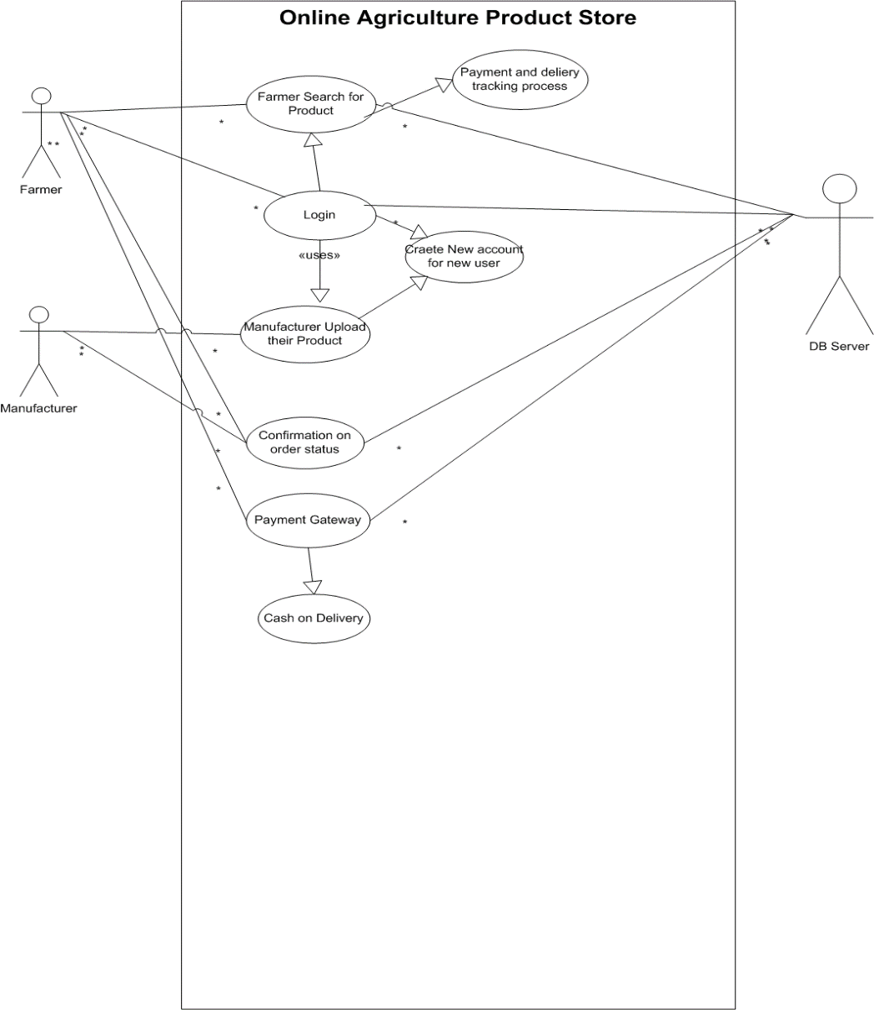

Question 11 – (minimum 5) Use Case Specs - 15 Marks

Prepare use case specs for all use cases.

1 Brief Description

This use case describes how online agriculture product store helpful for both farmers as well as manufacturer. Farmers can easily search multiple product and manufacturer also get no of customer.

2 Actors

User

Manufacturer

3 Preconditions

Active network connection is required

All the product available to sale.

4 Basic flow of Event

This use case begins when user login to the application .

Validate the user have already registered or not.

In search option user can search multiple products and select one product for purchase.

Then user add selected products into the cart.

User used payment gateway method for payment. Cash on deliver, UPI and card payment options are available.

The use case ends successfully.

5 Alternative Flow

Invalid User

If user is not registered with there email and password then he is unable to login

So use case ends with failure condition.

Question 12 – (minimum 5) Activity Diagrams - 15 Marks

Activity diagrams

1. User Registration

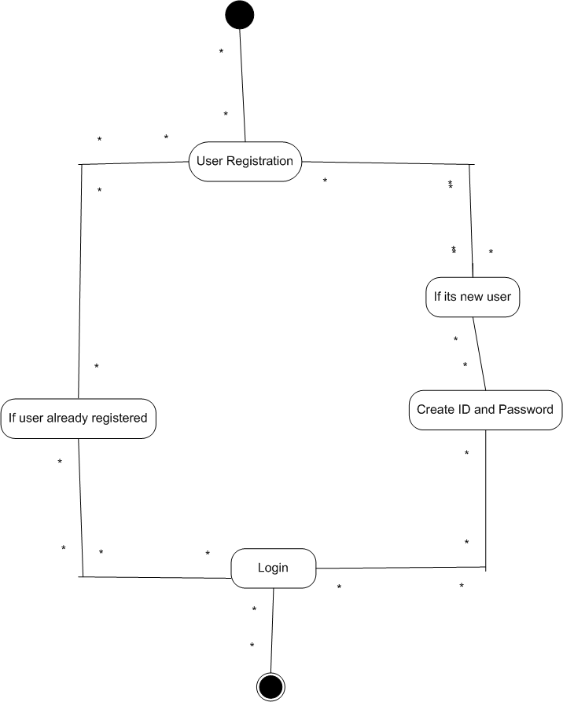

2 ) Search Products

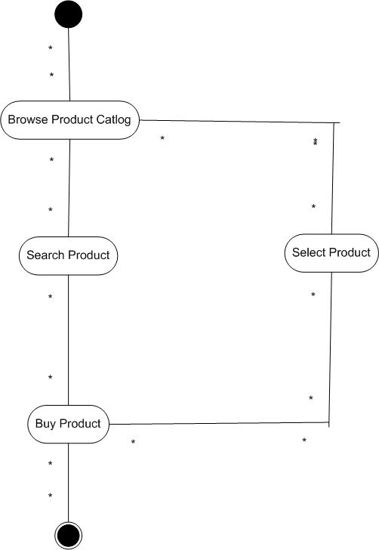

3 ) Add Product to cart

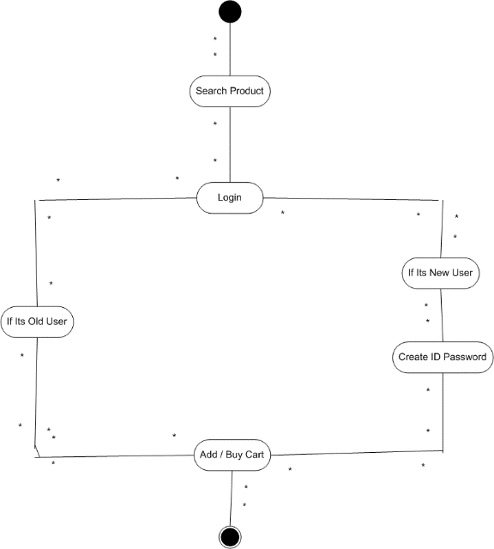

1. Making a Payment

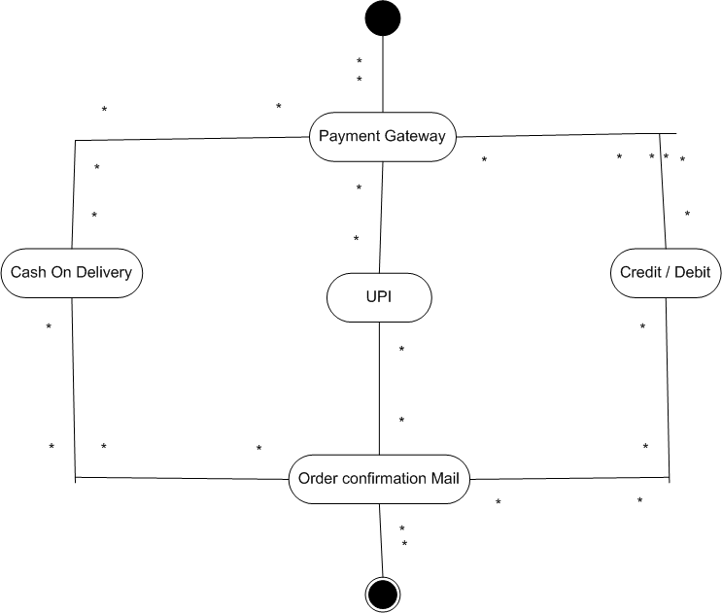

5 ) Delivery

