**Capstone Project 1 – prep 3**

**Question 1: Write 20 functional requirements? Identify minimum 20 functional requirements**

**Answers:**

**Functional requirements:**

|  |  |  |  |
| --- | --- | --- | --- |
| **Req ID** | **Req Name** | **Req Description** | **Priority** |
| FR001 | Product upload | Manufacturers should be able to upload fertilizers, seeds and pesticides with descriptions and pricing | 10 |
| FR002 | Product Search | Farmers should be able to search for products by category, name or manufacturers | 9 |
| FR003 | Order placement | Farmers should be able to place orders for selected products | 9 |
| FR004 | Order tracking | Farmers should be able to track the status of their orders in real time | 8 |
| FR005 | Farmer Registration | Farmers should be able to create accounts with their details and location for delivery | 7 |
| FR006 | Manufacturer Registration | Manufacturers should be able to create accounts and manage their product listings | 7 |
| FR007 | Customer support | A system for farmers to contact support via chat, email or phone should be included | 6 |
| FR008 | Deliver Management | Logistics and delivery systems should ensure timely dispatch of products to farmers | 6 |
| FR009 | Payment gateway | Secure online payments options should be available (credit, debit, UPI etc.) | 8 |
| FR010 | Ratings and Reviews | Farmers should be able to rate and review products and suppliers for quality assurance | 6 |

**Non-functional requirements:**

|  |  |  |  |
| --- | --- | --- | --- |
| **Req ID** | **Req Name** | **Req Description** | **Priority** |
| NFR001 | Usability | The app should have a simple intuitive interface for farmers with  minimal tech knowledge | 8 |
| NFR002 | Performance | The application should load pages quickly and support multiple concurrent users | 9 |
| NRF003 | System Security | The platform should ensure encrypted transactions and secure data storage | 10 |
| NRF004 | Compatibility | The platform should be accessible via mobile devices for ease of use | 8 |
| NRF005 | Response time | All pages should be loaded within 2 to 3 seconds under average network conditions | 9 |
| NRF006 | Scalability | The system should be able to handle a growing number of farmers and manufacturers | 9 |
| NRF007 | Availability | The system should maintain high uptime and reliability to ensure uninterrupted access | 7 |
| NRF008 | Responsiveness | The app should be optimized for different screen sizes to work seamlessly across devices | 6 |
| NRF009 | Data Backup | Regular backups should be taken to prevent data loss | 7 |
| NRF010 | Compliance | The system should follow legal guidelines regarding agricultural products sales | 6 |

**Question 2: –Minimum 5-page designs. Make wireframes and prototypes.**

**Answers:**

1. Login:

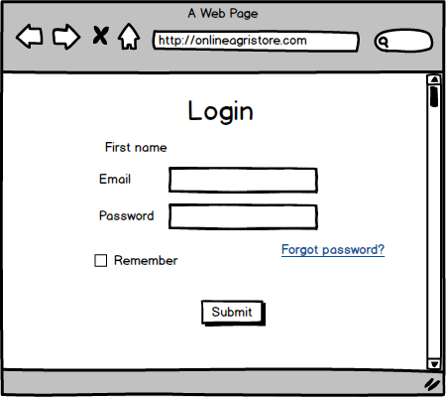

1. Search products:

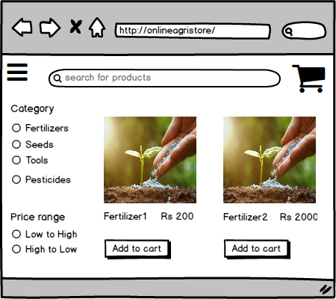

1. Product Detail:

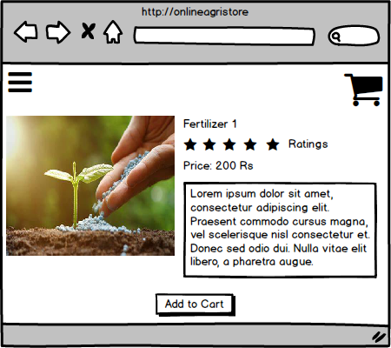

1. Registration:

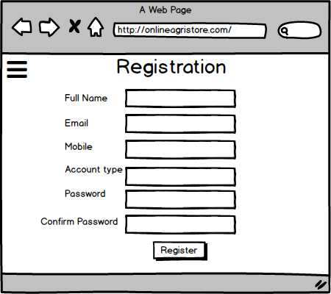

1. Payment:

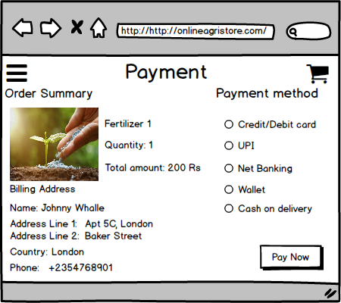

**Question 3: Make a note of the Tools which you are using for the above concepts.**

**Answer:**

1. **Microsoft Visio:** Microsoft Visio is used by business analysts to create professional diagrams like flowcharts, process maps, and organizational charts. It allows you to visually represent data and workflows, making complex processes easier to understand. It’s especially useful for brainstorming, analyzing systems, and explaining ideas to teams and stakeholders.
2. **Balsamiq:** Balsamiq is a tool for creating wireframes, which are basic, rough designs for user interfaces like apps or websites. It focuses on simplicity, helping business analysts quickly draft and share ideas. Balsamiq is ideal for brainstorming user interface layouts and getting feedback early in the design process without diving into detailed visuals.
3. **Axure:** Axure enables business analysts to design interactive prototypes that simulate how a website or app will look and function. It goes beyond static design by letting users test interactive elements, such as clickable buttons and menus. Axure is ideal for communicating how the final product should behave and ensuring everyone understands the user experience.

**Question 4: Prepare RTM.**

**Answer:**

RTM is a document used to track requirements throughout the project life cycle, ensuring that they are met, and no requirements are overlooked

|  |  |  |  |  |  |  |  |  |  |
| --- | --- | --- | --- | --- | --- | --- | --- | --- | --- |
| **Req ID** | **Req Name** | **Req Description** | **Design** | **Code** | **Unit testing** | **Component testing** | **System testing** | **SIT** | **UAT** |
| FR001 | Product upload | Manufacturers should be able to upload fertilizers, seeds and pesticides with descriptions and pricing | InProgress | Incomplete | Incomplete | Incomplete | Incomplete | Incomplete | Incomplete |
| FR002 | Product Search | Farmers should be able to search for products by category, name or manufacturers | InProgress | Incomplete | Incomplete | Incomplete | Incomplete | Incomplete | Incomplete |
| FR003 | Order placement | Farmers should be able to place orders for selected products | InProgress | Incomplete | Incomplete | Incomplete | Incomplete | Incomplete | Incomplete |
| FR004 | Order tracking | Farmers should be able to track the status of their orders in real time | InProgress | Incomplete | Incomplete | Incomplete | Incomplete | Incomplete | Incomplete |
| FR005 | Farmer Registration | Farmers should be able to create accounts with their details and location for delivery | Completed | InProgress | InProgress | Incomplete | Incomplete | Incomplete | Incomplete |
| FR006 | Manufacturer Registration | Manufacturers should be able to create accounts and manage their product listings | Completed | InProgress | InProgress | Incomplete | Incomplete | Incomplete | Incomplete |
| FR007 | Customer support | A system for farmers to contact support via chat, email or phone should be included | InProgress | Incomplete | Incomplete | Incomplete | Incomplete | Incomplete | Incomplete |
| FR008 | Deliver Management | Logistics and delivery systems should ensure timely dispatch of products to farmers | InProgress | Incomplete | Incomplete | Incomplete | Incomplete | Incomplete | Incomplete |
| FR009 | Payment gateway | Secure online payments options should be available (credit, debit, UPI etc.) | InProgress | Incomplete | Incomplete | Incomplete | Incomplete | Incomplete | Incomplete |
| FR010 | Ratings and Reviews | Farmers should be able to rate and review products and suppliers for quality assurance | InProgress | Incomplete | Incomplete | Incomplete | Incomplete | Incomplete | Incomplete |
| NFR001 | Usability | The app should have a simple intuitive interface for farmers with minimal tech knowledge | Incomplete | Incomplete | Incomplete | Incomplete | Incomplete | Incomplete | Incomplete |
| NFR002 | Performance | The application should load pages quickly and support multiple concurrent users | Incomplete | Incomplete | Incomplete | Incomplete | Incomplete | Incomplete | Incomplete |
| NRF003 | System Security | The platform should ensure encrypted transactions and secure data storage | Incomplete | Incomplete | Incomplete | Incomplete | Incomplete | Incomplete | Incomplete |
| NRF004 | Compatibility | The platform should be accessible via mobile devices for ease of use | Completed | Incomplete | Incomplete | Incomplete | Incomplete | Incomplete | Incomplete |
| NRF005 | Response time | All pages should be loaded within 2 to 3 seconds under average network conditions | Completed | Incomplete | Incomplete | Incomplete | Incomplete | Incomplete | Incomplete |
| NRF006 | Scalability | The system should be able to handle a growing number of farmers and manufacturers | Completed | Incomplete | Incomplete | Incomplete | Incomplete | Incomplete | Incomplete |
| NRF007 | Availability | The system should maintain high uptime and reliability to ensure uninterrupted access | Completed | Incomplete | Incomplete | Incomplete | Incomplete | Incomplete | Incomplete |
| NRF008 | Responsiveness | The app should be optimized for different screen sizes to work seamlessly across devices | Completed | Incomplete | Incomplete | Incomplete | Incomplete | Incomplete | Incomplete |
| NRF009 | Data Backup | Regular backups should be taken to prevent data loss | Completed | Incomplete | Incomplete | Incomplete | Incomplete | Incomplete | Incomplete |
| NRF010 | Compliance | The system should follow legal guidelines regarding agricultural products sales | Completed | Incomplete | Incomplete | Incomplete | Incomplete | Incomplete | Incomplete |

**Question 5: Prepare 10 test case documents**

**Answer:**

|  |  |  |  |  |  |  |
| --- | --- | --- | --- | --- | --- | --- |
| Test Case id | TC001 | | Test Case Name | | Product Upload | |
| Project id | PRJ546 | | Project Name | | Online Agriculture Product Store | |
| PM id | 4869 | | PM Name | | Vandanam | |
| Test Strategy id | PQ546TS001 | | Tester id | |  | |
| Test Plan id | PQ546TP001 | | Tester Name | | Json and Alekya | |
| Test Schedule id | PQ546TS001 | | Date of Test | |  | |
| Scenario: Manufactures should be able to upload fertilizers, seeds and pesticides with descriptions and pricing | | | | | | |
| Link to that page: | | | | | | |
| Input data | Set 1 | Set 2 | | Set 3 | | Set 4 |
|  | Product name |  | |  | |  |
|  | Category |  | |  | |  |
|  | Description |  | |  | |  |
|  | Pricing |  | |  | |  |
| Expected Behavior | Products are uploaded successfully and displayed in their listing |  | |  | |  |
| Actual Behavior | To be tested |  | |  | |  |
| Comments |  |  | |  | |  |
| Result (Pass/Fail) |  |  | |  | |  |

|  |  |  |  |  |  |  |
| --- | --- | --- | --- | --- | --- | --- |
| Test Case id | TC002 | | Test Case Name | | Product Search | |
| Project id | PRJ546 | | Project Name | | Online Agriculture Product Store | |
| PM id | 4869 | | PM Name | | Vandanam | |
| Test Strategy id | PQ546TS001 | | Tester id | |  | |
| Test Plan id | PQ546TP001 | | Tester Name | | Json and Alekya | |
| Test Schedule id | PQ546TS001 | | Date of Test | |  | |
| Scenario: Farmers should be able to search for products by category, name or manufacturer | | | | | | |
| Link to that page: | | | | | | |
| Input data | Set 1 | Set 2 | | Set 3 | | Set 4 |
|  | Search by category |  | |  | |  |
|  | Search by name |  | |  | |  |
|  | Search by manufacturer |  | |  | |  |
| Expected Behavior | Search results are displayed accurately based on the criteria |  | |  | |  |
| Actual Behavior | To be tested |  | |  | |  |
| Comments |  |  | |  | |  |
| Result (Pass/Fail) |  |  | |  | |  |

|  |  |  |  |  |  |  |
| --- | --- | --- | --- | --- | --- | --- |
| Test Case id | TC003 | | Test Case Name | | Order Placement | |
| Project id | PRJ546 | | Project Name | | Online Agriculture Product Store | |
| PM id | 4869 | | PM Name | | Vandanam | |
| Test Strategy id | PQ546TS001 | | Tester id | |  | |
| Test Plan id | PQ546TP001 | | Tester Name | | Json and Alekya | |
| Test Schedule id | PQ546TS001 | | Date of Test | |  | |
| Scenario: Farmers should be able to place orders for selected products | | | | | | |
| Link to that page: | | | | | | |
| Input data | Set 1 | Set 2 | | Set 3 | | Set 4 |
|  | Selected product name |  | |  | |  |
|  | Quantity |  | |  | |  |
|  | Payment method |  | |  | |  |
| Expected Behavior | Orders are successfully placed, and order details are displayed with confirmation |  | |  | |  |
| Actual Behavior | To be tested |  | |  | |  |
| Comments |  |  | |  | |  |
| Result (Pass/Fail) |  |  | |  | |  |

|  |  |  |  |  |  |  |
| --- | --- | --- | --- | --- | --- | --- |
| Test Case id | TC004 | | Test Case Name | | Order Tracking | |
| Project id | PRJ546 | | Project Name | | Online Agriculture Product Store | |
| PM id | 4869 | | PM Name | | Vandanam | |
| Test Strategy id | PQ546TS001 | | Tester id | |  | |
| Test Plan id | PQ546TP001 | | Tester Name | | Json and Alekya | |
| Test Schedule id | PQ546TS001 | | Date of Test | |  | |
| Scenario: Farmers should be able to track the status of their orders in real time | | | | | | |
| Link to that page: | | | | | | |
| Input data | Set 1 | Set 2 | | Set 3 | | Set 4 |
|  | Order id |  | |  | |  |
|  | Tracking status |  | |  | |  |
| Expected Behavior | Real time tracking information is displayed accurately |  | |  | |  |
| Actual Behavior | To be tested |  | |  | |  |
| Comments |  |  | |  | |  |
| Result (Pass/Fail) |  |  | |  | |  |

|  |  |  |  |  |  |  |
| --- | --- | --- | --- | --- | --- | --- |
| Test Case id | TC005 | | Test Case Name | | Farmer profile update | |
| Project id | PRJ546 | | Project Name | | Online Agriculture Product Store | |
| PM id | 4869 | | PM Name | | Vandanam | |
| Test Strategy id | PQ546TS001 | | Tester id | |  | |
| Test Plan id | PQ546TP001 | | Tester Name | | Json and Alekya | |
| Test Schedule id | PQ546TS001 | | Date of Test | |  | |
| Scenario: Farmers should be able to update their profile details | | | | | | |
| Link to that page: | | | | | | |
| Input data | Set 1 | Set 2 | | Set 3 | | Set 4 |
|  | Name |  | |  | |  |
|  | Phone number |  | |  | |  |
|  | Address |  | |  | |  |
| Expected Behavior | Profile updates should be reflected in the system successfully |  | |  | |  |
| Actual Behavior | To be tested |  | |  | |  |
| Comments |  |  | |  | |  |
| Result (Pass/Fail) |  |  | |  | |  |

|  |  |  |  |  |  |  |
| --- | --- | --- | --- | --- | --- | --- |
| Test Case id | TC006 | | Test Case Name | | Manufacturer Registration | |
| Project id | PRJ546 | | Project Name | | Online Agriculture Product Store | |
| PM id | 4869 | | PM Name | | Vandanam | |
| Test Strategy id | PQ546TS001 | | Tester id | |  | |
| Test Plan id | PQ546TP001 | | Tester Name | | Json and Alekya | |
| Test Schedule id | PQ546TS001 | | Date of Test | |  | |
| Scenario: Manufacturers should be able to update their profile details | | | | | | |
| Link to that page: | | | | | | |
| Input data | Set 1 | Set 2 | | Set 3 | | Set 4 |
|  | Name |  | |  | |  |
|  | Phone number |  | |  | |  |
|  | Address |  | |  | |  |
| Expected Behavior | Profile updates should be reflected in the system successfully |  | |  | |  |
| Actual Behavior | To be tested |  | |  | |  |
| Comments |  |  | |  | |  |
| Result (Pass/Fail) |  |  | |  | |  |

|  |  |  |  |  |  |  |
| --- | --- | --- | --- | --- | --- | --- |
| Test Case id | TC007 | | Test Case Name | | Customer support chat functionality | |
| Project id | PRJ546 | | Project Name | | Online Agriculture Product Store | |
| PM id | 4869 | | PM Name | | Vandanam | |
| Test Strategy id | PQ546TS001 | | Tester id | |  | |
| Test Plan id | PQ546TP001 | | Tester Name | | Json and Alekya | |
| Test Schedule id | PQ546TS001 | | Date of Test | |  | |
| Scenario: Customer should be able to use the chat feature to contact support | | | | | | |
| Link to that page: | | | | | | |
| Input data | Set 1 | Set 2 | | Set 3 | | Set 4 |
|  | Message content |  | |  | |  |
|  | Message length |  | |  | |  |
|  | Expected response time |  | |  | |  |
| Expected Behavior | Customers receive prompt replies from the support team via chat |  | |  | |  |
| Actual Behavior | To be tested |  | |  | |  |
| Comments |  |  | |  | |  |
| Result (Pass/Fail) |  |  | |  | |  |

|  |  |  |  |  |  |  |
| --- | --- | --- | --- | --- | --- | --- |
| Test Case id | TC008 | | Test Case Name | | Delivery status update | |
| Project id | PRJ546 | | Project Name | | Online Agriculture Product Store | |
| PM id | 4869 | | PM Name | | Vandanam | |
| Test Strategy id | PQ546TS001 | | Tester id | |  | |
| Test Plan id | PQ546TP001 | | Tester Name | | Json and Alekya | |
| Test Schedule id | PQ546TS001 | | Date of Test | |  | |
| Scenario: Customer should receive delivery status updates | | | | | | |
| Link to that page: | | | | | | |
| Input data | Set 1 | Set 2 | | Set 3 | | Set 4 |
|  | Order id |  | |  | |  |
|  | Delivery date |  | |  | |  |
| Expected Behavior | Delivery status update should be correctly displayed for each order |  | |  | |  |
| Actual Behavior | To be tested |  | |  | |  |
| Comments |  |  | |  | |  |
| Result (Pass/Fail) |  |  | |  | |  |

|  |  |  |  |  |  |  |
| --- | --- | --- | --- | --- | --- | --- |
| Test Case id | TC009 | | Test Case Name | | Payment gateway | |
| Project id | PRJ546 | | Project Name | | Online Agriculture Product Store | |
| PM id | 4869 | | PM Name | | Vandanam | |
| Test Strategy id | PQ546TS001 | | Tester id | |  | |
| Test Plan id | PQ546TP001 | | Tester Name | | Json and Alekya | |
| Test Schedule id | PQ546TS001 | | Date of Test | |  | |
| Scenario: Ensure that payment information is securely encrypted and transmitted | | | | | | |
| Link to that page: | | | | | | |
| Input data | Set 1 | Set 2 | | Set 3 | | Set 4 |
|  | Credit card details |  | |  | |  |
|  | Transaction ID |  | |  | |  |
| Expected Behavior | All sensitive payment details are encrypted before transmission |  | |  | |  |
| Actual Behavior | To be tested |  | |  | |  |
| Comments |  |  | |  | |  |
| Result (Pass/Fail) |  |  | |  | |  |

|  |  |  |  |  |  |  |
| --- | --- | --- | --- | --- | --- | --- |
| Test Case id | TC0010 | | Test Case Name | | Ratings and Reviews | |
| Project id | PRJ546 | | Project Name | | Online Agriculture Product Store | |
| PM id | 4869 | | PM Name | | Vandanam | |
| Test Strategy id | PQ546TS001 | | Tester id | |  | |
| Test Plan id | PQ546TP001 | | Tester Name | | Json and Alekya | |
| Test Schedule id | PQ546TS001 | | Date of Test | |  | |
| Scenario: Farmers can rate and review products and suppliers | | | | | | |
| Link to that page: | | | | | | |
| Input data | Set 1 | Set 2 | | Set 3 | | Set 4 |
|  | Product name |  | |  | |  |
|  | Rating |  | |  | |  |
|  | Review description |  | |  | |  |
| Expected Behavior | Farmers can successfully submit a star rating along with a text review |  | |  | |  |
| Actual Behavior | To be tested |  | |  | |  |
| Comments |  |  | |  | |  |
| Result (Pass/Fail) |  |  | |  | |  |

**Question 6: Draw DB design.**

**Answer:**

**DB schema** is a blueprint that outlines the structure of the database, including its tables, fields, relationships, constraints and other characteristics

**Entity relationship diagram** is a visual representation of the relationship between entities in a database. It depicts the entities (tables), attributes (properties/fields) and relationship between them

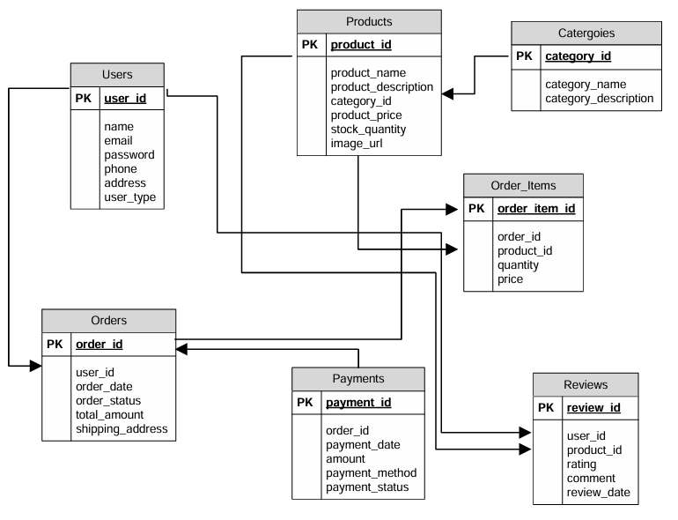

**Question7: What is a data flow diagram? Draw a data flow diagram to represent the in-flow and out-of-flow of data when a Farmer is placing an order for the product.**

**Answer:**

**Data flow diagram** is a graphical representation that shows how data moves within a system. It illustrates the inputs, processes, data stores and outputs making it easier to understand how information flows from one entity to another. DFD’s are widely used in system analysis and design to visualize data processes and the way information is handled, stored and transmitted between different system components.

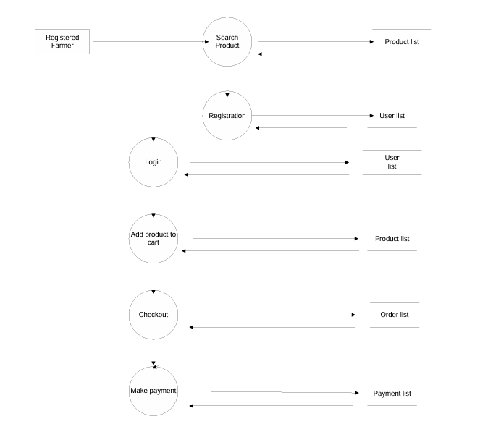

**Question 8: Change Request.**

**Due to a change in the Government Taxation structure. We should change the Tax structure. How do you handle change requests in a project?**

**Answer:**

1. **Understand the scope of change:** The first step is to understand the nature and scope of the requested change. This involves:

* Engaging with the requestor (Mr. Henry, Peter, Kevin and Ben) to clarify the changes
* Identifying why the change is needed, its objectives
* Defining what exactly needs to be changed. Modifying the tax structure due to new government policies might require changes to product pricing calculations, payment gateways and end user documentation

1. **Do the impact analysis:** Once the scope is understood, conduct a thorough impact analysis to evaluate the following:

* Budget and Resources: Assess the additional cost implications (development, testing, deployment) and availability of resources such as developers (Juhi, Teyson) and testers (Jason and Alekya)
* Timeline: Determine how the change will affect the project schedule. Will it extend the project timeline
* Risk assessment: Identifying potential risks such as bugs raising from the tax changes

1. **Prioritize change request:** Once the impact is assessed, prioritize the change request based on:

* Urgency: Is it critical for compliance or is in optional enhancement
* Value: Will the change provide significant value to stakeholders or users
* Effort: Is the change feasible given the project’s current phase and available resources
* Dependencies: Are there other features dependent on this change?
* In this scenario, changes to taxation should be treated as high priority since they are compliance related and can directly impact financial transactions.

1. **Seeking approval from the project:** After prioritizing, present the change to the project stakeholders for the approval. This involves:

* Preparing a formal change request document outlining the scope, impact, priority, cost and timeline of the change.
* Organizing a change review meeting with key stakeholders (Mr. Henry, Peter, Kevin, Ben) and team members to discuss the change.
* Stakeholders will decide whether to approve the change or defer it to a later phase.

1. **Communicate the change request:** Once approved, communicate the change across all relevant stakeholders to ensure alignment. This includes:

* Internal team: Inform developers, testers, and other project members of the approved change and provide necessary documentation (e.g. updated tax calculations).
* Stakeholders: Keep stakeholders (Peter, Kevin, Ben) informed about the changes impacts, timeline and expected outcome.
* End users: If required, communicate with farmers and manufacturers about updates in pricing or tax related information.

**Question 9: – Change Request Vs an Enhancement.**

**As the project is in progress, Ben and Kevin have contacted you. The reason is to inform you that they want the Farmers to sell their crop yields through this application i.e. Farmers should be able to add their crop yields or products and display to public and should be able to sell them. They also want to introduce Auction system for their Crop yields. As a BA, what will be your response?**

**Answer:**

**Change request:** A change request is a formal proposal to modify a project, product, process or system. It is typically used in project management and software development to handle modifications and improvements. A Change Request can be raised at any point during a project’s lifecycle, whether it’s due to new requirements, unforeseen issues, or the need for enhancements.

**Enhancement:** It refers to improvements or additions made to the software after its initial release. These changes are aimed at increasing the software value, performance or functionality based on evolving business needs, user feedback or technological advances.

Farmers should be able to add their crop yields or products and display them to public and should be able to sell them - Is an enhancement as its new addition to the project.

To handle new requirements, follow the following:

* **Stakeholder analysis:** Identify relevant stakeholders through RACI matrix
* **Requirement gathering:** Conducting a meeting with stakeholders (Kevin and Ben) to gather requirements for new functionality. This involves understanding the features such as farmers adding and managing their crop yields, display of products to the public and implementation of the auction.
* **Impact analysis**: Analyzing the impact of new requirements (enhancements) on existing project scope, timeline, budget and resources. This assessment would help determine the feasibility and potential implications of incorporating the requested features.
* **Documentation and Communication:** Document the detailed requirements, and changes in the project scope, seek approval from stakeholders and communicate to the project team, stakeholders to ensure everyone is aware of the proposed enhancements and their implications
* **Evaluation and Prioritization:** Working with the stakeholders and project team to evaluate risk involved and prioritize the requested enhancements. Evaluation My involve factors such as benefits, impact on project, alignment with business objective and available resources.

**Question 10: Come up with estimations – How many Manhours required**

**Answer:**

**Team Members involved in this project:**

* Project Manager - Mr. Vandanam
* Senior Java Developer - Ms. Juhi
* Java Developers - Mr. Teyson, Ms Lucie, Mr. Tucker, Mr. Bravo
* Network Admin – Mr. Mike
* DB Admin – Mr. John.
* Testers – Mr. Jason and Ms Alekya
* BA – Shruthi

Total resources: 12

Working hours a day = 8 hours

Duration = 18 months = 548 days

Exclude weekends: 156 days

Exclude public holidays: 12 days

Total working days: 380 days

Approx man hours: 8 hours * 12 resources * 380 days = 36480-man hours

**Question 11: Explain the UAT process**

**Answer:**

1. **Planning:** This phase involves strategizing UAT process. Key tasks include:

* Defining the scope of UAT by identifying which features for functionalities will be tested
* Preparing a UAT plan that includes timeline, objectives, deliverables and resources.
* Identifying the test environment and gathering the test data that is relevant for testing scenarios

1. **Designing:** In this stage, the focus is on creating detailed test cases based on user stories or requirements. Activities include:

* Developing clear and concise test scripts to cover all possible scenarios, including edge cases.
* Prioritizing test cases to focus first on critical features.

1. **UAT testers:** UAT testers are often end users or representative of the target audience. Their role is critical to ensure the product meets real world requirements. Their responsibilities include:

* executing test cases designed in early stage
* Providing feedback on usability, functionality and performance
* Reporting any anomalies, defects or deviations from expected results

1. **Bug fixing:** Any issues identified during UAT are logged and prioritized for resolution. This phase involves:

* Communicating defects to the development team.
* Retesting after fixes is applied to ensure that the identified issues are resolved
* Verifying that no new defects have been introduced during the bug fixing process

1. **Sign off:** Thie final step is achieving formal approval for the release of the product. This involves:

* Compiling a UAT summary report, outlining the test results and any unresolved issues
* Gaining sign off from stakeholders, confirming that the product is ready for deployment.
* Transitioning the product from testing to the production environment

**Question 12: What is a project closure document and what points should be included in it?**

**Answer:**

A project closure documents, also known as a project closure report – is a formal document that summarizes the key outcomes, lessons learned and final details of a completed project.

It serves as a comprehensive record of the project’s accomplishments, challenges and overall performance, providing valuable insights for stakeholders and future projects.

The project closure document includes the following:

1. **Project overview:** This section provides an overview of the project, including its project objectives, scope and stakeholders involved. It summarizes the project’s purpose and sets the context of the closure report.
2. **Achievements**: Highlights of the project’s success, including milestones reached and goals and goals accomplished.
3. **Lessons learned:** Insights gained from the project, including best practices and areas of improvements.
4. **Quality assurance:** Evaluation of the project’s adherence to quality standards and any audits conducted.
5. **Resource utilization:** Analysis of how resources (times, budget, personnel) were allocated and used
6. **Risk management:** Review of risk encountered, mitigation strategies applied, and their effectiveness
7. **Challenges**: Identification of obstacles faced during the project and how they were addressed.

|  |  |  |  |
| --- | --- | --- | --- |
| **Serial No.** | **Points to Include** | **Details** | **Reference link** |
| **1** | **Did the client sign off on the UAT testing** |  | Business_Scope.doc |
|  | Date of Signoff | 25 Mar 2025 |  |
|  | Name of the resource | Shruthi |  |
| **2** | **Objectives of the project** |  |  |
|  | User friendliness | Achieved |  |
|  | Customer satisfaction | ROI (Return of Investment) in 6 to 12 months |  |
|  | More Categories | Achieved |  |
| **3** | **Functionalities worked on** |  |  |
|  | Secured payment process | Achieved |  |
|  | Product shipment | Achieved |  |
| **4** | **Infrastructure** |  |  |
|  | Software installed | Achieved |  |
|  | Laptops purchased | Achieved |  |
| **5** | **Funding** |  |  |
|  | Amount approved | 2 crores |  |
|  | Amount used | 2 crores |  |
| **6** | **Overall project information** |  |  |
|  | Escalations | 30 |  |
|  | Customer satisfaction | High |  |
| **7** | **Value to the company** |  |  |
|  | Positive/Negative | Company has gained successful integration of processes, increased turnover by 25%, increased efficiency by 20% |  |
|  |  |  |  |