**Question 1**

Functional Requirements

**Answer**

|  |  |  |  |
| --- | --- | --- | --- |
| **Req ID** | **Req Name** | **Req Description** | **Priority** |
| FR0001 | Farmer registration | Farmers should be able to register with the application | 9 |
| FR0002 | Farmer search for products | Farmers should be able to search for available products in fertilizers, seeds, pesticides | 9 |
| FR0003 | Products search | Farmers should be able to find products by searching for required product | 8 |
| FR0004 | Products details | The application should display detailed information about each product, including, descriptions, specifications, and pricing | 9 |
| FR0005 | Product Wishlist | Customer should able to add their products to the wishlist for future buying and should able to remove it | 7 |
| FR0006 | Payment gateway | Platform should facilitate with different payment methods to perform secure transactions | 8 |
| FR0007 | Placing the order | The customer should able to place the selected order with quantity and address | 8 |
| FR0008 | Adding address | Customer should have option to add different address to place the order at different location | 7 |
| FR0009 | Buying the products | Customer should able to buy multiple products at a time by adding to the cart | 8 |
| FR0010 | Order confirmation | Customer should receive an order confirmation with details which contain product quantities, amount, delivery date | 9 |
| FR0011 | Tracking Order | Customer should able to track the order | 7 |
| FR0012 | Customer support | The customers should able to contact customer service or through e-mail, chat for their order | 8 |
| FR0013 | Product cancellation | Customer should able to cancel the product | 7 |

|  |  |  |  |
| --- | --- | --- | --- |
| NFR0101 | Page loading time | Each Page should load within 2 seconds time | 9 |
| NFR0102 | WCAG 2.1. | WCAG 2.1.  The system must meet Web Content Accessibility  Guidelines WCAG 2.1. | 8 |
| NFR0103 | Performance | The system should able to load at high speed | 8 |
| NFR0104 | compatibility | The system should work with a wide range of devices | 7 |
| NFR0105 | Maintainability | The system should be updated overtime | 8 |
| NFR0106 | Usability | The customer should able to navigate easily | 8 |
| NFR0107 | Security | System should keep the customers data safely | 9 |

**Question 2**

Minimum 5 page designs

**Answer**

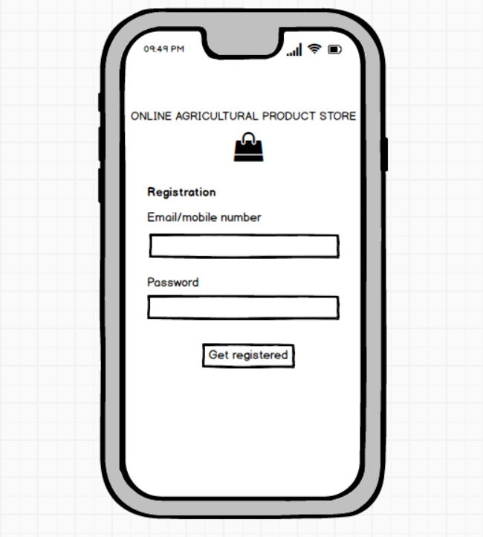 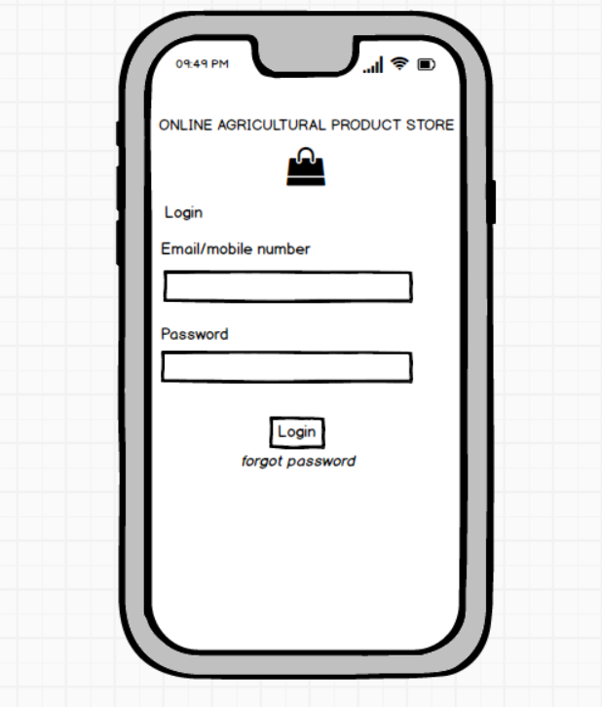

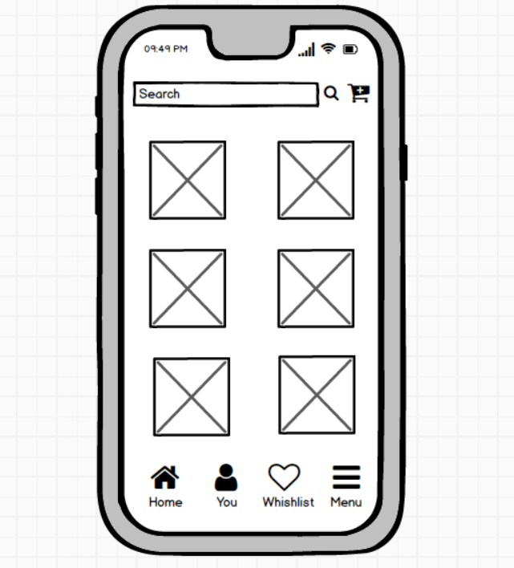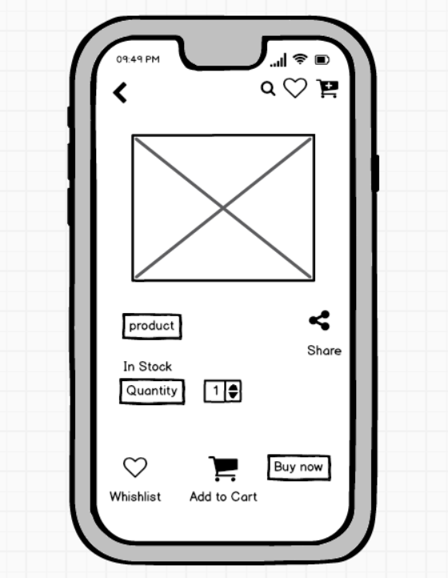

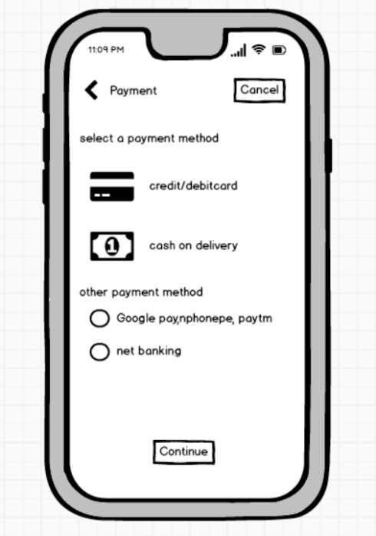

**Question 3**

Tools (Visio, Balsamiq)

**Answer**

* **Microsoft Visio**

Microsoft Visio is a diagramming and vector graphics application used to create diagrams, flowcharts, and other visual representations of complex information. It is designed to help users create a wide range of visual representations of information, processes, systems, and more. some key features of Microsoft Visio are diagram type, templates and shapes, stencils, Smart shapes etc.

* **Balsamiq**

Balsamiq is a wireframing and mockup tool that is widely used for design and software development. It allows you to create low-fidelity wireframes and prototypes quickly and easily.

* **Axure RP**

Axure RP is a powerful prototyping tool used in the field of user experience design, interaction design, and product development. It enables you to create interactive and dynamic prototypes for websites and applications. It offers advanced features for creating complex interactions and user flows.

**Question 4**

RTM

**Answer**





**Question 5**

10 Test Case Documents

**Answer**

**Test case 1: Farmer registration**



**Test case 2: Farmer login**



**Test case 3: product catalog**



**Test case 4: search product**



**Test case 5 : wishlist**



**Test case 6: Add to cart**



**Test case 7: Adding shipping details**



**Test case 8 : Payment process**



**Test case 9: Order Tracking**



**Test case 10: Return and exchange**



**Question 6**

DB Design

**Answer**

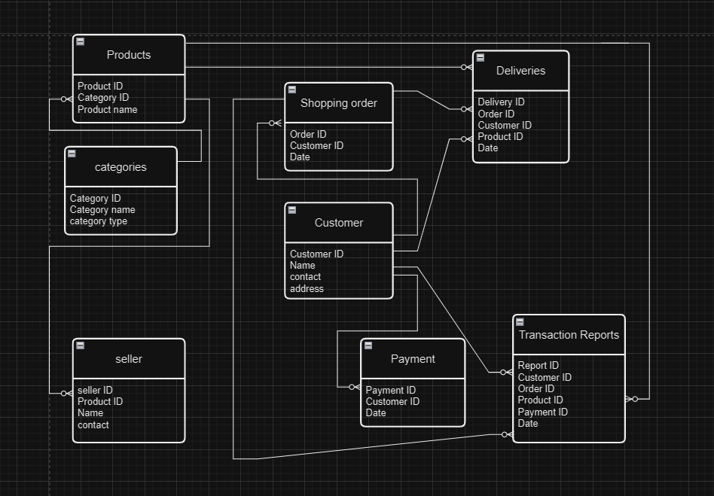

**Question 7**

Data Flow Diagram

**Question 8**

Change Request

**Answer**

Handling change requests in a project involves a systematic process to ensure that changes are effectively managed while minimizing disruption to the project's scope, timeline, and resources. Here are the steps typically followed to handle change requests:

1. Change Request Identification: Identifying and document the change request, includes specific details of the requested change, the reason for the change, and its potential impact on the project.

2. Change Impact Analysis: Assess the impact of the change on various aspects of the project, such as scope, timeline, cost, resources, and risks. Evaluating the feasibility and implications of implementing the change.

3. Change Evaluation: Reviewing the change request with key stakeholders, including project sponsors, clients, and relevant team members. Discussing the potential benefits, risks, and trade-offs associated with the change.

4. Change Prioritization: Prioritizing the change request based on its urgency, impact, and alignment with project goals. Determining whether the change is critical and must be implemented immediately or can be scheduled for a future phase or release.

5. Change Approval: Obtaining formal approval from the appropriate stakeholders, such as project sponsors or change control boards. Ensuring that all stakeholders are in agreement regarding the change and its implications.

6. Change Implementation: Incorporate the approved change into the project plan, including any necessary adjustments to the scope, schedule, budget, or resources. Updating project documentation, such as requirements, design, and test plans, to reflect the approved change.

7. Change Communication: Communicate the approved change to all relevant parties, including team members, clients, and other stakeholders. Explaining the reasons for the change, its impact on the project, and any adjustments to expectations or deliverables.

8. Change Tracking and Documentation: Tracking and documenting all approved changes, including the rationale, approvals, and implemented modifications. Maintaining a change log or change register to ensure transparency and accountability throughout the project.

9. Change Control and Monitoring: Monitoring the impact of implemented changes on the project's progress, risks, and quality. Maintaining open lines of communication with stakeholders to address any concerns or issues related to the approved changes.

**Question 9**

Change Request Vs an Enhancement

Answer

As a business analyst, my response to the request would be to classify it as an enhancement instead of a change request. A change request typically involves modifying the existing functionality or requirements, while an enhancement introduces new features or capabilities that were not initially specified.

In this case, the request to allow farmers to add their crop yields, display them to the general public, and enable selling through the application represents an enhancement because it introduces new functionality that goes beyond the initial scope of the project.

The introduction of an auction system for crop yields adds another layer of functionality to the application. To handle the change request

1. Requirement Gathering: I would meet with Ben and Kevin to gather detailed requirements for the new functionality. This involves understanding the specific features they envision, such as the process for farmers to add and manage their crop yields, the display of products to the public, and the implementation of the auction system.
2. Impact Analysis: I would analyze the impact of these enhancements on the existing project scope, timeline, budget, and resources. This assessment would help determine the feasibility and potential implications of incorporating the requested features.
3. Stakeholder Analysis: I would identify and involve relevant stakeholders, such as the project sponsor, development team, and other key personnel, to assess their perspectives and gather their inputs on the potential enhancements.
4. Documentation and Communication: I would document the detailed requirements and changes in the project scope, and communicate them to the project team, stakeholders, and any other parties involved. This would ensure everyone is aware of the proposed enhancements and their implications.
5. Evaluation and Prioritization: I would work with the project team and stakeholders to evaluate the value and priority of the requested enhancements. This evaluation would consider factors such as the potential benefits, impact on project goals, alignment with business objectives, and available resources.
6. Planning and Execution: If the enhancements are deemed feasible and approved, I would update the project plan, schedule, and resources accordingly. I would collaborate with the development team and other stakeholders to incorporate the new features into the application, ensuring proper testing and quality assurance.

**Question 10**

Estimations

Answer

Estimating the number of man-hours required for the requested enhancements (adding crop yields, displaying them to the public, and implementing an auction system) would depend on various factors, including the complexity of the features, the size of the existing system, the development team's expertise, and the development methodology used. Without specific details about the project, it's challenging to provide an accurate estimation.

1. Requirement Gathering and Analysis: 10-20 man-hours

This includes meetings with stakeholders, gathering detailed requirements, analyzing the impact, and documenting the enhancements.

1. Design and Architecture: 20-40 man-hours

This involves designing the system components, database structure, and user interface for the new features. It also includes identifying the necessary changes to accommodate the enhancements.

1. Development and Coding: 40-80 man-hours

The actual development of the new features, including backend and front end coding, integration with existing modules, and implementation of the auction system.

1. Testing and Quality Assurance: 20-40 man-hours

This phase involves writing test cases, performing unit testing, integration testing, and ensuring the proper functioning and stability of the added features.

1. Deployment and User Acceptance Testing (UAT): 10-20 man-hours

Deploying the updated system to a testing environment, conducting user acceptance testing, and resolving any issues identified during UAT.

1. Documentation and Training: 10-20 man-hours

Documenting the new features, updating user manuals or guides, and providing training or support materials for farmers and users. It's important to note that these estimations are rough figures and can vary significantly depending on the complexity and scale of the enhancements, the team's productivity, and other project-specific factors. It's recommended to involve the development team in the estimation process to get a more accurate assessment based on their expertise and knowledge of the project.

**Question 11**

UAT

**Answer**

To handle the situation of testing the final product and successfully completing it, the business analyst can follow these steps:

1. UAT Planning: Prepare a plan for User Acceptance Testing (UAT) in consultation with the client. This plan should include the scope of testing, test scenarios, test data, and timelines.

2. Test Environment Setup: Ensure that the required test environment is set up and available for the client to perform testing. This may include providing access to the testing environment, necessary test accounts, and any additional resources needed for testing.

3. Test Execution: Coordinate with the client to execute the planned test scenarios. Monitor the testing progress, provide support for any questions or issues that arise, and track the test results.

4. Defect Management: If any defects are identified during UAT, work closely with the client to understand the issues, document them, and track their resolution. Collaborate with the development team to address the reported defects and verify their fixes.

5. UAT Sign-off: Once the client has completed testing and is satisfied with the product's functionality, obtain their formal sign-off or approval. This indicates that the client has accepted the final product and is ready to move forward with its deployment.

Regarding the process to close the project, it typically involves the following steps:

1. Final Documentation: Ensure that all project-related documentation is complete, including requirements, design documents, test cases, and user manuals. Review and update these documents to reflect the final product.

2. Project Review: Conduct a project review meeting with key stakeholders, including the client, to discuss the overall project performance, achievements, and lessons learned. Gather feedback and suggestions for improvement.

3. Project Closure Report: Prepare a project closure report summarizing the project's objectives, deliverables, timeline, budget, and overall success. Include any important metrics or performance indicators.

4. Handover or Deployment: Coordinate with the necessary teams, such as deployment or operations, to ensure a smooth transition of the final product to the production environment. Provide any necessary training or documentation to support the deployment process.

5. Post-Project Evaluation: After the product is deployed and operational, conduct a post-project evaluation to assess its performance, gather user feedback, and identify any areas for further improvement.

UAT Acceptance Process: The User Acceptance Testing (UAT) Acceptance process involves the following steps:

1. Test Planning: Define the scope of UAT and identify the key features or functionalities to be tested. Prepare test scenarios and test cases based on user requirements.

2. Test Execution: Perform the planned test scenarios, following the test cases provided. Validate the system's behavior against the expected outcomes and verify that it meets the user's acceptance criteria.

3. Defect Reporting: If any issues or defects are identified during UAT, document them in a structured manner, including detailed steps to reproduce the problem. Communicate the issues to the development team for resolution.

4. Defect Resolution: Collaborate with the development team to address there ported defects. Verify the fixes provided by the development team and retest the affected areas.

5. Sign-off: Once all test scenarios have been executed, defects have been resolved, and the system meets the user's acceptance criteria, provide formal sign-off or approval. This signifies that the client accepts the product as meeting their requirements.

6. UAT Closure: Document the UAT results, including the test execution summary, any outstanding issues, and the overall assessment of the product.

Communicate the closure of UAT to all stakeholders involved in the testing process. The UAT Acceptance process ensures that the final product meets the client's expectations and is ready for deployment. It serves as a final validation before the project is considered complete and ready for closure.

**Question 12**

Project Closure Document

**Answer**

1. Project Overview: This section provides an overview of the project, including its objectives, scope, and stakeholders involved. It summarizes the project's purpose and sets the context for the closure report.

2. Project Achievements: Here, the document highlights the key achievements and deliverables of the project. It outlines the successful completion of milestones, tasks, and any significant accomplishments that were achieved.

3. Project Timeline and Budget: This section provides an overview of the project timeline, highlighting the start and end dates, major phases, and milestones. It also includes information on the project's budget, including any significant deviations or changes.

4. Lessons Learned: The lessons learned section reflects on the project's successes and challenges. It includes a comprehensive analysis of what worked well and what could have been improved. It highlights valuable insights and recommendations for future projects.

5. Stakeholder Feedback: This section gathers feedback from key stakeholders involved in the project. It includes their opinions, suggestions, and any concerns they may have expressed. The feedback helps in assessing the overall satisfaction and identifying areas for improvement.

6. Risks and Issues: The closure document discusses the risks and issues encountered throughout the project. It outlines the actions taken to mitigate these risks and resolve any issues that arose during the project's lifecycle.

7. Project Performance: This section evaluates the project's performance against the defined objectives and success criteria. It assesses factors such as scope adherence, timeline adherence, budget performance, quality of deliverables, and customer satisfaction.

8. Project Sign-off: The closure document includes formal sign-off or approval from key stakeholders, indicating their acceptance and satisfaction with the project's outcomes. This signifies the official closure of the project.

9. Project Documentation: This section provides an overview of the project documentation, including the list of documents produced, their location, and accessibility for future reference.

10.Next Steps and Recommendations: The closure document outlines any recommended actions or next steps following the project's closure. It may include suggestions for further improvements, additional tasks, or follow-up activities.