**Assignment 1:**

**Business Required Document:**

1. **Document Revisions**:

A table is included to track revisions, listing the version number, date, and changes made to the document.

|  |  |  |
| --- | --- | --- |
| Date | Version Number | Document Changes |
| 20/10/2024 | 0.1 | Initial Draft |
| 21/10/2024 | 0.2 | Revised based on stakeholder feedback |
| 22/10/2024 | 0.3 | Updated with additional requirements and risk assessments |
| 23/10/2024 | 1.0 | Final version ready for sign-off |
| 24/10/2024 | 1.1 | Minor updates post-UAT feedback |

1. **Approvals**:
   * A table is created to record the names, titles, signatures, and approval dates of key stakeholders responsible for signing off the document. The roles include:

|  |  |  |  |  |
| --- | --- | --- | --- | --- |
| Role | Name | Title | Signature | Date |
| Project Sponsor | Mr. Raja Shekhar | Dairy factory Operations Lead | Mr. Raja Shekhar | 25/10/2024 |
| Business Owner | Mr. Raja Reddy | Chief Operations Officer | Mr. Raja Reddy | 25/10/2024 |
| Project Manager | Mr. Nuthan | IT Department Lead | Mr. Nuthan | 25/10/2024 |
| System Architect | Mr. Pavan | Senior IT Architect | Mr. Pavan | 25/10/2024 |
| Development Lead | Mr. Vijay | Development Team Lead | Mr. Vijay | 25/10/2024 |

1. **RACI Chart**:
   * **Responsible (R)**: The individual responsible for producing the document.
   * **Accountable (A)**: The person accountable for the accuracy and completion of the document (e.g., the Project Manager).
   * **Support (S)**: The individuals or teams providing supporting services during the creation of the document.
   * **Consulted (C)**: Individuals who provide input (e.g., stakeholders, subject matter experts).
   * **Informed (I)**: Individuals who are informed of changes or updates.

|  |  |  |  |  |  |  |
| --- | --- | --- | --- | --- | --- | --- |
| **Name** | **Position** | **Responsible** | **Accountable** | **Support** | **Consulted** | **Informed** |
| Project  Sponsor | Dairy Parlour operations lead |  | X |  |  | X |
| Project manager | IT lead | X |  |  | X |  |
| Business analyst | Business analyst | X |  |  | X | X |
| System Architect | IT architect |  |  | X | X |  |
| Development  lead | Team Lead | X |  |  | X |  |
| User experience  lead | UI/UX |  |  | X | X |  |
| Quality lead | QA lead | X |  |  | X |  |
| Operations | Operations Department |  |  | X |  | X |
| Employees | End users |  |  |  | X |  |

**4.1 Business Goals**

1. **Streamline Inventory Management**: Implement a system that tracks stock levels in real-time to reduce delays in product availability, improving service reliability.
2. **Enhance Communication with Marketers**: Facilitate direct and timely communication with Dairy Parlour marketing professionals to ensure they have access to updated information on product availability, thus supporting more informed prescribing practices.
3. **Reduce Operational Costs**: Minimize manual tasks by automating inventory updates, order tracking, and supplier notifications, which will reduce overhead and increase process efficiency.
4. **Improve Product Availability**: Ensure that products are always in stock and available when needed, reducing the chances of stockouts that could disrupt Dairy Parlour delivery.
5. **Support Data-Driven Decision Making**: Provide insights into product demand, trends, and usage patterns to support strategic decisions and improve inventory planning.

**4.2 Business Objectives**

1. **Develop a Mobile-Friendly System**: Create a user-friendly mobile application for iOS and Android, enabling marketing professionals and staff to check inventory status and place orders anytime, anywhere.
2. **Integration with Existing Systems**: Ensure seamless integration with the existing HRMS (Human Resource Management System) for personnel management and an E-Learning Management System for training needs.
3. **Automate Notifications and Alerts**: Set up automatic alerts for low stock, expiring products, and order status updates, reducing manual follow-up.
4. **Centralize Data Management**: Consolidate inventory data in one system, improving data consistency and accessibility across departments.
5. **Enable Customizable Reporting**: Provide customizable reporting options that allow stakeholders to generate detailed reports on stock levels, usage trends, and ordering history to improve inventory forecasting.

**4.3 Business Rules**

1. **User Access Control**: Ensure that only authorized users have access to specific features, with roles defined for administrators, users, and external parties like suppliers, following data privacy policies.
2. **Compliance with Dairy Parlour Regulations**: Maintain adherence to Dairy Parlour industry standards, including data protection laws and privacy regulations, ensuring the system is secure and compliant.
3. **Inventory Threshold Alerts**: Set inventory thresholds that trigger automated alerts to notify relevant users when stock levels reach a minimum quantity.
4. **Order Approval Workflow**: Implement approval workflows for high-volume or high-cost orders, with specified levels of authorization required before processing.
5. **Data Retention Policies**: Follow data retention policies to ensure that inventory and order history data are stored securely for a defined period and deleted according to compliance requirements.

**4.4 Background**

1. **Current Inefficiencies in Manual Processes**: Describe how manual tracking has led to delays, errors, and inconsistencies in stock data, resulting in poor product availability.
2. **Need for Real-Time Information**: Highlight the demand from Dairy Parlour professionals for real-time access to inventory information to make informed decisions and avoid product shortages.
3. **Increased Operational Costs**: Explain the cost implications of manual labour involved in tracking inventory, processing orders, and updating stock information.
4. **Growing Demand for Automation**: Emphasize the rising need for automation to meet the increasing volume of orders and stock management requirements.
5. **Expected Benefits of Automation**: Outline the anticipated improvements in accuracy, efficiency, and cost savings that a software-based inventory system would bring.

**4.5 Project Objective**

1. **Deliver an Integrated Inventory Solution**: Develop and implement a centralized inventory management system that supports seamless communication with marketing professionals and suppliers.
2. **Enhance User Accessibility**: Provide a responsive, easy-to-use platform accessible from both desktop and mobile devices for on-the-go inventory management.
3. **Enable Real-Time Data Updates**: Ensure the system can update stock levels in real-time to provide accurate information to all users, including inventory staff and Dairy Parlour providers.
4. **Support Data Analytics for Better Forecasting**: Enable the system to capture data and produce analytical reports, improving inventory planning and reducing stockouts.
5. **Integrate Approval and Notification Workflows**: Include workflows for order approvals and automatic notifications, making the ordering and restocking processes more efficient.

**4.6 Project Scope**

**4.6.1 In-Scope Functionality**

1. **Real-Time Inventory Tracking**: Implement a system that allows for immediate tracking of product stock levels, avoiding the need for manual counts.
2. **Automated Notifications and Alerts**: Set up alerts for low stock, new orders, and deliveries, ensuring users are informed of critical updates.
3. **Order Management**: Enable users to place, track, and manage orders directly within the system, reducing manual intervention.
4. **Reporting and Analytics**: Provide tools to generate various reports on inventory status, product usage, and order history to support decision-making.
5. **Doctor Communication Portal**: Develop a portal within the system where marketing professionals can view available stock and submit product requests, reducing the need for phone or email interactions.

**4.6.2 Out-Scope Functionality**

1. **Advanced Data Analytics**: Exclude complex analytics functions, such as predictive analytics beyond basic forecasting.
2. **Patient Data Integration**: Avoid integration with patient management systems to maintain a focused inventory solution.
3. **Cross-Departmental Integration Beyond Inventory**: Exclude integration with non-inventory departments (e.g., finance) to keep the system streamlined.
4. **Customization for Each Doctor**: Provide a standardized interface without custom options for each doctor to simplify development and support.
5. **Complex Supplier Management Beyond Reordering**: Limit supplier management to basic reordering functionalities rather than comprehensive supplier relationship management.

**5. Assumptions**

1. **Infrastructure Availability**: Assume that the necessary IT infrastructure, including servers and network systems, will be available and meet performance standards.
2. **Data Integrity**: Assume existing data is accurate and can be migrated without major issues, ensuring a smooth transition to the new system.
3. **Staff Training**: Assume that staff will be available for training sessions to ensure they are fully prepared to use the new system.
4. **Stakeholder Engagement**: Assume continuous engagement from key stakeholders, including Dairy Parlour marketing professionals and inventory managers, for feedback and testing.
5. **Timely Vendor Support**: Assume vendors will provide timely support for technical issues during the development, testing, and deployment phases.

**6. Constraints**

1. **Budget Constraints**: Project funding is limited, which restricts additional features beyond the core requirements, focusing on essential inventory management functionalities.
2. **Time Constraints**: The project must be completed within a set timeframe, which impacts the scope of development and testing cycles.
3. **Compliance and Regulatory Requirements**: The system must adhere to Dairy Parlour data privacy regulations, which may impact design and development timelines.
4. **Limited Availability of End-Users for Testing**: Marketing professionals and staff may have limited availability for extensive testing, which could affect user acceptance testing (UAT) timelines.
5. **Dependency on Third-Party Vendors**: Reliance on third-party vendors for specific components, such as barcode scanning hardware, may impact project timelines if there are delays in procurement or integration.

**7. Risks**

* **Technological Risks**:
  1. Compatibility issues with the existing IT infrastructure may arise during integration.
  2. Potential delays in system response time due to increased data traffic.
  3. Security risks such as data breaches or unauthorized access need to be addressed.
  4. Insufficient support for mobile compatibility might hinder doctor accessibility.
  5. Unforeseen technical issues with automation features may delay deployment.
* **Skills Risks**:
  1. Limited internal expertise for managing new technology may require additional training.
  2. Reliance on specialized developers for system customization could pose delays.
  3. Dependency on third-party support for troubleshooting may impact system stability.
  4. Insufficient knowledge of Dairy Parlour regulations might lead to compliance issues.
  5. High learning curve for users, especially for those less tech-savvy, may delay adoption.
* **Political Risks**:
  1. Resistance from staff due to changes in established workflows may reduce system adoption.
  2. Conflicts between departments regarding resource allocation for the new system.
  3. External influences from regulatory bodies affecting project scope or timelines.
  4. Resistance to process transparency due to the automated nature of tracking.
  5. Prioritization of other projects might lead to delays in this project’s timeline.
* **Business Risks**:
  1. High investment cost without immediate return might impact business perception.
  2. Risk of project delays affecting product availability for Dairy Parlour providers.
  3. Failure to meet Dairy Parlour requirements could damage business reputation.
  4. Dependence on the system’s effectiveness for stock availability might cause stockouts.
  5. Potential increase in operational costs if the system requires extensive support.
* **Requirements Risks**:
  1. Misinterpretation of end-user needs could lead to system features that don't meet expectations.
  2. Ambiguity in requirement details may cause incomplete functionality.
  3. Changing requirements during development could affect project timelines and budget.
  4. Overlooked key requirements may result in rework and increased costs.
  5. Requirement gaps may lead

**8. Business Process Overview**

**8.1 Legacy System (AS-IS)**

1. **Manual Inventory Tracking**: Stock levels are updated manually through spreadsheets or paper records, leading to data inaccuracies and inefficiencies.
2. **Delayed Communication with Marketing professionals**: Marketing professionals rely on calls or emails to inquire about product availability, resulting in slow responses and delayed prescriptions.
3. **Fragmented Supplier Management**: Communication with suppliers is manual, often leading to delayed stock replenishment and product shortages.
4. **Infrequent Stock Audits**: Inventory checks are done periodically rather than continuously, increasing the chances of stockouts or overstocking.
5. **Limited Reporting**: Reporting is limited to manual data entry, making it difficult to generate timely, accurate reports on inventory levels, trends, and product movement.

**AS IS DIAGRAM:**

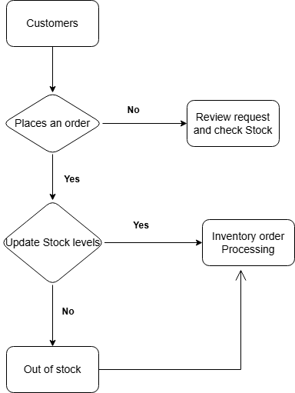

**8.2 Proposed Recommendations (TO-BE)**

1. **Automated Inventory Tracking**: Implement real-time tracking with automated updates to improve data accuracy and availability.
2. **Direct Communication Portal for Marketing professionals**: Introduce a portal where marketing professionals can view stock levels and place orders, reducing reliance on manual contact.
3. **Integrated Supplier Communication**: Automate supplier interactions, enabling prompt reordering and efficient stock management.
4. **Continuous Stock Audits**: Set up automated auditing features that regularly check stock levels to prevent discrepancies.
5. **Comprehensive Reporting and Analytics**: Implement automated reporting to provide timely insights on inventory trends, forecasts, and consumption patterns.

**TO BE DIAGRAM:**

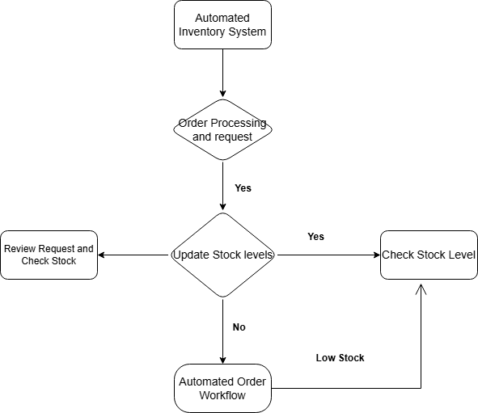

**9. Business Requirements**

* **Inventory Tracking Requirements**: The system should monitor stock levels in real-time, providing alerts for low or critical stock levels.
* **Order Management Requirements**: Enable users to place, track, and approve orders efficiently within the system.
* **User Access and Security**: Provide secure access based on user roles, ensuring data protection and compliance with Dairy Parlour regulations.
* **Supplier Management**: Automate communications with suppliers to streamline restocking processes and prevent stockouts.
* **Analytics and Reporting**: Allow the system to generate customizable reports on stock levels, order history, and inventory trends to aid decision-making.

**10. Appendices**

**10.1 List of Acronyms**

* **BRD**: Business Requirements Document
* **FRS**: Functional Requirements Specification
* **HRMS**: Human Resource Management System
* **UAT**: User Acceptance Testing
* **API**: Application Programming Interface

**10.2 Glossary of Terms**

* **Inventory Management System**: Software used to track and manage stock levels, orders, and supplier relationships.
* **Stakeholders**: Individuals or groups who have an interest in the project, such as marketing professionals, suppliers, and internal teams.
* **Real-Time Tracking**: System capability to update information instantly as changes occur.
* **Automated Notifications**: System-generated alerts sent to users for specific events like low stock or pending orders.
* **User Acceptance Testing (UAT)**: Testing phase in which end-users validate that the system meets their requirements.

**10.3 Related Documents**

* **Business Case Document**: Justification for the project, outlining the value and ROI.
* **Requirement Traceability Matrix**: Document linking requirements to testing phases and final delivery.
* **Project Plan**: Timeline and milestones for project phases, including development, testing, and deployment.
* **Stakeholder Analysis Report**: Analysis of stakeholder roles, interests, and engagement strategies.
* **Training Plan**: Outline of training sessions, user manuals, and support resources for end-users.

**11. Project Assumptions**

1. **Timely Availability of Resources**: The project assumes that necessary resources, including personnel, software, and hardware, will be available on schedule.
2. **Stakeholder Support**: Key stakeholders, such as marketing professionals and inventory managers, will be engaged throughout the project lifecycle for feedback and testing.
3. **Stable Regulatory Environment**: The project assumes no changes to Dairy Parlour regulations that would impact the system design or functionality.
4. **Data Readiness for Migration**: It is assumed that the existing inventory data is accurate and prepared for migration to the new system.
5. **Vendor Reliability**: Vendors involved in the project will deliver services, support, and integrations as scheduled.

**12. Project Constraints**

1. **Budgetary Limitations**: The project must stay within a predefined budget, restricting additional features or adjustments.
2. **Fixed Timeline**: The project has a strict timeline, and delays in any phase could affect the overall schedule.
3. **Limited User Availability for Testing**: Marketing professionals and staff may have limited availability for testing and training, which could impact user acceptance testing (UAT).
4. **Regulatory Compliance**: Adherence to data security and privacy regulations in Dairy Parlour may impact system design and development processes.
5. **Technological Limitations**: Constraints based on the existing IT infrastructure may restrict certain functionalities or require additional resources.

**13. Project Risks**

**Technological Risks**

1. Integration challenges with existing systems may delay implementation.
2. Potential issues with system scalability if inventory expands rapidly.
3. Security vulnerabilities could lead to data breaches, impacting compliance.
4. Mobile compatibility may require additional testing and support.
5. System performance could be compromised under high usage.

**Skills Risks**

1. Limited availability of skilled developers for specific functionalities.
2. High learning curve for staff unfamiliar with new technology.
3. Dependency on third-party support for troubleshooting and maintenance.
4. Need for specialized training in Dairy Parlour data regulations.
5. Potential lack of expertise for managing data migrations.

**Political Risks**

1. Resistance to adopting a new system from staff accustomed to manual processes.
2. Resource allocation conflicts with other ongoing projects.
3. Stakeholder disagreements over system functionalities and priorities.
4. External influences from Dairy Parlour bodies may affect the timeline.
5. Resistance to data transparency and automated tracking.

**Business Risks**

1. High implementation costs without immediate ROI.
2. Delays in deployment could impact product availability.
3. Compliance issues may arise, impacting business operations.
4. Potential stockouts if the system malfunctions during rollout.
5. Additional operational costs if the system requires ongoing support.

**Requirements Risks**

1. Misinterpretation of stakeholder requirements could lead to functionality gaps.
2. Requirement changes mid-project could impact timelines and budget.
3. Failure to capture specific needs could lead to system redesign.
4. Ambiguous requirements may result in misaligned features.
5. Overlooked needs could lead to rework or additional development costs.

**14. Business Process Overview**

**Legacy System (AS-IS)**

* Manual order placement and inventory checks.
* Delays in restocking due to lack of automation.
* Heavy reliance on paper records and spreadsheets.
* Inconsistent reporting due to manual updates.
* Communication delays with marketing professionals about stock availability.

**Proposed System (TO-BE)**

* Automated order and inventory tracking.
* Real-time stock updates accessible to all users.
* Automated notifications for low stock levels.
* Centralized, accurate data with instant reporting.
* Improved communication channels for marketing professionals.

**15. Business Requirements**

* **Inventory Tracking**: Real-time updates and low stock notifications.
* **Order Management**: Enable efficient, automated order processing.
* **Role-Based Access**: Ensure secure access based on user roles.
* **Supplier Communication**: Automated supplier contact for stock replenishment.
* **Customizable Reporting**: Allow generation of detailed inventory reports.

**16. Appendices**

**List of Acronyms**

* **BRD**: Business Requirements Document
* **RTM**: Requirement Traceability Matrix
* **UAT**: User Acceptance Testing
* **API**: Application Programming Interface
* **ERP**: Enterprise Resource Planning

**Glossary of Terms**

* **Inventory Management**: The process of tracking stock levels, orders, and supplier details.
* **Stakeholders**: Individuals or groups with a vested interest in the project.
* **Real-Time Tracking**: System updates reflecting inventory changes instantly.
* **Automated Notifications**: Alerts generated by the system for critical updates.
* **UAT**: Testing conducted by end-users to ensure the system meets requirements.

**Related Documents**

* **Business Case Document**: Outlines the project’s value, ROI, and justification.
* **RTM**: Maps requirements to development phases and testing.
* **Project Plan**: Details timelines, milestones, and resource allocation.
* **Stakeholder Analysis**: Defines stakeholder roles and engagement strategies.
* **Training Plan**: Specifies training schedules, resources, and support material for end-users.

1. **Process Flow Diagram**

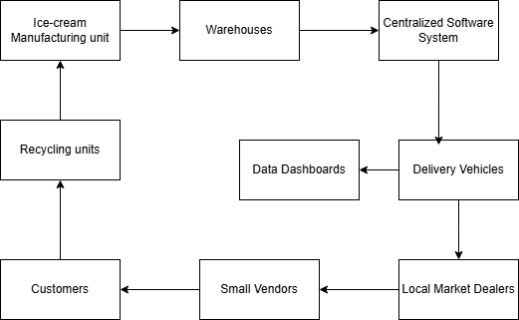

**Assignment 2:**

* 1. **Letter to Client and their Team**

Subject: Introduction as Your Business Analyst for the Home Service Provider Application

Respected City Craft Team,

I hope this message finds you well. My name is [Your Name], and I am excited to introduce myself as the Business Analyst assigned to collaborate with you and your team for the development of your home service provider application.

Understanding your vision and translating it into a successful application is my top priority. My role is to ensure that we thoroughly analyse your business requirements, identify your objectives, and align them with a practical and efficient solution. Throughout this journey, I will act as the bridge between your team and our technical experts to deliver a product that meets your expectations and exceeds your goals.

Over the coming weeks, I will work closely with you to understand:

* The key services you wish to offer through the application.
* The primary features and functionalities needed to enhance user experience.
* Any specific challenges or pain points you aim to address with this solution.

We will begin with a detailed business understanding process, which includes requirement-gathering sessions, stakeholder interviews, and an analysis of current workflows (if applicable). This process will enable us to create a clear roadmap for the application development and ensure alignment with your business objectives.

Please feel free to share any existing documentation, ideas, or concerns that can help us better understand your needs. I am here to listen, advise, and collaborate, ensuring a smooth and productive process.

I look forward to working with you and your team on this exciting project. Please let me know a convenient time for us to schedule our initial discussion.

Warm regards,

Akshay Vanathadupula

Business Analyst,

Emporia Solutions.

**Business Requirements Document (BRD)**

**Project Name: Online Ticketing System for Movie Bookings**

**Prepared By: [Akshay Vanathadupula]**

* 1. **Document Revisions**:

A table is included to track revisions, listing the version number, date, and changes made to the document.

|  |  |  |
| --- | --- | --- |
| Date | Version Number | Document Changes |
| 20/10/2024 | 0.1 | Initial Draft |
| 21/10/2024 | 0.2 | Revised based on stakeholder feedback |
| 22/10/2024 | 0.3 | Updated with additional requirements and risk assessments |
| 23/10/2024 | 1.0 | Final version ready for sign-off |
| 24/10/2024 | 1.1 | Minor updates post-UAT feedback |

* 1. **Approvals**:
  + A table is created to record the names, titles, signatures, and approval dates of key stakeholders responsible for signing off the document. The roles include:

|  |  |  |  |  |
| --- | --- | --- | --- | --- |
| Role | Name | Title | Signature | Date |
| Project Sponsor | Mr. Raja Shekhar | Block My Tickets Operations Lead | Mr. Raja Shekhar | 25/10/2024 |
| Business Owner | Mr. Raja Reddy | Chief Operations Officer | Mr. Raja Reddy | 25/10/2024 |
| Project Manager | Mr. Nuthan | IT Department Lead | Mr. Nuthan | 25/10/2024 |
| System Architect | Mr. Pavan | Senior IT Architect | Mr. Pavan | 25/10/2024 |
| Development Lead | Mr. Vijay | Development Team Lead | Mr. Vijay | 25/10/2024 |

* 1. **RACI Chart**:
  + **Responsible (R)**: The individual responsible for producing the document.
  + **Accountable (A)**: The person accountable for the accuracy and completion of the document (e.g., the Project Manager).
  + **Support (S)**: The individuals or teams providing supporting services during the creation of the document.
  + **Consulted (C)**: Individuals who provide input (e.g., stakeholders, subject matter experts).
  + **Informed (I)**: Individuals who are informed of changes or updates.

|  |  |  |  |  |  |  |
| --- | --- | --- | --- | --- | --- | --- |
| **Name** | **Position** | **Responsible** | **Accountable** | **Support** | **Consulted** | **Informed** |
| Project  Sponsor | Block My Ticket |  | X |  |  | X |
| Project manager | IT lead | X |  |  | X |  |
| Business analyst | Business analyst | X |  |  | X | X |
| System Architect | IT architect |  |  | X | X |  |
| Development  lead | Team Lead | X |  |  | X |  |
| Operations | Operations Department |  |  | X |  | X |
| Customers | End users |  |  |  | X |  |

**4. Business Goals:**

**4.1 Enhance User Experience**

The system aims to make movie ticket booking simple and convenient by providing an easy-to-use interface that allows users to quickly find and purchase tickets without difficulties.

**4.2 Increase Movie Ticket Sales**

By offering an accessible and efficient booking platform, theatres can increase their ticket sales, attract more audiences, and maximize revenue.

**4.3 Reduce Waiting Time**

The system eliminates the need for customers to stand in long queues at the box office by allowing them to book tickets online in advance.

**4.4 Enable Easy Cancellations & Refunds**

Users will be able to cancel their bookings within a specified period before the showtime and receive refunds based on theatre policies, providing more flexibility.

**4.5 Improve Customer Engagement**

The system will include features such as personalized recommendations, promotional offers, and loyalty programs to encourage repeat bookings and customer retention.

**5. Business Objectives:**

**5.1 Develop a Digital Ticketing Platform**

Create a website and mobile application that allows users to browse movies, select showtimes, book tickets, and make payments seamlessly.

**5.2 Provide Multiple Payment Options**

Support various payment methods, including credit/debit cards, UPI, mobile wallets, and net banking, for a smooth checkout experience.

**5.3 Implement Real-Time Seat Selection**

Users will be able to view and choose their seats in real-time before making a payment.

**5.4 Ensure Secure Transactions**

The system will integrate encrypted payment gateways and security measures to protect user data from unauthorized access and fraud.

**5.5 Integrate Promotions & Discounts**

Allow users to apply promo codes, receive discounts, and benefit from membership-based offers.

**6. Business Rules:**

**6.1 User Account Requirement**

Users must create an account to book tickets, access exclusive offers, and track their booking history.

**6.2 Ticket Booking Limitations**

To prevent misuse, there will be a limit on the maximum number of tickets a user can book per transaction.

**6.3 Refund & Cancellation Policy**

Cancellations will be allowed within a specified period before the showtime, and refunds will be processed based on theatre policies.

**6.4 Payment Processing Rules**

All transactions must be processed through authorized payment gateways to ensure security and compliance with financial regulations.

**6.5 Discount & Promo Code Validity**

Promotional discounts and codes will have specific validity periods, applicable only to selected movies, theatres, and showtimes.

**7. Background:**

**7.1 Current Booking Challenges**

Many customers face difficulties such as long queues, unavailable tickets, and limited payment options at physical ticket counters.

**7.2 Market Demand for Digital Solutions**

The rise in smartphone and internet usage has increased the demand for digital ticketing solutions, making online booking a preferred option.

**7.3 Competition in the Industry**

Several online platforms already offer ticket booking services; therefore, this system needs to provide unique features and superior service quality.

**7.4 Customer Expectations**

Customers expect a seamless booking experience with easy navigation, multiple payment methods, and secure transactions.

**7.5 Potential Business Benefits**

Implementing an online ticketing system can increase revenue, improve customer satisfaction, and reduce operational costs for theatres.

**8. Project Objective:**

**8.1 Build a Scalable Online Platform**

The system must handle high user traffic and process transactions without slowdowns.

**8.2 Improve User Convenience**

Users should be able to search for movies, select seats, and complete their bookings in just a few steps.

**8.3 Reduce Operational Dependency**

By automating ticket sales, the system will minimize the workload on theatre staff.

**8.4 Ensure Data Security & Privacy**

User data will be encrypted and protected against breaches to ensure compliance with security standards.

**8.5 Integrate with Theatre Systems**

The platform will connect with theatre databases for real-time movie schedule updates and seat availability.

**9. In-Scope Functionality:**

**9.1️. User Management**

* User Registration & Login: Users can register and log in via email, phone, or social media.
* Profile Management: Users can update personal details, preferences, and payment methods.
* Forgot Password & OTP Authentication: Secure login with OTP-based account recovery.

**9.2️. Movie Discovery & Selection**

* Movie Listings: Display all available movies with posters, trailers, and ratings.
* Search & Filters: Users can filter movies by genre, language, location, and showtime.
* Showtime Selection: Users can view and choose showtimes for their preferred movie.

**9.3️. Seat Booking & Reservation**

* Interactive Seat Map: Users can select available seats from a visual layout.
* Instant Seat Blocking: Seats are reserved temporarily during checkout.
* Group Booking Support: Users can book multiple seats in a single transaction.

**9.4️. Payment & E-Ticketing**

* Multiple Payment Options: Support for credit/debit cards, UPI, wallets, and net banking.
* Instant Booking Confirmation: Users receive a digital ticket via email and SMS.
* QR Code Integration: E-tickets include a QR code for contactless entry.

**9.5️. Booking Management & Cancellations**

* Booking History: Users can view past and upcoming bookings.
* Easy Cancellations & Refunds: Users can cancel and receive refunds per theatre policy.
* Modification Options: Users can change seat selection before payment.

**9.6️. Admin & Theatre Management**

* Dashboard for Theatre Owners: Manage movies, showtimes, and ticket pricing.
* Seat Availability Management: Dynamic seat availability updates.
* Revenue Tracking: Admins can monitor bookings, revenue, and trends.

**9.7️. Notifications & Customer Support**

* Booking Confirmation & Reminders: Users receive SMS/email reminders for bookings.
* Push Notifications: Alerts for offers, new releases, and showtime updates.
* Live Chat & Support: Customer assistance via chat, phone, or email.

**9.8️. Security & Compliance**

* Data Encryption: Ensures secure transactions via SSL/TLS.
* PCI-DSS Compliance: Safe and secure payment processing.
* User Data Protection: Compliance with GDPR and privacy regulations.

**9.2 Out-Scope Functionality:**

**9.2.1 Food & Beverage Ordering**

This version of the system will not include options for ordering food and drinks.

**9.2.2 Walk-In Counter Bookings**

The system is designed only for online bookings and does not handle physical counter sales.

**9.2.3 Streaming or Digital Rentals**

The platform is intended for booking movie tickets only and does not support streaming services.

**9.2.4 Customer Chat Support**

Live chat support will not be available; users can contact customer service via email or FAQs.

**9.2.5 Non-Movie Event Ticketing**

This system is exclusively for movies and will not support ticketing for concerts, plays, or other events.

**10. Assumptions:**

**10.1 Internet Connectivity is Required**

Users need a stable internet connection to access the platform and complete bookings.

**10.2 Platform Compatibility**

The system will be optimized for all major web browsers and mobile operating systems.

**10.3 Real-Time Theatre Data**

Theatres will provide updated schedules and seat availability in real-time.

**10.4 Payment Gateway Reliability**

It is assumed that payment providers will process transactions smoothly without major failures.

**10.5 Users Follow Platform Rules**

Users are expected to comply with the platform’s booking policies and payment terms.

**11. Constraints:**

**11.1 Budget Limitations**

The project must be developed within a fixed budget, which may restrict some advanced features.

**11.2 Strict Project Timeline**

The development and deployment of the system must be completed within the set timeframe.

**11.3 Data Privacy Compliance**

The system must adhere to regulations regarding data security and financial transactions.

**11.4 Technical Resource Availability**

The availability of skilled developers and IT professionals will impact the project’s progress.

**11.5 External System Dependencies**

The system will rely on third-party services like payment gateways and theatre management software.

**12. Risks and Types of Risks Involved:**

**12.1 Technical Risks**

Possible system failures, downtime, or slow response times can affect user experience.

**12.2 Financial Risks**

Unexpected costs or lower-than-expected adoption rates may impact revenue.

**12.3 Operational Risks**

Issues like incorrect seat allocation, refund delays, or fraudulent transactions may arise.

**12.4 Security Risks**

Potential threats include hacking attempts, data breaches, or payment fraud.

**12.5 Legal & Compliance Risks**

Failure to comply with data protection laws and financial regulations could lead to legal consequences.

**13. Business Process Overview:**

**AS-IS:**

**13.1 Long Waiting Time:** Customers need to stand in long queues, especially during peak hours.

**13.2 Limited Seat Availability:** Customers may reach the theatre only to find tickets sold out.

**13.3 Manual Processing:** Theatre staff handle ticket issuance, which increases human errors.

**13.4 Limited Payment Options:** Customers must use cash or card at the counter.

**13.5 No Remote Booking:** Users cannot book in advance without visiting the theatre.

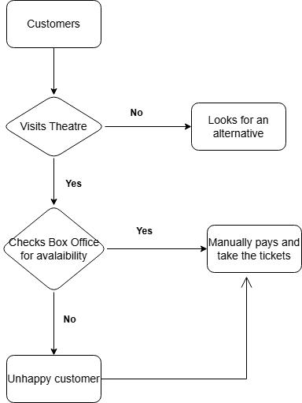

**13.1.1 Movie Search & Selection (TO-BE):**

Users can browse movies, filter by language, genre, and location, and select a preferred showtime.

**13.1.2 Seat Selection & Booking**

The system displays a real-time seat layout, allowing users to select available seats before checkout.

**13.1.3 Payment Processing**

After selecting seats, users proceed to secure payment checkout and complete transactions using various payment methods.

**13.1.4 Ticket Confirmation**

Once the payment is successful, users receive a confirmation email and SMS with an electronic ticket and QR code.

**13.1.5 Theatre Check-In & Validation**

Users scan their QR code at the theatre entrance for seamless access without the need for printed tickets.

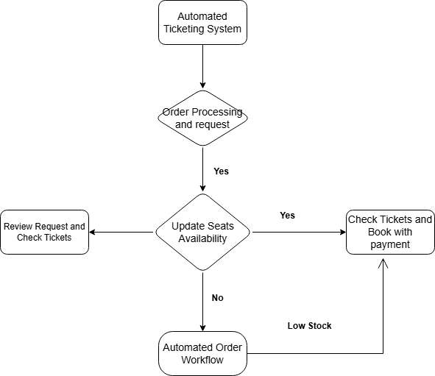

**14. Assumptions:**

* Users will have internet access to book tickets
* The system will be compatible with major web browsers and mobile devices
* Theatres will provide real-time seat availability data
* Payment gateways will be secure and reliable
* Users will follow platform rules and policies

**15. Appendices:**

* List of stakeholders and their roles
* Diagrams explaining system architecture
* User interface design wireframes
* Additional technical details on integrations
* Legal and compliance references

**16. List of Acronyms:**

* **OTP:** One-Time Password
* **UI:** User Interface
* **UX:** User Experience
* **API:** Application Programming Interface
* **SSL:** Secure Socket Layer

**17. Glossary of Terms:**

* **Booking Confirmation:** A receipt confirming the user's ticket purchase
* **Real-Time Updates:** Instant changes in seat availability and pricing
* **Payment Gateway:** A service that processes online payments
* **QR Code Ticketing:** Digital barcode used for theatre entry
* **Multi-Theatre Support:** The ability to book tickets for different cinema chains

**Software Requirements Specification (SRS)**

**Project Name: Online Ticketing System for Movie Bookings**

**1. Introduction:**

* In today’s digital era, convenience and efficiency are key factors in enhancing customer experience across industries. The **Online Movie Ticket Booking System** is a modern solution that allows users to browse movies, select showtimes, choose seats, and make secure payments, all from the comfort of their homes.
* This system aims to eliminate the hassle of long queues and last-minute ticket unavailability by providing a **user-friendly, fast, and reliable** platform for booking movie tickets. It caters to both customers and cinema administrators by streamlining the **ticketing process, seat management, and payment integration**

### **Key Features:**

✔️ **User Registration & Login:** Customers can create accounts and manage bookings.  
✔️ **Movie Listings & Showtimes:** Users can browse movies, view details, and select convenient showtimes.  
✔️ **Seat Selection:** An interactive seat map allows users to choose their preferred seats.  
✔️ **Multiple Payment Options:** Secure payment gateways for seamless transactions.  
✔️ **E-Ticket Generation:** Instant ticket confirmation via email/SMS with QR codes.  
✔️ **Refund & Cancellation Policies:** Easy cancellation process based on cinema policies.  
✔️ **Admin Panel:** Theatre owners can manage movie schedules, seat availability, and revenue tracking.

### **Business Benefits:**

🎬 **Enhanced User Experience** – Customers can book tickets anytime, anywhere.  
🎬 **Increased Revenue for Cinemas** – Optimized seat utilization and dynamic pricing strategies.  
🎬 **Data-Driven Insights** – Analysing customer preferences for better marketing campaigns.  
🎬 **Contactless Transactions** – Promotes digital payments and minimizes physical interactions.

**2. Goal of the Project:**

The primary goal of the **Online Movie Ticket Booking System** is to **provide a seamless, user-friendly, and efficient platform** for booking movie tickets online. This system aims to enhance the movie-watching experience by enabling users to conveniently browse movies, select showtimes, choose seats, and make secure payments—all from their digital devices.

**Specific Goals:**

1️. **Enhance Customer Convenience:**

* Allow users to book movie tickets anytime, anywhere.
* Eliminate the need to stand in long queues at theatres.

2️. **Optimize Theatre Operations:**

* Automate the ticket booking process to reduce manual work.
* Improve seat management and maximize occupancy rates.

3️. **Secure & Efficient Transactions:**

* Integrate multiple **secure** payment options (credit/debit cards, UPI, wallets, etc.).
* Generate digital tickets to reduce paper-based ticketing.

4️. **Increase Revenue for Cinemas:**

* Enable **dynamic pricing strategies** to adjust ticket prices based on demand.
* Boost advance bookings, reducing last-minute cancellations or empty seats.

5️. **Data-Driven Decision Making:**

* Collect and analyse user preferences to offer **personalized recommendations**.
* Provide cinemas with insights into customer behaviour and peak booking times.

**3. Use Case Diagram:**

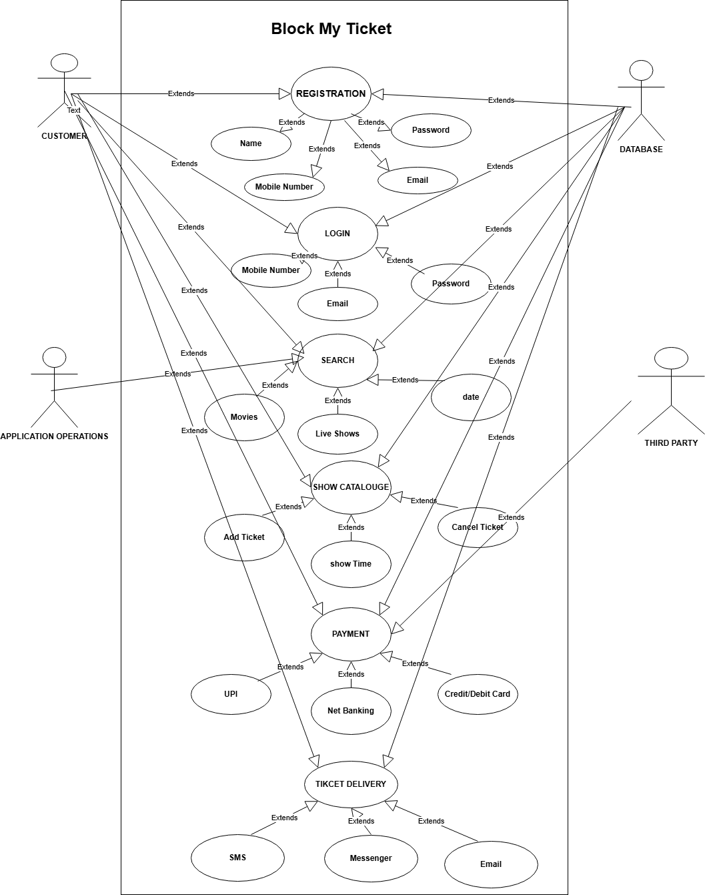

**4. Use Case Specifications:**

|  |  |
| --- | --- |
| **Use Case ID** | UC001 |
| **Use case Name** | User registration |
| **Created By** | Akshay Vanathadupula |
| **Date Created** | 04/02/2025 |
| **Last Update** | 04/02/2025 |
| **Actors** | User, System |
| **Description** | This use case describes how a new user registers on the platform using an email or mobile number. |
| **Pre-Conditions** | |  | | --- | |  |  |  | | --- | | The user must have a valid email or mobile number. | |
| **Post-Conditions** | The system creates the user account and sends a confirmation email or OTP. |
| **Main Flow** | 1. User clicks on "Sign Up". 2. User enters details (name, email, phone, password). 3. System sends an OTP for verification. 4. User enters OTP. 5. System verifies OTP and creates an account. 6. User is redirected to the dashboard. |
| **Alternate Flow** | 1A. If the OTP is incorrect, the system prompts the user to re-enter. 2A. If the email or phone is already registered, the system shows an error. |
| **Justification** | **Why: Allows users to access the platform and book tickets.** |
| **How: By collecting user details and verifying their identity via OTP.** |

|  |  |
| --- | --- |
| **Use Case ID** | UC002 |
| **Use case Name** | Movie Selection & Seat Booking |
| **Created By** | Akshay Vanathadupula |
| **Date Created** | 04/02/2025 |
| **Last Update** | 04/02/2025 |
| **Actors** | User, System |
| **Description** | This use case describes how a user selects a movie, chooses a showtime, and picks seats. |
| **Pre-Conditions** | User must be logged in to the platform. |
| **Post-Conditions** | The selected seats are temporarily reserved for the user. |
| **Main Flow** | 1. User logs into the system. 2. User selects a city and theatre. 3. System displays available movies and showtimes. 4. User selects a movie and showtime. 5. System displays available seats. 6. User selects preferred seats. 7. System holds the seats for a limited time (e.g., 5 minutes). |
| **Alternate Flow** | 1A. If seats are not available, the system displays a message. 2A. If the user does not confirm within the time limit, seats are released. |
| **Justification** | **Why:** **Ensures users can choose their preferred movie and seats.** |
| **How:** **By providing real-time seat availability and reservation options.** |

|  |  |
| --- | --- |
| **Use Case ID** | UC003 |
| **Use case Name** | Ticket Payment & Confirmation |
| **Created By** | Akshay Vanathadupula |
| **Date Created** | 04/02/2025 |
| **Last Update** | 04/02/2025 |
| **Actors** | User, Payment Gateway, System |
| **Description** | This use case describes how a user completes the ticket payment and receives a confirmation. |
| **Pre-Conditions** | User must have selected movie, showtime, and seats. |
| **Post-Conditions** | The system generates an e-ticket and sends confirmation to the user. |
| **Main Flow** | 1. User proceeds to checkout. 2. System displays total ticket price. 3. User selects a payment method. 4. User enters payment details. 5. Payment gateway processes the transaction. 6. If successful, the system confirms the booking. 7. User receives an e-ticket via email/SMS. |
| **Alternate Flow** | 1A. If payment fails, the user is prompted to retry or choose another method. 2A. If the session times out, the booking is cancelled. |
| **Justification** | **Why:** **ensures users can securely pay for their tickets.** |
| **How: By integrating a payment gateway and generating an e-ticket upon successful payment.** |

|  |  |
| --- | --- |
| **Use Case ID** | UC004 |
| **Use case Name** | Ticket Cancellation & Refund |
| **Created By** | Akshay Vanathadupula |
| **Date Created** | 05/02/2025 |
| **Last Update** | 05/02/2025 |
| **Actors** | User, System, Payment Gateway |
| **Description** | This use case describes how a user cancels a booked ticket and requests a refund. |
| **Pre-Conditions** | User must have a valid booking within the cancellation window. |
| **Post-Conditions** | The system cancels the ticket and processes a refund if applicable. |
| **Main Flow** | 1. User navigates to "My Bookings". 2. User selects a booking and clicks "Cancel". 3. System checks if cancellation is allowed. 4. If eligible, system confirms cancellation. 5. System processes the refund (if applicable). 6. User receives cancellation confirmation. |
| **Alternate Flow** | 1A. If cancellation is outside the allowed window, system shows an error. 2A. If the refund fails, system notifies the user. |
| **Justification** | **Why:** **Allows users to modify their plans.** |
| **How:** **By providing an easy way to cancel and process refunds through automated workflows.** |

|  |  |
| --- | --- |
| **Use Case ID** | UC005 |
| **Use case Name** | Movie Ratings & Reviews |
| **Created By** | Akshay Vanathadupula |
| **Date Created** | 05/02/2025 |
| **Last Update** | 05/02/2025 |
| **Actors** | User, System |
| **Description** | This use case describes how a user rates and reviews a movie after watching it. |
| **Pre-Conditions** | User must have booked and watched the movie. |
| **Post-Conditions** | The system saves the review and displays it publicly. |
| **Main Flow** | 1. User navigates to "My Past Bookings". 2. User selects a movie to review. 3. User enters a star rating and review text. 4. User submits the review. 5. System saves and publishes the review. |
| **Alternate Flow** | 1A. If the user has not watched the movie, review submission is restricted. 2A. If the review violates guidelines, the system flags it for moderation. |
| **Justification** | **Why:** **Helps future users make informed decisions.** |
| **How: By allowing users to share their experiences and rate movies.** |

**5. Functional Requirements (What the system must do)**

1️. **User Registration and Login**

* Users must be able to register by providing their name, email, phone number, and password.
* Login should be possible via email/phone and password, with an option for OTP authentication.
* Users should have the ability to reset their password via email/SMS OTP.

2️. **Movie Selection and Showtimes**

* The system should display all available movies with posters, descriptions, ratings, and trailers.
* Users should be able to filter movies based on **language, genre, theater location, and showtime**.
* Each movie page should show multiple showtimes across different cinema halls.

3️. **Seat Selection and Booking**

* Users should be able to view a **real-time seat layout** to choose available seats.
* The system should prevent double bookings by updating seat availability instantly.
* Users must confirm their seat selection before proceeding to payment.

4️. **Payment and Ticket Generation**

* The system should support multiple payment methods, including **credit/debit cards, UPI, mobile wallets, and net banking**.
* Users should receive a digital **E-Ticket via email and SMS**, containing a QR code for entry.
* If payment fails, the system should notify the user and allow retrying the payment.

5️. **Cancellation and Refund Policy**

* Users should be able to cancel bookings within a specific timeframe, based on theater policies.
* Refunds should be processed automatically and credited back to the user’s original payment method.
* The system should notify users via **email/SMS** once a refund is processed.

**6. Non-Functional Requirements (How the system must behave)**

1️. **Scalability**

* The system must handle high traffic, especially during peak hours (weekends, holidays, and major movie releases).
* It should support **at least 100,000 concurrent users** without performance issues.

2️. **Security and Data Protection**

* All user data, including payment details, must be encrypted using **SSL/TLS encryption**.
* The system should comply with **PCI-DSS standards** for secure payment processing.
* Multi-factor authentication (MFA) should be available for enhanced security.

3️. **Performance and Speed**

* The movie search and booking process should be **completed within 5 seconds**.
* The system should load movie listings in **less than 2 seconds**.
* Payment processing should take no more than **5 seconds**.

4️. **Availability and Reliability**

* The system should be available **24/7** with **99.9% uptime**.
* There should be automated failover mechanisms in case of server failure.
* Daily backups must be performed to prevent data loss.

5️. **Cross-Platform Compatibility**

* The system must be accessible via **web, mobile app (iOS & Android), and tablets**.
* It should support all major browsers, including **Chrome, Firefox, Edge, and Safari**.
* The UI/UX should be responsive and adapt to different screen sizes.

1. **Entity Relationship Diagram of Online Ticketing System:**

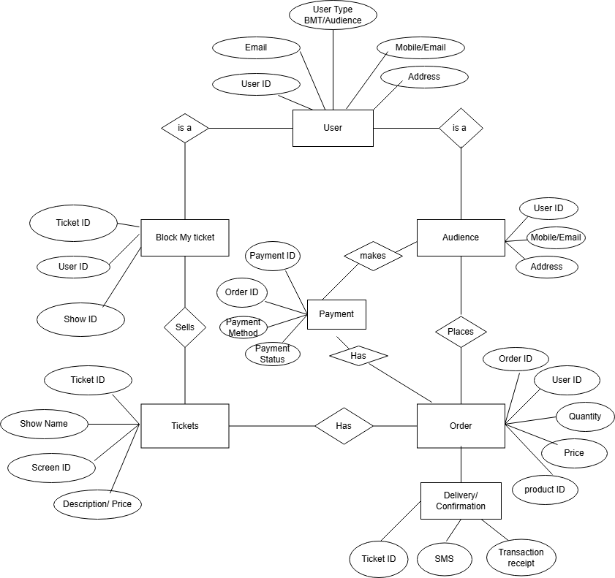

1. **40 user stories** for an **Online Agriculture Products Store for Farmers**;

|  |  |  |
| --- | --- | --- |
| **User Story: 1** | **Task: 1** | **Priority: High** |
| **Value Statement:**  As a farmer, I want to register on the platform using my mobile number and email so that I can access the store. |  | |
| **BV: 50** | **CP: 5** | |
| **Acceptance Criteria:**  1. Users can register using a valid email or mobile number. 2. OTP-based verification must be completed before account activation. |  | |

|  |  |  |
| --- | --- | --- |
| **User Story: 2** | **Task: 1** | **Priority: High** |
| **Value Statement:**  As a farmer, I want to log in securely so that I can access my account anytime. |  | |
| **BV: 50** | **CP: 3** | |
| **Acceptance Criteria:**  1. Users must enter the correct email/mobile number and password. 2. OTP-based login option must be available for password recovery. 3. After successful login, users are redirected to the dashboard**.** |  | |

|  |  |  |
| --- | --- | --- |
| **User Story: 3** | **Task: 2** | **Priority: High** |
| **Value Statement:**  As a farmer, I want to search and filter products based on category, price, and brand so that I can quickly find what I need. |  | |
| **BV: 50** | **CP: 8** | |
| **Acceptance Criteria:**  1. Users can search for products by name or category. 2. Filters should refine search results dynamically. 3. The system should return results within 2 seconds. |  | |

|  |  |  |
| --- | --- | --- |
| **User Story: 4** | **Task: 2** | **Priority: High** |
| **Value Statement:**  As a farmer, I want to add multiple products to my cart so that I can purchase them in one transaction. |  | |
| **BV: 50** | **CP: 5** | |
| **Acceptance Criteria:**  1. Users can add products to the cart with a single click. 2. Users can adjust quantity before checkout. 3. Cart updates dynamically when items are added or removed. |  | |

|  |  |  |
| --- | --- | --- |
| **User Story: 5** | **Task: 2** | **Priority: High** |
| **Value Statement:**  As a farmer, I want to make payments securely via UPI, credit/debit cards, and net banking so that I can complete my purchase easily. |  | |
| **BV: 100** | **CP: 13** | |
| **Acceptance Criteria:**  1. Users can select multiple payment options. 2. Transactions must be processed securely. 3. Payment confirmation is sent via SMS/email. |  | |

|  |  |  |
| --- | --- | --- |
| **User Story: 6** | **Task: 2** | **Priority: Medium** |
| **Value Statement:**  As a farmer, I want to track my order status in real-time so that I know when my delivery will arrive. |  | |
| **BV: 5** | **CP: 8** | |
| **Acceptance Criteria:**  1. Users can track orders from the "My Orders" section. 2. Real-time status updates must be available. 3. Delivery estimate should be provided. |  | |

|  |  |  |
| --- | --- | --- |
| **User Story: 7** | **Task: 3** | **Priority: Medium** |
| **Value Statement:**  As a farmer, I want to save products to my Wishlist so that I can purchase them later. |  | |
| **BV: 2** | **CP: 5** | |
| **Acceptance Criteria:**  1. Users can add or remove products from the Wishlist. 2. Wishlist items should persist even after logout. 3. Users can move Wishlist items directly to cart. |  | |

|  |  |  |
| --- | --- | --- |
| **User Story: 8** | **Task: 3** | **Priority: High** |
| **Value Statement:**  As a farmer, I want to chat with customer support in real-time so that I can resolve my issues quickly. |  | |
| **BV: 20** | **CP: 13** | |
| **Acceptance Criteria:**  1. Users can initiate chat from the help section. 2. System provides automated responses for FAQs. 3. Users can escalate issues to human agents. |  | |

|  |  |  |
| --- | --- | --- |
| **User Story: 9** | **Task: 4** | **Priority: High** |
| **Value Statement:**  As a farmer, I want to browse the platform in my local language so that I can understand the details easily. |  | |
| **BV: 10** | **CP:8** | |
| **Acceptance Criteria:**  1. Users can select a preferred language. 2. Translations should be contextually accurate. 3. Language selection must persist across sessions. |  | |

|  |  |  |
| --- | --- | --- |
| **User Story: 10** | **Task: 4** | **Priority: High** |
| **Value Statement:**  As a farmer, I want to access the store via a mobile app so that I can shop conveniently from my phone. |  | |
| **BV: 100** | **CP: 13** | |
| **Acceptance Criteria:**  1. Users can access all web features on mobile. 2. App UI is optimized for smaller screens. 3. Syncing between web and mobile is seamless. |  | |

|  |  |  |
| --- | --- | --- |
| **User Story: 11** | **Task:4** | **Priority: Medium** |
| **Value Statement:**  As a farmer, I want to read reviews and ratings before purchasing so that I can make informed decisions. |  | |
| **BV: 5** | **CP: 8** | |
| **Acceptance Criteria:**  1. Users can submit product ratings and reviews. 2. Reviews should be moderated for authenticity. 3. Average rating should be displayed for each product. |  | |

|  |  |  |
| --- | --- | --- |
| **User Story: 12** | **Task: 4** | **Priority: Medium** |
| **Value Statement:**  As a farmer, I want to apply discount coupons during checkout so that I can save money. |  | |
| **BV: 20** | **CP:8** | |
| **Acceptance Criteria:**  1. Users can enter a valid coupon code at checkout. 2. Discounts should be reflected in the final price. 3. Invalid coupons should display error messages. |  | |

|  |  |  |
| --- | --- | --- |
| **User Story: 13** | **Task: 5** | **Priority:High** |
| **Value Statement:**  As a farmer, I want a discount on bulk purchases so that I can save more when ordering in large quantities. |  | |
| **BV: 50** | **CP: 8** | |
| **Acceptance Criteria:**  1. Bulk discounts are auto-applied based on quantity. 2. Discount details are shown in the cart. 3. Users can see pricing breakdown before checkout. |  | |

|  |  |  |
| --- | --- | --- |
| **User Story: 14** | **Task: 5** | **Priority: High** |
| **Value Statement:**  As a farmer, I want to subscribe to regular deliveries of seeds and fertilizers so that I don’t have to reorder manually. |  | |
| **BV: 100** | **CP: 13** | |
| **Acceptance Criteria:**  1. Users can choose subscription plans during checkout. 2. Recurring payments must be processed automatically. 3. Users should be able to cancel or modify subscriptions. |  | |

|  |  |  |
| --- | --- | --- |
| **User Story: 15** | **Task: 5** | **Priority: High** |
| **Value Statement:**  As a farmer, I want to buy from different vendors so that I get better product variety and pricing. |  | |
| **BV: 100** | **CP: 21** | |
| **Acceptance Criteria:**  1. Farmers can see products from multiple vendors. 2. Orders can be placed from different vendors in one cart. 3. Vendor ratings and reviews should be displayed. |  | |

|  |  |  |
| --- | --- | --- |
| **User Story: 16** | **Task: 6** | **Priority: High** |
| **Value Statement:**  As a farmer, I want a chatbot for agricultural advice. |  | |
| **BV: 100** | **CP: 13** | |
| **Acceptance Criteria:**  1. The chatbot should provide instant responses to farming queries.  2. It should support both text and voice input.  3. The chatbot should recommend relevant products based on user input. |  | |

|  |  |  |
| --- | --- | --- |
| **User Story: 17** | **Task: 6** | **Priority: Medium** |
| **Value Statement:**  As a farmer, I want crop-specific product recommendations. |  | |
| **BV: 20** | **CP: 8** | |
| **Acceptance Criteria:**  1.The system should suggest products based on selected crops.  2. Recommendations should be displayed on the homepage and product pages.  3. Users should be able to filter recommendations by region and season. |  | |

|  |  |  |
| --- | --- | --- |
| **User Story: 18** | **Task: 6** | **Priority: Low** |
| **Value Statement:**  As a farmer, I want to compare similar products before buying. |  | |
| **BV: 10** | **CP: 5** | |
| **Acceptance Criteria:**  1. Users should be able to compare at least three products side by side.  2. Comparison should include price, reviews, and key specifications.  3. Users should be able to remove and add products to the comparison list. |  | |

|  |  |  |
| --- | --- | --- |
| **User Story: 19** | **Task: 6** | **Priority: Medium** |
| **Value Statement:**  As a farmer, I want personalized email and SMS offers. |  | |
| **BV: 5** | **CP: 5** | |
| **Acceptance Criteria:**  1. Users should receive offers based on their past purchases.  2. The system should allow users to opt in or out of marketing communications.  3. Emails and SMS should contain unique discount codes where applicable. |  | |

|  |  |  |
| --- | --- | --- |
| **User Story: 20** | **Task: 6** | **Priority: High** |
| **Value Statement:**   |  | | --- | |  |  |  | | --- | | As a farmer, I want referral rewards for inviting friends. | |  | |
| **BV: 50** | **CP: 8** | |
| **Acceptance Criteria:**  1. Users should receive a referral code/link to share.  2. A referred user must make a minimum purchase for the reward to be granted.  3. Rewards should be automatically credited to the user's wallet or account. |  | |

|  |  |  |
| --- | --- | --- |
| **User Story: 21** | **Task: 7** | **Priority: High** |
| **Value Statement:**   |  | | --- | |  |  |  | | --- | | As a farmer, I want EMI payment options for expensive products. | |  | |
| **BV: 100** | **CP: 13** | |
| **Acceptance Criteria:**  1. EMI payment should be available for orders above a certain amount.  2. Users should see EMI instalment breakdown before checkout.  3. EMI payments should integrate with at least two major payment providers. |  | |

|  |  |  |
| --- | --- | --- |
| **User Story: 22** | **Task: 7** | **Priority: medium** |
| **Value Statement:**  As a farmer, I want voice search functionality. |  | |
| **BV: 50** | **CP: 8** | |
| **Acceptance Criteria:**  1. Users should be able to search products using voice input.  2. The search system should return relevant products within 2 seconds.  3. The voice search should support at least two regional languages. |  | |

|  |  |  |
| --- | --- | --- |
| **User Story: 23** | **Task: 7** | **Priority: High** |
| **Value Statement:**   |  | | --- | |  |  |  | | --- | | As a farmer, I want an easy return and refund policy. | |  | |
| **BV: 50** | **CP: 13** | |
| **Acceptance Criteria:**  1. Users should be able to request a return within a set period (e.g., 7 days).  2. Refunds should be processed within 5 working days.  3. Users should receive email/SMS notifications for return status. |  | |

|  |  |  |
| --- | --- | --- |
| **User Story: 24** | **Task: 7** | **Priority: High** |
| **Value Statement:**  As a farmer, I want to check GST invoices for my purchases. |  | |
| **BV: 20** | **CP: 8** | |
| **Acceptance Criteria:**  1. Users should be able to download GST invoices after purchase.  2. Invoices should contain all necessary tax details as per Indian regulations.  3. GST invoices should be sent via email after order completion. |  | |

|  |  |  |
| --- | --- | --- |
| **User Story: 25** | **Task: 7** | **Priority: High** |
| **Value Statement:**   |  | | --- | |  |  |  | | --- | | As a farmer, I want a live weather forecast on the platform. | |  | |
| **BV: 50** | **CP: 13** | |
| **Acceptance Criteria:**  1. The weather forecast should update every hour.  2. Farmers should see weather conditions based on their location.  3. Alerts for extreme weather conditions should be provided. |  | |

|  |  |  |
| --- | --- | --- |
| **User Story: 26** | **Task: 8** | **Priority: Low** |
| **Value Statement:**  As a farmer, I want free shipping for large orders. |  | |
| **BV: 20** | **CP: 8** | |
| **Acceptance Criteria:**  1. Orders above a certain amount should automatically qualify for free shipping.  2. Users should see a banner displaying free shipping eligibility.  3. Free shipping should apply only to standard delivery timelines. |  | |

|  |  |  |
| --- | --- | --- |
| **User Story: 27** | **Task: 8** | **Priority: High** |
| **Value Statement:**  As a farmer, I want multi-language voice assistance. |  | |
| **BV: 50** | **CP: 21** | |
| **Acceptance Criteria:**  1. Voice assistance should support at least three regional languages.  2. Users should be able to ask for product details, orders, and recommendations.  3. The assistant should provide clear and accurate responses. |  | |

|  |  |  |
| --- | --- | --- |
| **User Story: 28** | **Task: 8** | **Priority: High** |
| **Value Statement:**  As a farmer, I want AI-powered pest and soil testing. |  | |
| **BV: 100** | **CP: 21** | |
| **Acceptance Criteria:**  1. Users should be able to upload soil and pest images for analysis.  2. The AI should provide relevant pest control solutions or fertilizer recommendations.  3. Results should be displayed within 10 seconds. |  | |

|  |  |  |
| --- | --- | --- |
| **User Story: 29** | **Task: 8** | **Priority: High** |
| **Value Statement:**   |  | | --- | |  |  |  | | --- | | As a farmer, I want a government subsidy integration section. | |  | |
| **BV: 100** | **CP: 21** | |
| **Acceptance Criteria:**  1. Users should be able to check subsidy eligibility for different products.  2. The platform should provide a list of required subsidy documents.  3. Users should receive subsidy-related notifications after purchase. |  | |

|  |  |  |
| --- | --- | --- |
| **User Story: 30** | **Task: 8** | **Priority: Low** |
| **Value Statement:**  As a farmer, I want a community forum for discussions. |  | |
| **BV: 20** | **CP: 8** | |
| **Acceptance Criteria:**  1. Farmers should be able to post queries and answers in the forum.  2. Moderators should be able to flag inappropriate content.  3. Users should receive notifications for new replies to their posts. |  | |

|  |  |  |
| --- | --- | --- |
| **User Story: 31** | **Task: 9** | **Priority: High** |
| **Value Statement:**   |  | | --- | |  |  |  | | --- | | As a farmer, I want a used farm equipment marketplace. | |  | |
| **BV: 20** | **CP: 21** | |
| **Acceptance Criteria:**  1. Users should be able to list their used equipment for sale.  2. Buyers should be able to contact sellers directly through the platform.  3. Listings should expire after a set period (e.g., 30 days). |  | |

|  |  |  |
| --- | --- | --- |
| **User Story: 32** | **Task: 9** | **Priority: High** |
| **Value Statement:**  As a farmer, I want push notifications for order updates. |  | |
| **BV: 5** | **CP: 5** | |
| **Acceptance Criteria:**  1. Users should receive notifications for order status changes.  2. Notifications should be available via both the app and SMS.  3. Users should be able to enable or disable push notifications. |  | |

|  |  |  |
| --- | --- | --- |
| **User Story: 33** | **Task: 9** | **Priority:** |
| **Value Statement:**  As a farmer, I want customer support via WhatsApp. |  | |
| **BV: 5** | **CP: 5** | |
| **Acceptance Criteria:**  1. Users should be able to start a chat with customer support via WhatsApp.  2. Support should be available during business hours.  3. Users should receive automated responses for common queries. |  | |

|  |  |  |
| --- | --- | --- |
| **User Story: 34** | **Task:9** | **Priority: High** |
| **Value Statement:**  As a farmer, I want seasonal product recommendations. |  | |
| **BV: 10** | **CP: 8** | |
| **Acceptance Criteria:**  1. The system should recommend products based on the current season.  2. Farmers should receive alerts about upcoming seasonal offers.  3. Recommendations should be visible on the homepage. |  | |

|  |  |  |
| --- | --- | --- |
| **User Story: 35** | **Task: 8** | **Priority: Medium** |
| **Value Statement:**  As a farmer, I want order cancellation before dispatch. |  | |
| **BV: 5** | **CP: 5** | |
| **Acceptance Criteria:**  1. Users should be able to cancel an order before dispatch.  2. Refunds should be processed within 3-5 business days.  3. Users should receive cancellation confirmation via email/SMS. |  | |

|  |  |  |
| --- | --- | --- |
| **User Story: 36** | **Task: 9** | **Priority: High** |
| **Value Statement:**  As a farmer, I want a mobile-friendly checkout process. |  | |
| **BV: 10** | **CP: 5** | |
| **Acceptance Criteria:**  1. The checkout process should be optimized for mobile devices.  2. Users should complete checkout in 3 steps or fewer.  3. The payment gateway should load within 2 seconds. |  | |

|  |  |  |
| --- | --- | --- |
| **User Story: 37** | **Task: 9** | **Priority: High** |
| **Value Statement:**  As a farmer, I want a purchase history dashboard. |  | |
| **BV: 5** | **CP: 5** | |
| **Acceptance Criteria:**  1. Users should see their past orders in a structured format.  2. Each order should include details like invoice, delivery date, and status.  3. Users should be able to filter orders by date range. |  | |

|  |  |  |
| --- | --- | --- |
| **User Story: 38** | **Task: 9** | **Priority:** |
| **Value Statement:**   |  | | --- | |  |  |  | | --- | | As a farmer, I want integration with government agricultural schemes. | |  | |
| **BV: 50** | **CP: 21** | |
| **Acceptance Criteria:**  1. Farmers should be able to check eligibility for various government schemes.  2. The platform should provide direct links to application portals.  3. Users should receive updates on scheme benefits related to their purchases. |  | |

|  |  |  |
| --- | --- | --- |
| **User Story: 39** | **Task:10** | **Priority: Medium** |
| **Value Statement:**  As a farmer, I want offline ordering through call centre support. |  | |
| **BV: 10** | **CP: 13** | |
| **Acceptance Criteria:**  1. Users should be able to place orders via a toll-free number.  2. The call centre should be able to create and track orders for customers.  3. Farmers should receive an SMS confirmation after placing an offline order. |  | |

|  |  |  |
| --- | --- | --- |
| **User Story: 40** | **Task: 10** | **Priority: High** |
| **Value Statement:**  As a farmer, I want an AI-powered chatbot for farming queries. |  | |
| **BV: 20** | **CP: 13** | |
| **Acceptance Criteria:**  1. The chatbot should provide answers to common farming-related queries.  2. Users should be able to access chatbot assistance from the homepage.  3. Chatbot responses should include product recommendations where relevant. |  | |