# Waterfall Project2 – Part -2/2

## Document 6

**Please prepare a use case diagram, activity diagram and a use case specification document.**

A.

**Use Case Diagram:**

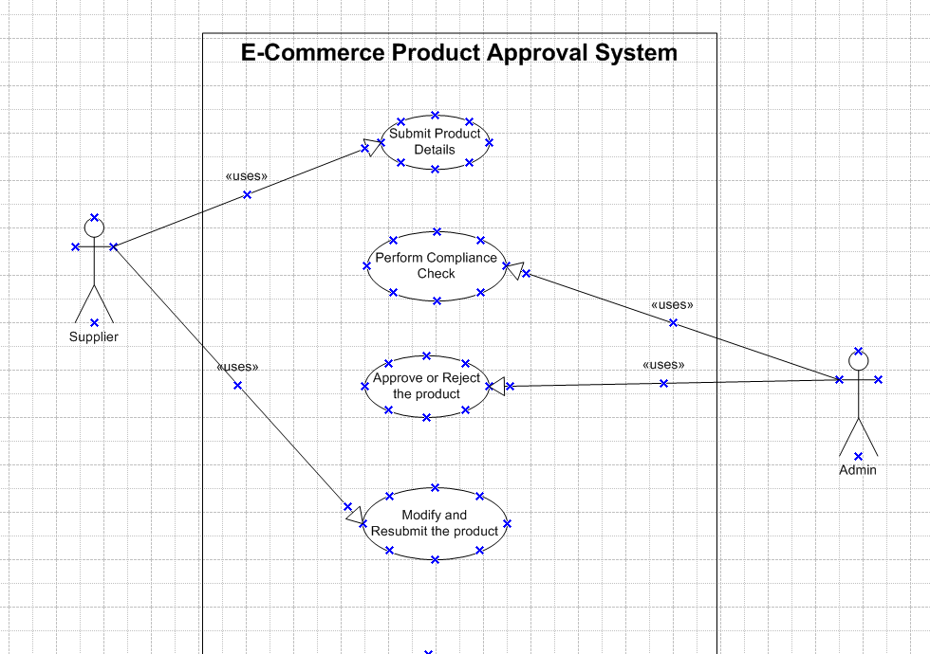

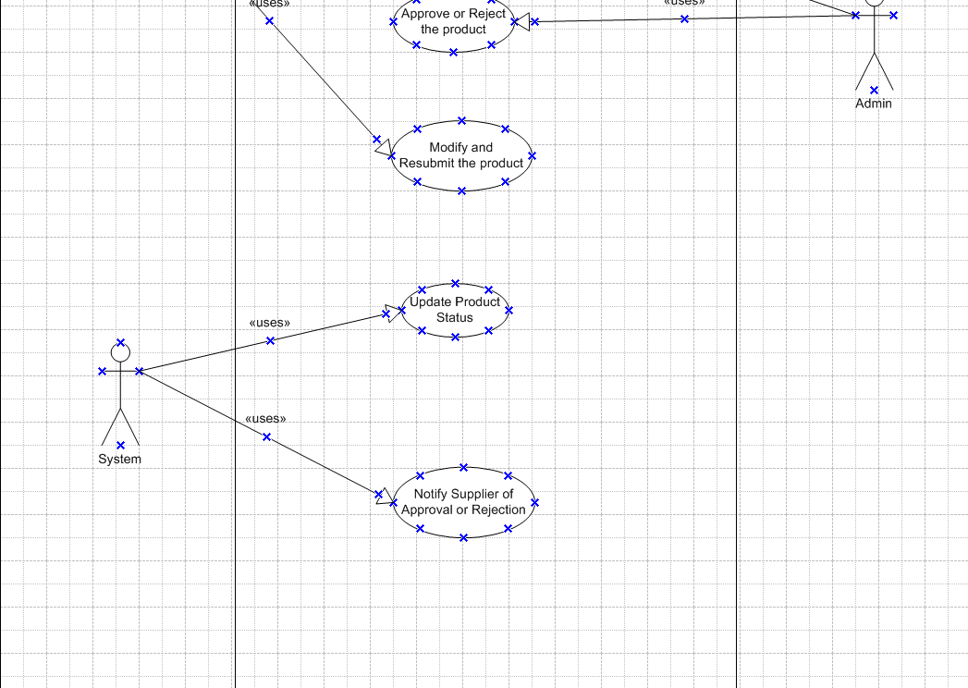

**Use Case Specification Document:**

**A.**

**Project Name:** Verotrack

**Prepared By:** Srikar

**Date:** 03/18/2025

**1. Use Case:** Submit Product Details

**1.1 Use Case ID:** UC001

**1.2 Use Case Name:** Submit Product Details

**1.3 Actor(s):** Supplier

**1.4 Description:** This use case describes how a supplier submits product details (such as name, price, stock availability, and compliance documents) for approval before listing them on the e-commerce platform.

**1.5 Preconditions:**

* The supplier must be a registered user on the platform.
* The supplier must log in with valid credentials.
* Product details must be complete and comply with government regulations.

**1.6 Postconditions:**

* Product submission is recorded in the system.
* The product enters the review queue for compliance verification.
* The supplier receives confirmation of submission.

**1.7 Flow of Events:**

**Basic Flow:**

1. The supplier logs into the e-commerce platform.
2. The supplier navigates to the "Add Product" section.
3. The supplier fills in all required product details (name, description, price, stock availability, and compliance documents).
4. The supplier clicks on the Submit button.
5. The system validates the submitted details.
6. If all required information is complete, the product is sent for review.
7. The supplier receives a confirmation notification.

**Alternative Flow:**

**A. Missing or Incorrect Information**

* If required information is missing or incorrect, the system prompts the supplier to correct the details before submission.

**2. Use Case:** Perform Compliance Check

**2.1 Use Case ID:** UC002

**2.2 Use Case Name:** Perform Compliance Check

**2.3 Actor(s):** Admin

**2.4 Description:** This use case describes how the admin reviews submitted product details to verify compliance with regulatory and platform policies.

**2.5 Preconditions:**

* A product must be submitted by a supplier.
* The admin must have review privileges.

**2.6 Postconditions:**

* The product is either approved or rejected.
* The supplier is notified of the decision.

**2.7 Flow of Events:**

**Basic Flow:**

1. The admin logs into the system.
2. The admin navigates to the Product Review section.
3. The admin selects a product from the review queue.
4. The admin checks the product details against regulatory and platform policies.
5. If the product meets all requirements, the admin approves it.
6. The system updates the product status to Approved.
7. The system notifies the supplier of the approval.

**Alternative Flow:**

**A. Non-compliant Product**

* If the product does not meet compliance requirements, the admin rejects it and provides a reason.
* The system updates the product status to **Rejected** and notifies the supplier with feedback.

**3. Use Case:** Approve or Reject Product

**3.1 Use Case ID:** UC003

**3.2 Use Case Name:** Approve or Reject Product

**3.3 Actor(s):** Admin

**3.4 Description:** This use case describes how an admin makes a final decision on whether a product can be listed on the e-commerce platform.

**3.5 Preconditions:**

* The product must have undergone a compliance check.
* The admin must have the authority to approve or reject products.

**3.6 Postconditions:**

* The product is either approved for listing or rejected with a reason.
* The supplier receives the decision notification.

**3.7 Flow of Events:**

**Basic Flow:**

1. The admin accesses the compliance-reviewed product.
2. The admin reviews feedback and supporting documents.
3. The admin selects either Approve or Reject.
4. If Approved, the system lists the product for sale.
5. If Rejected, the system provides feedback to the supplier.
6. The supplier receives a notification of the decision.

**4. Use Case:** Modify and Resubmit Product

**4.1 Use Case ID:** UC004

**4.2 Use Case Name:** Modify and Resubmit Product

**4.3 Actor(s):** Supplier

**4.4 Description:** This use case describes how a supplier modifies a rejected product and resubmits it for review.

**4.5 Preconditions:**

* The product must have been rejected in a previous submission.
* The supplier must receive feedback on why the product was rejected.

**4.6 Postconditions:**

* The modified product is resubmitted for review.
* The product enters the compliance check queue again.

**4.7 Flow of Events:**

**Basic Flow:**

1. The supplier logs into the e-commerce platform.
2. The supplier navigates to Rejected Products.
3. The supplier reviews the rejection feedback.
4. The supplier updates the product details as required.
5. The supplier resubmits the product for review.
6. The system confirms successful resubmission.

**Alternative Flow:**

**A. No Changes Made**

* If the supplier does not modify the product, the system does not allow resubmission.

**5. Use Case:** Notify Supplier of Approval/Rejection

**5.1 Use Case ID:** UC005

**5.2 Use Case Name:** Notify Supplier of Approval/Rejection

**5.3 Actor(s):** System

**5.4 Description:** This use case describes how the system sends automatic notifications to the supplier regarding the status of their product submission.

**5.5 Preconditions:**

* The product must have been reviewed by an admin.
* The system must have the supplier's registered contact details.

**5.6 Postconditions:**

* The supplier receives an email/SMS/notification with the approval or rejection status.

**5.7 Flow of Events:**

**Basic Flow:**

1. The system detects that a product has been approved or rejected.
2. The system generates an automated notification.
3. The system sends the notification to the supplier.
4. The supplier reviews the notification.

**6. Use Case:** Update Product Status

**6.1 Use Case ID:** UC006

**6.2 Use Case Name:** Update Product Status

**6.3 Actor(s):** System

**6.4 Description:** This use case describes how the system updates the status of a product after approval, rejection, or modification.

**6.5 Preconditions:**

* The product must have undergone a compliance check.
* The admin must have made a decision on approval or rejection.

**6.6 Postconditions:**

* The product status is updated in the database.

**6.7 Flow of Events:**

**Basic Flow:**

1. The system receives the admin’s decision (Approved or Rejected).
2. The system updates the product status accordingly.
3. The system triggers a notification to the supplier.

**Activity Diagram**

**A.** 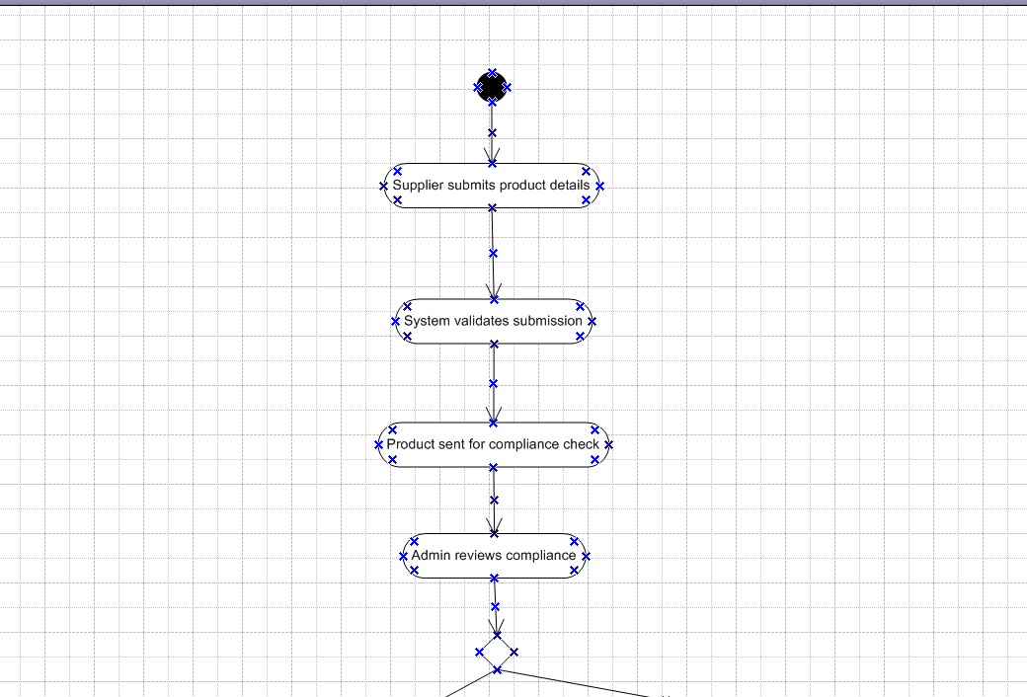

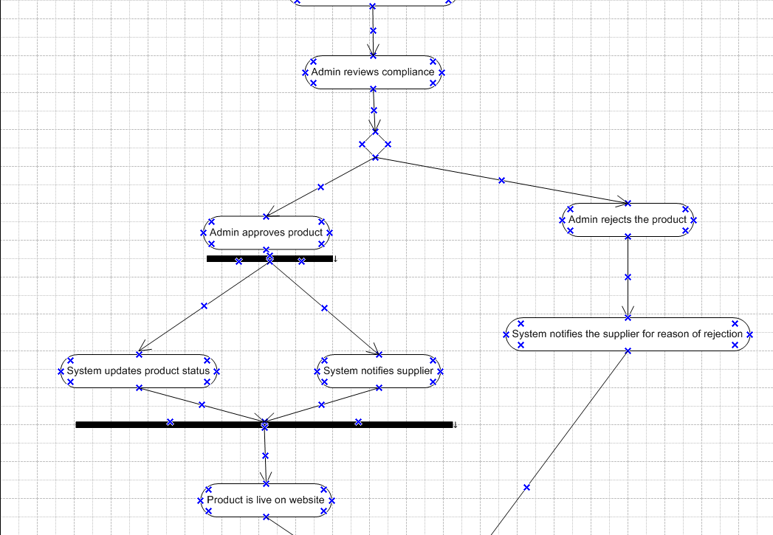

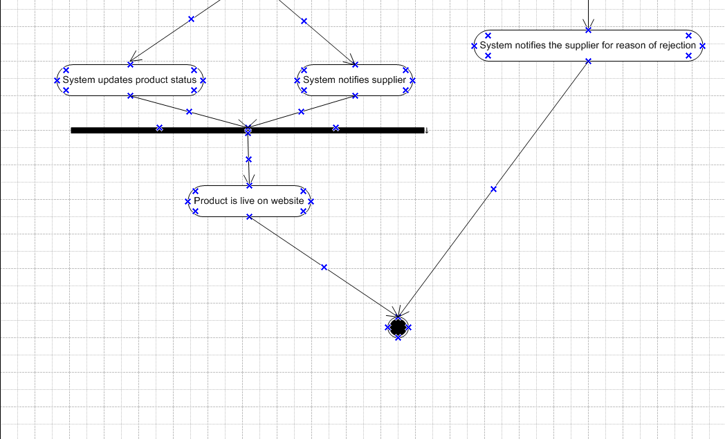

# Document 7: Screens and pages

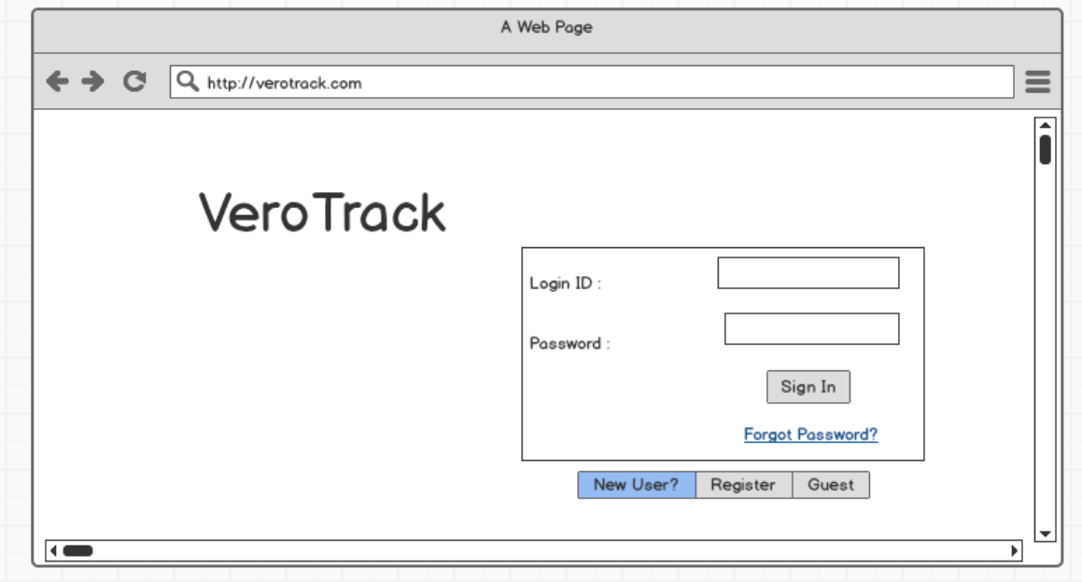

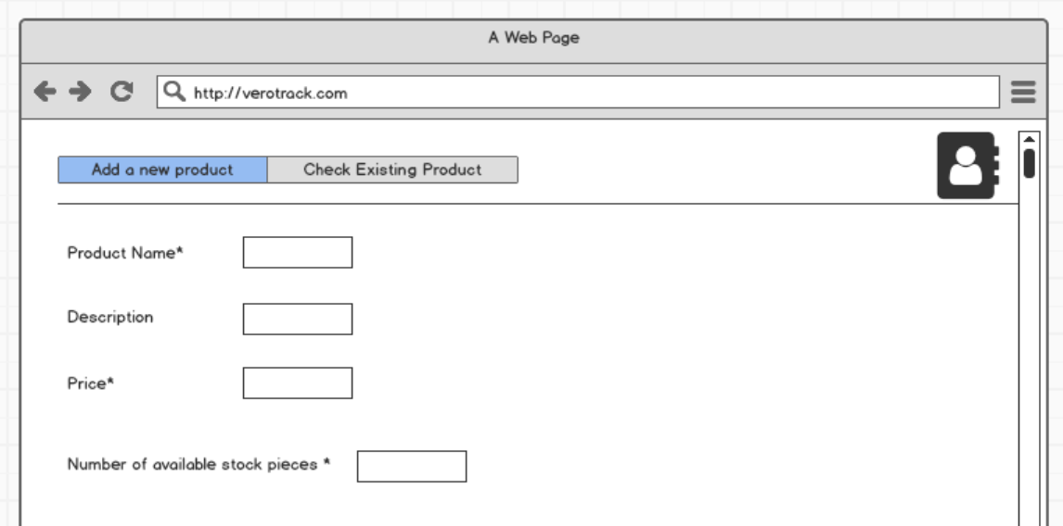

## 

## 

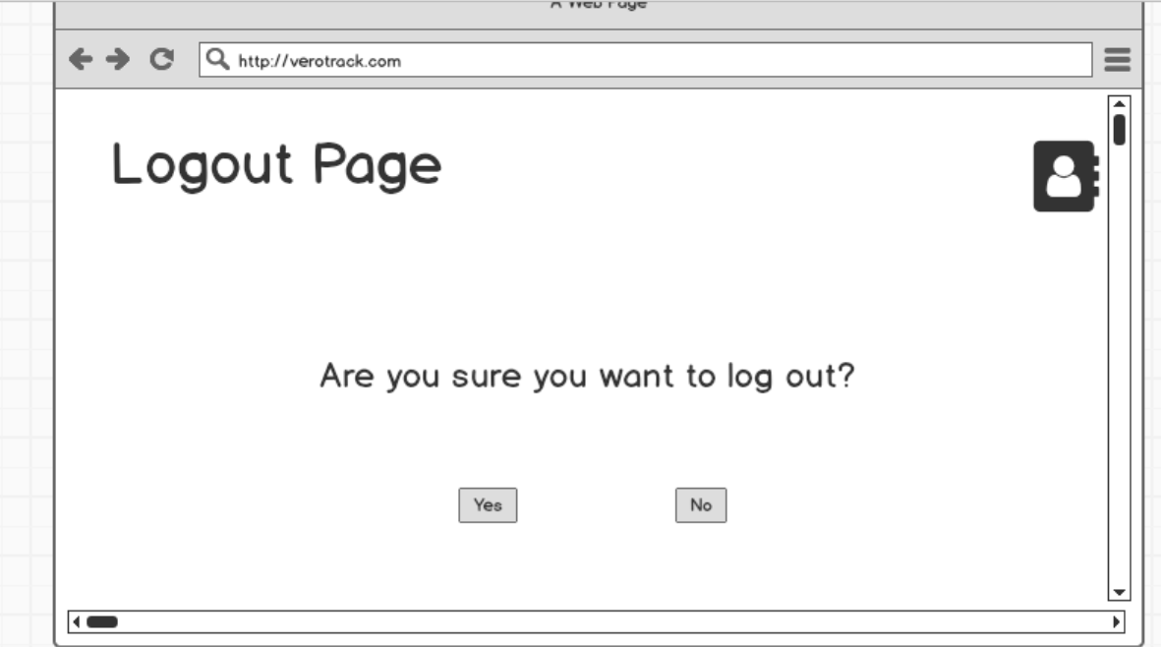

## Document 8

**Q. Tools-Visio and Axure : Write a paragraph on your experience using Visio and Axure for the project.**

**A.** Using Microsoft Visio and Axure RP for this project has been an insightful experience, allowing me to visualize and document various aspects of the e-commerce product approval system efficiently. In Visio, I created structured process flow diagrams, use case diagrams, and activity diagrams, leveraging its UML stencils and drag-and-drop functionality to represent workflows clearly. The ability to use swimlanes, decision nodes, and connectors helped in accurately mapping out the sequence of actions and stakeholder interactions. Meanwhile, Axure RP was particularly useful for developing interactive wireframes and prototypes for the supplier product submission interface. Its dynamic panels, conditional logic, and clickable prototypes provided a realistic simulation of user interactions, making it easier to communicate design ideas to stakeholders. Both tools complemented each other well—Visio for structured process modeling and Axure for UI/UX prototyping—ensuring a comprehensive representation of both functional and user experience aspects of the project.

## Document 9: BA experience

**My experience as BA in following phases:**

**1. Requirement Gathering**

As a Business Analyst, I played a crucial role in gathering requirements from key stakeholders, including suppliers, admins, and system users. I conducted elicitation sessions using techniques such as interviews, workshops, brainstorming, and document analysis to capture business needs. I also ensured that all requirements were documented clearly in a Business Requirement Document (BRD) and validated with stakeholders for completeness.

**2. Requirement Analysis**

After gathering requirements, I worked on analyzing them to ensure feasibility, clarity, and alignment with business goals. I categorized them into functional and non-functional requirements and created a Requirement Traceability Matrix (RTM) to track dependencies. I collaborated with technical teams to check feasibility and refined requirements where necessary, ensuring they were well-defined and achievable.

**3. Design**

In the design phase, I worked closely with UI/UX designers and system architects to define the user journey and system workflow. I created use case diagrams, process flow diagrams, and wireframes using Visio and Axure RP to visually represent the system. I also documented the Functional Specification Document (FSD) to ensure a clear understanding of system behavior.

**4. Development**

During the development phase, I acted as a bridge between business and technical teams, ensuring that the development aligned with the approved requirements. I participated in daily stand-ups and sprint planning to monitor progress and address any requirement clarifications needed by the development team.

**5. Testing**

I worked closely with the QA team to define test cases and ensure that all functional requirements were covered in User Acceptance Testing (UAT). I helped create test scenarios and test scripts and conducted UAT sessions with stakeholders to validate the system against business needs. I also managed change requests and defect tracking to ensure smooth resolution of any issues.

**6. Deployment**

For the deployment phase, I assisted in preparing training materials and user guides to facilitate a smooth transition for end users. I supported post-deployment testing and monitoring to ensure system stability and provided feedback to the development team on any required improvements. I also played a role in gathering initial user feedback and supporting stakeholder onboarding.