Question 1 – Identify minimum 20 functional requirements
Requirement ID | Requirement Name | Requirement Description | Priority
FR001 | User registration and login | Farmers should register and login | high
FR002 | Product catalog | Products should be displayed with full description | high
FR003 | Search | Main option to get into application | high
FR004 | Product category | To segregate products like seeds, pesticides and fertilizers | medium
FR005 | Product availability | Based on stock products will be displayed | medium
FR006 | Payment process | Processing payment option as per user | high
FR007 | Cart | Adding products to cart | medium
FR008 | Rating of product | Reviews help to pruchase the product | low
FR009 | Seller details | Details of the manufacturer | medium
FR010 | Shipping and delivery | Provide delivery related information | high
FR011 | Order Tracking System | Real-time order status updates for farmers. | medium
FR012 | Email / SMS Notifications | Alerts for order confirmation, delivery, offers | Medium
FR013 | Wishlist | Farmers can save products for future purchase. | low
FR014 | Discount | Apply discounts at checkout. | medium
FR015 | Order History | Farmers can view past orders and their details | low
FR016 | Forgot / Reset Password | Users can retrieve or reset their password via email. | high
FR017 | Logout Option | Users can log out of their account. | low
FR018 | FAQs Page | A page answering common user questions. | medium
FR019 | Language Selection Option | Users can choose their preferred language. | high
FR020 | Terms & Conditions | Display platform policies to users. | low
Question 2-Minimum 5 page designs - Make wireframe and prototypes
- Create account
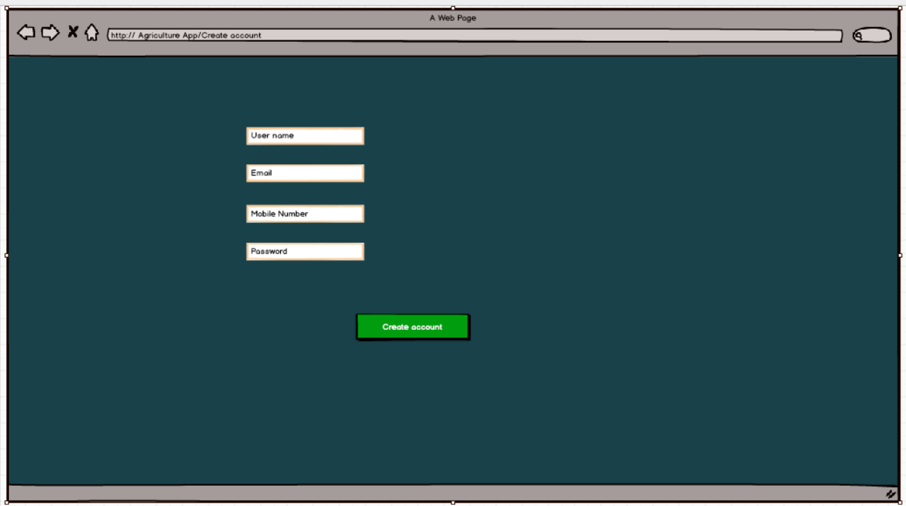
- Login
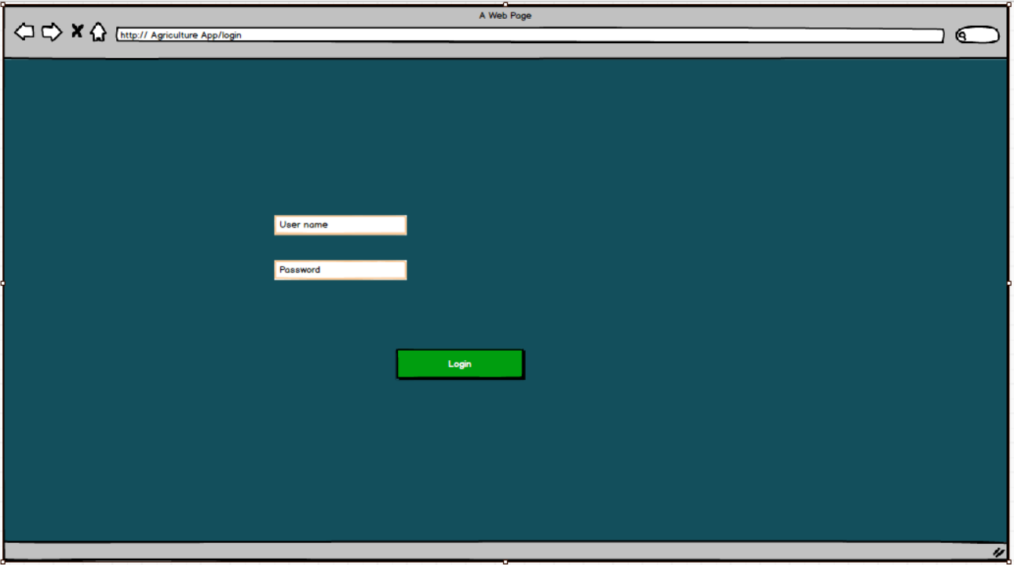
- Add to cart
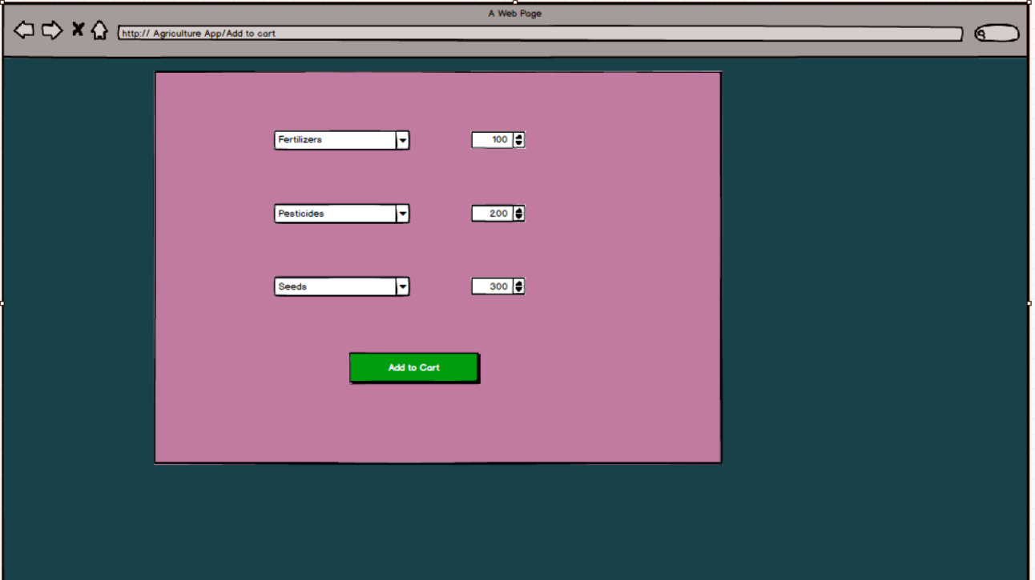
- Buy
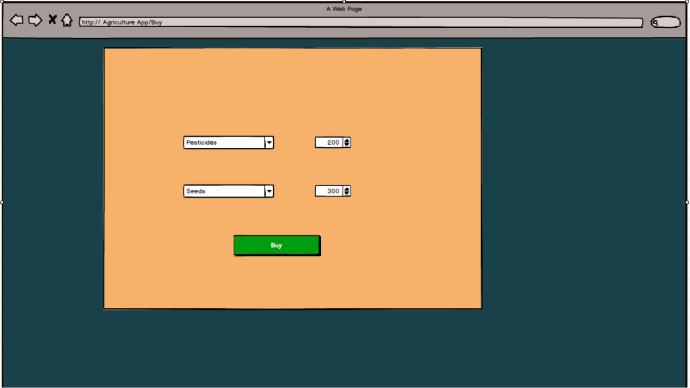
- Payment
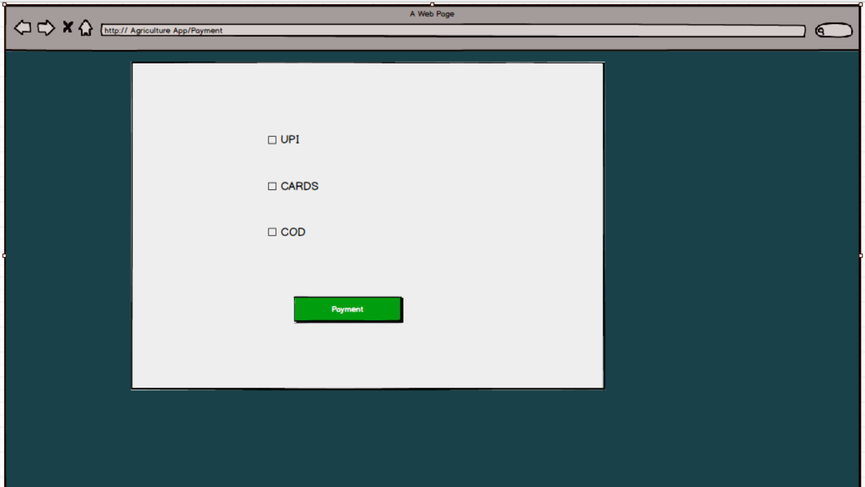
Question 3 - Make a note of the Tools, which you are using for above concepts. (Tools-Visio, Balsamiq)
Microsoft Visio :
It is a diagramming and vector graphic application Used to create diagrams, flowcharts, org charts, and other visiual representation of complex information.
Mainly used for technical reference and business documentation.
Viewed by and understood by Technical professionals and it supports data links and logic.
Balsamiq :
It is a rapid wire framing tool used to create mockups and prototypes of user interfaces.
Mainly used for early-stage app or website design.
It is simple and fast to use — no technical skills required.
Beneficial for prototyping and feedback gathering.

Question 4 – Prepare RTM
RTM.xlsx

Question 5: Prepare 10 Test Case Documents
Test case Id | TC021 | Test case Name | User registration
Project ID | P003 | Project Name | AgriStore
PM ID | PM303 | PM Name | Mr Vandanam
Test strategy ID | TS201 | Tester ID | T013
Test plan ID | TP003 | Tester Name | Ms Alekya
Test schedule ID | SCH020 | Date of Test | 2025-10-19
Scenario | farmer signs up using mobile number
Link to the page | https://agristore.com/product/123
Input data | Mobile no:9874561230
Expected behavior | user account created
Actual behavior
Comments
Results(Pass/Fail)

Test case Id | TC022 | Test case Name | User login
Project ID | P003 | Project Name | AgriStore
PM ID | PM303 | PM Name | Mr Vandanam
Test strategy ID | TS201 | Tester ID | T014
Test plan ID | TP003 | Tester Name | Mr Jason
Test schedule ID | SCH020 | Date of Test | 2025-10-19
Scenario | A registered farmer logs in with correct contact number
Link to the page | https://agristore.com/product/555
Input data | Mobile no:9874561230
Expected behavior | Login successful
Actual behavior
Comments
Results(Pass/Fail)

Test case Id | TC023 | Test case Name | Manufacturer adds product
Project ID | P003 | Project Name | AgriStore
PM ID | PM303 | PM Name | Mr Vandanam
Test strategy ID | TS201 | Tester ID | T013
Test plan ID | TP003 | Tester Name | Ms Alekya
Test schedule ID | SCH020 | Date of Test | 2025-10-19
Scenario | manufacturer logs in and adds product with full details
Link to the page | https://agristore.com/ manufacturer/addproduct
Input data | Product ,category,price,manufacturer
Expected behavior | Product list created
Actual behavior
Comments
Results(Pass/Fail)

Test case Id | TC024 | Test case Name | Product catalog
Project ID | P003 | Project Name | AgriStore
PM ID | PM303 | PM Name | Mr Vandanam
Test strategy ID | TS201 | Tester ID | T013
Test plan ID | TP003 | Tester Name | Mr Jason
Test schedule ID | SCH020 | Date of Test | 2025-10-19
Scenario | farmer views the product catalog
Link to the page | https://agristore.com/catalog
Input data | Product catalog
Expected behavior | Displays list of products with image, name, category, price, manufacturer details.
Actual behavior
Comments
Results(Pass/Fail)

Test case Id | TC025 | Test case Name | Search product by category
Project ID | P003 | Project Name | AgriStore
PM ID | PM303 | PM Name | Mr Vandanam
Test strategy ID | TS201 | Tester ID | T013
Test plan ID | TP003 | Tester Name | Ms Alekya
Test schedule ID | SCH020 | Date of Test | 2025-10-19
Scenario | farmer searches for “seeds”
Link to the page | https://agristore.com/product/555
Input data | Category : seeds
Expected behavior | Search results show products in category “seeds”
Actual behavior
Comments
Results(Pass/Fail)

Test case Id | TC026 | Test case Name | Check product availability
Project ID | P003 | Project Name | AgriStore
PM ID | PM303 | PM Name | Mr Vandanam
Test strategy ID | TS201 | Tester ID | T014
Test plan ID | TP003 | Tester Name | Mr Jason
Test schedule ID | SCH020 | Date of Test | 2025-10-19
Scenario | farmer checks the stock details
Link to the page | https://agrishop.com/product/123
Input data | Product123
Expected behavior | In stock or out of stock
Actual behavior
Comments
Results(Pass/Fail)

Test case Id | TC027 | Test case Name | Add product
Project ID | P003 | Project Name | AgriStore
PM ID | PM303 | PM Name | Mr Vandanam
Test strategy ID | TS201 | Tester ID | T013
Test plan ID | TP003 | Tester Name | Ms Alekya
Test schedule ID | SCH020 | Date of Test | 2025-10-19
Scenario | farmer adds a product to buy later
Link to the page | https://agristore.com/product/add-to-cart
Input data | Added to cart
Expected behavior | Product is added to cart
Actual behavior
Comments
Results(Pass/Fail)

Test case Id | TC028 | Test case Name | Payment process with card
Project ID | P003 | Project Name | AgriStore
PM ID | PM303 | PM Name | Mr Vandanam
Test strategy ID | TS201 | Tester ID | T014
Test plan ID | TP003 | Tester Name | Mr Jason
Test schedule ID | SCH020 | Date of Test | 2025-10-19
Scenario | farmer completes purchase using card
Link to the page | https://agrishop.com/product/555
Input data | Payment method: card, Amount: ₹2000
Expected behavior | Payment success, order confirmed
Actual behavior
Comments
Results(Pass/Fail)

Test case Id | TC009 | Test case Name | View seller/manufacturer details
Project ID | P003 | Project Name | AgriStore
PM ID | PM303 | PM Name | Mr Vandanam
Test strategy ID | TS201 | Tester ID | T013
Test plan ID | TP003 | Tester Name | Ms Alekya
Test schedule ID | SCH020 | Date of Test | 2025-10-19
Scenario | farmer views the manufacturer details
Link to the page | https://agrishop.com/product/555
Input data | Product ID: 555
Expected behavior | Manufacturer name, contact info, rating displayed
Actual behavior
Comments
Results(Pass/Fail)

Test case Id | TC010 | Test case Name | Order tracking
Project ID | P003 | Project Name | AgriStore
PM ID | PM303 | PM Name | Mr Vandanam
Test strategy ID | TS201 | Tester ID | T014
Test plan ID | TP003 | Tester Name | Mr Jason
Test schedule ID | SCH020 | Date of Test | 2025-10-19
Scenario | farmer checks the status of their placed order via tracking page
Link to the page | https://agristore.com/order/track/orderid12345
Input data | Order-orderid12345
Expected behavior | Show the status of the order
Actual behavior
Comments
Results(Pass/Fail)

Question 6 – After the requirements are thoroughly explained to the entire project team by business analyst, the Database architects have decided to do the database design and also to represent the in-flow and out-flow of data. Draw database schema and ER diagram
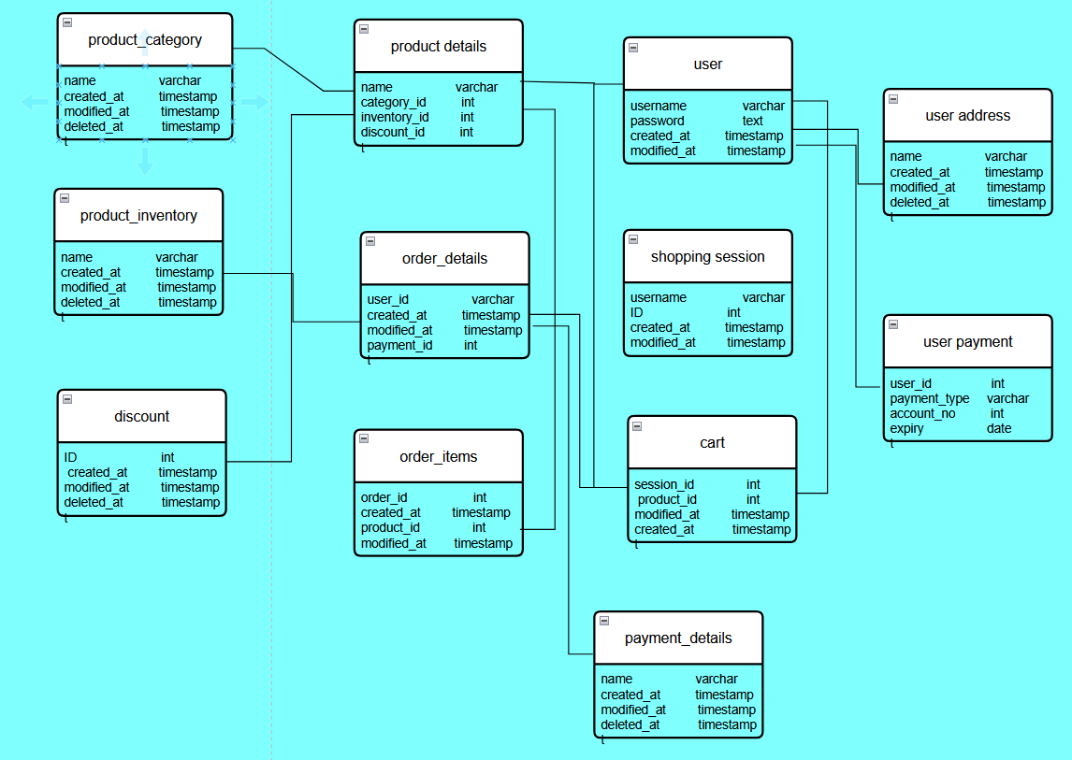

Question 7 – What is a data flow diagram? Draw a data flow diagram to represent the in-flow and out-flow of data when a Farmer is placing an order for the product
It helps understand system logic and useful for requirement gathering and system design. Mainly for better understanding of business stakeholders and developers.
A Data Flow Diagram (DFD) is a picture that shows how data moves through a system.
It shows where the data comes from and where it goes.
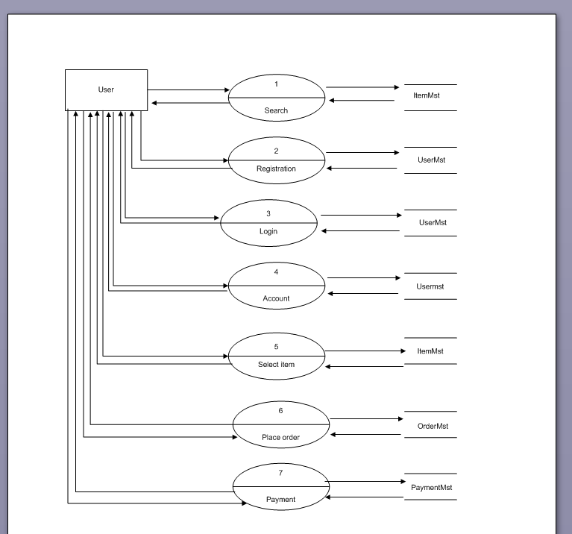

Question 8 - Due to change in the Government Taxation structure . we should change the Tax structure. How do you handle change requests in a project?
Whenever a change request comes, BA first should check if the change is a defect from the previous installation or not. If it is due to previous defect, it should be communicated to the technical team/support team to handle it. Else BA handles the change request by going through the following steps:
1. BA should first understand the scope of change.
2. He needs to analyze whether the change is inside/outside the scope of the project
3. BA then should do the analysis via:
a). Impact analysis: How many documents and programs are getting impacted due to the change
b). Feasibility study: Whether the change is possible or not, or whether we have required manpower/skill set or not
c). Effort estimation: What are the extra efforts in terms of man hours required to carry out the change.
4. Approve or reject the change request: After doing the analysis the data should be sent to Change Control Board (CCB) to approve or reject the change.
5. Communicate and implement the approved change request: The change request should be taken approval from the Project Manager, after approval log this change request into Change tracker.

Question 9 –As the project is in process, Ben and Kevin have contacted you. The reason is to inform you that they want the Farmers to sell their crop yields through this application i.e. Farmers should be able to add their crop yields or products and display to general public and should be able to sell them. They also want to introduce Auction system for their Crop yields. As a BA, what will be your response? Is this a change request or an enhancement?

The application is mainly built considering the farmer as a user but as farmer he himself wants to sell his own crop yields & go for auction, farmer here will become the seller. This is entirely a new change request as the goal of the project is only make agricultural products like seeds, pesticides and fertilizers available to farmers.
1. Description of the change: Enabling farmers to sell crop yields & introduce auction system
2. Change Request ID: A unique identifier (e.g., CR-001)
3. Date of Request: Date the change was requested on 21-10-2025.
4. Requested By: Name(s) of stakeholders (e.g., Ben and Kevin)
5. Description of Change: Allow farmers to sell their own crop yields and introduce an auction-based sale system.
6. Reason for Change: Why the change is needed to empower farmers and create a marketplace for their produce.
7. Impact Analysis: How it affects scope, cost, timeline, resources, and system design
8. Feasibility Assessment: Yes the change is possible with current tech resources.
9. Effort Estimate: Approximate time, cost, and resource impact
10. Priority: Medium
11.Approval Status: Approved
12. Approver: Names of stakeholders or steering committee members

Question 10 - estimations – How many Man hours required
Man hours are the required effort of the resources to complete a project. As per the case study, the duration of the project is 18 months and the current team size is around 11. As the trained resources are available, trainers are not required. As the structure of the project is available, new and enhanced infrastructure is not required.
The estimated project completion time = 18 months, which includes all phases from requirement analysis to deployment.
Man-hours = total number of working hours required from all team members to complete the project.
To calculate this:
Total Manhours=Number of Team Members×Working Hours per Day×Working Days per Month×Project Duration in Months
Number of Team Members | 11

Working Hours per Day | 8 hrs

Working Days per Month | 22 days

Project Duration | 18 months
Total Man-hours = 11×8×22×18= Total Estimated Effort = 34,848 Man-hours
Question 11 - Explain UAT Acceptance process
Planning: In this step, Blue Prints are made to implement UAT testing for every feature that needs to test and minimum standards for accepting the test.
Designing: Here the Test cases are designed to hide all the possibilities of software packages in a real world environment.
UAT Testers: A Testing team consists of a end users that meet the criteria for implementing testing. The end user must have expertise in subject matter, the ability to report the problems.
Bug Fixing: Whatever Bugs are found in the UAT Testing, the development team should work on them and make it software error free.
Sign Off: After removing all the bugs, the testing team indicates acceptance of the completion of the bugs. In this phase, all the stakeholders come to a conclusion that the software is ready to GO LIVE and sign it off.

Question 12 - Explain Project closure document
S.No. | Points to include | Details | Reference link
1 | Did the client signed off on the UAT Testing |  | Business scope document
 | Date of the signoff: | 20th Oct 2025
 | Name of the resource: | xxxx
2 | Objectives of the project
 | User friendliness | Achieved
 | Customer satisfaction | ROI in 6 months
 | More categories | Achieved
3 | Functionalities worked on
 | Secure payment processing | Achieved
 | Categories | Achieved
4 | Infrastructure
 | Softwares Installed | Achieved
 | Laptops purchased | Achieved
5 | Funding
 | Amount approved | Rs.1 crore
 | Amount used | Rs. 95 Lakhs
6 | Overall project Information
 | Escalations | 50
 | Customer satisfaction | High
7 | Value to the company
 | 1:16:18/1:17:Negative | Positive-90%  - Company has gained an edge over the competitors  - Increased clients  Trained employees  -New project in pipeline

