**A customer can make a payment either by Card or by Wallet or by Cash or by Net banking.**

**Q1. Draw a Use Case Diagram**

**Ans -**

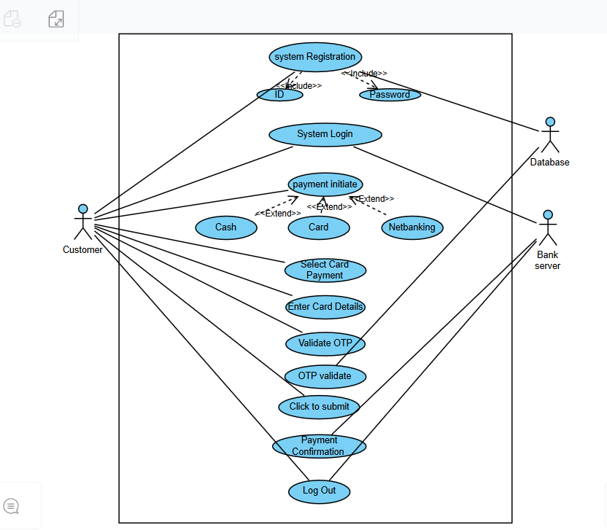

**Q2. Derive Boundary Classes, Controller classes, Entity Classes.**

**Ans -**

Boundary Class:

1. Payment to option boundary
2. Card Payment Boundary
3. Wallet payment
4. Cash payment
5. Net banking payment

Controller Class:

1. Payment initiated
2. Card payment
3. Wallet payment
4. Cash payment
5. Net banking

Entity class:

1. Customer
2. Payment
3. Card
4. wallet

**Q3. Place these classes on a three tier Architecture.**

**Ans -**

Use Layer:

1. Payment method selection
2. Card payment
3. Wallet payment
4. Cash payment
5. Net banking payment

Business Logic:

1. Payment initiated
2. Card payment
3. Wallet payment
4. Cash payment
5. Net banking

Data Layer:

1. Customer
2. Payment
3. Card
4. wallet

**Q-4. Explain Domain Model for Customer making payment through Net Banking.**

**Ans -**

Domain Model- it is a conceptual model that represents real world entities

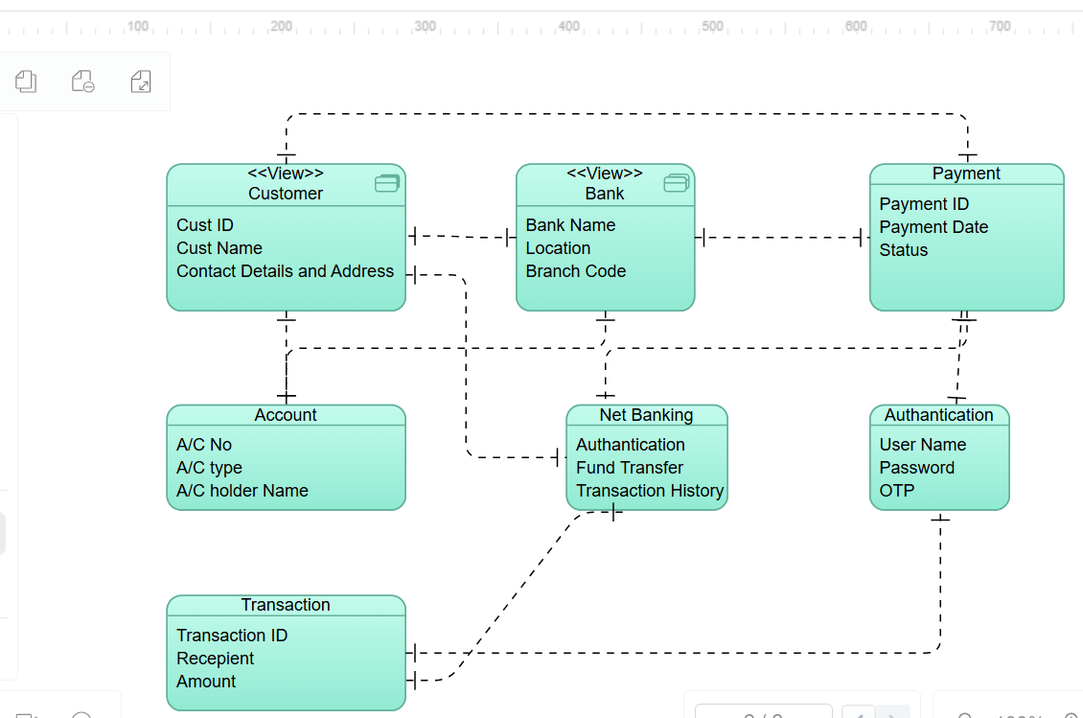

**Q-5. Draw a sequence diagram for payment done by Customer Net Banking**

**Ans -**

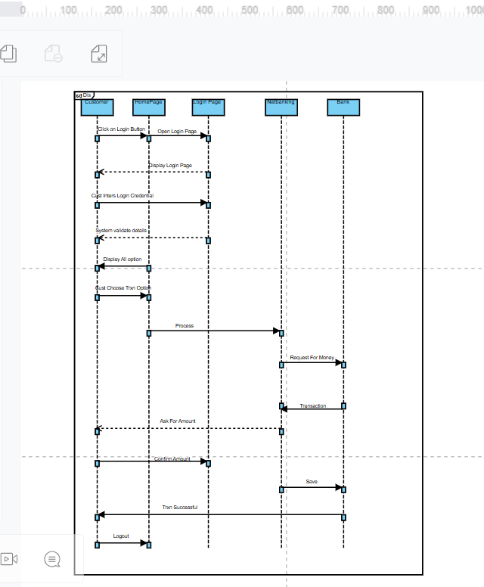

**Q6. Explain Conceptual Model for this Case.**

**Ans -**

Answer: A conceptual model is similar to domain model. It process payment done by customer using net banking and relation involved in payment transaction. It help to visualize flow of process.

The conceptual model helps in understanding the key concepts, their relationships, and the overall structure of the net banking payment system.

It serves as a foundation for designing the database schema, defining the application architecture, and implementing the necessary functionalities within the system.

**Customer:** This represents the users or customers who are using Net Banking.

**Service awareness**: Customers or users should be available net banking services and their features.

**Privacy of Data:** This node is important to protect the privacy and confidentiality of customer. **Technology Awareness:** Customers should be aware about all the latest technologies that are coming in market and used in net banking services.

**Bank:** This node represents a service provider responsible for offering bank services.

**Online Information:** It highlights the importance of providing accurate and up to date online information about net banking services to customers.

**Security and Privacy:** Bank should adapt the security policies which will help the customers to keep their data related to their transaction secure and private.

**Infrastructures:** This concept suggests that the underlying technological infrastructure including software and hardware systems. To complete the net banking services.

**Policies:** It represents various policies and regulations that govern the implementation and operation of Net banking services.

**Trust And Support:** This node indicates that’s the bank provide prompt and trustworthy services that helps cust enhance service experience.

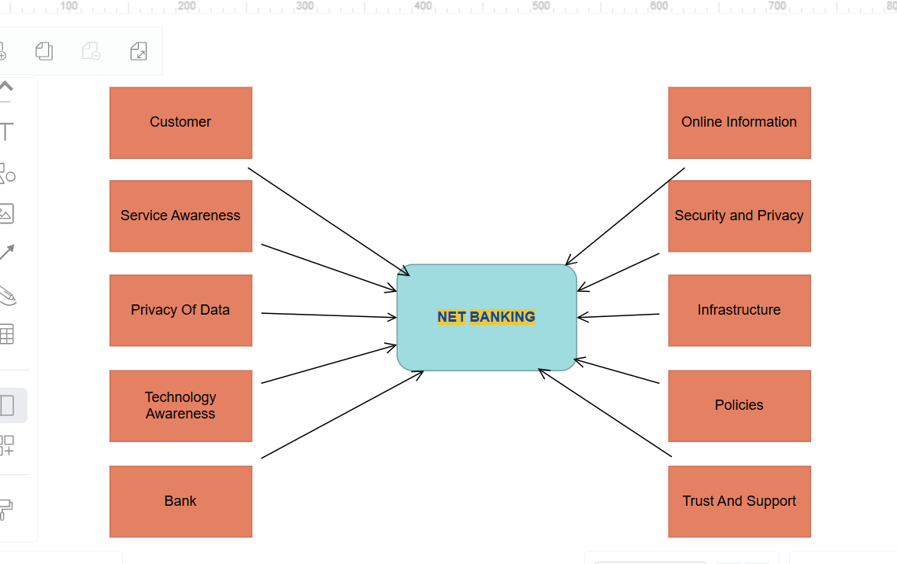

**Q7. What is MVC architecture? Explain MVC rules to derive classes from use case diagram and guidelines to place classes in 3-tier architecture**

Answer: To identify classes from use case diagrams we can apply MVC rules.

1. Model:

* The model class knows about all the data that need to be displayed.
* It is model who is aware about all the operations that can be applied to transform that class.
* It only represents the data of an application.
* The model represents enterprise data and business rules that govern access to and updates this data.
* All model classes are represented as entity classes.

2. View:

* The view represents the presentation of the application.
* The view class refers to the model.
* It uses query methods of the model to obtain the contents and renders it.
* The view is not dependent on the application logic.
* It remains same if there is any modification in the business logic.
* View class is the data required by query.
* View class is represented as boundary class or form class.

3. Controller:

* When user sends a request for something then it always go through controller.
* The controller is responsible for intercepting the requests from view and passes it to the model for appropriate action.
* After action has been taken on the data, the controller is responsible for directing the appropriate view to the user.
* In GUIs, the views and controllers often work very close together.
* Controller class is working based on user’s command.
* It understands command given by user through boundary class.

MVC Architecture Rules:

1. Combination of one actor and use case results in one boundary class.
2. Combination of two actors and a use case results in two boundary classes.
3. Combination of three actors and a use case result in three boundary classes.
4. Use case will result in a controller class.
5. Each actor will result in one entity class.

MVC Classes in 3 Tier architecture:

1. Place all entity classes in DB layer.

2. Place primary actor associated boundary class in application layer.

3. Place controller class in application layer.

4. If governing body influence or reusability is there with any of remaining boundary classes place them in business logic layer else place them in application layer.

**Q8. Explain BA contributions in project (Waterfall Model – all Stages)**

**Requirements Gathering-**

First, the stakeholders are identified.

In this phase, all the requirements are gathered from the stakeholder.

BA and Project Manager participate in this phase.

As per completing this phase, BRD will be generated.

**Requirements Analysis-**

The requirements are analyze to understand the scope of the project. Analyzing means the BA will check all the requirements, if he founds conflicting requirements then the BA will talk to the concerned stakeholder to clear it, remove the ambiguous requirements.

BA will prepare functional requirement.

The document which contains the functional requirements is called (FRS).[Functional Requirement Specifications]

Technical team will prepare non-functional requirement.

The document which contains the non-functional requirements is called (SSD).[Supplementary Support Document ]

BA will combine FRS and SSD to form SRS.[ Software Requirement Specifications]

BA will prepare RTM by referring SRS.

**Design-** As per the requirements are cleared, Design phase starts.

This has a detailed design document that outlines the software architecture, user interface, and system components.

HDD, ADD and solution document will be generated here.[High level Design Doc.]

BA Collaborate with designers, architects, and developers to translate requirements into system design.

BA Ensure that the design aligns with the documented requirements and addresses stakeholder needs.

**Development-**  The Development phase includes implementation.

It involves coding the software based on the design specifications.

Programmers or developer are involved in this phase.

Here BA acts as a mediator between the development team and the stakeholders.

BA clarifies the requirements, check if the development is going on right track or not.

BA also participates in scrum meetings.

**Testing-** In the testing phase, the software is tested as a whole to ensure that it meets the requirements and is free from defects. Testers are involved in this phase.

Test documents are generated here.

BA works with the testing team to ensure that the solution meets the requirements.

BA facilitates UAT, BA helps the users to know the functionality of the system and also helps them to use the system.

**Deployment-** Once the software has been tested and approved, it is deployed to the production environment.BA ensures that there is smooth transition from development phase to the production phase.

**Implementation-** It involves running the code for the very first time in production phase. Release manager handles this phase.

BA will update documentation and requirements specifications to reflect changes in the system over time.

**Maintenance-**

Running the code for second me in the production phase is called maintenance. This is done by support team

**Q9. What is conflict management? Explain using Thomas – Kilmann technique**

Answer: Conflict management is one of the competencies of BA. Conflict management is process of addressing disagreements and finding mutually acceptable solutions. It aimed at reducing negative aspects of conflict while increasing positive ones.

Conflict management steps:

1. Identify conflict

2. Discuss details

3. Agree with root problem

4. Check for every possible solution to avoid future conflicts

**Strategies of conflict management:**

1. Collaboration: In collaboration all parties work together to find solution.

2. Compromise: In compromise both parties giv Requirements Analysis-The requirements are analysed to understand the scope of the project. Analysing means the BA will check all the requirements, if he founds conflicting requirements then the BA will talk to the concerned stakeholder to clear it, remove the ambiguous requirements.e up something to reach agreement.

3. Accommodate: In accommodation, one party tries to fulfill other party needs by sacrificing their opinion.

4. Compete: In compete, we have to consider opinion of a single party as a final.

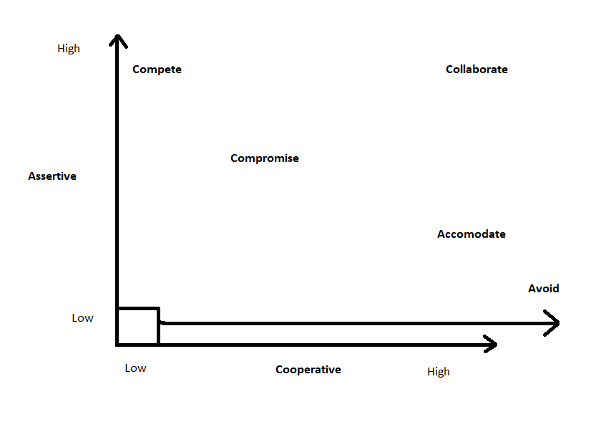

**Q10. List down the reasons for project failure**

Answer: Project can get failed by many reasons. Reasons are as follows:

1. Improper requirement gathering
2. Continuous change in requirements
3. Lack of user involvement
4. Lack of executive support
5. Unrealistic support
6. Improper planning

**Q11. List the Challenges faced in projects for BA**

Answer:

1. Lack of Training
2. Obtaining sign-off on requirements
3. Co ordination between developers and testers
4. Conducting meetings
5. Making sure status reporting is effective
6. Dividing clients for UAT completion
7. People management (coordinating with different people and teams)
8. Overall making sure project health is good and having no issues.

**Q12. Write about Document Naming Standards**

Answer: All documents are name includes project id, document name, version no, document no with file extension.

Format to name documents is:

[Project ID][Document Type]V[x]D[y].ext

Example: PQ563FRDV1D5.docx

**Q13. What are the Do’s and Don’ts of a Business analyst.**

Answer: Do’s and Don’ts of BA are as follows:

1. Never say No to the client
2. There is no word as ‘By Default’
3. Never imagine in terms of GUI
4. Question existence of existence
5. Consult SME for clarification in requirements
6. Every problem of client is unique. No two problems are same. Every problem has a unique solution.
7. Go to client with plain mind with no assumptions. Listen carefully and completely until he is done and then ask your queries.
8. Never interrupt client while he is speaking.
9. Never try to give straight way solutions based on previous experience and your assumptions.
10. Try to concentrate on important and true requirements.
11. Don’t get washed away by add on functionalities or don’t imagine solutions in screen basis.

**Q14. Write the difference between packages and sub-systems**

Answer:

|  |  |  |
| --- | --- | --- |
| Sr No | Packages | Subsystems |
| 1 | A package can be termed as container which tends to organize group of elements present in system into more manageable unit. | A subsystem is components which represents individual behavior unit in system. |
| 2 | Packages are collection of components which are not reusable in nature. | Subsystems are collection of components which are reusable in nature. |
| 3 | Application development companies work on packages. | Product based companies work on subsystems. |
| 4 | Package is represented as rectangle with tab in upper left corner contains name of package and icon. | Subsystem is displayed as rectangle that contains name of subsystem and icon along with <<subsystem>> keyword. |
| 5 | Packages are smaller and more focused in scope. | Subsystems are larger and encompass multiple package and modules. |
| 6 | They manage dependencies at class and component level. | They manage dependencies at higher level, define boundaries and interfaces between different parts of system. |

**Q15. What is camel-casing and explain where it will be used.**

Answer: Camel case is way of writing where initial word is small alphabet and from second word onwards first alphabet is capital and rest are small. Camel casing are used to write method names. Method names are represented as camel casing.

One object sends message to perform an operation to other object and receiving object performs an operation. These messages are sent by methods and method names are represented as camel casing.

Ex. readAndWrite();

**Q16. Illustrate Development server and what are the accesses does business analyst has?**

Answer: A development servers refers to dedicated environment or server that is used during software development process. It provides a platform for developers and testers to build, test and debug applications before they are deployed to a production environment. The development server typically replicates target production environment to ensure compatibility and accurate testing.

Read only access

Collaborative access

Limited configuration access

**Q17. What is Data Mapping?**

Answer: Data mapping is process of establishing a relationship between data elements in two or more different data sources. It involves defining how data from one source and transform data in another source. It is mostly used in data integration, data migration and data transformation.

Main purpose of data mapping is to ensure data can be transferred, converted. It involves identifying source data elements determine their meaning and structure.

The main purpose of data mapping is-

**Data integration-**

While combining the data from different sources, it ensures that the data is properly matched.

**Data Migration-**

While migrating the data from legacy system(source) to the new system(destination), the data elements are mapped accurately into the new system.

Required techniques are applied to covert the data into the format that is required by the new system.

**Data Transformation-**

Data transformation means converting the data from one format to other.

In data mapping, data transformation plays very important role which ensures that the data of legacy system(source) is mapped correctly to the data in new system(destination).

**Q18. What is API. Explain how you would use API integration in the case of your application Date format is dd-mm-yyyy and it is accepting some data from Other Application from US whose Date Format is mm-dd-yyyy**

**Ans –**

API stands for Application Programming Interface.

It is a software intermediary that allows the two applications to communicate with each other.

It is the set of rules, protocols and tools that define how different software application should interact with each other.

API allows sharing of only necessary information and keeps the internal system details hidden, which helps the system security.

For the above scenario, Establish API communication- set up API communication between your application and other application to exchange data.

Do Data formatting- while sending the data from one application to other, convert the date format from dd-mm-yyyy to mm-dd-yyyy.

While receiving the data from other application, parse the data and extract the date, month and year and re-arrange them accordingly.

Perform Data Validation and ensure that the converted date remains in a valid format.