**WAREHOUSE MANAGEMENT SYSTEM (WMS)**

**6.Please prepare a use case diagram, activity diagram and a use case specification document.**

**Use Case diagram**

A Use Case Diagram in [Unified Modeling Language (UML)](https://www.geeksforgeeks.org/unified-modeling-language-uml-introduction/) is a visual representation that illustrates the interactions between users (actors) and a system. It captures the functional requirements of a system, showing how different users engage with various use cases, or specific functionalities, within the system.  
  
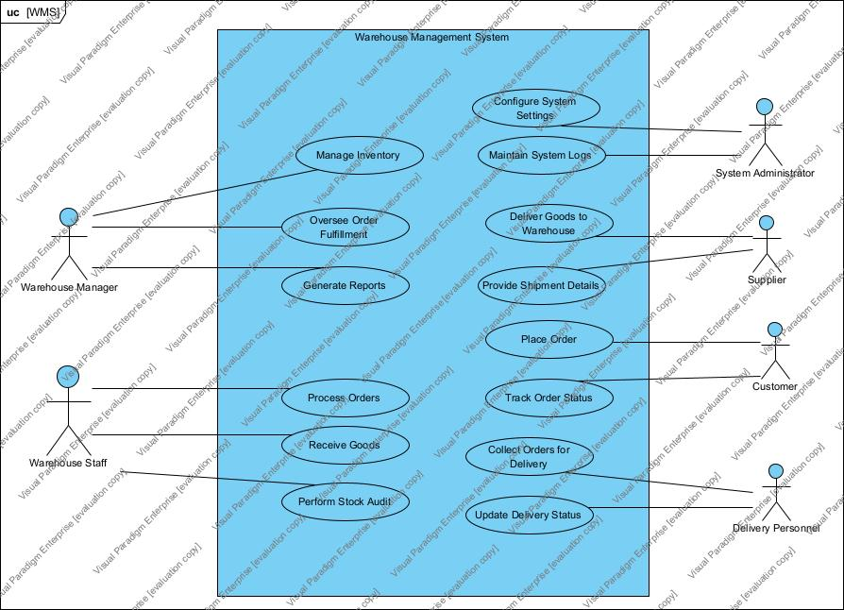

**Activity diagram**

Activity diagrams are an essential part of the UML (Unified Modeling Language) that help visualize workflows, processes, or activities within a system. They depict how different actions are connected and how a system moves from one state to another. By offering a clear picture of both simple and complex workflows, activity diagrams make it easier for developers and stakeholders to understand how various elements interact in a system.

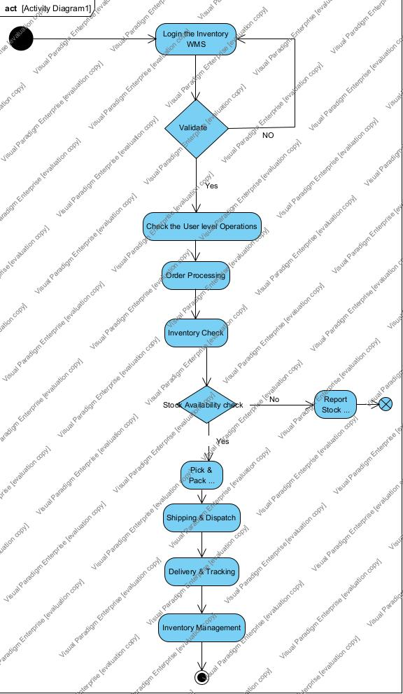

**use case specification document**

**1. Use Case Name**: Order Processing

**2. Use Case Description**

This use case describes the process of receiving, processing, and fulfilling a customer order within the Warehouse Management System (WMS).

**3. Actors**

* Primary Actors: Warehouse Manager, Warehouse Staff,
* Secondary Actors: Delivery Personnel, Supplier, Customer, System (WMS)

**4. Basic Flow**

1. Customer places an order via the system.
2. WMS verifies stock availability.
3. If items are in stock, the order is confirmed and a picking request is generated.
4. Warehouse staff picks and packs the items.
5. The system generates a shipping label.
6. Delivery personnel is assigned and notified.
7. The order is dispatched and tracking details are updated.
8. The customer receives the order and confirms delivery.

**5. Alternate Flow**

* Stock Unavailable: If items are out of stock, the system notifies the customer and either cancels or backorders the item.
* Order Cancellation: If the customer cancels before dispatch, the order is marked as cancelled, and inventory is updated.

**6. Exceptional Flows**

* Payment Failure: If payment fails, the order is not confirmed, and the customer is notified.
* Address Invalid: If the delivery address is invalid, the system requests an update from the customer before proceeding.

**7. Pre-Conditions**

* Customer must have an active account.
* Inventory must be maintained in the system.
* Warehouse staff must be logged into the system.

**8. Post-Conditions**

* Order status is updated to "Delivered."
* Inventory is deducted accordingly.
* Customer is notified of successful order fulfilment.

**9. Assumptions**

* Customers provide accurate delivery information.
* Warehouse staff processes orders in a timely manner.
* The system has real-time inventory tracking enabled.

**10. Constraints**

* Order processing time should not exceed predefined SLAs.
* Limited stock availability may delay processing.
* System downtime can impact order fulfilment.

**11. Dependencies**

* Inventory Management System must provide accurate stock data.
* Shipping & Delivery system must function correctly.
* Payment Gateway integration should be operational.

**12. Inputs and Outputs**

* Inputs: Customer Order, Inventory Data, Payment Details
* Outputs: Order Confirmation, Shipping Label, Delivery Status Update

**13. Business Rules**

* Orders must be processed within a defined SLA.
* Priority orders must be picked and shipped first.
* Order cancellations must be logged and refunded based on policy.

**14. Miscellaneous Information**

* System logs must store order processing details for auditing.
* Notifications should be sent to customers at each order stage.

**1. Use Case Name**: Inventory Management

**2. Use Case Description**

This use case describes how warehouse managers and staff manage inventory levels in the WMS.

**3. Actors**

* Primary Actors: Warehouse Manager, Warehouse Staff
* Secondary Actors: System (WMS)

**4. Basic Flow**

1. Warehouse staff logs into the system.
2. Staff updates inventory (add, update, or remove items).
3. WMS verifies and logs changes.
4. System updates stock levels.
5. System generates reports on stock availability.

**5. Alternate Flow**

* Stock Discrepancy: If stock levels are incorrect, the system triggers an audit request.

**6. Exceptional Flows**

* Database Failure: If inventory data is lost, system restores from backup.
* Unauthorized Access: If an unauthorized user attempt changes, system denies access.

**7. Pre-Conditions**

* User must have appropriate access rights.
* The WMS must have real-time stock-tracking enabled.

**8. Post-Conditions**

* Inventory records are updated accurately.
* System reflects real-time stock levels.

**9. Assumptions**

* Warehouse staff regularly updates stock.
* System-generated reports are accurate.

**10. Constraints**

* Only authorized personnel can modify inventory data.
* Periodic audits are mandatory.

**11. Dependencies**

* Order Processing module relies on accurate stock data.
* Supplier system should update stock details.

**12. Inputs and Outputs**

* Inputs: New Inventory Data, Stock Updates, Audit Logs
* Outputs: Updated Stock Records, Reports, Audit Logs

**13. Business Rules**

* Stock audits must be conducted periodically.
* All inventory changes must be logged for tracking.

**14. Miscellaneous Information**

* System should provide alerts for low stock levels.

**1. Use Case Name:** Shipping & Delivery Management

**2. Use Case Description**

This use case describes the shipping and delivery process of fulfilled orders.

**3. Actors**

* Primary Actors: Warehouse Staff, Delivery Personnel
* Secondary Actors: Customer, System (WMS)

**4. Basic Flow**

1. Warehouse staff prepares the shipment.
2. WMS generates a shipping label.
3. Delivery personnel is assigned and notified.
4. Order is picked up for delivery.
5. Customer receives the order and confirms delivery.
6. System updates order status to "Delivered."

**5. Alternate Flow**

* Delayed Delivery: If delivery is delayed, system notifies the customer.

**6. Exceptional Flows**

* Lost Shipment: If a package is lost, a replacement/refund process is triggered.
* Incorrect Address: If delivery fails due to an incorrect address, the system flags the order for correction.

**7. Pre-Conditions**

* The order must be fully processed and packed.
* Delivery personnel must be assigned.

**8. Post-Conditions**

* Order is successfully delivered.
* System logs the delivery details.
* Customer receives notification of completion.

**9. Assumptions**

* Delivery personnel follow assigned schedules.
* Customers provide correct address details.

**10. Constraints**

* Delivery must be completed within the SLA.
* Tracking updates must be real-time.

**11. Dependencies**

* Order Processing must be completed before shipping.
* Inventory system updates stock after shipment.

**12. Inputs and Outputs**

* Inputs: Order Details, Customer Address, Shipping Label
* Outputs: Tracking Updates, Delivery Confirmation, Notifications

**13. Business Rules**

* Delivery timelines must be met as per SLA.
* Order tracking updates must be real-time.

**14. Miscellaneous Information**

* Shipping labels should include customer contact details.
* System should provide estimated delivery times.

**Creation of Screens & pages using Axure**

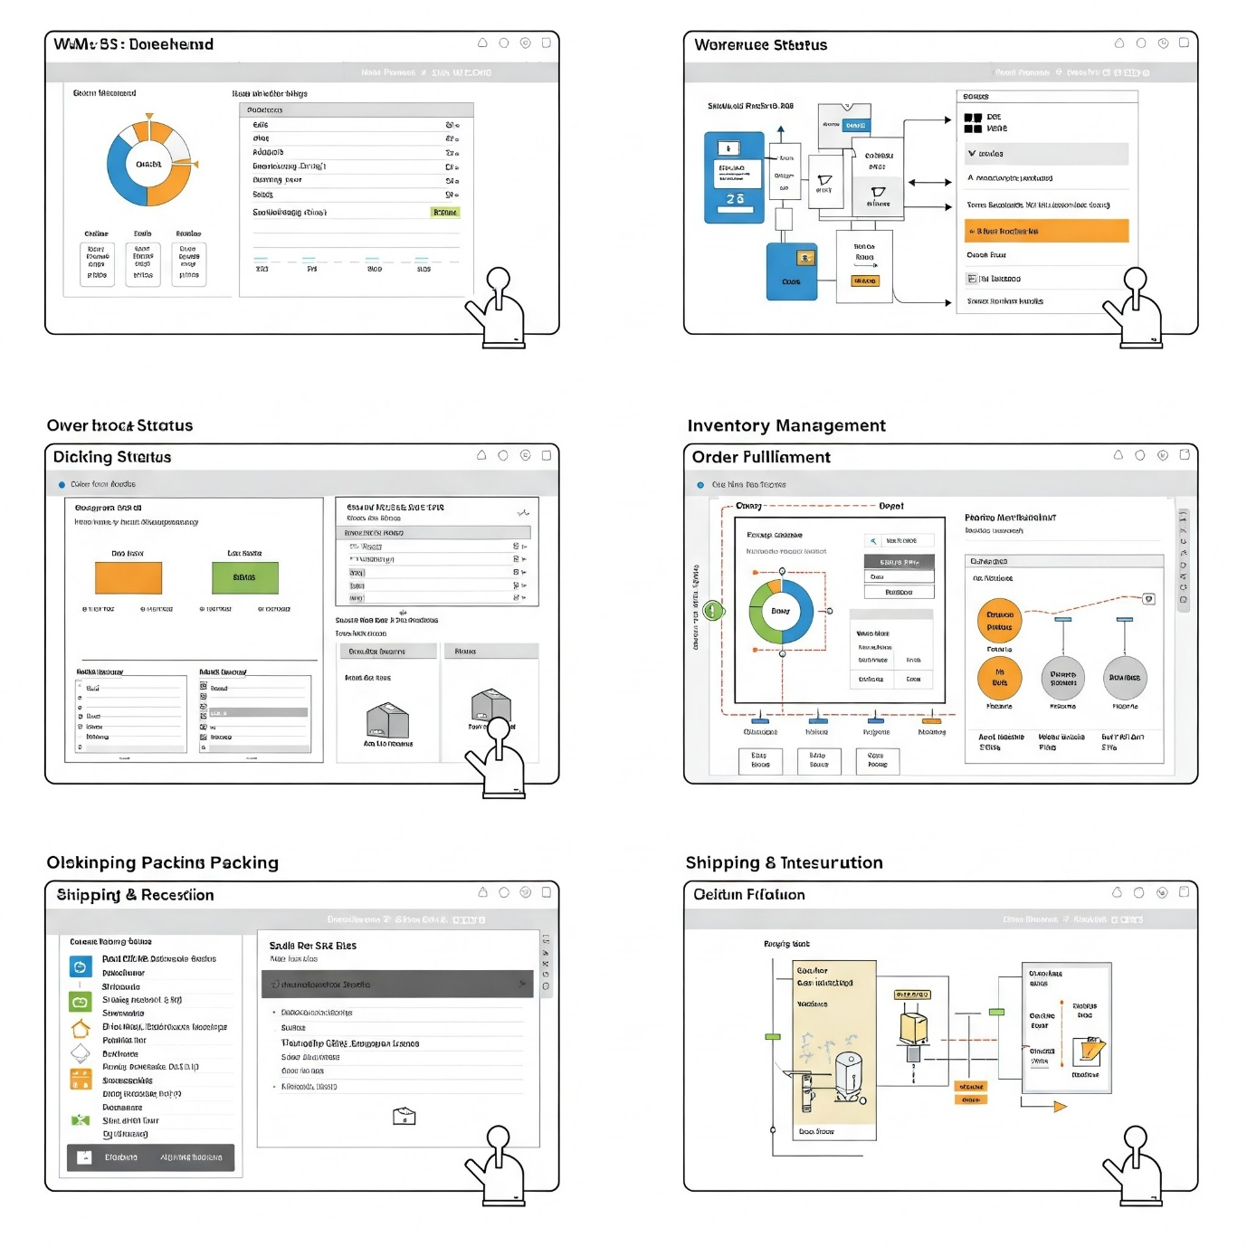

**My Experience as a BA using Visio and Axure tools:**

I got to know the tools knowledge and training via COEPD tools training sessions & I practised the tools regularly. For this WMS application development, I used Axure to create a Screens & Pages. Using Axure for the WMS project proved to be valuable assets. Visio excelled in creating clear and concise process flows, system architecture diagrams, and network layouts. Its intuitive interface and shape libraries facilitated rapid prototyping and communication of complex concepts. Axure, on the other hand, proved invaluable for creating interactive prototypes of user interfaces. Its features for defining interactions, states, and conditional logic allowed for a realistic simulation of user flows, enabling early identification of usability issues and gathering valuable feedback from stakeholders.

Personally, I feel that both tools very effective in Visual representation,

* **Visio:** Excellent for process flows, system architecture, and network diagrams.
* **Axure:** Ideal for creating interactive prototypes of user interfaces, simulating user flows, and gathering feedback.

**My experience as BA in following phases:  
1. Requirement Gathering**

* Engaged with key stakeholders, including warehouse managers, logistics teams, inventory controllers, and IT teams, to gather requirements.
* Conducted workshops, interviews, and site visits to understand existing warehouse operations, pain points, and system needs.
* Captured functional and non-functional requirements related to order processing, inventory tracking, stock replenishment, shipment management, and reporting.
* Documented detailed Business Requirement Documents (BRD), User Stories, and Process Workflows.

**2. Requirement Analysis**

* Analysed warehouse workflows, including receiving, picking, packing, and shipping to identify process optimization opportunities.
* Developed Use Case Diagrams, Process Flow Diagrams, and Entity Relationship Diagrams (ERD) to map system interactions.
* Worked closely with the technical team to assess feasibility, system integration points (e.g., ERP, barcode scanners, RFID systems), and potential constraints.
* Prioritized key requirements based on business impact and warehouse operational efficiency.

**3. Design**

* Defined UI/UX wireframes and prototypes for WMS screens such as Dashboard, Order Processing, Inventory Management, and Shipment Tracking.
* Created functional specifications outlining key system functionalities, including real-time inventory tracking, automated stock replenishment, and role-based access.
* Worked with the architecture team to ensure seamless integration with external systems like ERP, e-commerce platforms, and third-party logistics providers.

**4. Development**

* Acted as the bridge between business and development teams, ensuring the system was built as per the documented requirements.
* Conducted sprint planning and backlog refinement in an Agile environment to ensure key warehouse features were prioritized.
* Provided continuous feedback and clarifications on features such as inventory adjustments, warehouse slotting, and barcode scanning functionalities.
* Assisted in data migration planning for transitioning from the old system to the new WMS.

**5. Testing**

* Collaborated with QA teams to define test scenarios, test cases, and acceptance criteria for order fulfilment, warehouse operations, and shipping.
* Conducted User Acceptance Testing (UAT) with warehouse staff to validate the usability of features like real-time stock updates and order tracking.
* Ensured integration testing with ERP, barcode scanning, and automated picking systems to prevent operational disruptions.
* Identified and documented defects, worked with the development team for quick resolution, and ensured the system met business requirements before deployment.

**6. Deployment**

* Provided end-user training for warehouse staff, logistics personnel, and inventory managers on the new WMS system.
* Created user manuals, SOPs, and training videos for smooth adoption of the WMS.
* Supported go-live activities, including data migration validation, system monitoring, and issue resolution.
* Collected post-deployment feedback, tracked system performance, and recommended enhancements for future releases.