Document 1: Definition of Done
Project Name: Global TIS
Prepared By: Roopshree S.
Date: 07-07-2025
Definition of Done is a technique where the team agrees on, and prominently displays, a list of criteria which must be met before a backlog item is considered done.
Purpose of DoD:
The Definition of Done (DoD) ensures that every user story, task or increment delivered meets a shared standard of completeness and is ready for release or deployment. It reduces ambiguity and improves quality by providing clear, agreed-upon criteria.
General DoD Criteria:
Area | Criteria
Requirements | The story is fully understood and accepted by Product Owner
Design | UI/UX is approved, and design complied with system standard.
Development | Code is written; peer reviewed and follows naming convention
Unit Testing | Unit test written and pass with 90%+ coverage
Integration | Code integration into the main branch without conflicts
Build/Deployment | Builds successfully in CI/CD environment.
Functional Testing | QA validates that feature works per acceptance criteria.
Non-Functional Testing | Performance, security and load testing completed.
Documentation | User story is documented.
PO Acceptance | Product Owner reviews and accepts the user story.
Regression Tested | Regression tests conducted and passed.
Demo-Ready | Feature is ready for sprint review.
Production-Ready | No critical bugs and can be released if required.

Document 2- Product Vision
Scrum Project: Global TIS
Venue: Virtual
Date: 08/07/2025 | Start Time: 10:00 AM | End Time: 6:00 PM | Duration: 8 hours
Client: Global TIS
Stakeholder: Webster Britney, Russ Micheal, Oliveria Joao, S Umesh
Scrum Team
Scrum Master: Vipul Sharma
Product Owner: Oliveria Joao
Scrum Developer 1: Divya Nayak
Scrum Developer 2: Neha Shinde
Scrum Developer 3: Saurabh D.
Scrum Developer 4: Kavita Bagle
Scrum Developer 5: Sunil More
Vision
Target  - Bank and financial institution using Global TIS ATM network.  - ATM operations teams, field service vendor and helpdesk engineer.  - End-users/customers who reply on ATM services for transaction. | Need  - Real-time monitoring of ATM performance and faults.  - Reduce ATM downtime and improve response time to issues.  - Provide secure, compliant and always available ATM access. | Product  - A centralized ATM lifecycle management system.  - Enables installation tracking, maintenance scheduling and fault alerts.  - Compatible with existing ATM hardware/software.  - Modular and scalable for future integration. | Value  - Minimizes ATM downtime and improves customer satisfaction.  - Meets SLA compliance goals and reduces manual efforts.  - Increase operational efficiency and reduce support cost.  - Supports regulatory compliance, service transparency and business KPIs.

Document 3: User stories
User Story No.: US001 | Tasks: 03 |  | Priority: High
Value Statement:
As a Helpdesk Engineer,
I want to receive real-time alerts for ATM failures
So that I can act quickly to resolve issues and reduce downtime.
BV: 30 |  | CP: 05
Acceptance Criteria:
- Alerts should be generated within 30 sec of ATM failure.
- Alert should include ATM ID, location and error code.
- Ticket auto generated in service portal.

User Story No.: US002 | Tasks: 03 |  | Priority: Medium
Value Statement:
As a Project Manager,
I want to track ATM installation progress by location,
so that I can ensure deadlines are met and vendors are performing.
BV: 40 |  | CP: 03
Acceptance Criteria:
- Track installation steps (Site ready → Installed → Activated).
- Must support filtering by region and vendor.
- Export should be accurate and downloadable.

User Story No.: US003 | Tasks: 03 |  | Priority: High
Value Statement:
As an Operations Lead,
I want to monitor SLA compliance of maintenance vendors,
so that I can ensure service quality and take corrective action
BV: 30 |  | CP: 08
Acceptance Criteria:
- SLA threshold set per ticket type.
- SLA breach highlights in red with timestamp.
- Email notification sent to vendor and lead.

User Story No.: US004 | Tasks: 03 |  | Priority: High
Value Statement:
As a Field Service Technician,
I want automated ticket creation from alerts,
so that I don’t miss urgent ATM issues.
BV: 50 |  | CP: 05
Acceptance Criteria:
- Ticket must auto-fill ATM ID, error, location, and timestamp.
- Status updates must reflect in real-time.
- Must be accessible via mobile.

User Story No.: US005 | Tasks: 03 |  | Priority: Medium
Value Statement:
As a Compliance Officer,
I want monthly reports on ATM service metrics,
so that I can ensure we meet internal compliance standards
BV: 60 |  | CP: 08
Acceptance Criteria:
- Report includes metrics: downtime %, SLA met/missed, open/closed tickets.
- Must be scheduled monthly.
- Report must be exportable and tamper-proof (PDF with timestamp).

Document 4: Agile PO Experience
The Product Owner has a vision of the product keeping the domain/industry experience and the market need.
The following are the responsibilities of PO in a project:
- Market Analysis:-
- Conducted market analysis to identify gaps in ATM lifecycle management, especially around real time fault handling and SLA tracking.
- Evaluated the availability of similar products, including tools used by banks and managed service providers.
- Identified that most solutions lack centralized visibility across installation, maintenance, and compliance.

- Enterprise Analysis:-
- Performed due diligence on the opportunity to reduce ATM downtime, optimize vendor management, and increase regulatory compliance.
- Worked closely with business stakeholders and field teams to assess the ROI potential of a centralized monitoring system.
- Product Vision and Roadmap:-
- Defined a clear product vision: “To build a unified platform that offers full control and visibility over ATM services from installation to maintenance across the Global TIS network.”
- Created a product roadmap with high-level features such as:
- ATM Installation Tracker
- Real-time Fault Monitoring
- SLA Compliance Dashboard
- Vendor Ticketing System
- Performance Reports Module
- Planned delivery across 5 major sprints over 6 months.
- Managing Product Features:-
- Prioritized features based on:
- Operational criticality (e.g., fault alerting)
- Business value (e.g., SLA metrics reporting)
- Ease of implementation
- Managed and balanced stakeholder expectations, including IT, Operations, Vendors, and Compliance Teams.
- Managing Product Backlog:-
- Continuously groomed and prioritized the Product Backlog.
- Reprioritized stories during sprint reviews based on stakeholder feedback and sprint performance.
- Broke down epics like “ATM Monitoring” into granular user stories such as “real-time alert for critical fault.”
- Managing Overall Iteration Progress:-
- Conducted regular Sprint Reviews to validate increments.
- Collaborated with the Scrum Master and Business Analyst to perform retrospectives and identify process improvements.
- Reprioritized stories and features in upcoming sprints based on dependencies and business urgency.
From this project I have learned how to handle sprint meetings such as:
- Sprint Planning Meeting – Defined sprint goals, committed user stories, and assigned tasks.
- Daily Scrum Meeting – Monitored progress, addressed blockers, and coordinated among developers.
- Sprint Review Meeting – Presented deliverables to stakeholders and gathered feedback.
- Sprint Retrospective Meeting – Evaluated sprint success, identified improvement actions.
- Backlog Refinement Meeting – Refined epics into stories, added BV and CP, and maintained clarity.
User Story Creation Experience:
- Story Number (e.g., US001)
- Tasks (in numeric format for planning)
- Priority (High, Medium, Low)
- Acceptance Criteria (detailed testable conditions)
- BV (Business Value) & CP (Complexity Point) (for ROI-based prioritization)
Document 5: Product and sprint backlog and product and sprint burndown charts
Product Backlog:-
- A Product Backlog is a prioritized list of all features, enhancements, bug fixes, technical work, and knowledge acquisition needed to deliver a product. It is owned by the Product Owner and evolves throughout the project.
- It includes high level items like epic, features and user stories that reflect the entire scope of the project.

User Story ID | User Story | Task | Priority | BV | CP | Sprint
US001 | As a Helpdesk Engineer,  I want to receive real-time alerts for ATM failures  So that I can act quickly to resolve issues and reduce downtime. | 03 | High | 30 | 05 | Sprint-1
US002 | As a Project Manager,  I want to track ATM installation progress by location,  so that I can ensure deadlines are met and vendors are performing. | 03 | Medium | 40 | 03 | Sprint-1
US003 | As an Operations Lead,  I want to monitor SLA compliance of maintenance vendors,  so that I can ensure service quality and take corrective action. | 03 | High | 30 | 08 | Sprint-1
US004 | As a Field Service Technician,  I want automated ticket creation from alerts,  so that I don’t miss urgent ATM issues. | 03 | High | 50 | 05 | Sprint-1
US005 | As a Compliance Officer,  I want monthly reports on ATM service metrics,  so that I can ensure we meet internal compliance standards. | 03 | Medium | 60 | 08 | Sprint-1

Sprint Backlog:-
- A Sprint Backlog is a subset of the product backlog, selected during Sprint Planning, that the team commits to deliver in the current sprint.
- It includes selected user stories, task to complete those stories, effort estimates, daily updates during the sprint.

User story ID | User Story | Task | Owner | Status | Estimated efforts
US001 | Register a new ATM location | Form design, backend integration, UI testing | Divya | In-progress | 5
US002 | Track ATM installation status | Build status module, link to DB, test | Sunil | In-progress | 8
US003 | Raise issues via support form | Create form, set up backend logic, email alerts | Kavita | In-progress | 3

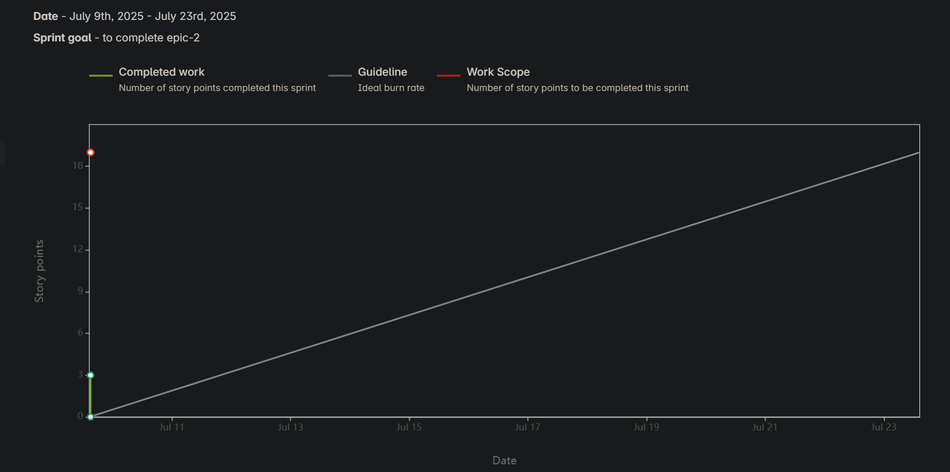

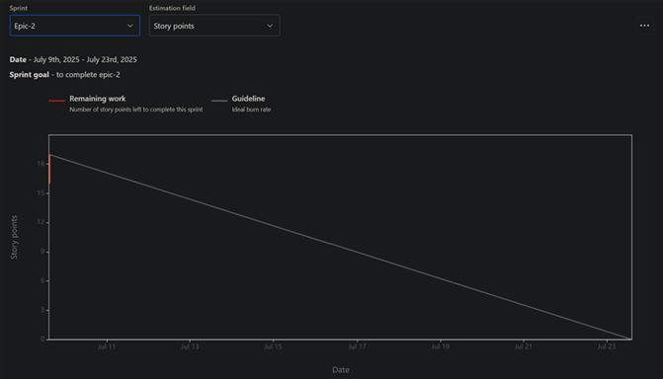

Document 6: Sprint meetings
Meeting Type 1: Sprint Planning meeting
Field | Details
Date | 10 july 2025
Time | 10:00 AM- 11:00 AM
Location | Teams
Prepared By | Roopshree S.
Attendees | Webster Britney, Russ Micheal, Oliveria Joao, S Umesh, Vipul Sharma, Oliveria Joao, Divya Nayak, Neha Shinde, Saurabh D., Kavita Bagle, Sunil More

Agenda Topics
Topic | Presenter | Time allotted
Sprint Goal Finalization | Product Owner | 20 mins
Review of User Stories & Estimation | Scrum Team | 40 mins
Sprint Backlog Confirmation | Scrum Master | 20 mins

Other Information
Item | Details
Observers | QA Manager, Business Analyst
Resources | Jira board, confluence, sprint backlog document
Special Notes | Focus on prioritizing ATM software installation module in this sprint.

Meeting Type 2: Sprint review meeting
Field | Details
Date | 10 july 2025
Time | 10:00 AM- 11:00 AM
Location | Teams
Prepared By | Roopshree S.
Attendees | Webster Britney, Russ Micheal, Oliveria Joao, S Umesh, Vipul Sharma, Oliveria Joao, Divya Nayak, Neha Shinde, Saurabh D., Kavita Bagle, Sunil More

Sprint Status | Things to Demo | Quick Updates | What’s Next
Sprint completes 90% scope | ATM software setup module, PIN generation interface | Minor bugs in card reader config, resolved | Begin installation module with ATM location tracking setup

Meeting Type 3: Sprint retrospective meeting
Field | Details
Date | 10 july 2025
Time | 10:00 AM- 11:00 AM
Location | Teams
Prepared By | Roopshree S.
Attendees | Webster Britney, Russ Micheal, Oliveria Joao, S Umesh, Vipul Sharma, Oliveria Joao, Divya Nayak, Neha Shinde, Saurabh D., Kavita Bagle, Sunil More

Agenda | What went well | What didn’t go well | Questions | Reference
Sprint 1 review | Timely delivery of PIN module and UI integration | ATM location services integration was delayed | Can we avoid external dependency bottleneck? | Sprint board, jira board
Improvement | Great coordination among Dev &QA | Daily stand-up exceeded timebox | Can we assign a timekeeper in each stand-up | Retrospective action list

Meeting Type 4: Daily Stand-up meeting:
Question | Name | Week (7-7-25 to 11-7-25)
Question | Name | Mon | Tue | Wed | Thu | Fri | Sat | Sun
What did you do yesterday? | Divya | Complete login API | Fixed minor UI bugs | Code review of Story #2 | Finalized data models | Wrote unit test for story #3
What did you do yesterday? | Sunil | Researched new reporting plugin | Drafted report module wireframes | Integrated analytics dashboard | Team sync & retrospective | Helped QA with bugs
What did you do yesterday? | Saurabh | Setup development environment | Started story- backend | Created SQL schema | Backend API testing | Assisted in release planning
What will you do today? | Divya | Start Story #3 frontend | Debug data-binding issue | Collaborating with Designer |  | Prepare sprint demo
  Implement
  login
  validation
What will you do today? | Sunil |  | Fix CSS issues | Build test cases | Merge PR to dev branch | Complete documentation
  Create report filters UI
What will you do today? | Saurabh | Finish backend logic for Story #4 | API testing & validation | Assist Dev 2 with UI alignment | Dependency on backend fix | Run final regression test
What (if any) is blocking your progress? | Divya | Awaiting feedback from UX team | - | - | Dependency on backend fix
What (if any) is blocking your progress? | Sunil | Waiting for data model confirmation | - | Need final approval on reports layout | -
What (if any) is blocking your progress? | Saurabh | Access issues to QA server | - | - | - | Need test credentials from DevOps

