1. **BPM Model:**

**Goal**: To make Agriculture products easily available at one place

**Input**: Agriculture products Data, Trained employees, Product Catalog, Customer Details, Cart Details, Order Details, Customer Address, Customer Feedback

**Resources**: Internet, Delivery Agents, Farmers, Companies producing Agricultural Products, Payment Gateways

**Output**: Details of products, selected items in Shopping Cart, Order confirmation Acknowledgement, Delivery of Product

**Activities**: Registration, Login, Searching the product, Selection of product, buying the product, payment, delivery

**Value Created**: Customer satisfaction as he saves his conveyance time and cost

1. **SWOT Analysis:**
2. **Strengths**: As this is a new a scheme will be helpful to all farmers.
3. Experienced people who are working in that field are there.
4. Experienced team from APT solutions.
5. Scalability to add more features and more regions
6. It will connect Farmers, Suppliers, Buyers in one ecosystem
7. Digital payment solutions for secure transactions
8. Convenient for users as it is accessible everywhere.

**Weakness**:

1. People are not that aware about online applications as they may lack experience with smartphones.
2. Connectivity issue as user base belongs to remote areas
3. Trust issues
4. More chances for replication of idea.
5. If the app doesn’t support local language, it will fail
6. App’s demand may vary seasonally, which will affect usage of app.
7. Dependencies on Third Parties i.e. Payment gateways and suppliers increases.

**Opportunity**:

1. It can bring digital Transformation in agriculture industry
2. Changes of market enhancement
3. Can add value added services or features like videos for handling app, weather information, market prices etc.
4. Promote organic and ecofriendly products
5. Can collaborate with Government Agencies, private Companies
6. Exploring AI options
7. Empowering women and Youth

**Threats**:

1. Competition with new players in the market
2. Infrastructure limitations like internet and devices for app use
3. Trust about product Quality
4. Political effect
5. Operational challenges with vendors, distributors.
6. Financial risk as the as the number of orders may fluctuate based on plating, harvesting which will lead to generation of inconsistent revenue
7. **Feasibility Study:**

Budget: 2 Cr

Time: 18 Months

1. **Technology:** Payment gateways, security**,**
2. **Hardware:** Backup server, Database server, Network architecture
3. **Software:** Payment systems, agri store software, security software
4. **Trained Resources:** PM, Java Developers, Testers, BA & Network admin
5. **Budget:** Software development cost, Hardware cost, salary costs
6. **Time frame:** Based on Members in Project
7. **GAP Analysis:**

**Current State:**

1. No system to Communicate Between Buyers and Sellers.
2. Farmers Dependence on few vendors for purchase of agricultural Products
3. Less Awareness in Rural Regions.
4. Use of Offline Product Purchase system.
5. Less Availability of Products.

**Proposed State:**

1. System which will communicate between buyers and sellers
2. Farmers will not be dependent on Few vendors as They are getting a large platform for purchase of products.
3. More Awareness in rural Regions.
4. Use of Online Product Purchase System.
5. More Availability of Products
6. **Risk Analysis:**

**BA Risks:**  1. incomplete requirements

2. Frequent change in requirements

3. Improper planning

4. Coordinate between testers, developers and stakeholders

5. lack of training

**Process/ Project Risks:**

1. Technical Issues
2. System Downtime
3. Untrained Employees
4. Bugs in system

**Environmental Risks:**

1. Changes in Weather conditions
2. **Stakeholder Analysis (RACI matrix):**

|  |  |  |  |  |  |  |
| --- | --- | --- | --- | --- | --- | --- |
| **Name** | **Position** | **Contact Details of persons** | **R** | **A** | **C** | **I** |
| Mr. Henry | Owner |  | - | - | ✓ | ✓ |
| Mr. Peter | Stakeholder |  | - | - | ✓ | ✓ |
| Mr. Kevin | Stakeholder |  | - | - | ✓ | ✓ |
| Mr. Ben | Stakeholder |  | - | - | ✓ | ✓ |
| Mr. Pandu | Financial Head |  | - | - | ✓ | ✓ |
| Mr. Doku | Project Co-ordinator |  | - | - | ✓ | ✓ |
| Mr. Karthik | Delivery Head |  | - | ✓ | - | - |
| Mr. Vandanam | Project Manager |  | - | ✓ | - | - |
| Ms. Juhi | Senior Java Developer |  | - | ✓ | - | - |
| Mr. Teyson | Java Developer |  | ✓ | - | - | - |
| Ms. Lucie | Java Developer |  | ✓ | - | - | - |
| Mr. Tucker | Java Developer |  | ✓ | - | - | - |
| Mr. Bravo | Java Developer |  | ✓ | - | - | - |
| Mr. Mike | Network Admin |  | - | - | ✓ | - |
| Mr. John | DB Admin |  | - | - | ✓ | - |
| Mr. Jason | Tester |  | ✓ | - | - | - |
| Ms. Alekya | Tester |  | ✓ | - | - | - |
| Mr.Krishna | BA |  | - | ✓ | - | - |

1. **Business Case Document:**
   1. Why is this app being Developed?

-To help Farmers to buy Agriculture products Easily.

* 1. What is the current Situation in the market?

-Currently Farmers need to go to market to buy the products.

* 1. How will you solve the issue with this application?

-This application will help farmers to communicate to a wide range of sellers.

* 1. What are Your Resources?

-Payment gateway application, Internet, Delivery Agents, Componies which are providing the products

* 1. What is the Time frame for the Project?

-18 Months

* 1. What is the Budget for the Project?

-2 Cr

* 1. What will be the Stake of Other Stakeholders?

-Mr. Henry 90% rest 10% by his 3 Friends

* 1. Who are the stake holders?

-SONNY company, APT Solutions and their respective Members

* 1. What is agenda to complete the project?

-Work With Waterfall Model

* 1. What are the Pain Areas in this Project?

-Creating awareness among people about the application.

* 1. What was the Previous method used by customers?

-Framers Need to go to the Market

* 1. How will you Guide People to use the online system?

-By creating the videos

* 1. What procedure do expect for this system?

-Waterfall method

* 1. Is it a CSR initiative?

-Yes

1. **Four SDLC Methodologies:**

Methodology is a system of Methods Used.

SDLC Methodologies are the processes used by the Development team to complete the SDLC (software development life cycle). They are cost effective and time efficient. There are four SDLC methodologies i.e. Sequential, Iterative, Evolutionary and Agile.

1. **Sequential -** It is a linear Method. In this methodology each face must be completed before initiation of the next phase. The waterfall model is a sequential SDLC model. In the sequential method Validation is done at the end.

2. **Iterative-** It is based on an Iterative and Incremental action. Validation is completed at each stage in this method. Rational Unified Process is one model of Iterative Method.

3. **Evolutionary -**This method focuses on Risk Analysis. A prototype is produced in one of the phases of this method and is re-engineered as per customer requirement.

**Agile-** Can be implemented where fast delivery is required. No documentation is required. It has 4 Values And 12 Principles. Scrum, Kanban are few models used in Agile Methodology

1. **Waterfall RUP spiral and Scrum Models:**
   1. **Waterfall RUP spiral:**

It is more forward approach of waterfall model. In this model, project goes into seven phases of life cycle. Requirement gathering, requirement analysis, Design, Development, Testing, Configuration Management and Deployment.

Testing will be done at the end of process.

* 1. **RUP Model:**

RUP is based on set of elements which describes what is to be produced, skills required and how the goal will get achieve.

The main elements are Who, What and How which describes roles and responsibilities, output comes of related work input and how to get specific result respectively.

Model has four lifecycle phases.

i. **Inception:** It is agreement between team and customer for what to build

**ii. Elaboration:** It is agreement within team for design ad architecture

iii. **Construction:** It is implementation of full system.

iv. **Transition**: to delivery defect correction, to ensure customer feedback.

Within each iteration, tasks categorizes into nine disciplines.

Business Modelling, Requirements, Analysis and Design, Implementation test, Deployment, Configuration and change management and environment

* 1. **Spiral Model:**

The evolutionary Model works in four phases. Planning, Risk analysis, Engineering and Evaluation.

A project repeatedly passes through these four phases in spiral way, hence it known as Spiral model.

**Workflow**: Requirements gathered in planning phase. In next phase, we can identify risk and alternate solutions. A prototype is produced at the end of risk analysis phase. Software is produced at the end of engineering phase. Customer can evaluate project in evaluation phase.

In this model, angular component represents progress and radius denotes cost of project.

* 1. **Scrum Model:**

This model has Faster delivery and no documentation is required in this process so the customer can be retained, as the code itself forms as documentation.Scrum can be implemented either at the beginning or at the middle of the project if the project is falling behind.

Key Words in Scrum are:

1. Scrum team - Includes BA, Developers and Testers. Average size7-8

2. Product Owner – Responsible for how the product has to be.

3. Scrum Master: Monitor the Performance of the Team. Usually, BA plays this role.

4. Burn Down Chart: Graphical view of Work left Vs Time in an iteration.

5. Epic: Set of related user stories

6. Product Backlog: All stories and all requirements are mentioned here

7. Meetings:

i. **Sprint planning meeting**: Happens at beginning of each sprint.

ii. **Daily Scrum Meeting**: Team has to answers 3 questions about daily progress

iii. **Sprint Review Meeting**: Happens at the end of Sprint. Completed User Stories are

demonstrated to Product owner.

iv. **Sprint Retrospective**: Team answers the questions saying what went well, what not and what improvements are required.

8. Iteration: Each Iteration includes all waterfall Activities. Time 1-4weeks

9. Scrum: Iterative Development Methodology

10. Sprint: Time Boxed to deliver a specific set of user stories.

11. Storypoints: Determine the size of user story.

**10. Difference between Waterfall and V Model:**

|  |  |  |
| --- | --- | --- |
| **Sr No** | **Waterfall Model** | **V Model** |
| 1 | It is low cost model | It is high cost model |
| 2 | It is less flexible | It is more flexible |
| 3 | In waterfall model, we can not return to earlier phase | In V model we can return to earlier phase. |
| 4 | In this model, testing starts after development phase. | In this model, testing happens at every phase. |
| 5 | Success ratio is low | Success ratio is high. |
| 6 | In waterfall model, less involvement of customer. | In V model high involvement of customer. |
| 7 | We can identify bugs after testing phase only | We can identify bugs at every phase, as testing get done at every phase of lifecycle. |
| 8 | Waterfall model is low risk model. | V model is high risk lifecycle. |

**11. As a BA, state your reason for choosing one model for this project:**

1. **Waterfall Model** will be best suited method for Online Agriculture Product Store.
2. As this is a small project with low complexity.
3. The requirements for this project are clear and well defined.
4. Waterfall Method makes the Project Cost effective and Time Efficient.
5. Minimal Customer involvement During Development Phase.
6. Since each phase is completed before next, it makes the project budget predictable.

**12. Gantt Chart:**

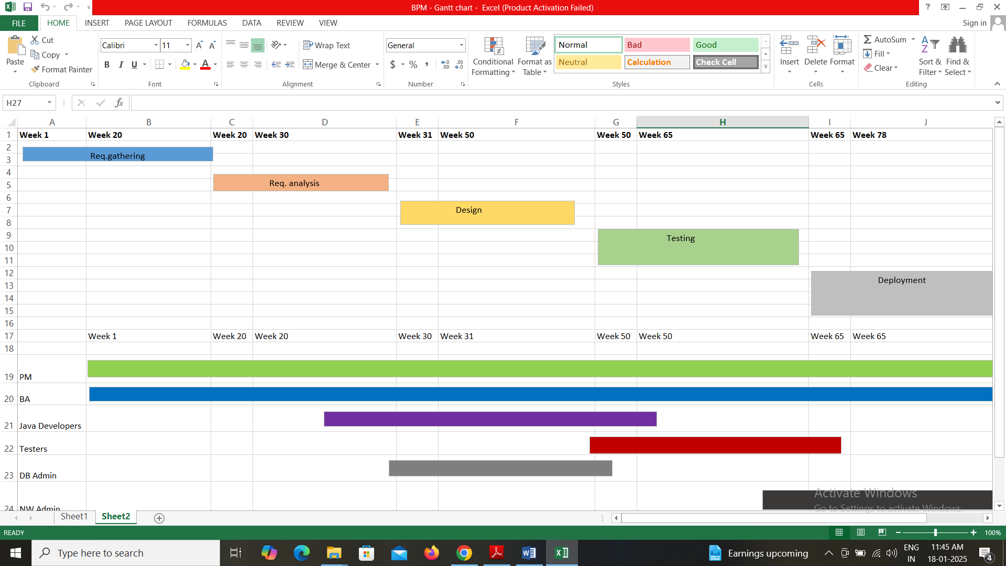

**13. Difference between Fixed Bid and Billing projects:**

|  |  |  |
| --- | --- | --- |
| Sr. No. | Fixed Bid Projects | Billing Projects |
| 1. | In Fixed Bid Projects client pays the total amount when the work is done. | In Billing Projects client pays the amount in Hourly or Daily Rate |
| 2. | Project scope is Limited in Fixed Bid Projects. | Project scope is High in Billing Projects. |
| 3. | In Fixed Bid Projects payment is based on full delivery. | In Billing Projects payment is Periodic as work processes. |

14. **Timesheets:**

|  |  |  |  |  |
| --- | --- | --- | --- | --- |
| **Design Timesheet** | | | | |
| **Sr. No.** | **Task** | **Start Time** | **End Time** | **Duration**  **(hrs)** |
| **1.** | Requirements analysis | 10:00 | 11:30 | 01:30 |
| **2.** | Documentation | 11:30 | 12:15 | 00:45 |
| **3.** | Stakeholder Review | 12:15 | 02:30 | 02:15 |
| **4.** | Risk Assessment | 03:00 | 04:30 | 01:30 |
| **5.** | Team meeting | 04:30 | 06:30 | 02:00 |

|  |  |  |  |  |
| --- | --- | --- | --- | --- |
| **Development Timesheet** | | | | |
| **Sr. No.** | **Task** | **Start Time** | **End Time** | **Duration**  **(hrs)** |
| **1.** | Process Mapping | 10:00 | 11:30 | 01:30 |
| **2.** | Process Building | 11:30 | 12:15 | 00:45 |
| **3.** | Development | 12:15 | 02:30 | 02:15 |
| **4.** | Bug Detection | 03:00 | 04:30 | 01:30 |
| **5.** | Team meeting | 04:30 | 06:30 | 02:00 |

|  |  |  |  |  |
| --- | --- | --- | --- | --- |
| **Testing Timesheet** | | | | |
| **Sr. No.** | **Task** | **Start Time** | **End Time** | **Duration**  **(hrs)** |
| **1.** | Test Planning | 10:00 | 11:30 | 01:30 |
| **2.** | Test case Design | 11:30 | 12:15 | 00:45 |
| **3.** | Test Execution | 12:15 | 02:30 | 02:15 |
| **4.** | Bug testing & reporting | 03:00 | 04:30 | 01:30 |
| **5.** | Team meeting | 04:30 | 06:30 | 02:00 |

|  |  |  |  |  |
| --- | --- | --- | --- | --- |
| **UAT Timesheet** | | | | |
| **Sr. No.** | **Task** | **Start Time** | **End Time** | **Duration**  **(hrs)** |
| **1.** | UAT Planning | 10:00 | 11:30 | 01:30 |
| **2.** | Test Case Review | 11:30 | 12:15 | 00:45 |
| **3.** | Issue Reporting | 12:15 | 02:30 | 02:15 |
| **4.** | Test Execution | 03:00 | 04:30 | 01:30 |
| **5.** | Team meeting | 04:30 | 06:30 | 02:00 |

|  |  |  |  |  |
| --- | --- | --- | --- | --- |
| **Deployment and Implementation Timesheet** | | | | |
| **Sr. No.** | **Task** | **Start Time** | **End Time** | **Duration**  **(hrs)** |
| **1.** | Pre-Deployment planning | 10:00 | 11:30 | 01:30 |
| **2.** | Server Preparation | 11:30 | 12:15 | 00:45 |
| **3.** | Software installation | 12:15 | 02:30 | 02:15 |
| **4.** | DB Configuration | 03:00 | 04:30 | 01:30 |
| **5.** | Deployment | 04:30 | 06:30 | 02:00 |