|  |
| --- |
| Question 1 – Audits - 5 Marks |

4 Quarterly Audits are planned Q1, Q2, Q3, Q4 for this Project what is your

Knowledge on how these Audits will happen for a BA?

ANSWER:-

The purpose of quarterly audit is to track the project and project progress with compliances. Also identify the issue and their solution is on right path. Evaluate the quality of the deliverables

Q1 AUDIT: - INITIATION OF PROJECT

* Verify whether requirements are well-documented and approved by stakeholders.
* To ensure the traceability requirement to project deliverables.
* To check the functional and non-functional requirements with the project goals.
* Check which elicitation technique is used to gather the required
* BA prepare the BRD by interacting with the client
* Check BA prepared document like BPM RTM to understand the requirement properly

Q2 AUDIT: - Execution Phase

* To evaluate the requirement have been effectively communicated to the development team.
* To check the project is on the right path for the feature implementation
* Check if stakeholder feedback is being incorporated during iterative reviews.
* Timesheet is proper or not
* BA tracking the status of the project or not
* BA updating the status of the project to the stakeholder

Q3 Audit:- testing phase

* This phase audit is done to check the bucks ,error or defect is reporting and resolution process are effective
* To check the RTM matrix is used for project to meet the proper requirements
* Review on user acceptance test to confirm the app is going on track to meet the requirements

Q4 Audit: - Delivery part

* In this phase or audit to confirm the final product should meet all the requirement
* To crosscheck the farmers and manufacturers about the application usability
* To check the BA is helping the client for UAT
* Heck the BA plan to training session for the users
* Has BA taken the sign off document from the client

|  |
| --- |
| Question 2 – BA Approach Strategy - 6 Marks |

Before the Project is going to Kick Start, The Committee asked Mr Karthik to submit BA Approach Strategy

Write BA Approach strategy (As a business analyst, what are the steps that you would need to follow to complete a project – What Elicitation Techniques to apply, how to do Stakeholder Analysis RACI/ILS, What Documents to Write, What process to follow to Sign off on the Documents, How to take Approvals from the Client, What Communication Channels to establish n implement, How to Handle Change Requests, How to update the progress of the project to the Stakeholders, How to take signoff on the UAT- Client Project Acceptance Form ) Your Team Project Manager - Mr Vandanam Senior

Java Developer - Ms. Juhi

Java Developers - Mr Teyson, Ms Lucie, Mr Tucker, Mr Bravo

Network Admin - Mr MikeDB Admin - Mr John.

* ELICITATION TECHNIQUE :-1)DOCUMENT ANALYSIS :-Team should check the existing data industry practice

2) BRAINSTORMING:- To collect the maximum idea form the stakeholders and prioritize them to meet the requirement

3) INTERVIEWS:- one on one conversation to farmers and manufactures to understand the need

4) WORKSHOP:- stakeholder working together to identify the requirement

5) Prototyping:-this is the online agriculture product so visual representation of the application feature for validation

STAKEHOLDER ANALYSIS AND RACI MATRIX:-

* Conduct the stakeholder analysis using the RACI matrix to identify the stakeholder and their responsibility
* Identify the stakeholder interest ,expectation and potential risk to understand and manage through the project
* Stakeholder role is to set a committee for the budget allocation time ,management,
* APT SOLUTION is 3rd party stakeholder who deliver the project milestone
* Farmers provide the requirement and feedback
* Manufacturer provide the product information and delivery support.

|  |  |  |  |  |  |  |
| --- | --- | --- | --- | --- | --- | --- |
| Task / Deliverable | Mr. Henry (Sponsor) | Mr. Pandu (Finance Head) | Mr. Doku (Coordinator) | Mr. Karthik (Delivery Head) | Mr. Peter,Mr.Kelvin,Mr.Ben | Ms. Juhi (Java Developer) |
| Project Planning | I | C | R, C | I | C | C |
| Budget Planning | I | R | C | I | I | I |
| Requirement Gathering | I | I | C | I | R | C |
| Project Scheduling | I | C | R | I | C | C |
| Project Execution | I | C | R | R | I | C |
| Quality Control/Delivery Management | I | C | C | A | I | C |
| Risk Management | I | C | R | C | C | C |
| Progress Updates | I | I | I | R | I | I |
| Project Review and Feedback | I | I | C | A | R | C |

DOCUMENTAION:-

* BRD:-Business required document that outline the project scope objectives and deliverables.
* FRD:-functional required document that outline the online project functional requirement
* NFRD:-non-functional required document is use as references to meet the need.
* Wireframes and mock-ups:-The wireframe that shows the basic sketch that outline structure of the design and mock-up shows that how final product look and feel.
* Test cases and scenarios: it is an essential part of the software testing process
* Change request forms: - if there is an any change request from client side this documentation should be clear.
* UAT sign off form:-it is formal document that confirm the software is ready for market release
* COMMUNICATION CHANNAL:-Internal Team
* Daily stand-ups (Scrum)
* Weekly progress meetings
* Project management tools
* Progress update With Stakeholders:
  + Bi-weekly status reports
  + Email updates
  + Quarterly review meetings

CHANGE REQUEST HANDLING:-

* + - Document the change request with details
    - Do the analysis of request
    - Present the analysis to the Committee for approval.
    - Update the project plan and budget accordingly
    - Track the changes

PROJECT UPDATE TO STAKEHOLDER:-

* + Weekly status report:-summarizing completed task ,ongoing activities risk and mitigation
  + Monthly presentation:-monthly activity to highlight the achievement.
  + Dashboard reports:-tracking of project progress and resources allocation.

UAT AND CLIENT ACCEPT FORM:

* Develop the UAT plan and test scenarios
* Conduct the UAT session and with farmers and manufacturers
* Address the feedback and retest if requires
* Do the formal signoff on formal signoff form
* Submit the client acceptance from for final approval

|  |  |
| --- | --- |
| Question 3 – 3-Tier Architecture - 5 Marks |  |

Explain and illustrate 3-tier architecture?

This software architecture pattern organize application in to 3 layers.

* Presentation layers
* Application layer
* Data layer

PRESENTAON LAYER:-

* This layer allow them to interact with the system (farmers and manufacturer)
* They use the web site or mobile application to connect with the system
* Farmers and manufacturer are search the agriculture product like seed fertilizers
* Placing the orders and track them

APPLICATION LAYER:-This layer handle the users request and processes data between the presentation layer (users) and database.

* This layer do the product management like adding ,updating and displaying the product details
* Do the order processing and communication between farmer and manufacturer
* Ensure the data validation and security

DATA LAYER:- This layer is responsible for storing managing data for application

* Need data of the product like agriculture product seeds fertilizers
* Farmers and manufacturer details
* Transaction history

BENEFITS OF 3 TEIR ARCHITCTURE:-

* Each layer handle the specific responsibility making system easier to maintain properly
* Layer can be scaled independently
* Application layer can be reuse different frontends like mobile and web

|  |
| --- |
| Question 4 – BA Approach Strategy for Framing Questions – 10 Marks |

Business Analyst should keep what points in his/her mind before he frames a Question to ask to the Stakeholder

( 5 W 1H – SMART – RACI – 3 Tier Architecture – Use Cases, Use case Specs, Activity Diagrams, Models, Page designs)

ANSWER:-

5W 1H:-

1. Who are the users of this system? Farmers and manufacturers.
2. What problems are being solved? Difficulty in procuring agricultural products for farmers.
3. When should the project be delivered? Within 18 months.
4. Where will the solution be used? Remote villages and cities with internet access.
5. Why is this project needed? To improve accessibility and communication for farmers and manufacturers.
6. How will the system function? Through an online/mobile application enabling direct transactions.

SMART:- This framework ensure that the goal are well structured and measurable

S-SPECIFIC:-

* Specific purpose of the project should be define with the outcome
* In this case primary goal is agriculture online store build for farmers and manufacturers and connect them to the technology
* Ensure that this app will work on remote area for easy access

M-MEASURABLE:-

* use the matrices to track the project
* number of the farmers and manufacturer registered within 6 months
* average time taken to place the order

A-ACHIEVABLE :-

* can this goal will is achievable with available resources
* like budget is 2cr is sufficient for this project
* time is 18 months

R-RELEVANT:-

* This goal is aligned with broader vision
* The platform directly addresses the critical procurement challenges faced by farmers.

T-TIME BOUND:-

* To clarify the deadline and milestone of the project
* 18 months duration is allotted for this project
* EXAMPLE:-

|  |  |
| --- | --- |
| Requirement Gathering (RG) | Duration IN days |
| Requirement Analysis (RA) | 60 |
| Design | 60 |
| Development (D1) | 90 |
| Testing (T1) | 30 |
| Development (D2) | 30 |
| Testing (T2) | 60 |
| Development (D3) | 60 |
| Testing (T3) | 90 |
| Development (D4) | 90 |
| Testing (T4) | 60 |
| UAT | 60 |

RACI:-

R-RESPOSIBILTY:-Primary person who responsible for the task

A –ACCOUNTIBILITY-A person who is accountable for result of the task

C-CONSULTANT-A person who consulting or guiding during the task

I-INFORMED- A person who informed the progress of the task.

3 Tier Architecture:-

* PRESENTAION LAYER:- User interface and experience for farmers and companies.
* APPLICATION LAYER:- Business logic and processes for transactions and communication.
* DATA LAYER:- Database design for storing product details, transactions, and user data.

USE CASES:-

* Identify the actors like farmer’s manufacturer or company.
* Identify the key factor of the use cases like how to place the order, browsing product and delivery of the product.
* Detail scenarios of precondition and post condition of the project.

ACTIVITY DIGRAM AND MODEL:

* Upload the product details by the company or manufacturer on the site
* Farmer register their detail on online portal and login the site
* Place the order by farmer with payment
* Order processing and delivery process

PAGE DESIGN:- This online application is for farmers who don’t know about the technology so ensure the question cover interface preference accessibility requirement and layout design to enhance the user friendliness.

|  |
| --- |
| Question 5 – Elicitation Techniques - 6 Marks |

As a Business Analyst, What Elicitation Techniques you are aware of? ( BDRFOWJIPQU)

ANSWER:-

BRAINSTORMING:-

* Brainstorming can be done individually or in group
* In this process collect the idea, prioritize and review or analyse
* The idea comes from what user and stakeholder seen
* The main advantage of this technique is it can come with innovative ideas it can be very efficient to user and stakeholder to define their requirement.

DOCUMENT ANALYSIS:-

* It is important part before start the project
* It done through reading the document and understand the project requirements and product.

WORKSHOP:-

* Workshop comprise 6 to 10 or more user and stakeholder working together and identify the requirments
* There are 3 stage of workshop

1)prepare:-Prepare all agenda of the project like RACI, scope ,objective delivery expectation ,venue meeting room, send invitation and take follow-up through the email and call

2) Execute:-Explain agenda delivery and rules ,documentation

3)Wrap-up-MOM(Minutes of meeting) attendance, topic discussed and follow up action.

REVERS ENGINEERING:-

* It is also called the back engg.
* It is the process of extracting the knowledge and information from anything man made and reproduce it
* There are 2 part of reverse engineering

1)Black box reverse engineering:-in this the details are studied without examining internal issue

2) white box reverse engineering:-in this the details studied with internal issue.

FOCUS GROUP:-

* In this involve the selected participant representing the users to discuss the specific need and concern
* Provide insight in to expectation and challenges

OBSERVATION:-

* Observing the users or even doing part of their job can provide the information of input and output
* It is useful for those who cannot explain their exact requirement for the new project
* Their are 2 type of the observation
  + - 1. Active observation:- in this BA observe the current process and ask the question like why it has been done ,BA can break the routine of the person being observation and may be participate in the work
      2. Passive observation:-In this BA observe the process without ask any question ,BA write whole process what he/she sees.

JAD:- JOINT APPLICATION DEVELOPMENT

* Application develop through JAD has a higher customer satisfaction and less errors
* There are step of the JAD
  + - * 1. Define session:- Define the purpose or objective of the JAD session and select the jad team invite them and obtain the commitment from the stakeholder
        2. Research product:-become familiar to the product and gather the information
        3. Prepare:-prepare any visual add ,developing agenda and prepare the meeting rom
        4. Conduct session:-follow the agenda to gather the requirement of the project
        5. Draft the document:-prepare the formal documentation of information capture in JAD session the final doc prepare stakeholder for review and validation
        6. Roles:- JAD team is very heart of the jad process

INTERVIEW:-

* Interview of user and stakeholder is very important to creating a software
* Interview is very good approach where the interviewee is going to ask question related software and document

PROTOTYPING:-

* When requirements are unclear or evolving.
* When testing new ideas or concepts.
* When it’s critical to avoid expensive rework later.

SURVEY:-

* It is useful for obtaining the requirement from the users and stakeholders who have a major inputs
* It can be slow to create and may not get the god response

USE CASE SPECS:-

* It give the detail description of how user interact with the system and achieve the specific goal
* A use case capture the interaction between users and the system
* Provide standardized way to capture the requirement

|  |
| --- |
| Question 6 – This project Elicitation Techniques - 5 Marks |

Which Elicitation Techniques can be used in this Project and Justify your selection of Elicitation Techniques?

Prototyping

Use case Specs

Document Analysis

Brainstorming

Fertilizers, seeds, pesticides details from the manufacturers and should be able to display them to the

Farmers To gather the business requirements from the client, you went to SOONY and met Mr. Henry. When Mr.Henry was asked about the project and what are they expecting from the project, Mr. Henry stated that he is expecting to have a login for all its users (fertilizers, seeds, pesticides manufacturers and Farmers) , a product catalog of fertilizers, seeds, pesticides, a search option to search for products, payment process, and delivery tracking .After doing the stakeholder analysis, you have found out that Peter,Kevin, Ben are the key stakeholders and you have scheduled an appointment to meet them. After meeting with them and trying to gather the stakeholder requirements, Kevin said that, a Farmer should be able to browse through the products catalog once they visit the website and need to have a search option so that they can search for any product they need. Peter said that, if a farmer wants to buy any product or add them to buy-later list, they need to login first using their email id and password. If it is a new user, then they can create a new account by submitting their email ID and creating a secure password. Ben added saying that, Farmers needs to have an easy-to-use payment gateway which should include cash-on-delivery (COD), Credit/Debit card and UPI options so that the user’s experience should be better. Kevin mentioned that, a user gets an email confirmation regarding their

order status. A delivery tracker to track the where about of their order Identify Business Requirements (which includes Stakeholder Requirements)

BR001 – Farmers should be able to search for available products in fertilizers, seeds, pesticidesBR002 – Manufacturers should be able to upload and display their products in the application

ANSWER:-

USE CASE SPECS:-

* use case provide the detail information how user interact with the system making them familiar with system like login ,product search and order placement ,it can help to interact with farmers as well as manufacturer .
* it is also help to manufacturer to upload the product on the system
* ensure that system meets the need

DOCUMENT ANALYSIS:-

* Analysing the existing documentation like current workflow. Procedure, product specification from the manufacturers
* It help to understand the existing data of the industry
* Identify the gap between the current process and future process

BRAINSTORMING:-

* Brainstorming session with the stakeholder kelvin, ben and peter can suggest the innovative idea for improving the users experience
* Facilitates collaborative discussion to refine requirements like email confirmations or delivery tracking.
* Encourages creative solutions for potential challenges (e.g., user-friendly interfaces or efficient payment processes).
* Helps prioritize features based on stakeholder consensus.

STAKEHOLDER REQUIRMENT:-

* SR001: Farmers need a login system to access advanced features
* SR002: New users should be able to create an account securely
* SR003: Farmers should have an easy-to-use payment gateway, including COD, Credit/Debit cards, and UPI options
* SR004: Email confirmation should be sent to users regarding their order status

|  |
| --- |
| Question 7 – 10 Business Requirements- 10 Marks |

Make suitable Assumptions and identify at least 10 Business Requirements

ANSWER:-

* USER REGISTRAION :- The application must allow farmers, manufacturers, and other users to register and create accounts using an intuitive and secure sign-up process. Users should log in using their credentials and have role-based access control ( Farmer, Manufacturer, Admin).
* PRODUCT MANAGEMENT:- Manufacturers must be able to upload and manage product details ( fertilizers, seeds, pesticides), including descriptions, prices, availability, and images.
* PRODUCT BROWSING AND SEARCH:-Farmers should be able to browse products categorized by type (fertilizers, seeds, pesticides) and search using keywords or filters ( price range, product type, brand).
* ORDERING AND PAYMENT:- Farmers must be able to select products, place orders, and make payments online through secure payment gateways (e.g.credit/debit cards, UPI, net banking).
* DELIVERY MANAGEMENT:- The application should capture farmers’ delivery locations during the ordering process and notify manufacturers to arrange for logistics.
* INVENTORY AND TRACKING:-Manufacturers should be able to track product inventory levels and mark products as Out of Stock or restock as needed.
* COMMUNICATION PLATFORM:-Farmers and manufacturers should be able to communicate directly through a secure messaging system within the application for queries or negotiations.
* MULTI LANUAGE FACILITY : -The application should support multiple languages, including the local languages of rural farmers, to ensure accessibility.
* TRAING FOR FARMERS :- The platform should provide tutorials or FAQs on how to use the application and educate farmers on modern agricultural products and their benefits.
* ANALITICS AND REPORTING: - Admins should have access to analytics dashboards for monitoring key metrics like total users, sales, popular products, and regional demand trends.

|  |
| --- |
| Question 8 –Assumptions- 5 Marks |

List your assumptions

* INTERNET ACCESS:-we can assume that farmers in remote area having a basic internet access to connect with app
* Device availability:-farmers have a smartphone or computer to place the order
* Manufacturer will collaborate with platform
* The budget 2 cr and given time line which is 18 months is sufficient for this project
* Farmers may need a training for using the application
* Application will have very simple feature to use and easy to understand basically for the beginners
* This application will be in regional languages specially for farmers who don’t know the English and Hindi
* Multiple secure payment option will be available

|  |
| --- |
| Question 9 – This project Requirements Priority - 8 Marks |

|  |  |  |  |
| --- | --- | --- | --- |
| BR001 | Farmer Search for Products | Farmers should be able to search for available products in fertilizers, seeds, pesticides | 8 |
| BR002 | Manufacturers upload their Products | Manufacturers should be able to upload and display their products in the application | 8 |

Give Priority 1 to 10 numbers ( 1 being low priority – 10 being high priority) to these

Once the requirements are finalized, as a business analyst, one of the major roles is to act as a liaison between the client and the project team. To gather the requirements correctly from the client side and then to deliver those requirements to the project team in a way they understand. To make the project team understand the requirements, you need to convert those requirements into UML diagrams and screen mock-ups.

ANSWER:-

|  |  |  |  |
| --- | --- | --- | --- |
| REQ ID | REQ NAME | REQ DESCRIPTION | PRIORITY |
| BR001 | Farmer Search for Products | Farmers should be able to search for available products in fertilizers, seeds, pesticides | 8 |
| BR002 | Manufacturers upload their Products | Manufacturers should be able to upload and display their products in the application | 8 |
| BR003 | Product Categories | Products should be displayed categorically | 7 |
| BR004 | User Registration | Farmers and manufacturers should have a secure registration process. | 9 |
| BR005 | Payment Gateway | The application should integrate secure payment gateways supporting multiple payment options. | 9 |
| BR006 | Multi-Language Support | the application should support local and regional languages for better accessibility. | 6 |
| BR007 | Farmer-Manufacturer Communication | A secure messaging platform should enable farmers and manufacturers to communicate. | 7 |

-

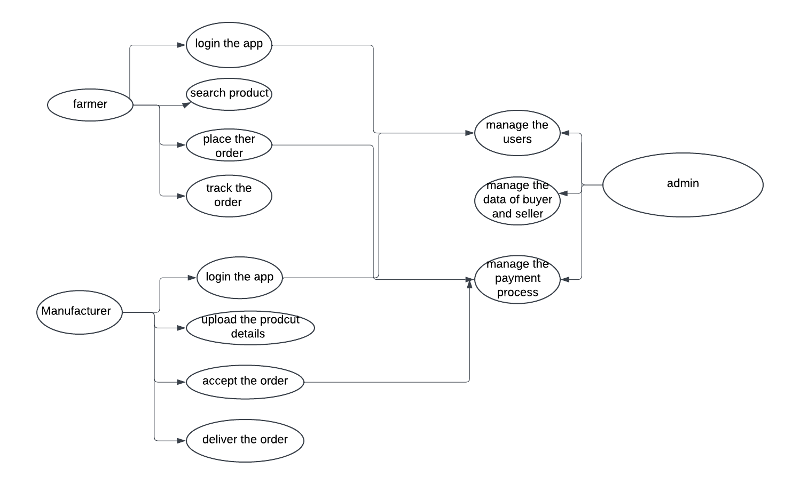

|  |
| --- |
| Question 10 – Use Case Diagram - 10 Marks |

Draw use case diagram

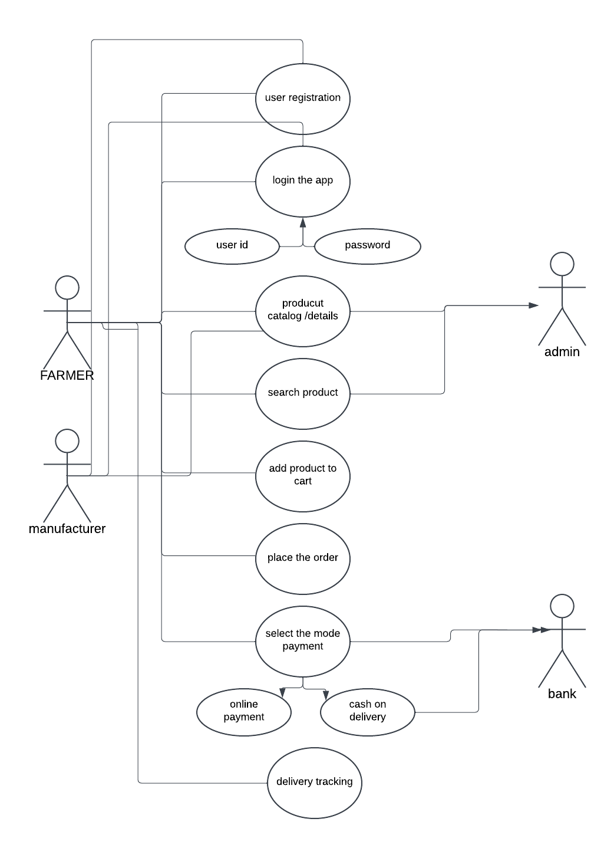

|  |
| --- |
| Question 11 – (minimum 5) Use Case Specs - 15 Marks |

Prepare use case specs for all use cases

|  |  |
| --- | --- |
|  | USE CASE SPECS 1:- FARMER AND MANUFACTURER REGISTERE THEIR DETAILS |
| ACTORS | Farmer, Manufacturer |
| DESCRIPTION | Farmer, Manufacturer need to register their detail to access the application |
| PRECONDITION | Internet connectivity and access to the application.(mobile or laptop) |
| BASIC FLOW | 1)The user accesses the application and selects the "Register" option.  2)The user inputs details like name, contact information, address, and role (Farmer/Manufacturer). 3)Manufacturers input additional information about their company. 4)The system validates the details. 5)A confirmation message is sent to the user via email/SMS. |
| ALTERNATE FLOW | If validation fails, the system notifies the user with appropriate error messages. |
| POST CONDITION | The user account is successfully created and can log in. |

|  |  |
| --- | --- |
|  | USE CASE SPECS 2 :-MANUFACTURER UPLOAD PRODCUT DETAIL ON APPLICATION |
| ACTORS | Manufacturer |
| DESCRIPTION | Manufacturers add product details like fertilizers, seeds, and pesticides to the application. |
| PRECONDITION | The manufacturer must be registered and logged in. |
| BASIC FLOW | The manufacturer logs into the application.  1) Selects the "Add Product" option.  2) Inputs product details such as name, category (fertilizer, seed, pesticide), description, price, and stock quantity.  3) Uploads relevant images and documents.  4) Submits the product details.  5) The system validates and saves the product details. |
| ALTERNATE FLOW | 1) manufacturer select the wrong category to upload the product information, it will shown error"  incorrect product category |
| POST CONDITION | The product has been successfully updated in the system |

|  |  |
| --- | --- |
|  | USE CASE SPECS 3:- FARMER BROWES THE AGRICULTUER PRODUCT |
| ACTORS | farmer |
| DESCRIPTION | Farmer will browsing the product on the agriculture platform |
| PRECONDITION | farmer must be register and login to the profile |
| BASIC FLOW | 1)The farmer logs into the application.  2)Selects the "Browse Products" option.  3)Filters products by category, price, or location.  4)Views product details like description, price, and manufacturer informati |
| ALTERNATE FLOW | if there are no product match system will show the error message |
| POST CONDITION | farmer succesfully sew the product detail and able to add in the cart |
|  | USE CASE SPEC 4:- FARMER PURCHASE THE PRODUCT IN THE PLATFORM |
| ACTORS | farmer |
| DESCRIPTION | farmer will purchase the product from the platform |
| PRECONDITION | 1)farmer must have to login the website or application  2)farmer need to select the product and add in to cart |
| BASIC FLOW | 1)farmer must have to login the website or application  2)search the product  3)farmer need to select the product and add in to cart  4) select the payment gateway  5) do the transaction |
| ALTERNATE FLOW | 1) product is may not available  2) payment failed  3) farmers need to retry the payment method or select the other mode of payment |
| POST CONDITION | payment is successfully debited and order is placed |

|  |  |
| --- | --- |
|  | USE CASE 5:- USER MAKING PAYMENT FOR ONLINE ORDER |
| ACTORS | Farmer, Admin, Bank |
| DESCRIPTION | How the user do the payment process after selection of the product |
| PRECONDITION | 1)farmer have internet connection and mobile/laptop  2)user should have a bank account |
| BASIC FLOW | 1. User validation performed. 2. Application displays multiple options Pay by Credit card, DebiT card, Net Banking, and UPI. 3 User selects the Payment mode and fill the details. 5. Application displays Payment completed. 6. User receives email and SMS with the Order completion |
| ALTERNATE FLOW | 1)incorrect card detail:-if user fill the incorrect details user receive the massage from the bank about payment failure 2)incorrect otp 3)insufficient funds |
| POST CONDITION | payment successfully debited and order is placed |

|  |
| --- |
| Question 12 – (minimum 5) Activity Diagrams - 15 Marks |

Activity diagrams

1) login page of the portal

2) sign up the page

3)purchase the order

4) manufacturer upload the product

5) order cancellation

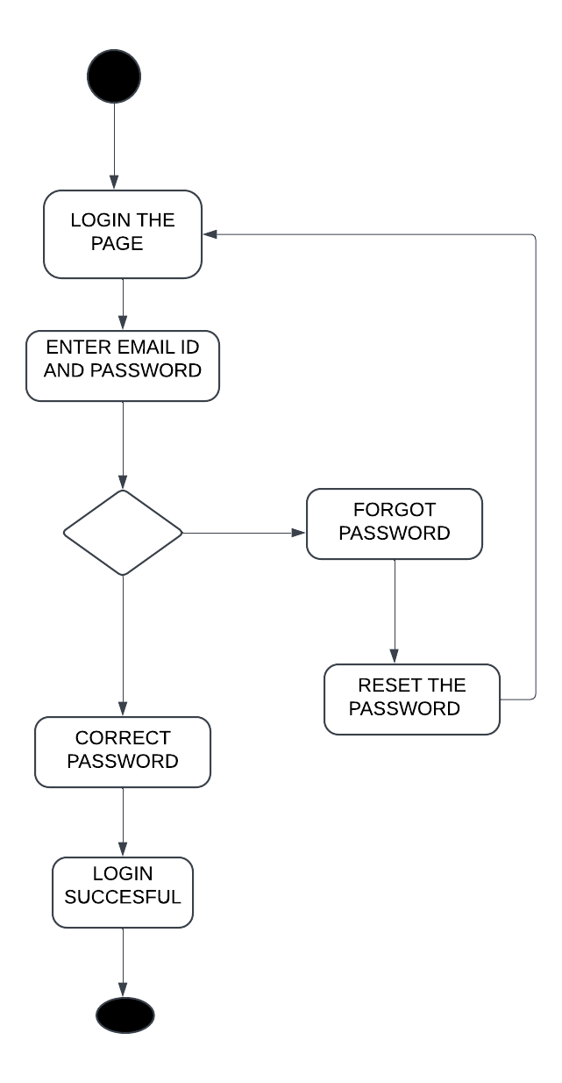

2)sign up page

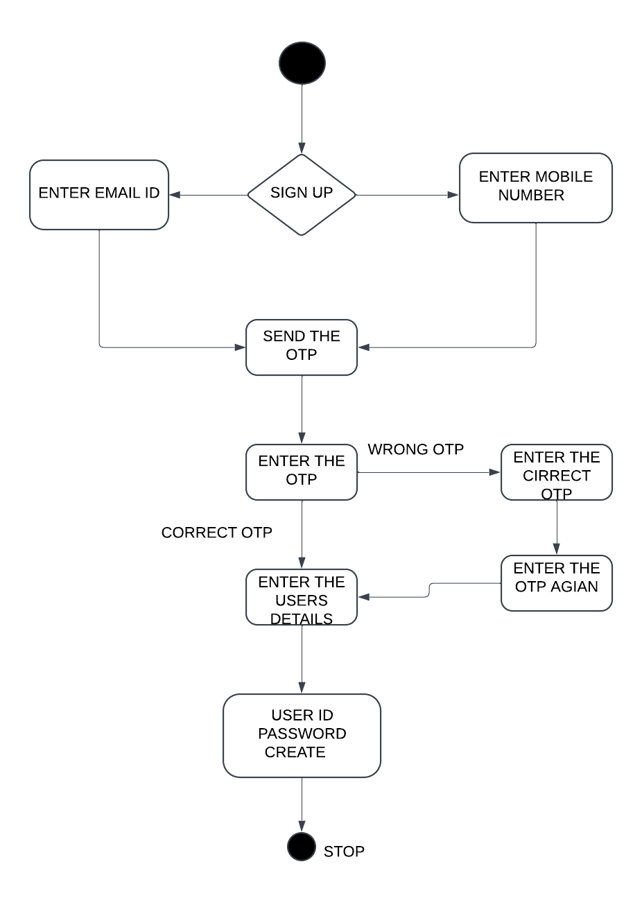

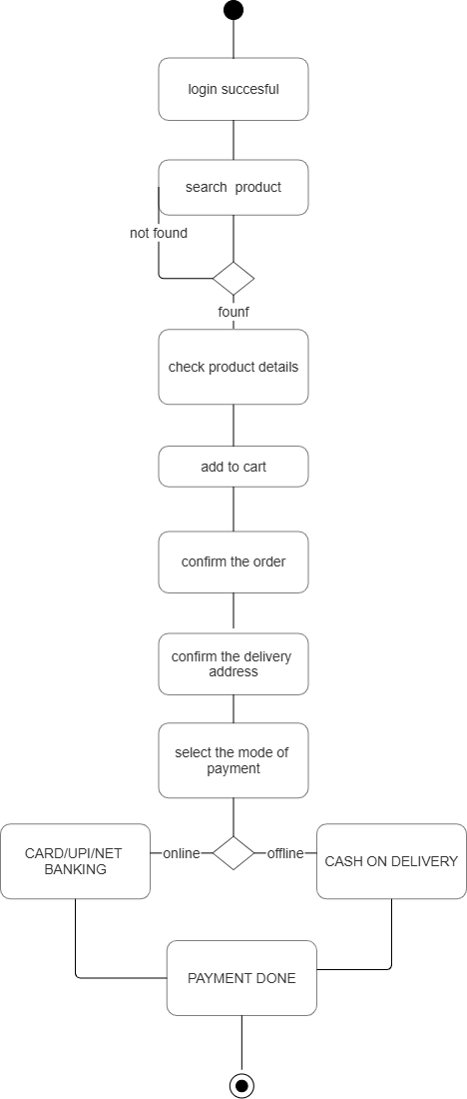

4) Manufacturer upload digram:-

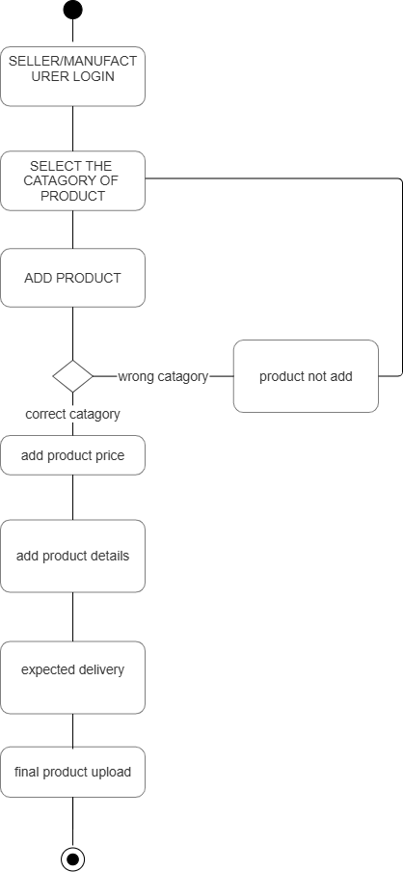

5) order cancellation digram

