**Capstone Project Prep 1 Part 3**

**Question 1:** Identify minimum 20 functional requirements  
 **Solution1:**    
  
**Functional Requirements:** Functional requirements describe the behaviour and information that the solution will manage. They describe capabilities the system will be able to perform in terms of behaviours or operations – specific information technology application actions or responses.   
  
**Non – Functional Requirements:** These capture conditions that do not directly relate to the behaviour or functionality of the solution, but rather describe environmental condition under which the solution must remain effective or qualities that the systems must have. They are also known as quality or supplementary requirements. These can include requirements related to capacity, speed, security, availability and the information architecture and presentation of the user interface.

|  |  |  |  |
| --- | --- | --- | --- |
| **Functional Requirements** | | | |
| **Req ID** | **Req Name** | **Req Description** | **Priority** |
| FR001 | Farmer & Manufacturer Registration | Farmers & Manufacturer should be able to register with the application | 10 |
| FR002 | Product Management & Listing | Manufacturers can list fertilizers, pesticides, seeds and farming products with product details and images | 10 |
| FR003 | Farmer Search for Products | Farmers should be able to search for available products like fertilizers, pesticides, sees. | 9 |
| FR004 | Add to Cart and Checkout | Farmers can add products to cart and proceed to checkout | 10 |
| FR005 | Order Confirmation | Farmer should get order confirmation via email, SMS and application confirmation | 10 |
| FR006 | Order Tracking | Farmers should be able to track orders and Manufactures can manage orders and shipping. | 10 |
| FR007 | Payment Options | Farmers should be able to pay using UPI, COD, Credit / Debit Card, Net banking | 10 |
| FR008 | Customer Reviews & rating | Farmers should be able to rate and review the products purchased for better user experience | 7 |
| FR009 | Customer Support | Farmers should be able to reach out to the customer support in case of any issues with the product or application or anything else | 8 |
| FR010 | Local Language Support | Customer support should be available in the local languages or multiple languages based on Farmer comfort | 8 |

|  |  |  |  |
| --- | --- | --- | --- |
| **Non - Functional Requirements** | | | |
| **Req ID** | **Req Name** | **Req Description** | **Priority** |
| NFR0101 | Page Loading Time | Each Page should load within 2 seconds time | 9 |
| NFR0102 | WCAG 2.1 | The system must meet Web Content Accessibility Guidelines WCAG 2.1 | 9 |
| NFR0103 | Scalability | The system should be able to handle increasing users and product listings smoothly. | 10 |
| NFR0104 | Security | Strong security measures to protect user data and transaction | 10 |
| NFR0105 | Application & Website responsiveness | The business model should work well on different mobile devices and website like in different screen sizes. | 10 |
| NFR0106 | Data Backup & recovery | regular backups to prevent data loss in case of system failures. | 9 |
| NFR0107 | All time Service or Uptime service | The platform should be accessible to everyone at all times | 10 |
| NFR0108 | E-Commerce Guidelines | The platform should be in compliance with Indian e-commerce and data protection rules / guidelines / laws. | 9 |
| NFR0109 | Third - party integration | Support for logistics, accounting and farm advisory service integration | 8 |
| NFR0110 | Data Analytics & reports | Should be able to provide insights into sales, user behaviour and product trend | 8 |

**Question 2:** Make wireframe and prototypes  
**Solution:**   
**Wireframe**: Wireframe is a basic / rough schematic or visual representation in the early stages of a digital product. Can be drawn with pen and paper  
**Prototype:** A prototype is a sample or model of a product built to test a concept or process. It is a term used in contexts, including schematics, designs and programming.   
  
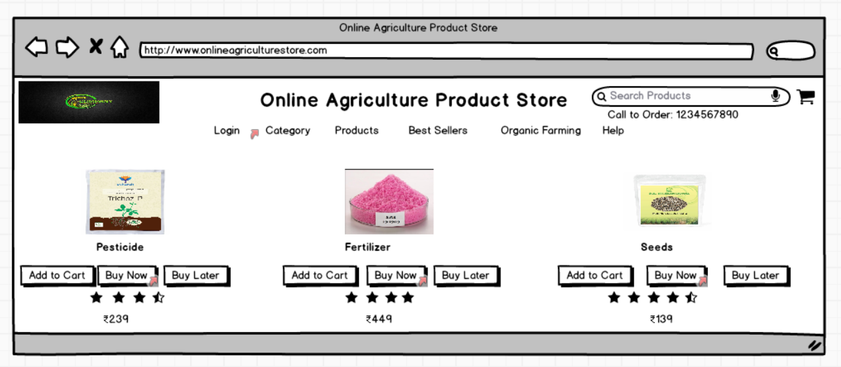

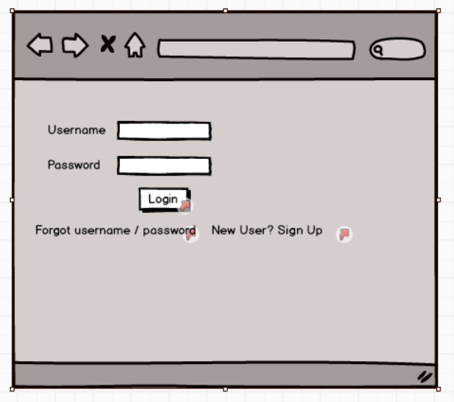

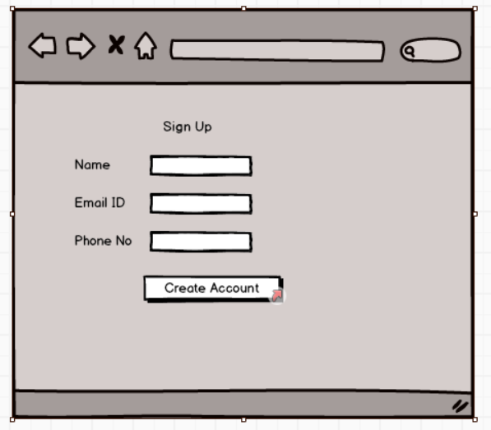

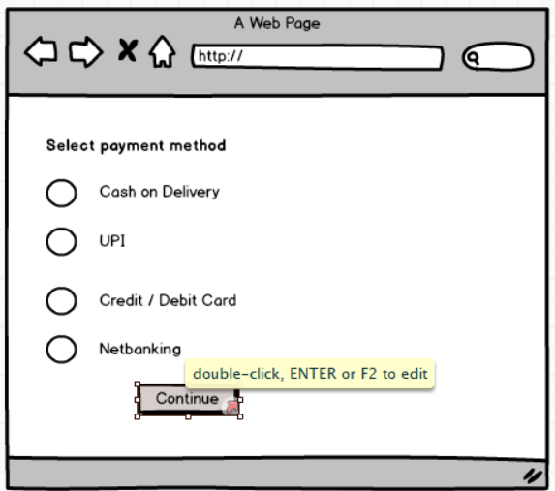

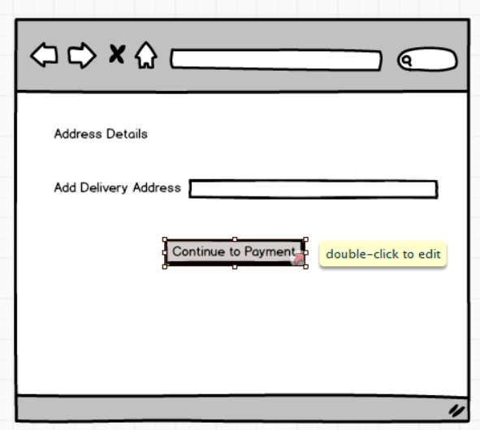

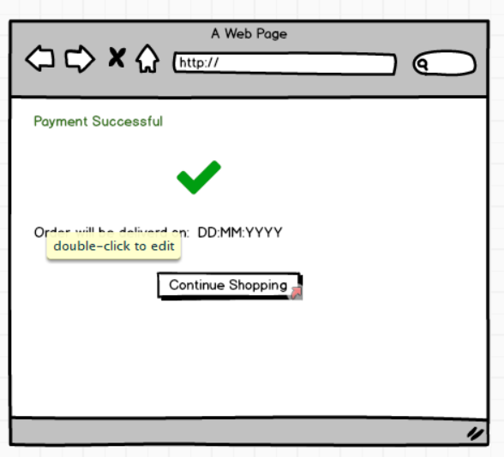

**Question 3:** Make a note of the Tools, which you are using for above concepts.  
  
**Solution:** The following can tools can be used for the above concepts:   
  
**Microsoft Visio:** A diagramming and vector graphics application used to create diagrams, flowcharts and other visual representations of complex information. MS Visio have multiple key features as follows:   
a. Diagram Creation  
b. Template building and shapes  
c. Drag & Drop interface and many more  
  
**Balsmiq:** Balsmiq is a rapid wireframing tool used to create mockups and prototypes of user interfaces. It helps designers, developers, UI / UX engineers and product teams to quickly visualize the structure and layout of web pages, mobile application and software application.  
  
> The following are the some of the key features of this tool:  
a. Website Wireframes  
b. Mobile application wireframes  
c. Software UI mockups  
d. Early-stage Prototyping

**Question 4:** Mr. Henry and peter have approached you regarding the current status of the project. How will you tackle this situation?  
  
**Solution:** RTM stands for Requirements Traceability Matrix, it is a document to track the requirements throughout the project lifecycle, ensuring that they are met and that no requirements are overlooked.  
  
**Solution:**

|  |  |  |  |  |  |  |  |  |
| --- | --- | --- | --- | --- | --- | --- | --- | --- |
| **Req ID** | **Req Name** | **Req Description** | **Design** | **Code** | **UT (Unit Testing** | **ST (System Testing)** | **SIT** | **UAT (User Acceptance Testing)** |
| FR001 | User registration | **User should register themselves** | complete | complete | complete | complete | complete | Incomplete |
| FR002 | Product Management & Listing | Manufacturers can list products with details and images | complete | complete | complete | complete | complete | Incomplete |
| FR003 | Search Proud t | user should be able to search product | complete | complete | complete | complete | complete | Incomplete |
| FR004 | User request for detailed products | user should be able to request for details of the product | complete | complete | complete | complete | complete | Incomplete |
| FR005 | Add to cart & Checkout | users should be able to add the products to cart and complete the  purchase | complete | complete | complete | complete | complete | Incomplete |
| FR006 | Order Confirmation | Farmer should get order confirmation via email, SMS and application confirmation | complete | complete | complete | complete | complete | Incomplete |
| FR007 | Order Tracking | user can track orders and manufacturers manage shipping | complete | complete | complete | complete | complete | Incomplete |
| FR008 | Payment Options | Farmers should be able to pay using UPI, COD, Credit / Debit Card, Net banking | complete | complete | complete | complete | complete | Incomplete |
| FR009 | Customer Reviews & rating | Farmers should be able to rate and review the products purchased for better user experience | complete | complete | complete | complete | complete | Incomplete |
| FR010 | Customer Support | Farmers should be able to reach out to the customer support in case of any issues with the product or application or anything else | complete | complete | complete | complete | complete | Incomplete |

|  |  |  |  |  |  |  |  |  |
| --- | --- | --- | --- | --- | --- | --- | --- | --- |
| **Req ID** | **Req Name** | **Req Description** | **Design** | **Code** | **UT (Unit Testing** | **ST (System Testing)** | **SIT** | **UAT (User Acceptance Testing)** |
| NFR010 | Page Loading Time | Each Page should load within 2 seconds time | complete | complete | complete | complete | complete | Incomplete |
| NFR011 | WCAG 2.1 | The system must meet Web Content Accessibility Guidelines WCAG 2.1 | complete | complete | complete | complete | complete | Incomplete |
| NFR012 | Scalability | The system should be able to handle increasing users and product listings smoothly. | complete | complete | complete | complete | complete | Incomplete |
| NFR013 | Security | Strong security measures to protect user data and transaction | complete | complete | complete | complete | complete | Incomplete |
| NFR014 | Application & Website responsiveness | The business model should work well on different mobile devices and website like in different screen sizes. | complete | complete | complete | complete | complete | Incomplete |
| NFR015 | Data Backup & recovery | regular backups to prevent data loss in case of system failures. | complete | complete | complete | complete | complete | Incomplete |
| NFR016 | All time Service or Uptime service | The platform should be accessible to everyone at all times | complete | complete | complete | complete | complete | Incomplete |
| NFR017 | E-Commerce Guidelines | The platform should be in compliance with Indian e-commerce and data protection rules / guidelines / laws. | complete | complete | complete | complete | complete | Incomplete |
| NFR018 | Third - party integration | Support for logistics, accounting and farm advisory service integration | complete | complete | complete | complete | complete | Incomplete |
| NFR019 | Data Analytics & reports | Should be able to provide insights into sales, user behaviour and product trend | complete | complete | complete | complete | complete | Incomplete |

**Question 5:** Prepare 10 Test Case Documents  
  
**Solution:** A test caser document is a detailed outline used by testers to ensure that a software application or system is working as expected.   
  
**Test Case Document 1: User Registration**

|  |  |  |
| --- | --- | --- |
| Test case ID | TC001 | Test case Name |
| Project ID |  | Project Name |
| Test Strategy ID |  | PM Name |
| Test Plan ID |  | Tester ID |
| Test schedule ID |  | Tester Name |
| Scenario | User Registration | Data of Test |
| Link to that page |  |  |
|  |  |  |
| Input data | Enter name, email, phone and password |  |
| Expected behaviour | The user account is created and SMS sent |  |
| comments |  |  |
| Result |  |  |

**Test case Document 2: User Login**

|  |  |  |
| --- | --- | --- |
| Test case ID | TC002 | Testcase Name |
| Project ID |  | Project Name |
| Test Strategy ID |  | PM Name |
| Test Plan ID |  | Tester ID |
| Test schedule ID |  | Tester Name |
| Scenario | User Login | Data of Test |
| Link to that page |  |  |
|  |  |  |
| Input data | Enter registered email id or mobile number and password |  |
| Expected behaviour | User successfully logged in and redirected to homepage |  |
| comments |  |  |
| Result |  |  |

**Test case Document 3: Product Listing**

|  |  |  |
| --- | --- | --- |
| Test case ID | TC003 | Test case Name |
| Project ID |  | Project Name |
| Test Strategy ID |  | PM Name |
| Test Plan ID |  | Tester ID |
| Test schedule ID |  | Tester Name |
| Scenario | Product Listing | Data of Test |
| Link to that page |  |  |
|  |  |  |
| Input data | The manufacturer should enter the product details like Name, category, price, description, image, etc., |  |
| Expected behaviour | The product is added and displayed in the product listings. |  |
| comments |  |  |
| Result |  |  |

**Test case Document 4: Sear for Product**

|  |  |  |
| --- | --- | --- |
| Test case ID | TC004 | Test case Name |
| Project ID |  | Project Name |
| Test Strategy ID |  | PM Name |
| Test Plan ID |  | Tester ID |
| Test schedule ID |  | Tester Name |
| Scenario | Search for Product | Data of Test |
| Link to that page |  |  |
|  |  |  |
| Input data | User enter a keyword in the search bar and clicks on search using filters like category, price, brand etc., |  |
| Expected behaviour | Relevant products based on search displayed |  |
| comments |  |  |
| Result |  |  |

**Test case Document 5: Add to Cart**

|  |  |  |
| --- | --- | --- |
| Test case ID | TC005 | Test case Name |
| Project ID |  | Project Name |
| Test Strategy ID |  | PM Name |
| Test Plan ID |  | Tester ID |
| Test schedule ID |  | Tester Name |
| Scenario | Add to Cart | Data of Test |
| Link to that page |  |  |
|  |  |  |
| Input data | User select the product and click on add to cart button |  |
| Expected behaviour | Product added to the cart |  |
| comments |  |  |
| Result |  |  |

**Test case Document 6: Checkout**

|  |  |  |
| --- | --- | --- |
| Test case ID | TC006 | Test case Name |
| Project ID |  | Project Name |
| Test Strategy ID |  | PM Name |
| Test Plan ID |  | Tester ID |
| Test schedule ID |  | Tester Name |
| Scenario | Checkout | Data of Test |
| Link to that page |  |  |
|  |  |  |
| Input data | User clicks on proceed to checkout, enter delivery details, select payment method and complete the payment |  |
| Expected behaviour | order placed successfully and confirmation displayed. |  |
| comments |  |  |
| Result |  |  |

**Test case Document 7: Order Tracking**

|  |  |  |
| --- | --- | --- |
| Test case ID | TC007 | Test case Name |
| Project ID |  | Project Name |
| Test Strategy ID |  | PM Name |
| Test Plan ID |  | Tester ID |
| Test schedule ID |  | Tester Name |
| Scenario | Order Tracking | Data of Test |
| Link to that page |  |  |
|  |  |  |
| Input data | User go to my order section and check the tracker details |  |
| Expected behaviour | The order status will be displayed (Shipping, Dispatched, etc.,) |  |
| comments |  |  |
| Result |  |  |

**Test case Document 8: Delivery Agent Assigned**

|  |  |  |
| --- | --- | --- |
| Test case ID | TC008 | Test case Name |
| Project ID |  | Project Name |
| Test Strategy ID |  | PM Name |
| Test Plan ID |  | Tester ID |
| Test schedule ID |  | Tester Name |
| Scenario | Delivery Agent assigned | Data of Test |
| Link to that page |  |  |
|  |  |  |
| Input data | Manufacturer manage the shipping and a delivery agent will be assigned |  |
| Expected behaviour | Delivery Agent deliver the product to user |  |
| comments |  |  |
| Result |  |  |

**Test case Document 9: Product Review and Rating**

|  |  |  |
| --- | --- | --- |
| Test case ID | TC009 | Test case Name |
| Project ID |  | Project Name |
| Test Strategy ID |  | PM Name |
| Test Plan ID |  | Tester ID |
| Test schedule ID |  | Tester Name |
| Scenario | Product Review and Rating | Data of Test |
| Link to that page |  |  |
|  |  |  |
| Input data | User click on "write a review" and enter rating and comment |  |
| Expected behaviour | Review and Rating displayed on the product page |  |
| comments |  |  |
| Result |  |  |

**Test case Document 10: User Logout**

|  |  |  |
| --- | --- | --- |
| Test case ID | TC010 | Test case Name |
| Project ID |  | Project Name |
| Test Strategy ID |  | PM Name |
| Test Plan ID |  | Tester ID |
| Test schedule ID |  | Tester Name |
| Scenario | User logout | Data of Test |
| Link to that page |  |  |
|  |  |  |
| Input data | User clicks on profile icon and select the logout option |  |
| Expected behaviour | Logged out successfully message displayed and redirected to login page |  |
| comments |  |  |
| Result |  |  |

**Question 6: Draw database schema and ER diagram  
  
Solution:**    
**DB Schema**: DB Schema is a blueprint that outlines the structure of database, including its tables, fields, relationships, constraints and other characteristics.  
  
**ER Diagram:** An Entity Relationship Diagram (ERD) is a visual representation of the relationships between entities in a database. It depicts the entities (Such as Tables) attributes (Properties or fields) and relationship between them.  
  
**DB Schema:**  **1. User Table** > name  
> email  
> password  
> phone  
> address  
  
**2. Products Table** > Product _ id  
> user _ id  
> name  
> category  
> price  
> quantity _ available  
> description  
> status  
  
**3. Orders Table** > order _ id  
> customer _ id  
> amount  
> order _ date  
> order _ status  
  
**4. Item Table** > item _ id  
> order _ id  
> product _ id  
> quantity  
> price  
  
**5. Payment Table**> payment _ id  
> order _ id  
> payment _ method  
> payment _ status  
> transaction _ is  
> payment _ date  
  
**6. Review Table**> review _ id  
> user _ id  
> product _ id  
> rating  
> comment  
> review _ date  
  
**Relationships & Constraints:** > **Users -> Products:** One to Many ( A Manufacturer cab list multiple products)  
**> Users -> orders:** One to Many ( A farmer cab place multiple orders)  
**> Orders -> Order _ items:** One to Many ( A single order can contain multiple items)  
**> Orders -> Payments:** One to One ( Each order can only have a single payment or transaction)   
**> Users -> reviews:** One to Many ( A single user can leave multiple reviews)   
  
  
**Question 7:** What is a data flow diagram? Draw a data flow diagram to represent the in-flow and out-flow of data when a Farmer is placing an order for the product  
  
  
**Solution:   
Data Flow Diagram (DFD):**  A Data flow diagram (DFD) is a graphical representation of the flow of data within the system. It visually shows how data moves from one process to another, how it is stored and where it ends up.   
  
> It helps analysts and designers understand the flow of data within a system, identify potential bottlenecks or inefficiencies and communicate system requirements of stakeholders.   
  
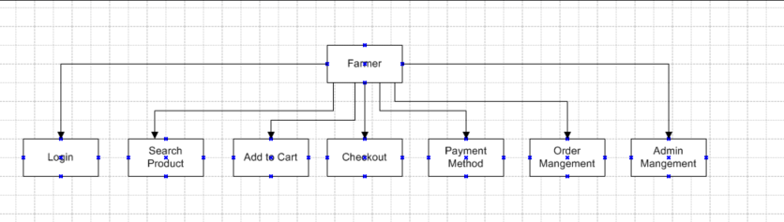  
  
**Question 8:** How do you handle change requests in a project?  
  
**Solution:** A change request is a formal proposal to alter a system, product or project.   
  
1. **Understand the scope of change request and document the change request in the change tracker**  
 **a.** It defines what the change request entails, including the problem it addresses and expected outcome.   
 **b.** Identify which components of the project will be affected example: requirements, design, development, testing, deployment etc.,  
  
**2. Do the impact analysis – Project scope, schedule, budget, timeframe, risks and resources**  
 **a.** Assess how the change affects the project timeline, budget, resources and deliverables.  
 **b.** Identify the risks associated with the change request by implementing.  
 **c.** Analyse dependencies, how the change affects other project components or systems.   
   
3. **Prioritize change requests based on urgency, importance and impact on project.**   
 **a. Urgency:** Immediate / planned for next phase / future consideration  
 **b. Importance:** Must analyse how important or essential is the change for the business goal.  
 **c. Impact on Project:** What are the consequences of the change and to which extent the change affects the system, operations and the resources.  **>** All the prioritization will be categorized such as High, Medium and Low.  
  
**4. Seek approval from the project sponsor for the change request.**   
 **a.** Submit the impact analysis report to the change control board (CCB) to relevant decision makers.  
 **b.** Justify the necessity and benefits of the change.  
 **c.** Get approvals from stakeholders like project sponsor, technical leads etc.,  
**d.** Once approved, update project documents, budget and timelines accordingly.   
  
5. **Communicate the change request and its potential impact to all relevant stakeholders, including the project team.**   
 **a.** Inform all the teams which will be impacted like development, testing, operations etc.  
 **b.** Document the approved changes in the project management tool.  
 **c.** Ensure all team members understand their new roles and responsibilities related to the change.   
 **d.** Keep stakeholders updated on the implementation progress and potential risks

**Question 9:** As the project is in process, Ben and Kevin have contacted you. The reason is to inform you that they want the Farmers to sell their crop yields through this application i.e. Farmers should be able to add their crop yields or products and display to general public and should be able to sell them. They also want to introduce Auction system for their Crop yields.   
  
As a BA, what will be your response? Is this a change request or an enhancement???  
  
**Solution:** In this case, allowing farmers to be able to add their crop yields or products to general public **would constitutes as a change request rather than Enhancement**. The reasons would be as follows:

1. **Scope Impact:** Initially the project was designed as an e-commerce platform where manufacturers can sell their farming products.   
     
   > The new request introduces a market place feature for farmers which mostly change the platform’s scope.
2. **Complexity & system changes:** Most of the changes for the UI/UX and new functionalities.   
     
   > Auction system is entirely new module, involving bid management, pricing and many more updates.
3. **Resource & Timeline impact:** New workflow, payment gateway modifications, and logistics handling will require significant effort and manpower.

**Action Plan for Business Analyst:   
 1. Document the change requests:** Gather detailed requirements from stakeholders regarding product listing, payment processing, auction rules etc,  
 **2. Impact Analysis:** Evaluate the technical, financial and timeline impact of the change request.  
 **3. Prioritize & Seek Approval:** Since it significantly changes the existence platform’s functionality escalate it to the project sponsor for approval  
 **4. Update Stakeholders:** Ensure that all teams, including legal and financial are aware of the change requests.

**Question 10:** Come up with estimations – How many Manhours required  
  
**Solution:** Man hours are required effort of the resources to complete a project. There are 3 types of projects: Small: Up to 500 hours  
 Medium: Up to 1000 hours  
 Large: Up to 1500 hours  
**Analysis:**   
1. As per the case study, the duration of the project is 18 months and the current team is size is 12. This will come under medium project.   
  
2. As the trained resources are available, trainers are not required.   
  
> The initial project is an agriculture e-commerce platform where manufacturers list their products and farmers can browse and purchase products online. Below is the breakdown of estimated effort in man hours for development, testing and deployment.   
  
1. Business Analysis & Requirements Gathering estimation - 70-80 hours  
2. Design – 100 hours  
3. Development – 400 – 500 hours  
4. Testing – 200 hours  
5. Deployment – 50 hours  
6. User Acceptance Testing (UAT) – 50 hours  
  
> Toal Estimation hours are between 800–900 man hours. This estimation provides a structured plan for the initial project scope.

**Question 11:** Project has finally completed all the stages i.e., design, development, testing etc. Now, it is the role of a business analyst to contact the client for testing of the final product and have to successfully complete it.   
How are you going to handle this situation? And once it is done, what will be the process to close the project? Explain UAT Acceptance process  
  
**Solution:** Before initiating the User Acceptance Testing (UAT), the following steps must be ensured for a structed approach:   
  
**1. Plan UAT:**   
 a. Define UAT scope and identify test scenarios.  
 b. Align with the client on the acceptance criteria.   
 c. Assign responsibilities to the key stakeholders.   
  
In this step, blue prints are made to implement UAT testing for every feature that needs to test and minimum standards for accepting the test.   
  
**2. Designing:** Here, the test cases are designed to hide all the possibilities of software packages in a real-world environment.   
  
> Providing the necessary credentials and access to the client team.   
  
**3. UAT Testers:** A testing team consists of an end user that meets the criteria for implementing testing. They should know the test cases to run and understand the functionalities.   
  
> The client team tests the system using the predefined test scenarios.  
> They validate functional and business workflow.  
  
**4. Bug Fixing:** Whatever bugs are found in the UAT testing, the development team should work on them and make it software error free.   
  
> Collects feedback on any defect, missing or useability issues.   
  
**5. Sign Off:** After removing all the bugs, the testing team indicates acceptance of the completion of the bugs. In this phase, all the stakeholders come to a conclusion that the software is ready to go live and sign it off.   
  
> Once all the issues are sorted the client retests the system.   
> If the system meets all acceptance criteria will obtain a form UAT sign off.

**Question 12:** Explain Project closure document **Solution:** A project closure document also known as project closure report. It is a formal document that summarizes the key outcomes, lesion learned and final details of a completed project. **>** It serves a comprehensive record of the project’s accomplishments, challenges and over performance providing valuable insights for stakeholders and future projects. > Points to be included in the project closure document are: **1. Project Overview:**   
 A brief summary of project objective, scope and stakeholders.

**2. Achievements:** Key milestones and successful outcomes of the project.

**3. Lessons Learner:** Opportunities learned from the project execution so that they can be minimised for the future projects.

**4. Quality Assurance:** Quality Check, quality testing, bug fixing and overall quality assurance.

**5. Resource Management:** Managing the timeline, manpower, budget and other resources in the project.

**6. Risk Management:** Risk encountered in the project and risk mitigation process.

**7. Challenges:** Issues encountered while achieving the defined or desired project results and how to overcome for the future projects.

|  |  |  |  |
| --- | --- | --- | --- |
| **S. No** | **Points to include** | **Details** | **Recent Links** |
| 1 | Did the client signed off the UAT testing |  | <Link> |
|  | Date of sign off: | Date |
|  | Name of the resource: | Name |
| 2 | Objectives of the Project |  |  |
|  | user friendliness | Achieved |  |
|  | Customer satisfaction | ROI in 6 months |  |
|  | More categories | Achieved |  |
| 3 | Functionalities worked on |  |  |
|  | Secure payment processing | Achieved |  |
|  | categories | Achieved |  |
| 4 | Infrastructure |  |  |
|  | software installed | Achieved |  |
|  | Laptops purchased | Achieved |  |
| 5 | Funding |  |  |
|  | Amount approved | ₹xxxxxxxx | <Link> |
|  | Amount used | ₹xxxxxxx |
| 6 | Overall project information |  |  |
|  | Escalations | Number of escalations |  |
|  | Customer satisfaction | High/Medium/Low |  |
| 7 | Value to the company |  |  |
|  | Positives/ Negatives | Business Value Report |  |