**BA MOCK - CASE STUDY**

1. A company is having manufacturing plants and warehouses in various parts of the country. They manufacture ice-cream and milk products. They want to build software to achieve two goals.

• Manage the inventory

• Quickest delivery to the customers

**BRD Document for manufacturing plants and warehouses**

Project Name: Inventory & Delivery Optimization System (IDOS)  
Project ID: IDOS-2024-001  
Version ID: 1.0  
Author: Yogesh

**Document Revisions:**

|  |  |  |  |
| --- | --- | --- | --- |
| **Version** | **Date** | **Author** | **Description** |
| 1.0 | 2025-04-21 | Yogesh | Initial Draft Submitted |

**Approvals:**

|  |  |  |  |  |
| --- | --- | --- | --- | --- |
| **Role** | **Name** | **Title** | **Signature** | **Date** |
| Project Sponsor | John Doe | VP of Product Development | Signed | 22/4/25 |
| Business Owner | Jane Smith | Director of Operations | Signed | 22/4/25 |
| Project Manager | Mike Johnson | Project Manager | Signed | 22/4/25 |

**RASCI CHART:**

|  |  |  |  |  |  |
| --- | --- | --- | --- | --- | --- |
| **Task/Deliverable** | **Responsible** | **Accountable** | **Supportive** | **Consulted** | **Informed** |
| Requirements Gathering | BA Team | PM | SME | Client | All |
| Inventory System Design | Dev Lead | PM | QA | Architect | All |
| Delivery Route Optimization | Dev Team | Dev Lead | Logistics | BA Team | All |
| System Testing & UAT | QA Lead | PM | Dev Team | Client | All |
| Deployment & Training | Dev Ops | PM | BA | Client | All |

**BUSINESS GOALS:**

**Organisational Goals:**

* Reduce Wastage: Minimize spoilage of perishable goods (ice-cream & milk products) through efficient inventory tracking.
* Improve Delivery Efficiency: Ensure fastest possible delivery to maintain product quality and customer satisfaction.
* Cost Optimization: Reduce logistics and storage costs by optimizing inventory and delivery routes.
* Scalability: Support business expansion with additional plants and warehouses.

**Organisational Needs:**

* Real-Time Inventory Visibility: Track stock levels, expiry dates, and batch numbers.
* Automated Replenishment Alerts: Notify when stock reaches reorder levels.
* Route Optimization: Use AI/ML to determine the fastest delivery paths.
* Demand Forecasting: Predict demand trends to prevent overstocking/understocking.
* Multi-location Management: Centralized dashboard for all plants and warehouses.

**BUSINESS OBJECTIVES:**

**Efficient Inventory Management:**

* Track raw materials, finished goods, and stock levels across plants and warehouses.
* Minimize wastage (especially for perishable items like ice cream and milk).
* Automate reordering and procurement processes.

**Optimized Delivery System:**

* Ensure quickest delivery to customers (considering perishability).
* Route optimization for delivery vehicles.
* Real-time tracking of shipments.

**Enhanced Customer Satisfaction:**

* Provide accurate delivery time estimates.
* Enable online ordering and payment.
* Offer order tracking for customers.

**Functionalities to Develop in Software**

**Inventory Management Module**

* Real-time stock monitoring (raw materials & finished goods)
* Batch and expiry date tracking (critical for perishable items).
* Automated alerts for low stock or near-expiry products.
* Multi-location inventory tracking (plants, warehouses).
* Supplier management and procurement automation.

**Order & Delivery Management Module**

* Order processing (B2B/B2C) with prioritization (perishable items first).
* Route optimization for delivery vehicles (GPS integration).
* Delivery personnel tracking (mobile app for drivers).
* Proof of delivery (digital signatures/OTP verification).

**Customer-Facing Module (E-Commerce & Tracking)**

* Online ordering portal (website/app).
* Real-time order status updates.
* Subscription model for regular milk delivery.
* Feedback and complaint management.

**Admins & Operations Dashboard**

* Centralized control for inventory, orders, and deliveries.
* Role-based access (warehouse manager, delivery team, admin).
* Integration  with ERP/accounting software.

**Mobile Applications (Android & iOS)**

Customer App (B2C)

* Browse products (ice cream, milk, etc.).
* Place orders with delivery scheduling.
* Track orders in real-time (like Swiggy/Zomato).
* Payment integration (UPI, cards, wallets).
* Subscription management (daily milk delivery).

Warehouse/inventory Management App (For Staff)

* Scan barcodes for stock updates.
* Receive alerts for low stock/expiry.
* Update inventory in real-time.

**BUSINESS RULES:**

**Organization Policies:**

* Inventory Accuracy Policy: All inventory levels must be updated in real-time to prevent stockouts or overstocking.
* Delivery Time Policy**:** Orders must be delivered within **24 hours** for perishable goods (ice cream) and **48 hours** for non-perishable goods (milk products).
* Quality Control**:** All products must undergo quality checks before dispatch from manufacturing plants and warehouses.
* Warehouse Location Policy**:** Warehouses must be strategically located near high-demand regions to minimize delivery time.
* Cold Chain Compliance policy**:** All storage and transportation must maintain required temperature controls to prevent spoilage.

**Procedures:**

Inventory Update Procedure:

* Stock levels must be updated immediately after production, dispatch, or delivery.
* Automated alerts must be triggered when stock falls below the reorder level.

Order Fulfillment:

* Orders are prioritized based on delivery distance and product shelf life.
* Nearest warehouse must be selected for order dispatch to minimize delivery time.

Delivery Routing:

* Delivery routes must be optimized using GPS and traffic data for the fastest delivery.
* Refrigerated  vehicles must be used for ice-cream transport.

**Rules & Regulations:**

Regulatory Compliance:

* All products must comply with Food Regulation Standards.
* Proper labeling with expiry dates, batch numbers, and storage conditions must be enforced.

Safety Rules:

* Warehouse staff must follow hygiene and safety protocols (e.g., gloves, sanitization).
* Vehicles must undergo regular maintenance checks to prevent breakdowns.

Data Security Rules:

* Customer and inventory data must be encrypted and stored securely.
* Access to inventory systems must be role-based (e.g., managers, warehouse staff).

Return & Refund Rules:

* Damaged  or spoiled products must be accepted for returns within **24 hours** of delivery.
* Refunds or replacements must be processed within **3 business days**.

**BACKGROUND:**

**Business Issues/Problems identified:**

Inefficient Inventory Management:

* Lack of real-time tracking of stock levels leads to overstocking or stockouts.
* Difficulty in predicting demand, resulting in wastage (especially for perishable items).
* Manual processes causing delays and errors in inventory updates.

Slow and Inefficient Delivery:

* Delays  in order fulfillment due to poor coordination between warehouses and delivery systems.
* Lack of of optimized routing increases delivery time and costs.
* Inability to prioritize urgent deliveries (e.g., ice cream requiring cold chain logistics).

**Expected Benefits of the Software Solution:**

Improved Inventory Management:

* Real -time tracking of stock levels across plants and warehouses.
* Automated demand forecasting to reduce waste and optimize production.
* Alert for low stock or expiry dates to minimize losses.

Faster and Cost-Effective Deliveries:

* Route optimization for quickest delivery based on traffic, distance, and product shelf life.
* Integration with logistics providers for seamless dispatch.

**PROJECT OBJECTIVE:**

The objective of this project is to develop a **comprehensive inventory and delivery management system** for the company’s ice-cream and milk product operations. The software will:

**Optimize Inventory Management:**

* Track raw materials, work-in-progress, and finished goods across manufacturing plants and warehouses.
* Ensure real-time visibility of stock levels to prevent shortages or overstocking.
* Automate reorder triggers based on demand forecasts and expiry dates (critical for perishable goods).
* Integrate  with production scheduling to align manufacturing with inventory needs.

**Enable Quickest Delivery to Customers**

* Implement  a **smart logistics system** to determine the fastest delivery routes based on real-time factors like traffic, weather, and warehouse proximity.
* Integrate with **order management systems** to prioritize time-sensitive deliveries (especially for perishable items like ice cream).
* Provide **live tracking** for customers and logistics teams to monitor shipments.

**Alignment with Business Objectives**

* By improving inventory control, the system will minimize spoilage of perishable goods.
* Faster deliveries and accurate stock availability will improve service levels.
* Optimized logistics and inventory will reduce operational costs.
* The system should support business growth by handling multiple plants and warehouses.

**PROJECT SCOPE:**

**In-Scope Functionality**

Inventory Management:

* Track raw materials (milk, sugar, flavors, etc.) and finished goods (ice-cream, milk products) across plants and warehouses.
* Real -time stock level monitoring with alerts for low stock or expiry.
* Batch and expiry date tracking for perishable items.
* Automated reordering based on predefined thresholds.
* Inventory reconciliation and reporting (stock-in, stock-out, wastage).

Warehouse & Plant Management:

* Location-wise inventory tracking (plants, warehouses, distribution centers).
* Transfer of stock between facilities with tracking.
* Storage  condition monitoring (temperature, humidity for perishable items).

Order & Delivery Management:

* Order processing system (B2B/B2C order capture).
* Route optimization for quickest delivery based on real-time traffic and distance.
* Delivery  tracking with estimated time of arrival (ETA).
* Dispatch scheduling based on vehicle availability and demand.

Customer & Vendor Management:

* Customer database with order history and preferences.
* Vendor/supplier management for raw material procurement.

**Out of Scope Functionality:**

1. HR & Payroll Management (Employee salaries, attendance).
2. Financial Accounting (Invoicing, taxation, profit/loss calculations).
3. Marketing & CRM (Promotions, loyalty programs, customer engagement).
4. Manufacturing Process Automation (Production line machinery control).
5. Advanced AI-based Demand Prediction (Beyond basic forecasting).
6. IoT-based Cold Chain Monitoring (Real-time sensor integration for trucks).
7. Multi-country/Global Logistics (Only domestic operations considered).

**ASSUMPTIONS:**

Geographical Distribution:

* The company has multiple manufacturing plants and warehouses spread across different regions.
* Warehouses are strategically located near high-demand areas for faster delivery.

Product Perishability:

* Ice-cream and milk products have a limited shelf life and require cold storage.
* Inventory management must account for expiration dates to minimize waste.

Demand variability:

* Demand fluctuates based on seasons (e.g., higher ice-cream sales in summer).
* Historical sales data is available for forecasting.

Delivery Constraints:

* Quickest delivery implies same-day or next-day delivery for local orders.
* Delivery vehicles are refrigerated to maintain product quality.

Inventory Management:

* Real -time tracking of stock levels across warehouses is required.
* Automated reordering from manufacturing plants when stock reaches a threshold.

Regulatory Compliance:

* The  system adheres to food safety and transportation regulations.
* Proper documentation for perishable goods is maintained.

Scalability:

* The software should handle an increase in warehouses, products, and order volumes.

**CONSTRAINTS:**

Product-Related Constraints:

* Ice-cream and milk products have a short shelf life, requiring strict inventory management to avoid spoilage.
* Products must be stored and transported in refrigerated conditions (cold chain logistics).
* Need  to track manufacturing dates and expiry dates to prioritize stock rotation (FIFO – First In, First Out).

Inventory Management Constraints:

* Inventory levels must be updated in real-time across plants and warehouses.
* Seasonal demand (e.g., higher ice-cream sales in summer) affects stock planning.
* Limited refrigerated storage space in warehouses.
* Dependency on raw material suppliers (milk, sugar, etc.) affects production schedules.

Delivery & Logistics Constraints:

* Products must reach customers quickly to prevent melting/spoilage.
* Warehouses and plants may be far from some customers, increasing delivery time.
* Requires refrigerated vehicles, which are costlier and limited in availability.
* Urban congestion or rural accessibility can delay deliveries.

Technology & Software Constraints:

* Must integrate with existing ERP, warehouse management, and logistics systems.
* Real time synchronization needed to avoid stock mismanagement.
* Software should handle expansion to new locations.

**RISKS**

**Technological Risks:**

Risk Description:

* System failure or downtime disrupting inventory management or delivery tracking.
* Cybersecurity threats compromising sensitive data.
* Integration  issues between warehouse, manufacturing, and delivery systems.

Mitigation Strategy:

* Implement robust backup and disaster recovery solutions.
* Use secure cloud-based systems with encryption.
* Conduct thorough system integration testing before deployment.

**Skill Risks:**

Risk Description:

* Lack of technical expertise to manage the software.
* Employees resistant to adopting new technology.
* Insufficient training for warehouse staff on inventory software.

Mitigation Strategy:

* Hire skilled IT professionals or outsource to experts.
* Conduct change management and training programs.
* Provide hands-on training for warehouse staff.

**Political Risks:**

Risk Description:

* Changes in food safety regulations affecting operations.
* Trade restrictions impacting supply chain logistics.
* Local government policies delaying warehouse expansions.

Mitigation Strategy:

* Stay updated on regulatory changes and adapt processes.
* Diversify supplier base to reduce dependency.
* Engage with local authorities for compliance and approvals.

**Business Risks:**

Risk Description:

* Fluctuating demand leading to overstocking or stockouts.
* High logistics costs affecting profitability.
* Competition offering faster delivery options.

Mitigation Strategy:

* Use demand forecasting tools for better inventory planning.
* Optimize  delivery routes using AI/ML algorithms.
* Invest in last-mile delivery partnerships or automation.

**Requirement Risks:**

Risk Description:

* Under or changing requirements leading to software inefficiencies.
* Stakeholders having conflicting expectations.
* Inadequate  user feedback during development.

Mitigation Strategy:

* Conduct detailed requirement gathering and validation.
* Hold stakeholder alignment workshops.
* Implement agile development with iterative feedback loops.

**BUSINESS PROCESS OVERVIEW:**

**Legacy System (As-Is):**

Inventory Management:

* Manual tracking of raw materials (milk, sugar, flavors) and finished goods (ice cream, milk products).
* Spreadsheet -based or paper-based records leading to human errors and delays.
* Lack of real-time visibility into stock levels across plants and warehouses.
* Overstocking or stockouts due to poor demand forecasting.

Order Processing & Delivery:

* Orders received via phone, email, or in-person, leading to miscommunication.
* Manual assignment of delivery routes based on driver familiarity rather than optimization.
* No real-time tracking of delivery vehicles, causing delays and customer dissatisfaction.
* Inefficient coordination between warehouses and delivery teams.

Product Planning:

* Production schedules based on historical estimates rather than real-time demand.
* No  integration between sales data and manufacturing, leading to inefficiencies.

**Proposed Recommendation (To-Be):**

Automated Inventory Management System:

* Implement an ERP (Enterprise Resource Planning) or WMS (Warehouse Management System) for real-time inventory tracking.
* Use barcode/RFID scanning for accurate stock updates.
* Automated alerts for low stock or expiry dates.
* Integration with suppliers for just-in-time inventory replenishment.

Order & Delivery Optimization:

* Centralized Order Management System (OMS) to process orders digitally (website/app/ERP).
* Route Optimization Software (e.g., using AI/Google Maps API) for fastest delivery paths.
* Real-time GPS tracking of delivery vehicles for better ETAs and customer notifications.
* Dynamic dispatching based on traffic, weather, and demand.

Smart Production Planning:

* Demand Forecasting using AI/ML to adjust production based on sales trends.
* Integration between sales, inventory, and production to avoid over/underproduction.

**BUSINESS REQUIREMENTS:**

High Priority Requirements:

|  |  |  |  |
| --- | --- | --- | --- |
| **Req ID** | **Requirement Description** | **Use Case** | **Category** |
| BR001 | Real-time inventory tracking across plants/warehouses | Inventory Management | High Priority |
| BR002 | Automated demand forecasting for production planning | Production Optimization | High Priority |
| BR003 | Route optimization for quickest delivery to customers | Delivery Management | High Priority |
| BR004 | Integration  with logistics partners for live tracking | Shipment Tracking | High Priority |
| BR005 | Batch /expiry management for perishable products | Quality Control | High Priority |

Medium Priority Requiremets:

|  |  |  |  |
| --- | --- | --- | --- |
| **Req ID** | **Requirements Description** | **Use Case Reference** | **Category** |
| BR001 | Multi-location stock transfer management | Warehouse Operations | Medium Priority |
| BR002 | Customer portal for order tracking | Customer Self-Service | Medium Priority |
| BR003 | Dynamic pricing based on demand & inventory levels | Sales & Pricing Strategy | Medium Priority |
| BR004 | Supplier management for raw materials procurement | Procurement Process | Medium Priority |
| BR005 | Workforce management for delivery personnel | Logistics  Optimization | Medium Priority |

Non-Functional Requirements

|  |  |  |  |
| --- | --- | --- | --- |
| **Req ID** | **Requirements Description** | **Use Case Reference** | **Category** |
| NFR001 | System must handle 10,000+ concurrent users | Scalability | Non-Functional |
| NFR002 | <2 sec response time for order/inventory queries | Performance | Non-Functional |
| NFR003 | 99.9% uptime for inventory & delivery systems | Reliability | Non-Functional |
| NFR004 | Role-based access control for sensitive operations | Security | Non-Functional |
| NFR005 | Mobile -responsive UI for field agents & customers | Usability | Non-Functional |

* **High Priority:** Critical for core operations (inventory, delivery, production).
* **Medium Priority:** Important but can be phased in after core features.
* **Non-Functional:** Technical constraints ensuring system efficiency, security, and scalability.

Key Reference Material:

* **Use Case Documentation**: [Link to Use Case Document](https://chat.deepseek.com/a/chat/s/070f4c30-c7a5-4d5e-ba96-05598df3afe2)
* **Technical Design Document**: [Link to Design Document](https://chat.deepseek.com/a/chat/s/070f4c30-c7a5-4d5e-ba96-05598df3afe2)
* **Test Plan**: [Link to Test Plan](https://chat.deepseek.com/a/chat/s/070f4c30-c7a5-4d5e-ba96-05598df3afe2)
* **Security Compliance Guidelines**: [Link to Security Guidelines](https://chat.deepseek.com/a/chat/s/070f4c30-c7a5-4d5e-ba96-05598df3afe2)

**Appendices:**

**List of Acronyms**

* MFA: Multi-Factor Authentication
* SSO: Single Sign-On
* HRMS: Human Resource Management System
* LMS: Learning Management System

**PROCESS FLOW DIAGRAM**

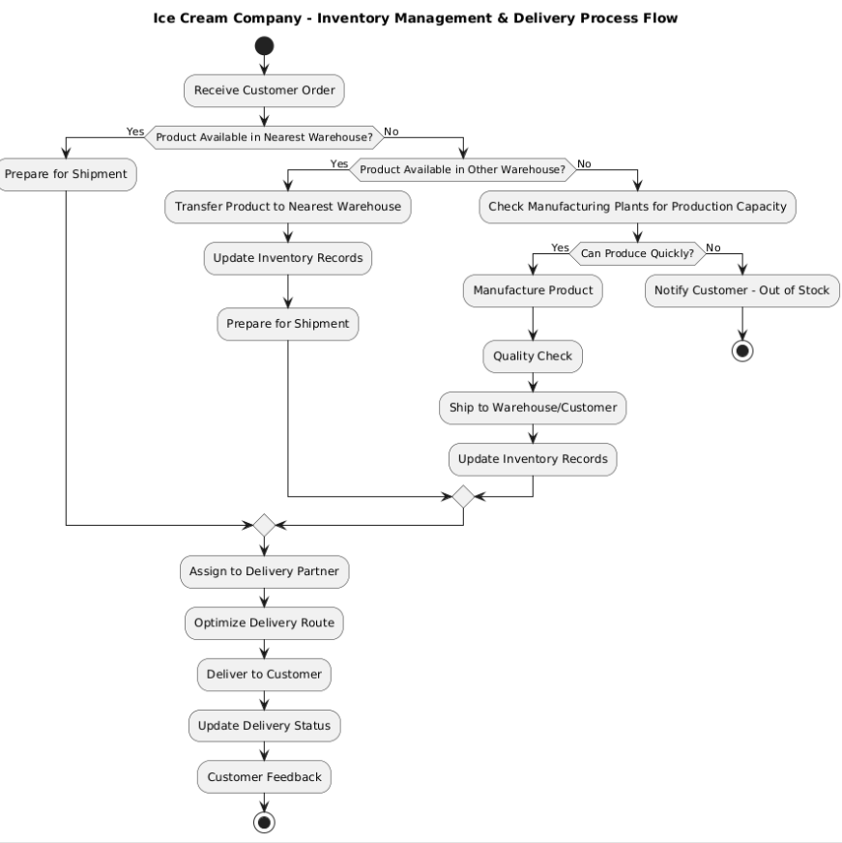

**Assignment -2**

* 1. **Write an introduction letter to a client introducing yourself as a business analyst in charge of working with the client and his team to start the business understanding process.**

**Subject:** Introduction – Your Business Analyst for the Upcoming Project

Dear John,

I hope this message finds you well.

My name is Yogesh Gowda and I’m reaching out to introduce myself as the Business Analyst assigned to work with you and your team on the upcoming [Project Name or Initiative]. I’ll be your primary point of contact for gathering business requirements, understanding your goals and challenges, and ensuring that we align the project deliverables with your expectations.

Our initial focus will be to dive into the **business understanding phase**, where I’ll work closely with you and key stakeholders to:

* Understand the current business processes and pain points
* Identify key objectives, priorities, and success criteria
* Translate your needs into clear and actionable requirements

My goal is to make this process smooth, collaborative, and insightful so that we set a strong foundation for the project’s success.

I’ll be in touch shortly to schedule our first session, but please feel free to reach out to me in the meantime if you have any questions or thoughts.

Looking forward to working together!

Warm regards,  
**Yogesh Gowda**  
Business Analyst  
Accenture  
9740812081  
yogeshgowda24@accenture.co.in

* 1. **BRD for a Ticketing System**

**Project Name:** Ticketing System

**Project ID:** ECS-001

**Version ID:** 0.1

**Author:** Yogesh

**Document Revisions:**

|  |  |  |
| --- | --- | --- |
| **Date** | **Version Number** | **Document Changes** |
| 23-04-2025 | 0.1 | Initial Draft |

**Approvals:**

|  |  |  |  |  |
| --- | --- | --- | --- | --- |
| **Role** | **Name** | **Title** | **Signature** | **Date** |
| Project Sponsor | John Doe | VP of Product Development | Signed | 23/4/25 |
| Business Owner | Jane Smith | Director of Operations | Signed | 23/4/25 |
| Project Manager | Mike Johnson | Project Manager | Signed | 23/4/25 |

**RASCI CHART:**

|  |  |  |  |  |  |
| --- | --- | --- | --- | --- | --- |
| **Task/Role** | **Project Manager** | **Product Owner** | **Developers** | **QA Testers** | **UI/UX** |
| Requirements Gathering | C | A | S | I | C |
| System Design | C | A | R | I | R |
| UI/UX Design | I | A | I | I | R |
| Development | S | A | R | S | I |
| Testing | S | A | S | R | I |
| Deployment | S | A | S | S | I |
| User Training | R | A | I | I | I |
| Maintenance & Support | A | S | R | S | I |
| Budget Approval | C | R | I | I | I |

**Role Definitions:**

* R (Responsible): Who does the work?
* A (Accountable): Who approves/signs off? (Only one per task)
* S (Supportive): Who assists in completing the task?
* C (Consulted): Who provides input/feedback?
* I (Informed): Who needs to be kept updated?

**INTRODUCTION**

**Business Goals:**

* **Enhance Customer Support Efficiency** – Streamline ticket management to reduce resolution time and improve service quality.
* **Improve Team Collaboration** – Enable seamless communication between support teams with centralized ticket tracking.
* **Increase Accountability & Transparency** – Track ticket status, assign ownership, and monitor performance metrics (e.g., response time, resolution rate).
* **Automate Routine Tasks** – Implement automation (e.g., ticket categorization, prioritization, and routing) to reduce manual effort.
* **Enhance Reporting & Analytics** – Generate insights from ticket data to identify trends, bottlenecks, and areas for improvement.

**Business Objectives:**

The primary objective of the Ticketing System project is to design and implement a centralized platform to streamline the management of customer service requests, internal IT support, and other service-related inquiries. The system aims to improve operational efficiency, enhance customer satisfaction, and ensure timely resolution of issues.

**Business Rules:**

Ticket Creation:

* Users must be registered and logged in to create a ticket.
* Each ticket must have a unique ID, generated automatically.
* Mandatory fields: Title, Description, Category, Priority, and Contact Information.
* Default status upon creation: "Open".

Ticket Categorization:

* Tickets must be assigned to a predefined category (e.g., Technical Issue, Billing, General Inquiry).
* Each category is mapped to a specific support team.

Ticket Assignment and Workflow:

* Tickets are auto-assigned to support agents based on availability and expertise.
* Agents can reassign tickets within their team.
* Ticket status flow: Open → In Progress → Resolved → Closed.

SLA (Service Level Agreement):

* Each priority level has a predefined response and resolution time.
* SLA timers start from ticket creation.
* Breach of SLA triggers an alert to the support manager.

**BACKGROUND:**

In today’s fast-paced and customer-centric business environment, organizations must efficiently manage and resolve user issues, requests, and incidents. A Ticketing System serves as a centralized platform that facilitates the logging, tracking, and resolution of such issues in a streamlined and systematic manner.

Traditional methods of handling support queries through emails or spreadsheets often lead to delayed responses, lack of accountability, and poor customer satisfaction. To overcome these challenges, implementing a robust Ticketing System becomes essential. It helps in organizing service requests, prioritizing them based on urgency, assigning them to appropriate personnel, and ensuring timely resolution through automation and reporting features.

The objective of this project is to develop a scalable and user-friendly Ticketing System that caters to both internal teams and external customers. It aims to enhance productivity, improve communication, and ensure a high level of service delivery through effective ticket lifecycle management.

**PROJECT OBJECTIVE:**

The objective of this project is to design and implement a comprehensive Ticketing System that streamlines the process of reporting, tracking, and resolving support requests. The system will serve as a centralized platform for users to raise issues, and for support teams to manage, prioritize, and resolve tickets efficiently. Key goals include improving response times, enhancing user satisfaction, ensuring accountability through status tracking, and providing data for performance analysis and continuous improvement.

**PROJECT SCOPE:**

**In-Scope Functionality:**

* User registration, login, and role-based access control (admin, support agent, end-user).
* Ticket creation, assignment, tracking, updating, escalation, and closure.
* Ticket categorization and prioritization.
* Email and/or in-app notifications for ticket updates, escalations, and resolutions.
* Set up and manage service level agreements for different ticket types or priorities.

**Out of Scope Functionality:**

* A dedicated native mobile application is not included in this phase.
* System will be deployed in English only.
* AI/ML-based smart ticket routing or virtual assistants not included.
* Only cloud-hosted deployment is planned in this scope.

**ASSUMPTIONS:**

* The system will initially serve a predefined number of users (e.g., 500 internal users), with scalability considered for future growth.
* All users will have stable internet access and compatible browsers/devices to access the system.
* Required APIs and third-party services (e.g., payment gateways, email services) will be available and reliable throughout the project.
* Key stakeholders and subject matter experts will be available for requirements gathering, reviews, and user acceptance testing (UAT).
* The system will comply with standard security policies (e.g., role-based access control, data encryption) as per organization norms.

**CONSTRAINTS:**

* The project must be completed within 4 months from the start date.
* No phase of the project (planning, development, testing, deployment) should exceed its allocated timeline.
* The system must support ticket creation, status tracking, priority assignment, user roles, and basic reporting features.
* Advanced features like AI-based routing or chat integration are out of scope for the initial release.
* The project team consists of 1 project manager, 2 developers, 1 QA engineer, and 1 UX designer.
* External consultants are not allowed due to budget limitations.

**RISKS:**

* Uncontrolled expansion of project requirements can lead to delays and budget overruns.
* Difficulties integrating with existing systems (e.g., payment gateways, CRM, user authentication services).
* Risk of data breaches, especially with user personal and payment information.
* System may not handle peak loads during high-demand events (e.g., ticket launches).
* Bugs or performance issues discovered post-launch can affect user trust and satisfaction.

**BUSINESS PROCESS OVERVIEW:**

**(**Legacy System (As-Is)

* Tickets are logged manually via email or phone and entered into a spreadsheet or basic CRM.
* Status updates are inconsistent; there's no centralized system for tracking resolution.
* No real-time dashboard or SLA tracking. Reporting is time-consuming and inaccurate.
* Escalations and priority management rely heavily on human intervention.
* Not integrated with other systems like email, SMS, or user portals.
* High risk of human error and lost tickets.
* Delays in response and resolution times.
* Lack of accountability and performance monitoring.

Proposed Recommendation (To-Be)

* A web-based application (e.g., Jira Service Management, Freshdesk, or custom-built) for users and agents to manage tickets.
* Auto-assign tickets based on category, priority, and agent workload.
* Set and monitor SLAs, send automated alerts on breaches.
* Users can raise, track, and update tickets.
* Support ticket creation via email, portal, chat, or phone.
* Improved customer satisfaction through faster resolution and better communication.
* Enhanced operational efficiency with automation.

**BUSINESS REQUIREMENTS:**

High Priority Requirements:

|  |  |  |
| --- | --- | --- |
| **Requirement Type** | **Requirement Description** | **Priority** |
| User Account Management | Users should be able to create, update, and manage their accounts, including passwords and contact information. | High |
| Ticket Creation | The system should allow users to create tickets with details like issue description, category, and priority. | High |
| Ticket Assignment | Tickets should be assigned to the appropriate support staff based on the issue category and priority. | High |
| Ticket Tracking | |  | | --- | |  |  |  | | --- | | Users should be able to track the status and progress of their tickets in real time. | | High |
| Communication System | There should be an integrated messaging system to facilitate communication between users and support staff. | High |
| SLA Management | The system should track Service Level Agreements within time | High |

Non-Functional Requirements:

|  |  |  |
| --- | --- | --- |
| **Requirement Type** | **Requirement Description** | **Priority** |
| Performance | The system should support concurrent users without degradation in performance, capable of handling at least 1000 simultaneous users. | High |
| Scalability | |  | | --- | |  |  |  | | --- | | The system must be scalable to accommodate increasing user base and growing ticket volume. | | High |
| Availability | |  | | --- | |  |  |  | | --- | | The system should be available 99.9% of the time with minimal downtime for maintenance. | | High |
| Security | |  | | --- | |  |  |  | | --- | | The system should comply with industry standards for data protection (e.g., encryption, secure authentication). | | High |
| Enhancement | The system should have an intuitive and user-friendly interface, ensuring ease of use for both customers and support agents. | High |

**Software Requirements Specification (SRS) for Ticketing System**

Version: 1.0  
Date: 24/4/2025  
Prepared by: Yogesh  
Approved by: John

**Introduction:**

**Purpose:**

The purpose of this document is to define the requirements for the Ticketing System. This system is intended to allow users to raise, track, and manage tickets related to service issues, inquiries, or feature requests. It will be used by customers, support agents, and administrators.

**Scope:**

The Ticketing System is a web-based application that provides functionalities for:

* Ticket creation and tracking
* Assigning tickets to support agents
* Updating ticket status and history
* Generating reports and analytics
* Notification and communication features

**Definitions, Acronyms, and Abbreviations:**

* SRS: Software Requirements Specification
* UI: User Interface
* API: Application Programming Interface
* Admin: Administrator of the system
* SLA**:** Service Level Agreement

**References:**

* IEEE SRS Template
* RESTful API Design Guidelines
* Bootstrap Documentation (for UI framework)

**Overall Description:**

**Product Perspective:**

The system is standalone but can integrate with existing CRM or user management systems. It has modules for user roles (admin, agent, customer) and dashboards.

**Product Functions:**

* User registration and login
* Ticket submission with category, priority, and attachments
* Ticket listing with filters
* Commenting and updating status
* Role-based dashboards
* Notifications (email/SMS)
* Reports (open, closed, overdue tickets)

**User classes and Characteristics:**

* Customer: Can submit and view their tickets
* Support Agent: Can view, update, and resolve tickets
* Administrator: Full access, manage users, assign roles

**Operating Environment:**

* Web browser (Chrome, Firefox, Safari)
* Backend server (Node.js/Python/Django or Java/Spring Boot)
* Database (MySQL/PostgreSQL)

**Design and Implementation Constraints:**

* The application must be responsive and mobile-friendly
* Data must be encrypted during transmission
* Follow REST architecture for APIs

**Assumptions and Dependencies:**

* SMTP server for sending emails is available
* SMS gateway integration for notifications
* Users have internet access

**System features**

**Functional Requirements:**

User Registration & Login:

* Users can register via form or SSO
* Password recovery via email
* Role-based login access

Ticket Management:

* Create Ticket: Title, description, priority, category, attachments
* Update Ticket: Status changes (Open, In Progress, Resolved, Closed)
* Assign Ticket: Agents can be assigned by admin or automatically

Dashboard:

* Customers: View status of submitted tickets
* Agents: View assigned tickets with SLA timers
* Admins: View all tickets, reports, and user activities

Notifications:

* Email/ SMS on ticket creation, updates, and closures
* SLA breach alerts for agents and admins

Reporting:

* Exporting reports (CSV, PDF)
* Filter by date, status, priority, agent

**External Interface Requirements:**

User Interfaces:

* Web- based UI with mobile responsiveness
* Intuitive dashboard for each user type

Software Interfaces:

* RESTful APIs for mobile integration
* SMTP for email services
* SMS API for notifications

**Non-Functional Requirements:**

Performance Requirements:

* Must support 500 concurrent users
* API response time < 1 second

Security Requirements:

* JWT for authentication
* Role-based access control
* Data encryption (HTTPS, TLS)

Usability:

* Minimalist UI with onboarding support
* Accessible design

Reliability and Availability:

* System uptime ≥ 99.9%
* Auto -retry mechanisms for critical operations

Maintainability:

* Modular code structure
* Logging and monitoring tools integration
* Deployable on AWS, Azure, or on-premises

**Appendices:**

**Use Case Diagram of Ticketing System**

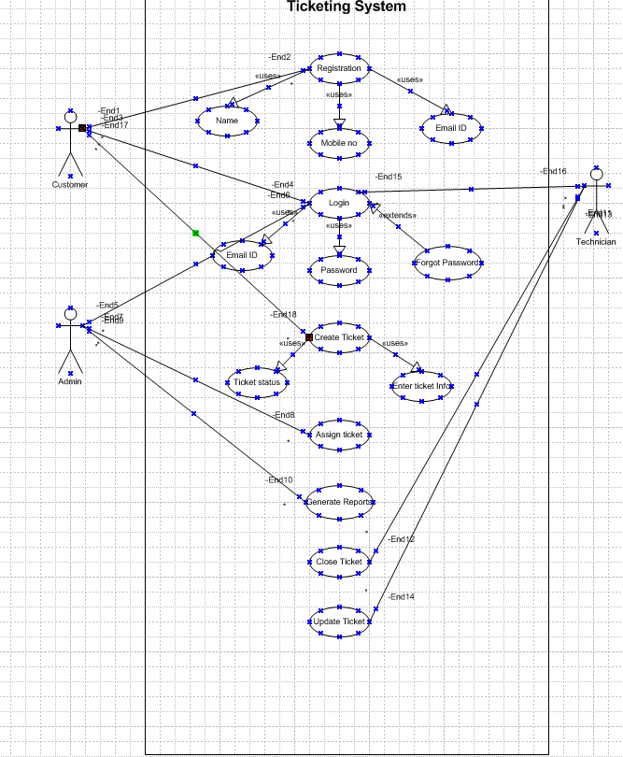

* 1. **Make an ERD of creating a support ticket/Ticketing life cycle.**

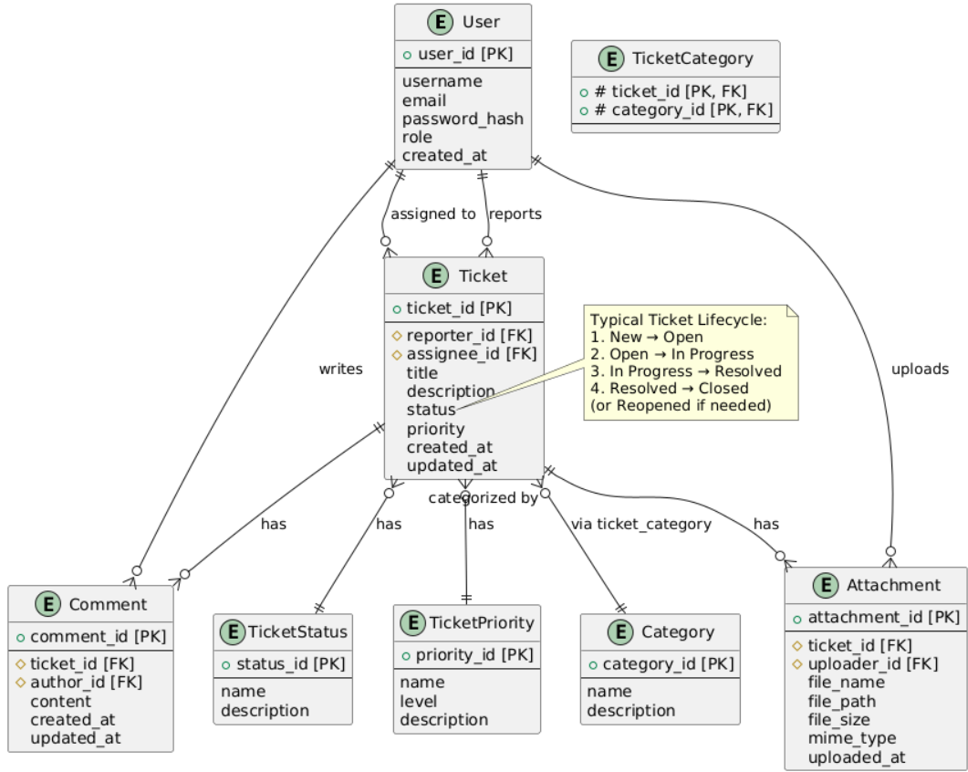

* 1. **User story of shopping from ecommerce**

|  |  |  |  |
| --- | --- | --- | --- |
| User Story No: 1 | Tasks : Implement login page, connect to backend authentication | | Priority: High |
| **As a** Guest User **I want to** browse products without logging in **So that** I can explore the store before deciding to register | | | |
| BV:100 | | CP:03 | |
| ACCEPTANCE CRITERIA  User can log in using email and password. Successful login redirects to dashboard. Invalid login shows error message | | | |

|  |  |  |  |
| --- | --- | --- | --- |
| User Story No: 2 | Tasks : Implement login page, connect to backend authentication | | Priority: High |
| **As a** new visitor **I want to** register on the site **So that** I can shop and manage my orders | | | |
| BV:200 | | CP:05 | |
| ACCEPTANCE CRITERIA  Mandatory fields: name, email, password. Validations for email format and password strength. Confirmation email sent after registration | | | |

|  |  |  |  |
| --- | --- | --- | --- |
| User Story No: 3 | Tasks : Build product listing page | | Priority: High |
| As a shopper I want to browse all available products So that I can find items to buy | | | |
| BV:200 | | CP:03 | |
| ACCEPTANCE CRITERIA  Products displayed in grid layout. Includes images, title, price, and rating. Pagination or infinite scroll | | | |

|  |  |  |  |
| --- | --- | --- | --- |
| User Story No:4 | Tasks : Implement product search functionality | | Priority: High |
| **As a** user **I want to** search for specific products **So that** I can find them quickly | | | |
| BV:100 | | CP:02 | |
| ACCEPTANCE CRITERIA  Search bar is visible on all pages. Real-time search suggestions. Results match query terms | | | |

|  |  |  |  |
| --- | --- | --- | --- |
| User Story No: 5 | Tasks : Add filter/sort options | | Priority: High |
| As a customer I want to filter and sort products So that I can narrow down results | | | |
| BV:500 | | CP:01 | |
| ACCEPTANCE CRITERIA  Filter by category, price, rating. Sort by price or popularity. Works in combination with search | | | |

|  |  |  |  |
| --- | --- | --- | --- |
| User Story No: 6 | Tasks : Product detail page design | | Priority: High |
| **As a** buyer **I want to** see product details **So that** I can make informed decisions | | | |
| BV:100 | | CP:05 | |
| ACCEPTANCE CRITERIA  Show title, description, price, stock status. Image gallery and reviews. Add to cart button present | | | |

|  |  |  |  |
| --- | --- | --- | --- |
| User Story No: 7 | Tasks : Add to cart functionality | | Priority: High |
| As a customer I want to add items to my cart So that I can purchase them later | | | |
| BV:100 | | CP:05 | |
| ACCEPTANCE CRITERIA  Cart icon updates on addition. Products persist in cart. Quantity updates possible | | | |

|  |  |  |  |
| --- | --- | --- | --- |
| User Story No: 8 | Tasks : View shopping cart | | Priority: High |
| **As a** shopper **I want to** review items in my cart **So that** I can manage my purchase list | | | |
| BV:500 | | CP:02 | |
| ACCEPTANCE CRITERIA  Shows product list with price and quantity. Option to remove or edit items. Total price displayed | | | |

|  |  |  |  |
| --- | --- | --- | --- |
| User Story No: 9 | Tasks : Checkout page implementation | | Priority: High |
| As a buyer I want to checkout easily So that I can complete my purchase | | | |
| BV:300 | | CP:03 | |
| ACCEPTANCE CRITERIA  Form to collect address and payment info. Summary of order before submission. Confirmation email on order success | | | |

|  |  |  |  |
| --- | --- | --- | --- |
| User Story No: 10 | Tasks : Add support for promo codes | | Priority: Medium |
| **As a** customer **I want to** apply promo codes **So that** I can get discounts | | | |
| BV:300 | | CP:03 | |
| ACCEPTANCE CRITERIA  Promo field on checkout. Valid code updates total. Invalid code shows error | | | |

|  |  |  |  |
| --- | --- | --- | --- |
| User Story No: 11 | Tasks : Add payment gateway integration | | Priority: High |
| As a customer I want to pay using credit/debit card or UPI So that I can complete my order securely | | | |
| BV:300 | | CP:05 | |
| ACCEPTANCE CRITERIA  Supports multiple payment methods. Secure transaction with confirmation. Error messages on failure | | | |

|  |  |  |  |
| --- | --- | --- | --- |
| User Story No: 12 | Tasks : Implement guest checkout | | Priority: Medium |
| **As a** new user **I want to** checkout without registration **So that** I can order faster | | | |
| BV:500 | | CP:01 | |
| ACCEPTANCE CRITERIA  Option to continue as guest. Must enter email and address. Guest receives order confirmation | | | |

|  |  |  |  |
| --- | --- | --- | --- |
| User Story No: 13 | Tasks : Show related products | | Priority: Medium |
| As a shopper I want to see similar products So that I can explore more options | | | |
| BV:100 | | CP:05 | |
| ACCEPTANCE CRITERIA  Display related items on product page. Based on category or user behavior. Clickable and redirect to detail page | | | |

|  |  |  |  |
| --- | --- | --- | --- |
| User Story No: 14 | Tasks : Wishlist feature | | Priority: Medium |
| **As a** user **I want to** save products **So that** I can buy them later | | | |
| BV:200 | | CP:01 | |
| ACCEPTANCE CRITERIA  Heart icon to add to wishlist. View wishlist in profile. Remove from wishlist option | | | |

|  |  |  |  |
| --- | --- | --- | --- |
| User Story No: 15 | Tasks : Order history view | | Priority: High |
| As a logged-in user I want to view my past orders So that I can track and reorder | | | |
| BV:200 | | CP:05 | |
| ACCEPTANCE CRITERIA  Orders listed with status and date. Click to view full order. Download invoice option | | | |

|  |  |  |  |
| --- | --- | --- | --- |
| User Story No: 16 | Tasks : Implement product reviews | | Priority: Medium |
| **As a** customer **I want to** leave product reviews **So that** I can share my experience | | | |
| BV:500 | | CP:05 | |
| ACCEPTANCE CRITERIA  Rating and text fields. Moderation system for reviews. Display average rating on product page | | | |

|  |  |  |  |
| --- | --- | --- | --- |
| User Story No: 17 | Tasks : Admin panel for product management | | Priority: High |
| As an admin I want to add, edit, or delete products So that I can manage the catalog | | | |
| BV:100 | | CP:01 | |
| ACCEPTANCE CRITERIA  CRUD operations for products. Upload images and manage stock. Restricted to admin role | | | |

|  |  |  |  |
| --- | --- | --- | --- |
| User Story No: 18 | Tasks : Stock alert system | | Priority: Medium |
| **As a** user **I want to** be notified when items are back in stock **So that** I can purchase them | | | |
| BV:500 | | CP:05 | |
| ACCEPTANCE CRITERIA  Option to subscribe for stock alerts. Automatic email when available. Unsubscribe option | | | |

|  |  |  |  |
| --- | --- | --- | --- |
| User Story No: 19 | Tasks : Order tracking feature | | Priority: High |
| As a buyer I want to track my shipment So that I know when it arrives | | | |
| BV:100 | | CP:05 | |
| ACCEPTANCE CRITERIA  Show delivery status with timestamps. Link to courier tracking page. Notify user on delivery stages | | | |

|  |  |  |  |
| --- | --- | --- | --- |
| User Story No: 20 | Tasks : Newsletter subscription | | Priority: Low |
| **As a** visitor **I want to** subscribe to newsletters **So that** I get offers and updates | | | |
| BV:500 | | CP:05 | |
| ACCEPTANCE CRITERIA  Email field and subscribe button. Confirmation email sent. Option to unsubscribe | | | |

|  |  |  |  |
| --- | --- | --- | --- |
| User Story No: 21 | Tasks : Enable address book | | Priority: Medium |
| As a user I want to save multiple addresses So that I can select them during checkout | | | |
| BV:200 | | CP:03 | |
| ACCEPTANCE CRITERIA  Add/edit/delete address. Set default address. Address dropdown at checkout | | | |

|  |  |  |  |
| --- | --- | --- | --- |
| User Story No: 22 | Tasks : User profile management | | Priority: High |
| **As a** registered user **I want to** manage my account details **So that** I can keep my info updated | | | |
| BV:500 | | CP:01 | |
| ACCEPTANCE CRITERIA  Update name, email, password. View account activity. Secure password change flow | | | |

|  |  |  |  |
| --- | --- | --- | --- |
| User Story No: 23 | Tasks : Enable social media login | | Priority: Medium |
| As a user I want to login using Google or Facebook So that I can save time | | | |
| BV:100 | | CP:05 | |
| ACCEPTANCE CRITERIA  Google/Facebook login buttons. Redirect to profile on success. Link to existing account | | | |

|  |  |  |  |
| --- | --- | --- | --- |
| User Story No: 24 | Tasks : Implement product categories | | Priority: High |
| **As a** customer **I want to** browse by category **So that** I can find products easily | | | |
| BV:200 | | CP:01 | |
| ACCEPTANCE CRITERIA  Categories in header or sidebar. Clicking filters product list. Sub-categories supported | | | |

|  |  |  |  |
| --- | --- | --- | --- |
| User Story No: 25 | Tasks : Email notifications setup | | Priority: Medium |
| As a user I want to receive email updates So that I stay informed about my orders | | | |
| BV:200 | | CP:05 | |
| ACCEPTANCE CRITERIA  Email on order placed, shipped, delivered. Email on password reset and profile update. Unsubscribe link in footer | | | |

|  |  |  |  |
| --- | --- | --- | --- |
| User Story No: 26 | Tasks : Product image zoom | | Priority: Low |
| **As a** shopper **I want to** zoom into product images **So that** I can see product details | | | |
| BV:500 | | CP:05 | |
| ACCEPTANCE CRITERIA  Hover zoom or lightbox feature. Works on all product images. Mobile pinch zoom support | | | |

|  |  |  |  |
| --- | --- | --- | --- |
| User Story No: 27 | Tasks : Show item availability | | Priority: Medium |
| As a buyer I want to know if a product is in stock So that I can plan my purchase | | | |
| BV:200 | | CP:02 | |
| ACCEPTANCE CRITERIA  “In Stock” or “Out of Stock” label. Prevent adding out-of-stock items to cart. Notify if item becomes unavailable | | | |

|  |  |  |  |
| --- | --- | --- | --- |
| User Story No: 28 | Tasks : Implement referral system | | Priority: Low |
| **As a** user **I want to** refer others **So that** I can earn rewards | | | |
| BV:500 | | CP:02 | |
| ACCEPTANCE CRITERIA  Unique referral code. Reward for both referrer and referee. Referral history in profile | | | |

|  |  |  |  |
| --- | --- | --- | --- |
| User Story No: 29 | Tasks : Enable product comparison | | Priority: Medium |
| As a user I want to compare products So that I can choose the best | | | |
| BV:100 | | CP:02 | |
| ACCEPTANCE CRITERIA  Checkbox to add to comparison. Display side-by-side features. Clear comparison table | | | |

|  |  |  |  |
| --- | --- | --- | --- |
| User Story No: 30 | Tasks : Integrate live chat | | Priority: Medium |
| **As a** visitor **I want to** chat with support **So that** I can get help instantly | | | |
| BV:100 | | CP:02 | |
| ACCEPTANCE CRITERIA  Floating chat widget. Support agents respond live. History stored in user profile | | | |

|  |  |  |  |
| --- | --- | --- | --- |
| User Story No: 31 | Tasks : Enable multi-language support | | Priority: Medium |
| **As a** visitor **I want to** chat with support **So that** I can get help instantly | | | |
| BV:500 | | CP:01 | |
| ACCEPTANCE CRITERIA  Floating chat widget. Support agents respond live. History stored in user profile | | | |

|  |  |  |  |
| --- | --- | --- | --- |
| User Story No: 32 | Tasks : Add currency switcher | | Priority: Medium |
| As a global user I want to view prices in my currency So that I can understand costs better | | | |
| BV:100 | | CP:01 | |
| ACCEPTANCE CRITERIA  Currency dropdown. Prices update instantly. Use live exchange rates | | | |

|  |  |  |  |
| --- | --- | --- | --- |
| User Story No: 33 | Tasks : Track abandoned carts | | Priority: Medium |
| **As a** merchant **I want to** recover abandoned carts **So that** I can increase sales | | | |
| BV:200 | | CP:03 | |
| ACCEPTANCE CRITERIA  Save cart for logged-in users. Email reminders after timeout. Report of abandoned carts | | | |

|  |  |  |  |
| --- | --- | --- | --- |
| User Story No: 34 | Tasks : Admin user management | | Priority: High |
| As an admin I want to manage users So that I can control access and activity | | | |
| BV:200 | | CP:03 | |
| ACCEPTANCE CRITERIA  Search, block, and delete users. Assign user roles. Track login activity | | | |

|  |  |  |  |
| --- | --- | --- | --- |
| User Story No: 35 | Tasks : Generate sales reports | | Priority: Medium |
| **As an** admin **I want to** generate sales reports **So that** I can track business performance | | | |
| BV:100 | | CP:01 | |
| ACCEPTANCE CRITERIA  Daily/weekly/monthly filters. Download as PDF/CSV. Graphs and summary statistics | | | |

|  |  |  |  |
| --- | --- | --- | --- |
| User Story No: 36 | Tasks : Build mobile responsive UI | | Priority: High |
| As a mobile user I want to shop easily on mobile So that I have a smooth experience | | | |
| BV:200 | | CP:03 | |
| ACCEPTANCE CRITERIA  Works across all screen sizes. No broken layouts. Touch-friendly buttons | | | |

|  |  |  |  |
| --- | --- | --- | --- |
| User Story No: 37 | Tasks : Display shipping options | | Priority: High |
| **As a** buyer **I want to** select shipping method **So that** I can choose the best option | | | |
| BV:200 | | CP:02 | |
| ACCEPTANCE CRITERIA  Options for standard/express. Estimated delivery date shown | | | |

|  |  |  |  |
| --- | --- | --- | --- |
| User Story No: 38 | Tasks : Enable product tagging | | Priority:Low |
| As an admin I want to tag products So that I can group and search efficiently | | | |
| BV:100 | | CP:02 | |
| ACCEPTANCE CRITERIA  Add tags on product form. Filter products by tags. Visible to users in product detail | | | |

|  |  |  |  |
| --- | --- | --- | --- |
| User Story No: 39 | Tasks : Enable auto-suggestions in search | | Priority: Medium |
| **As a** user **I want to** see suggestions while typing **So that** I find products faster | | | |
| BV:200 | | CP:03 | |
| ACCEPTANCE CRITERIA  Shows popular and matching items. Works for product name and tags. Keyboard navigable | | | |

|  |  |  |  |
| --- | --- | --- | --- |
| User Story No: 40 | Tasks : Set up loyalty points system | | Priority: Medium |
| As a frequent shopper I want to earn points So that I can redeem them later | | | |
| BV:100 | | CP:01 | |
| ACCEPTANCE CRITERIA  Points earned per purchase. Redeem at checkout. Show balance in profile | | | |