1. **Document 6- Please prepare a use case diagram, activity diagram and a use case specification document.**

**Activity Diagram:**

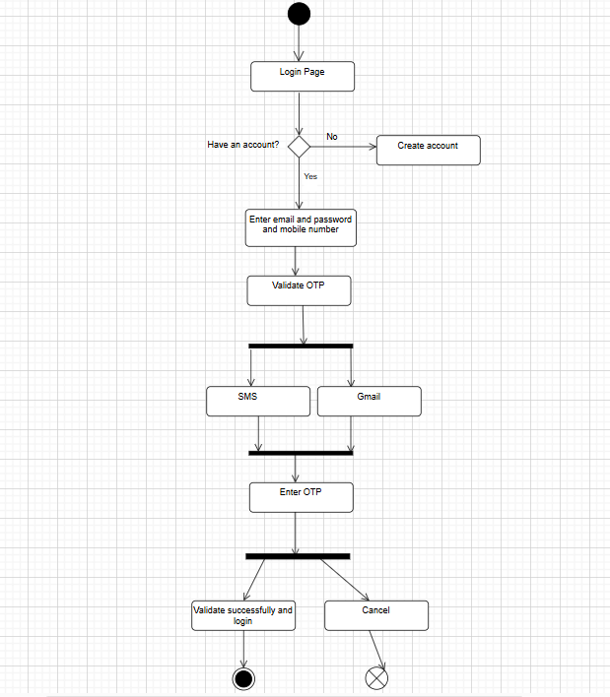

**1. Use Case Name:**

User Login with Multi-Factor Authentication (MFA)

**2. Use Case Description:**

This use case describes the process by which a user logs into the application using their username, strong password, and multi-factor authentication (MFA). The goal is to enhance login security by implementing additional authentication measures.

**3. Actors:**

* Primary Actor: End User (Application User)
* Secondary Actors: Authentication Service Provider (for MFA), System Database, Email/SMS Service for OTP delivery

**4. Basic Flow:**

1. The user navigates to the login page.
2. The user enters a valid username and password.
3. The system verifies the credentials against the database.
4. Upon successful verification, the system triggers the MFA process.
5. The user receives an OTP via the chosen MFA method (SMS, email, or authenticator app).
6. The user enters the OTP.
7. The system verifies the OTP.
8. If the OTP is correct, the user is granted access to the system.

**5. Alternate Flow:**

* A1: If the user does not receive the OTP:
  + The user clicks on "Resend OTP."
  + The system generates and sends a new OTP.
  + The user proceeds to enter the newly received OTP.

**6. Exceptional Flows:**

* E1: Invalid username or password:
  + The system displays an error message prompting the user to re-enter the credentials.
* E2: Invalid OTP:
  + The system displays an error message and allows three retry attempts.
  + After three failed attempts, the user account is temporarily locked.
* E3: MFA Service Failure:
  + The system notifies the user of the issue and suggests trying again later or contacting support.

**7. Pre-Conditions:**

* The user must have an active account.
* MFA must be configured for the user’s account.
* The user must have access to the selected MFA delivery method (email/SMS/app).

**8. Post-Conditions:**

* Successful authentication grants access to the system’s dashboard.
* Failed authentication leads to appropriate error messages or account lockout after multiple unsuccessful attempts.

**9. Assumptions:**

* Users have registered a valid email address or phone number for MFA.
* The authentication service and database are operational during the login attempt.
* Internet connectivity is available for OTP delivery.

**10. Constraints:**

* OTP validity is limited to 5 minutes.
* Maximum of three OTP resend attempts per login session.
* Password must meet security standards (e.g., minimum length, special characters, etc.).

**11. Dependencies:**

* Dependency on third-party MFA providers for OTP generation and delivery.
* Dependency on the system database for user credential verification.
* Email/SMS delivery systems must be operational.

**12. Inputs and Outputs:**

* Inputs: Username, Password, OTP
* Outputs: Success notification and access to the user dashboard or relevant error messages.

**13. Business Rules:**

* Password complexity must meet organization security policies.
* MFA is mandatory for all users during login.
* Accounts are locked after three failed login or OTP attempts within a session.

**14. Miscellaneous Information:**

* The login page is responsive and accessible across devices (desktop, mobile, tablet).
* Accessibility features like screen reader support and high-contrast mode are available.
* System logs all login attempts for audit and security purposes.

1. **Document 7- Screens and pages**

**Website**

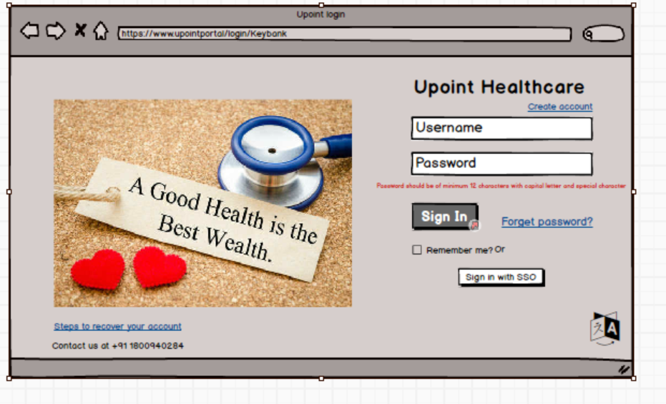

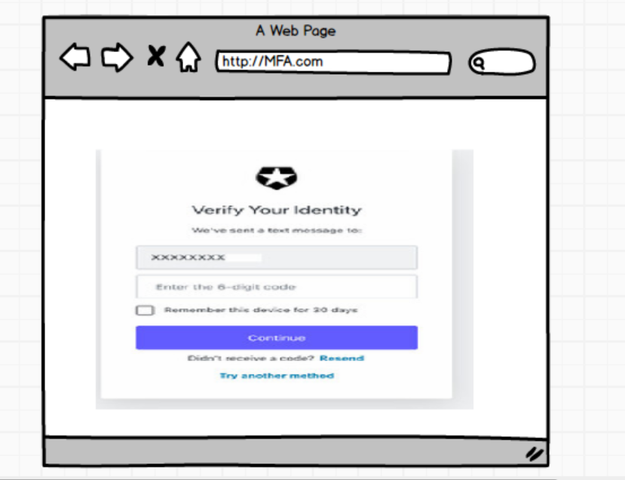

1. **Document 8- Tools-Visio and Axure Write a paragraph on your experience using Visio and Axure for the project.**

In my projects, I have utilized Microsoft Visio extensively for creating detailed process flow diagrams, data flow diagrams (DFDs), and system architecture diagrams. Visio proved invaluable in visually representing complex business processes and system interactions, facilitating clear communication among stakeholders and technical teams. It helped in mapping out workflows, identifying process inefficiencies, and ensuring alignment between business requirements and technical solutions. Additionally, I used Axure RP for developing interactive wireframes and prototypes, which played a crucial role in gathering stakeholder feedback early in the development cycle. Axure's ability to create dynamic, clickable prototypes enabled stakeholders to visualize the product, leading to improved requirement validation and reduced rework during development. The combination of Visio for process visualization and Axure for user experience design significantly streamlined project execution, enhanced stakeholder engagement, and ensured successful project outcomes.

1. **Document 9- BA experience**

**1. Requirement Gathering**

* Requirement Prioritization: Utilized the MoSCoW technique to prioritize requirements into Must-have, Should-have, Could-have, and Won't-have categories.
* Client Unavailability Management: Faced client unavailability during this phase. Proactively sourced alternative points of contact from the client's side to obtain necessary information ASAP to prevent project delays.
* Requirement Validation: Applied the FURPS technique (Functionality, Usability, Reliability, Performance, Supportability) to validate and ensure the quality of gathered requirements.
* Eliminating Redundancies: Identified and immediately removed duplicated or repeated requirements to streamline the requirement set.
* Prototyping: Used prototyping techniques to provide clients and stakeholders with visual representations, enabling them to provide more specific and actionable feedback.

**2. Requirement Analysis**

* UML Diagrams: Developed UML diagrams to visually represent and describe system requirements.
* Activity Diagrams: Created activity diagrams to outline the process flows, ensuring clarity on functional processes.
* Stakeholder Communication: Communicated diagrams to the project team. Addressed feedback from team members, considering valid points and modifying diagrams accordingly to reach consensus.
* Documentation: Prepared comprehensive Business Requirements Specification (BRS) and Software Requirements Specification (SRS) documents.

**3. Design**

* Test Case Preparation: Derived test cases directly from use case diagrams, ensuring thorough test coverage.
* Client Communication: Engaged with clients to discuss design elements and solution documents, ensuring alignment with business needs.
* Negative Testing Focus: Developed negative test cases alongside positive ones to cover all edge cases and prevent future development issues.
* RTM Updates: Updated the Requirements Traceability Matrix (RTM) to confirm that all requirements were covered during the design phase.
* Test Data Preparation: Created relevant test data for thorough testing.

**4. Development**

* JAD Sessions: Organized Joint Application Development (JAD) sessions to ensure collaboration between business stakeholders and the technical team.
* Resolving Team Conflicts: Addressed team member disagreements during JAD sessions through one-on-one discussions, explaining the impact of their actions on the project, thereby fostering a healthy team environment.
* Technical Clarifications: Acted as a liaison between the technical team and stakeholders, clarifying queries during the coding phase.
* Meeting Coordination: Conducted regular meetings with the technical team and clients. Managed challenges due to participant unavailability by recording sessions and holding follow-up discussions with absent members.
* Code Reference: Ensured the development team referred to the prepared diagrams during unit coding.

**5. Testing**

* Test Case Execution: Performed high-level testing based on use cases to ensure the solution met business expectations.
* Test Data Management: Coordinated with the client to obtain test data essential for testing activities.
* RTM Verification: Continuously updated RTM to confirm that each requirement had corresponding test cases and was validated during testing.
* Client Signoff: Facilitated client signoff on testing activities to move forward with deployment.
* User Acceptance Testing (UAT): Prepared and guided the client through UAT, ensuring they were fully equipped to evaluate the final solution**.**

**6. Deployment**

* Project Closure: Forwarded the finalized RTM to the client, attaching it to the project closure document for reference.
* End-User Manuals: Coordinated the creation and sharing of end-user manuals to ensure smooth adoption.
* Training Sessions: Planned and organized comprehensive training sessions for end-users, ensuring 100% attendance and understanding by following up with absentees.

**Key Techniques & Tools Used:**

* Requirement Prioritization: MoSCoW
* Requirement Validation: FURPS
* Documentation: BRS, SRS, RTM
* Modeling Tools: UML Diagrams, Activity Diagrams
* Testing: Positive & Negative Test Cases, Test Data Preparation
* Collaboration: JAD Sessions, Regular Stakeholder Meetings
* Process Model: Waterfall Methodology

**Impact of Project:**

* Enhanced login security by introducing strong password requirements and multi-factor authentication (MFA).
* Improved user experience and compliance with healthcare data regulations (HIPAA, ACA).
* Ensured seamless integration of the login module within the uPoint portal, supporting healthcare enrollment processes with enhanced security and usability.