Nurturing Process - Capstone Project1 – Part -3/3
Question 1 – Functional Requirements - 15 Marks Identify minimum 20 functional requirements Example : Functional requirement: When an order is fulfilled, the local printer shall print a packing slip. Non-Functional Requirement: Packing slips shall be printed on both sides of 4”x 6” white paper, the standard size for packing slips used by local printers.

Answer :
Functional Requirements
Req ID | Req Name | Req Description | Priority
FR0001 | Farmer Registration | Farmers should be able to register with email ID and secure password | 8
FR0002 | Manufacturer Registration | Manufacturers should be able to register to upload products | 8
FR0003 | Login Functionality | Login Functionality,Both Farmers and Manufacturers should be able to login to the system | 9
FR0004 | Product Catalog | Farmers should be able to browse categorized products (fertilizers, seeds, etc.) | 10
FR0005 | Product Search | Farmers should be able to search for specific products using keywords | 9
FR0006 | Add to Cart | Farmers should be able to add selected products to a cart | 8
FR0007 | Save for Later | Farmers should be able to save products in a buy-later list | 7
FR0008 | Place Order | Farmers should be able to place an order for selected products | 9
FR0009 | Payment Gateway | System should support multiple payment methods: COD, UPI, Credit/Debit cards | 10
FR0010 | Order Confirmation Email | Email confirmation should be sent after a successful order | 8
FR0011 | Delivery Tracking | Farmers should be able to track their order delivery status | 9
FR0012 | Manufacturer Product Upload | Manufacturers should be able to upload product details (name, category, price, etc) | 9
FR0013 | Manufacturer Product Management | Manufacturers should be able to edit or remove products | 8
FR0014 | Admin Dashboard | Admin should be able to monitor all users, orders, and product listings | 7
FR0015 | Product Detail View | Farmers can view detailed product information including price, brand, etc | 8
FR0016 | Forgot Password | Users should be able to reset forgotten passwords | 7
FR0017 | Product Reviews/Feedback | Farmers should be able to leave reviews for purchased products | 6
FR0018 | Order History | Order History,Farmers should be able to view past orders and status | 7
FR0019 | Notification Alerts | System should notify users of important updates (e.g., order shipped, payment status) | 7
FR0020 | Responsive Design | Application should support both mobile and web platforms | 9

Non-Functional Requirements (NFRs) :
Req ID | Req Name | Req Description | Priority
NFR0101 | Page Loading Time | Each page should load within 2 seconds | 9
NFR0102 | WCAG 2.1 | System must comply with accessibility standards WCAG 2.1 | 8
NFR0103 | System Availability | The system should have 99.9% uptime | 9
NFR0104 | Data Security | All user data and transactions must be encrypted and securely stored | 10
NFR0105 | Scalability | The system should support growing number of users without performance degradation | 8
NFR0106 | Browser Compatibility | Browser Compatibility,The application should work seamlessly across major browsers (Chrome, Edge, etc.) | 7

- Use Case Diagram

Question 2–Minimum 5 page design
Make wireframe and prototypes
Answer :
- A wireframe is a basic visual representation (like a blueprint) of a screen or page in a system. It focuses on Layout,Structure,Functionality.
- A prototype is a working model of the system, often interactive, that simulates the user experience and system behavior
These are the 5 wireframe page Design,The sketches represent the key functionality and layout flow of the system

- . Wireframes and Prototype :

1 .Home Page :

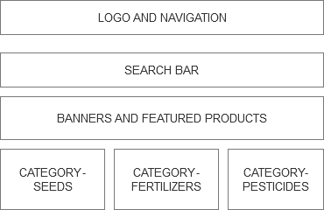
- User Registration / Login Page :
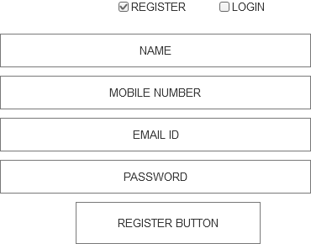

- Product Listing Page :
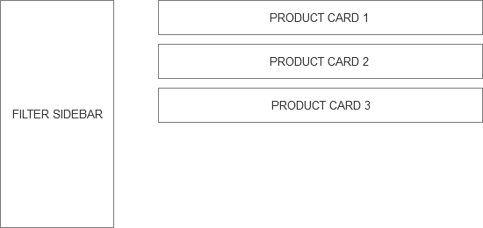

4. Product Detail Page + Add to Cart
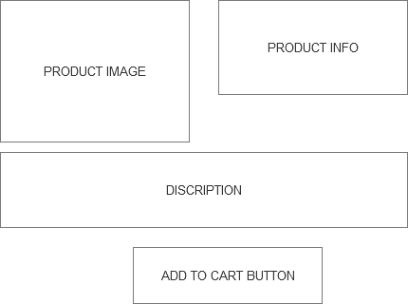
5. Checkout + Payment Page
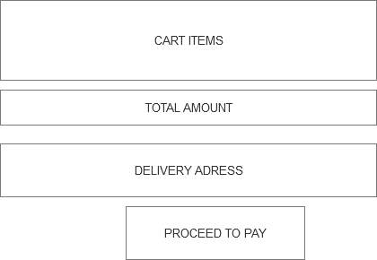

Place order :
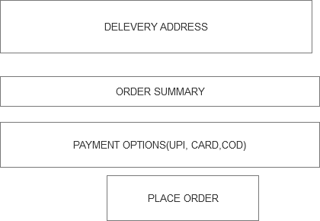

Prototypes :

Question 3 – Tools (Visio, Balsamiq) – 15Marks
Make a note of the Tools, which you are using for above concepts.
Answer :
Here’s a brief note on the tools Axure RP, Balsamiq, and Microsoft Visio suitable for academic or project documentation:
1. Axure RP
Purpose:
Axure RP is a powerful prototyping tool used to create interactive wireframes and functional mockups.
Key Features:
• Allows for advanced interactivity and conditional logic
• Supports clickable prototypes with real-time simulation
• Useful for UX professionals, Business Analysts, and UI Designers
Use Case:
Ideal for high-fidelity prototypes, user flows, and system logic modeling in complex web/mobile applications
2. Balsamiq
Purpose:
Balsamiq is a low-fidelity wireframing tool designed for sketch-style screen mockups.
Key Features:
• Easy drag-and-drop interface
• Focuses on functionality and structure, not design
• Great for early-stage brainstorming and stakeholder presentations
Use Case:
Best for quickly drafting user interfaces, app layouts, and web page structures in the initial stages of product design.

3. Microsoft Visio
Purpose:
Visio is a diagramming tool used to create professional flowcharts, process diagrams, and UML diagrams.
Key Features:
• Includes templates for Activity Diagrams, Use Case Diagrams, Data Flow Diagrams, etc.
• Integrates well with other Microsoft Office tools
• Suitable for technical and business users alike
Use Case:
Ideal for modeling workflows, business processes, system architecture, and documentation of technical diagrams.
Question 4 – RTM - 6 Marks
A business analyst’s key responsibilities are to keep track of the requirements and make sure that no requirement is missed.
Answer :
A Business Analyst’s key responsibility is to ensure that all requirements are captured, tracked, and implemented throughout the project lifecycle. One of the essential tools used for this purpose is the Requirement Traceability Matrix (RTM).
The Requirement Traceability Matrix (RTM) is a document that maps and traces user requirements with:
• Functional Specifications
• Design Documents
• Test Cases
• Development Progress
• UAT (User Acceptance Testing) Results
It ensures complete coverage and validation of each requirement.
So as per the given question I will tackle the situation by making RTM
Req ID | Req Name | Req Description | Design Ref | T1 | T2 | T3 | T4 | UAT
FR0001 | Farmer Registration | Farmers should be able to register with the application | D1 | Pass | Pass | Pass | N/A | Completed
FR0002 | Farmer Search for Products | Farmers should be able to search for products in fertilizer,seeds, pesticides | D2 | Pass | Pass | In Prog | N/A | Pending
FR0003 | Add Product to Cart | Farmers can add selected products to their cart | D3 | Pass | Pass | Pass | N/A | Completed
FR0004 | Make Payment | Farmers can make secure online payments | D4 | Pass | In Prog | N/A | N/A | In Review
FR0005 | Manufacturer Product Upload | Manufacturers should be able to upload and manage their product listings | D5 | Pass | Pass | N/A | N/A | Completed
FR0006 | Order Delivery Tracking | Farmers can track order delivery status after purchase | D6 | N/A | Planned | N/A | N/A | Pending
NFR0101 | Page Loading Time | Each page should load within 2 seconds | D7 | Pass | N/A | N/A | N/A | Completed
NFR0102 | WCAG 2.1 Compliance | The system must comply with WCAG 2.1 accessibility standards | D8 | In Prog | N/A | N/A | N/A | In Review
NFR0103 | System Uptime | The system should maintain 99.9% uptime availability | D9 | Planned | N/A | N/A | N/A | Completed
NFR0105 | Mobile Responsiveness | Application should be fully responsive on all mobile devices | D11 | Pass | Pass | N/A | N/A | Completed
Legend:
• FR = Functional Requirement
• NFR = Non-Functional Requirement
• T1–T4 = Testing Stages (T1: Unit Test, T2: Integration, T3: System Test, T4: Regression)
• UAT = User Acceptance Testing

Question 5 – Test Case Documents - 10 Marks
Prepare 10 Test Case Documents
Answer :
A test case document is a detailed outline used to ensure that a software application or system is working as expected.
Purpose of test case document is to validate the functionality, performance and usability of a system by checking if the application behaves correctly under specific inputs and conditions.
Each Test Case Document includes:
• Test Case ID
• Test Scenario
• Test Steps
• Test Data
• Expected Result
• Actual Result
• Status (Pass/Fail)
Test Case 1 – Farmer Registration
Field | Value
Test Case ID | TC001
Scenario | Verify that a farmer can register successfully
Test Steps | 1. Go to registration page 2. Fill valid details 3. Click submit
Test Data | Name: Pradnya, Email: pradnya@mail.com, Phone: 9000100010
Expected Result | Registration successful and confirmation message displayed
Actual Result | Registration successful
Status | Pass

Test Case 2 – Invalid Email in Registration :
Field | Value
Test Case ID | TC002
Scenario | Check validation on entering an invalid email
Test Steps | Enter invalid email and submit
Test Data | Email: ramu[at]mail
Expected Result | Error: “Invalid email format
Actual Result | Error displayed
Status | Pass
Test Case 3 – Product Search Functionality
Field | Value
Test Case ID | TC003
Scenario | Verify search returns results based on keyword
Test Steps | 1. Enter keyword “fertilizer” in search 2. Click search
Test Data | fertilizer
Expected Result | Product list containing fertilizer appears
Actual Result | Product list displayed
Status | Pass
Test Case 4 – Add Product to Cart
Field | Value
Test Case ID | TC004
Scenario | Check if product is added to cart successfully
Test Steps | 1. Click on product 2. Click “Add to Cart
Test Data | Product ID: 101
Expected Result | Confirmation message: “Product added to cart
Actual Result | Message displayed
Status | Pass
Test Case 5 – Make Payment (Successful)
Field | Value
Test Case ID | TC005
Scenario | Verify successful payment with valid card
Test Steps | Enter valid payment details and submit
Test Data | Card No: 4111 1111 1111 1111
Expected Result | Payment success and order confirmation
Actual Result | Payment processed
Status | Pass
Test Case 6 – Payment with Invalid Card
Field | Value
Test Case ID | TC006
Scenario | Verify system response to invalid card
Test Steps | Enter invalid card details
Test Data | Card No: 1234 0000 0000 0000
Expected Result | Error: “Invalid card number
Actual Result | Error displayed
Status | Pass
Test Case 7 – View Cart
Field | Value
Test Case ID | TC007
Scenario | Verify that cart shows correct product list
Test Steps | Click on cart icon
Test Data | Logged-in user
Expected Result | All added products visible
Actual Result | Products displayed
Status | Pass
Test Case 8 – Order Tracking
Field | Value
Test Case ID | TC008
Scenario | Verify order tracking after purchase
Test Steps | Click on “My Orders” and select order
Test Data | Order ID: ORD123
Expected Result | Status: “Shipped / In Transit
Actual Result | Status shown
Status | Pass
Test Case 9 – Manufacturer Product Upload
Field | Value
Test Case ID | TC009
Scenario | Verify manufacturer can upload new product
Test Steps | Login as manufacturer, go to Add Product
Test Data | Product: “Organic Pesticide
Expected Result | Product listed on store
Actual Result | Product listed
Status | Pass
Test Case 10 – Page Load Time :
Field | Value
Test Case ID | TC010
Scenario | Verify each page loads within 2 seconds
Test Steps | Navigate through various pages
Test Data | Homepage, Cart, Product Page
Expected Result | Pages load within 2 seconds
Actual Result | Avg. Load Time: 1.7s
Status | Pass

OR

Test Case ID | Test Scenario | Test Steps | Test Data | Expected Result | Actual Result | Status (Pass/Fail)
TC001 | Verify that a farmer can register successfully | 1. Go to registration page 2. Fill valid details 3. Click submit | Name: Pradnya, Email: pradnya@mail.com, Phone: 9000100010 | Registration successful and confirmation message displayed | Registration successful | Pass
TC002 | Check validation on entering an invalid email | Enter invalid email and submit | Email: ramu[at]mail | Error: “Invalid email format | Error displayed | Pass
TC003 | Verify search returns results based on keyword | 1. Enter keyword “fertilizer” in search 2. Click search | fertilizer | Product list containing fertilizer appears | Product list displayed | Pass
TC004 | Check if product is added to cart successfully | 1. Click on product 2. Click “Add to Cart | Product ID: 101 | Confirmation message: “Product added to | Message displayed | Pass
TC005 | Verify successful payment with valid card | Enter valid payment details and submit | Card No: 4111 1111 1111 1111 | Payment success and order confirmation | Payment processed | Pass
TC006 | Verify system response to invalid card | Enter invalid card details | Card No: 1234 0000 0000 0000 | Error: “Invalid card number | Error displayed | Pass
TC007 | Verify that cart shows correct product list | Click on cart icon | Logged-in user | All added products visible | Products displayed | Pass
TC008 | Verify order tracking after purchase | Click on “My Orders” and select order | Order ID: ORD123 | Status: “Shipped / In Transit | Status shown | Pass
TC009 | Verify manufacturer can upload new product | Login as manufacturer, go to Add Product | Product: “Organic Pesticide | Product listed on store | Product listed | Pass
TC010 | Verify each page loads within 2 seconds | Navigate through various pages | Homepage, Cart, Product Page | Pages load within 2 seconds | Avg. Load Time: 1.7s | Pass

Question 6 – DB Design – 8 Marks
After the requirements are thoroughly explained to the entire project team by business analyst, the Database architects have decided to do the database design and also to represent the in-flow and out-flow of data. Draw database schema and ER diagram
Answer :
A database schema is the structure of a database that defines how data is organized, stored, and related to each other..
An entity relationship diagram (ERD) is a visual representation of the relationships between entities in a database. It depicts the entities (such as tables), attributes (properties or fields),and relationship between them.

Database Schema
Here are the main entities and their attributes:
1. Farmers
• Farmer ID (PK)
• Full Name
• Email
• Phone Number
• Address
• Password
• Registration Date
2. Manufacturers
• Manufacturer ID (PK)
• Company Name
• Email
• Contact Number
• Address
• Password
• Registration Date
3. Products
• Product ID (PK)
• Manufacturer ID (FK)
• Product Name
• Category (Seed/Fertilizer/Pesticide)
• Description
• Price
• Quantity
• Created At
4. Orders
• Order ID (PK)
• Farmer ID (FK)
• Order Date
• Status
• Total Amount
5. OrderDetails
• Order Detail ID (PK)
• Order ID (FK)
• Product ID (FK)
• Quantity
• Unit Price
6. Feedback
• Feedback ID (PK)
• Farmer ID (FK)
• Product ID (FK)
• Rating
• Comment
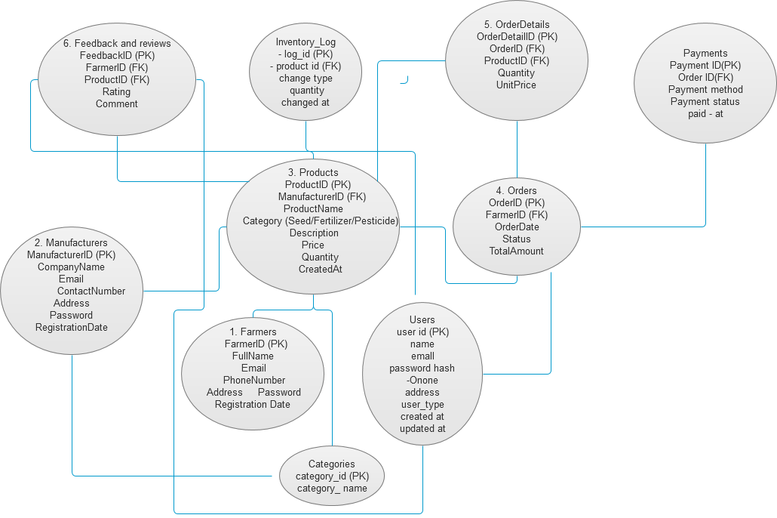

Feedback
Feedback ID
Farmer ID
Product ID
Rating
Comment
ER Diagram :
Farmers
Farmer ID
Name
Phone number
Email
Password
Address
District

Orders
Order ID
Farmer ID
Order Date
Status

Order Deatails
Order detail ID
Order ID
Product ID
Quantity
Price

Manufacturers
Manuactures ID
Name
Email
Phone
Address
Products
Products ID
Name
Type
Description
Price
Manufacturer ID
Stock QTY

Question 7 – Data Flow Diagram - 3 Marks
What is a data flow diagram? Draw a data flow diagram to represent the in-flow and out-flow of data when a Farmer is placing an order for the product.
Answer :
A Data flow diagram (DFD) is a graphical representation of the flow of the data within a system. It visually shows how data moves from one process to another , how it is storedand where it ends up .
It helps analysts and designers understand the flow of data within a system, identify potential bottlenecks or inefficiencies, and communicate system requirements to stakeholders.

data flow diagram :

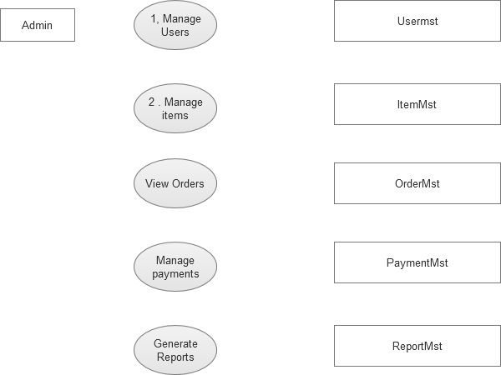

Question 8 – Change Request - 10 Marks
Due to change in the Government Taxation structure . we should change the Tax structure How do you handle change requests in a project?
Answer :
A Change Request is a formal proposal to modify any part of a project after it has started. It can relate to scope, features, design, schedule, budget, or any project documentation or deliverable.
To handle a change request related to a change in Government Taxation structure in an online agriculture store project, you should follow a structured Change Management Process. Here’s how you can approach it step-by-step:
- Identify and Log the Change Request
Initiator: The change request could be raised by the finance team, legal team, or management due to new tax regulations.

Documentation: Create a formal Change Request (CR) document stating the reason, impact, and urgency of the change.

2. Analyze the Impact
Business Impact: Assess how the new taxation structure affects product pricing, invoices, billing, and reporting.
Technical Impact: Identify what parts of the system (backend, frontend, database) need updates – e.g., GST calculation logic, invoice templates.
Timeline and Cost: Estimate the time and resources needed to implement and test the changes.

3. Review and Approval
Present the analysis to key stakeholders (Product Owner, Project Sponsor, Finance team).
Get formal approval before proceeding. Prioritize the change if it’s urgent due to regulatory compliance.

4. Update Project Plan
Modify the project scope, timeline, and resource allocation based on the change.
Communicate the updated plan to all relevant team members.

5. Implement the Change
Developers modify the codebase to reflect the new tax rules.
Update APIs, tax modules, database tables, and UI as needed.

6. Testing
Perform unit testing, integration testing, and user acceptance testing (UAT).
Ensure the new tax calculations are accurate and reflected correctly in invoices and reports.

7. Deployment
Deploy changes to the live environment, preferably during low-traffic hours.
Ensure rollback plans are in place in case of issues.
8. Post-Implementation Review
Monitor the system for any issues.
Gather feedback from users (farmers, customers, admin).
Document lessons learned.

So , Handling a change in the tax structure involves identifying the change, assessing its business and technical impact, getting stakeholder approvals, updating the system accordingly, testing thoroughly, and ensuring compliance post-deployment.

Question 9 – Change Request Vs an Enhancement - 5 Marks
As the project is in process, Ben and Kevin have contacted you. The reason is to inform you that they want the Farmers to sell their crop yields through this application i.e. Farmers should be able to add their crop yields or products and display to general public and should be able to sell them. They also want to introduce Auction system for their Crop yields. As a BA, what will be your response? Is this a change request or an enhancement???
Answer :
As a Business Analyst, my response would be:

This is a Change Request, not just an enhancement.

Reason:
•The original scope of the project likely focused on connecting farmers with manufacturers or suppliers (e.g., purchasing agricultural inputs).
•Introducing a farmer-to-public selling model and an auction system significantly alters the core functionality and scope of the application.
•It requires new features, such as:
•Farmer product listing dashboard
•Public product catalog view
•Bidding mechanism for auctions
•Order management and payment integration for direct sales

These functionalities were not part of the initial project plan, hence this request changes the agreed scope and deliverables. Therefore, it qualifies as a Change Request and must go through the formal change management process, including impact analysis, approvals, and updates to the project plan.

Question 10 – Estimations - 6 Marks
Come up with estimations – How many Manhours required
Answer:
1. Project Estimation Overview
Let’s assume this is a medium-sized web application with user types like Farmers, Manufacturers, Admin, and features like product listing, ordering, payments, etc.

Phase | Estimated Manhours
Requirements Gathering | 20 hours
Business Analysis & Documentation | 24 hours
UI/UX Design | 30 hours
Frontend Development | 80 hours
Backend Development | 100 hours
Database Design & Integration | 30 hours
Payment Gateway Integration | 16 hours
Testing & Bug Fixing | 40 hours
Deployment & Review | 10 hours
Total | 350 hours
If multiple people are involved, divide by the number of resources to get calendar time.
•Agile or iterative teams may do this in sprints.
•These estimates are for typical functionality —
can be adjusted based on actual scope.

Question 11 – UAT – 6 Marks
Project has finally completed all the stages i.e., design, development, testing etc. Now, it is the role of a business analyst to contact the client for testing of the final product and have to successfully complete it. How are you going to handle this situation? And once it is done, what will be the process to close the project? Explain UAT Acceptance process.
Answer :
The user acceptance process (UAT) is the final stage of software or project development lifecycle where end user (usually clients or stakeholders) tests the system to ensure it meets their business requirements and is ready for launch .
To Handle UAT (User Acceptance Testing):

As the Business Analyst, after the product has passed internal QA, I would follow this structured approach:
1. Prepare for UAT
•UAT Environment Setup: Ensure a separate, stable environment identical to production.
•Test Data: Prepare realistic data for end-to-end testing.
•UAT Test Plan & Scenarios: Draft UAT scenarios based on business requirements and share them with the client.
•UAT Schedule: Coordinate with the client to finalize UAT timelines and allocate testers from their side.

2. Engage the Client
•Reach out to the client formally, notifying them that the product is ready for UAT.
•Provide them with:
•UAT Test Plan
•Login credentials (if needed)
•Support contact (for questions or issues)
•A feedback/issue tracker (like Excel sheet or Jira)

3. Support During UAT
•Be available to support and clarify any questions from the client.
•Track issues or change requests raised during UAT.
•Coordinate with the development/testing team for any quick fixes.
•Document all feedback and resolutions.

UAT Acceptance Process:
1.Client executes UAT test cases
2.Client verifies that the system meets business requirements
3.BA documents outcomes of all test cases
4.Client signs off with a formal UAT Acceptance Document or Email Confirmation
Project Closure Process:

Once UAT is successfully completed and signed off:
1. Final Deployment
•Deploy the solution to the production environment.

2. Documentation Handover
•Deliver user manuals, technical documentation, and final project report.

3. Client Training (if required)
•Provide training or a demo session for end users.

4. Closure Meeting
•Conduct a formal closure meeting with stakeholders to confirm all deliverables are met.

5. Sign-off
•Obtain final Project Closure Sign-Off from the client.

6. Archive Project Artifacts
•Store all relevant project files, documentation, and lessons learned for future reference.

Question 12 – Project Closure Document - 6 Marks
Explain Project closure document
Answer :
Project closure document
Purpose of the Project Closure Document:
•To obtain formal sign-off from the client/stakeholders
•To document lessons learned and key takeaways
•To confirm that all deliverables and requirements have been fulfilled
•To release project resources (team, budget, infrastructure)
•To close all contracts and finalize payments

Key Components of a Project Closure Document:
1.Project Overview
•Project name, client, start and end dates, scope summary
2.Deliverables Summary
•List of final deliverables provided (e.g., software, documentation, training)
3.UAT and Sign-Off Confirmation
•Proof of successful User Acceptance Testing and client approval
4.Budget and Time Summary
•Overview of planned vs actual budget and timelines
5.Issue Log & Resolutions
•Summary of key issues faced and how they were resolved
6.Lessons Learned
•What went well, what could be improved in future projects
7.Resource Release
•Confirmation of team release and handover of responsibilities
8.Client Acknowledgement
•Signature or formal acceptance from the client or stakeholder

Importance’s
•It marks the official end of the project lifecycle.
•It ensures accountability, transparency, and client satisfaction.
•It helps in knowledge transfer for future projects.

