**Question 1 – Functional Requirements**

**Identify minimum 20 functional requirements Example: Functional requirement: When an order is fulfilled, the local printer shall print a packing slip. Non-Functional Requirement: Packing slips shall be printed on both sides of 4”x 6” white paper, the standard size for packing slips used by local printers.**

**Answer:**

**Functional requirements**

|  |  |  |  |
| --- | --- | --- | --- |
| **Req ID** | **Req Name** | **Req Description** | **Priority** |
| FR0001 | Farmer Registration | Farmers should be able to register with the application using their email ID and a secure password. | 8 |
| FR0002 | Manufacturer Registration | Manufacturers (fertilizers, seeds, pesticides) should be able to register with the application. | 8 |
| FR0003 | Product Catalog Display | Farmers should be able to browse through a catalog of fertilizers, seeds, and pesticides. | 9 |
| FR0004 | Product Search | Farmers should be able to search for specific products using keywords or filters. | 9 |
| FR0005 | Add to Cart | Farmers should be able to add products to their cart for purchase. | 9 |
| FR0006 | Buy Later List | Farmers should be able to save products to a "Buy Later" list for future purchase. | 7 |
| FR0007 | Login for Farmers | Farmers should be able to log in using their registered email ID and password. | 9 |
| FR0008 | Login for Manufacturers | Manufacturers should be able to log in using their registered email ID and password. | 8 |
| FR0009 | Product Details Submission | Manufacturers should be able to submit product details (fertilizers, seeds, pesticides) to the catalog. | 8 |
| FR0010 | Payment Gateway Integration | Farmers should be able to pay using COD, Credit/Debit Card, and UPI options. | 9 |
| FR0011 | Order Confirmation Email | Farmers should receive an email confirmation after placing an order. | 8 |
| FR0012 | Delivery Tracking | Farmers should be able to track the status and location of their order. | 9 |
| FR0013 | Order History | Farmers should be able to view their past orders and their statuses. | 7 |
| FR0014 | Product Reviews and Ratings | Farmers should be able to leave reviews and ratings for purchased products. | 6 |
| FR0015 | Manufacturer Dashboard | Manufacturers should have a dashboard to view and manage their product listings. | 8 |
| FR0016 | Farmer Profile Management | Farmers should be able to update their profile information (e.g., address, contact details). | 7 |
| FR0017 | Manufacturer Profile Management | Manufacturers should be able to update their profile information (e.g., company details). | 7 |
| FR0018 | Order Cancellation | Farmers should be able to cancel an order before it is shipped. | 7 |
| FR0019 | Notifications | Farmers should receive notifications for order updates, promotions, and new products. | 7 |
| FR0020 | Admin Dashboard | Admins should have a dashboard to manage users, products, and orders. | 8 |

**Non-Functional Requirements**

|  |  |  |  |
| --- | --- | --- | --- |
| **Req ID** | **Req Name** | **Req Description** | **Priority** |
| NFR0101 | Page Loading Time | Each page should load within 2 seconds. | 9 |
| NFR0102 | WCAG 2.1 Compliance | The system must meet Web Content Accessibility Guidelines (WCAG 2.1). | 8 |
| NFR0103 | Scalability | The system should handle up to 10,000 concurrent users without performance degradation. | 8 |
| NFR0104 | Security | The system must use HTTPS and encrypt sensitive data (e.g., passwords, payment details). | 9 |
| NFR0105 | Database Backup | The system must perform daily backups of the database. | 8 |
| NFR0106 | Mobile Responsiveness | The application should be fully responsive and functional on mobile devices. | 9 |
| NFR0107 | Browser Compatibility | The application should work seamlessly on Chrome, Firefox, Safari, and Edge. | 8 |
| NFR0108 | Uptime | The system should have 99.9% uptime. | 9 |
| NFR0109 | Error Handling | The system should display user-friendly error messages for invalid inputs or system errors. | 7 |
| NFR0110 | Data Privacy | The system must comply with data privacy regulations (e.g., GDPR). | 8 |

**Question 2– Minimum 5page designs- 1 Make wireframe and prototypes**

**LOG IN Page**

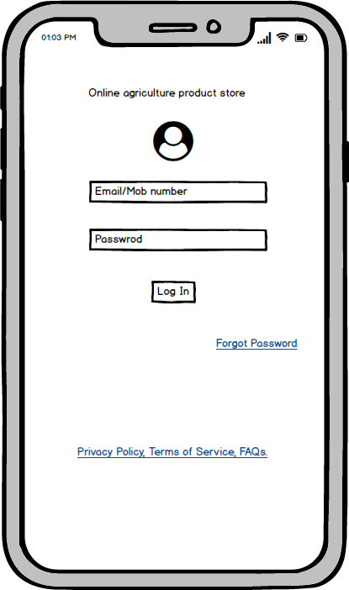

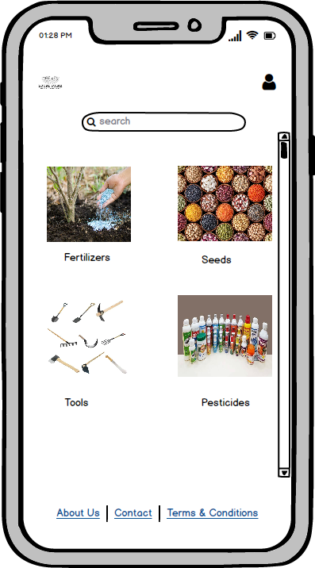

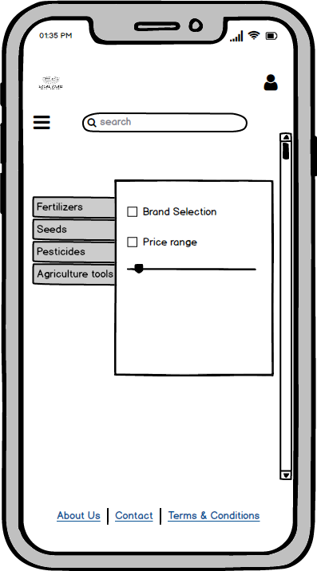

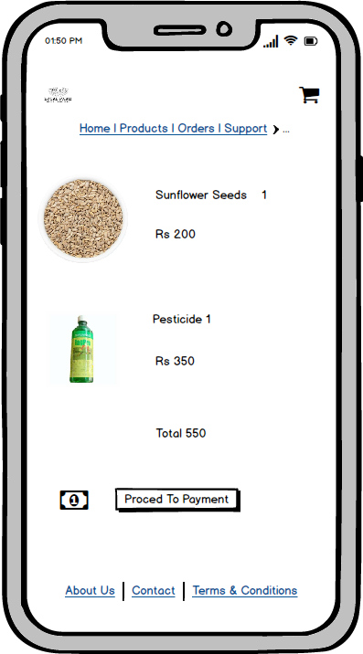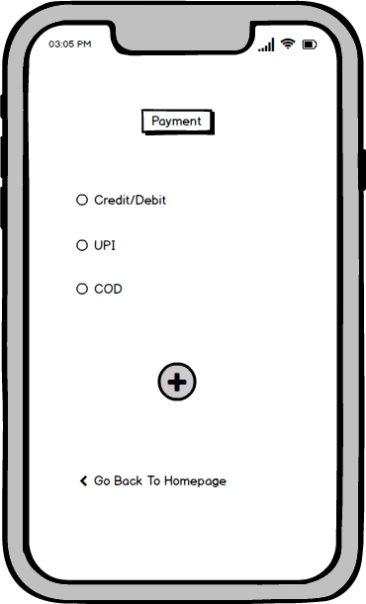

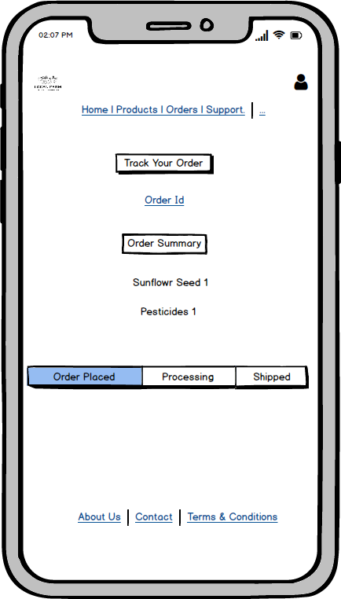

**Question 3 – Tools (Visio, Balsamiq) –**

**1. Microsoft Visio**

**Microsoft Visio is a powerful diagramming tool for creating flowcharts, process maps, and organizational charts. It offers a wide range of templates and shapes, integrates with Microsoft Office, and is ideal for professionals needing detailed visual representations. Best for technical diagrams rather than UX/UI design.**

**2. Balsamiq**

**Balsamiq is a rapid wireframing tool focused on low-fidelity sketches. Its simple, drag-and-drop interface and sketch-style designs help teams quickly brainstorm and iterate ideas. Perfect for early-stage design concepts, it avoids distractions from visual details, making it ideal for UX designers and product managers.**

**3. Axure RP**

**Axure RP is a robust prototyping tool for creating high-fidelity, interactive prototypes. It supports advanced features like conditional logic, dynamic content, and documentation generation. Ideal for UX designers and product teams needing detailed, functional prototypes for user testing and stakeholder presentations.**

**Question 4 – RTM –**

|  |  |  |  |  |  |  |  |  |  |
| --- | --- | --- | --- | --- | --- | --- | --- | --- | --- |
| **Req ID** | **Req Name** | **Req Description** | **Design** | **Code** | **Unit Testing** | **Component Testing** | **System Testing** | **SIT** | **UAT** |
| FR0001 | User Registration | Allow users to create an account with name, email, password, and phone number. | Completed | Completed | Passed | Passed | Passed | Passed | Passed |
| FR0002 | User Registration | Allow users to create an account with name, email, password, and phone number. | Completed | Completed | Passed | Passed | Passed | Passed | Passed |
| FR0003 | Product Search | Enable users to search for products by name, category, or price range. | Completed | Completed | Passed | Passed | Passed | Passed | Passed |
| FR0004 | Shopping Cart | Allow users to add, remove, or update items in the shopping cart. | Completed | Completed | Passed | Passed | Passed | Passed | Passed |
| FR0005 | Checkout Process | Enable users to complete purchases with a secure payment gateway. | Completed | Completed | Passed | Passed | In Progress | Not Started | Not Started |
| FR0006 | Payment Integration | Integrate payment gateways like PayPal and credit card processing. | Completed | Completed | Passed | Passed | Passed | Passed | Passed |
| NFR0101 | Order History | Allow users to view their past orders and order status. | Completed | Completed | Passed | Passed | Passed | Passed | Not Started |
| NFR0102 | Performance | The system should load product pages in under 2 seconds. | Completed | Completed | Passed | Passed | Passed | Passed | Passed |
| NFR0103 | Security | All user data must be encrypted using SSL/TLS protocols. | Completed | Completed | Passed | Passed | Passed | Passed | Passed |
| NFR0104 | Scalability | The system should support up to 10,000 concurrent users. | Completed | Completed | Passed | Passed | Passed | Passed | Passed |

**Question 5 – 10 Test Case Documents**

|  |  |  |  |
| --- | --- | --- | --- |
| **Test Case Id** | TC001 | **Test Case Name** | User Registration |
| **Project ID** | PRJ001 | **Project Name** | Online Agriculture Store |
| **PM ID** | 1234 | **PM Name** | MrVandanam |
| **Test Strategy ID** | TS001 | **Tester Id** |  |
| **Test Plan ID** | TP001 | **Tester Name** | Mr Jason |
| **Test Schedule ID** | SCH001 | **Date of Test** |  |
| **Scenario** To authenticate a successful user login on Gmail.com | | | |
| **Link to that page:** | | | |
| **Input Data** | | Name, contact number, Email ID | |
| **Expected Behavior** | | Once username and password are entered, the web page redirects to the user's inbox, displaying and highlighting new emails at the top | |
| **Actual Behavior:** | | As expected | |
| **Comments:** | | NA | |
| **Result** | | Pass | |

|  |  |  |  |
| --- | --- | --- | --- |
| **Test Case Id** | TC002 | **Test Case Name** | Search for Fertilizers |
| **Project ID** | PRJ002 | **Project Name** | Online Agriculture Store |
| **PM ID** | 1234 | **PM Name** | Mr Vandanam |
| **Test Strategy ID** | TS002 | **Tester Id** |  |
| **Test Plan ID** | TP002 | **Tester Name** | Mr Jason |
| **Test Schedule ID** | SCH002 | **Date of Test** |  |
| **Scenario** Filter Results | | | |
| **Link to that page:** | | | |
| **Input Data** | | Product key names, Product alternative names | |
| **Expected Behavior** | | The user should be able to see results with default search criteria when at least one of the filter parameters isn't mandatory | |
| **Actual Behavior:** | | As expected | |
| **Comments:** | | NA | |
| **Result** | | Pass | |

|  |  |  |  |
| --- | --- | --- | --- |
| **Test Case Id** | TC003 | **Test Case Name** | "Seller Product Creation Access and Functionality" |
| **Project ID** | PRJ003 | **Project Name** | Online Agriculture Store |
| **PM ID** | 1234 | **PM Name** | Mr Vandanam |
| **Test Strategy ID** | TS003 | **Tester Id** |  |
| **Test Plan ID** | TP003 | **Tester Name** | Mr Jason |
| **Test Schedule ID** | SCH003 | **Date of Test** |  |
| **Scenario** Seller Product Creation | | | |
| **Link to that page:** | | | |
| **Input Data** | | Product, Product pictures, product prices | |
| **Expected Behavior** | | Authenticated sellers can access authorized product creation panels under authorized categories | |
| **Actual Behavior:** | | As expected | |
| **Comments:** | | NA | |
| **Result** | | Pass | |

|  |  |  |  |
| --- | --- | --- | --- |
| **Test Case Id** | TC004 | **Test Case Name** | "Product Details Display and Validation" |
| **Project ID** | PRJ04 | **Project Name** | Online Agriculture Store |
| **PM ID** | 1234 | **PM Name** | Mr Vandanam |
| **Test Strategy ID** | TS004 | **Tester Id** |  |
| **Test Plan ID** | TP004 | **Tester Name** | Miss Alkeya |
| **Test Schedule ID** | SCH004 | **Date of Test** |  |
| **Scenario** Product details | | | |
| **Link to that page:** | | | |
| **Input Data** | | Product colour alternatives, Product quantity, product quality | |
| **Expected Behavior** | | Test that all the product details are displayed correctly and that no empty/invalid details are displayed. | |
| **Actual Behavior:** | | As expected | |
| **Comments:** | | NA | |
| **Result** | | Pass | |

|  |  |  |  |
| --- | --- | --- | --- |
| **Test Case Id** | TC005 | **Test Case Name** | "Product Details Display and Validation" |
| **Project ID** | PRJ05 | **Project Name** | Online Agriculture Store |
| **PM ID** | 1234 | **PM Name** | Mr Vandanam |
| **Test Strategy ID** | TS005 | **Tester Id** |  |
| **Test Plan ID** | TP005 | **Tester Name** | Mr Jason |
| **Test Schedule ID** | SCH005 | **Date of Test** |  |
| **Scenario** Shopping Cart | | | |
| **Link to that page:** | | | |
| **Input Data** | | Item price, item quantity | |
| **Expected Behavior** | | Test that all added items have at least a quantity, price, and delete option associated with it. | |
| **Actual Behavior:** | | As expected | |
| **Comments:** | | NA | |
| **Result** | | Pass | |

|  |  |  |  |
| --- | --- | --- | --- |
| **Test Case Id** | TC006 | **Test Case Name** | "Product Details Display and Validation" |
| **Project ID** | PRJ06 | **Project Name** | Online Agriculture Store |
| **PM ID** | 1234 | **PM Name** | Mr Vandanam |
| **Test Strategy ID** | TS006 | **Tester Id** |  |
| **Test Plan ID** | TP006 | **Tester Name** | Mr Jason |
| **Test Schedule ID** | SCH006 | **Date of Test** |  |
| **Scenario** Checkout page | | | |
| **Link to that page:** | | | |
| **Input Data** | | Item price, coupon details, price breakup | |
| **Expected Behavior** | | User should be shown the total amount with the necessary breakup as applicable. | |
| **Actual Behavior:** | | As expected | |
| **Comments:** | | NA | |
| **Result** | | Pass | |

|  |  |  |  |
| --- | --- | --- | --- |
| **Test Case Id** | TC007 | **Test Case Name** | "Returning Customer Payment Redirection and Login" |
| **Project ID** | PRJ07 | **Project Name** | Online Agriculture Store |
| **PM ID** | 1234 | **PM Name** | Mr Vandanam |
| **Test Strategy ID** | TS007 | **Tester Id** |  |
| **Test Plan ID** | TP007 | **Tester Name** | Mr Jason |
| **Test Schedule ID** | SCH007 | **Date of Test** |  |
| **Scenario** Payment page | | | |
| **Link to that page:** | | | |
| **Input Data** | | Saved payment method, card numbers, UPI, Customer ID of net banking | |
| **Expected Behavior** | | For returning customers, they should be redirected to log in for checkout | |
| **Actual Behavior:** | | As expected | |
| **Comments:** | | NA | |
| **Result** | | Pass | |

|  |  |  |  |
| --- | --- | --- | --- |
| **Test Case Id** | TC008 | **Test Case Name** | "Session Timeout After Inactivity" |
| **Project ID** | PRJ08 | **Project Name** | Online Agriculture Store |
| **PM ID** | 1234 | **PM Name** | Mr Vandanam |
| **Test Strategy ID** | TS008 | **Tester Id** |  |
| **Test Plan ID** | TP008 | **Tester Name** | Mr Jason |
| **Test Schedule ID** | SCH008 | **Date of Test** |  |
| **Scenario** Session log out if page left idle for more than 10 minutes | | | |
| **Link to that page:** | | | |
| **Input Data** | | Timer for page loading | |
| **Expected Behavior** | | Maintain a session for each user and test verify the session times out after a while | |
| **Actual Behavior:** | | As expected | |
| **Comments:** | | NA | |
| **Result** | | Pass | |

|  |  |  |  |
| --- | --- | --- | --- |
| **Test Case Id** | TC009 | **Test Case Name** | "Order Confirmation and Notification" |
| **Project ID** | PRJ09 | **Project Name** | Online Agriculture Store |
| **PM ID** | 1234 | **PM Name** | Mr Vandanam |
| **Test Strategy ID** | TS009 | **Tester Id** |  |
| **Test Plan ID** | TP009 | **Tester Name** | Mr Jason |
| **Test Schedule ID** | SCH009 | **Date of Test** |  |
| **Scenario** Order Confirmation and Notification | | | |
| **Link to that page:** | | | |
| **Input Data** | | Order ID, Payment Confirmation, User Email, User Phone Number | |
| **Expected Behavior** | | User should receive an order confirmation email and SMS with the order details. The confirmation page should display the order summary. | |
| **Actual Behavior:** | | As expected | |
| **Comments:** | | NA | |
| **Result** | | Pass | |

|  |  |  |  |
| --- | --- | --- | --- |
| **Test Case Id** | TC010 | **Test Case Name** | "App Installation and Uninstallation Verification" |
| **Project ID** | PRJ10 | **Project Name** | Online Agriculture Store |
| **PM ID** | 1234 | **PM Name** | Mr Vandanam |
| **Test Strategy ID** | TS010 | **Tester Id** |  |
| **Test Plan ID** | TP010 | **Tester Name** | Mr Jason |
| **Test Schedule ID** | SCH010 | **Date of Test** |  |
| **Scenario** App installation/uninstallation | | | |
| **Link to that page:** | | | |
| **Input Data** | | device details, auto fill up, contact number | |
| **Expected Behavior** | | The application is installed and works correctly/ The application is uninstalled. The app's icon isn't displayed on the device's OS. | |
| **Actual Behavior:** | | As expected | |
| **Comments:** | | NA | |
| **Result** | | Pass | |

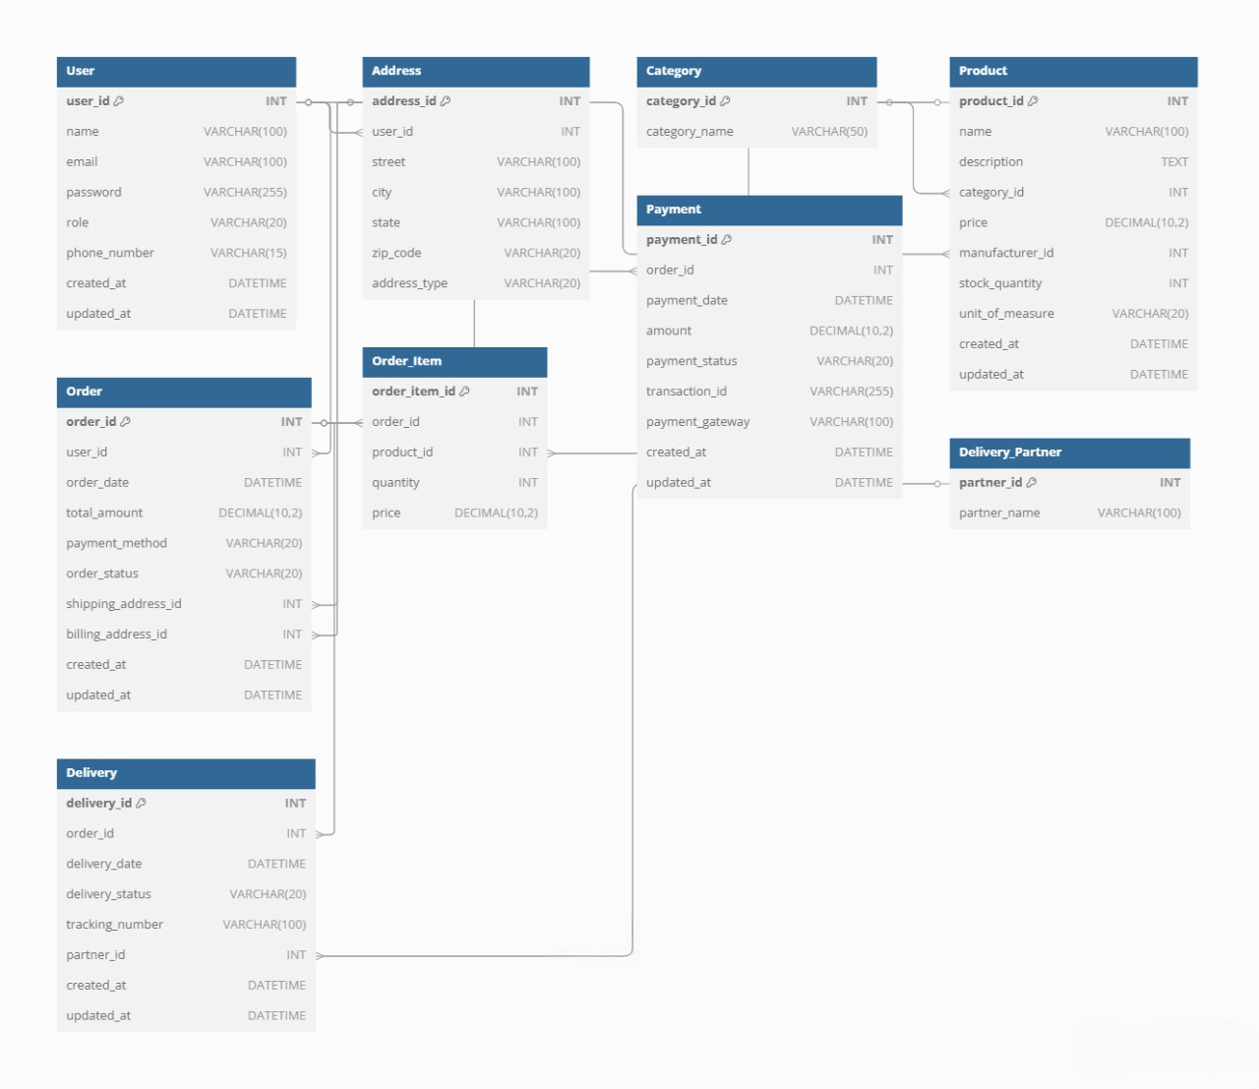**Question 6 – DB Design**

**Question 7 – Data Flow Diagram**

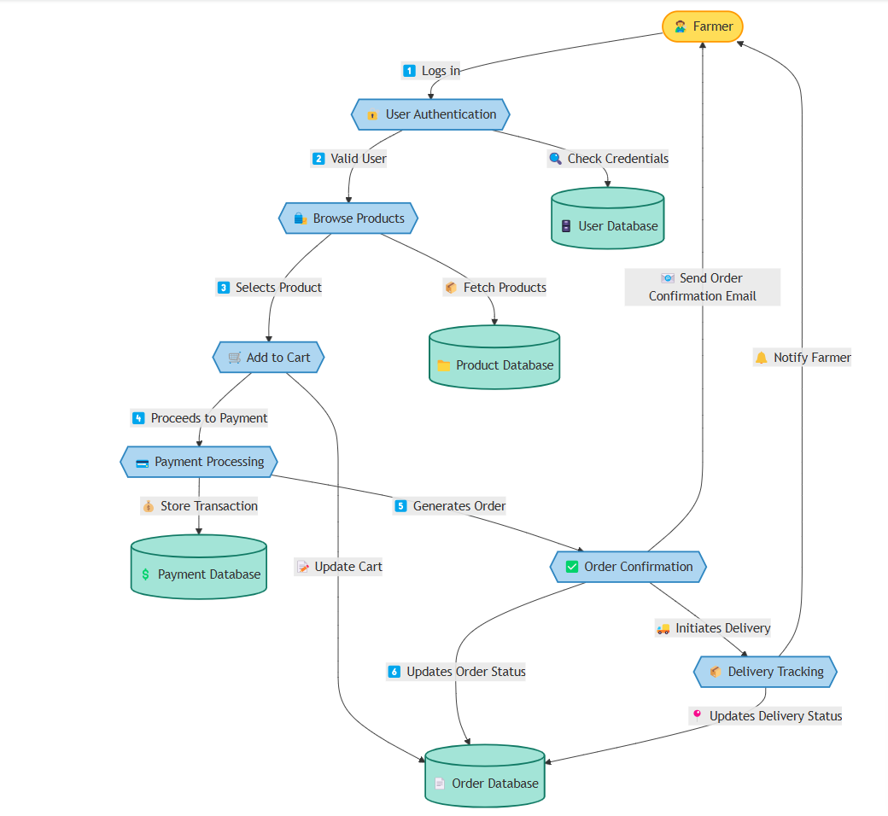

**Question 8 – Change Request - Due to change in the Government Taxation structure. we should change the Tax structure How do you handle change requests in a project?** **As the project is in process, Ben and Kevin have contacted you. The reason is to inform you that they want the Farmers to sell their crop yields through this application i.e. Farmers should be able to add their crop yields or products and display to general public and should be able to sell them. They also want to introduce Auction system for their Crop yields. As a BA, what will be your response? Is this a change request or an enhancement?**

**Change information should include the following:**

* **The reason/business justification for the change**
* **Why the change is needed-giving detailed information on implications of not implementing the change-le., security risks, Government taxation, Compliances etc.**
* **Known risks or impact to the business of implementing the change consideration should also be given to the risk and impact to the business of not implementing the change.**
* **Required resources-including people, time, and investment/costs.**

**The status of a change at this stage of the change process will be: NEW and then AWAITING ASSESSMENT**

**The Change Manager assigns the change a priority based on the following information: Priority information (priority is based on how quickly the change needs to be implemented)**

* **Emergency-Causing loss of service or severe usability problems to a larger number of Users, a mission-critical system, or some equally serious problem. Immediate action required.**
* **High-Needs doing within 48 hours. Severely affecting some users or impacting upon many users. To be given highest priority for change building, testing, and implementation resources. (Other than emergency).**
* **Medium-No severe impact, but rectification cannot be deferred until the next scheduled release or upgrade. To be allocated medium priority for resources.**
* **Low-needs doing by the indicated date. A change is justified and necessary but can wait until the next scheduled release or upgrade. To be allocated resources accordingly.**

**A change request is a formal proposal for an alteration to some product or system. In project management, a change request often arises when the client wants an addition or alteration to the agreed-upon deliverables for a project. Such a change may involve an additional feature or customization or an extension of service, among other things.**

**An enhancement project is one in which new capabilities are added to an existing system. Enhancement projects might also involve correcting defects, adding new reports, and modifying functionality to comply with revised business rules or needs.**

**So, this is an enhancement in the project.**

**As a business analyst, my response to Ben and Kevin's request would be to classify it as an enhancement rather than a change request. A change request typically involves modifications to existing functionality or requirements, while an enhancement introduces new features or capabilities that were not initially specified. In this case, the request to allow farmers to add their crop yields, display them to the general public, and enable selling through the application represents an enhancement because it introduces new functionality that goes beyond the initial scope of the project. Additionally, the introduction of an auction system for crop yields adds another layer of functionality to the application.**

**To address this enhancement request, I would follow the standard process for handling new requirements:**

**1. Requirement Gathering: I would meet with Ben and Kevin to gather detailed requirements for the new functionality. This would involve understanding the specific features they envision, such as the process for farmers to add and manage their crop yields, the display of products to the public, and the implementation of the auction system.**

**2. Impact Analysis: I would analyze the impact of these enhancements on the existing project scope, timeline, budget, and resources. This assessment would help determine the feasibility and potential implications of incorporating the requested features.**

**3. Stakeholder Analysis: I would identify and involve relevant stakeholders, such as the project sponsor, development team, and other key personnel, to assess their perspectives and gather their inputs on the potential enhancements.**

**4. Documentation and Communication: I would document the detailed requirement sand changes in the project scope, and communicate them to the project team, stakeholders, and any other parties involved. This would ensure everyone is aware of the proposed enhancements and their implications.**

**5. Evaluation and Prioritization: I would work with the project team and stakeholders to evaluate the value and priority of the requested enhancements. This evaluation would consider factors such as the potential benefits, impact on project goals, alignment with business objectives, and available resources.**

**6. Planning and Execution: If the enhancements are deemed feasible and approved, I would update the project plan, schedule, and resources accordingly. I would collaborate with the development team and other stakeholders to incorporate the new features into the application, ensuring proper testing and quality assurance. By treating this request as an enhancement, the project can effectively manage the additional requirements and deliver the desired functionality while considering the impact on the ongoing project.**

**Question 10 – Estimations**

|  |  |
| --- | --- |
| Total Man | Hours Estimation |
| | **Phase** | | --- | | **Requirements Gathering** | | **System Design** | | **Development** | | **Testing** | | **Deployment** | | **Training and Documentation** | | **Total** | | | **Estimated Hours** | | --- | | **40 hours** | | **80 hours** | | **400 hours** | | **160 hours** | | **40 hours** | | **40 hours** | | **760 hours** | |

|  |  |  |  |
| --- | --- | --- | --- |
| **Role** | **Hours** | **Number of People** | **Total Hours** |
| Business Analyst (BA) | 40 | 1 | 40 |
| Solution Architect | 40 | 1 | 40 |
| UX/UI Designer | 40 | 1 | 40 |
| Backend Developer | 200 | 2 | 400 |
| Frontend Developer | 100 | 1 | 100 |
| Database Administrator | 100 | 1 | 100 |
| QA Engineer | 80 | 1 | 80 |
| Testers | 80 | 1 | 80 |
| DevOps Engineer | 20 | 1 | 20 |
| Technical Writer | 20 | 1 | 20 |
| Trainer | 20 | 1 | 20 |
| **Total** |  | **11 people** | **760 hours** |

**Question 11 – UAT – Project has finally completed all the stages i.e., design, development, testing etc. Now, it is the role of a business analyst to contact the client for testing of the final product and have to successfully complete it. How are you going to handle this situation? And once it is done, what will be the process to close the project? Explain UAT Acceptance process**

**Handling User Acceptance Testing (UAT)**

**1. Prepare for UAT**

* **Review Requirements: Ensure all requirements are documented and understood by the client.**
* **Create UAT Plan:**
  + **Define the scope, objectives, and timeline for UAT.**
  + **Identify test scenarios and test cases based on business requirements.**
* **Prepare Test Environment:**
  + **Set up a UAT environment that mirrors the production environment.**
  + **Ensure all necessary data and configurations are in place.**
* **Train Users:**
  + **Provide training to the client's team on how to use the application and perform UAT.**

**2. Conduct UAT**

* **Share UAT Plan: Provide the UAT plan, test scenarios, and test cases to the client.**
* **Support Testing:**
  + **Be available to answer questions and resolve issues during UAT.**
  + **Log any defects or issues reported by the client.**
* **Monitor Progress:**
  + **Track the progress of UAT and ensure all test cases are executed.**
  + **Provide regular updates to stakeholders.**

**3. Resolve Issues**

* **Prioritize Defects: Work with the development team to prioritize and fix defects.**
* **Retest: Ensure all fixes are retested by the client.**
* **Obtain Sign-Off: Once all issues are resolved and the client is satisfied, obtain formal UAT sign-off.**

**UAT Acceptance Process**

1. **UAT Kickoff Meeting:**
   * **Explain the UAT process, objectives, and timelines to the client.**
   * **Provide access to the UAT environment and test cases.**
2. **Test Execution:**
   * **The client executes the test cases and reports any issues.**
   * **The BA logs and tracks defects in a defect tracking system.**
3. **Defect Resolution:**
   * **The development team fixes the defects.**
   * **The BA coordinates retesting of the fixes.**
4. **UAT Sign-Off:**
   * **Once all test cases are passed and the client is satisfied, the BA obtains formal UAT sign-off.**
   * **The sign-off document should include:**
     + **Confirmation that all requirements have been met.**
     + **Approval to proceed with deployment to production.**

**Project Closure Process**

**Once UAT is successfully completed, the project can be closed. Here’s how to handle project closure:**

**1. Final Deliverables**

* **Handover Documentation:**
  + **Provide all project documentation, including requirements, design, test cases, and user manuals.**
* **Training:**
  + **Conduct final training sessions for the client's team.**
* **Knowledge Transfer:**
  + **Ensure the client understands how to maintain and support the application.**

**2. Post-Implementation Review**

* **Evaluate Success:**
  + **Conduct a post-implementation review to assess whether the project met its objectives.**
* **Lessons Learned:**
  + **Document lessons learned and best practices for future projects.**

**3. Formal Closure**

* **Obtain Final Sign-Off:**
  + **Obtain formal sign-off from the client confirming that all deliverables have been accepted.**
* **Close Contracts:**
  + **Ensure all contracts and agreements are formally closed.**
* **Celebrate Success:**
  + **Acknowledge the team's efforts and celebrate the successful completion of the project.**

**Sample UAT Sign-Off Document**

**User Acceptance Testing (UAT) Sign-Off**

**Project Name: [Project Name]  
Date: [Date]**

**We, the undersigned, confirm that:**

1. **All test cases have been executed as per the UAT plan.**
2. **All defects have been resolved and retested.**
3. **The application meets the agreed-upon requirements and is ready for deployment to production.**

**Sign-Off:**

* **Client Representative: [Name, Signature, Date]**
* **Business Analyst: [Name, Signature, Date]**
* **Project Manager: [Name, Signature, Date]**

**Sample Project Closure Document**

**Project Closure Report**

**Project Name: [Project Name]  
Date: [Date]**

**1. Project Overview:**

* **Objectives: [Brief description of project objectives].**
* **Deliverables: [List of deliverables].**

**2. UAT Summary:**

* **UAT was conducted from [Start Date] to [End Date].**
* **All test cases were executed, and defects were resolved.**

**3. Post-Implementation Review:**

* **The project met its objectives and delivered the expected benefits.**
* **Lessons learned: [List of lessons learned].**

**4. Final Sign-Off:**

* **Client Representative: [Name, Signature, Date]**
* **Business Analyst: [Name, Signature, Date]**
* **Project Manager: [Name, Signature, Date]**

**Question 12 – Project Closure Document**

|  |  |  |  |
| --- | --- | --- | --- |
| **Sr No** | **Points to Include** | **Details** | **Reference Link** |
| 1 | **Client Sign-Off on UAT Testing** | - UAT testing signed off by the client (Mr. Henry) on 15-Oct-23. - Name of resources involved: Mr. Henry. | ABC Doc |
| 2 | **Objectives of the Project** | - **User-friendliness**: Achieved. - **Customer Satisfaction**: ROI achieved in 6 months. - **More Categories**: Achieved. | ABC Doc |
| 3 | **Functionalities Worked On** | - Product catalog (fertilizers, seeds, pesticides). - Search functionality. - Payment gateway (COD, Credit/Debit card, UPI). - Delivery tracking. | ABC Doc |
| 4 | **Infrastructure** | - Secured payment processing: Achieved. - Software installed. - Laptops purchased. | ABC Doc |
| 5 | **Funding** | - Amount approved: 2 Crore INR. - Amount used: 2 Crore INR. | ABC Doc |
| 6 | **Overall Project Information** | - Escalations: 25 resolved. - Customer Satisfaction: High. - Value to Company: Positive (95%). - Company successfully developed an app to help remote farmers get products at their doorstep. - Upcoming projects and increased users. | ABC Doc |
| 7 | **Value to Company** | - Positive impact (95%). - Successfully developed an app to help remote farmers. - Increased users and upcoming projects. | ABC Doc |
| 8 | **Achievements** | - User-friendly application developed. - Secured payment processing achieved. - Positive customer satisfaction (95%). - ROI achieved in 6 months. - Increased users and upcoming projects. | ABC Doc |
| 9 | **Lessons Learned** | - Importance of user-friendly design for farmers with limited technical knowledge. - Need for robust payment and delivery tracking systems. - Effective stakeholder communication is critical for success. | ABC Doc |
| 10 | **Quality Assurance** | - UAT testing signed off by the client (Mr. Henry) on 15-Oct-23. - All functionalities tested and approved. - High customer satisfaction achieved. | ABC Doc |
| 11 | **Resource Utilization** | - Laptops purchased and software installed. - Full budget of 2 Crore INR utilized effectively. - Team resources (developers, testers, admins) utilized efficiently. | ABC Doc |
| 12 | **Risk Management** | - Escalations managed effectively (25 escalations resolved). - Risks related to payment processing and delivery tracking mitigated. | ABC Doc |
| 13 | **Challenges** | - Ensuring application usability for remote farmers. - Integrating multiple payment gateways. - Managing logistics for delivery tracking. | ABC Doc |