**CAPSTONE PROJECT 2**

**Question 1**

write Agile Manifesto

**Answer**

* **Four main values**

1. Individuals and interactions over processes and tools
2. Working software over comprehensive documentation
3. Customer collaboration over contract negotiation
4. Responding to change over following a plan

* **Twelve Principles of Agile Software**

1. Satisfy the customer through early and continuous delivery of valuable software.
2. Welcome changing requirements, even late in development. Agile processes harness change for the customer's competitive advantage.
3. Deliver working software frequently, from a couple of weeks to a couple of months, with a preference to the shorter timescale.
4. Business people and developers must work together daily throughout the project.
5. Build projects around motivated individuals. Give them the environment and support they need, and trust them to get the job done.
6. The most efficient and effective method of conveying information to and within a development team is face-to-face conversation.
7. Working software is the primary measure of progress.
8. Agile processes promote sustainable development. The sponsors, developers, and users should be able to maintain a constant pace indefinitely.
9. Continuous attention to technical excellence and good design enhances agility.
10. Simplicity the art of maximizing the amount of work not done is essential.
11. The best architectures, requirements, and designs emerge from self-organizing teams.
12. At regular intervals, the team reflects on how to become more effective, then tunes and adjusts its behavior accordingly.

**Question 2**

User Stories- Acceptance Criteria-BV-CP

**Answer**

















































































**Question 3**

What is epic? Write 2 epics

**Answer**

* Epic is a large user story or a collection of related user stories that represents a significant feature or functionality. Epics are high level, often spanning multiple sprints or iterations, and they provide a way to organize and prioritize work in a product backlog.
* Epics are often associated with user needs or business requirements. They are user-focused and are used to capture the overall functionality or value that needs to be delivered.
* Epics are part of the product backlog, which is a dynamic and prioritized list of features, enhancements, and fixes that the development team maintains. The product backlog is continuously refined and adjusted based on feedback and changing priorities.
* Epics are a valuable tool for Agile teams to break down large-scale projects into manageable pieces, facilitate communication among team members and stakeholders, and ensure that the development efforts align with the overall goals of the project.
* **Epic: Ratings and Reviews**

The Ratings and Reviews Enhancement epic aims to improve user engagement and feedback by enhancing the ratings and reviews feature in our application. This includes providing users with the ability to rate and review products, services, or content, and to interact with others' feedback in a more dynamic and user-friendly manner.

User Stories:

1)As a User, I want to submit a rating for a product:

Acceptance Criteria:

On the product page, I can see a star rating widget.

I can click on the stars to select my rating.

After selecting a rating, a confirmation message is displayed.

2)As a User, I want to submit a written review for a product:

Acceptance Criteria:

On the product page, there's a text box for entering a review.

I can type my review and submit it.

The review is displayed on the product page along with my username and timestamp.

3)As a User, I want to view aggregated ratings for a product:

Acceptance Criteria:

On the product page, I can see the average rating displayed prominently.

The star rating is visually represented with appropriate graphics.

4)As a User, I want to view detailed reviews for a product:

Acceptance Criteria:

On the product page, there's a section dedicated to reviews.

Reviews are displayed in reverse chronological order.

Each review includes the username, rating, timestamp, and the written content.

5)As a User, I want to comment on a review:

Acceptance Criteria:

Below each review, there's a comment box.

I can enter a comment and submit it.

Comments are displayed beneath the respective reviews.

* **Epic: Real Time Order Tracking**

The Real-Time Order Tracking epic focuses on enhancing user experience by implementing a real-time tracking system for orders, providing users with accurate and up-to-date information about the status and location of their deliveries.

User Stories:

1)As a User, I want to see the real-time status of my order:

Acceptance Criteria:

On the order details screen, there is a section dedicated to real-time status.

The status updates dynamically, reflecting the current stage of the order (e.g., preparing, out for delivery).

2)As a User, I want to receive push notifications for key order events:

Acceptance Criteria:

I receive a push notification when the order is confirmed.

I receive a notification when the delivery is in route.

I receive a notification upon the delivery driver's arrival.

3)As a User, I want to view the live location of my delivery driver:

Acceptance Criteria:

A map is displayed on the order details screen showing the live location of the delivery driver.

The driver's location updates in real-time as they approach the delivery destination.

4)As a User, I want to receive an estimated time of arrival for my order:

Acceptance Criteria:

The app calculates and displays the estimated time of arrival based on the current location of the delivery driver and other relevant factors.

The ETA is updated dynamically as the driver progresses.

5)As a User, I want to view a history of my past orders with detailed tracking information:

Acceptance Criteria:

The app includes a section where users can access their order history.

Each past order includes detailed tracking information, such as status updates and delivery timestamps.

6)As a User, I want to provide feedback on the delivery experience through the tracking interface:

Acceptance Criteria:

A feedback option is available within the order tracking interface.

Users can rate the delivery and provide optional written feedback.

**Question 4**

What is the difference between BV and CP

**Answer**

**Business Value**

* BV is a measure of how much value a feature or a project will bring to the business.
* It is usually determined by the stakeholders and is based on factors such as revenue generation, customer satisfaction, and market share.
* The primary goal of assigning business value is to prioritize tasks based on their strategic importance to the business.
* It helps teams focus on delivering the most valuable features first.

**Complexity points**

* CP, on the other hand, is a measure of the complexity of a feature or a project.
* It is usually determined by the development team and is based on factors such as the number of components, the number of interactions between components, and the number of external dependencies.
* Complexity Points, also known as Story Points, represent the effort or complexity involved in implementing a specific task or feature.
* Teams use relative estimates to assign complexity points, considering factors such as technical challenges, dependencies, and overall effort required.
* The main purpose of using complexity points is to estimate and plan the amount of work involved in completing a task. It aids in capacity planning and helps teams set realistic goals for each iteration.

**Question 5**

Explain about Sprint

**Answer**

* **Time – boxed Duration**

Sprints have a fixed duration, commonly ranging from 1 to 4 weeks. The most common duration is two weeks, but teams can choose a length that works best for them. Sprints typically have consistent durations throughout the project to establish a predictable and sustainable development pace.

* **Defined Goal**

Before the start of each sprint, the Scrum Team, which includes the Product Owner and the Development Team, collaboratively defines a sprint goal. The goal is usually formulated during the sprint planning meeting. The sprint goal should be aligned with the overall project goals and contribute to the delivery of business value. It reflects why the sprint is being conducted and what the team aims to achieve.

* **Sprint Planning**

It is a time-boxed meeting held at the beginning of each sprint. The purpose of sprint planning is to define what the development team will work on during the sprint and how the work will be accomplished. The sprint planning meeting involves the entire Scrum Team, which includes the Product Owner, Scrum Master, and members of the Development Team.

* **Daily Stand-up Meetings**

Daily stand-up meetings occur every day throughout the duration of the sprint. They are typically held at the same time and place, preferably at the start of the working day. The daily stand-up is a daily synchronization point for the development team. It allows team members to share updates on their progress, discuss any challenges or impediments, and ensure alignment on sprint goals.

* **Development and Testing**

The development team works on the tasks identified in the sprint backlog. They collaborate closely, often using techniques like pair programming and frequent code reviews to ensure high-quality work. Testing is an integral part of a sprint. Automated tests are run to validate code changes, and manual testing may be conducted to ensure the quality of the software.

* **Incremental Delivery**

The concept of incremental delivery involves breaking down a project into small, manageable increments and delivering a usable, potentially shippable product at the end of each iteration or sprint.

* **Sprint Review and Retrospective**

The Sprint Review is held to demonstrate the work completed during the sprint. It provides an opportunity for the Scrum Team to showcase the potentially shippable product increment to stakeholders, including the Product Owner, customers, and other team members.

The Sprint Retrospective is a reflection and improvement session. It provides the team with a dedicated time to inspect how the sprint went in terms of processes, communication, and collaboration.

* **Backlog Refinement**

Backlog refinement is a continuous and collaborative activity that occurs throughout the project. However, during the sprint, it becomes more focused on preparing items for the upcoming sprints. The primary purpose of backlog refinement during the sprint is to ensure that the product backlog items are well-defined, estimated, and prioritized for potential inclusion in the next sprint.

**Question 6**

Explain Product backlog and sprint back log

**Answer**

|  |  |  |
| --- | --- | --- |
| S.No | Product Backlog | Sprint Backlog |
| 1 | Anything that needed to accomplish the project vision | Anything that is needed to fulfill the sprint goal |
| 2 | Product Owner owns | Development team owns |
| 3 | Contains requirements defects, tasks. | A Subset of product backlog items defined as a priority by the product owner. |
| 4 | Everyone contributes to the product backlog | Only the development team contributes to the sprint backlog |
| 5 | Product backlog refinement meeting is to refine the product backlog | Sprint Planning meeting is to refine the sprint backlog items |
| 6 | Product backlog evolves and changes will be done by the PO through the product lifecycle | No changes are allowed to the sprint backlog items once the sprint has started |
| 7 | Release burndown metric is used | Sprint burndown metric is used |
| 8 | Estimate is done at a user story level | Estimate is done at the activity or task level. |
| 9 | Daily stand up meeting does not discuss product backlog items | Daily stand up meeting discuss the sprint backlog in accordance with sprint goal. |

**Question 7**

What is impediments log? write 2 impediments

**Answer**

* An impediments log, often used in agile and Scrum methodologies, is a document or tool that teams use to keep track of obstacles, challenges, or issues that hinder the progress of a project.
* The purpose of the impediments log is to create transparency, promote communication, and facilitate the timely resolution of issues to ensure the smooth functioning of the development process.
* Team members, Scrum Masters, or any stakeholders can identify and log impediments. These can include technical issues, dependencies, resource constraints, external disruptions, or any other challenges that may impact the team's progress.

**Impediments**

**Delivery partner shortage in a specific region**



**Technical issue causing intermittent order processing failure**



**Question 8**

Explain Velocity of the Team

**Answer**

Velocity is a metric used in Agile methodologies, particularly in Scrum, to measure the amount of work a development team can complete in a given iteration, typically a sprint. It helps the team, Product Owner, and stakeholders understand the team's capacity for delivering work and aids in planning future sprints.

How is it calculated

**Story Point Estimation**

Before a sprint begins, the team estimates the effort required to complete each user story using story points. Story points are a relative measure of complexity, effort, and risk associated with each story.

**Tracking Completed Work**

At the end of the sprint, the team reviews the user stories that were completed and the corresponding story points. Only user stories that meet the team's Definition of Done are considered completed.

**Summing Story Points**

At the end of the sprint, the total sum of story points for the completed user stories is calculated. This sum represents the team's velocity for that particular sprint.

Velocity = ∑ Story Points of Completed User Stories in a Sprint

**Average Velocity**

Teams often calculate the average velocity over several sprints to establish a more stable and predictable measure. This involves summing the velocities of multiple sprints and dividing by the number of sprints.

**Question 9**

Draw Sprint Burn Charts and Product Burn Down Charts

**Answer**

**Sprint Burnup chart**

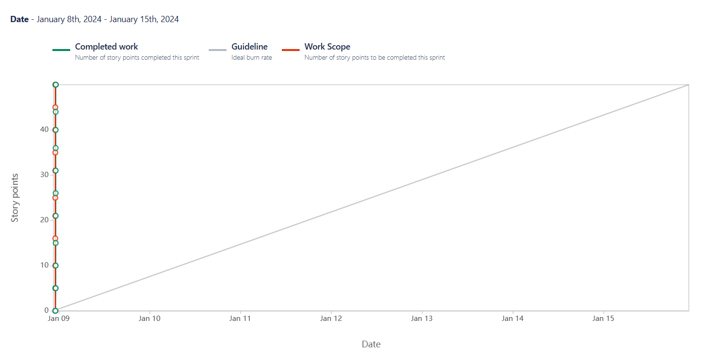

**Sprint Burn Chart**

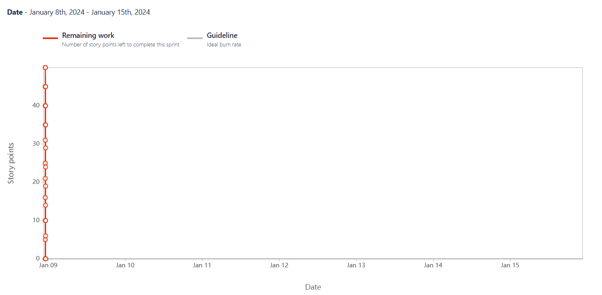

**Question 10**

Explain about Product Grooming

**Answer**

* "Product Grooming" in the context of agile development methodologies, specifically Scrum. In Scrum, the term commonly used is "Backlog Grooming" or "Backlog Refinement."
* This is a regular activity that involves reviewing, prioritizing, and refining the items in the product backlog.
* The product backlog is a dynamic list of features, enhancements, and bug fixes that represent the work to be done on a product.
* It's typically done regularly, often before the start of a sprint planning meeting. The frequency may vary depending on the team and the specific needs of the project.
* The product owner, development team, and sometimes the Scrum Master participate in backlog grooming. Subject matter experts may also be involved to provide insights into specific items.

How is it conducted

* **Setting the context:**

At the beginning of a backlog grooming session, it's important to set the context by reviewing the overall project goals, the current state of the product, and any changes or updates in the business environment. This helps ensure that the team understands the broader context of the work.

* **Backlog Review:**

The team reviews the items in the product backlog, which may include user stories, features, bug fixes, and technical tasks. This involves assessing the completeness and clarity of each item

* **Prioritization:**

Prioritization involves determining the order in which backlog items will be addressed. The product owner plays a crucial role in prioritizing items based on business value, customer needs, and project goals.

* **Refinement and Estimation:**

Refinement includes breaking down large user stories into smaller, more manageable tasks. The team also estimates the effort required to complete each task. This can be done using techniques like story points or time-based estimates.

* **Dependency Analysis:**

Teams identify and analyze dependencies between backlog items. Understanding dependencies is crucial for planning and ensuring that work can proceed smoothly without unnecessary delays.

* **Acceptance criteria:**

Acceptance criteria define the conditions that must be met for a backlog item to be considered complete. These criteria are crucial for ensuring that the team and stakeholders have a shared understanding of what "done" means for each item.

* **Backlog Grooming Meetings:**

Backlog grooming meetings are scheduled sessions where the team, product owner, and sometimes stakeholders collaborate to review and refine the backlog. These meetings provide a structured forum for discussing upcoming work and making adjustments to the backlog.

**Question 11**

Explain the roles of Scrum Master and Product Owner

**Answer**

|  |  |  |
| --- | --- | --- |
| **Criteria** | **Product Owner** | **Scrum Master** |
| **Nature of work** | Collaborates with all the stakeholders and brings the vision of a product into the product backlog. | Acts as a team coach and is responsible for maintaining the quality of the product. |
| **Responsibilities** | Responsible for completing the project on time. Acts as an intermediary between development team and the customers | Ensures the scrum framework is followed and helps the development team create a quality product. |
| **Accountability** | Responsible for project backlog and the timely completion of the product and for providing updates to the clients and stakeholders. | Accountable for the quality of the entire project and for giving updates to the management about the completion of the product. |
| **Reporting** | Reports to top management and clients. | Reports to top management about the efficiency of the team and the quality of the product. |
| **Qualities** | Communication and the leadership skills, creativity, critical thinking and a sharp mind are key assets for any product owner. | Thorough knowledge of scrum theory and practices. Being able to lead the team but without the sense of authority. |

**Question 12**

Explain all Meetings Conducted in Scrum Project

**Answer**

* **Sprint Planning**

This meeting marks the beginning of a sprint. The team collaborates to select the backlog items they will work on during the upcoming sprint. The product owner provides insights into the priority of backlog items, and the team agrees on the scope of work.

* **Daily Stand-up**

A short daily meeting where team members provide updates on their progress, discuss any challenges or impediments, and synchronize their efforts. It helps in maintaining transparency and team coordination.

* **Sprint Review**

Conducted at the end of a sprint, the team presents the completed work to stakeholders, and feedback is gathered. The goal is to demonstrate the increment of the product and gather insights for future iterations.

* **Sprint Retrospective**

Also held at the end of a sprint, the retrospective is a reflection on the recent sprint. The team discusses what went well, what could be improved, and plans for implementing those improvements in the next sprint.

* **Backlog Grooming**

Backlog grooming involves regularly reviewing and refining the product backlog. It includes adding new items, clarifying details, estimating effort, and ensuring that the backlog is ready for upcoming sprints.

* **Release Planning**

This meeting focuses on planning for the release of the product. It involves reviewing the overall product roadmap, prioritizing features, and determining when certain features or increments will be delivered to customers.

**Question 13**

Explain Sprint Size and Scrum Size

**Answer**

**Sprint Size**

Sprint Size usually refers to the duration of a sprint in the Scrum framework. A sprint is a time-boxed iteration during which a potentially shippable product increment is created. The length of a sprint is determined during the Sprint Planning meeting and is agreed upon by the Scrum Team. Common sprint durations are 1, 2, or 4 weeks. The sprint size is chosen based on factors such as the project's nature, the team's capacity, and the desire for regular feedback and adaptation.

**Scrum size**

Scrum Team Size refers to the number of individuals on the Scrum Team, including the Product Owner, Scrum Master, and Development Team members. The Scrum Guide recommends small, cross-functional teams of 3 to 9 people. The size is chosen to enhance communication, collaboration, and adaptability. A smaller team can be more responsive, while a larger team may bring more diverse skills.

**Question 14**

Explain DOR and DOD

**Answer**

**"Definition of Ready" (DoR)**

It is a concept in Agile and Scrum methodologies that outlines the criteria a user story or backlog item must meet before it is considered ready to be taken up by the development team for implementation during a sprint. The Definition of Ready helps ensure that the team has a shared understanding of the work to be done and that the necessary information is available for a successful implementation.

Here are key aspects typically included in the Definition of Ready:

**Clear Description:** The user story or backlog item should have a clear and concise description that provides a shared understanding among the team members.

**Acceptance Criteria:** Well-defined acceptance criteria should be specified. These criteria outline the conditions that must be met for the user story to be considered complete.

**Dependencies Identified:** Any dependencies on other user stories, teams, or external factors should be identified and addressed.

**Estimation:** The team should have a rough estimate of the effort required to complete the user story. This can be in the form of story points, hours, or another estimation method used by the team.

**Testability:** The user story should be written in a way that makes it easily testable. This ensures that testing can be carried out effectively during and after implementation.

**Agreement from Product Owner**: The product owner or the person responsible for prioritizing the backlog should agree that the user story is ready to be taken up in the upcoming sprint.

**Dependencies Resolved:** Any external dependencies or impediments that could hinder the progress of the user story should be resolved or at least identified.

**The "Definition of Done" (DoD)**

It is a crucial concept in Agile and Scrum methodologies. It defines the criteria or conditions that a product increment or a user story must meet to be considered complete and ready for release. The Definition of Done is agreed upon by the Scrum Team during the Sprint Planning or early in the project and is used as a guideline for the development team throughout the sprint.

Here are key elements typically included in the Definition of Done:

**Code Complete:** All coding for the user story or feature is finished, and the code has been reviewed.

**Unit Testing:** Unit tests have been written and passed, ensuring that the code functions as expected at the individual component level.

**Integration Testing:** The code has been integrated into the larger system, and integration tests have been conducted to verify that the components work together.

**Acceptance Testing:** The user story has been tested against the defined acceptance criteria to ensure that it meets the requirements of the product owner and stakeholders.

**Documentation:** Any necessary documentation, such as user manuals or technical documentation, has been updated to reflect the changes.

**Code Review:** The code has undergone a peer review process to ensure quality, adherence to coding standards, and knowledge sharing within the team.

**No Critical Defects:** The user story has no critical defects, and any identified issues are either fixed or have an agreed-upon plan for resolution.

**Regression Testing:** Regression testing has been performed to ensure that the changes do not negatively impact existing functionality.

**Product Owner Approval:** The product owner reviews the completed user story and approves it for release.

**Demonstration:** The team is able to demonstrate the completed user story or feature during the Sprint Review.

**Question 15**

Explain Prioritization Techniques and MVP

**Answer**

**Prioritization Techniques:**

Prioritization is a crucial aspect of project and product management, helping teams focus on delivering the most valuable work first. There are various prioritization techniques, and the choice of method often depends on the project's context, goals, and stakeholders. Here are some common prioritization techniques:

**MoSCoW Method**: This technique categorizes requirements into four groups: Must-haves, Should-haves, Could-haves, and Won't-haves. It helps in defining the relative importance of different features or tasks.

**Weighted Shortest Job First (WSJF):** WSJF is calculated by dividing the cost of delay by the job size. It helps prioritize features based on their economic impact and urgency.

**Kano Model:** This model classifies features into basic expectations, performance requirements, and delighters. It helps in understanding customer satisfaction and prioritizing features accordingly.

**Value vs. Complexity:** Plotting features on a matrix with one axis representing the value they provide and the other representing their complexity helps in visualizing priorities. High-value, low-complexity items are often prioritized first.

**Buy a Feature**: Stakeholders are given a budget, and they "buy" features by allocating their budget to the features they find most valuable. This collaborative approach involves stakeholders directly in the prioritization process.

**Minimum Viable Product (MVP):**

A Minimum Viable Product (MVP) is a version of a product that includes only the essential features necessary to meet the needs of early adopters and gather feedback for future development. The concept is closely linked to the Lean Startup methodology and aims to deliver value quickly while minimizing development effort.

Key characteristics of an MVP include:

**Core Functionality:** An MVP includes only the core features that address the most critical needs of the target audience.

**Quick Release:** The focus is on rapid development and release to gather feedback and learn from real user interactions.

**Iterative Development:** Additional features and improvements are added based on user feedback and evolving requirements.

**Learning and Adaptation:** The primary goal is to learn from user behavior, validate assumptions, and adapt the product based on real-world usage.

**Resource Optimization:** Resources are optimized by avoiding extensive development of features that may not align with user preferences.

**Early Market Entry:** An MVP allows a product to enter the market sooner, gaining a competitive advantage and reducing time-to-market.

**Question 16**

Difference between Business Analyst and Product Owner

**Answer**

|  |  |  |
| --- | --- | --- |
| **Aspects** | **Business Analyst** | **Product owner** |
| **Role focus** | Understand business needs, processes, and requirements | Define, prioritize, and convey requirements for the product |
| **Requirements gathering** | Gathers and documents detailed business requirements. | Creates user stories and defines product features. |
| **Problem Solving** | Identifies problems, inefficiencies, and suggests improvements. | Drives the product vision, strategy, and value proposition. |
| **Communication** | Acts as a liaison between business stakeholders and development teams. | Collaborates with stakeholders, customers, and the development team. |
| **Documentation** | Creates documentation of business rules, workflows and requirements. | Manages the product backlog and maintains clear user stories |
| **Scope Definition** | Helps to define the scope of projects based on business needs. | Defines the scope of product features and enhancements. |
| **Backlog management** | Not typically responsible for managing a product backlog. | Manages and prioritizes the product backlog items. |
| **Prioritization** | Does not have a primary role in prioritizing features. | Prioritizes features based on business value, user needs, and market trends. |
| **Decision Making** | Provides input but not responsible for final product decisions. | Makes final decisions on product features, enhancements, and priorities. |
| **Collaboration** | Collaborates with business stakeholders and development teams. | Collaborates closely with stakeholders, customers, and the development team. |
| **Acceptance** | Ensures business requirements are met. | Ensures user stories meet acceptance criteria and align with product vision. |

**Question 17**

Prepare a sample Resume of 3yrs exp Product Owner

**Answer**

