**Detailed information:**

Mr Hendry is a successful businessperson and one of the wealthiest people

**Hendry’s friends:** Peter, Kevin, and Ben  
**occupation of Henry’s friends:** Farming

**Difficulties in farming:**

Peter told to Hendry that he is facing difficulties in procuring fertilizers and also   
Kevin said that he’s also facing the same issue while buying seeds for farming.   
Ben: Lack of pesticides, which helps in reducing the pests in crops

**Henry decided to build an online agricultural store, similar to an e-commerce platform.**

**Online web and mobile application:** To help many farmers buy farming products

**Source:** Farmers and manufacturing companies to buy the products from companies using the internet

**Application Type:** user-friendly

**Requirements:** The products should be able to browse the products and display them to the farmers, and buy and deliver to the farmers' location   
**Application undertaken by:** Sonny Company to develop the application

**Financial Head:** Mr Pandu  
**Project coordinator:** Mr Dooku  
**Committee people:** Mr Pandu, Mr Dooku, Mr Hendry  
**Project undertaken by** APT IT Solutions

**Project Budget:** 2 Crores  
**Duration:** 18 months under the CSR initiative

**Stakeholders:** Peter, Kevin, and Ben  
Stakeholders share their requirements.

**Deliveries head in APT IT solutions:** Mr Karthik

**Project manager:** Mr. Vardaman

**Senior Java developer:** Ms Juhi

**Java developers:** Mr Teyson, Ms Lucie, Mr Tucker, Mr Bravo

**Network admin:** Mr Mike

**Database admin:** Mr John

**Tester**: Mr Jackson and Ms Alekhya

**Business** **Analyst:** You (Hari Charan)

**1Q)** **Identify a minimum of 20 functional requirements**

**A:**

|  |  |  |  |
| --- | --- | --- | --- |
| **Requirments ID** | **Requirments name** | **Requirements Description** | **priority** |
| FR001 | Farmers login | Farmers should be able to log in to the app | 9 |
| FR002 | Farmers search for products. | Farmers should be able to search for products like fertilizer, seeds, and pesticides | 7 |
| FR003 | Manufactors login | Manufacturers should be able to register for the app | 8 |
| FR004 | Manufactors product listing | Manufacturers should be able to list their products | 7 |
| FR005 | Products display | The app should be able to show the products based on the price descriptions and specifications | 8 |
| FR006 | Add to cart | Users should be able to add their products to the cart for later purchases | 6 |
| FR007 | Cart management | Users should be able to manage their cart by adding or removing products | 8 |
| Fr008 | Willslist management | Users should be able to manage their wishlists by adding or removing products | 9 |
| FR009 | Multiple payments | The payment should be able to be done with multiple options, like credit cards, debit cards, and wallets | 9 |
| FR010 | Order confirmation | Users should receive an order confirmation along with the details, such as the products' quantities, the total amount, and the estimated delivery date | 7 |
| FR011 | Order placement | Users should be able to place orders for selected products, quantities, and delivery addresses as well | 8 |
| FR012 | Order tracking | Users should be able to track the order status based on real-time delivery | 7 |
| FR013 | Order history | Users should be able to view the previous order history, including order details and status | 8 |
| FR014 | Customer support | Users should be able to access customer support, like live chat, email, phone, or messaging, for order assistance | 9 |
| FR015 | Ratings and reviews | Users should be able to provide ratings and reviews | 9 |
| FR016 | Products recommendation | Users should be able to get product recommendations based on their purchases | 8 |
| FR017 | Products sharing | Users should be able to share the products or the product links to easily access them | 7 |
| FR018 | Secure transactions | The app should be able to implement safe and secure payments for the user | 9 |
| FR019 | Product Filtering | Users should be able to filter the products based on product type and price | 8 |
| FR020 | Account management | Users should be able to manage their account settings, including password profile, phone, and email | 9 |

Non-Functionality:

|  |  |  |  |
| --- | --- | --- | --- |
| Requirments ID | Requirments name | Requirements Description | priority |
| NFR001 | |  | | --- | |  |  |  | | --- | | Usability | | User-friendly interface for farmers with local language support | 9 |
| NFR002 | |  | | --- | |  |  |  | | --- | | Security | | |  | | --- | |  |  |  | | --- | | Protect users’ personal and payment information. | | 8 |
| NFR003 | |  | | --- | |  |  |  | | --- | | Compatibility | | Works in Android and iOS, and all web browsers | 7 |
| NFR004 | Maintainability | code design for easier updates and bug fixes | 9 |
| NFR005 | |  | | --- | |  |  |  | | --- | | Delivery Integration | | Integration with delivery partners and order tracking | 7 |

**2Q) Make a wireframe and a prototype**

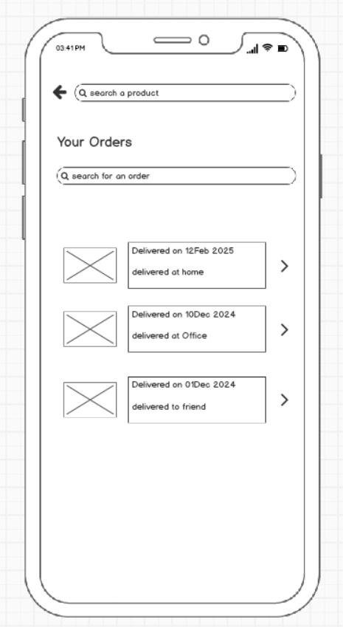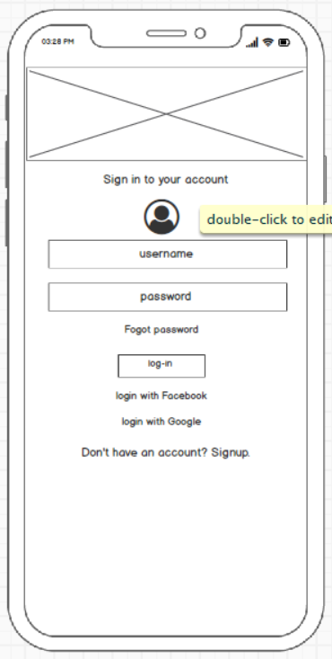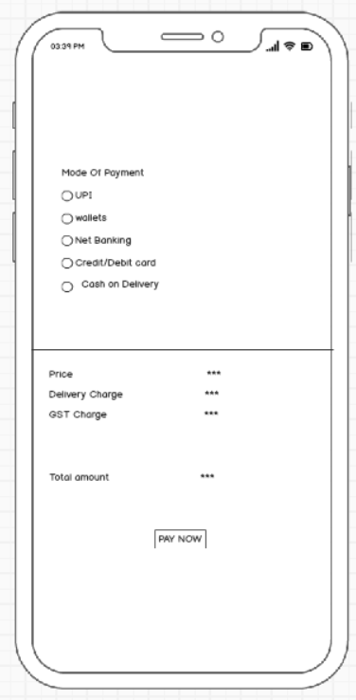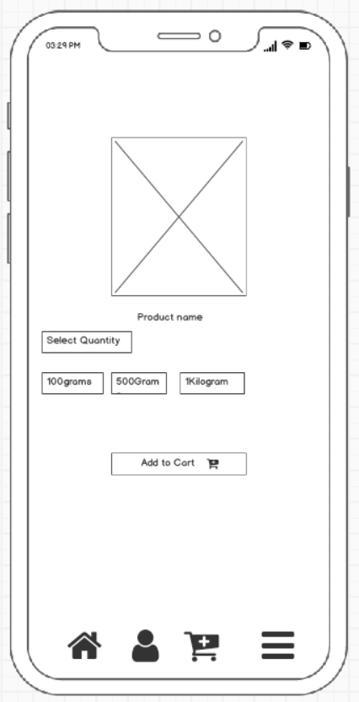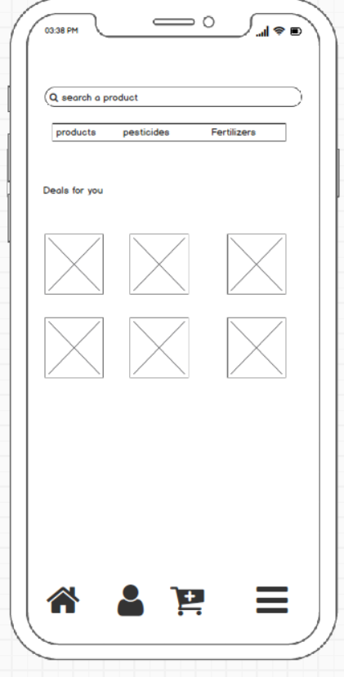

**3)** **Make a note of the Tools that you are using for the above concepts.**

**A: The most commonly used tools for the above concepts are:**

**MS Visio:** MS Visio is a popular tool for creating diagrams, Flowcharts, and wireframes. It offers a wide range of templates and shapes to create visual representations of processes and systems.

**Balsamic**: It is a wireframing tool used by UX/UI designers, business analysts, and developers to create quick and low-fidelity mockups of user interfaces.

**Axure:** It is used by UX/UI designers, business analysts, and developers to create quick and low-fidelity mockups of user interfaces.

Mockups: Mockups are a web-based design tool that provides a comprehensive set of features for wireframing and prototyping. It allows you to create interactive wireframes and prototypes with a user-friendly interface

4Q) A business analyst’s key responsibilities are to track requirements and ensure that no requirement is overlooked.

Mr. Henry and Peter have approached you regarding the current status of the project. How will you tackle this situation?

A:

Test case description: Farmers Login

1. Test case ID: 001
2. Test case Description: Verify or cross-check that the farmers will be able to log in to the application using valid credentials
3. Test steps:

* Enter valid user details while registering for an account
* Click on the Registration button

1. Expected result: The farmers should be able to log in to their accounts after a successful registration

Test case Description: Product search

1. Testcase ID: 002
2. Test case Description: Verify that the farmers can search for products that are in the application
3. Test steps:

* Enter the product name in the search option in the application
* Click on the search option

1. Expected result: The farmers can be able to see products that manufacturers upload based on the searched products

Test case Description: Manufacturer login

1. Test case ID: 003

2. Test Case Description: Verify that the manufacturer should be able to register with valid information

3. Test steps:

* Enter valid details while registering for an account
* Click on complete Registration, and then you will be redirected to the app user interface

4. Estimated Result: The manufacturer will be able to log in soon after entering the valid credentials in the given fields

Test case Description: Manufacturer's product listing

1. Test case ID: 004

2. Test Case Description: Verify that manufacturers will be able to list their products based on the quantity and quality

3. Test Case Steps:

* Enter all the mandatory fields, such as price, quantity, pictures, etc.
* Click on the upload option to get listed online

4. Estimated Results: The Manufacturer could be able to see the insights after listing

Test case Description: Products display

1. Test case ID: 005

2. Test Case Description: The Verify products should be displayed based on the descriptions, like reviews, acting, and quality

3. Test Case Steps:

* Enter products
* Click on a product

4. Estimated Results: The products will be displayed as per the ratings, reviews, and stock available

Test case Description: Add to cart

1. Test case ID: 006

2. Test Case Description: The display of products can be able to stored in the cart along with the quantity before a payment

3. Test Case Steps:

Enter the product name and select the product based on the quality needed

Click on add to cart

4 Estimated Results: The added products will be displayed in the cart along with the quantity for the final payment

Test case Description: cart management

1. Test case ID: 007

2. Test Case Description: Verify that products can be able to managed by adding or removing the products that are in the cart

3. Test Case Steps:

* Click on the cart option, which is usually displayed on the homepage and also in the profile session
* Now you can manage the cart

4 Estimated Results: You will be able to decide by adding or removing the products

Test case Description: wish list

1. Test case ID: 008

2. Test Case Description: Verify that products can be able to the wishlist to buy them later

3. Test Case Steps:

* Click on products
* Scroll down you see Add products to wishlist

4 Estimated Results: Soon after adding to your wishlist, you will be able to see the added products in your wishlist

Test case Description: Multiple Payments

1. Test case ID: 009

2. Test Case Description: The payment should be able to be done with multiple options, like credit cards, debit cards, and wallets

3. Test Case Steps:

* Go to the cart and click on Proceed to Pay. "
* Then click and select the payment to proceed

4 Estimated Results: To continue with the order, select a payment option with a credit card, debit card, or wallet

Test case Description: Order Confirmation

1. Test case ID: 010

2. Test Case Description: Users should receive an order confirmation along with the details, such as the products' quantities, the total amount, and the estimated delivery date

3. Test Case Steps:

Click and select orders

To see the confirmed orders

4 Estimated Results: You will be able to see confirmed products along with the estimated delivery

Test case Description:

1. Test case ID: 011

2. Test Case Description: Users should be able to place orders for selected products, quantities, and delivery addresses as well

3. Test Case Steps:

Select the items that are in the cart

Update the delivery addresses manually before payment

4 Estimated Results: You will be able to see the selected items along with the delivery addresses to which the items need to be delivered

Test case Description: order tracking

1. Test case ID: 012

2. Test Case Description: Users should be able to track the order status based on real-time delivery

3. Test Case Steps:

Click and select the orders

Click on order tracking

4Estimated Results: We can able to see the order items along with the tracking status and estimated delivery

Test case Description: order history

1. Test case ID: 013

2. Test Case Description: Users should be able to view the previous order history, including order details and status

3. Test Case Steps:

* Click on profile and go to orders
* Then we can able to see the order history based on the calendar

4 Estimated Results: We can able to see the ordered items along with the month and year by filtering

Test case Description: customer support

1. Test case ID: 014

2. Test Case Description: Users should be able to access customer support, like live chat, email, phone, or messaging, for order assistance

3. Test Case Steps:

* Select on order
* Click on customer support

4 Estimated Results: Users/ Farmers should be able to access a proper customer based on the requirement, with a solution

Test case Description: Ratings and reviews

1. Test case ID: 015

2. Test Case Description: Users should be able to provide ratings and reviews and ratings

3. Test Case Steps:

* Click on the product and
* Scroll down to the bottom

1. Estimated Results: The users or Farmers will be able to see and provide the products based on their reviews

6Q) After the business analyst thoroughly explained the requirements to the entire project team, the database architects decided to do the database design and represent the inflow and outflow of data.

Draw a database schema and ER diagram.

A: 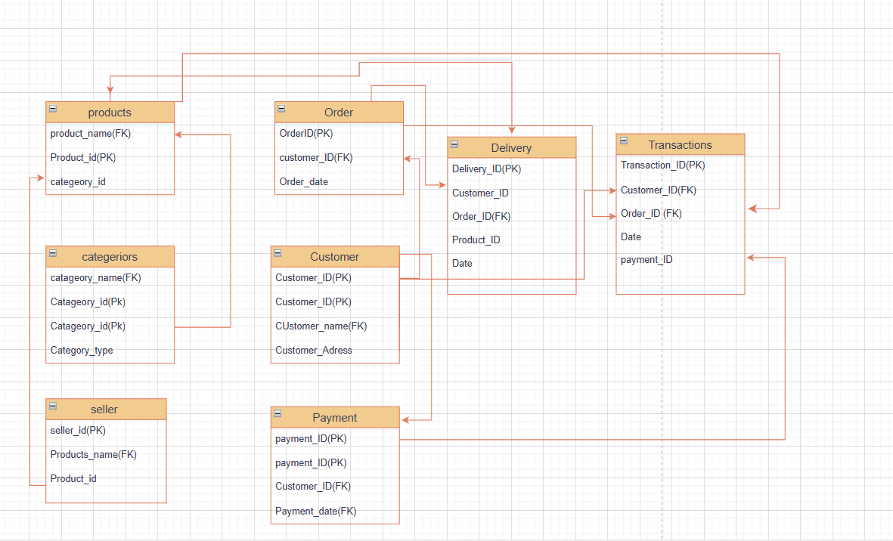

7Q) What is a data flow diagram? Draw a data flow diagram to represent the inflow and outflow of data when a Farmer is placing an order for the product

A: Data flow diagram: It is a diagram that represents the flow of data through a process or a system is known as a data flow diagram

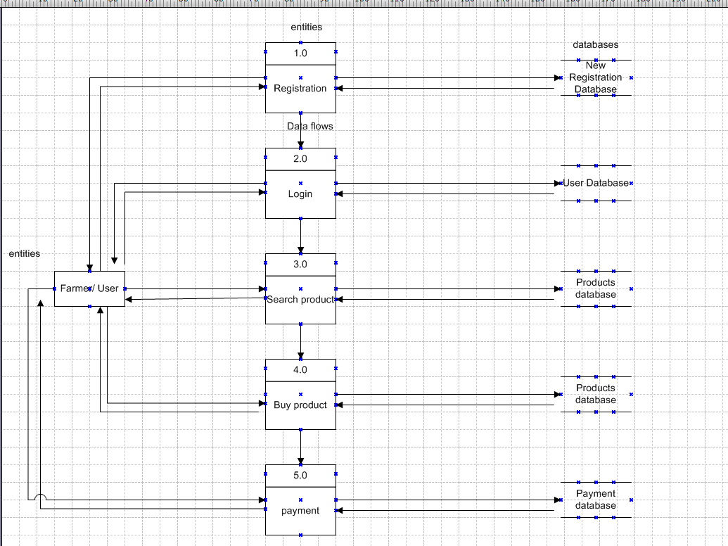

8Q) **Due to a change in the Government Taxation structure. We should change the Tax structure. How do you handle change requests in a project?**

A: As a BA, we should always be ready to handle the change request from the client side based on the current market scenario trends and other parameters

Whenever a change request is requested from the client, the BA should analyse this change request. Initially, the BA should perform the feasibility study to accept the change, and then impact analysis to measure the change to the project, and finally, perform effort estimation and implement the requested change in request.

Change management will impact the project scope, which means that any requirement that was not scoped as part of the initial business requirement document must be managed under change management, and the BA, along with the PM, has to review and follow the change control process. This means when a change is initiated.

BA should

* Initially, BA should document the change request
* The BA should analyse whether the change request is a change or a defect from previous need communications
* The project manager should provide initial approval if the BA needs to move further in analysing the change request
* When it comes to change management, whether to change the changes or it also depends on other factors, which are, for a business analyst as well as the project manager, whether the change request is major or minor.
* In case the change is major, it will not only expand the scope of the project but will also lead to an increase in the delivery time of the project
* The business analyst will help the stakeholders in understanding how the change request is going to impact on the change request will impact the organisation and the negatives of the particular change request

By following the steps above, a project can be efficiently managed to change the request, ensuring that changes are evaluated, approved, and implemented in a manner by minimizes the disruptions and completes the project successfully

9Q) As the project is in process, Ben and Kevin have contacted you. The reason is to inform you that they want the Farmers to sell their crop yields through this application, i.e., Farmers should be able to add their crop yields or products and display them to the general public and should be able to sell them. They also want to introduce an Auction system for their Crop yields. As a BA, what will be your response?

Is this a change request or an enhancement?

A) Adding features that let farmers list and sell their crops through the app, and also run auctions, would be a big shift from our original plan. It brings in new user roles, adds complex features like listings, transactions, and bidding, and could impact the app’s design, backend systems, and even legal requirements.

Because of the scale and impact, I’d consider this a change request rather than a simple enhancement.

* **Gather Requirements:** I’ll first work with you to get all the details about how these features should work.
* **Analyze Impact:** Then, I’ll look into how this change would affect our current scope, timeline, budget, and resources.
* **Check Feasibility:** I’ll consult with the dev, design, and legal teams to make sure everything’s doable and compliant.
* **Review with Stakeholders:** I’ll present the findings to decision-makers to get their input and approval.
* **Update the Plan:** If we get the green light, we’ll update the project plan to include these new features.

10Q) As the project is in process, Ben and Kevin have contacted you. The reason is to inform you that they want the Farmers to sell their crop yields through this application, i.e., Farmers should be able to add their crop yields or products and display them to the general public and should be able to sell them. They also want to introduce an Auction system for their Crop yields. As a BA, what will be your response? Is this a change request or an enhancement???

A: Based on your input, as a business analyst, the request to allow farmers to list and sell their crop yields directly through the application, as well as to introduce an auction system, constitutes a significant functional change from the original scope of the project.

To make a change to the new requirements, I would follow the basic standard process for the change request.

Gathering Requirements: I would meet with Ben and Kevin to gather the detailed requirements for the new functionalities. This will help me out what functionality they are looking for, like adding the crop yield in the action system for the public to manage their crops.

Impact analysis: I would analyze the impact of these changes on the existing requirements of the project scope, timeline, budget, and resources. This assessment would help me to do a feasibility study.

Stakeholder analysis: I would identify and involve internal stakeholders like developers and project managers to know their views and gather their input on the new requirements

Documentation: I would document the detailed requirements and changes in the project, and communicate with the project team

Communication: I would communicate with the project team regarding the new requirements based on the documentation part where stakeholders and other parties are involved, and make sure everyone is aware of the new changes

Evaluation: I would work with the project team and stakeholders to evaluate the value and priority of the requested changes. This evaluation will be considered as a potential benefits that show an impact on requirements, goals, and objectives

Planning and execution: If the new changes are ready to change and approved, o would update the project plan schedule and the resources accordingly, and I will be in touch with the development team and stakeholders to add the new features in the application

10Q) Come up with estimations – How many Manhours are required?

A:

|  |  |  |
| --- | --- | --- |
| **Role Involved** | **Task Involved** | **Estimated man-hours** |
| Business Analyst | Requirments Gathering | 20-30hrs |
| UI/UX designer | Farmer and UI Designer | 10-20 |
| Development | Back-end and front-end development | 80-100 |
| Design architect | Designing and architecture | 30-40 |
| Testing | Testing the code | 20-25 |

11Q) The Project has finally completed all the stages, i.e., design, development, testing, etc. Now, it is the role of a business analyst to contact the client for testing of the final product and have to complete it. How are you going to handle this situation? And once it is done, what will be the process to close the project?

Explain the UAT Acceptance process.

1. To handle this situation of testing the final product or application, the BA will follow the steps below

* UAT planning: Preparing a plan for UAT in consultation with the client. This step will include testing scenarios, test data, and timelines
* Test environment stage: Make sure that the environment is set up and available for the client to perform testing. This may include providing access to the environment necessary to test the account and other additional resources.
* Test execution stage: meet with client to execute the planning test and monitor the test process, providing support for issues with are tracked in the testing stage
* Defect management: If any defects are identified during the UAT, work with the client to understand the issues, document them, and track their solution. After this client will accept and forward this as a final product
* UAT signoff: Once the client has done with the testing and is ok with the app functionality will go with the signoff approvals.

**Process for UAT:**

* **Plan the Testing**  
  First, we define what needs to be tested, who will test it (usually real users or business stakeholders), and what success looks like. We also create a schedule and prepare test scenarios.
* **Set Up the Environment**  
  We create a separate testing space (similar to the live system) with test data and give testers the access they need to do their work.
* **Prepare Test Cases**  
  Test cases are written based on real business use cases. These help guide testers to check if the system works the way it should.
* **Run the Tests**  
  Testers go through the test cases, use the system, and note whether things work as expected. Any issues or bugs they find are reported.
* **Fix Issues**  
  Developers fix the bugs, and the testers check again to make sure everything’s been properly resolved.
* **Final Check**  
  A last round of testing is done to make sure everything works smoothly and the system is ready to go live.
* **Get Approval**  
  Once everyone’s happy with the results, the users or stakeholders give their formal sign-off—this means the system is approved and ready for launch.

12Q) Explain the Project closure document

A: The Project Closure Document is a formal report created at the end of a project to confirm its completion. It summarizes the project, verifies that all deliverables and objectives have been met, and obtains final approval from stakeholders, marking the official closure of the project.

**Project Overview**

* Project Name:
* Project Manager:
* Start Date:
* End Date:
* Client/Stakeholder:
* Project Objective:

**2. Project Deliverables**

|  |  |  |
| --- | --- | --- |
| Deliverable | status | Remarks |
| application | sucess | Approved by the client |
| Testing | sucess | Tested and deployed |

**3. Performance Summary**

|  |  |  |  |
| --- | --- | --- | --- |
| **Parameters** | **Planned** | **Actual** | **Remarks** |
| Budget | 2.5cr | 2cr | Over budget |
| Timeline | 23months | 18months | delayed |

**4. Lessons Learned**

* Time sheets got delayed
* Weekly sprints have gone well
* Requirements need to be improved for the next project

**5. Outstanding Issues:**

|  |  |  |  |  |  |
| --- | --- | --- | --- | --- | --- |
| **Issue/Task** | |  | | --- | |  |  |  | | --- | | **Owner** | | **Due Date** | **Remarks** |
|  |  |  |  |
|  |  |  |  |

6. **Resource Release**

* The project team has been released from project duties
* All assets/tools/licenses are returned or closed

**7. final signoffs:**

I confirm that the project is completed, deliverables have been accepted, and the project can be formally closed.

**Client/Stakeholder Name:**  
**Signature:**  
**Date:**

**Project Manager Name:**  
**Signature:**  
**Date:**