**Answer 1:** Functional requirement is a detailed specification of a system's functionalities that are necessary to meet the needs of the business. These requirements describe how the system should behave and what it should do, focusing on the user's interactions with the system.

|  |  |  |  |
| --- | --- | --- | --- |
| **Req ID** | **Requirement Category** | **Description** | **Priority** |
| FR001 | Search | The system must enable farmers to search for products available in the categories of fertilizers, seeds, and pesticides. | 3 |
| FR002 | Upload and Display | The system should provide manufacturers with the capability to upload and showcase their products within the application. | 2 |
| FR003 | Login | The system needs to offer a login feature where users can access their accounts using their email ID and password. | 1 |
| FR004 | Account Creation | The system must facilitate the creation of new user accounts by allowing users to submit their email ID and create a password. | 2 |
| FR005 | Browse | The system should permit farmers to view the product catalog without requiring them to log in. | 2 |
| FR006 | Registration | The system needs to support a registration process for new users to sign up by providing their email ID and setting a secure password. | 3 |
| FR007 | Payment Gateways | The system must integrate multiple payment gateway options including COD, UPI, and Credit/Debit cards for product purchases. | 1 |
| FR008 | Add to Cart | The system should enable farmers to add desired products to their cart before proceeding to purchase. | 2 |
| FR009 | Page Loading Time | Each page should load within 2 seconds time. | 1 |
| FR010 | WCAG 2.1 Compliance | The system must meet Web Content Accessibility Guidelines WCAG 2.1. | 1 |
| FR011 | Order Confirmation | The system must send email confirmations to users regarding their order status after an order is placed. | 2 |
| FR012 | Delivery Tracking | The system should incorporate a feature to track the delivery status and location of orders. | 2 |
| FR013 | Product Reviews | The system should allow users to leave reviews and ratings for products they have purchased. | 3 |
| FR014 | Wishlist | The system should enable users to add products to a wishlist for future reference. | 2 |
| FR015 | Notifications | The system should send notifications to users about new products, offers, and updates. | 2 |

Answer 2: **Registration Page**

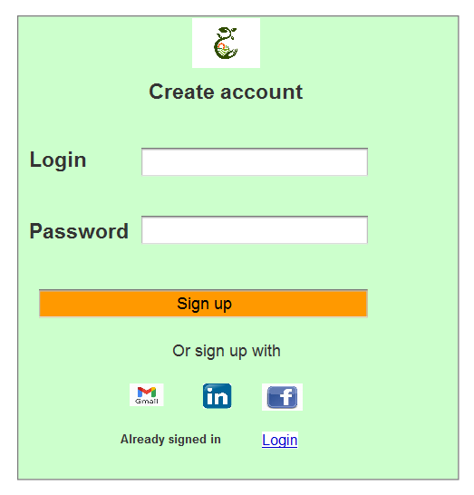

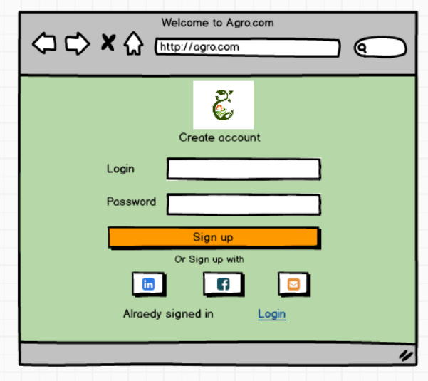

**Login Page**

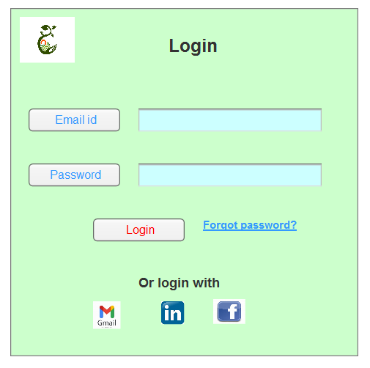

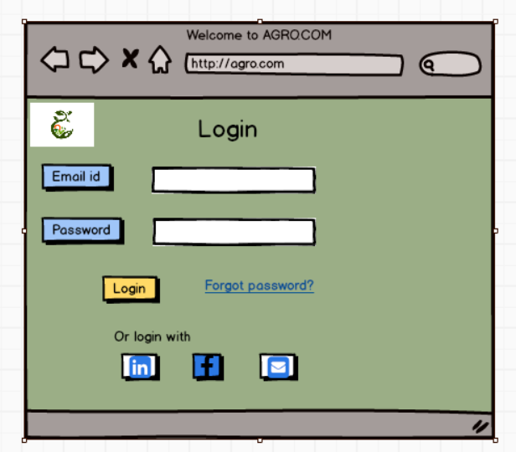

**Home Page**

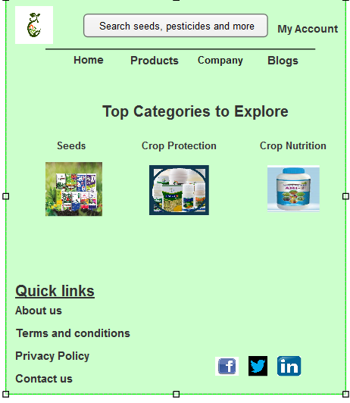

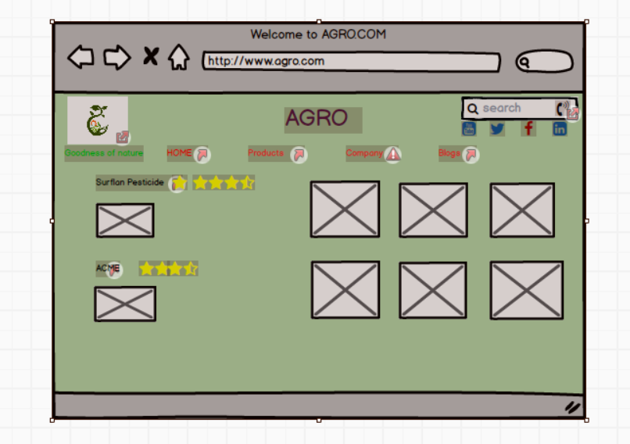

**Add to cart**

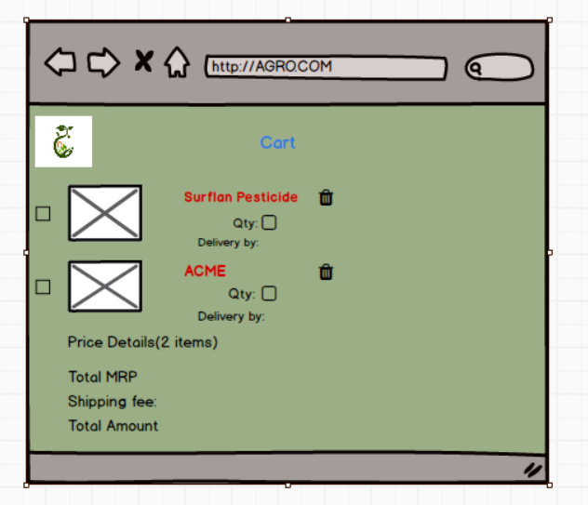

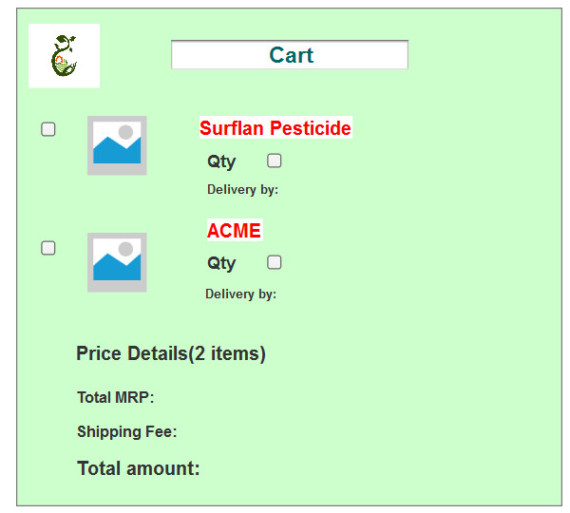

**Payment**

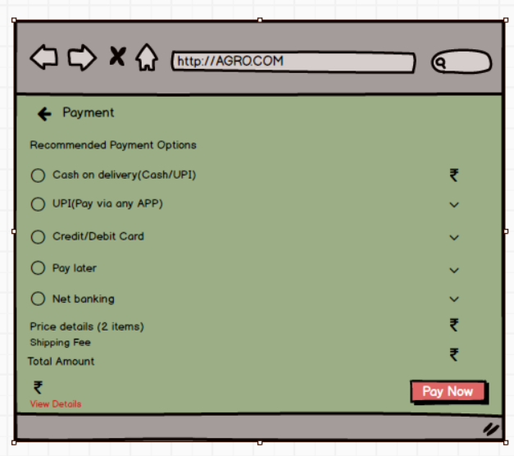

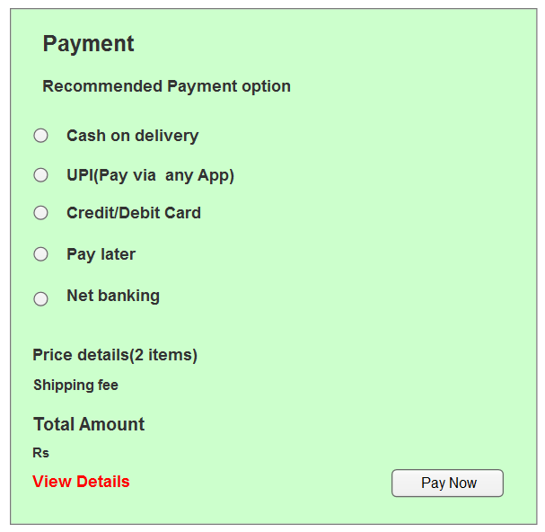

Answer 3:

**Microsoft Visio:** Microsoft Visio is a diagramming and vector graphics application used to create a variety of diagrams such as flowcharts, org charts, floor plans, and network diagrams. It's particularly useful for visualizing data, processes, and organizational structures, making it easier to communicate complex information clearly.

**Axure RP:** Axure RP is a more advanced and powerful prototyping tool used for creating interactive prototypes and specifications. It allows UX professionals to build realistic, functional prototypes with unlimited combinations of event triggers, conditions, and actions. This helps in exploring digital experiences and gathering high-quality user feedback.

**Balsamiq** is a wireframing tool designed for creating low-fidelity, high-impact mockups quickly. t's ideal for brainstorming, testing concepts, and communicating ideas clearly before any code is written. Balsamiq helps teams focus on structure and flow without getting bogged down by design details.

Answer 4:

RTM:



Answer 5: **Test case document: A test document is a detailed outline used by testers to ensure that a software application or system is working as expected.**

|  |  |  |  |
| --- | --- | --- | --- |
| Test Case ID | TC001 | Test case Name | Verify Product Search |
| Project ID | PROJ001 | Project name | AgriApp |
| PM ID | PM001 | PM Name | Mr Vandanam |
| Test strategy ID | STRAT001 | Tester ID | TST001 |
| Test plan ID | PLAN001 | Tester Name | Mr Jason |
| Test scheduled ID | SCHED001 | Date of Test | 23-03-2025 |
| Scenario | Farmers should be able to search for products in fertilizers, seeds, and pesticides. |  |  |
| Link to that page: | /search |  |  |
| Input Data | Fertilizers, Seeds, Pesticides |  |  |
| Expected behaviour | The system displays relevant products in the search results. |  |  |
| Actual behaviour |  |  |  |
| Comments |  |  |  |
| Result(Pass/Fail) |  |  |  |

|  |  |  |  |
| --- | --- | --- | --- |
| Test Case ID | TC002 | Test case Name | Verify Product Upload |
| Project ID | PROJ001 | Project name | AgriApp |
| PM ID | PM001 | PM Name | Mr Vandanam |
| Test strategy ID | STRAT001 | Tester ID | TST002 |
| Test plan ID | PLAN001 | Tester Name | Ms Alekya |
| Test scheduled ID | SCHED001 | Date of Test | 28-03-2025 |
| Scenario | Manufacturers should be able to upload and display their products. |  |  |
| Link to that page: | /upload |  |  |
| Input Data | Product Name, Description, Price, Image |  |  |
| Expected behaviour | The system allows the product to be uploaded and displays it in the product catalogue. |  |  |
| Actual behaviour |  |  |  |
| Comments |  |  |  |
| Result(Pass/Fail) |  |  |  |

|  |  |  |  |
| --- | --- | --- | --- |
| Test Case ID | TST003 | Test case Name | Verify User Login |
| Project ID | PROJ001 | Project name | AgriApp |
| PM ID | PM001 | PM Name | Mr Vandanam |
| Test strategy ID | STRAT001 | Tester ID | TST003 |
| Test plan ID | PLAN001 | Tester Name | Mr Jason |
| Test scheduled ID | SCHED001 | Date of Test | 05-04-2025 |
| Scenario | Users should be able to log in using their email ID and password. |  |  |
| Link to that page: | /login |  |  |
| Input Data | Email ID, Password |  |  |
| Expected behaviour | The system allows the user to log in and access their account. |  |  |
| Actual behaviour |  |  |  |
| Comments |  |  |  |
| Result(Pass/Fail) |  |  |  |

|  |  |  |  |
| --- | --- | --- | --- |
| Test Case ID | TC004 | Test case Name | Verify Account Creation |
| Project ID | PROJ001 | Project name | AgriApp |
| PM ID | PM001 | PM Name | Mr Vandanam |
| Test strategy ID | STRAT001 | Tester ID | TST004 |
| Test plan ID | PLAN001 | Tester Name | Ms Alekya |
| Test scheduled ID | SCHED001 | Date of Test | 15-04-2025 |
| Scenario | New users should be able to create an account by submitting their email ID and password. |  |  |
| Link to that page: | /create_account |  |  |
| Input Data | Email ID, Password |  |  |
| Expected behaviour | The system creates a new user account and sends a confirmation email. |  |  |
| Actual behaviour |  |  |  |
| Comments |  |  |  |
| Result(Pass/Fail) |  |  |  |

|  |  |  |  |
| --- | --- | --- | --- |
| Test Case ID | TC005 | Test case Name | Verify Product Browsing |
| Project ID | PROJ001 | Project name | AgriApp |
| PM ID | PM001 | PM Name | Mr Vandanam |
| Test strategy ID | STRAT001 | Tester ID | TST005 |
| Test plan ID | PLAN001 | Tester Name | Mr Jason |
| Test scheduled ID | SCHED001 | Date of Test | 15-04-2025 |
| Scenario | Farmers should be able to browse the product catalog without logging in. |  |  |
| Link to that page: | /create_account |  |  |
| Input Data | Email ID, Password |  |  |
| Expected behaviour | The system creates a new user account and sends a confirmation email. |  |  |
| Actual behaviour |  |  |  |
| Comments |  |  |  |
| Result(Pass/Fail) |  |  |  |

|  |  |  |  |
| --- | --- | --- | --- |
| Test Case ID | TC006 | Test case Name | Verify User Registration |
| Project ID | PROJ001 | Project name | AgriApp |
| PM ID | PM001 | PM Name | Mr Vandanam |
| Test strategy ID | STRAT001 | Tester ID | TST006 |
| Test plan ID | PLAN001 | Tester Name | Mr Jason |
| Test scheduled ID | SCHED001 | Date of Test | 15-04-2025 |
| Scenario | New users should be able to register by providing their email ID and secure password. |  |  |
| Link to that page: | /register |  |  |
| Input Data | Email ID, Password |  |  |
| Expected behaviour | The system registers the new user and sends a confirmation email. |  |  |
| Actual behaviour |  |  |  |
| Comments |  |  |  |
| Result(Pass/Fail) |  |  |  |

|  |  |  |  |
| --- | --- | --- | --- |
| Test Case ID | TC007 | Test case Name | Verify Payment Gateway |
| Project ID | PROJ001 | Project name | AgriApp |
| PM ID | PM001 | PM Name | Mr Vandanam |
| Test strategy ID | STRAT001 | Tester ID | TST007 |
| Test plan ID | PLAN001 | Tester Name | Mr Jason |
| Test scheduled ID | SCHED001 | Date of Test | 25-04-2025 |
| Scenario | Farmers should be able to buy products using COD, UPI, and Credit/Debit card options. |  |  |
| Link to that page: | /checkout |  |  |
| Input Data | Payment Details |  |  |
| Expected behaviour | The system processes the payment and confirms the order. |  |  |
| Actual behaviour |  |  |  |
| Comments |  |  |  |
| Result(Pass/Fail) |  |  |  |

|  |  |  |  |
| --- | --- | --- | --- |
| Test Case ID | TC008 | Test case Name | Verify Add to Cart |
| Project ID | PROJ001 | Project name | AgriApp |
| PM ID | PM001 | PM Name | Mr Vandanam |
| Test strategy ID | STRAT001 | Tester ID | TST008 |
| Test plan ID | PLAN001 | Tester Name | Mr Jason |
| Test scheduled ID | SCHED001 | Date of Test | 05-05-2025 |
| Scenario | Farmers should be able to add products to their cart before purchasing. |  |  |
| Link to that page: | /cart |  |  |
| Input Data | Product Selection |  |  |
| Expected behaviour | The system adds the selected products to the user's cart. |  |  |
| Actual behaviour |  |  |  |
| Comments |  |  |  |
| Result(Pass/Fail) |  |  |  |

|  |  |  |  |
| --- | --- | --- | --- |
| Test Case ID | TC009 | Test case Name | Verify Order Confirmation |
| Project ID | PROJ001 | Project name | AgriApp |
| PM ID | PM001 | PM Name | Mr Vandanam |
| Test strategy ID | STRAT001 | Tester ID | TST009 |
| Test plan ID | PLAN001 | Tester Name | Mr Jason |
| Test scheduled ID | SCHED001 | Date of Test | 15-05-2025 |
| Scenario | Users should receive an email confirmation regarding their order status after placing an order. |  |  |
| Link to that page: | /order_confirmation |  |  |
| Input Data | Order Details |  |  |
| Expected behaviour | The system sends an email confirmation with the order details. |  |  |
| Actual behaviour |  |  |  |
| Comments |  |  |  |
| Result(Pass/Fail) |  |  |  |

|  |  |  |  |
| --- | --- | --- | --- |
| Test Case ID | TC010 | Test case Name | Verify Delivery Tracking |
| Project ID | PROJ001 | Project name | AgriApp |
| PM ID | PM001 | PM Name | Mr Vandanam |
| Test strategy ID | STRAT001 | Tester ID | TST010 |
| Test plan ID | PLAN001 | Tester Name | Mr Jason |
| Test scheduled ID | SCHED001 | Date of Test | 25-05-2025 |
| Scenario | The system should have a delivery tracker to track the whereabouts of orders. |  |  |
| Link to that page: | /delivery_tracking |  |  |
| Input Data | Order ID, Delivery Status |  |  |
| Expected behaviour | The system displays the delivery status and location of the order. |  |  |
| Actual behaviour |  |  |  |
| Comments |  |  |  |
| Result(Pass/Fail) |  |  |  |

Answer 6: **DB Schema: A database schema is the formal definition of how data is organized within a database. It outlines the structure of the database, including the tables, fields, relationships, constraints, and indexes. Essentially, it is the blueprint that guides how data is stored and managed.**

**Key Components of a Database Schema:**

1. **Tables**: Represent entities and hold data.
2. **Fields/Columns**: Attributes of the tables.
3. **Primary Keys**: Unique identifiers for records in a table.
4. **Foreign Keys**: References to primary keys in other tables to establish relationships.
5. **Indexes**: Improve the speed of data retrieval.
6. **Constraints**: Rules to maintain data integrity (e.g., NOT NULL, UNIQUE).
7. **Views**: Virtual tables created by querying data from one or more tables.

An Entity Relationship Diagram(ERD) is a visual representation of the relationships between entities in a database. It illustrates how different entities (tables) in the database are related to each other. ER diagrams use specific symbols to represent entities, attributes, and relationships.

**Key Components of an ER Diagram:**

1. **Entities**: Represent tables in the database (depicted as rectangles).
2. **Attributes**: Represent fields or columns of the entities (depicted as ovals).
3. **Primary Keys**: Unique identifiers for entities (underlined attributes).
4. **Foreign Keys**: Attributes that establish relationships between entities.
5. **Relationships**: Depict how entities are related to each other (represented by diamonds and lines).

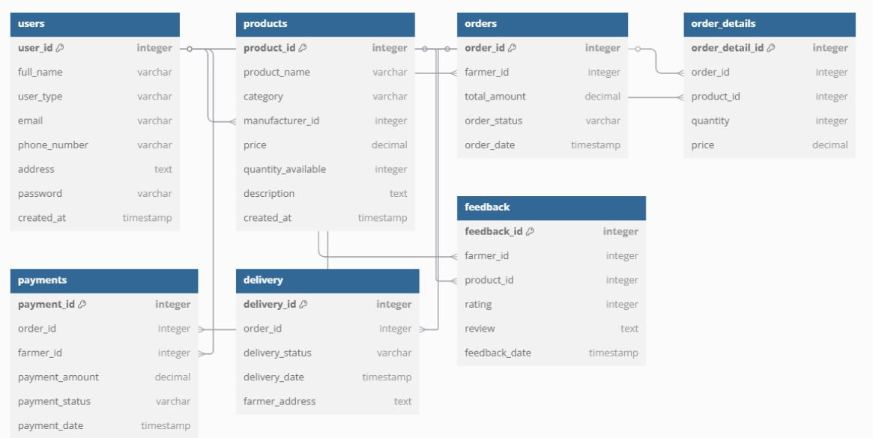

**Primary Key**

A *Primary Key* is a unique identifier for each row in a table. No two rows can have the same primary key value, and it cannot be *NULL*.

Example from the ER Diagram:

- users table → user_id (PK)

- products table→ product_id (PK)

- orders table→ order_id (PK)

**Foreign Key**

A Foreign Key is a column that links one table to another. It references the *Primary Key (PK)* of another table to establish relationships.

Example from the ER Diagram:

products table → manufacturer_id is a *Foreign Key* referencing user_id in *users* (A product belongs to a manufacturer).

orders table → farmer_id is a *Foreign Key* referencing user_id in *users* (A farmer places an order).

order_details table→ order_id and product_id are *Foreign Keys* referencing orders and products.

**Secondary Key**

A *Secondary Key* (or *Alternate Key) is a column that is not the primary key but is still unique and used for searching data efficiently.

Example from the ER Diagram:

- users table→ email is unique and can be a *Secondary Key*

- products table→ product_name can be a *Secondary Key*

- orders table→ order_status is often used in searches (though not unique)

Example from the ER Diagram:

* In the **Users** table, email can be considered a secondary key, as it is often unique for users but not the primary key of the table.

Answer 7:

* Data flow diagram- Data Flow Diagram is a graphical representation of the flow of data within a system. It shows visually how data moves from one process to another, how its stored and where it ends up.
* It helps analyst and designers to understand the flow data within a system, identify potential bottlenecks or inefficiencies and communicate system requirements to stakeholders.

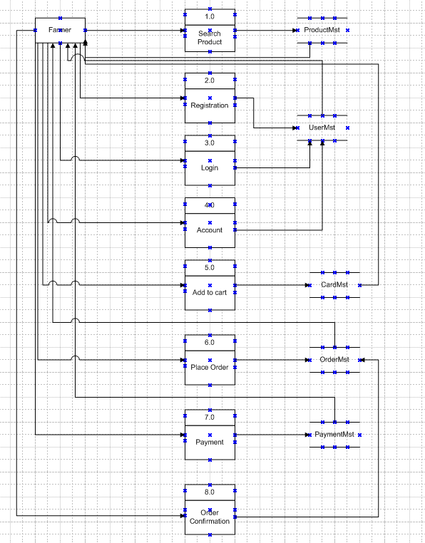

Answer 8: Change Request is a formal proposal to alter a system, product or a project.

* **Document the Request**: Record details of the change request.
* **Do Impact analysis:** Assess how the change will affect the current system.
* **Evaluate Costs and Benefits**: Estimate the costs and benefits of the change.
* **Conduct Risk Analysis**: Identify and mitigate potential risks.
* **Seek Approvals**: Get the necessary approvals from stakeholders.
* **Plan the Implementation**: Create a detailed plan for implementing the change.
* **Execute the Change**: Implement the change as planned.
* **Test the Changes**: Ensure the change works correctly through thorough testing.
* **Review and Document**: Review the success of the change and update relevant documentation.
* **Communicate with Stakeholders**: Inform stakeholders about the change and its benefits.

Answer 9: As a Business Analyst, I would handle the request from Ben and Kevin as follows:

* **Understand Requirements**: Get clear details on how farmers will sell their crops and how the auction system will work.
* **Document Request**: Write down the request with all necessary details.
* **Analyze Impact**: Check how this will affect the current system and identify any changes needed.
* **Evaluate Costs and Benefits**: Assess the effort, resources, and benefits of the changes.
* **Conduct Risk Assessment**: Identify potential risks and plan how to address them.
* **Get Approvals**: Present the findings to stakeholders and get their approval.
* **Plan Implementation**: Create a detailed plan for adding these new features.
* **Execute Change**: Implement the changes as planned.
* **Test Changes**: Thoroughly test the new features to ensure they work correctly.
* **Review and Document**: Review the success of the changes and update any relevant documentation.

This is a **change request** because it significantly changes the scope of the original project.

Answer 10: **In project management, manhours are used to estimate the total labour required to complete a project. They help in planning, scheduling, and resource allocation by providing a way to quantify the effort needed for different tasks. Manhours are the required effort of the resources to complete a project. These are the 3 types of projects:**

* Small- Upto 500 hours
* Medium-Upto 1000 hours
* Large-Upto 1500 hours

Analysis:

* As per the case study, the duration of the project is 18months and the current team size is around 15. This will come under medium project.

|  |  |
| --- | --- |
| **Duration** | **Value** |
| Project Duration | 18 months (=78 weeks) |
| Team Size | 15 members |
| Weekly Work Hours per Member | 40 hours |
| **Total Available Manhours** | **46,800 manhours** |

|  |  |  |
| --- | --- | --- |
| **Task Description** | **Days Allocated** | **Total Manhours** |
| Requirements Gathering and Analysis | 30 | 3,600 |
| System Design | 40 | 4,800 |
| Development | 180 | 21,600 |
| Testing | 60 | 7,200 |
| Training and Documentation | 40 | 4,800 |
| Deployment and Go-Live Support | 40 | 4,800 |
| **Total Days Taken** | **390** | **46,800** |

**Answer 11:**

**1. Planning:** In this step, Blue Prints are made to implement UAT testing for every feature that needs to test and minimum standards for accepting the test.

**2. Designing:** Here, the test cases are created and designed to hide all the possibilities in a real world environment.

**3. UAT Testers:** A testing team consists of a end users that meet the criteria for implementing testing. The end user must have expertise in subject matter , the ability to report the problems.

**4. Bug Fixing:** Whatever bugs/ issues are found in the UAT Testing, the development team should work on them and make it software error free.

**5. Sign-off:** After removing all the bugs, the testing team indicates acceptance of the completion of the bugs. In this phase, all the stakeholders come to a conclusion that the software is ready to GO LIVE and sign it off.

A **Project Closure Document** is a formal record that signifies the completion of a project. It includes all necessary information and final deliverables to ensure that the project is properly concluded.

**Answer 12: Key Components of a Project Closure Document**

1. **Project Overview**
   * **Project Name**: The title of the project.
   * **Project Manager**: Name of the person managing the project.
   * **Project Sponsor**: Name of the person or organization sponsoring the project.
   * **Project Start and End Dates**: The timeline of the project.
2. **Objectives and Scope**
   * **Project Objectives**: A summary of what the project aimed to achieve.
   * **Project Scope**: A detailed outline of the project’s scope, including any changes that occurred during the project.
3. **Deliverables**
   * **Final Deliverables**: List of all final deliverables that were completed and handed over to the client or stakeholders.
   * **Acceptance Criteria**: Criteria that were used to evaluate the deliverables and ensure they meet the required standards.
4. **Project Performance**
   * **Success Criteria**: Metrics and benchmarks used to measure the success of the project.
   * **Performance Analysis**: An analysis of how the project performed against the initial plan, including any variances in schedule, budget, and scope.
5. **Lessons Learned**
   * **Challenges and Issues**: Summary of any challenges or issues faced during the project and how they were addressed.
   * **Best Practices**: Identification of best practices and strategies that contributed to the project’s success.
6. **Final Project Report**
   * **Summary of Activities**: A brief summary of all the activities and phases of the project.
   * **Client Feedback**: Feedback from the client or stakeholders on the final deliverables and overall project performance.
7. **Financial Summary**
   * **Budget Overview**: Summary of the project’s budget, including initial estimates and actual expenditures.
   * **Cost Variances**: Analysis of any cost variances and reasons for the differences.
8. **Closure Activities**
   * **Handover Process**: Details on how the final deliverables were handed over to the client or stakeholders.
   * **Documentation**: List of all documentation provided to the client, including user manuals, technical guides, and training materials.
   * **Resource Release**: Information on the release of project resources, such as team members and equipment.
9. **Approval and Sign-off**
   * **Sign-off Sheet**: A formal sign-off from the project sponsor or client indicating that the project has been completed to their satisfaction.
   * **Approval Signatures**: Signatures from key stakeholders, including the project manager and sponsor.

