**AGILE PART-2**

**WFT- WORK FLOW TRACKER**

**Ans-1 Definition Done ( DOD)**

As Per Agile Extension to the BABOK® Guide v2, Definition of Done is a technique where the

team agrees on, and prominently displays, a list of criteria which must be met before a

backlog item is considered done. That is the team has to create a well-defined, unambiguous, measurable, agreed-upon, and shared Definition of Done between all team members.

The best form of Definition of Done representation is a checklist of activities that has to

demonstrate the agreed value and quality of a user story. So, this checklist should include:

* acceptance criteria (to satisfy customer requirements for a product)
* quality criteria (to satisfy quality requirements for a product)

Definition of Done may be defined for different levels of project work. For example, in Agile

/ Scrum framework these levels of work could be user story, sprint, and release.

The **Definition of Done (DoD)** ensures that all user stories, features, and deliverables meet quality standards before being considered complete.

* **General DoD Criteria**
* Code Completeness: The feature is fully developed, with all required functionality implemented.
* Code Review: Code has been reviewed, approved, and follows best practices (clean, maintainable, and well-documented).
* Unit Testing: At least 80% test coverage is achieved for core functionalities.
* Integration Testing: The feature has been tested with external systems (APIs, fraud detection tools, accounting systems).
* Security & Compliance: The system follows data protection laws and security best practices (authentication, role-based access).
* Performance Testing: The feature performs efficiently under expected user load.
* Bug Fixes: Critical and high-priority bugs have been resolved before release.
* User Acceptance Testing (UAT): Business stakeholders have validated that the feature meets requirements.
* Documentation: Relevant documentation is updated, including API docs, user guides, and release notes.
* Deployment Ready: The feature is successfully deployed in a staging environment and is ready for production release.
* Monitoring & Logging: Error handling, system logs, and monitoring alerts are in place for tracking performance issues.
* Feature-Specific DoD
* Dashboard & Reports: Real-time data updates, filtering options, and export functionality are verified.
* SLA Management: Custom rules are configurable, and alerts trigger correctly for SLA violations.
* Claims Processing & Syncing: Data syncs correctly with external accounting systems.
* Notifications & Alerts: Users receive timely, actionable notifications for urgent claims or required investigations.
* Feature ok-ed by Product Owner - Product Owner signs off on the feature, confirming it meets business needs.
* Feature Ok-ed by UX Designer – UX design team has validated the user interface and experience.
* QA Performed & Issues Resolved – QA team has conducted functional, regression, and exploratory testing, and all critical defects are resolved.
* Peer Code Review Performed – Code has been reviewed and approved by at least one peer to ensure best practices, security, and performance.

**Ans-2**

**Product vision**

|  |  |  |  |
| --- | --- | --- | --- |
| **Scrum Project Name** | **WFT- Work Flow Tracker** |  |  |
| **Venue :** | Pune Allsate office |  |  |
| **Date : 12/03/2025** | **Start time : 13/03/2025** | **End time : 13/06/2025** | **Duration : 3 months** |
| **Client :** | Allsate |  |  |
| **Stakeholder list :** | Claims manager  Operations director  Claims medical analyst  Team Lead  Claims Processor |  |  |
|  | **SCRUM TEAM** |  |  |
| **Scrum master :** | Mr Ajay |  |  |
| **PO :** | Ms. Pooja |  |  |
| **Scrum developer 1** | Mr Anil |  |  |
| **Scrum developer 2** | Ms Anna |  |  |
| **Scrum developer 3** | Mr Sid |  |  |

|  |  |  |  |
| --- | --- | --- | --- |
| **Vision :**  The **Workflow Tracker** is designed to enhance the efficiency, accuracy, and transparency of insurance claim processing through real time tracking. | | | |
| **Target Group**     * Claims medical analyst * Claims processor | **Needs**   * Implement a centralized tracking system to monitor claim processing in real time. * Utilize complexity analysis to allocate claims efficiently based on skill level. * Generate data-driven insights to optimize workflows and enhance operational efficiency. * Improve compliance and reporting through automated tracking and documentation. | **Product**   * Work Flow tracker * This project will ensure better workload distribution, faster claim resolution, and compliance with industry regulations. * It is feasible to develop the product because it is an enhancement | **Value**   * Improve Claim Processing Efficiency * Assess Case Complexity * Enhance Decision-Making * Ensure Compliance & Accuracy |

**Answer-3 User Stories**

|  |  |  |
| --- | --- | --- |
| **User Story No : 1** | **Tasks :** Real-time Tracking of Claims | **Priority : High** |
| **Value Statement :** AS A **CLAIMS MANAGER**, I WANT TO MONITOR THE NUMBER OF INSURANCE CLAIMS BEING PROCESSED IN REAL TIME, SO THAT I CAN ENSURE EFFICIENT WORKFLOW MANAGEMENT AND IDENTIFY BOTTLENECKS. | | |
| **BV : 500** | **CP : 3** | |
| **ACCEPTANCE CRITERIA :**   * Claims should be updated in real-time as they progress through different stages. * The dashboard should categorize claims based on their status (e.g., New, In Progress, Completed). * Users should be able to filter and search claims based on specific parameters (e.g., date, status, complexity). | | |

|  |  |  |
| --- | --- | --- |
| **User Story No : 2** | **Tasks :** Complexity Assessment for Claims | **Priority : High** |
| **Value Statement :** AS A **CLAIMS ANALYST**, I WANT TO CATEGORIZE CLAIMS BASED ON COMPLEXITY LEVELS (E.G., SIMPLE, MODERATE, COMPLEX), SO THAT I CAN PRIORITIZE WORK AND ALLOCATE RESOURCES EFFECTIVELY. | | |
| **BV : 400** | **CP : 5** | |
| **ACCEPTANCE CRITERIA :**  • Claims should be automatically classified based on parameters such as claim amount, documentation required, and type of insurance.  • Analysts should be able to manually update complexity levels if needed.  • The system should provide a visual indicator of claim complexity to assist in prioritization. | | |

|  |  |  |
| --- | --- | --- |
| **User Story No : 3** | **Tasks :** Performance Analytics and Reporting | **Priority : Medium** |
| **Value Statement :** AS A **CLAIMS MANAGER ,** I WANT TO GENERATE REPORTS AND ANALYZE TRENDS IN CLAIM PROCESSING, SO THAT I CAN MAKE DATA-DRIVEN DECISIONS TO OPTIMIZE EFFICIENCY AND REDUCE PROCESSING TIME. | | |
| **BV : 400** | **CP : 3** | |
| **ACCEPTANCE CRITERIA :**   * Reports should include metrics such as average processing time, claim complexity distribution, and team productivity. * Users should be able to export reports in multiple formats (e.g., PDF, Excel). * Data should be visualized using charts and graphs for easy interpretation. | | |

|  |  |  |
| --- | --- | --- |
| **User Story No : 4** | **Tasks :** Resource Allocation Optimization | **Priority : H**igh |
| **Value Statement :**  AS A **TEAM LEAD**, I WANT TO ADJUST TEAM WORKLOADS BASED ON CLAIM COMPLEXITY AND PROCESSING SPEED, SO THAT I CAN ENSURE A BALANCED DISTRIBUTION OF TASKS AND PREVENT BACKLOGS. | | |
| **BV : 5** | **CP: 2** | |
| **ACCEPTANCE CRITERIA :**   * The system should allow managers to reassign claims based on workload and expertise. * A dashboard should provide insights into team workload and pending claims. * Notifications should alert team leads if a team member is overloaded or if claims are pending beyond the expected timeframe. | | |

|  |  |  |
| --- | --- | --- |
| **User Story No : 5** | **Tasks : Complexity level** | **Priority : high** |
| **Value Statement : AS A** CLAIMS MANAGER,**I WANT TO** TRACK AND MANAGE THE NUMBER OF INSURANCE CLAIMS PROCESSED WHILE ASSESSING THEIR COMPLEXITY IN REAL TIME, **SO THAT** I CAN OPTIMIZE RESOURCE ALLOCATION, IMPROVE OPERATIONAL EFFICIENCY, AND ENSURE TIMELY RESOLUTION OF CLAIMS. | | |
| **BV : 500** | **CP : 03** | |
| * **ACCEPTANCE CRITERIA :** * The system should display real-time tracking of processed claims. * It should categorize claims based on complexity levels (e.g., simple, moderate, complex). * Analytics and reporting features should provide insights into claim processing trends. * The system should allow resource allocation adjustments based on workload and claim complexity. * Users should be able to generate reports for performance evaluation and forecasting. | | |

|  |  |  |
| --- | --- | --- |
| **User Story No : 6** | **Tasks :** Develop system for tracking claims by assigned processor. | **Priority : high** |
| **Value Statement :** Managers can distribute and track workloads. | | |
| **BV : 500** | **CP : 05** | |
| * **ACCEPTANCE CRITERIA :** The system should display claims assigned to each processor with workload statistics. | | |

|  |  |  |
| --- | --- | --- |
| **User Story No : 7** | **Tasks :** Add a note-taking feature to each claim. | **Priority : medium** |
| **Value Statement :** Ensures claim handlers can document important updates. | | |
| **BV : 500** | **CP : 02** | |
| * **ACCEPTANCE CRITERIA :** Notes should be editable and timestamped with author details.. | | |

|  |  |  |
| --- | --- | --- |
| **User Story No : 8** | **Tasks :** Implement automated complexity classification (Simple, Moderate, Complex) | **Priority : high** |
| **Value Statement : AS A** CLAIMS MANAGER,**I WANT it**  Helps prioritize claims efficiently. | | |
| **BV : 50**0 | **CP : 03** | |
| * **ACCEPTANCE CRITERIA :** Complexity level should be assigned automatically and be editable if needed. | | |

|  |  |  |
| --- | --- | --- |
| **User Story No : 9** | **Tasks :** Allow manual override for complexity classification. | **Priority : medium** |
| **Value Statement : AS A** CLAIMS MANAGER,**I WANT TO** ENSURES HUMAN INTERVENTION WHERE NEEDED. | | |
| **BV : 500** | **CP : 01** | |
| * **ACCEPTANCE CRITERIA :** Admins should be able to manually adjust complexity with an audit log. | | |

|  |  |  |
| --- | --- | --- |
| **User Story No : 10** | **Tasks :** Develop a visual indicator for complexity levels. | **Priority : medium** |
| **Value Statement : AS A** CLAIMS MANAGER,**I WANT TO** ALLOWS QUICK IDENTIFICATION OF CLAIM DIFFICULTY. | | |
| **BV : 400** | **CP : 05** | |
| * **ACCEPTANCE CRITERIA :** THE SYSTEM SHOULD DISPLAY COLOR-CODED COMPLEXITY TAGS ON EACH CLAIM. | | |

|  |  |  |
| --- | --- | --- |
| **User Story No : 11** | **Tasks :** Create a dashboard displaying average claim processing times. | **Priority : high** |
| **Value Statement :** HELPS IN MONITORING OPERATIONAL EFFICIENCY. | | |
| **BV : 500** | **CP : 03** | |
| * **ACCEPTANCE CRITERIA :** Dashboard should display claim processing times segmented by type and complexity. | | |

|  |  |  |
| --- | --- | --- |
| **User Story No : 12** | **Tasks :** Enable claim performance reports generation. | **Priority : high** |
| **Value Statement : AS A CLAIMS MANAGER , I WANT** SUPPORTS DATA-DRIVEN DECISION-MAKING. | | |
| **BV : 500** | **CP : 02** | |
| * **ACCEPTANCE CRITERIA :**   Users should be able to download PDF/Excel reports on claim status and processing trends. | | |

|  |  |  |
| --- | --- | --- |
| **User Story No : 13** | **Tasks :** Compare complexity levels with resolution times. | **Priority : medium** |
| **Value Statement : AS A CLAIMS ANALYST , I WANT THE TOOL TO** HELP IN PROCESS OPTIMIZATION. | | |
| **BV : 500** | **CP : 03** | |
| * **ACCEPTANCE CRITERIA :** Alerts should be triggered when a claim approaches SLA deadlines. | | |

|  |  |  |
| --- | --- | --- |
| **User Story No : 14** | **Tasks :** Implement a daily digest notification for pending claims. | **Priority : medium** |
| **Value Statement : AS A** CLAIMS MANAGER, HELPS PROCESSORS MANAGE WORKLOADS EFFICIENTLY. | | |
| **BV : 500** | **CP : 03** | |
| * **ACCEPTANCE CRITERIA :** System should send daily summaries of pending claims. | | |

|  |  |  |
| --- | --- | --- |
| **User Story No : 15** | **Tasks :** Develop SLA-based pending claim alert system. | **Priority : high** |
| **Value Statement : AS A** CLAIMS MANAGER,**I WANT TO** ENSURES SLAS ARE MET WITHOUT DELAYS. | | |
| **BV : 500** | **CP : 03** | |
| * **ACCEPTANCE CRITERIA :** Alerts should be triggered when a claim approaches SLA deadlines. | | |

|  |  |  |
| --- | --- | --- |
| **User Story No : 16** | **Tasks :** Implement a daily digest notification for pending claims. | **Priority : medium** |
| **Value Statement : AS A** CLAIMS MANAGER,**I WANT TO** HELPS PROCESSORS MANAGE WORKLOADS EFFICIENTLY. | | |
| **BV : 500** | **CP : 03** | |
| * **ACCEPTANCE CRITERIA :** System should be able to see daily summaries of pending claims. | | |

|  |  |  |
| --- | --- | --- |
| **User Story No : 17** | **Tasks : Complexity level** | **Priority : high** |
| **Value Statement : AS A CLAIMS MANAGER I WANT IT** ALLOW SYSTEM ADMINS TO CREATE CUSTOM USER ROLES. | | |
| **BV : 500** | **CP : 03** | |
| * **ACCEPTANCE CRITERIA :** Admins should be able to assign specific permissions to different roles. | | |

|  |  |  |
| --- | --- | --- |
| **User Story No : 18** | **Tasks :** Enable API integration for external reporting tools. | **Priority : medium** |
| **Value Statement : AS A** PRODUCT OWNER ,**I WANT IT TO** SUPPORTS ADVANCED ANALYTICS AND CUSTOM DASHBOARDS. | | |
| **BV : 500** | **CP : 03** | |
| * **ACCEPTANCE CRITERIA :**   Users should be able to fetch claims data via API securely | | |

|  |  |  |
| --- | --- | --- |
| **User Story No : 19** | **Tasks : User friendly UI** | **Priority : high** |
| **Value Statement : AS A** CLAIMS MANAGER,**I WANT TO** USER FRIENDLY UI. | | |
| **BV : 500** | **CP : 02** | |
| * **ACCEPTANCE CRITERIA :** UI should be responsive across devices. | | |

|  |  |  |
| --- | --- | --- |
| **User Story No : 20** | **Tasks : Connect to a BI tool** | **Priority : high** |
| **Value Statement : AS AN OPERATIONS DIRECTOR**, I WANT TO CONNECT THE SYSTEM TO A BI TOOL SO THAT I CAN PERFORM ADVANCED ANALYTICS. | | |
| **BV : 5** | **CP : 03** | |
| * **ACCEPTANCE CRITERIA :**   **The tool should be able to integrate with Power BI.** | | |

|  |  |  |
| --- | --- | --- |
| **User Story No : 21** | **Tasks : Adjust Dashboard widgets** | **Priority : high** |
| **Value Statement : AS A TEAM LEAD**, I WANT TO ADJUST DASHBOARD WIDGETS SO THAT I CAN VIEW RELEVANT KPIS. | | |
| **BV : 5** | **CP : 03** | |
| * **ACCEPTANCE CRITERIA :** TL should be able to mark the performers as per the KPI. | | |

|  |  |  |
| --- | --- | --- |
| **User Story No : 22** | **Tasks : Complexity level** | **Priority : high** |
| **Value Statement :**  **AS A CLAIMS MANAGER**, I WANT TO FILTER REPORTS BY INSURANCE TYPE SO THAT I CAN ANALYZE CLAIM TRENDS. | | |
| **BV : 5** | **CP : 03** | |
| * **ACCEPTANCE CRITERIA :**   The reports should be generated based on insurance types, claim types, complexity level which would give a better understanding of the trends. | | |

|  |  |  |
| --- | --- | --- |
| **User Story No : 23** | **Tasks : Complexity level** | **Priority : high** |
| **Value Statement : As a System Admin**, I want to create custom user roles so that I can control system access. | | |
| **BV : 500** | **CP : 03** | |
| * **ACCEPTANCE CRITERIA :** * The system should display real-time tracking of processed claims. * It should categorize claims based on complexity levels (e.g., simple, moderate, complex). * Analytics and reporting features should provide insights into claim processing trends. * The system should allow resource allocation adjustments based on workload and claim complexity. * Users should be able to generate reports for performance evaluation and forecasting. | | |

|  |  |  |
| --- | --- | --- |
| **User Story No : 24** | **Tasks : Complexity level** | **Priority : high** |
| **Value Statement : AS AN OPERATIONS DIRECTOR**, I WANT SYSTEM LOGS OF CLAIM MODIFICATIONS SO THAT I CAN ENSURE AUDIT COMPLIANCE. | | |
| **BV : 500** | **CP : 03** | |
| * **ACCEPTANCE CRITERIA :**   The system records **every modification** made to a claim, including changes in **status, assigned processor, pay-out amount, and supporting documents**. Each log entry includes **timestamp, user ID, role, and action performed**. | | |

|  |  |  |
| --- | --- | --- |
| **User Story No : 26** | **Tasks : Compare claim complexity** | **Priority : high** |
| **Value Statement :**  **As a Business Analyst**, I want to compare claim complexity vs. resolution time so that I can optimize efficiency. | | |
| **BV : 100** | **CP : 03** | |
| * **ACCEPTANCE CRITERIA :** * It should categorize claims based on complexity levels (e.g., simple, moderate, complex). * The system should allow resource allocation adjustments based on workload and claim complexity. | | |

|  |  |  |
| --- | --- | --- |
| **User Story No : 27** | **Tasks : Define permission for roles** | **Priority : high** |
| **Value Statement : AS A** CLAIMS MANAGER,**I WANT** DEFINE PERMISSIONS FOR DIFFERENT USER ROLES | | |
| **BV : 500** | **CP : 05** | |
| **ACCEPTANCE CRITERIA :**  Users have access only to permitted features. Admins can create and modify user roles.  Changes to roles are logged for audit purposes. | | |

|  |  |  |
| --- | --- | --- |
| **User Story No : 28** | **Tasks : Role-based access control** | **Priority : medium** |
| **Value Statement : AS A** OPERATIONS DIRECTOR I WANT ROLE BASED ACCESSES FOR ALL USERS. | | |
| **BV : 100** | **CP : 03** | |
| * **ACCEPTANCE CRITERIA :** The system should display real-time tracking of processed claims. * It should categorize claims based on complexity levels (e.g., simple, moderate, complex). * It should have role based logins that becomes easier for users to work upon. | | |

|  |  |  |
| --- | --- | --- |
| **User Story No : 29** | **Tasks : Complexity level** | **Priority : high** |
| **Value Statement : AS AN INSURANCE ADJUSTER**, I WANT TO BE NOTIFIED IF A CLAIM REQUIRES ADDITIONAL INVESTIGATION SO THAT I CAN REVIEW IT. | | |
| **BV : 300** | **CP : 03** | |
| * **ACCEPTANCE CRITERIA :** * The system should display real-time tracking of processed claims. * It should categorize claims based on complexity levels (e.g., simple, moderate, complex). | | |

|  |  |  |
| --- | --- | --- |
| **User Story No : 30** | **Tasks : Complexity level** | **Priority : high** |
| **Value Statement : AS A** CLAIMS MANAGER,**I WANT TO** TRACK AND MANAGE THE NUMBER OF INSURANCE CLAIMS PROCESSED WHILE ASSESSING THEIR COMPLEXITY IN REAL TIME, **SO THAT** I CAN OPTIMIZE RESOURCE ALLOCATION, IMPROVE OPERATIONAL EFFICIENCY, AND ENSURE TIMELY RESOLUTION OF CLAIMS. | | |
| **BV : 5** | **CP : 03** | |
| * **ACCEPTANCE CRITERIA :** * The system should display real-time tracking of processed claims. * It should categorize claims based on complexity levels (e.g., simple, moderate, complex). * Analytics and reporting features should provide insights into claim processing trends. * The system should allow resource allocation adjustments based on workload and claim complexity. * Users should be able to generate reports for performance evaluation and forecasting. | | |

|  |  |  |
| --- | --- | --- |
| **User Story No : 31** | **Tasks : Fraud detection** | **Priority : high** |
| **Value Statement : AS A SYSTEM ADMIN**, I WANT TO INTEGRATE THE SYSTEM WITH AN EXTERNAL FRAUD DETECTION TOOL SO THAT I CAN ENHANCE SECURITY. | | |
| **BV : 100** | **CP : 03** | |
| * **ACCEPTANCE CRITERIA :**   The system connects with the **fraud detection tool via secure API integration**. Claims data (e.g., policyholder details, claim amount, claim history) is **automatically sent** for fraud assessment. The fraud detection tool **returns a risk score and fraud indicators**, which are displayed on the claim details page. | | |

|  |  |  |
| --- | --- | --- |
| **User Story No : 32** | **Tasks : Complexity level** | **Priority : high** |
| **Value Statement : AS AN INSURANCE ADJUSTER**, I WANT TO BE NOTIFIED IF A CLAIM REQUIRES ADDITIONAL INVESTIGATION SO THAT I CAN REVIEW IT. | | |
| **BV : 500** | **CP : 03** | |
| * **ACCEPTANCE CRITERIA :** * The system **automatically flags claims** requiring additional investigation based on predefined rules (e.g., high-risk fraud score, missing documents, inconsistent details). Adjusters receive **real-time notifications** via email and in-app alerts when a claim is flagged. The flagged claims are **highlighted in the adjuster’s dashboard** for quick access. The notification includes **claim details, reason for investigation, and required next steps**. | | |

|  |  |  |
| --- | --- | --- |
| **User Story No : 33** | **Tasks : View KPIs** | **Priority : high** |
| **Value Statement : AS A TEAM LEAD**, I WANT TO ADJUST DASHBOARD WIDGETS SO THAT I CAN VIEW RELEVANT KPIS. | | |
| **BV : 500** | **CP : 03** | |
| * **ACCEPTANCE CRITERIA :** * Users can **customize the dashboard layout** by adding, removing, or rearranging widgets. A **widget library** provides predefined KPIs such as **claims processed, average handling time, SLA compliance, pending claims, and fraud alerts**. Filters allow users to **adjust KPIs by date range, team, claim type, or complexity level**. | | |

|  |  |  |
| --- | --- | --- |
| **User Story No : 34** | **Tasks : API Access** | **Priority : high** |
| **Value Statement : AS A CLAIMS ANALYST**, I WANT API ACCESS TO CLAIMS DATA SO THAT I CAN BUILD CUSTOM REPORTS. | | |
| **BV : 500** | **CP : 03** | |
| * **ACCEPTANCE CRITERIA :**   Secure API endpoints are available to retrieve claims data, including claim ID, status, complexity, assigned processor, and resolution time. API supports filtering by **date range, insurance type, claim status, assigned team, and complexity level**. | | |

|  |  |  |
| --- | --- | --- |
| **User Story No : 35** | **Tasks : Sync with accounting system** | **Priority : high** |
| **Value Statement : AS A CLAIMS PROCESSOR**, I WANT TO SYNC CLAIMS DATA WITH THE ACCOUNTING SYSTEM SO THAT I CAN STREAMLINE PAYOUTS. | | |
| **BV : 100** | **CP : 03** | |
| * **ACCEPTANCE CRITERIA :**   The system automatically syncs **approved claims** with the accounting system for payout processing. Claims data includes **claim ID, policyholder details, approved amount, settlement status, and payment method**. Sync occurs in **real-time or scheduled batches**, depending on system configuration. | | |

|  |  |  |
| --- | --- | --- |
| **User Story No : 36** | **Tasks : Configure custom SLA** | **Priority : high** |
| **Value Statement : AS A SYSTEM ADMIN**, I WANT TO CONFIGURE CUSTOM SLA RULES SO THAT THEY MATCH BUSINESS POLICIES. | | |
| **BV : 500** | **CP : 03** | |
| * **ACCEPTANCE CRITERIA :**   System Admins can create, edit, and delete SLA rules through an intuitive configuration panel.  SLA rules can be defined based on claim type, priority level, complexity, and department. | | |

|  |  |  |
| --- | --- | --- |
| **User Story No : 37** | **Tasks : reports on SLA Violation** | **Priority : medium** |
| **Value Statement : AS AN OPERATIONS DIRECTOR**, I WANT REPORTS ON SLA VIOLATIONS SO THAT I CAN TAKE CORRECTIVE MEASURES. | | |
| **BV : 100** | **CP : 03** | |
| * **ACCEPTANCE CRITERIA :**   The system generates a report listing all SLA-violated claims, including claim ID, assigned processor, and elapsed time. Reports can be filtered by date range, claim type, team, and severity of SLA breach. Reports display the reason for SLA violations | | |

|  |  |  |
| --- | --- | --- |
| **User Story No : 38** | **Tasks : Notify Team for urgent claims** | **Priority : medium** |
| **Value Statement : AS A TEAM LEAD**, I WANT TO NOTIFY TEAM MEMBERS OF URGENT CLAIMS SO THAT THEY CAN PRIORITIZE THEM. | | |
| **BV : 500** | **CP : 03** | |
| * **ACCEPTANCE CRITERIA :**   Team Leads can mark a claim as "Urgent" from the claims dashboard. Urgent claim notifications are sent to assigned team members via email and in-app alerts. Urgent claims are highlighted on the team's dashboard with a distinct label or colour. The system logs all urgent claim notifications for audit purposes. Users can acknowledge urgent claim notifications to confirm they have seen them. | | |

|  |  |  |
| --- | --- | --- |
| **User Story No : 39** | **Tasks : Custom Reports** | **Priority : high** |
| **Value Statement : AS A CLAIMS ANALYST**, I WANT API ACCESS TO CLAIMS DATA SO THAT I CAN BUILD CUSTOM REPORTS. | | |
| **BV : 500** | **CP : 03** | |
| * **ACCEPTANCE CRITERIA :** * API requests can be filtered by date range, insurance type, claim status, and assigned processor. API authentication and authorization are implemented to ensure secure access. The system logs API requests for audit and monitoring purposes. | | |

|  |  |  |
| --- | --- | --- |
| **User Story No : 40** | **Tasks : Filter Reports** | **Priority : high** |
| **Value Statement : AS A** CLAIMS MANAGER,**I WANT TO** FILTER REPORTS BY INSURANCE TYPE SO THAT I CAN ANALYSE CLAIM TRENDS. | | |
| **BV : 100** | **CP : 03** | |
| * **ACCEPTANCE CRITERIA :**   Users can select one or multiple insurance types (e.g., health, auto, home) in the report filters. Reports update dynamically based on the selected insurance type. Users can export filtered reports in PDF and Excel formats. | | |

**Answer 4 :**

**Agile PO Experience :**

1. Defining and Managing the Workflow Tracker

* Establish a **Claims Workflow** with key stages.
* Use tools like **JIRA, Azure DevOps, or Trello** to maintain the tracker.

1. Backlog Management & Traceability

* Create and refine **Epics, Features, and User Stories** related to claims processing.
* Link each story to relevant workflow stages to ensure **end-to-end traceability**.
* Maintain status updates (To Do, In Progress, Done) for each work item.

1. Mapping Requirements to Project Goals

* Ensure regulatory and compliance requirements (HIPAA, GDPR, etc.) are integrated into the workflow.
* Align tasks with business objectives, such as **reducing claim processing time** or **enhancing fraud detection mechanisms**.
* Use **traceability matrices** to track how requirements map to deliverables.

### **Coordination with Stakeholders**

* **Development Team:** Provide clarity on requirements, ensure sprint goals align with claim processing needs.
* **Business Analysts & QA Team:** Ensure test cases cover all workflow scenarios.
* **Regulatory Teams:** Validate that compliance checkpoints are embedded in the workflow.

### **Monitoring & Continuous Improvement**

### **Track KPIs (e.g., claim resolution time, error rates).**

### **Gather feedback from claims processors, insurers, and customers for backlog refinement.**

### **Implement improvements based on retrospectives and sprint reviews.**

**Answer- 5**

This **Product Backlog** aligns with **Agile best practices** by breaking down user stories into **tasks**, setting **priorities**, and allocating them into **Sprints**.

|  |  |  |  |  |  |  |
| --- | --- | --- | --- | --- | --- | --- |
| **User Story ID** | **User Story** | **Tasks** | **Priority** | **BV** | **CP** | **Sprint** |
| US-001 | As a Claims Manager, I want to monitor the number of insurance claims being processed in real time, so that. I can ensure efficient workflow management and identify bottlenecks.  Implement claim status categorization (New, In Progress, Completed)  Enable search and filtering by date, status, and complexity. | Develop real-time tracking dashboard | High | **5** | **3** | **Sprint 1** |
| **US-002** | As a Claims Analyst, I want to categorize claims based on complexity levels (simple, moderate, complex), so that I can prioritize work and allocate resources effectively. | Develop algorithm for automatic complexity assessment  Allow manual updates for complexity classification.  Display complexity level with visual indicators | **High** | **4** | **5** | **Sprint 1** |
| **US-003** | As an Operations Director, I want to generate reports and analyse trends in claim processing, so that I can make data-driven decisions to optimize efficiency and reduce processing time | Implement claim processing analytics module.  Enable export of reports in multiple formats (PDF, Excel)  Display visual charts and graphs for data insights. | **Medium** | **4** | **2** | **Sprint 2** |
| **US-004** | As a Team Lead, I want to adjust team workloads based on claim complexity and processing speed, so that I can ensure a balanced distribution of tasks and prevent backlogs. | Develop workload distribution dashboard.  Implement reassignment feature for claims.  Set up workload monitoring with alerts. | **High** | **5** | **5** | **Sprint 2** |
| **US-005** | As a Claims Processor, I want to receive alerts when a claim is pending beyond a predefined time, so that I can take necessary actions to expedite processing and meet service-level agreements. | Develop SLA-based claim alert system.  Configure email and in-app notifications for pending claims.  Implement SLA threshold settings for managers. | **Medium** | **3** | **3** | **Sprint 3** |

This **Sprint Backlog** assigns **tasks to owners**, tracks their **status**, and includes **estimated effort (story points)** for sprint planning.

|  |  |  |  |  |  |
| --- | --- | --- | --- | --- | --- |
| **User Story ID** | **User Story** | **Tasks** | **Owner** | **Status** | **Estimated Effort** |
| **US-001** | As a Claims Manager, I want to monitor the number of insurance claims being processed in real time, so that I can ensure efficient workflow management and identify bottlenecks. | Develop real-time tracking dashboard.  Implement claim status categorization (New, In Progress, Completed)  Enable search and filtering by date, status, and complexity. | Mr Anil  Ms Anna  Mr Sid | Completed  To Do  To Do | 3  2  3 |
| **US-002** | As a Claims Analyst, I want to categorize claims based on complexity levels (simple, moderate, complex), so that I can prioritize work and allocate resources effectively. | Develop algorithm for automatic complexity assessment.  Allow manual updates for complexity classification.  Display complexity level with visual indicators. | Mr Anil  Ms Anna  Mr Sid | In-  Progress  To Do  To Do | 5  2  2 |
| **US-003** | As an Operations Director, I want to generate reports and analyse trends in claim processing, so that I can make data-driven decisions to optimize efficiency and reduce processing time. | Implement claim processing analytics module.  Enable export of reports in multiple formats (PDF, Excel).  Display visual charts and graphs for data insights | Mr Anil  Ms Anna  Mr Sid | In-  Progress  To Do  To Do | 3  3  3 |
| **US-004** | As a Team Lead, I want to adjust team workloads based on claim complexity and processing speed, so that I can ensure a balanced distribution of tasks and prevent backlogs. | Develop workload distribution dashboard.  Implement reassignment feature for claims.  Set up workload monitoring with alerts. | Mr Anil  Ms Anna  Mr Sid | In-  Progress  To Do  To Do | 5  3  3 |
| **US-005** | As a Claims Processor, I want to receive alerts when a claim is pending beyond a predefined time, so that I can take necessary actions to expedite processing and meet service-level agreements. | Develop SLA-based claim alert system.  Configure email and in-app notifications for pending claims.  Implement SLA threshold settings for managers | Mr Anil  Ms Anna  Mr Sid | In-  Progress  To Do  To Do | 3  2  2 |
|  |  |  |  |  |  |

**Burndown**

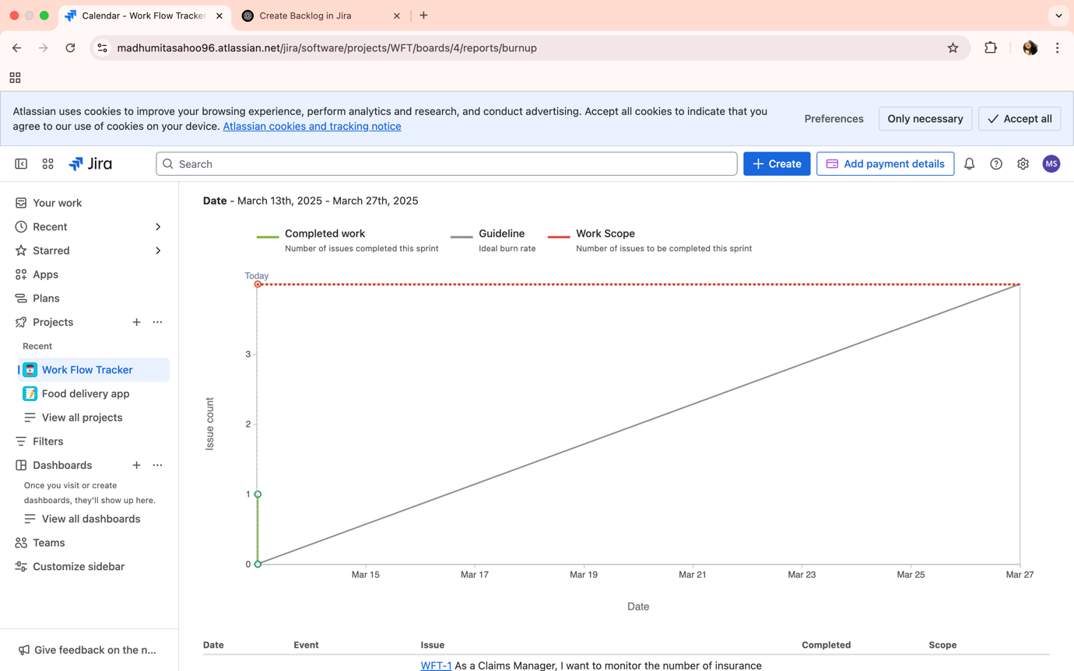

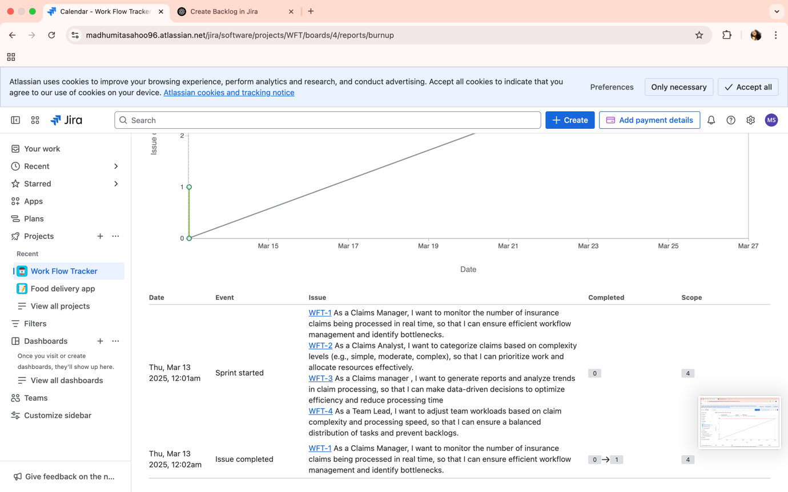

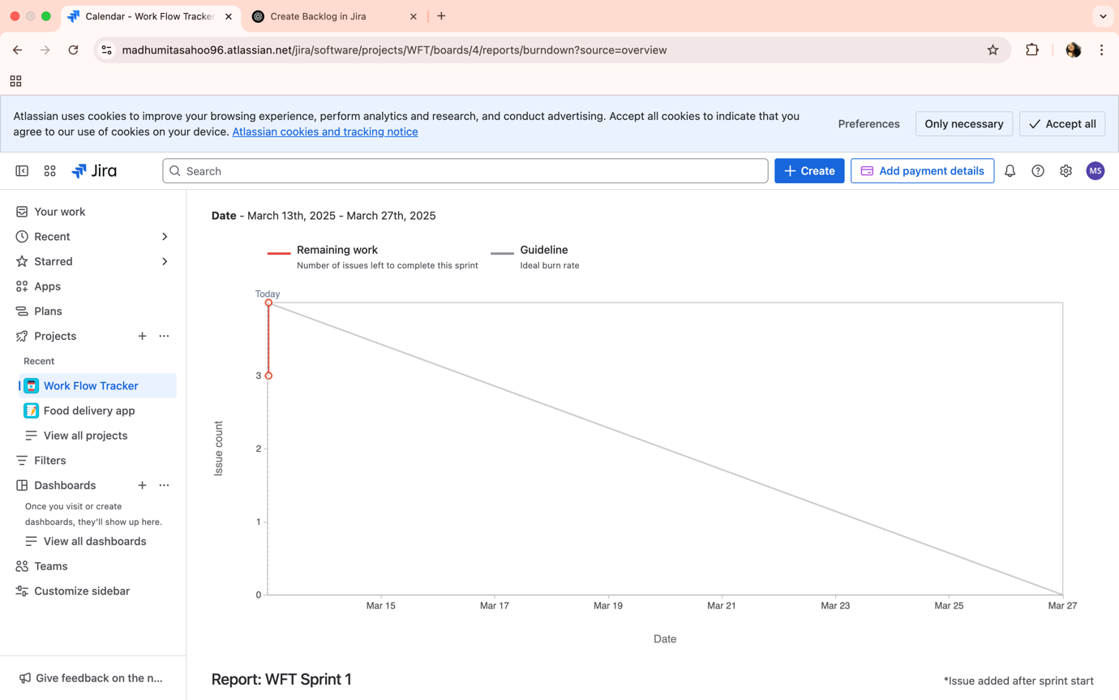

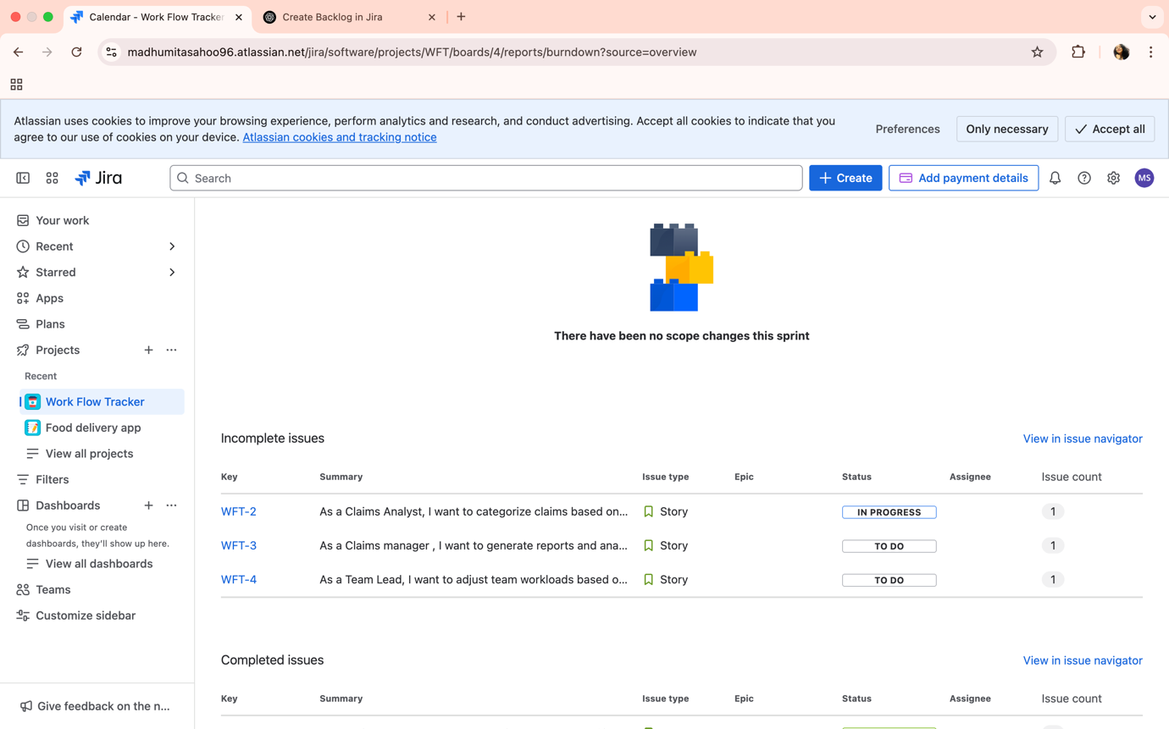

**Answer-6**

**Sprint Meetings**

**Meeting Type 1: Sprint planning meeting**

|  |  |
| --- | --- |
| **Date** | **21/03/2025** |
| **Time** | **11:00 am** |
| **Location** | **Pune** |
| **Prepared by** | **Mr Ajay** |
| **Attendees** | **Mr Ajay, Ms Pooja , Ms Anna, Mr Sid** |

**Agenda Topics**

|  |  |  |
| --- | --- | --- |
| **Topic** | **Presenter** | **Time allotted** |
| Adjust the widgets so that TL can view relevant KPIs. | PO- Ms Pooja | 1:00- 2:00 pm |
|  |  |  |

**Other Information**

|  |  |
| --- | --- |
| **Observers** |  |
| **Resources** |  |
| **Special** |  |

**Meeting Type 2 : Sprint review meeting**

|  |  |
| --- | --- |
| **Date** | **22/03/2025** |
| **Time** | **11:00 am** |
| **Location** | **Pune** |
| **Prepared By** | **Scrum Master- Mr. Ajay** |
| **Attendees** | **Mr Ajay, Ms Pooja , Ms Anna, Mr Sid** |

|  |  |  |  |
| --- | --- | --- | --- |
| **Sprint Status** | **Things to do** | **Quick updates** | **What’s next** |
| **In- progress** | **1.** |  |  |

**Meeting Type 3 : Sprint Retrospective meeting**

|  |  |
| --- | --- |
| **Date** |  |
| **Time** |  |
| **Location** |  |
| **Prepared by** |  |
| **Attendees** |  |

|  |  |  |  |  |
| --- | --- | --- | --- | --- |
| **Agenda** | **What went well** | **What didn’t go well** | **Questions** | **Reference** |
|  |  |  |  |  |
|  |  |  |  |  |

**Meeting Type 4 : Daily stand-up meeting**

|  |  |  |  |  |  |  |  |  |
| --- | --- | --- | --- | --- | --- | --- | --- | --- |
| **Question** | **Name/Role** |  | | | | | | |
| **What did you do yesterday ?** | Developer  Mr Sid  Ms. Anna  Mr. Anil | **Completed tasks**   * As a Claims Manager, I want to monitor the number of insurance claims being processed in real time, so that. I can ensure efficient workflow management and identify bottlenecks. * As a Claims Analyst, I want to categorize claims based on complexity levels (simple, moderate, complex), so that I can prioritize work. |  |  |  |  |  |  |
| **What will you do today ?** | Developer  Mr Sid  Ms. Anna  Mr. Anil | **Current day Priority**  Adjust the widgets so that TL can view relevant KPIs. |  |  |  |  |  |  |
| **What (if any) is blocking your progress ?** | Developer  Mr Sid  Ms. Anna  Mr. Anil | Identified the obstacles that need resolution. |  |  |  |  |  |  |