**Q1. Identify minimum 20 functional requirements**

**Ans.**

**Functional Requirements**

Functional requirements define the specific behaviours, functions or Operations of a system. They describe what the system should do, outlining the necessary tasks, actions or activities it must perform to achieve its objectives. Below are 20 Functional Requirements:

|  |  |  |
| --- | --- | --- |
| **Req ID** | **Req Name** | **Req Description** |
| FR001 | User Registration: | New users (Farmers and Manufacturers) shall be able to register by providing their email ID, password, and other required details. |
| FR002 | User Login: | Existing users shall log in using their registered email and password. |
| FR003 | Password Recovery: | Users shall be able to recover or reset their password via an email link. |
| FR004 | Product Catalog: | The system shall display a categorized product catalog (fertilizers, seeds, pesticides) to users. |
| FR005 | Product Search: | The system shall allow users to search products by name, category, or manufacturer. |
| FR006 | Product Filters: | Users shall filter products based on attributes like price range, brand, and availability. |
| FR007 | Add to Cart: | Farmers shall add selected products to a shopping cart for purchase. |
| FR008 | Save for Later | Farmers shall save products to a "Buy Later" list for future consideration. |
| FR009 | Payment Options | The system shall provide payment options, including COD, Credit/Debit Card, and UPI. |
| FR010 | Secure Payment Gateway | Payments shall be processed securely using industry-standard encryption protocols. |
| FR011 | Order Confirmation | The system shall send an email confirmation to the user upon successful order placement. |
| FR012 | Delivery Tracking | Farmers shall track the status and location of their order in real-time. |
| FR013 | Order History | Farmers shall view their past orders, including product details, order date, and status. |
| FR014 | Manufacturer Product Upload | Manufacturers shall upload product details, including name, category, price, and description. |
| FR015 | Product Management | Manufacturers shall update or remove product details as needed. |
| FR016 | Farmer Profile Management | Farmers shall update their profile details, such as address and contact information. |
| FR017 | Notifications | The system shall send notifications for order updates, such as "Order Shipped" or "Order Delivered." |
| FR018 | Delivery Scheduling | Farmers shall select a preferred delivery date and time slot during checkout. |
| FR019 | Product Reviews | Farmers shall leave reviews and ratings for purchased products. |
| FR020 | Admin Dashboard | An admin dashboard shall allow the management of users, products, and orders. |

**Non Functional Requirements**

These Requirements describe the qualities and attributes of a system, focusing on how the system performs rather than the specific behaviors and functions.

|  |  |  |
| --- | --- | --- |
| Req ID | Req Name | Req Description |
| NFR001 | System Response Time | The system should respond to any user action (e.g., loading a product catalog or processing payments) within 3 seconds. |
| NFR002 | Concurrent Users | The application should support at least 10,000 concurrent users without degradation in performance. |
| NFR003 | Data Throughput | The system should handle at least 100 transactions per second during peak hours. |
| NFR004 | Horizontal Scalability | The system should scale horizontally to support future user and data growth. |
| NFR005 | Database Scalability | The database must support growth in product catalog size, up to 10 million products. |
| NFR006 | System Uptime | The application should have 99.9% availability, ensuring minimal downtime (less than 8.76 hours/year). |
| NFR007 | Disaster Recovery | The system should recover from a disaster (e.g., server failure) within 30 minutes. |
| NFR008 | User Authentication | Ensure secure user authentication using encrypted passwords and support multi-factor authentication (MFA). |
| NFR009 | Data Encryption | All sensitive data (e.g., user credentials, payment details) must be encrypted during storage and transmission using AES-256 and SSL/TLS. |
| NFR010 | Access Control | Differentiate access levels for farmers, manufacturers, and administrators. |
| NFR011 | Mobile Accessibility | The application must be fully functional on mobile devices with screen sizes ranging from 4 to 10 inches. |
| NFR012 | User Interface Standards | The system should comply with WCAG 2.1 AA accessibility guidelines. |
| NFR013 | Ease of Use | New users should be able to complete registration in less than 2 minutes. |
| NFR014 | Fault Tolerance | The system should continue to function normally even if one server fails in the cluster. |
| NFR015 | Data Integrity | Ensure that no transactions are lost or duplicated, even during a system crash. |
| NFR016 | Modular Code | The codebase should follow a modular architecture, ensuring that minor updates can be deployed in under 2 hours. |
| NFR017 | Logging and Monitoring | Include comprehensive logging to monitor performance and troubleshoot issues in real-time. |
| NFR018 | Data Protection | Ensure compliance with GDPR and Indian IT Act for user data privacy. |
| NFR019 | Payment Compliance | The payment gateway must adhere to PCI DSS standards. |
| NFR020 | Multi-Language Support | The system should support at least 3 local languages (e.g., Hindi, Telugu, Tamil) in addition to English. |

**Q2. Make wireframe and prototypes**

**Ans.** Below Given are 5 Wireframes for different pages of a Online Shopping website:

1. **Registration Page**

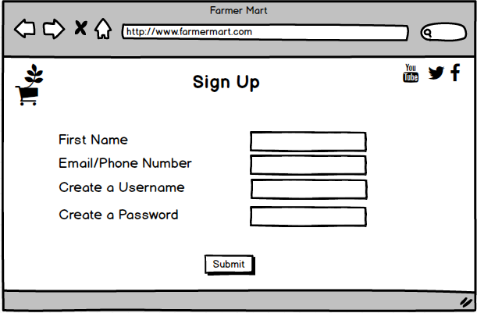

1. **Login Page**

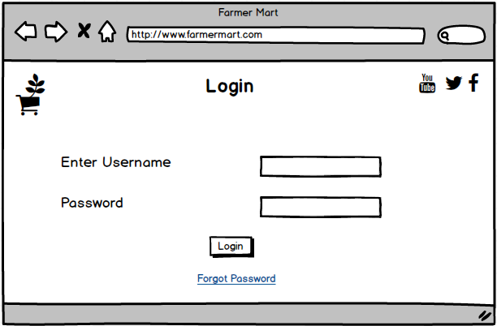

1. **Search For Products**

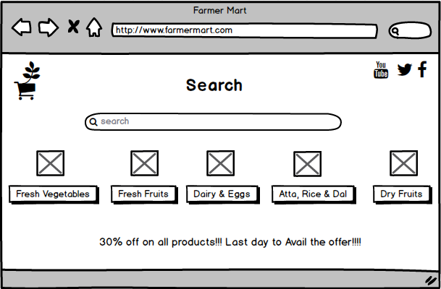

1. **Check Out Page**

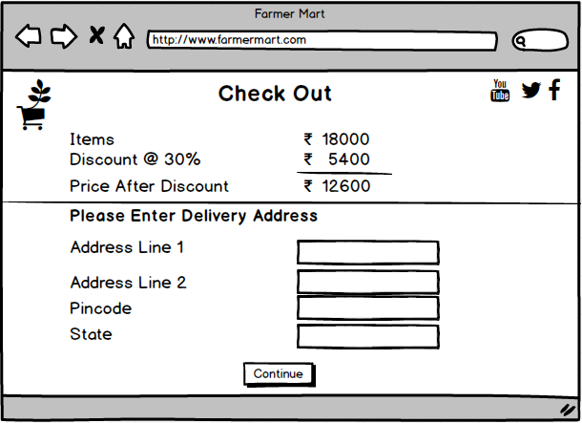

1. **Payments Page**

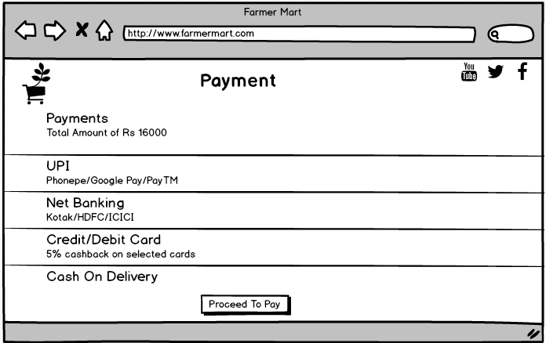

**Q3. Make a note of the Tools, which you are using for above concepts.**

### ****Balsamiq****

Balsamiq is a user-friendly, low-fidelity wireframing tool designed for creating quick sketches of user interfaces. It uses a drag-and-drop interface with pre-built elements like buttons, input fields, and menus, making it easy to visualize layouts and workflows. Balsamiq is ideal for early-stage brainstorming as it emphasizes structure and functionality over visual details. It allows teams to collaborate and refine designs based on stakeholder feedback. In the above scenario, Balsamiq can be used to outline the basic structure of the online store's pages, such as the product catalog, login screen, and checkout process.

### ****Microsoft Visio****

Microsoft Visio is a versatile diagramming tool that can be adapted for wireframing. It offers templates and shapes for creating detailed flowcharts, wireframes, and even prototypes. Visio's strength lies in its ability to visually represent complex workflows and relationships, making it suitable for designing both static wireframes and process diagrams. In the context of the above scenario, Visio could be used to map out the application's user flow (e.g., registration to checkout) and create more detailed wireframes to communicate ideas with technical teams.

**Axure RP Pro**

Axure is a powerful prototyping and wireframing tool used by designers and UX professionals to create interactive, high-fidelity prototypes without coding. It allows users to build dynamic, clickable prototypes with advanced interactions, conditional logic, and real-time collaboration, making it ideal for testing and refining user experiences before development.

**Q4. A business analyst’s key responsibilities are to keep track of the requirements and make sure that no requirement is missed. Mr. Henry and peter have approached you regarding the current status of the project. How will you tackle this situation?**

**Ans.** This situation can be tackled with the help of **Requirements Traceability Matrix (RTM).** It is a document to track the requirements throughout the Project life cycle, ensuring that all of them are met and no requirements are overlooked. A Requirements Traceability Matrix (RTM) is a document that links project requirements to their corresponding deliverables, ensuring that all requirements are met throughout the development process. It helps track progress, verify that each requirement is implemented correctly, and maintain alignment between business needs and project outcomes. Example of an R TM is given below:

|  |  |  |  |  |  |  |  |  |  |
| --- | --- | --- | --- | --- | --- | --- | --- | --- | --- |
| **Req ID** | **Req Name** | **Req Description** | **Design** | **Code** | **Unit Testing** | **Component Testing** | **System Testing** | **SIT** | **UAT** |
| **FR001** | Farmer Registration | Farmers should be able to register with the application | Complete | Complete | Complete | Complete | Complete | Complete | Incomplete |
| **FR002** | Farmer Search for Products | Farmers should be able to search for available products in fertilizers, seeds, pesticides | Complete | Complete | Complete | Complete | Incomplete | Incomplete | Incomplete |
| **FR003** | Farmer request for Detailed Products | Farmer should be able to request for Details of the Product | Complete | Complete | Complete | Complete | Incomplete | Incomplete | Incomplete |
| **FR004** | Add Product to the Cart | Farmer should be able to add products to the Cart | Complete | Complete | Complete | Complete | Incomplete | Incomplete | Incomplete |
| **FR005** | Buy Product | Farmer should be able to buy the Product | Complete | Complete | Complete | Complete | Incomplete | Incomplete | Incomplete |
| **NFR001** | Page Loading Time | Each page should load within 2 seconds time | Complete | Complete | Complete | Complete | Incomplete | Incomplete | Incomplete |
| **NFR002** | System Response Time | The system should respond to any user action within 3 seconds | Complete | Complete | Complete | Complete | Incomplete | Incomplete | Incomplete |

**Q5. Prepare 10 Test Case Documents**

**Ans.** A Test Case Document is a detailed document that outlines the specific conditions, inputs, actions, and expected outcomes for testing a particular feature or functionality of a software application. It helps ensure that software behaves as expected by defining test scenarios, preconditions, steps to execute, expected results, and postconditions. This document is critical for systematic testing and helps track the validation process during quality assurance.

|  |  |  |  |  |  |  |  |  |  |  |  |  |  |  |  |
| --- | --- | --- | --- | --- | --- | --- | --- | --- | --- | --- | --- | --- | --- | --- | --- |
| **Test Case ID** | **Requirement ID** | **Test Case Name** | **Description** | **Preconditions** | **Test Steps** | **Expected Result** | **Status** |  |  |  |  |  |  |  |  |
| TC0001 | FR0001 | Verify Farmer Registration | Test farmer registration functionality | Application must be accessible, test data prepared | 1. Navigate to registration page. \n2. Enter valid email and password. \n3. Submit form. | User should be successfully registered, and confirmation message displayed. | Pending |  |  |  |  |  |  |  |  |
| TC0002 | FR0001 | Validate Duplicate Registration | Ensure duplicate accounts cannot be created with the same email | Application must be accessible, valid email prepared | 1. Navigate to registration page. \n2. Enter an email already registered. \n3. Submit form. | Error message indicating duplicate account should appear. | Pending |  |  |  |  |  |  |  |  |
| TC0003 | FR0002 | Search Products by Name | Verify that farmers can search for a product by its name | Product catalog should have at least one product | 1. Navigate to search bar. \n2. Enter a valid product name. \n3. Click search. | Relevant product results should be displayed. | Pending |  |  |  |  |  |  |  |  |
| TC0004 | FR0002 | Search with No Results | Validate system response when no products match search query | Product catalog accessible | 1. Navigate to search bar. \n2. Enter a non-existent product name. \n3. Click search. | A message stating "No results found" should be displayed. | Pending |  |  |  |  |  |  |  |  |
| TC0005 | NFR0101 | Verify Page Load Time | Ensure all pages load within the defined time limit | Network speed is stable | 1. Access application page. \n2. Record load time. | All pages should load within 2 seconds. | Pending |  |  |  |  |  |  |  |  |
| TC0006 | NFR0102 | Validate Accessibility Compliance | Check system adherence to WCAG 2.1 guidelines | Accessibility testing tools available | 1. Use testing tool to analyze page for WCAG 2.1 compliance. | The system should meet WCAG 2.1 standards. | Pending |  |  |  |  |  |  |  |  |
| TC0007 | FR0002 | Search Using Filters | Test product search functionality with filters applied (e.g., category, price range) | Product catalog accessible | 1. Navigate to filters. \n2. Apply specific filters. \n3. Perform search. | Filtered results matching the criteria should appear. | Pending |  |  |  |  |  |  |  |  |
| TC0008 | FR0001 | Validate Password Complexity | Ensure the system enforces secure password requirements during registration | Registration page accessible | 1. Enter weak password. \n2. Attempt registration. | Error message indicating password does not meet requirements. | Pending |  |  |  |  |  |  |  |  |
| TC0009 | FR0002 | Verify Search Performance | Test search functionality responsiveness and speed | Product catalog accessible | 1. Perform multiple searches with various keywords. | Search results should appear within 1 second. | Pending |  |  |  |  |  |  |  |  |
| TC0010 | FR0002 | Verify Search Suggestions | Ensure the system provides suggestions for partially entered keywords | Product catalog accessible | 1. Enter partial keyword in search bar. | Relevant suggestions should appear as user types. | Pending |  |  |  |  |  |  |  |  |

**Q6. After the requirements are thoroughly explained to the entire project team by business analyst, the Database architects have decided to do the database design and also to represent the in-flow and out-flow of data. Draw database schema and ER diagram.**

**Ans.** DB Schema is a blueprint that outlines the structure of a Database, including its tables, fields, relationships, constraints and other characteristics.

An Entity Relationship diagram is a visual representation of the relationships between entities in a database. It depicts the Entities (such as tables), attributes (properties or fields) and relationships between them.

Given Below is an Example of a DB Schema:

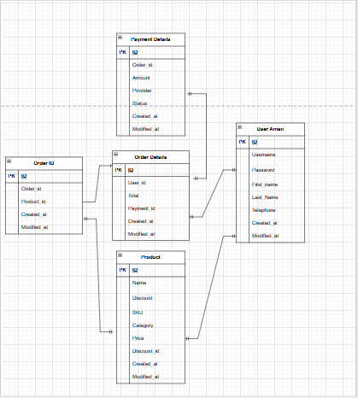

Given Below is an example of an Entity Relationship Diagram:

**Order Item**

Order Item ID

Order ID

Product ID

Quantity

Price

**User**

User Id

Name

Email

Password

Role

**Order**

Order ID

Order Date

Total Amount

Payment status

Delivery Status

**Order ID**

**Order Date**

#### Us

User Id

**Payment**

Payment ID

Order ID

Payment date

Payment method

Payment status

**Product**

Product ID

Name

Description

Category

Price

**Delivery Tracking**

Delivery ID

Order ID

Tracking Number

Estimated delivery date

Current status

**Q7. What is a data flow diagram? Draw a data flow diagram to represent the in-flow and out-flow of data when a Farmer is placing an order for the product.**

A **Data Flow Diagram (DFD)** is a graphical representation of the flow of data within a system. It illustrates how data is processed, stored, and communicated between entities, processes, and data stores. A DFD helps in understanding the system's functionality and the movement of data in a clear and structured way.

#### **Key Components of a DFD:**

1. **External Entities**: Sources or destinations of data outside the system (e.g., Farmers, Manufacturers).
2. **Processes**: Actions or operations performed on the data (e.g., Place Order, Update Inventory).
3. **Data Stores**: Repositories where data is stored (e.g., Products Database, Orders Database).
4. **Data Flows**: Arrows that show the movement of data between entities, processes, and data stores.

**Given Below is a Dataflow diagram when a Farmer places an order:**

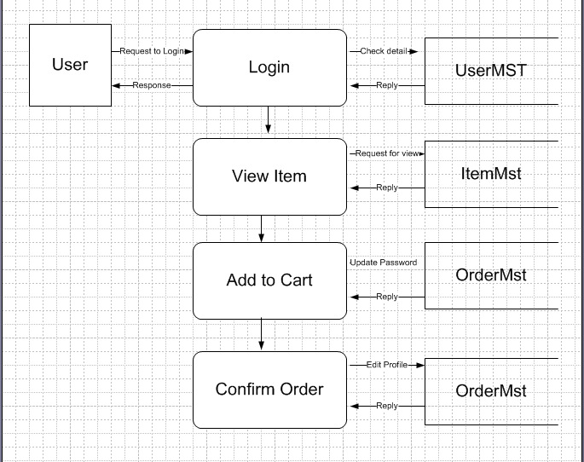

**Q8. Due to change in the Government Taxation structure, we should change the Tax structure How do you handle change requests in a project?**

Handling change requests in a project requires a structured and efficient approach to ensure minimal disruption while aligning with project goals. Below is a step-by-step process to handle change requests, such as the one regarding the change in the Government Taxation structure:

**Steps to Handle Change Requests:**

1. **Receive and Document the Change Request**
   * Record the request details, including its description, reason, and impact. For example, document the specific changes in tax rules and their implications on the application.
2. **Assess the Impact**
   * Evaluate how the change affects the project scope, timeline, budget, and resources.
   * In this case, determine how the tax structure change impacts product prices, invoicing, payment calculations, and database modifications.
3. **Prioritize the Change**
   * Discuss with stakeholders (e.g., Mr. Henry, Project Manager) to determine the urgency and importance of the change.
   * Categorize the request as "critical" if it's a legal compliance issue.
4. **Engage Relevant Teams**
   * Involve technical teams, such as database architects, developers, and testers, to understand the technical feasibility and implementation approach.
   * Ensure all affected modules (e.g., pricing, tax calculation, invoice generation) are identified.
5. **Update Project Documentation**
   * Update the **Requirements Traceability Matrix (RTM)** to include the new requirements related to tax changes.
   * Revise functional specifications and system design documents to reflect the changes.
6. **Obtain Approval**
   * Present the impact analysis and updated documentation to the Change Control Board (CCB) or decision-makers (e.g., Mr. Henry, committee members).
   * Secure formal approval before proceeding.
7. **Plan for Implementation**
   * Create a detailed plan to implement the changes, including tasks, timelines, and assigned resources.
   * Ensure all new tax rules are incorporated into the system logic, database, and user interfaces.
8. **Communicate with Stakeholders**
   * Inform all stakeholders (farmers, manufacturers, project team) about the upcoming changes.
   * Provide training or updates if the changes affect user behavior.
9. **Implement the Changes**
   * Update the system with the revised tax structure.
   * Modify tax-related fields in the database and ensure dynamic application of tax rules.
10. **Test the Changes**
    * Conduct rigorous testing to verify that the tax changes are correctly applied in all scenarios (e.g., product purchase, invoice generation, refunds).
    * Perform regression testing to ensure no other functionality is impacted.
11. **Monitor and Evaluate**
    * After deployment, monitor the system for any issues or user feedback.
    * Evaluate if the implemented changes meet the intended objectives.
12. **Document Lessons Learned**
    * Record the process and any challenges faced to improve the handling of future change requests.

**Q9. As the project is in process, Ben and Kevin have contacted you. The reason is to inform you that they want the Farmers to sell their crop yields through this application i.e. Farmers should be able to add their crop yields or products and display to general public and should be able to sell them. They also want to introduce Auction system for their Crop yields. As a BA, what will be your response? Is this a change request or an enhancement?**

This scenario would likely be considered a rather than a **change request rather than an enhancement**.

### ****Reasoning:****

* **Original Scope**: The original scope of the project, based on the requirements gathered earlier, was to provide a platform for farmers to purchase agricultural products (fertilizers, seeds, and pesticides) from manufacturers, not to sell their crop yields. This is a core function of the application that has now changed.
* **New Requirement**: The new requirement, where farmers would not only buy products but also sell their crop yields and engage in an auction system, introduces a significant shift in the platform’s functionality. This adds new features (crop selling and auction system) that were not initially anticipated.

### ****Change Request vs Enhancement:****

* **Change Request**: A **change request** typically involves modifications to the agreed-upon scope of the project. In this case, the introduction of a feature for farmers to sell their crop yields and implement an auction system alters the original purpose and business flow of the platform. It’s a shift from being a buyer-only platform to a platform that facilitates both buying and selling, which requires significant adjustments.
* **Enhancement**: An **enhancement** usually refers to improvements to existing features or adding more options within the original scope. For example, expanding the types of products offered for sale or improving search functionality would be an enhancement. However, adding an entirely new business model (selling crops, auction system) is not just an improvement but a new feature.

### ****Steps to Handle the Change Request:****

1. **Impact Analysis**: Assess the impact on the project timeline, cost, resources, and technical feasibility. This new functionality would likely involve changes to the database, UI, order management system, and possibly the addition of new modules like auctions and user listings for selling crops.
2. **Stakeholder Communication**: Clearly communicate the implications of this new request with Mr. Henry, Ben, and Kevin. Ensure all stakeholders understand the additional costs, time, and resource requirements that might be involved.
3. **Document the Change**: Create a formal document outlining the change request, including new functionality, business rules for the auction system, UI/UX adjustments, and any other relevant details.
4. **Revised Project Plan**: Based on the impact analysis, revise the project plan and schedule to account for this new feature. If the change is approved, ensure that the development team is aligned with the updated requirements.

**Q10. Come up with estimations – How many Manhours required.**

**Ans.**

To estimate the manhours required completing the overall project and also for implementing the **new features** (selling crop yields and auction system) in the Online Agriculture Product Store, we need to break down the tasks involved. A high-level estimation based on common software development practices, which includes tasks such as requirement analysis, design, development, testing, and deployment is as follows:

In the Given scenario the Total time period of the project is 18 months and the team size is 15.

### ****Total Estimated Manhours**: **1025 hrs****

* **Requirement Analysis & Documentation**: 62 hours
* **System Design**: 125 hours
* **Development**: 450 hours
* **Integration**: 125 hours
* **Testing**: 175 hours
* **Deployment**: 88 hours

### ****Manhour Distribution for Team Members**:**

* **Business Analyst (BA)**: 62 hours (Requirement Analysis & Documentation)
* **System Architects & Designers**: 125 hours (System Design)
* **Backend & Frontend Developers**: 450 hours (Development)
* **Integration Developers**: 175 hours (Integration)
* **QA/Testers**: 175 hours (Testing)
* **DevOps/Deployment Team**: 88 hours (Deployment)

### ****Breakdown of Tasks:****

#### 1. **Requirement Analysis & Documentation (20-30 hours)**

* Understand and document the detailed requirements for adding crop yields and auction functionality.
* Meet with stakeholders (Ben, Kevin, Mr. Henry) to confirm business rules and expectations.
* Document new use cases, user stories, and functional/non-functional requirements.

**Estimated Manhours**: 25 hours

#### 2. **System Design (40-60 hours)**

* Design database schema changes to accommodate the crop yields and auction functionalities (e.g., farmer profiles, crop details, bidding details).
* Design the architecture for the auction system and new seller functionality.
* Design UI/UX for farmers to add their products, view auction details, and manage their listings.

**Estimated Manhours**: 50 hours

#### 3. **Development (160-200 hours)**

* **Backend Development**:
  + Implement APIs for farmers to create crop listings, update product details, and manage auctions.
  + Develop backend logic for auction creation, bidding process, and auction results.
  + Modify the payment gateway to handle selling transactions.
  + Modify the product catalog system to include the crops available for sale.
* **Frontend Development**:
  + Develop user interfaces for farmers to add and manage their crop yields.
  + Implement auction-related UI features (auction countdown, bid functionality, current highest bid).
  + Make changes to the product catalog to accommodate seller and auction views.

**Estimated Manhours**: 180 hours

#### 4. **Integration (40-60 hours)**

* Integrate the new auction and crop selling functionalities into the existing platform.
* Ensure smooth integration with the product catalog, order management, and payment systems.
* Test integration for potential conflicts or performance issues.

**Estimated Manhours**: 50 hours

#### 5. **Testing (60-80 hours)**

* **Unit Testing**: Ensure all new backend components (e.g., auction logic, crop listing management) are working as expected.
* **UI Testing**: Test the new user interfaces for usability, responsiveness, and bug fixes.
* **Integration Testing**: Test the interactions between crop selling, auction systems, and the existing system (including payment and delivery tracking).
* **User Acceptance Testing (UAT)**: Have stakeholders review the new features and provide feedback for further adjustments.

**Estimated Manhours**: 70 hours

#### 6. **Deployment & Post-Deployment Support (30-40 hours)**

* Deploy the new features to staging and production environments.
* Monitor the system for any bugs or performance issues post-deployment.
* Provide support for any hotfixes and issues that arise immediately after release.

**Estimated Manhours**: 35 hours

**Q11. Project has finally completed all the stages i.e., design, development, testing etc. Now, it is the role of a business analyst to contact the client for testing of the final product and have to successfully complete it. How are you going to handle this situation? And once it is done, what will be the process to close the project? Explain UAT Acceptance process.**

The **User Acceptance Testing (UAT)** phase is a crucial part of ensuring that the final product meets the client’s expectations and requirements. The manner in which we should handle this situation and manage the closure of the project, along with an explanation of the **UAT Acceptance Process is as follows**:

1. **Preparation:**
   * As a BA, ensure that all requirements are documented clearly and the product matches those requirements.
   * Define acceptance criteria for each functional aspect of the system. These criteria should reflect the stakeholders' expectations.
2. **Testing:**
   * Have end users (farmers, manufacturers, and other relevant parties) execute the tests as per the UAT plan.
   * Document the outcomes of these tests, whether they pass or fail. All issues identified should be logged and addressed immediately by the development team.
3. **Review & Issue Resolution:**
   * **Feedback Loop**: Gather feedback from UAT testers and prioritize any issues.
   * Work closely with the development and QA teams to ensure that all issues are addressed before the final product is approved.
4. **Sign-off:**
   * **UAT Acceptance Sign-off**: Once all issues are resolved and the application functions as expected, the stakeholders will give a **formal sign-off**.
     + This is a critical part of the process, as it signifies that the application has been accepted and is ready for deployment.
   * Ensure that all UAT test results, feedback, and sign-off documentation are collected and stored for reference.

#### 1. **Prepare for UAT:**

* **Review the Requirements**: Ensure that the product delivered aligns with the business requirements that were originally gathered and documented. This includes both the original and new features (e.g., crop selling and auction system).
* **Create UAT Test Plan**: Prepare a UAT Test Plan that outlines:
  + **Objectives**: What the UAT phase aims to achieve (validating that the product meets user needs).
  + **Test Cases**: Detailed test cases based on user stories and requirements.
  + **Test Environment**: Ensure that the test environment mirrors production conditions as closely as possible.
  + **Resources**: Identify the users who will participate in testing (e.g., farmers, administrators).
  + **Timeline**: Set clear timelines for when testing will begin and end.

#### 2. **Coordinate with Stakeholders:**

* **Schedule UAT Sessions**: Coordinate with **Mr. Henry**, **Ben**, **Kevin**, and other stakeholders to schedule UAT sessions. Ensure that all participants understand their roles and the objectives of UAT.
* **Provide Training**: If necessary, offer training to the users (farmers, manufacturers, etc.) on how to perform UAT and use the application effectively.

#### 3. **Executing UAT:**

* **Conduct UAT Sessions**: During UAT, have stakeholders test the application based on the test cases. They should:
  + Verify functionality (e.g., login, search products, crop selling, auction bidding).
  + Check the usability and design (e.g., ease of use for farmers to list crops or bid).
  + Test the integration with payment gateways and delivery tracking.
  + Report any issues or bugs they encounter.
* **Log Issues**: Ensure that any issues, bugs, or feedback are logged in a **defect tracking system**. Work with the development team to prioritize and resolve these issues quickly.

#### 4. **Monitor UAT Progress:**

* **Regular Check-ins**: Hold regular meetings with the stakeholders to review the testing progress and address any concerns that arise.
* **Track Test Results**: Keep track of test results to ensure all critical functionalities are working as expected. If any issues are discovered, they should be addressed promptly.

#### 5. **Obtain UAT Sign-off:**

* Once all tests have passed or critical issues are resolved, get formal sign-off from the stakeholders. **UAT sign-off** indicates that the stakeholders are satisfied with the product and that the application is ready for deployment.

### ****Closing the Project:****

1. **Post-UAT Reviews and Documentation**:
   * **Review Project Objectives**: Confirm that the project objectives were met and that the deliverables were completed as per the initial agreement.
   * **Final Documentation**: Ensure that all project documentation, including requirements, test cases, test results, and user manuals, is complete and handed over to the client.
2. **Client Handover**:
   * **Client Training**: If required, provide training to the client on how to use the system, especially for new features (e.g., crop selling and auction).
   * **System Handover**: Provide all technical documentation, including the architecture, system design, and user manuals.
3. **Project Closure Report**:
   * Create a **project closure report** summarizing the project’s performance:
     + Achievements.
     + Key milestones.
     + Challenges encountered and how they were resolved.
     + Final budget and timeline.
     + Stakeholder feedback.
4. **Feedback from Stakeholders**:
   * Gather feedback from the client (Mr. Henry, Ben, Kevin) and other stakeholders regarding the overall experience and any potential future improvements.
5. **Project Closure**:
   * Once the client is satisfied and all necessary documents are handed over, formally **close the project**. This typically involves:
     + Archiving project materials.
     + Closing out financials.
     + Conducting a post-mortem analysis to identify lessons learned for future projects.

### ****Conclusion:****

By following the steps outlined above, you will help ensure that the project is completed successfully and that all stakeholders are satisfied with the final product. Proper UAT execution and a well-structured project closure process will help cement the success of the application and its continued use.

**Q12. Explain Project closure document.**

A **Project Closure Document** also known as a **Project Closure Report** is an essential part of the project management process, marking the formal conclusion of a project. It serves as a record of the project's outcomes, final deliverables, and lessons learned, ensuring that the project is fully completed and that all necessary administrative steps are followed before closing the project. It also helps in assessing whether the project met its objectives and in identifying areas for improvement in future projects.

**Key Components of a Project Closure Document:**

1. **Project Overview**:
   * **Project Name**: The name or title of the project.
   * **Project ID/Code**: If applicable, the unique identifier for the project.
   * **Project Manager**: The person responsible for the overall management and successful completion of the project.
   * **Stakeholders**: List of key stakeholders (e.g., Mr. Henry, Ben, Kevin, the development team, etc.).
   * **Project Duration**: The start date and end date of the project.
   * **Project Budget**: The allocated budget for the project and the actual expenditure.
2. **Project Objectives and Scope**:
   * A summary of the initial objectives and scope of the project as defined during the planning phase. This section ensures that the project is assessed based on the original goals.
   * Mention of any scope changes occurred during the project (such as the addition of features like crop selling and auction systems).
3. **Final Deliverables**:
   * A list of the **final deliverables** that were agreed upon at the beginning of the project. For example, the developed online agriculture product store with functionalities like product catalog, search options, crop selling, and auction systems.
   * Confirm if all deliverables were completed and whether they met the quality standards and expectations of the stakeholders.
4. **Resource Utilization & Risk Management**:
   * **Schedule Performance**: Compare the original project timeline with the actual time taken to complete the project.
   * **Budget Performance**: Compare the original budget with the actual cost incurred, noting any deviations and reasons for them.
   * **Quality Metrics**: Assess whether the quality of the deliverables met the pre-established standards and whether they passed user acceptance testing (UAT).
   * **Risk and Issue Management**: Review how well risks and issues were managed throughout the project, and whether there were any major unexpected challenges.
5. **User Acceptance Testing (UAT) Summary**:
   * **UAT Results**: Summarize the results of the UAT phase, including any issues raised by stakeholders and how they were resolved.
   * **Sign-off**: Document the **UAT sign-off** from stakeholders confirming that the product met their expectations and was ready for deployment.
6. **Lessons Learned**:
   * A critical section that records insights and lessons learned during the project. This can include both **successes** (things that went well) and **challenges** (areas where the project faced difficulties).
   * Recommendations for future projects based on the lessons learned, such as improvements in communication, resource allocation, or project planning.

The **Project Closure Document** is crucial for ensuring transparency and accountability at the end of a project, and it serves as a key reference point for evaluating the project's success and identifying areas for future improvements. Would you like assistance with drafting any specific sections of this document?

Bottom of Form