**MOCK INTERVIEW CASE STUDY**

**ASSIGNMENT - 1**

**Scenario:** A company is having manufacturing plants and warehouses in various parts of the country. They manufacture ice-cream and milk products. They want to build software to achieve two goals. i. Manage the inventory. Ii Quickest delivery to the customers

**BRD DOCUMENT**

**Dairy and Plants Inventory Management Application**

**PRJ - 20201**

**Version: 1.0.1.2.1**

**Sarath Guru Raj**

1. **Document Revisions**

|  |  |  |
| --- | --- | --- |
| **Date** | **Version Number** | **Document Changes** |
| 05/04/2025 | 0.1 | Initial Draft of the project documentation |
| 11/04/2025 | 0.2 | Updated Project objectives and scope |
| 21/04/2025 | 0.3 | Stakeholder analysis and elicitation techniques |
| 27/04/2025 | 0.4 | Added risk assessment and mitigation strategies |
| 06/04/2025 | 0.5 | Finalized functional requirement and success criteria |
| 11/04/2025 | 0.6 | Updated priority and RTM status |
| 19/04/2025 | 0.7 | Incorporated appendices and Finalized documents |

1. **Approvals**

|  |  |  |  |  |
| --- | --- | --- | --- | --- |
| **Role** | **Name** | **Title** | **Signature** | **Date** |
| Project Sponsor | Ram Kumar | Senior Vice President | Ram Kumar | 01/05/2025 |
| Business Owner | Sharma | Director of Operations | Sharma | 01/05/2025 |
| Project Manager | Vikram | IT Project Manger | Vikram | 02/05/2025 |
| System Architect | Neha Srider | Lead Architect | Neha Srider | 02/05/2025 |
| Development Lead | Arjun Rao | Lead Technical Manager | Arjun Rao | 03/05/2025 |
| User Experience Lead | Priya verma | Ux/UI lead | Priya verma | 03/05/2025 |
| Quality Lead | Desai kumar | QA manager | Desai kumar | 04/05/2025 |
| Content Lead | Kavita Raj | Documentation Specialist | Kavita Raj | 04/05/2025 |

1. **RACI Chart for This Document**

**RACI Chart**

|  |  |  |  |  |  |  |  |
| --- | --- | --- | --- | --- | --- | --- | --- |
| **Name** | **Position** | **\*** | **R** | **A** | **S** | **C** | **I** |
| Ram Kumar | Project Sponsor | X |  | X |  | X | X |
| Sharma | Business Owner | X |  | X | X | X | X |
| Vikram | Project Manager | X | X | X | X |  | X |
| Neha Srider | System Architect |  | X |  | X |  | X |
| Arjun Rao | Development Lead |  | X |  | X |  | X |
| Priya verma | User Experience Lead |  | X |  | X |  | X |
| Desai kumar | Quality Lead |  | X |  | X |  | X |
| Kavita Raj | Content Lead |  | X |  | X |  | X |

1. **Introduction**
   1. **Business Goals**

The primary goal of this project is to develop a comprehensive software solution that enhances inventory management and optimizes delivery operations. By implementing real-time inventory tracking, the system will minimize product wastage, improve stock utilization, and ensure availability across multiple warehouses. Additionally, the software will incorporate an automated route optimization feature, reducing delivery time and ensuring that perishable products reach customers in the freshest condition. Through efficient order processing and fulfilment, the company aims to enhance customer satisfaction while simultaneously lowering operational costs associated with logistics and supply chain management

* 1. **Business Objectives**
* **Centralized Inventory Management:** Implement a cloud-based inventory system to track stock levels across all warehouses and manufacturing plants.
* **Automated Delivery Optimization:** Develop an intelligent system that calculates the fastest and most efficient delivery routes in real-time.
* **Seamless ERP Integration:** Enable smooth synchronization with existing supply chain management and ERP software to avoid data duplication and inconsistency.
* **Real-time Data and Alerts:** Provide live tracking, automated stock replenishment alerts, and expiry date management to minimize wastage.
* **Enhanced Customer Satisfaction:** Reduce order fulfilment time, ensure fresh product delivery, and improve the overall customer experience
  1. **Business Rules**
* **Real-time Inventory Updates:** The inventory database should be updated automatically with every transaction to reflect accurate stock levels.
* **Order Prioritization:** Orders should be fulfilled from the nearest warehouse to ensure the fastest delivery time and optimal cost.
* **Perishable Product Management:** Items nearing expiration should be prioritized for delivery to minimize wastage.
* **Automated Notifications:** The system should generate alerts for low stock levels, pending replenishment, and delivery delays.
* **Role-based Access Control:** Employees should have access based on their roles, ensuring data security and controlled system usage.

* 1. **Background**

Currently, company faces challenges in managing its inventory efficiently due to reliance on manual tracking methods, leading to stock discrepancies and wastage. Additionally, delivery routes are manually planned based on experience rather than data-driven insights, often resulting in delayed shipments and increased costs. A digital transformation is necessary to automate these processes, enhance visibility, and improve overall efficiency.

* 1. **Project Objective**
* Develop an integrated software system for managing inventory efficiently and optimizing delivery routes.
* Ensure real-time inventory tracking to minimize wastage and improve stock management.
* Implement an AI-driven route optimization module to reduce delivery time and enhance logistics efficiency.
* Facilitate seamless integration with existing ERP and supply chain management systems.
* Enhance customer satisfaction by ensuring timely delivery of fresh products.
* Enable data-driven decision-making with real-time analytics and reporting features.
  1. **Project Scope**

The company manufactures and distributes ice cream and milk products across multiple locations. The software solution aims to streamline inventory management and delivery optimization for improved efficiency and reduced wastage

* + 1. **In Scope Functionality**
* **Real-time Management:** Live tracking of stock levels and automated updates.
* **Stock Replenishment Alerts:** Notifications for low stock levels and restocking schedules.
* **Order Processing and Fulfilment:** Automation of order placement, picking, and shipping workflows.
* **Delivery Route Optimization:** AI-based routing system to ensure the fastest deliveries with minimal fuel costs.
* **Integration with Logistics Providers:** API connectivity with third-party logistics (3PL) partners for efficient shipment handling.
* **User Access Control:** Role-based access management to secure critical business data.
* **Mobile App for Delivery Personnel:** A mobile-friendly interface for drivers to receive orders, navigate optimized routes, and update delivery status.
* **Analytics and Reporting Dashboards:** Customizable reports on inventory levels, order trends, and logistics efficiency.
  + 1. **Out Scope Functionality**
* **Direct Customer Order Placement:** The software will not include a customer-facing e-commerce portal.
* **AI-driven Demand Forecasting:** Advanced predictive analytics for demand forecasting will not be implemented in this phase.
* **Autonomous Delivery Systems**: Drone or robotic delivery will not be part of this project.

1. **Assumptions**

* The company will provide accurate and up-to-date inventory and logistics data.
* All warehouses and manufacturing plants have a stable internet connection to support real-time data synchronization.
* Employees will receive necessary training to effectively use the new system.
* Integration with third-party logistics providers is feasible based on API availability

1. **Constraints**

* **Budget:** The project must be developed within the allocated budget, limiting the scope for additional features beyond initial planning.
* **Time Limitations:** The project must be completed within six months from the initiation date.
* **Data Privacy & Compliance:** Any data handling should comply with local regulation and internationals standards especially when dealing with client data
* **Technical Constraints:** The system should be compatible with existing IT infrastructure, including hardware and network capabilities.
* **Resource Constraints**: Training sessions will be required for employees, which may take time and impact initial adoption
* **Regulatory Constraints:** Compliance with regional and international logistics laws governing vehicle movement and cold chain transportation.

1. **Risks**
   1. **Technological Risks**

* **Integration Challenges:** Compatibility issues with existing ERP and supply chain management systems.
* **System Downtime:** Unexpected failures leading to operational delays and loss of productivity.
* **Scalability Issues:** Difficulty in expanding the system as the business grows
  1. **Skills Risks**
* **IT Support Dependency:** Reliance on skilled developers and IT personnel for system maintenance.
* **Knowledge Gaps:** Shortage of technical experts to manage AI-driven logistics optimization.
* **Workforce Training:** Employees may require extensive training to adapt to the new system.
  1. **Political Risks**
* **Regulatory Changes:** New laws may impact food safety and transportation regulations.
* **Regional Restrictions:** Delivery operations may be affected by state or country-specific policies.
* **Governmental Compliance Costs:** Additional investments may be required to meet legal standards.
  1. **Business Risks**
* **Employee Resistance**: Difficulty in transitioning from manual to automated processes.
* **Budget Overruns:** Unanticipated expenses may affect project feasibility.
* **Competitive Pressure**: Market fluctuations may require rapid system enhancements.
  1. **Requirements Risks**
* **Changing Business Needs:** Adjustments in company goals may alter software requirements.
* **Misalignment of Stakeholder Expectations**: Differences in perceived and actual software capabilities.
* **Feature Creep:** Uncontrolled expansion of project scope leading to delays and cost overruns.
  1. **Other Risks**
* **Data Loss Risks:** Possible loss of historical records during migration to the new system.
* **Cybersecurity Threats:** Risk of data breaches affecting sensitive inventory and customer information.
* **Supply Chain Disruptions:** Strikes, weather conditions, or supplier failures impacting operations.

1. **Business Process Overview**

Let’s see the overview of the business process both in current state and proposed changes, outlining feature will improve the existing processes.

* 1. **Legacy System (AS-IS)**

Current system relies heavily on manual and semi-automated processes, leading to inefficiencies in inventory management and logistics.

1. **Manual Record Keeping:** Inventory is tracked using spreadsheets and manual logs, which often leads to data discrepancies.
2. **Lack of Real-Time Visibility:** Warehouse managers do not have real-time access to stock levels, causing overstocking or stockout
3. **Inefficient Replenishment Process:** Orders for raw materials and finished goods are placed reactively rather than proactively based on demand forecasts.
4. **No Centralized Database:** Each warehouse maintains its own inventory records, leading to misalignment in stock data across different locations.
5. **Phone and Email-Based Orders:** Orders are received manually via phone or email, leading to miscommunication and processing delays**.**
6. **Delayed Order Fulfilment:** Without real-time inventory tracking, there are frequent delays in confirming and dispatching orders.
7. **Static Delivery Routes:** Delivery routes are determined manually without considering real-time traffic data, resulting in increased transportation time and costs.
8. **No Customer Tracking System:** Customers lack visibility into their order status and estimated delivery time.
9. **High Dependency on Human Intervention:** Manual allocation of orders to warehouses and delivery teams results in inefficiencies and human errors.
   1. **Proposed Recommendations (TO-BE)**

The proposed system aims to automate and streamline inventory management and delivery processes using modern technologies.

##### 

1. **Automated Stock Tracking:** Real-time updates of stock levels with barcode/RFID scanning at warehouses.
2. **AI-Based Demand Forecasting:** Predictive analytics to forecast demand and optimize inventory levels.
3. Centralized Inventory Database: A unified system that integrates all warehouses for real-time stock visibility.
4. **Automated Replenishment:** Trigger-based stock replenishment alerts to ensure optimal inventory levels.
5. **Digital Order Processing:** Customers and internal teams can place and manage orders through a centralized digital platform**.**
6. **AI-Driven Route Optimization:** Intelligent routing using AI and GPS data to determine the fastest and most cost-effective delivery routes.
7. **Integrated Delivery Tracking System:** Customers and internal teams can track deliveries in real time with estimated delivery times.
8. **Dynamic Warehouse Allocation:** Orders are automatically assigned to the nearest warehouse with available stock to minimize delivery time.
9. **Mobile App for Delivery Personnel:** Delivery staff can receive real-time route guidance, delivery instructions, and customer feedback collection.
10. **Automated Notifications:** Customers receive order status updates via SMS, email, or mobile app notifications.
11. **Data-Driven Performance Monitoring:** Analytics dashboards provide insights into stock movement, order trends, and delivery efficiency.
12. **Resources Planning:**
    1. **Development Plan**
13. **Requirement Gathering & Analysis** – 2 Weeks
14. **System Design & Architecture** – 3 Weeks
15. **Development** – 8 Weeks
16. **Testing & Quality Assurance** – 4 Weeks
17. **Deployment & Training** – 3 Weeks
18. **Ongoing Maintenance & Support** – Continuous
    1. **Budget & Cost Estimation**

* **Development Costs** – Rs.80,00,000
* **Infrastructure & Hosting** – Rs 8,00,000/year
* **Maintenance & Support** – Rs 160,000/year
* **Training & Change Management** – Rs 40,000

1. **Business Requirements**

|  |  |  |  |
| --- | --- | --- | --- |
| **Req ID** | **Req Name** | **Req Description** | **Priority** |
| BR001 | Real-Time Inventory Tracking | System must update inventory levels in real time using barcode/RFID scanning. | High |
| BR002 | Centralized Database | Inventory data must be stored in a single system accessible across all warehouses. | High |
| BR003 | Demand Forecasting | AI-based analytics must predict demand and adjust inventory accordingly. | Medium |
| BR004 | Automated Stock Replenishment | System should trigger automatic purchase orders when stock reaches a threshold. | High |
| BR005 | Digital Order Management | Customers and internal users should be able to place and manage orders online. | High |
| BR006 | Order Status Tracking | Orders must be trackable in real-time from processing to delivery. | High |
| BR007 | Dynamic Warehouse Allocation | System should allocate orders to the nearest warehouse with stock availability. | High |
| BR008 | Route Optimization | AI should calculate the fastest delivery routes based on traffic and distance. | High |
| BR009 | Delivery Personnel Mobile App | Delivery staff should receive real-time route guidance and order details. | Medium |
| BR010 | Customer Delivery Tracking | Customers should have access to real-time delivery tracking and estimated arrival times. | High |
| BR011 | Automated Notifications | Customers should receive SMS/email updates on order status. | Medium |
| BR012 | Performance Dashboards | Reports on stock levels, sales, and deliveries must be available for analysis. | Medium |
| BR013 | User Role Management | Different user roles should have varying levels of access to the system. | High |
| BR014 | Integration with ERP | The system must integrate with the company's existing ERP software. | High |
| BR015 | Security & Data Encryption | Sensitive information should be encrypted and access restricted. | High |
| BR016 | Scalability | The system should support future expansion of warehouses and delivery locations. | Medium |
| BR017 | Customer Feedback Collection | Customers should be able to rate deliveries and provide feedback. | Low |
| BR018 | Offline Functionality | Mobile apps should function offline and sync when connected. | Medium |
| BR019 | Returns & Refund Processing | The system should support easy return requests and refunds. | Medium |
| BR020 | Audit Trail | All actions in the system should be logged for accountability. | High |
| BR021 | Multi-Warehouse Support | System should manage multiple warehouse locations effectively. | High |
| BR022 | Supplier Management | Ability to track suppliers, deliveries, and purchase history. | Medium |
| BR023 | Delivery Scheduling | Customers should be able to choose delivery time slots. | Medium |
| BR024 | Multi-Currency Support | If applicable, the system should handle transactions in multiple currencies. | Low |
| BR025 | Load Optimization | The system should optimize vehicle loads for efficient deliveries. | Medium |
| BR026 | Custom Reports | Users should be able to generate custom reports based on needs. | Low |
| BR027 | Customer Support Chat | A chat feature should be available for customers facing order issues. | Medium |
| BR028 | Geo-Fencing for Deliveries | Alerts should trigger when a delivery vehicle enters/exits a defined zone. | Low |
| BR029 | AI-Based Fraud Detection | Detect anomalies in order patterns to prevent fraud. | Low |
| BR030 | Multi-Language Support | The system should support multiple languages for diverse users. | Low |

1. **Appendices**
   1. **List of Acronyms**
      * + **GUI –** Graphical User Interface
        + **KPI –** Key Performance Indicator
        + **QA –** Quality Assurance
        + **BRD –** Business Requirement Document
        + **UAT –** User Acceptance Testing
        + **FRD –** Functional Requirement Document
        + **NFRD –** Nonfunctional Requirement Document
        + **CRM –** Customer Relationship Management
        + **UI /UX –** User Interface / User Experience
        + **API –** Application Programming Interface
        + **ERP –** Enterprise Resource Planning
   2. **Glossary of Terms**

* **Inventory Management System (IMS)** – A system used to track stock levels, orders, and deliveries.
* **Order Fulfillment** – The complete process of receiving, processing, and delivering orders.
* **Route Optimization** – The process of finding the most efficient delivery routes
  1. **Related Documents**
* Change Management Plan Document
* BRD
* Project Plan document
* Testing application document
* Risk Management Document
* UAT plan document

1. **Process Flow Diagrams**

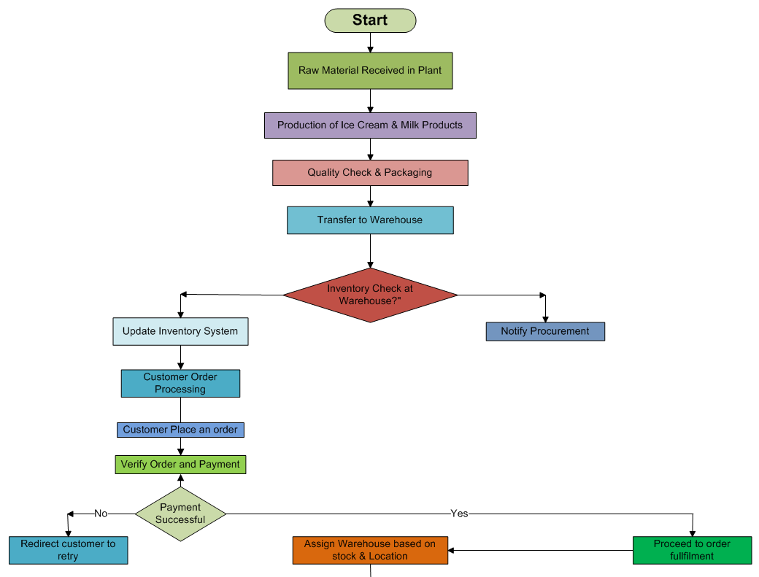

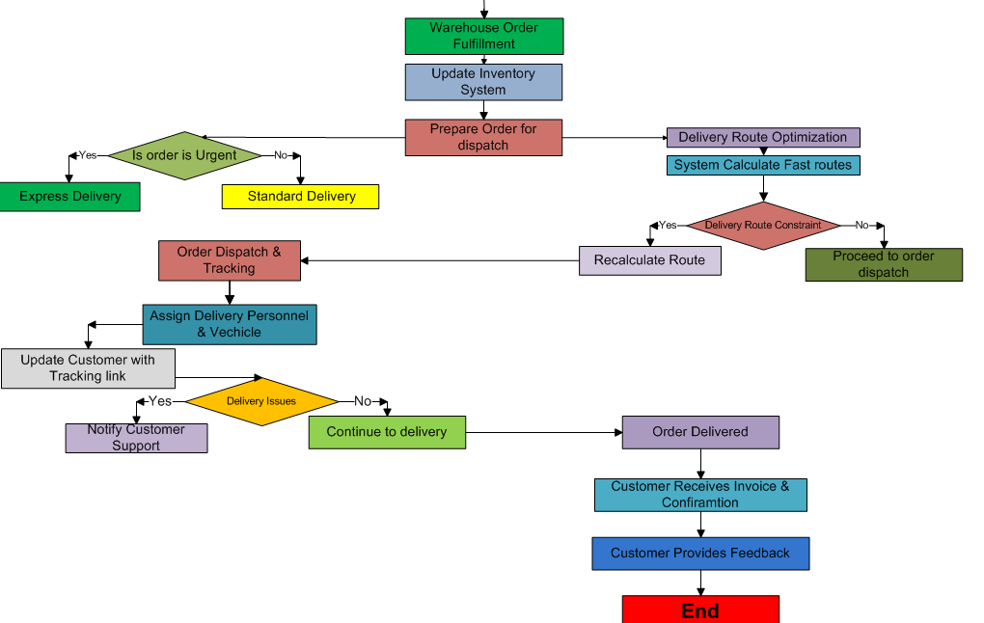

**ASSIGNMENT – 2**

* 1. **Introduction Letter**

**Sarath Guru Raj**

**Business Analyst**

ABC Enterprises LTD, Bangalore

sarath@abcgroup.com

20/03/2025

**Robert**

**Robert’s Dairy Enterprises**

Vice President

Robertdairy1@gmail.com

**Subject:** Introduction as Your Business Analyst for Inventory & Delivery Management Software

Dear **Robert**,

I hope this email finds you well. My name is **Sarath Guru Raj**, and I am the **Business Analyst** assigned to collaborate with you and your team on the **Inventory & Delivery Management Software project**. It is a pleasure to introduce myself, and I look forward to working closely with you to ensure a smooth and efficient business understanding process.

The primary objective of this project is to develop a comprehensive software solution that will:

* + - * 1. Effectively manage inventory across multiple manufacturing plants and warehouses.
        2. Optimize delivery operations to ensure the quickest possible order fulfillment for customers.

As part of my role, I will be responsible for gathering business requirements, analyzing workflows, and working with key stakeholders to define the functional and technical aspects of the solution. Over the next few days, I will initiate discussions to gain deeper insights into your existing processes, challenges, and expectations from this software.

To begin, I would like to schedule an initial business discussion at your earliest convenience. Kindly let me know a suitable time for this meeting. Additionally, if there are any relevant documents or key points you would like to highlight beforehand, please feel free to share them. I am committed to ensuring this project aligns with your business goals and delivers maximum efficiency and value. Please do not hesitate to reach out with any questions or clarifications.

Looking forward to a productive collaboration.

Best regards,

**Sarath Guru Raj**

**Business Analyst**

**ABC Enterprises LTD, Bangalore**

* 1. **BRD for Online Ticketing System**
  2. **Document Revisions**

|  |  |  |
| --- | --- | --- |
| **Date** | **Version Number** | **Document Changes** |
| 05/03/2025 | 0.1 | Initial Draft of the project documentation |
| 11/03/2025 | 0.2 | Updated Project objectives and scope |
| 21/03/2025 | 0.3 | Stakeholder analysis and elicitation techniques |
| 27/03/2025 | 0.4 | Added risk assessment and mitigation strategies |
| 06/03/2025 | 0.5 | Finalized functional requirement and success criteria |
| 11/03/2025 | 0.6 | Updated priority and RTM status |
| 19/03/2025 | 0.7 | Incorporated appendices and Finalized documents |

* 1. **Approvals**

|  |  |  |  |  |
| --- | --- | --- | --- | --- |
| **Role** | **Name** | **Title** | **Signature** | **Date** |
| Project Sponsor | Kumar | Business Owner | Kumar | 01/06/2025 |
| Project Manager | Rao | IT Project Manger | Rao | 02/06/2025 |
| System Architect | Rohit | Lead Architect | Rohit | 02/06/2025 |
| Development Lead | Kesave | Lead Technical Manager | Kesave | 03/06/2025 |
| User Experience Lead | Arjun | Ux/UI lead | Arjun | 03/06/2025 |
| Quality Lead | Karhtick | QA manager | Karhtick | 04/06/2025 |
| Content Lead | Raj | Documentation Specialist | Raj | 04/05/2025 |

* 1. **RACI Chart for This Document**

**RACI Chart**

|  |  |  |  |  |  |  |  |
| --- | --- | --- | --- | --- | --- | --- | --- |
| **Name** | **Position** | **\*** | **R** | **A** | **S** | **C** | **I** |
| Kumar | Business Owner | X |  | X | X | X | X |
| Rao | IT Project Manger | X | X | X | X |  | X |
| Rohit | Lead Architect |  | X |  | X |  | X |
| Kesave | Lead Technical Manager |  | X |  | X |  | X |
| Arjun | Ux/UI lead |  | X |  | X |  | X |
| Karhtick | QA manager |  | X |  | X |  | X |
| Raj | Documentation Specialist |  | X |  | X |  | X |

* 1. **Business Goals**

The Online Ticketing System aims to streamline ticket booking for various events such as concerts, movies, and travel. It will provide a user-friendly interface for customers and ensure seamless operations for event organizers.

**2.4.1 Business Objectives**

* Enable customers to browse, book, and manage tickets effortlessly.
* Provide real-time seat availability and secure payment options.
* Generate automated booking confirmations and invoices.
* Support event organizers with sales tracking and reporting.

**2.4.2 Business Rules**

* A user must register before purchasing tickets.
* Ticket availability is based on a real-time inventory.
* Booked tickets cannot be modified but can be cancelled within a defined time frame.

**2.4.3 Background**

Currently, ticket bookings are managed through third-party agents or manual processes, leading to inefficiencies and errors. This project aims to automate and centralize the system for better control.

**2.4.4 Project Objective**

To develop a scalable, secure, and user-friendly online ticketing platform that improves customer experience and operational efficiency.

**2.4.5 Project Scope**

**2.4.5.1 In-Scope Functionality**

* User registration and login
* Ticket search, booking, and cancellation
* Payment processing and invoicing
* Event management dashboard

**2.4.5.2 Out-of-Scope Functionality**

* Physical ticket printing
* On-site event check-ins
* Loyalty or reward programs

**2.5 Assumptions**

* Users will have access to the internet and compatible devices.
* Event organizers will provide accurate and timely event details.
* Payment gateways will support multiple transaction methods.

**2.6. Constraints**

* Compliance with financial regulations for online transactions.
* System availability should be 99.9% uptime to prevent booking failures.
* Data privacy and security measures must be enforced.

**2.7 Risks**

* High traffic overload during peak event launches.
* Payment failures due to third-party gateway issues.
* Cybersecurity threats such as fraudulent bookings or data breaches.

**2.8 Business Process Overview**

**2.8.1 Legacy System (AS-IS)**

* Manual booking via phone calls or third-party websites.
* Limited real-time updates on seat availability.
* Higher chances of overbooking or double bookings.

**2.8.2 Proposed Recommendations (TO-BE)**

* Fully automated booking and payment system.
* Real-time seat and ticket availability tracking.
* Centralized event management for organizers.

**2.9 Business Requirements**

|  |  |  |  |
| --- | --- | --- | --- |
| **Req ID** | **Requirement Name** | **Requirement Description** | **Priority** |
| BR001 | User Registration & Login | Users must be able to create an account, log in securely, and manage profiles. | High |
| BR002 | Event Search & Filtering | Users should be able to search for events using keywords, date, and category. | High |
| BR003 | Real-Time Ticket Availability | The system should update seat and ticket availability in real-time. | High |
| BR004 | Secure Payment Processing | Users must be able to make payments through multiple methods securely. | High |
| BR005 | Booking Confirmation & Receipt | The system must generate an automated confirmation email and digital invoice. | High |
| BR006 | Ticket Cancellation & Refund | Users should be able to cancel bookings within the refund policy timeframe. | Medium |
| BR007 | Event Organizer Dashboard | Event organizers should have access to sales, bookings, and event analytics. | Medium |
| BR008 | Multi-Language Support | The platform should support multiple languages for accessibility. | Low |
| BR009 | Customer Support Chatbot | A chatbot should be available for basic customer queries. | Medium |
| BR010 | Mobile App Integration | The system should be accessible via a mobile application. | Medium |

**2.10. Appendices**

**2.10.1 List of Acronyms**

* **BRD** – Business Requirements Document
* **RASCI** – Responsible, Accountable, Supportive, Consulted, Informed
* **API** – Application Programming Interface

**2.10.2 Glossary of Terms**

* **Event Organizer** – A person or company managing an event.
* **Payment Gateway** – A service that processes online payments.
* **Booking Confirmation** – A digital ticket issued after successful payment.

**2.10.3 Related Documents**

* Functional Specification Document
* User Experience (UX) Wireframes
* Compliance & Security Guidelines
  1. **SRS for Online Ticket System**

**3.1. Introduction**

**3.1.1 Purpose**

This document defines the software requirements for the Online Ticketing System, which allows users to search, book, and manage event tickets online while providing real-time availability updates and secure payment options.

**3.1.2 Document Conventions**

|  |  |
| --- | --- |
| **FR** | Functional Requirements. |
| **NFR** | Non-Functional Requirements. |
| **Priority Levels** | High (H), Medium (M), Low (L). |

**3.1.3 Key Stakeholders**

|  |  |
| --- | --- |
| **Business Analysts & Product Owners** | To validate business needs. |
| **QA Team** | To define test cases based on system requirements. |
| **Developers** | To implement functional and non-functional requirements. |
| **Stakeholders & Investors** | To understand system capabilities. |

**3.1.4 Product Scope**

The system will provide a centralized online platform for users to book tickets for events, concerts, movies, and travel. The system will feature real-time availability tracking, secure payment gateways, and mobile accessibility.

* + 1. **References**
* Business Requirements Document (BRD) for Online Ticketing System.
* Payment Gateway API documentation.

**3.2 Overall Description**

**3.2.1 Product Perspective**

This software will replace traditional ticket counters and third-party booking systems by providing a direct, seamless, and secure booking experience through a web and mobile platform.

**3.2.2 Product Functions**

* User registration and authentication.
* Event search and filtering.
* Real-time ticket availability updates.
* Secure online payment and invoicing.
* Ticket cancellation and refund processing.
* Event organizer dashboard with analytics.

**3.2.3 User Specifications**

|  |  |  |
| --- | --- | --- |
| **User Type** | **Description** | **Access Level** |
| Customers | Users who book tickets | Front-end portal |
| Event Organizers | Manage ticket sales & reports | Admin Dashboard |
| System Admins | Maintain the platform | Full System Access |

**3.2.4 Operating Environment**

* **Web Application:** Compatible with Chrome, Firefox, Edge, Safari.
* **Mobile Application:** Supports Android & iOS.
* **Cloud Hosting:** Scalable cloud-based infrastructure.

**3.2.5 Design and Implementation Constraints**

* Must integrate with multiple secure payment gateways.
* Ensure compliance with GDPR, PCI DSS, and other industry regulations.
* Support high traffic volumes during peak booking periods.

**3.3. Requirements**

**3.3.1 Functional Requirements (FRs)**

|  |  |  |  |
| --- | --- | --- | --- |
| **Req ID** | **Requirement Name** | **Requirement Description** | **Priority** |
| FR001 | User Registration & Login | Users must create accounts and log in securely. | High |
| FR002 | Event Search & Filtering | Users can search for events based on filters. | High |
| FR003 | Real-Time Ticket Updates | Display updated seat availability. | High |
| FR004 | Secure Payment Processing | Support multiple payment gateways (UPI, Credit/Debit, Wallets). | High |
| FR005 | Booking Confirmation & Invoice | Generate invoices and send confirmation emails. | High |
| FR006 | Ticket Cancellation & Refund | Allow cancellations within the refund policy period. | Medium |
| FR007 | Admin Dashboard for Organizers | Provide sales and booking analytics. | Medium |
| FR008 | Multi-Language Support | Enable localization for different regions. | Low |
| FR009 | Customer Support Chatbot | Provide automated assistance to customers. | Medium |
| FR010 | Mobile App Integration | Ensure seamless experience across mobile devices. | Medium |

**3.3.2 Non Functional Requirements (NFRs)**

|  |  |  |  |
| --- | --- | --- | --- |
| **Req ID** | **Requirement Name** | **Requirement Description** | **Priority** |
| NFR001 | System Availability | Ensure 99.9% uptime for high reliability. | High |
| NFR002 | Security & Data Privacy | Implement AES-256 encryption for sensitive data. | High |
| NFR003 | Performance Optimization | Ensure booking confirmation within 2 seconds. | High |
| NFR004 | Scalability | Support 100,000+ concurrent users. | High |
| NFR005 | Compliance | Adhere to GDPR, PCI DSS, and local data laws. | High |
| NFR006 | User-Friendly UI/UX | Ensure an intuitive interface for all users. | Medium |
| NFR007 | Disaster Recovery Plan | Maintain daily backups with a 1-hour recovery window. | High |
| NFR008 | Cross-Browser Compatibility | Compatible with Chrome, Firefox, Edge, Safari. | Medium |
| NFR009 | Third-Party API Support | Enable integrations for promotions, event listings, etc. | Medium |
| NFR010 | Monitoring & Logging | Implement real-time error tracking for issue resolution. | Medium |

**3.4 Appendices**

**3.4.1 Acronyms**

* **SRS** – Software Requirements Specification
* **FR** – Functional Requirement
* **NFR** – Non-Functional Requirement
* **GDPR** – General Data Protection Regulation

**3.4.2 Glossary of Terms**

* **Event Organizer** – A person managing an event’s ticketing process.
* **Booking Confirmation** – A receipt issued upon successful ticket booking.
* **Payment Gateway** – A service for processing online payments.

**3.4.3 Related Documents**

* Business Requirements Document (BRD) for Online Ticketing System
* Payment Gateway API documentation
* Compliance & Security Guidelines
  1. **ERD for Online Ticket System**

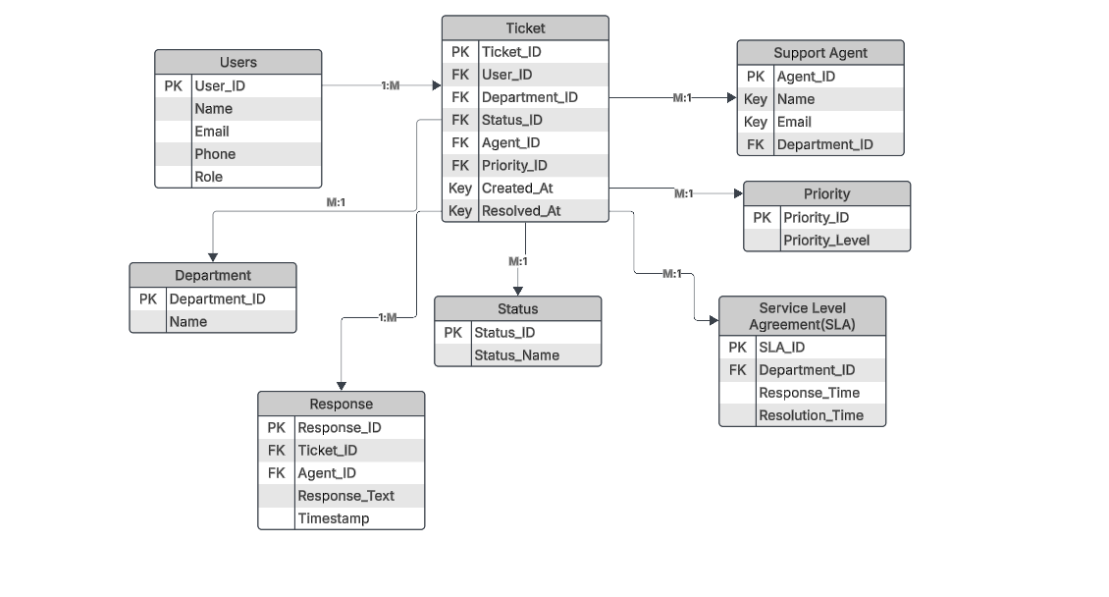

* 1. **User Story shopping from Ecommerce**

|  |  |  |  |
| --- | --- | --- | --- |
| **User Story :** 01 | **Tasks :** Register For Account | | **Priority :** High |
| AS A CUSTOMER,  I WANT TO REGISTER AN ACCOUNT,  SO THAT I CAN PLACE ORDERS AND TRACK MY PURCHASES | | | |
| **BV :** 500 | | **CP:** 5 | |
| **Acceptance Criteria:**  1.Users can successfully create an account using email, phone  2. System sends an confirmation email or OTP for verification | | | |

|  |  |  |
| --- | --- | --- |
| **User Story :** 02 | **Tasks :** Login to Account | **Priority :** High |
| AS A CUSTOMER,  I WANT TO LOGIN SECURELY,  SO THAT I CAN ACCESS MY ACCOUNT AND PLACE ORDERS | | |
| **BV :** 500 | | **CP:** 5 |
| **Acceptance Criteria:**  1.User can log in using email/password, OTP  2. System lock account after three failed attempts for security | | |

|  |  |  |  |
| --- | --- | --- | --- |
| **User Story :** 03 | **Tasks :** Reset Password | | **Priority :** Medium |
| AS A CUSTOMER,  I WANT TO RESET MY PASSWORD ,  SO THAT I CAN LOGIN IT | | | |
| **BV :** 500 | | **CP:** 5 | |
| **Acceptance Criteria:**  1.User receives a reset link via email or OTP via SMS  2. System verifies the link/OTP and allows password change | | | |

|  |  |  |  |
| --- | --- | --- | --- |
| **User Story :** 04 | **Tasks :**  Browse Products | | **Priority :** High |
| AS A CUSTOMER,  I WANT TO BROWSE PRODUCTS ACROSS DIFFERENT CATEGORIES,  SO THAT I CAN PURCHASE MY PRODUCTS | | | |
| **BV :** 500 | | **CP:** 3 | |
| **Acceptance Criteria:**  1.User can navigate through multiple categories  2. Products are displayed with images, descriptions and prices | | | |

|  |  |  |  |
| --- | --- | --- | --- |
| **User Story :** 05 | **Tasks :** Search for products | | **Priority :** High |
| AS A CUSTOMER,  I WANT TO SEARCH FOR PRODUCTS,  SO THAT I CAN QUICKLY MATCH MY PREFERENCE | | | |
| **BV :** 500 | | **CP:** 3 | |
| **Acceptance Criteria:**  1.Search Results display relevant products  2. Filters refine search results based on price, rating and category | | | |

|  |  |  |
| --- | --- | --- |
| **User Story :** 06 | **Tasks :** View Product Details | **Priority :** High |
| AS A CUSTOMER,  I WANT TO VIEW PROUDCTS DETAILS,  SO THAT I CAN QUICKLY MATCH MY PREFERENCE | | |
| **BV :** 500 | | **CP:** 1 |
| **Acceptance Criteria:**  1.Click on a product opens a detailed view  2. User can see reviews, specifications and related products | | |

|  |  |  |  |
| --- | --- | --- | --- |
| **User Story :** 07 | **Tasks :** Filter and Sort Products | | **Priority :** Medium |
| AS A CUSTOMER,  I WANT TO FILTER AND SORT PRODUCT  SO THAT I CAN MATCH MY PREFERENCE | | | |
| **BV :** 200 | | **CP:** 5 | |
| **Acceptance Criteria:**  1.User can filter products using multiple criteria  2. Sorting Options include price, popularity and rating | | | |

|  |  |  |  |
| --- | --- | --- | --- |
| **User Story :** 08 | **Tasks :** Add Product to cart | | **Priority :** High |
| AS A CUSTOMER,  I WANT TO ADD A PRODUCT TO MY CART,  SO THAT I CAN PURCHASE LATER | | | |
| **BV :** 500 | | **CP:** 1 | |
| **Acceptance Criteria:**  1.User click “ADD to cart and the item is added  2. Cart icon updates with the number of items | | | |

|  |  |  |  |
| --- | --- | --- | --- |
| **User Story :** 09 | **Tasks :** Remove Product from Cart | | **Priority :** Medium |
| AS A CUSTOMER,  I WANT TO REMOVE UNWANTED PRODUCTS,  SO THAT I CAN EASILY SEE MY PRODUCTS | | | |
| **BV :** 100 | | **CP:** 3 | |
| **Acceptance Criteria:**  1.User selects an item and clicks Remove and the item is deleted  2. Cart Updates and reflects the remaining items | | | |

|  |  |  |  |
| --- | --- | --- | --- |
| **User Story :** 10 | **Tasks :** Update Cart Quantity | | **Priority :** Medium |
| AS A CUSTOMER,  I WANT TO CHANGE THE PRODUCT QUANTITY,  SO THAT I CAN SEE THE QUANTITY BEFORE CHECKOUT | | | |
| **BV :** 200 | | **CP:** 5 | |
| **Acceptance Criteria:**  1.User can increase or decrease the quantity  2. The total price updates dynamically based on quantity | | | |

|  |  |  |  |
| --- | --- | --- | --- |
| **User Story :** 11 | **Tasks :** Save Items for Later | | **Priority :** High |
| AS A CUSTOMER,  I WANT TO SAVE ITEMS FOR LATER,  SO THAT I CAN PURCHASE THEM LATER | | | |
| **BV :** 200 | | **CP:** 3 | |
| **Acceptance Criteria:**  1.User Clicks “Save for Later” and item moves to wish list  2. Wish list updates accordingly | | | |

|  |  |  |  |
| --- | --- | --- | --- |
| **User Story :** 12 | **Tasks :** View Cart Summary | | **Priority :** High |
| AS A CUSTOMER,  I WANT TO REVIEW MY CART  SO THAT I CAN ABLE TO CHECKOUT | | | |
| **BV :** 500 | | **CP:** 3 | |
| **Acceptance Criteria:**  1.User can see a summary of all selected items  2.The total price including discounts is displayed | | | |

|  |  |  |  |
| --- | --- | --- | --- |
| **User Story :** 13 | **Tasks :** Apply Coupon Codes | | **Priority :** Medium |
| AS A CUSTOMER,  I WANT TO APPLY COUPONS FOR DISCOUNTS,  SO THAT I CAN GET DISCOUNT ON MY PRODUCTS | | | |
| **BV :** 100 | | **CP:** 3 | |
| **Acceptance Criteria:**  1.User enters a valid coupon and the discount is applied  2.Invalid coupons shows an error message | | | |

|  |  |  |  |
| --- | --- | --- | --- |
| **User Story :** 14 | **Tasks :** Select Delivery Address | | **Priority :** High |
| AS A CUSTOMER,  I WANT TO ENTER/SELECT A DELIVERY ADDRESS,  SO THAT I CAN ORDER MY PRODUCT | | | |
| **BV :** 200 | | **CP:** 3 | |
| **Acceptance Criteria:**  1.User can add new address or select from saved addresses  2.System validates address format | | | |

|  |  |  |  |
| --- | --- | --- | --- |
| **User Story :** 15 | **Tasks :** Choose Payment Method | | **Priority :** High |
| AS A CUSTOMER,  I WANT TO CHOOSE FROM MULTIPLE PAYMENT OPTIONS,  SO THAT I CAN MAKE PAYMENT | | | |
| **BV :** 500 | | **CP:** 3 | |
| **Acceptance Criteria:**  1.User can select credit/debit card ,UPI, wallet or COD  2.Payment Page redirects securely for card transactions | | | |

|  |  |  |  |  |  |
| --- | --- | --- | --- | --- | --- |
|  |  |  |  |  |  |

|  |  |  |  |
| --- | --- | --- | --- |
| **User Story :** 16 | **Tasks:** Complete order placement | | **Priority :** High |
| AS A CUSTOMER,  I WANT TO PLACE AN ORDER SUCCESSFULLY,  SO THAT I CAN RECEIVE MY PRODUCT | | | |
| **BV :** 500 | | **CP:** 3 | |
| **Acceptance Criteria:**  1.Clicking Place order confirms the purchase  2.Systems generates an order confirmation message | | | |

|  |  |  |  |
| --- | --- | --- | --- |
| **User Story :** 17 | **Tasks :** Track my order | | **Priority :** High |
| AS A CUSTOMER,  I WANT TO TRACK MY ORDER STATUS,  SO THAT I CAN VIEW MY EXPECTED DELVIERY | | | |
| **BV :** 500 | | **CP:** 1 | |
| **Acceptance Criteria:**  1.System updates order status in real time  2. Tracking link is available for courier orders | | | |

|  |  |  |  |
| --- | --- | --- | --- |
| **User Story :** 18 | **Tasks :** Cancel an order | | **Priority :** Medium |
| AS A CUSTOMER,  I WANT TO CANCEL MY ORDER BEFORE SHIPPING,  SO THAT I CAN ORDER MY ANOTHER PRODUCT | | | |
| **BV :** 200 | | **CP:** 1 | |
| **Acceptance Criteria:**  1.Cancellation is allowed only before dispatch  2. System provides an automatic refund if prepaid | | | |

|  |  |  |  |
| --- | --- | --- | --- |
| **User Story :** 19 | **Tasks :** Return or Exchange an Item | | **Priority :** Medium |
| AS A CUSTOMER,  I WANT TO RETURN/EXCHANGE PRODUCTS IF DEFECTIVE  SO THAT I WON’T GET WRONG PRODUCT | | | |
| **BV :** 200 | | **CP:** 5 | |
| **Acceptance Criteria:**  1.User selects reason for return/exchange  2.System initiates pickup and refund | | | |

|  |  |  |  |
| --- | --- | --- | --- |
| **User Story :** 20 | **Tasks :** Provide Product Review | | **Priority :** Medium |
| AS A CUSTOMER,  I WANT TO LEAVE A REVIEW AFTER RECEIVING MY ORDER  SO THAT I CAN PRODUCT REVIEW | | | |
| **BV :** 200 | | **CP:** 2 | |
| **Acceptance Criteria:**  1.User can submit a star rating and comment  2. Review appears under the product details | | | |

|  |  |  |  |
| --- | --- | --- | --- |
| **User Story :** 21 | **Tasks :** View Order History | | **Priority :** Medium |
| AS A CUSTOMER,  I WANT TO SEE MY PAST ORDERS,  SO THAT I CAN REPURCHASE MY ORDERS | | | |
| **BV :** 200 | | **CP:** 5 | |
| **Acceptance Criteria:**  1.Order History page shows all completed transactions  2. Each order has a detailed invoice | | | |

|  |  |  |  |
| --- | --- | --- | --- |
| **User Story :** 22 | **Tasks :** Receive Order Confirmation Mail | | **Priority :** High |
| AS A CUSTOMER,  I WANT TO EMAIL CONFIRMATION AFTER PLACING AN ORDER  SO THAT I CAN GET ALERTS | | | |
| **BV :** 200 | | **CP:** 5 | |
| **Acceptance Criteria:**  1.System sends an order confirmation email  2.Email Contains order details and estimated delivery date | | | |

|  |  |  |  |
| --- | --- | --- | --- |
| **User Story :** 23 | **Tasks:** Wishlist Feature | | **Priority :** Medium |
| AS A CUSTOMER,  I WANT TO SAVE PRODUCTS IN A WISHLIST,  SO THAT I CAN ORDER MY PRODUCT LATER | | | |
| **BV :** 200 | | **CP:** 3 | |
| **Acceptance Criteria:**  1.User clicks “ADD to wishlist and product is saved  2. Wishlist can be accessed later from the profile | | | |

|  |  |  |  |
| --- | --- | --- | --- |
| **User Story :** 24 | **Tasks :** Guest Checkout | | **Priority :** Medium |
| AS A CUSTOMER,  I WANT TO PLACE AN ORDER WITHOUT REGISTRATION,  SO THAT I CAN LOGIN LATER | | | |
| **BV :** 200 | | **CP:** 3 | |
| **Acceptance Criteria:**  1.Guest checkout allows purchasing without an account  2. Email is required for order updates | | | |

|  |  |  |  |
| --- | --- | --- | --- |
| **User Story :** 25 | **Tasks :** Add multiple addresses | | **Priority :** Medium |
| AS A CUSTOMER,  I WANT TO SAVE MULTIPLE DELIVERY ADDRESSES  SO THAT I CAN ORDERS IN FUTURE | | | |
| **BV :** 100 | | **CP:** 3 | |
| **Acceptance Criteria:**  1.User can add, edit and delete saved addresses  2. System allows selecting a preferred default address | | | |

|  |  |  |  |
| --- | --- | --- | --- |
| **User Story :** 26 | **Tasks:** Subscribe to newsletters | | **Priority :** Medium |
| AS A CUSTOMER,  I WANT TO SUBSCRIBE TO NEWSLETTERS  SO THAT I CAN DO FOR PROMOTIONS AND OFFERS, | | | |
| **BV :** 200 | | **CP:** 3 | |
| **Acceptance Criteria:**  1.user Receive a confirmation email for subscription  2.Newsletters contain exclusive offers and updates | | | |

|  |  |  |  |
| --- | --- | --- | --- |
| **User Story :** 27 | **Tasks :** Contact Customer Support | | **Priority :** High |
| AS A CUSTOMER,  I WANT TO CONTACT CUSTOMER SUPPORT FOR QUERIES ,  SO THAT I CAN RAISE MY ISSUES | | | |
| **BV :** 200 | | **CP:** 5 | |
| **Acceptance Criteria:**  1.User can access live chat, email or call options  2. Support team receives and responds to queries | | | |

|  |  |  |  |  |  |
| --- | --- | --- | --- | --- | --- |
|  |  |  |  |  |  |

|  |  |  |  |
| --- | --- | --- | --- |
| **User Story :** 28 | **Tasks :** View seller information | | **Priority :** Medium |
| AS A CUSTOMER,  I WANT TO VIEW SELLER DETAILS ,  SO THAT I CAN PURCHASE A PRODUCT BEFORE IT | | | |
| **BV :** 200 | | **CP:** 5 | |
| **Acceptance Criteria:**  1.Products page displays seller rating and details  2. Users can filter products by seller | | | |

|  |  |  |  |
| --- | --- | --- | --- |
| **User Story :** 29 | **Tasks :** Compare Products | | **Priority :** Medium |
| AS A CUSTOMER,  I WANT TO COMPARE SIMILAR PRODUCTS,  SO THAT I CAN COMPARE BEFORE PURCHASE | | | |
| **BV :** 200 | | **CP:** 2 | |
| **Acceptance Criteria:**  1.Users can select multiple products to compare features  2. Comparison table highlights key differences | | | |

|  |  |  |  |
| --- | --- | --- | --- |
| **User Story :** 30 | **Tasks :** View Frequently bough together items | | **Priority :** Medium |
| AS A CUSTOMER,  I WANT TO SEE SUGGESTED PRODUCTS,  SO THAT I CAN ORDER FREQUENTLY | | | |
| **BV :** 200 | | **CP:** 1 | |
| **Acceptance Criteria:**  1.System suggests relevant products based on past purchases  2.User can add suggested products directly to cart | | | |

|  |  |  |  |
| --- | --- | --- | --- |
| **User Story :** 31 | **Tasks :** Track Refunds | | **Priority :** Medium |
| AS A CUSTOMER,  I WANT TO TRACK THE REFUNDS,  SO THAT I CAN VIEW THE STATUS | | | |
| **BV :** 200 | | **CP:** 7 | |
| **Acceptance Criteria:**  1.System provides real time refund status updates  2. Users receive notifications when refunds are processed | | | |

|  |  |  |  |
| --- | --- | --- | --- |
| **User Story :** 32 | **Tasks :** Refer a friend | | **Priority :** Low |
| AS A CUSTOMER,  I WANT TO REFER FRIENDS ,  SO THAT I CAN EARN REWARDS | | | |
| **BV :** 100 | | **CP:** 3 | |
| **Acceptance Criteria:**  1.User receives a referral code/link to share  2. Referral discounts are applied upon successful referral | | | |

|  |  |  |  |
| --- | --- | --- | --- |
| **User Story :** 33 | **Tasks :** Pay Later option | | **Priority :** Medium |
| AS A CUSTOMER,  I WANT TO BUY NOW, PAY LATER  SO THAT I CAN DO PAYMENT OPTIONS LATER | | | |
| **BV :** 200 | | **CP:** 1 | |
| **Acceptance Criteria:**  1.Users can choose EMI or pay later services  2. Payment provider verifies eligibility before approval | | | |

|  |  |  |  |
| --- | --- | --- | --- |
| **User Story :** 34 | **Tasks :** Set price alerts | | **Priority :** Low |
| AS A CUSTOMER,  I WANT TO SET ALERTS ,  SO THAT MY PRODUCT PRICES DROP | | | |
| **BV :** 100 | | **CP:** 2 | |
| **Acceptance Criteria:**  1.Users receive notifications when the price changes  2. Alerts can be set for specific price thresholds | | | |

|  |  |  |  |
| --- | --- | --- | --- |
| **User Story :** 35 | **Tasks :** Access Loyalty Program | | **Priority :** Medium |
| AS A CUSTOMER,  I WANT TO EARN AND REDEEM POINTS,  SO THAT I CAN DO MORE PURCHASES | | | |
| **BV :** 200 | | **CP:** 3 | |
| **Acceptance Criteria:**  1.User earn points on eligible orders  2. Loyalty points can be redeemed at checkouts | | | |

|  |  |  |  |
| --- | --- | --- | --- |
| **User Story :** 36 | **Tasks :** Dark mode UI | | **Priority :** Low |
| AS A CUSTOMER,  I WANT AN OPTION TO SWITCH TO DARK MODE,  SO THAT I CAN HAVE BETTER READABILITY | | | |
| **BV :** 100 | | **CP:** 3 | |
| **Acceptance Criteria:**  1.User can enable/disable dark mode in settings  2. System remembers the users choice across sessions | | | |

|  |  |  |  |
| --- | --- | --- | --- |
| **User Story :** 37 | **Tasks :** Get estimated Delivery date | | **Priority :** High |
| AS A CUSTOMER,  I WANT TO KNOW THE DELIVERY DATE,  SO THAT I CAN PLACE AN ORDER BEFORE | | | |
| **BV :** 200 | | **CP:** 2 | |
| **Acceptance Criteria:**  1.Delivery estimation is shown before checkout  2. Estimated date updates based on users location | | | |

|  |  |  |  |
| --- | --- | --- | --- |
| **User Story :** 38 | **Tasks :** Buy gift cards | | **Priority :** Medium |
| AS A CUSTOMER,  I WANT TO PURCHASE GIFTS  SO THAT I CAN SELL TO OTHERS | | | |
| **BV :** 200 | | **CP:** 3 | |
| **Acceptance Criteria:**  1.User can buy and send gift cards via mail  2. Gifts cards have a unique code for redemption | | | |

|  |  |  |  |
| --- | --- | --- | --- |
| **User Story :** 39 | **Tasks :** Report a defective product | | **Priority :** High |
| AS A CUSTOMER,  I WANT TO REPORT A DEFECTIVE PRODUCT  SO THAT I CAN GET NON DEFECTIVE PURHCASE | | | |
| **BV :** 500 | | **CP:** 3 | |
| **Acceptance Criteria:**  1.Users can submit a complaint with images and details  2. Customers support reviews and takes necessary action | | | |

|  |  |  |  |
| --- | --- | --- | --- |
| **User Story :** 40 | **Tasks :** Leave feedback on Service | | **Priority :** Medium |
| AS A CUSTOMER,  I WANT TO RATE MY OVERALL SHOPPING  SO THAT I CAN GAIN MY RATING EXPERIENCE | | | |
| **BV :** 200 | | **CP:** 3 | |
| **Acceptance Criteria:**  1.User can provide feedback via rating system  2. Reviews are visible on the platform for service improvements | | | |