Document 1: Definition of Done
Definition of Done (DoD) – HSBC Canada Exit (FCR System Decommissioning)
Project Name: HSBC Canada Exit – Removal from FCR System
Purpose:
This Definition of Done defines the minimum criteria that must be satisfied for any backlog item, user story, or sprint deliverable related to the removal of Canada-specific data, rules, and configurations from the Financial Crime Risk (FCR) system. This ensures:
- Regulatory compliance (PIPEDA, HSBC Data Governance)
- Operational efficiency
- Enhanced system performance

DoD Checklist for User Stories
- Code, script, or configuration changes created to remove Canada-specific data, rules, and configurations
- All assumptions and requirements documented in the user story are fully met
- System builds successfully without errors after Canada removal
- Unit tests created for modified components and all tests pass
- Application deployed successfully in test environment (similar to production)
- Functional and regression testing performed across impacted modules (rules engine, case management, reporting)
- Test results documented and validated
- Any UI/UX changes reviewed and approved by UX team (if applicable)
- QA performed and all defects resolved
- Acceptance criteria met and validated
- Product Owner reviewed and signed off the functionality
- Code refactoring (if needed) completed to maintain code quality
- Any configuration changes documented and validated
- Documentation (data dictionary, process flows, configuration guide) updated
- Peer code review completed and approved
- Compliance and Data Governance sign-off obtained to confirm regulatory alignment (PIPEDA, HSBC Data Governance)

DoD for Sprint Completion
- All user stories in the sprint meet the above DoD
- Integration and system testing across modules (including non-impacted ones) pass
- Sprint Review conducted and feedback captured
- Sprint Retrospective held to capture lessons learned

DoD for Release Completion
- All sprints forming the release meet the Sprint DoD
- End-to-end testing for the system (pre- and post-Canada removal) completed
- Release notes and deployment guide updated
- Deployment to production successful and validated
- Final compliance and data governance sign-off obtained before release
- Post-production monitoring plan in place to track performance and operational benefits
Version: 1.0
Date: 04-Mar-2025
Author: Anjali Mehta
Reviewed by: Project Manager, Compliance Lead
Approved by: Product Owner

Document 2- Product Vision
Product Vision – HSBC Canada Exit (FCR System Decommissioning)
Scrum Project Details
Project Name: HSBC Canada Exit – Removal from FCR System
Venue: Virtual (MS Teams)
Date: 04-Mar-2025
Start time: 10:00 AM
End time: 11:30 AM
Duration: 1 hour 30 minutes
Client: HSBC Global Operations
Stakeholder List
Project Sponsor – HSBC Global Compliance
Product Owner – Financial Crime Risk Team
Scrum Master – Project Delivery Team
Developers – Application and Data Engineering Teams
Compliance & Legal Representatives
Business Analysts – Global Data Governance Team
Quality Assurance – Testing Team

Scrum Team
Scrum Master: John Doe
Product Owner: Anjali Mehta
Scrum Developer 1: Developer A
Scrum Developer 2: Developer B
Scrum Developer 3: Developer C
Scrum Developer 4: Developer D
Scrum Developer 5: Developer E
Vision: To fully remove Canada as a booking country from HSBC’s Financial Crime Risk (FCR) system, ensuring compliance with global data governance standards while enhancing system performance and operational efficiency for remaining booking countries.
Target Group
Market Segment: Global Banking and Financial Services
Target Users/Customers:
Financial Crime Risk Investigators
Global Compliance Teams
Data Governance Teams
IT Operations Teams

Needs
Problems Addressed:
Ensure regulatory compliance (PIPEDA, HSBC Data Governance)
Reduce system complexity and technical debt
Improve system performance by removing unused Canadian data
Streamline operational processes for non-Canadian bookings

Product
Product: Enhanced Financial Crime Risk (FCR) system without Canada-specific data and configurations.
What makes it desirable and special?
This initiative aligns with HSBC’s global simplification strategy and ensures regulatory compliance. It reduces risk exposure, improves system speed, and simplifies investigation processes for non-Canadian bookings.
Feasibility: This is feasible through a structured Agile approach with dedicated teams and compliance oversight.
Value
How will this benefit HSBC?
- Compliance with regulatory standards (PIPEDA, HSBC Data Governance)
- Reduced operational risk
- Faster investigations due to cleaner data and optimized rules
- Cost savings through reduced system complexity

Business Goals:
Ensure successful exit from the Canadian market
Maintain compliance and regulatory approvals
Enhance operational efficiency across global investigations
Business Model: This is a regulatory-driven project, aligned with HSBC’s strategic exit from Canada, ensuring global compliance and operational simplification.
Version: 1.0
Date: 04-Mar-2025
Author: Anjali Mehta
Reviewed by: Project Manager, Compliance Lead
Approved by: Product Owner

Document 3: User stories

User Story No: US001
Value Statement:
As a Compliance Analyst
I want to identify all existing Canadian data, rules, and configurations in the FCR system
so that I can ensure no relevant data is missed during cleanup.

BV (Business Value): 100
CP (Complexity Points): 5

Acceptance Criteria:
All Canadian data sources, configurations, and rules are documented.
Data inventory is reviewed and approved by Data Governance.
Data lineage and flow is validated to ensure completeness.

User Story No: US002
Value Statement:
As a System Administrator
I want to remove all Canadian data, rules, and configurations from the FCR system
so that I can ensure the system is compliant with HSBC's global data governance standards.

BV: 500
CP: 8

Acceptance Criteria:
All identified Canadian components are removed.
No errors introduced in global rules processing.
Code repository reflects removal with proper documentation.
Peer review and approval completed.

User Story No: US003
Value Statement:
As a QA Tester
I want to conduct comprehensive regression testing
so that I can confirm removal of Canadian data does not impact other booking countries.

BV: 500
CP: 8

Acceptance Criteria:
Regression test plan covers all impacted processes.
Tests are executed across booking countries.
No critical or high defects found.
Sign-off received from Product Owner.

User Story No: US004
Value Statement:
As a Performance Analyst
I want to validate system performance post-cleanup
so that I can ensure system operates efficiently with reduced data volume.
BV: Improves operational efficiency.
CP: 5
Acceptance Criteria:
Performance metrics captured before and after.
System performance shows measurable improvement.
Performance report shared with stakeholders.

User Story No: US005
Value Statement:
As a Business Analyst
I want to update all documentation, process flows, and governance artifacts
so that I can ensure ongoing compliance with HSBC standards.

BV:200
CP: 3

Acceptance Criteria:
All relevant documents updated.
Governance team reviews and approves updates.
Documents stored in central repository.

Document 4: Agile PO Experience
Role Overview – Product Owner (PO)
The Product Owner plays a critical role in defining, prioritizing, and delivering product features aligned with business needs, market trends, and regulatory requirements. For the HSBC Canada Exit – FCR System Cleanup project, the PO ensured that all requirements related to removing Canadian data from the Financial Crime Risk (FCR) system were identified, prioritized, and executed effectively.

Responsibilities of the Product Owner in this Project
1. Market Analysis
Analysis of regulatory requirements driving the Canada exit.
Assessment of global FCR system usage and how Canadian data impacts existing processes.
Identifying similar initiatives (e.g., exits in other regions) to leverage learnings.
2. Enterprise Analysis
Due diligence on impact of removing Canadian data from the global FCR system.
Ensured alignment with HSBC’s global regulatory and compliance teams.
3. Product Vision and Roadmap
Developed product vision focusing on a clean, globally compliant FCR system free of Canadian data.
Created high-level roadmap covering:
Data identification
Data removal
Process adjustment
Testing and validation
Documentation updates
4. Managing Product Features
Collaborated with stakeholders to prioritize removal activities.
Defined high-priority stories (data removal, configuration updates, regression testing).
Ensured features provided high ROI by reducing compliance risk and operational overhead.
5. Managing Product Backlog
Created and prioritized user stories.
Reprioritized backlog based on changing business needs (e.g., regulatory deadlines).
Collaborated with Business Analyst to group stories into meaningful epics.
6. Managing Overall Iteration Progress
Regularly reviewed sprint progress.
Reprioritized sprints if blockers arose.
Participated in sprint retrospectives to continuously improve delivery processes.

Sprint Meetings Handled
Sprint Planning Meeting: Defined scope for each sprint.
Daily Scrum Meeting: Participated to remove blockers and provide clarifications.
Sprint Review Meeting: Validated deliverables against acceptance criteria.
Sprint Retrospective Meeting: Captured lessons learned and areas for improvement.
Backlog Refinement Meeting: Ensured backlog was continuously groomed and prioritized.

User Story Creation – Key Learnings
Learned how to create effective user stories by including:

Story Number: Unique identifier for tracking.
Tasks: Granular activities within each story.
Priority: Business urgency and impact.
Acceptance Criteria: Clear conditions to mark story as done.
BV (Business Value): Why this story matters to the business.
CP (Complexity Points): Effort estimate to complete the story.

PO’s Role in Scrum Process
Acted as the bridge between stakeholders (business, compliance, technology) and the Scrum team.
Translated high-level regulatory requirements into clear user stories.
Ensured continuous communication between all parties.
Owned and managed the Product Backlog ensuring it reflects the latest regulatory priorities.
Vision Statement:
To enhance HSBC’s global FCR system by ensuring complete removal of all Canadian data and configurations, ensuring compliance with HSBC’s exit strategy and reducing regulatory risk.

Document 5: Product and sprint backlog and product and sprint burndown charts
User Story ID | User Story | Tasks | Priority | BV (Business Value) | CP (Complexity Points) | Sprint
US-001 | Remove all Canada KYC data from FCR system | Identify impacted tables | High | 9 | 5 | Sprint 1
 |  | Archive historical data
 |  | Execute deletion scripts
US-002 | Remove all AML transaction data linked to Canada entities | Identify transactions | High | 8 | 4 | Sprint 1
 |  | Update screening history
 |  | Validate system logs
US-003 | Update Compliance Dashboard to exclude Canada records | Modify dashboard queries | Medium | 7 | 3 | Sprint 2
 |  | Test and validate
 |  | Update reporting templates
US-004 | Audit log cleanup for Canada removal | Review historical audits | High | 9 | 5 | Sprint 2
 |  | Update audit logs
 |  | Compliance review sign-off
US-005 | Final validation and Compliance approval | Consolidate cleanup evidence | High | 10 | 4 | Sprint 3
 |  | Host validation session
 |  | Archive final records

Sprint Backlog

User Story ID | User Story | Tasks | Owner | Status | Estimated Effort (Hours)
US-001 | Remove all Canada KYC data from FCR system | Identify impacted tables | Dev 1 | In Progress | 4
US-001 |  | Archive historical data | Dev 2 | Completed | 6
US-001 |  | Execute deletion scripts | Dev 3 | In Progress | 5
US-002 | Remove all AML transaction data linked to Canada entities | Identify transactions | Dev 1 | Completed | 3
US-002 |  | Update screening history | Dev 2 | In Progress | 4
US-002 |  | Validate system logs | Dev 3 | Not Started | 3

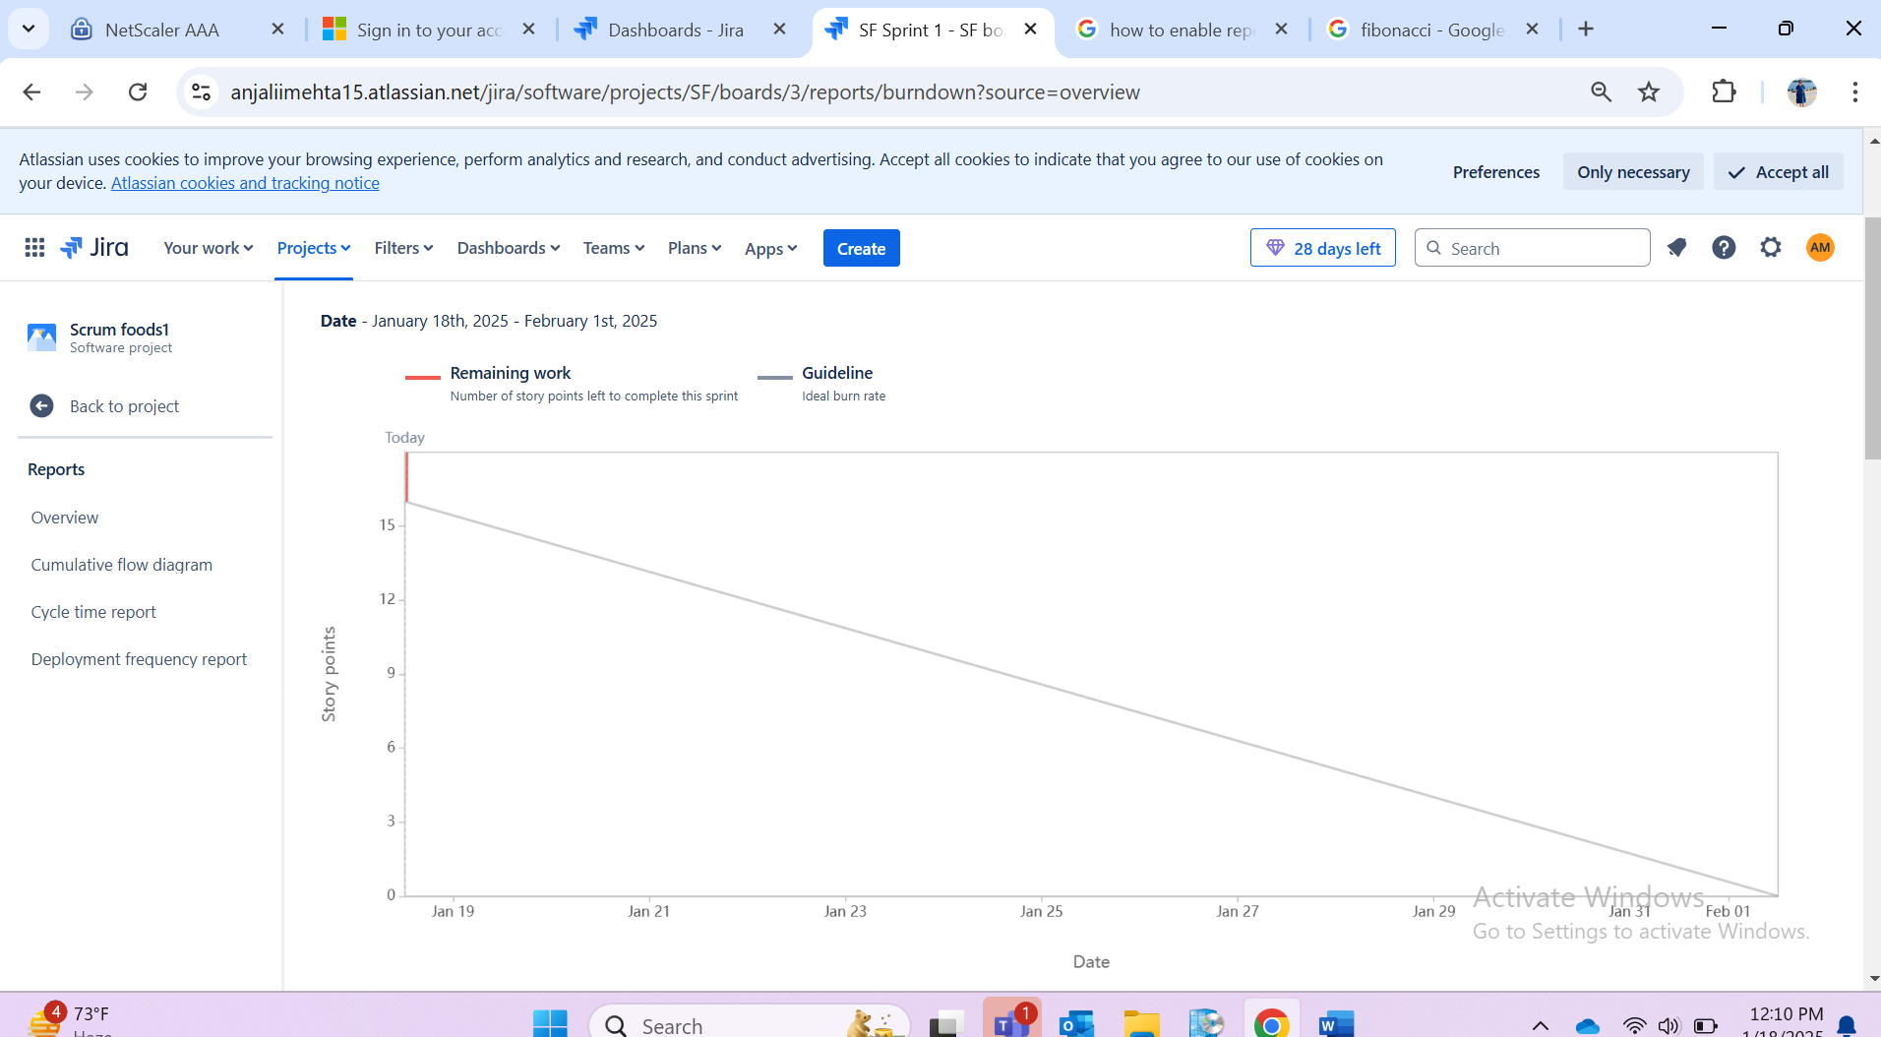

Document 6: Sprint meetings
Meeting Type 1: Sprint Planning Meeting
Field | Details
Date | 3/5/2025
Time | 11:00 AM
Location | Virtual – MS Teams
Prepared By | Scrum Master
Attendees | Product Owner, Scrum Master, Developers, Business Analyst, Compliance Lead
Agenda Topics | Scope for this sprint  Review of stories (removal of Canada data from FCR systems)  Dependencies, risks, blockers  Resource allocation and ownership  Estimation of user stories
Topic | Presenter
Sprint Goal & Scope | Product Owner
Review of Backlog | Business Analyst
Story Estimation | Developers
Dependency Discussion | Scrum Master
Other Information | All Canada-related regulatory requirements, audit logs, and KYC history are already archived per compliance.
Observers | Data Governance Lead (optional)
Resources | Jira, Confluence, SharePoint, System Design Docs
Special Notes | Focused sprint to achieve full data removal for HSBC Canada within FCR platforms (aligned to global exit plan).

Meeting Type 2: Sprint Review Meeting
Field | Details
Date | 4/15/2025
Time | 1:00 OM
Location | Virtual – MS Teams
Prepared By | Scrum Master
Attendees | Product Owner, Scrum Master, Developers, Business Analyst, Compliance Lead, IT Ops
Sprint Status | Completed – Removal of Canada data from all FCR systems (KYC, AML, Screening)
Things to Demo | Cleaned FCR data (no Canada references in KYC, AML, Screening)  Updated system logs  Removal audit trail shared with Compliance
Quick Updates | No P1 defects raised  3 minor defects raised and fixed within sprint
What’s Next | Final validation by Data Governance  Compliance sign-off  Archive process for historical repo

Meeting Type 3: Sprint Retrospective Meeting

Field | Details
Date | 4/16/2025
Time | 4:00 PM
Location | Virtual – MS Teams
Prepared By | Scrum Master
Attendees | Scrum Team, Product Owner, Business Analyst, Compliance Lead
Agenda | - What went well?
 | - What could be improved?
 | - Action points for next sprint
What Went Well | - Clear backlog prioritization
 | - Effective collaboration with Compliance team
 | - Automated cleanup scripts worked well
What Didn’t Go Well | - Initial uncertainty around archived records led to rework
 | - Test environment mismatched production, delaying final tests
Questions | - Can we automate validation for future country exits?
 | - Do we need a pre-sprint checklist for regulatory exits?
Reference | Jira Board, Confluence Wiki, Historical Audit Reports

Meeting Type 4: Daily Stand-up Meeting (Sample Week)
Question | Developer 1 | Developer 2 | Developer 3
What did you do yesterday? | Removed legacy Canada records from KYC tables | Validated AML transaction history removal | Updated audit logs and compliance reports
What will you do today? | Run batch jobs for screening data removal | Review defect fixes with QA | Prepare test evidence for Compliance review
What (if any) is blocking your progress? | Access to historical data archive for final cross-check | Clarification needed on audit report format | No blockers

