**Capstone Project2 –Agile-Scrum**

Q1) Question 1 – write Agile Manifesto – 8 Marks

Four main Values

1) Individuals and interactions over processes and tools

2) Working software over comprehensive documentation

3) Customer collaboration over contract negotiation

4) Responding to change over following a plan

Twelve Principles of Agile Software

1.Satisfy the customer through early and continuous delivery of valuable software.

2.Welcome changing requirements, even late in development. Agile processes harness change for

the customer's competitive advantage.

3.Deliver working software frequently, from a couple of weeks to a couple of months, with a

preference to the shorter timescale.

4.Business people and developers must work together daily throughout the project.

5.Build projects around motivated individuals. Give them the environment and support they need,

and trust them to get the job done.

6. The most efficient and effective method of conveying information to and within a development

team is face-to-face conversation.

7. Working software is the primary measure of progress.

8. Agile processes promote sustainable development. The sponsors, developers, and users should be

able to maintain a constant pace indefinitely.

9. Continuous attention to technical excellence and good design enhances agility.

10. Simplicity--the art of maximizing the amount of work not done--is essential.

11.The best architecture, requirements, and designs emerge from self-organizing teams.

12.At regular intervals, the team reflects on how to become more effective, then tunes and adjusts

its behavior accordingly.

Question 2) Write minimum 40 User stories and their Acceptance Criteria along with their BV and CP

|  |  |  |
| --- | --- | --- |
| **User Story no: 001** | Tasks: Registration of customers | Priority: Highest |
| AS A CUSTOMER | | |
| I WANT TO REGISTER TO SCRUM FOOD APP | | |
| SO THAT I CAN ORDER FOOD | | |
| BV: 500 | | CP: 34 |
| Acceptance Criteria | | |
| Should have email address, location, mobile phone number and should verify with OTP | | |
|  |  |  |
|  |  |  |
| **User Story no: 002** | Tasks: Registration of restaurant | Priority: Highest |
| AS A RESTAURANT OWNER | | |
| I WANT TO REGISTER TO SCRUM FOOD APP | | |
| SO THAT I CAN SELL FOOD ON THE APP | | |
| BV: 500 | | CP: 34 |
| Acceptance Criteria | | |
| Should have a registered business, menu, email address, mobile phone number and should verify with OTP | | |
|  |  |  |
|  |  |  |
| **User Story no: 003** | Tasks: Registration of delivery boy | Priority: Highest |
| AS A DELIVERY BOY | | |
| I WANT TO REGISTER TO SCRUM FOOD APP | | |
| SO THAT I CAN DELIVER PARCELS | | |
| BV: 500 | | CP: 34 |
| Acceptance Criteria | | |
| Should have a registered driving license, government id, email address, mobile phone number and should verify with OTP | | |
|  |  |  |
|  |  |  |
| **User Story no: 004** | Tasks: Registration of Regional Administrator | Priority: Highest |
| AS A REGIONAL ADMINISTRATOR | | |
| I WANT TO REGISTER TO SCRUM FOOD APP | | |
| SO THAT I CAN MANAGE THE RESTAURANTS AND DELIVERY BOYS IN MY REGION ALONG WITH GRIEVENCES AND COMPLAINTS | | |
| BV: 500 | | CP: 34 |
| Acceptance Criteria | | |
| Should have a employee code,official email address, mobile phone number and should verify with OTP | | |
|  |  |  |
|  |  |  |
| **User Story no: 005** | Tasks: Registration of Administrator | Priority: Highest |
| AS AN ADMINISTRATOR | | |
| I WANT TO REGISTER TO SCRUM FOOD APP | | |
| SO THAT I CAN MANAGE THE RESTAURANTS AND DELIVERY BOYS , GREIVENECES AND COMPLAINTS | | |
| BV: 500 | | CP: 34 |
| Acceptance Criteria | | |
| Should have a employee code,official email address, mobile phone number and should verify with OTP | | |

|  |  |  |
| --- | --- | --- |
| **User Story no: 006** | Tasks: Login of customers | Priority: Highest |
| AS A CUSTOMER | | |
| I WANT TO LOGIN TO SCRUM FOOD APP | | |
| SO THAT I CAN ORDER FOOD | | |
| BV: 500 | | CP: 21 |
| Acceptance Criteria | | |
| Should have email address, mobile phone number and should verify with OTP | | |
|  |  |  |
|  |  |  |
| **User Story no: 007** | Tasks: Login of restaurant | Priority: Highest |
| AS A RESTAURANT OWNER | | |
| I WANT TO LOGIN TO SCRUM FOOD APP | | |
| SO THAT I CAN SELL FOOD ON THE APP & CHECK MY REVENUE A;;ONG WITH DELIVERY BOY DETAILS | | |
| BV: 500 | | CP: 21 |
| Acceptance Criteria | | |
| Should have a registered business, menu, email address, mobile phone number and should verify with OTP | | |
|  |  |  |
|  |  |  |
| **User Story no: 008** | Tasks: Registration of delivery boy | Priority: Highest |
| AS A DELIVERY BOY | | |
| I WANT TO LOGIN TO SCRUM FOOD APP | | |
| SO THAT I CAN ACCEPT & DELIVER PARCELS & CHECK MY REVENUE | | |
| BV: 500 | | CP: 21 |
| Acceptance Criteria | | |
| Should have a registered driving license, government id, email address, mobile phone number and should verify with OTP | | |
|  |  |  |
|  |  |  |
| **User Story no: 009** | Tasks: Login of Regional Administrator | Priority: Highest |
| AS A REGIONAL ADMINISTRATOR | | |
| I WANT TO LOGIN TO SCRUM FOOD APP | | |
| SO THAT I CAN MANAGE THE RESTAURANTS AND DELIVERY BOYS IN MY REGION ALONG WITH RESPONDING TO GRIEVENCES AND COMPLAINTS | | |
| BV: 500 | | CP: 21 |
| Acceptance Criteria | | |
| Should have a employee code,official email address, mobile phone number and should verify with OTP | | |
|  |  |  |
|  |  |  |
| **User Story no: 010** | Tasks: Login of Administrator | Priority: Highest |
| AS AN ADMINISTRATOR | | |
| I WANT TO LOGIN TO SCRUM FOOD APP | | |
| SO THAT I CAN MANAGE THE RESTAURANTS AND DELIVERY BOYS , GREIVENECES AND COMPLAINTS | | |
| BV: 500 | | CP: 21 |
| Acceptance Criteria | | |
| Should have a employee code,official email address, mobile phone number and should verify with OTP | | |

|  |  |  |
| --- | --- | --- |
| **User Story no: 011** | Tasks: Check my orders for customers | Priority: Highest |
| AS A CUSTOMER | | |
| I WANT TO CHECK MY CURRENT AND PREVIOUS ORDERS | | |
| SO THAT I CAN TRACK THE CURRENT DELIVERIES AND PAST ORDERS | | |
| BV: 500 | | CP: 21 |
| Acceptance Criteria | | |
| Should have ordered food before | | |
|  |  |  |
|  |  |  |
| **User Story no: 012** | Tasks: Check orders for restaurant | Priority: Highest |
| AS A RESTAURANT OWNER | | |
| I WANT TO CHECK MY CURRENT AND PREVIOUS ORDERS | | |
| SO THAT I CAN PREPARE FOOD ACCORDINGLY AND FULFILL THE ORDERS ALONG WITH UNDERSTANDING MY REVENUE | | |
| BV: 500 | | CP: 21 |
| Acceptance Criteria | | |
| Should have received orders from the customer and should be able to login | | |
|  |  |  |
|  |  |  |
| **User Story no: 013** | Tasks: CHECK ORDERS FOR DELIVERY BOY | Priority: Highest |
| AS A DELIVERY BOY | | |
| I WANT TO CHECK MY CURRENT AND PREVIOUS ORDERS | | |
| SO THAT I CAN ACCEPT & DELIVER PARCELS & CHECK MY REVENUE | | |
| BV: 500 | | CP: 21 |
| Acceptance Criteria | | |
| Should have orders and must be able to login | | |
|  |  |  |
|  |  |  |
| **User Story no: 014** | Tasks: Check Orders for Regional Administrator | Priority: Highest |
| AS A REGIONAL ADMINISTRATOR | | |
| I WANT TO CHECK ORDERS | | |
| SO THAT I CAN UNDERSTAND THE FULFILMENT RATIO OF RESTAURANTS, DELIVERY BOYS AND SEE FEEDBACKS FOR THE FOOD AND DELIVERY BOYS IN MY REGION | | |
| BV: 500 | | CP: 21 |
| Acceptance Criteria | | |
| Should have restaurants and delivery boys registered in the region with order history | | |
|  |  |  |
|  |  |  |
| **User Story no: 015** | Tasks: Login of Administrator | Priority: Highest |
| AS AN ADMINISTRATOR | | |
| I WANT TO CHECK ORDERS | | |
| SO THAT I CAN UNDERSTAND THE FULFILMENT RATIO OF RESTAURANTS, DELIVERY BOYS AND SEE COMPLAINTS AND GREVIENCES | | |
| BV: 500 | | CP: 21 |
| Acceptance Criteria | | |
| Should have restaurants and delivery boys registered in the region with order history | | |

|  |  |  |
| --- | --- | --- |
| **User Story no: 016** | Tasks: Track delivery for customers | Priority: Highest |
| AS A CUSTOMER | | |
| I WANT TO TRACK MY ORDER | | |
| SO THAT I CAN UNDERSTAND THE EXPECTED DELIVERY TIME | | |
| BV: 100 | | CP: 21 |
| Acceptance Criteria | | |
| Should have ordered food & has active mobile network | | |
|  |  |  |
|  |  |  |
| **User Story no: 017** | Tasks: Update delivery for delivery boys | Priority: Highest |
| AS A DELIVERY BOY | | |
| I WANT TO UPDATE THE STATUS OF DELIVERY | | |
| SO THAT THE CUSTOMER CAN UNDERSTAND THE EXPECTED DELIVERY TIME | | |
| BV: 100 | | CP: 21 |
| Acceptance Criteria | | |
| Should have accepted order and should update the status | | |
|  |  |  |
|  |  |  |
| **User Story no: 018** | Tasks: Check assigned delivery boy for the order | Priority: Highest |
| AS A DELIVERY BOY | | |
| I WANT TO CHECK THE ASSIGNED DELIVERY BOY FOR AN ORDER | | |
| SO THAT I CAN HANDOVER THE PARCEL TO THE CONCERNED PERSON | | |
| BV: 100 | | CP: 21 |
| Acceptance Criteria | | |
| Should have accepted the order and must be able to add OTP from the delivery boy | | |
|  |  |  |
|  |  |  |
| **User Story no: 019** | Tasks: Check Delivery Times and Food preparation time for the order | Priority: Highest |
| AS A REGIONAL ADMINISTRATOR | | |
| I WANT TO CHECK THE TIME FOR DELIVERY AND FOOD PREPARATION | | |
| SO THAT I CAN ENSURE THAT THINGS ARE UPTO THE MARK | | |
| BV: 500 | | CP: 21 |
| Acceptance Criteria | | |
| Should have restaurants and delivery boys registered in the region with live tracking | | |

|  |  |  |
| --- | --- | --- |
| **User Story no: 020** | Tasks: Raise issues for customers | Priority: Highest |
| AS A CUSTOMER | | |
| I WANT TO HAVE AN OPTION TO RAISE ISSUES WITH THE FOOD AND DELIVERY | | |
| SO THAT I CAN COMPLAINT IF NECESSARY | | |
| BV: 500 | | CP: 21 |
| Acceptance Criteria | | |
| Should have ordered food & MUST HAVE IT DELIVERED | | |
|  |  |  |
|  |  |  |
| **User Story no: 021** | Tasks: Raise issues for delivery boys | Priority: Highest |
| AS A DELIVERY BOY | | |
| I WANT TO HAVE AN OPTION TO RAISE ISSUES REGARDING RESTAUTANTS AND CUSTOMERS | | |
| SO THAT I CAN COMPLAINT IF NECESSARY | | |
| BV: 100 | | CP: 8 |
| Acceptance Criteria | | |
| Should have accepted the food orderand must be loged in to the application | | |
|  |  |  |
|  |  |  |
| **User Story no: 022** | Tasks: Raise issues for restaurants | Priority: Highest |
| AS A RESTAURANT | | |
| I WANT TO HAVE AN OPTION TO RAISE ISSUES REGARDING DELIVERY BOYS AND CUSTOMERS | | |
| SO THAT I CAN COMPLAINT IF NECESSARY | | |
| BV: 100 | | CP: 8 |
| Acceptance Criteria | | |
| Must have completed orders with the delivery boy or the customer | | |
|  |  |  |
|  |  |  |
| **User Story no: 023** | Tasks: Resolve issues for R. Administrator | Priority: Highest |
| AS A REGIONAL ADMINISTRATOR | | |
| I WANT TO HAVE AN OPTION TO VIEW THE OPEN ISSUES | | |
| SO THAT I CAN RESOLVE THEM | | |
| BV: 100 | | CP: 8 |
| Acceptance Criteria | | |
| Should have restaurants and delivery boys registered in the region with access to view issues | | |
|  |  |  |
| **User Story no: 024** | Tasks: Resolve issues for Administrator | Priority: Highest |
| AS AN ADMINISTRATOR | | |
| I WANT TO HAVE AN OPTION TO VIEW THE OPEN ISSUES | | |
| SO THAT I CAN TRACK AND RESOLVE ISSUES IF REQUIRED | | |
| BV: 500 | | CP: 55 |
| Acceptance Criteria | | |
| Should have restaurants and delivery boys registered with access to view issues | | |

|  |  |  |
| --- | --- | --- |
| **User Story no: 025** | Tasks: View menu for customers | Priority: Highest |
| AS A CUSTOMER | | |
| I WANT TO VIEW MENU | | |
| SO THAT I CAN ORDER FOOD ITEMS | | |
| BV: 100 | | CP: 8 |
| Acceptance Criteria | | |
| Should have registered and logged in to the app, also should have selected a restaurant to see the menu | | |
|  |  |  |
|  |  |  |
| **User Story no: 026** | Tasks: Update/upload menu for restaurants | Priority: Highest |
| AS A RESTAURANT | | |
| I WANT TO ADD MENU | | |
| SO THAT CUSTOMERS CAN ORDER FOOD ITEMS | | |
| BV: 500 | | CP: 21 |
| Acceptance Criteria | | |
| Should have registered the business and must have prepared a menu | | |
|  |  |  |
|  |  |  |
| **User Story no: 027** | Tasks: Add address for users | Priority: Highest |
| AS A CUSTOMER | | |
| I WANT TO ADD ADDRESS | | |
| SO THAT I CAN GET THE FOOD ITEMS DELIVERED TO THE ADRESS OF MY CHOICE | | |
| BV: 100 | | CP: 13 |
| Acceptance Criteria | | |
| Should have registered AND MUST HAVE LOGGED IN TO THE APP | | |
|  |  |  |
|  |  |  |
| **User Story no: 028** | Tasks: Add address for restaurants | Priority: Highest |
| AS A RESTAURANT | | |
| I WANT TO ADD ADDRESS | | |
| SO THAT CUSTOMERS CAN UNDERSTAND THE LOCATION OF MY RESTAURANT | | |
| BV: 100 | | CP: 13 |
| Acceptance Criteria | | |
| Should have registered AND MUST HAVE LOGGED IN TO THE APP | | |
|  |  |  |
| **User Story no: 029** | Tasks: Select payment options for customer | Priority: Highest |
| AS A CUSTOMER | | |
| I WANT TO ADD A PAYMENT OPTION | | |
| SO THAT I CAN MAKE A PAYMENT FOR MY ORDER | | |
| BV: 500 | | CP: 34 |
| Acceptance Criteria | | |
| Should be able to use UPI, cards, COD and all payment options | | |
|  |  |  |
| **User Story no: 030** | Tasks: Feedback options for customer | Priority: Highest |
| AS A CUSTOMER | | |
| I WANT TO HAVE A FEEDBACK OPTION | | |
| SO THAT I CAN SHARE A FEEDBACK FOR THE RESTAURANT, FOOD & DELIVERY BOY | | |
| BV: 100 | | CP: 8 |
| Acceptance Criteria | | |
| Should have placed an order and must be able to share pics. | | |
|  |  |  |
| **User Story no: 031** | Tasks: Rate options for customer | Priority: Highest |
| AS A CUSTOMER | | |
| I WANT TO HAVE A RATING OPTION | | |
| SO THAT I CAN RATE A RESTAURANT, THE FOOD & DELIVERY BOY | | |
| BV: 100 | | CP: 8 |
| Acceptance Criteria | | |
| Should have placed an order and must be able to login to the application. | | |
|  |  |  |
| **User Story no: 031** | Tasks: View feedback for delivery boys | Priority: Highest |
| AS A DELIVERY BOY | | |
| I WANT TO HAVE THE OPTION TO CHECK MY FEEDBACK | | |
| SO THAT I CAN WORK ON THE FEEDBACKS | | |
| BV: 100 | | CP: 8 |
| Acceptance Criteria | | |
| Should have registered , completed orders and must be able to login to the application. | | |
|  |  |  |
| **User Story no: 032** | Tasks: View ratings for delivery boys | Priority: Highest |
| AS A DELIVERY BOY | | |
| I WANT TO HAVE THE OPTION TO CHECK MY RATINGS | | |
| SO THAT I CAN WORK ON THE THEM | | |
| BV: 100 | | CP: 8 |
| Acceptance Criteria | | |
| Should have registered , completed orders and must be able to login to the application. | | |
|  |  |  |
| **User Story no: 033** | Tasks: View ratings for restaurants | Priority: Highest |
| AS A RESTAURANT | | |
| I WANT TO HAVE THE OPTION TO CHECK MY RATINGS | | |
| SO THAT I CAN WORK ON THE THEM | | |
| BV: 100 | | CP: 8 |
| Acceptance Criteria | | |
| Should have registered , completed orders and must be able to login to the application. | | |
|  |  |  |
|  |  |  |
| **User Story no: 034** | Tasks: View feedback for restaurants | Priority: Highest |
| AS A RESTAURANT | | |
| I WANT TO HAVE THE OPTION TO CHECK MY FEEDBACK | | |
| SO THAT I CAN WORK ON THE FEEDBACKS | | |
| BV: 100 | | CP: 8 |
| Acceptance Criteria | | |
| Should have registered , completed orders and must be able to login to the application. | | |

|  |  |  |
| --- | --- | --- |
| **User Story no: 035** | Tasks: Registration of Business Owner | Priority: Highest |
| AS A BUSINESS OWNER | | |
| I WANT TO REGISTER TO SCRUM FOOD APP | | |
| SO THAT I CAN CHECK REPORTS, MAKE PAYMENTS AND SOLVE ISSUES | | |
| BV: 500 | | CP: 21 |
| Acceptance Criteria | | |
| Should have product owner access,email address, mobile phone number and should verify with OTP | | |
|  |  |  |
| **User Story no: 036** | Tasks: Login of business owner | Priority: Highest |
| AS A BUSINESS OWNER | | |
| I WANT TO LOGIN TO SCRUM FOOD APP | | |
| SO THAT I CAN CHECK REPORTS, MAKE PAYMENTS AND SOLVE ISSUES | | |
| BV: 500 | | CP: 21 |
| Acceptance Criteria | | |
| Should have product owner access,email address, mobile phone number and should verify with OTP | | |
|  |  |  |
| **User Story no: 037** | Tasks: View reports | Priority: Highest |
| AS A BUSINESS OWNER | | |
| I WANT TO VIEW BUSINESS REPORTS | | |
| SO THAT I CAN BE ALLIGNED WITH THE BUSINESS OBJECTIVES | | |
| BV: 500 | | CP: 21 |
| Acceptance Criteria | | |
| Should have product owner access,email address, mobile phone number and should verify with OTP | | |
|  |  |  |
|  |  |  |
| **User Story no: 038** | Tasks: View reports for business owner | Priority: Highest |
| AS A BUSINESS OWNER | | |
| I WANT TO VIEW BUSINESS REPORTS | | |
| SO THAT I CAN BE ALLIGNED WITH THE BUSINESS OBJECTIVES | | |
| BV: 500 | | CP: 55 |
| Acceptance Criteria | | |
| Should have product owner access,email address, mobile phone number and should verify with OTP | | |
|  |  |  |
|  |  |  |
| **User Story no: 039** | Tasks: UPDATE payment for business owner | Priority: Highest |
| AS A BUSINESS OWNER | | |
| I WANT TO HAVE AN OPTION TO UPDATE PAYMENT | | |
| SO THAT I CAN UPDATE PAYMENTS FOR RESTAURANTS AND DELIVERY BOYS | | |
| BV: 500 | | CP: 55 |
| Acceptance Criteria | | |
| Should have product owner access,email address, mobile phone number and should verify with OTP | | |
|  |  |  |
|  |  |  |
| **User Story no: 040** | Tasks: Add item to cart for customer | Priority: Highest |
| AS A CUSTOMER | | |
| I WANT TO HAVE AN OPTION TO ADD ITEMS TO CART | | |
| SO THAT I CAN PLACE ORDER | | |
| BV: 500 | | CP: 21 |
| Acceptance Criteria | | |
| Should have logged in to the app and active mobile network | | |

Question 3) Question 3– What is epic? Write 2 epics – 5 Marks

Answer) An epic is a relatively large user story. An epic is broken down into themes and then user stories. Epics, are larger user stories that can be broken down into smaller, manageable stories before the start of a sprint. An epic is a significant piece of work that will strategically add value to your product and business.

1. Login – Consumer, restaurants, delivery boys, regional administrator, administrator and business owner should be able to login with Email ID and Password
2. Register: Consumer, restaurants, delivery boys, regional administrator, administrator and business owner should be able to register with Email ID and Password

Question 4) What is he difference between BV and CP:

BV – Business Value This is not the cost of Development or the complexity of the feature. Business Value is how important is this feature (user Story) to the Business. This is estimated by Scrum Currency Notes. We provide Rs 500, Rs 100, Rs 50, Rs 20 and Rs 10 Denominations. These estimations are done by the Stakeholders (Clients). If different values are selected by the stakeholders, then discussions will happen, and they agree to one BV value to that user story.

CP – Complexity Points CP is also known as Story Points (SP). CP is the effort required by the Scrum Developers to develop this feature (user story) using technology. Efforts include time taken to solve the complexity and write the code. CP is estimated by the Scrum Developers by using Poker cards. We provide pokers with values “?”, 1, 2, 3, 5, 8, 13, 21, 34, 55 and so on BIG. If the entire Project development takes 200 points, then this user story coding effort will be… how many points? … Thinking in this way, Scrum Developers will give CP to the User story. If different values are selected by the Scrum Developers, then discussions will happen, and they agree to one CP value to that user story.

Question 5) Question 5 –Explain about Sprint– 5 Marks

What is sprint Duration: 2 Weeks - Your sprint Value is 2 weeks

Scrum is a subunit of Sprint.

What is scrum Duration: 1 day – Your scrum Value ? 1 day

PBI: Contain list of all the user stories and Epic created by Product owner

Task: Unit of Work done by 1 Developer in 1 Scrum

**WIP: Work In Progress**; the features that are in the production process / Phase but not yet the finished product. WIP therefore refers to all the task that are at various stages of the production process.

**Sprint Backlog** -includes a List of committed user stories by Development and QA team for that particular sprint will be added in the sprint backlog

|  |  |  |  |
| --- | --- | --- | --- |
| PBI | Tasks | WIP | Done |
| Login | Login user with registered email id and password. An OTP will be sent for two way authentication | Adding the email option | In progress |
|  |  | Adding the password bar | In progress |
|  |  | Mechanism for sending OTP | In progress |

Question 6 – Explain Product backlog and sprint back log

**– A product backlog** is a prioritized list of work for the development team that is derived from the roadmap and its requirements.

A product backlog includes all user stories, requirements and epics.

The most important items are shown at the top of the product backlog so the team knows what to deliver first.

**­-- Sprint back log** – is the subset of product backlog A sprint backlog is the set of items that a cross-functional product team selects from its product backlog to work on during the upcoming sprint. Typically, the team will agree on these items during its sprint planning session. In fact, the sprint backlog represents the primary output of sprint planning.

Question 7) What is impediments log? write 2 impediments

An Agile impediment log is used to record, track and resolve a list of obstacles, challenges that delay the

team's performance. Impediments represent anything that impedes or can impede the team delivery.

An Impediment is anything that keeps the Team from getting work Done and that slows Velocity.

All challenges faced by the team will be logged in this impediments log

Example- sick team member, a missing resource, lack of management support Business or customer

issues; Unresolved dependencies

Organizational Impediments – issues that are dependent on others to solve. These issues include

but are not limited to:

Slow internet

Issues with obtaining input from other teams or divisions

Lack of training

Question 8) – Explain Velocity of the Team

**Velocity** is a metric that calculates how long user stories within a particular sprint have taken to complete against their estimate.

Actual velocity is calculated by dividing the total Story Points completed by the team by the number of

Sprints. For instance, if the Scrum Team has finished a total of 80 points over 4 Sprints then the actual

velocity of the team would be 20 points per Sprint

80 / 4 = 20

Question 9) Question 9 – Draw Sprint Burn Charts n Product Burn Down Charts– 3 Marks

Answer) A product burndown chart shows how much work remains for the entire project, whereas a

sprint burndown chart shows how much work remains in a specific iteration.

A sprint burndown chart includes:

**X-axis**- The horizontal axis of the graph represents the remaining amount of time to

complete the project usually depicted in days. Sprints

**Y-axis**- The vertical axis of the graph represents the effort needed to complete the

project. Story Pt

**Actual work line** - This represents the actual number of tasks remaining. It might be

straight in some cases; however, it often changes due to unforeseen issues in the project

or an increase in the number of tasks.

**Sprint backlog diagram:**

1. Sprint backlog for Registration Sprint:

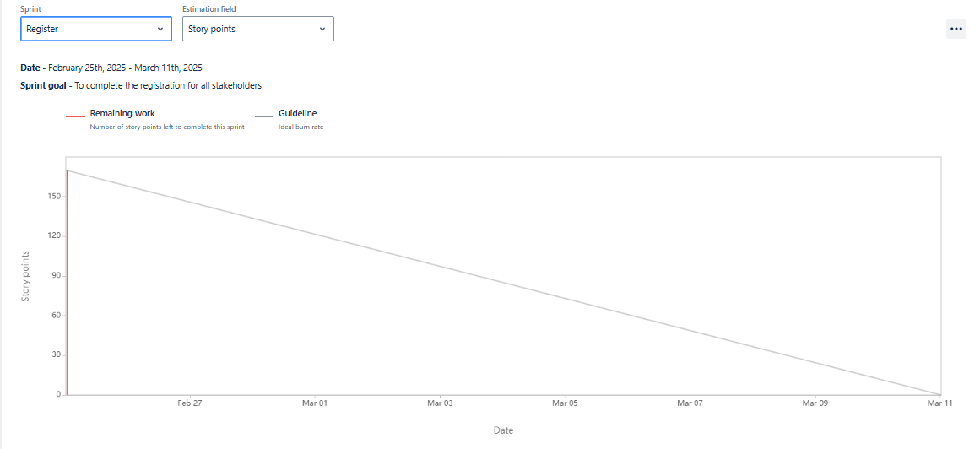

1. Sprint backlog for Login sprint: (ongoing sprint)

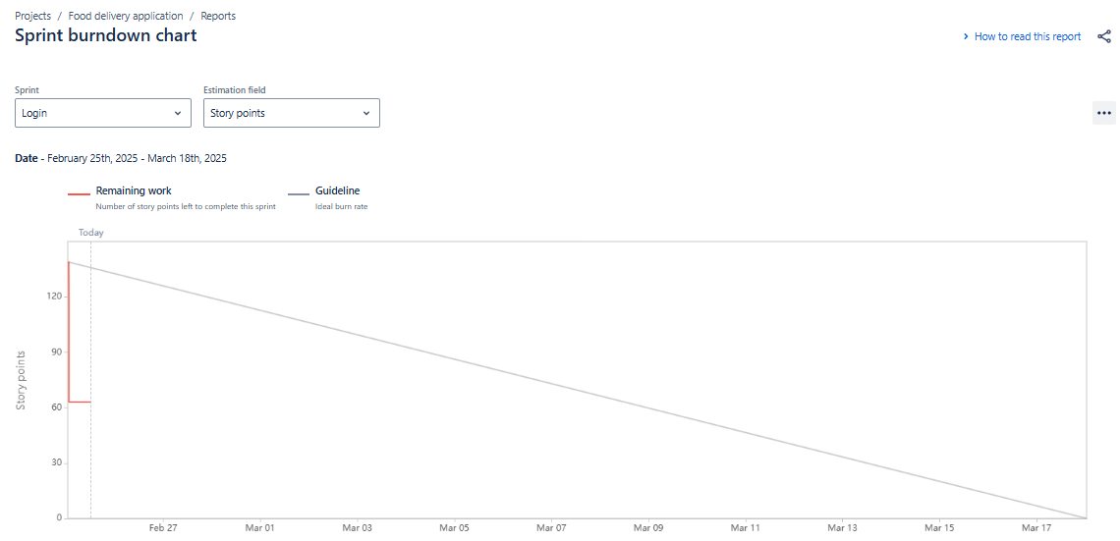

1. Product Backlog:

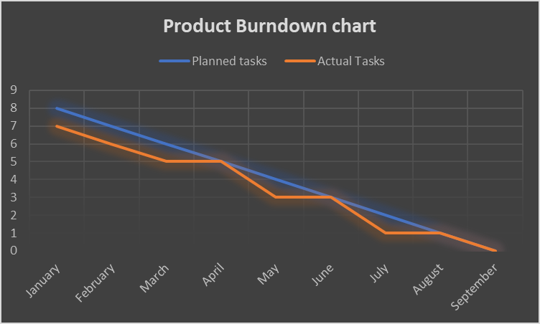

Question 10) Question 10 – Explain about Product Grooming – 2 Marks

Answer) Grooming is a stage in Agile where-in the software that is developed in iterations is put for enhancement due to defects found in the product/software.

Question 11) Explain the roles of Scrum Master and Product Owner

Answer) **A Scrum Master** popularly known as a coach, motivator and leader of an Agile team. The role of a Scrum Master is to educate the team on Agile processes and help team members follow Scrum practices

religiously. Facilitation scrum event as and when it is required .

The Scrum Master collaborates both with the Product Owner (PO) who focuses on building the right

product, and the development team that focuses on building the product right. A Scrum Master’s job is

essentially to help everyone understand and imbibe Scrum values, principles, and practices and get the

best product out to the customer.

**The Product Owner** takes the lead in many aspects of a product’s development. As a member of the

Scrum Team, the Product Owner provides clarity to the team about a product’s vision and goal. All work

is derived and prioritized based on the Product Goal in order to deliver value to all stakeholders

including those within their organization and all users both inside and out. Product Owners identify,

measure and maximize value throughout the entire product's lifecycle.

* Defining the vision
* Prioritizing the product backlog
* Taking an overview of development stages
* Handling communications
* Knowing what the client needs
* Evaluating progress

Question 12) – Explain all Meetings Conducted in Scrum Project

Answer) There are various meetings conducted in a scrum project and they are:

**Brainstorming meeting :- These meeting help to gather requreiements and include in the requirements when important.**

**JAD sessions**

**Sprint planning meeting**: This happens at the beginning of each sprint and the team decides what they will be delivering in this sprint.

**Daily Scrum Meeting:**  This happens everyday wherein the team answers these 3 questions.

1. What did we do today?
2. What will you do tomorrow?
3. Are there any impediments that is slowing or stopping you?

**Sprint retrospective meeting:-** This happens at the end of each sprint wherein the team answers these 3 questions:

1. What went well in the sprint?
2. What did not go well?
3. What are the required areas of improvements in the next sprint?

Only the Scrum Developers will participate and will discuss about Challenges faced and come up with lessons learnt. We can use these lessons learnt in Sprint Planning Meeting to select user stories for the next sprint.

**Sprint review meeting:-** This happens at the end of each sprint where the scrum team presents the completed user stories to the product owner and gets it cleared.

All Stakeholders like Scrum Developers, Product owner, Scrum master, Client,

3rd party reviewers will participate. What they discuss is

|  |
| --- |
| **We as team,** |
| **Write here** |

Question 13 – Explain Sprint Size and Scrum Size

**Sprint Size-** A sprint is an agile based methodology similar to an iteration. A sprint is time boxed to deliver specific user stories and functionalities within a set time period. During a sprint the user stories can be removed from the sprint but new user stories can not be added so that the team does not loose focus.

Sprints are the soul of Scrum methodology within Agile Project Management. A Sprint is a time-boxed event of weeks in which your Scrum team focuses only on a sprint goal. The goal is typically a product increment or iteration, often an updated, improved version of your product or software. Normally a sprint happens for two weeks but can be extended up to 4 weeks.

**Scrum Size-** The optimum size for the scrum team is around 8 - 10 members with varying skill sets and large

enough to accomplish the tasks comfortably and share, communicate, and collaborate effectively.

A Scrum team will have 1 Scrum Master, 1Product Owner and 8 to 10 Scrum Developers

Question 14) The Definition of Done & Definition of Ready:

The DoD is a comprehensive checklist of necessary criteria that ensures the increment is at the desired quality and is truly "done".

This includes all the work that must be done for the working increment to be useful and releasable and could consist of things like writing code, testing, documentation, and meeting regulatory requirements.

It is crucial for transparency and ensuring the Increment is respecting the standards of the organisation or the product and also satisfies the Scrum Team's quality standards.

The DoD is often refined and agreed upon by the entire Scrum Team, and it's revisited as the team learns and the product evolves.

**The Definition of Ready:**

Definition of Ready (DoR)

* Used to determine if a user story or task is ready to start working on
* Applies to product backlog items
* Used during backlog refinement at the start of a sprint
* Ensures that all necessary information, requirements, and clarifications are in place

Definition of Done (DoD)

* Used to determine if a user story or task is complete
* Applies to working software
* Used at the end of a sprint to check the quality of a product increment
* Ensures that a product is ready to be accepted by users
* Includes quality checks, testing, documentation, and other crucial elements

Question 15) Explain Prioritization Techniques and MVP –

Answer) Prioritization means to prepare the request to be moved to the development phase. Requirements are prioritized based on risk, cost, budget & benefit to the organization.

There are various techniques used for prioritization:

MOSCOW

is a prioritization technique used in business analysis and software development to reach a common understanding with stakeholders on the importance they place on the delivery of each requirement - also known as MOSCOW prioritization or MOSCOW analysis

The MOSCOW method can help. MOSCOW stands for must, should, could and would:

M - Must have this requirement to meet the business needs.

S-Should have this requirement if possible, but project success does not rely on it.

C-Could have this requirement if it does not affect anything else in the project.

W-Would like to have this requirement later, but it won't be delivered this time.

Other techniques:

Techniques

100 Dollars Test

Top 10 requirements

Numerical Assignment -Mandatory, very important, rather important, not important, does not matter.

A minimum viable product (MVP) is the release of a new product (or a major new feature) that is used

to validate customer needs and demands prior to developing a more fully featured product. To reduce

development time and effort, an MVP includes only the minimum capabilities required to be a viable

customer solution

A minimum viable product is a version of a product with just enough features to be usable by early

customers who can then provide feedback for future product development. A focus on releasing an MVP

means that developers potentially avoid lengthy and unnecessary work.

Question 16) Difference between Business Analyst n Product Owner :

**Product Owner:**

In many organizations, the Product Owner also has a Product Manager title and is responsible for making

decisions about the product, for managing the product’s strategic roadmap and for communicating that

roadmap. If there are cross-product impacts, then coordination of feature prioritization with other

product POs is necessary - because certainly those in the C-suite are going to want to see a consolidated

view of all product priorities.

**Business Analyst role**

Similar to the PO, the BA plays a critical role in working with the scrum team to execute the product

vision by defining needs and recommend solutions that deliver value. The BA goes a bit deeper by

breaking down high level product features into user stories, with the appropriate amount of detail. This

may result in other BA artifacts –some of the most common examples I’ve experienced are capabilities

gap analysis and process flow diagrams.

Q17) Resume:

