Renewable Energy Integration
Question 6: Please prepare a use case diagram, activity diagram and a use case specification document?

Answer:
Use Case Diagram
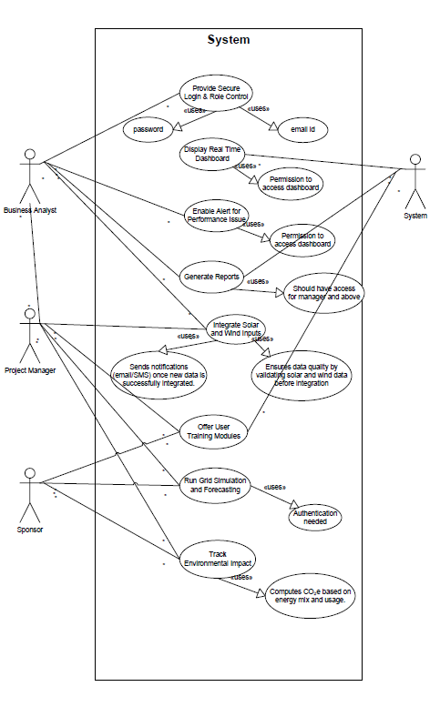

Activity Diagram:

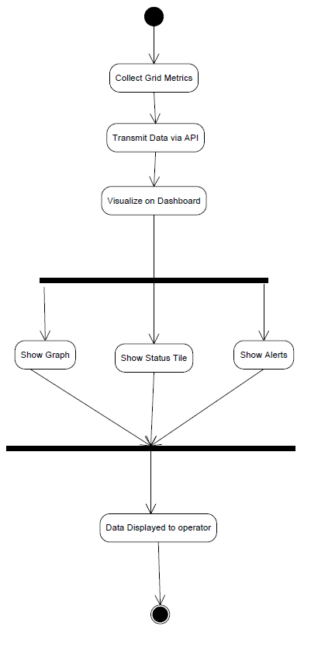

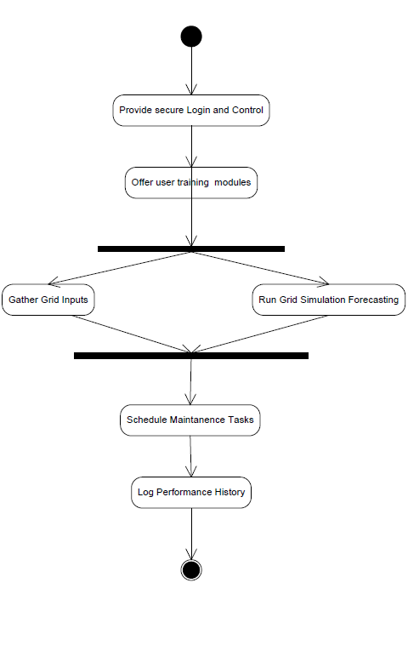

Use Case Name: Display Real-Time Dashboard:
1. Use Case Description:
Provides grid operators with an interface that continuously visualizes power flow, operational status, generation levels, and system alerts.
2. Actors:
- Primary Actors:
  - Grid Operators – monitor system performance and anomalies.
  - System Administrator – configure dashboard settings and access.
- Secondary Actors:
  - Project Manager – tracks system stability via dashboard KPIs.
3. Basic Flow:
- Backend system collects operational metrics.
- APIs transmit data to dashboard every 5 seconds.
- Data is visualized using graphs, meters, and tables.
4. Alternate Flow:
- Cached values are shown if API polling fails briefly (e.g., <60 seconds).
5. Exceptional Flows:
- API is unresponsive >2 min → Dashboard turns red and prompts “Data Stream Unavailable” banner.
6. Pre-Conditions:
- Sensor network and grid systems must be live.
- Dashboard is connected to real-time stream.
7. Post-Conditions:
- Operators see updated status, graphs, and flags.
8. Assumptions:
- API connections are stable and timely.
- Operator permissions are valid.
9. Constraints:
- Display refresh rate capped at every 5 seconds.
- Max dashboard latency: 2 seconds.
10. Dependencies:
- Data ingestion engine, visualization libraries (e.g., D3.js), APIs.
11. Inputs and Outputs:
- Inputs: Metrics from grid (energy flow, battery levels, alerts).
- Outputs: Graphs, live tiles, status banners.
12. Business Rules:
- Critical errors are red and sticky.
- Users must log in to access private modules.
13. Miscellaneous Information:
- Based on BR002, FR0003
- Links to Performance Monitoring System

Use Case Name: Enable Alerts for Performance Issues
1. Use Case Description:
Monitors key grid metrics and instantly alerts teams if anomalies like voltage fluctuation, system fault, or disconnection are detected.
2. Actors:
- Primary Actors:
  - System Monitoring Module – detects issues in real-time.
- Secondary Actors:
  - Operators – respond to alert.
  - Maintenance Team – dispatched if necessary.
3. Basic Flow:
- Metrics like voltage, frequency, latency are tracked.
- Rule engine applies thresholds.
- If deviation is detected, alert is triggered.
- System logs event and notifies stakeholders.
4. Alternate Flow:
- Transient fluctuation auto-corrects and alert is auto-dismissed.
5. Exceptional Flows:
- Notification server is down → alert is queued and escalated via SMS fallback.
6. Pre-Conditions:
- Threshold rules are pre-configured.
- Real-time metrics are flowing.
7. Post-Conditions:
- Alerts are logged, displayed, and optionally acknowledged.
8. Assumptions:
- No configuration errors in alert rules.
- Communication to users is active.
9. Constraints:
- Alerts must be delivered within 60 seconds.
- Max retries: 3 before manual escalation.
10. Dependencies:
- Notification system (email, SMS gateway), monitoring sensors.
11. Inputs and Outputs:
- Inputs: Voltage logs, fault events, rule definitions
- Outputs: Alerts via dashboard/email/SMS
12. Business Rules:
- Alerts must contain timestamp, cause, and severity.
- Auto-clear alerts only if metric stays normal for 5 minutes.
13. Miscellaneous Information:
- FR0005 and BR003
- Based on SCADA monitoring standards

Use Case Name: Generate Reports
1. Use Case Description:
Allows authorized users to export performance, compliance, and energy flow reports for analysis, auditing, or policy review.
2. Actors:
- Primary Actors:
  - Grid Admin – generates scheduled reports.
  - Business Analyst – uses data for analysis and insights.
- Secondary Actors:
  - QA Team – validates data integrity.
  - Sponsor – reviews high-level KPIs.
3. Basic Flow:
- User logs into reporting module.
- Selects report type, filters, format.
- System queries historical data store.
- Report is rendered and exported.
4. Alternate Flow:
- Recurring report: User sets daily/weekly schedule and email delivery.
5. Exceptional Flows:
- No data in selected period → system flags and prompts retry.
6. Pre-Conditions:
- User must be authenticated.
- Reporting engine is online.
7. Post-Conditions:
- Report is saved and available for review.
8. Assumptions:
- All modules correctly log data.
- No corruption in storage layer.
9. Constraints:
- Report generation SLA: under 30 seconds.
- Export formats limited to PDF, Excel, JSON.
10. Dependencies:
- Report generator, DB engine, visualization library.
11. Inputs and Outputs:
- Inputs: Filters (dates, categories), report type.
- Outputs: Downloadable file, dashboard preview.
12. Business Rules:
- Reports must use official government templates for audits.
- User actions on reports must be logged.
13. Miscellaneous Information:
- Based on BR004, FR0006
- Compliant with energy audit standards

Question 7: Screens and pages

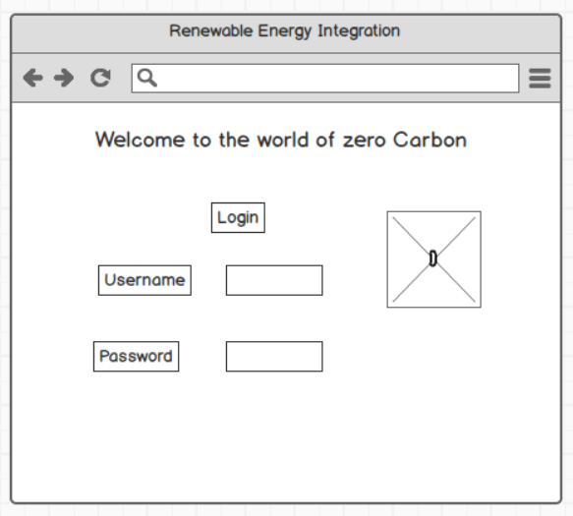

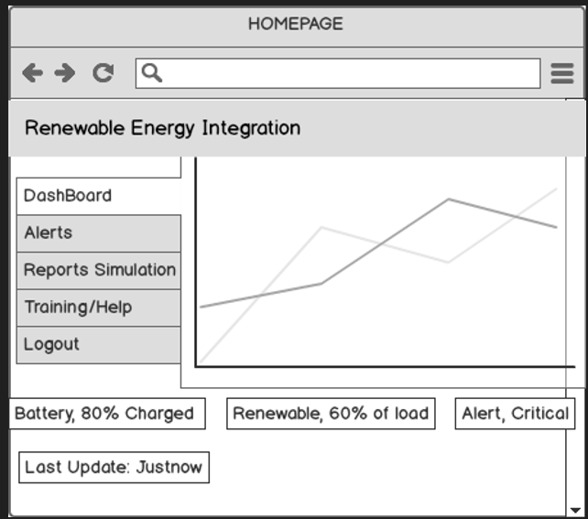
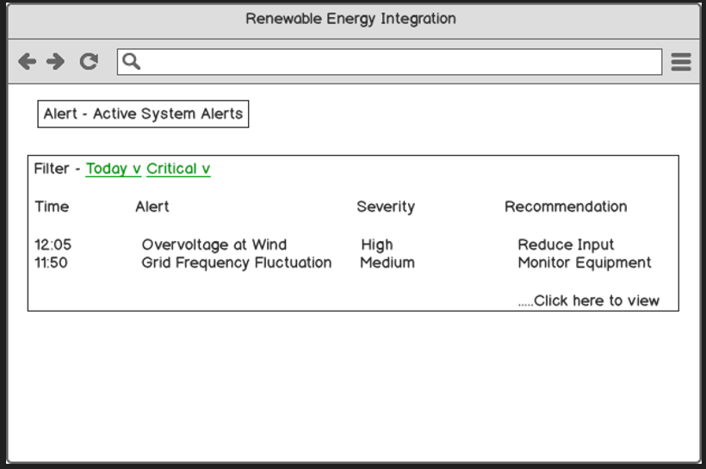

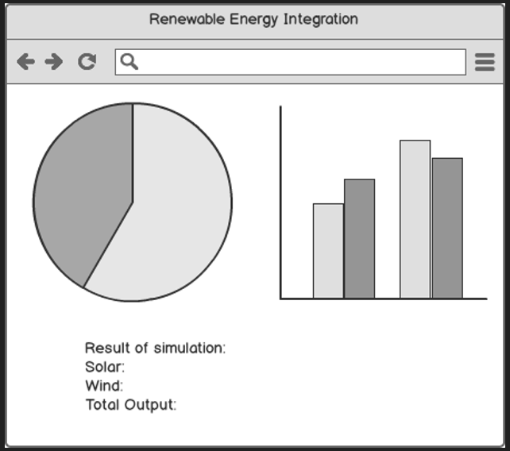
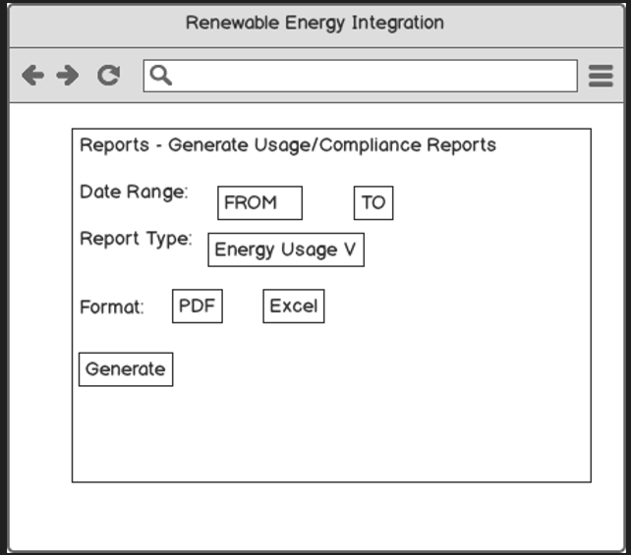

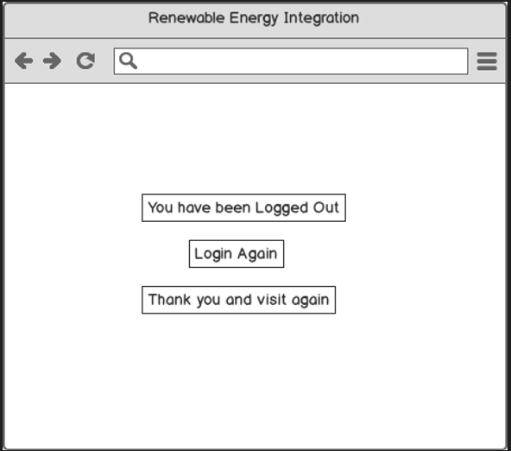

Question 8: Write a paragraph on your experience using Visio and Axure for the project.
Tools-Visio and Axure
I used Microsoft Visio to draw clear diagrams that show how the new renewable-energy grid will work, and Balsamiq to sketch the web screens that operators will see. Visio helped me map the big ideas-like which parts collect solar power, where we store energy, and how alerts move through the system-so engineers could follow the flow easily. Balsamiq let me make quick, hand-drawn-style wireframes of the login page, real-time dashboard, alert list, and report screen, so managers could click through a simple mock-up and give feedback early. Using both tools kept the project on track: Visio explained the system logic, and Balsamiq showed the user journey.
- Visio: easy “drag-and-drop” shapes, good for big system diagrams, auto-align keeps drawings tidy.
- Balsamiq: fast to sketch screens, looks like a whiteboard, helps get quick approval.
- Benefit: everyone (engineers and managers) saw the same plan from back-end flow to front-end screens.
- Challenge: Visio diagrams can get busy; I grouped items to keep them readable.
- Outcome: fewer re-works and faster sign-off because visuals were clear and shared early.
Document 9 – BA Experience
As the Business Analyst on the Renewable Energy Grid Integration project, I navigated every phase of the Waterfall lifecycle - from initial requirements to final deployment. In this narrative I reflect on my journey through Requirement Gathering, Requirement Analysis, Design, Development, Testing, and Deployment. I describe the tasks I performed, the challenges I faced, the tools and techniques I used (such as MoSCoW, FURPS, UML, and RTM), and how issues were handled along the way. The tone is natural and honest, recounting how we delivered critical features like renewable-energy dashboards, alert systems, simulation tools, and reporting modules.
Requirement Gathering
Requirement gathering was the first major phase of the project, and I approached it by engaging a wide range of stakeholders. I worked with grid engineers, IT staff, environmental specialists, and regulatory representatives to understand what the new system needed to accomplish. We conducted interviews, surveys, and interactive workshops to elicit both functional and non-functional requirements. Early on, we realised that our existing grid systems had significant gaps-they had no real-time monitoring dashboards or automated alerting mechanisms and struggled with the variability of solar and wind energy. These AS-IS insights framed why the project was crucial. Stakeholders emphasised that the new platform must introduce modern capabilities such as live dashboards, automated alerts, and scenario-simulation tools.
During these discussions I captured a variety of requirements. The most critical included:
- Real-time Energy-Flow Monitoring dashboard to display current generation, consumption, and storage levels
- Alert System to notify operators of anomalies such as voltage spikes or equipment faults
- Simulation Interface for testing different grid scenarios and forecasting performance
- Data-Reporting module for periodic energy and efficiency reports
To manage the wish list of features I applied the MoSCoW prioritisation technique. The dashboard and alert system were marked Must-have (critical for real-time operations) while items like complex analytics visualisations were Could-have for a later phase.
Challenges & Solutions
- Scheduling conflicts. Key stakeholders were often unavailable. I offered flexible meeting times and used concise email questionnaires when live sessions were impossible.
- Duplicate requirements. Different groups sometimes expressed the same need in different terms. I consolidated overlaps and validated each item with a RACI matrix, ensuring a single, clear owner for approvals.
By the end of the Requirement Gathering phase we had a well-defined, prioritised list of requirements and a shared understanding of the project’s goals.

Requirement Analysis
In the Requirement Analysis phase I refined raw requirements into a clear blueprint. I drafted the Business Requirements Document (BRD), translated it into functional (FRD) and non-functional specifications, and aligned each item with business objectives - for example, improving grid reliability through real-time monitoring meant the dashboard needed strict performance criteria.
Using the FURPS model, I captured:
- Functionality: real-time data, alert thresholds, simulation controls
- Usability: intuitive dashboards for non-technical operators
- Reliability: alerts must be issued within 60 seconds of an anomaly
- Performance: dashboards must update every five seconds without lag
- Security: role-based access and audit logging
I created UML use-case and activity diagrams to visualise user interactions, and completed a gap analysis to confirm the proposed future state addressed current deficiencies.
Challenges & Solutions
- Late compliance request. A regulator asked for an additional report late in the phase. Following change-control, we classed it Should-have for a future release, protecting timelines.
- Conflicting requirements. I facilitated workshops to reconcile differences and document agreed-upon solutions.
By the end of analysis, we had an approved, traceable scope baseline - including solar and wind integration, dashboards, alerting, simulation, and reporting - ready for design.

Design
During Design I worked with architects to ensure databases, UI layouts, and integrations met requirements. I helped define the alert workflow with sequence diagrams, confirming that a rule engine would evaluate data in real time. I also reviewed simulation-interface prototypes to ensure users could input scenario parameters and receive meaningful forecasts.
I kept FURPS front-of-mind, pushing for responsive UIs, scalable architectures, and built-in security. When the complexity of the simulation engine raised concerns, I brokered a compromise: a simplified model for the first release with advanced capabilities slated for later.
Throughout the phase I maintained traceability, mapping every design element back to its originating requirement and catching omissions early.

Development
As development started, I used an evolving Requirement Traceability Matrix (RTM) to track each feature from code to test cases. I answered developer questions promptly-e.g., supplying exact voltage-spike thresholds for alerts-and organised informal demos to catch deviations early. When a minor scope change (an extra filter in reports) surfaced, I triaged the effort, reprioritised work, and documented the change with client sign-off.

Testing
Working with QA, I ensured every requirement had corresponding unit, system, and UAT cases via the RTM. I coordinated User Acceptance Testing with grid operators and energy-authority staff, collecting feedback and overseeing fixes-such as replacing technical abbreviations with user-friendly labels and fine-tuning the forecasting algorithm.
Deployment
Before go-live I delivered user training sessions and quick-reference guides. We executed a phased rollout, piloting in one region first. On day one we quickly corrected data-entry typos that blocked email alerts, demonstrating responsive support. A last-minute glitch in a vendor weather API caused data gaps; I provided cached data as a stop-gap and communicated transparently with stakeholders until the vendor resolved the issue.
After successful launch I compiled lessons learned and captured enhancement ideas-e.g., a mobile app for field technicians-for the next iteration.
Reflection
Guided by structured BA practices, diligent traceability, and open communication, we delivered a solution that gives operators real-time visibility and predictive control over renewable-energy flows. Watching the system go live and knowing it makes renewable-energy management more efficient is the most rewarding part of my BA career so far.

