# 4 BA Mock - Case study

**Assignment 1:**

1. Please make a BRD which can be presented to the client along with complete development and resource plan.

# **Milk Products & Ice-Cream Delivery**

# **100340042**

# **Version 2.2**

# **Arihant Jamed**

**Table of Contents:**

|  |  |  |
| --- | --- | --- |
| **Topic** | **Name** | **Page Number** |
| 1 | Document Revision | 1 |
| 2 | Approvals | 1 |
| 3 | RACI Chart for This Document | 2 |
| 4 | Introduction | 2 |
|  | 4.1 – Business Goals | 2 |
|  | 4.2 - Business Objectives | 3 |
| 5 | Scope of work | 3 |
|  | 5.1 – Functional Requirement | 3 |
|  | 5.2 – Non-Functional Requirement | 3 |
| 6 | Constraints | 3 |
| 7 | Risks | 4 |
|  | 7.1. Technological Risk | 4 |
|  | 7.2. Skill Risks | 5 |
|  | 7.3. Political Risks | 5 |
|  | 7.4. Business Risks | 6 |
|  | 7.5. Requirements Risks | 6 |
|  | 7.6. Other Risks | 7 |
| 8 | Business Process Overview | 7 |
|  | 8.1 – Legacy System (AS-IS) | 7 |
|  | 8.2 – Proposed Recommendations (TO-BE) | 8 |
| 9 | Development & Resource Plan | 8 |

# **Document Revision:**

|  |  |  |
| --- | --- | --- |
| **Date** | **Version** | **Document Changes** |
| 3/4/2025 | 1.0 | Initial Draft |
| 4/4/2025 | 1.1 | Draft modification on privacy policy |
| 10/4/2025 | 2.0 | Draft Completed for client review |
| 29/4/2025 | 2.1 | Minor demographical changes |
| 30/4/2025 | 2.2 | Final Draft |

# **Approvals:**

|  |  |  |  |
| --- | --- | --- | --- |
| **Role** | **Name** | **Title** | **Signature** |
| Project Sponsor | Rajesh Khanna | AVP | Signed |
| Business Owner | Sailaja Josyula | SD | Signed |
| Project Manager | Ravi Kumar | AD | Signed |
| System Architect | Anand Joshi | M | Signed |
| Development Lead | Mathew Jose | SM | Signed |
| User Experience Lead | Mahalakshmi | SA | Signed |
| Quality Lead | Mohd Ibrahim | SA | Signed |
| Content Lead | Savitha Kumari | M | Signed |

# **RACI Chart for This Document:**

|  |  |  |  |  |  |  |
| --- | --- | --- | --- | --- | --- | --- |
| **Name** | **Position** | **\*** | **R** | **A** | **C** | **I** |
| Arihant Jamed | Business Analyst | Signing authority | Yes | Yes |  |  |
| Rajesh Khanna | Project Sponsor | Signing authority |  | Yes |  |  |
| Sailaja Josyula | Business Owner | Signing authority | Yes | Yes |  |  |
| Ravi Kumar | Project Manager |  |  |  | Yes |  |
| Anand Joshi | System Architect |  |  |  | Yes |  |
| Mathew Jose | Development Lead |  |  |  | Yes |  |
| Mahalakshmi | User Experience Lead |  |  |  |  | Yes |
| Mohd Ibrahim | Quality Lead |  |  |  |  | Yes |
| Savitha Kumari | Content Lead |  |  |  |  | Yes |

# **Introduction:**

# **4.1 Business Goals:**

Ability to sell Milk products and ice creams directly from the manufacturing plants and warehouses online in a web application. It involves tracking, ordering, and storing goods, track stock levels, expiry dates. Efficient **inventory management** across multiple warehouses. **Optimized delivery routes** to ensure fast customer service for better customer experience.

# **4.2. Business Objectives:**

We will provide an IT solution with easy usage of web application. The software aims to:

* Reduce stock discrepancies and improve visibility across locations.
* Improve demand forecasting to optimize storage.
* Minimize delivery times using real-time tracking and AI-powered logistics.
* Enhance customer satisfaction with fast and reliable deliveries.
* Ensure compliance with food safety and cold-chain management regulations.

# **5. Scope of Work:**

**In-Scope Features**

* **Inventory Management:** Automated stock tracking, expiration alerts, reordering system.
* **Order Fulfillment:** Prioritization based on demand, express processing.
* **Logistics Optimization:** AI-driven route planning, dynamic scheduling.
* **Cold Chain Monitoring:** Real-time temperature tracking for perishable goods.

**Out-of-Scope Features**

* Customer-facing order management.
* External marketplace integrations (unless requested later).
* Advanced AI demand prediction (planned for future iterations).

# **5.1. Functional Requirement:**

**Inventory Management**

* Ability to track stock levels in **real-time**.
* Automated alerts for **low-stock and expired items**.
* Demand forecasting using **historical and seasonal trends**.

**Delivery Optimization**

* AI-based **route optimization** for deliveries.
* Dynamic scheduling system for **order prioritization**.
* **Temperature control monitoring** for cold-chain transport.

**Reporting & Analytics**

* **Real-time dashboards** for inventory and logistics performance.
* Customizable reporting templates for **demand analysis**.

# **5.2 Non-Funactional Requirement**

* **High Availability:** 99.99% uptime via **cloud infrastructure**.
* **Scalability:** Ability to handle **future expansion** of manufacturing units.
* **Data Security:** **Role-based access** with end-to-end encryption.
* **Compliance:** Follows **food safety regulations and quality standards**.

# **6. Constraints:**

* **Resource Constraints** - Conflicts in resource allocation due to multiple projects or competing priorities
* **Stakeholder Constraints** - Ensuring consistent and effective communication and engagement with all stakeholders
* **Technological Constraints** - Keeping up with rapidly changing technology and implementing new solutions
* **Regulatory Constraints** - Meeting industry-specific regulations, standards, and legal requirements
* **Cultural Constraints** - Aligning the project with the organization's culture and values
* **Geographical Constraints** - Coordinating project activities across different time zones
* **Financial Constraints** - Dealing with cost fluctuations for materials, labour, and other expenses

# **7. Risks:**

We may have risk factor while the project progress and we need to ensure that these risks are identified early and action them accordingly. Some of the risks that could slow down the timelines are:

# **7.1. Technological Risk:**

Technological risks are challenges and potential threats associated with the use of technology in projects or operations.

**Risk:**

* Technology becomes outdated or incompatible with new systems
* Difficulties in integrating new technology with existing systems
* Hardware/Software failures
* Data breaches, cyberattacks, and unauthorized access
* Technology not performing as expected, leading to inefficiencies.
* Losing critical data due to system failures or errors

**Avoid:**

* Regularly update and upgrade technology to stay current
* Choose technology that is compatible with existing systems
* Choose reliable and well-supported technology solutions
* Conduct thorough research and performance testing before adoption
* Implement robust data backup and recovery solutions

**Mitigate:**

* Adopt flexible and scalable solutions that can adapt to future changes
* Conduct thorough testing and pilot programs before full implementation
* Regularly update security protocols, conduct audits, and provide employee training
* Implement redundancy and failover mechanisms, and perform regular maintenance
* Monitor performance continuously and address issues promptly
* Regularly test backup and recovery processes to ensure effectiveness

**Transfer:**

* Outsource technology management to vendors who stay updated with the latest advancements
* Engage third-party experts to manage integration tasks
* Obtain cyber insurance to cover potential losses from security breaches
* Use managed services or cloud providers with robust uptime guarantees
* Use service-level agreements (SLAs) with vendors to ensure performance standards
* Use cloud storage solutions with built-in redundancy and data protection

**Accept:**

* Plan for periodic reviews and updates, acknowledging that some degree of obsolescence is inevitable
* Develop contingency plans for potential integration challenges
* Prepare an incident response plan to address security incidents promptly
* Maintain a disaster recovery plan to minimize downtime and data loss
* Develop performance improvement plans and address issues as they arise
* Establish data retention policies and ensure critical data is backed up frequently

# **7.2. Skill Risks:**

Skill risks refer to the potential challenges and threats associated with the skills and expertise needed to complete a project successfully. These risks can impact the project's timeline, quality, and overall success. Here are some common skill risks and strategies to address them:

* **Skill Gaps:** Lack of necessary skills or expertise within the project team
* **Turnover:** Loss of key personnel with critical skills
* **Training Needs:** Insufficient training for team members to perform their tasks effectively
* **Dependency on Key Personnel:** Over-reliance on a few individuals with specialized skills
* **Evolving Technology:** Rapid changes in technology that require new skills and knowledge
* **Performance Variability:** Inconsistent performance levels among team members

**Avoid:** Conduct thorough skills assessment during the project planning phase to identify any skill gaps and ensure the team has the necessary expertise

**Mitigate:** Provide ongoing training and professional development opportunities to ensure team members have the skills required for the project

**Transfer:** Outsource specific tasks or functions that require specialized skills to external experts or consultants

**Accept:** Acknowledge that some level of performance variability is inevitable and plan for it by setting realistic performance expectations and providing additional support where needed

# **7.3. Political Risks:**

Political risks refer to potential challenges and threats arising from political decisions, events, or conditions that can impact an organization's operations, profitability, and strategic goals

* **Regulatory Changes:** New laws, regulations, or policies that may affect business operations.
* **Political Instability:** Unrest, conflict, or changes in government that can disrupt business activities.
* **Expropriation:** Government takeover or seizure of private assets and property.
* **Trade Restrictions:** Tariffs, import/export controls, and trade barriers that impact global operations.
* **Corruption:** Unethical practices, bribery, and corruption within political and governmental institutions.
* **Taxation Changes:** Changes in tax laws or rates that affect financial planning and profitability.
* **Sanctions:** Economic or political sanctions imposed on specific countries or entities.
* **Policy Uncertainty:** Unpredictable policy decisions that create uncertainty for businesses.

**Avoid:** Refrain from entering markets with high political instability or significant regulatory challenges.

**Mitigate:** Monitor political developments and engage in active lobbying or advocacy to influence policy decisions.

**Transfer:** Obtain political risk insurance to cover potential losses from expropriation or government seizure.

**Accept:** Acknowledge that some level of policy uncertainty is inherent in international operations and develop flexible strategies to adapt to changing conditions.

# **7.4. Business Risks:**

Business risks are uncertainties or potential threats that can negatively impact an organization's operations, profitability, and strategic goals. Here are some common business risks and strategies to address them:

* **Market Risk:** Changes in market conditions, competition, and customer preferences.
* **Operational Risk:** Internal processes, systems, or events that disrupt business operations.
* **Financial Risk:** Risks related to financial management, such as liquidity, credit, and interest rate risks.
* **Strategic Risk:** Risks associated with long-term strategic decisions and planning.
* **Compliance Risk:** Non-compliance with laws, regulations, and industry standards.
* **Reputation Risk:** Damage to the organization's reputation due to negative events or publicity.
* **Technological Risk:** Rapid changes in technology and potential technological failures.
* **Supply Chain Risk:** Disruptions in the supply chain that affect production and delivery.
* **Human Resource Risk:** Challenges related to employee recruitment, retention, and performance.
* **Environmental Risk:** Environmental factors that can impact the business, such as natural disasters and climate change.

**Avoid:** Refrain from entering markets with high volatility or significant regulatory challenges.

**Mitigate:** Implement robust business continuity and disaster recovery plans to minimize the impact of disruptions.

**Transfer:** Obtain insurance coverage for property damage, business interruption, and other potential losses.

**Accept:** Acknowledge that market fluctuations are inherent to business operations and develop flexible strategies to adapt.

# **7.5. Requirements Risks:**

Requirement risks are potential issues and uncertainties associated with gathering, defining, and managing project requirements. These risks can lead to project delays, cost overruns, and failure to meet stakeholder expectations.

* **Incomplete Requirements:** Critical requirements are missed or not fully defined.
* **Changing Requirements:** Requirements change frequently during the project lifecycle.
* **Ambiguous Requirements:** Requirements are unclear or open to interpretation.
* **Unprioritized Requirements:** Lack of clear prioritization of requirements leads to confusion and delays.
* **Unvalidated Requirements:** Requirements are not validated with stakeholders, leading to incorrect assumptions.
* **Scope Creep:** Uncontrolled changes or additions to the project scope.
* **Stakeholder Misalignment:** Misalignment between stakeholders on project requirements.

**Avoid:** Conduct thorough requirements gathering sessions with all relevant stakeholders to ensure completeness.

**Mitigate:** Implement a formal change control process to manage and approve changes to requirements.

**Mitigate:** Conduct regular reviews and validation sessions with stakeholders to ensure requirements accurately reflect their needs.

**Transfer:** Engage external consultants or experts to help prioritize requirements based on business value and impact.

# **7.6. Other Risks:**

Some additional types of risks that organizations and projects might encounter.

* Reputation Risks
* Supply Chain Risks
* Human Resource Risks
* Project Management Risks

# **8. Business Process Overview:**

The current and thew future state of the process is depicted below.

# **8.1. Legacy System (AS-IS):**

The company might be facing several challenges related to **inventory management and delivery efficiency**, such as:

* **Lack of Real-time Stock Visibility**: Warehouses and manufacturing plants may not have an accurate system to track inventory levels.
* **Overstocking & Understocking Issues**: Without demand forecasting, some locations may have excess ice cream or milk products, while others face shortages
* **Slow Order Fulfillment:** Inefficient logistics and manual processes may cause delays in deliveries
* **High Transportation Costs:** Without optimized delivery routes, fuel and operational costs may be higher than necessary
* **Temperature Control Risks**: Ice cream and milk products require strict cold-chain management, and any inefficiencies could lead to product spoilage
* **Customer Dissatisfaction:** Delayed deliveries and unavailable stock could lead to lost sales and unhappy customers

# **8.2. Proposed Recommendations (TO-BE):**

The new **inventory management and delivery optimization software** is being developed to:

1. **Improve Stock Tracking** – Enable real-time inventory updates across warehouses and manufacturing units.
2. **Enhance Delivery Speed** – Optimize transportation routes using AI-driven logistics solutions.
3. **Minimize Wastage** – Ensure better stock distribution and track product expiration to avoid spoilage.
4. **Automate Processes** – Reduce manual workload and streamline operations.
5. **Boost Customer Satisfaction** – Faster deliveries and better inventory availability will improve the buying experience.
6. **Increase Profitability** – Lower transportation costs and better stock management lead to higher efficiency.

# **9. Development & Resource Plan:**

**Technology Stack**

* **Backend:** Python / Node.js
* **Frontend:** React.js / Angular
* **Database:** PostgreSQL / MongoDB
* **Cloud Infrastructure:** AWS / Azure
* **Mobile Access:** Android & iOS compatibility

**Team & Resource Allocation**

|  |  |  |
| --- | --- | --- |
| **Role** | **Responsibilities** | **Required Resources** |
| **Business Analyst** | Requirement gathering, stakeholder meetings | 1 |
| **Project Manager** | Sprint planning, risk management | 1 |
| **Developers (Frontend & Backend)** | Software development & integration | 4 to 6 |
| **QA Engineers** | Testing & validation | 2 |
| **UX/UI Designer** | Interface design | 1 |
| **DevOps Engineer** | Deployment & maintenance | 1 |
| **Data Analyst** | Forecast modeling & reporting | 1 |

**Development Roadmap (Agile/Scrum)**

This project aligns well with Agile methodologies, allowing iterative improvements and rapid adaptation to real-world challenges.

|  |  |  |
| --- | --- | --- |
| **Phase** | **Timeline** | **Deliverables** |
| **Phase 1: Requirement Analysis** | 2 Weeks | BRD, Stakeholder approvals |
| **Phase 2: MVP Development** | 6 Weeks | Inventory tracking module |
| **Phase 3: Logistics Optimization** | 4 Weeks | AI-based routing & scheduling |
| **Phase 4: Testing & Refinements** | 3 Weeks | User Acceptance Testing (UAT) |
| **Phase 5: Deployment & Training** | 2 Weeks | Final rollout & employee training |

**Cost Estimation**

- Development Costs: $200K – Based on tech stack and development hours.

- Operational Costs: $140K – Cloud hosting, maintenance, upgrades.

- Training & Implementation: $191K – Employee training and initial support.

2. Prepare process flow diagram using your imagination.

**Flow Diagram of Low Stock & Expiry product Management**

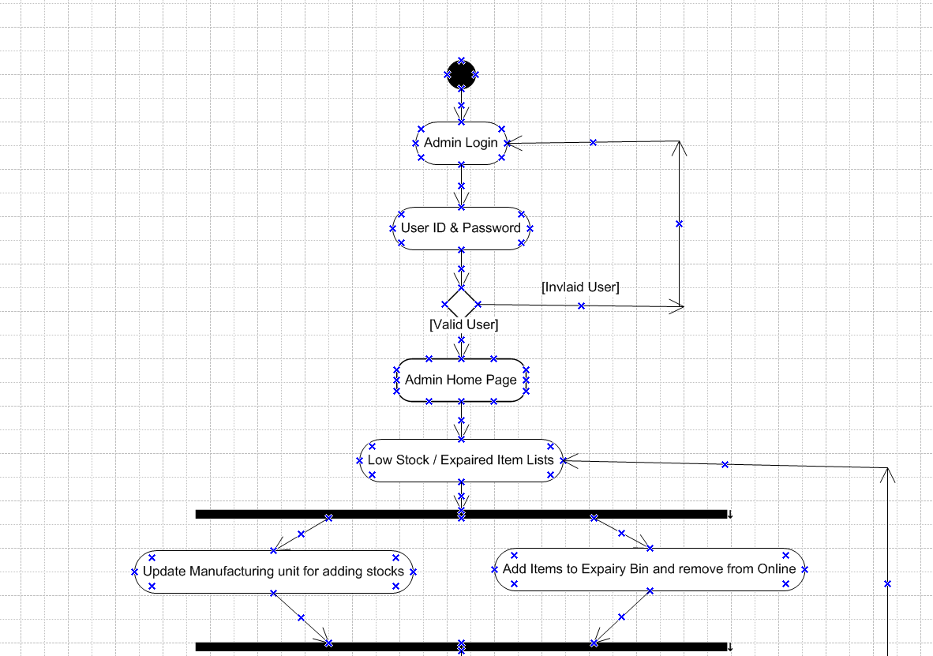

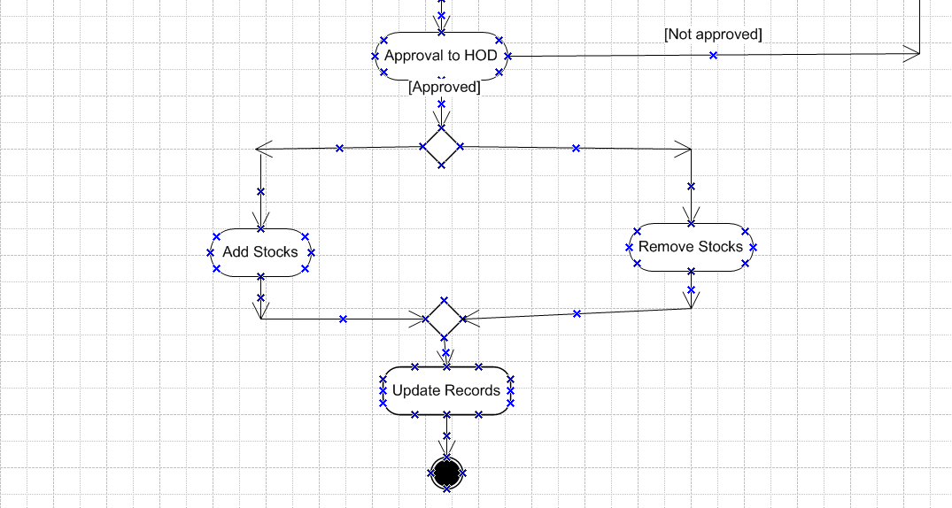

**Overall Operations**

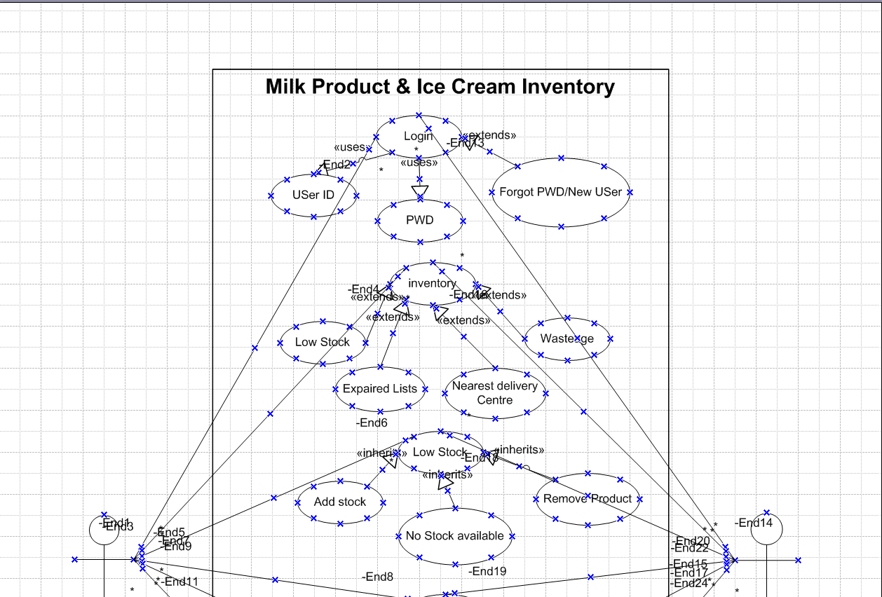

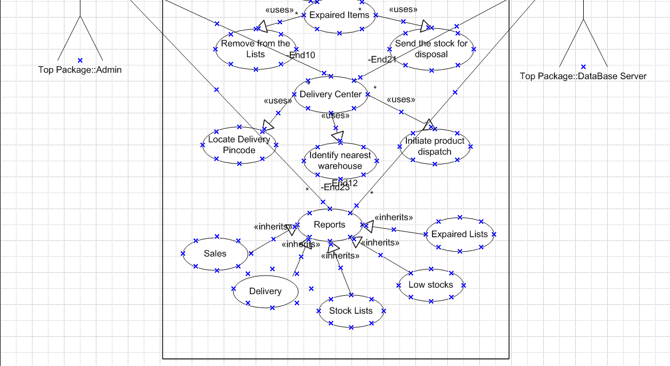

**Assignment 2:**

1. Write an introduction letter to a client introducing yourself as a business analyst in charge of working with the client and his team to start the business understanding process.

**Arihant Jamed**  
Business Analyst  
ABC Solutions Pvt. Ltd.  
Arihant@abc.com | +91 - 9884014825  
30/4/2025

**Mr. Pradeep Khabrani**  
Milk Product & Ice-cream Manufacturing Ltd.  
SIDCO Industrial Estate, Oragadam, Chennai.

**Subject:** Introduction as Your Business Analyst – Initiating the Business Understanding Process.

Dear Pradeep,

I hope this message finds you well. I am excited to introduce myself as the Business Analyst assigned to collaborate with you and your team on understanding your business requirements and ensuring a smooth transition into the project development phase.

As part of this engagement, my primary focus will be to gather, analyze, and refine business needs, ensuring that our solution aligns with your company’s objectives. Over the coming weeks, I will be working closely with your team to:

* **Identify key business challenges and opportunities** to create a solution that drives efficiency and growth.
* **Facilitate stakeholder discussions** to clarify requirements and priorities.
* **Define clear business and functional specifications** that will guide the project’s development.
* **Ensure alignment with industry best practices and compliance standards** to support long-term success.

I look forward to building a productive and collaborative relationship with you and your team. To kick off this process, I’d like to schedule an initial discussion to better understand your expectations, goals, and any existing systems or workflows that will influence our approach.

Please let me know a convenient time for us to connect. Feel free to reach out to me at Arihant@abc.com or +91 – 9884014825 at any time.

Looking forward to working together on this exciting initiative!

Best regards,  
Arihant Jamed  
Business Analyst  
ABC Solutions Pvt. Ltd.

2. Prepare a brief BRD and SRS for a project- Horoscope or Ticketing system or online store.

**Online Store - Business Requirement Document (BRD)**

# **Online eStore**

# **100213434**

# **Version 2.0**

# **Arihant Jamed**

**Table of Contents:**

|  |  |  |
| --- | --- | --- |
| **Topic** | **Name** | **Page Number** |
| 1 | Document Revision | 13 |
| 2 | Approvals | 13 |
| 3 | RACI Chart for This Document | 13 |
| 4 | Introduction | 14 |
|  | Business Objectives | 14 |
|  | Business Rules | 14 |
| 5 | Project Scope | 14 |
|  | Functional Requirement | 14 |
|  | Non-Functional Requirement | 15 |
| 6 | Constraints | 15 |
| 7 | Risks | 16 |
|  | Technological Risk | 16 |
|  | Skill Risks | 17 |
|  | Political Risks | 17 |
|  | Business Risks | 18 |
|  | Requirements Risks | 18 |
|  | Other Risks | 19 |
| 8 | Business Process Overview | 19 |
|  | Legacy System (AS-IS) | 19 |
|  | Proposed Recommendations (TO-BE) | 19 |
| 9 | Development & Resource Plan | 20 |
| 10 | Cost Estimation | 20 |
| 11 | Related documents | 20 |

# **Document Revision:**

|  |  |  |
| --- | --- | --- |
| **Date** | **Version** | **Document Changes** |
| 19/3/2025 | 1.0 | Initial Draft |
| 4/4/2025 | 1.1 | Draft modification on privacy policy/Client review updates/security updates |
| 5/1/2025 | 2.0 | Final Draft |

# **Approvals:**

|  |  |  |  |  |
| --- | --- | --- | --- | --- |
| **Role** | **Name** | **Title** | **Signature** | **Date** |
| Project Sponsor | Rajesh Khanna | AVP | Signed | 03-02-2025 |
| Business Owner | Sailaja Josyula | SD | Signed | 03-02-2025 |
| Project Manager | Ravi Kumar | AD | Signed | 03-01-2025 |
| System Architect | Anand Joshi | M | Signed | 28-02-2025 |
| Development Lead | Mathew Jose | SM | Signed | 28-02-2025 |
| User Experience Lead | Mahalakshmi | SA | Signed | 28-02-2025 |
| Quality Lead | Mohd Ibrahim | SA | Signed | 27-02-2025 |
| Content Lead | Savitha Kumari | M | Signed | 27-02-2025 |

# **RACI Chart for This Document:**

|  |  |  |  |  |  |  |
| --- | --- | --- | --- | --- | --- | --- |
| **Name** | **Position** | **\*** | **R** | **A** | **C** | **I** |
| Arihant Jamed | Business Analyst | Signing authority | Yes | Yes |  |  |
| Rajesh Khanna | Project Sponsor | Signing authority |  | Yes |  |  |
| Sailaja Josyula | Business Owner | Signing authority | Yes | Yes |  |  |
| Ravi Kumar | Project Manager |  |  |  | Yes |  |
| Anand Joshi | System Architect |  |  |  | Yes |  |
| Mathew Jose | Development Lead |  |  |  | Yes |  |
| Mahalakshmi | User Experience Lead |  |  |  |  | Yes |
| Mohd Ibrahim | Quality Lead |  |  |  |  | Yes |
| Savitha Kumari | Content Lead |  |  |  |  | Yes |

# **Introduction**

**Business Objective:**

The Online Electronic Store aims to provide a seamless digital shopping experience by offering a diverse range of electronic products with secure transactions and fast delivery. It enhances customer convenience through intuitive navigation, personalized recommendations, and real-time inventory updates. By integrating efficient order management and analytics, the platform enables businesses to optimize sales and improve customer satisfaction. The system supports multiple payment options and ensures compliance with security standards to build trust with users. With mobile-friendly access and scalable infrastructure, it helps businesses expand their reach and drive revenue growth in the competitive e-commerce landscape.

**Business Rules:**

Establishing clear **business rules and regulations** for an **online electronic store** ensures ethical operations, workplace integrity, and compliance with industry standards. Here are some key areas to consider:

**1. Workplace Conduct**

* Employees must adhere to professional behavior, maintain transparency, and treat colleagues, customers, and stakeholders with respect.
* Strict compliance with anti-discrimination policies, ensuring inclusivity in hiring and workplace culture.
* Confidentiality agreements to protect proprietary business information and customer data.

**2. Conflict of Interest**

* Employees must disclose any personal or financial interests that may interfere with business decisions.
* Vendors or suppliers with existing relationships with employees must undergo thorough due diligence to prevent favoritism.
* Employees should not engage in unauthorized partnerships or endorsements that conflict with business goals.

**3. Data Privacy & Security**

* The store must comply with data protection regulations (GDPR, CCPA) to safeguard user data.
* Employees must follow cybersecurity protocols to prevent data breaches and fraud.
* Unauthorized access to sensitive business or customer data is strictly prohibited.

**4. Ethical Sales & Marketing Practices**

* No misleading advertisements or deceptive promotions; all product descriptions must be accurate.
* Transparent refund and return policies to protect consumer rights.
* Prohibition of price manipulation or unethical competitive strategies.

**5. Compliance & Legal Regulations**

* Adherence to e-commerce laws, including tax regulations and international trade rules.
* Employees must report any unethical business practices or violations.
* Compliance with product safety standards and intellectual property laws.

# **Project scope**

This scope is to develop a simple ease of use web application and mobile applications for electronic estore.

**In Scope (Included Features)**

* Secure user registration & login
* Product catalog with search & filter options
* Shopping cart & secure checkout
* Payment gateway integration (UPI, cards, wallets)
* Order tracking & notifications (SMS/email)
* Inventory management & stock updates
* Customer support & return processing
* Analytics & reporting for business insights
* Mobile & web-friendly design
* Multi-vendor integration for third-party sellers

**Out of Scope (Excluded Features)**

* Physical store operations & in-store inventory tracking
* Manufacturing & assembly of products
* Direct shipping & logistics management (outsourced)
* Advanced AI-driven automation beyond recommendations
* Full-fledged ERP integration beyond inventory sync
* Global tax compliance (focus on domestic regulations)
* Marketplace for services (only physical products)

**Assumptions:**

* Customers have reliable internet access and familiarity with online shopping.
* Vendors will provide accurate product descriptions, pricing, and stock availability.
* Payment gateways will function smoothly with secure transaction processing.
* Logistics partners will ensure timely delivery and order tracking.
* Users will engage with promotions, discounts, and recommendation algorithms.
* The system will scale efficiently as the user base grows.
* Compliance with data protection laws (GDPR, PCI-DSS) will be maintained.
* The platform will be accessed from various devices (mobile, tablet, desktop).
* Customers will follow return and refund policies in good faith.

**Constraints:**

**Budget Limitations** – Costs for platform development, marketing, and logistics must be managed efficiently.  
**Technical Dependencies** – Integration with payment gateways, inventory management, and third-party logistics must be seamless.  
**Regulatory Compliance** – Adherence to e-commerce laws, data protection (GDPR, PCI-DSS), and taxation policies.  
**Security Risks** – Preventing fraud, cyberattacks, and unauthorized access to customer data.  
**Scalability Challenges** – Ensuring smooth performance as the number of users and transactions grow.  
**User Adoption & Experience** – The platform must be intuitive and mobile-friendly to attract and retain customers.  
**Vendor Reliability** – Suppliers must maintain product availability, accurate descriptions, and timely delivery.  
**Logistics & Delivery Constraints** – External partners may have limitations in service areas, causing delays or operational inefficiencies

# **Risks:**

We may have risk factor while the project progress and we need to ensure that these risks are identified early and action them accordingly. Some of the risks that could slow down the timelines are:

# **Technological Risk:**

Technological risks are challenges and potential threats associated with the use of technology in projects or operations.

**Risk:**

* Technology becomes outdated or incompatible with new systems
* Difficulties in integrating new technology with existing systems
* Hardware/Software failures
* Data breaches, cyberattacks, and unauthorized access
* Technology not performing as expected, leading to inefficiencies.
* Losing critical data due to system failures or errors

**Avoid:**

* Regularly update and upgrade technology to stay current
* Choose technology that is compatible with existing systems
* Choose reliable and well-supported technology solutions
* Conduct thorough research and performance testing before adoption
* Implement robust data backup and recovery solutions

**Mitigate:**

* Adopt flexible and scalable solutions that can adapt to future changes
* Conduct thorough testing and pilot programs before full implementation
* Regularly update security protocols, conduct audits, and provide employee training
* Implement redundancy and failover mechanisms, and perform regular maintenance
* Monitor performance continuously and address issues promptly
* Regularly test backup and recovery processes to ensure effectiveness

**Transfer:**

* Outsource technology management to vendors who stay updated with the latest advancements
* Engage third-party experts to manage integration tasks
* Obtain cyber insurance to cover potential losses from security breaches
* Use managed services or cloud providers with robust uptime guarantees
* Use service-level agreements (SLAs) with vendors to ensure performance standards
* Use cloud storage solutions with built-in redundancy and data protection

**Accept:**

* Plan for periodic reviews and updates, acknowledging that some degree of obsolescence is inevitable
* Develop contingency plans for potential integration challenges
* Prepare an incident response plan to address security incidents promptly
* Maintain a disaster recovery plan to minimize downtime and data loss
* Develop performance improvement plans and address issues as they arise
* Establish data retention policies and ensure critical data is backed up frequently

# **Skill Risks:**

Skill risks refer to the potential challenges and threats associated with the skills and expertise needed to complete a project successfully. These risks can impact the project's timeline, quality, and overall success. Here are some common skill risks and strategies to address them:

* **Skill Gaps:** Lack of necessary skills or expertise within the project team
* **Turnover:** Loss of key personnel with critical skills
* **Training Needs:** Insufficient training for team members to perform their tasks effectively
* **Dependency on Key Personnel:** Over-reliance on a few individuals with specialized skills
* **Evolving Technology:** Rapid changes in technology that require new skills and knowledge
* **Performance Variability:** Inconsistent performance levels among team members

**Avoid:** Conduct thorough skills assessment during the project planning phase to identify any skill gaps and ensure the team has the necessary expertise

**Mitigate:** Provide ongoing training and professional development opportunities to ensure team members have the skills required for the project

**Transfer:** Outsource specific tasks or functions that require specialized skills to external experts or consultants

**Accept:** Acknowledge that some level of performance variability is inevitable and plan for it by setting realistic performance expectations and providing additional support where needed

# **Political Risks:**

Political risks refer to potential challenges and threats arising from political decisions, events, or conditions that can impact an organization's operations, profitability, and strategic goals

* **Regulatory Changes:** New laws, regulations, or policies that may affect business operations.
* **Political Instability:** Unrest, conflict, or changes in government that can disrupt business activities.
* **Expropriation:** Government takeover or seizure of private assets and property.
* **Trade Restrictions:** Tariffs, import/export controls, and trade barriers that impact global operations.
* **Corruption:** Unethical practices, bribery, and corruption within political and governmental institutions.
* **Taxation Changes:** Changes in tax laws or rates that affect financial planning and profitability.
* **Sanctions:** Economic or political sanctions imposed on specific countries or entities.
* **Policy Uncertainty:** Unpredictable policy decisions that create uncertainty for businesses.

**Avoid:** Refrain from entering markets with high political instability or significant regulatory challenges.

**Mitigate:** Monitor political developments and engage in active lobbying or advocacy to influence policy decisions.

**Transfer:** Obtain political risk insurance to cover potential losses from expropriation or government seizure.

**Accept:** Acknowledge that some level of policy uncertainty is inherent in international operations and develop flexible strategies to adapt to changing conditions.

# **Business Risks:**

Business risks are uncertainties or potential threats that can negatively impact an organization's operations, profitability, and strategic goals. Here are some common business risks and strategies to address them:

* **Market Risk:** Changes in market conditions, competition, and customer preferences.
* **Operational Risk:** Internal processes, systems, or events that disrupt business operations.
* **Financial Risk:** Risks related to financial management, such as liquidity, credit, and interest rate risks.
* **Strategic Risk:** Risks associated with long-term strategic decisions and planning.
* **Compliance Risk:** Non-compliance with laws, regulations, and industry standards.
* **Reputation Risk:** Damage to the organization's reputation due to negative events or publicity.
* **Technological Risk:** Rapid changes in technology and potential technological failures.
* **Supply Chain Risk:** Disruptions in the supply chain that affect production and delivery.
* **Human Resource Risk:** Challenges related to employee recruitment, retention, and performance.
* **Environmental Risk:** Environmental factors that can impact the business, such as natural disasters and climate change.

**Avoid:** Refrain from entering markets with high volatility or significant regulatory challenges.

**Mitigate:** Implement robust business continuity and disaster recovery plans to minimize the impact of disruptions.

**Transfer:** Obtain insurance coverage for property damage, business interruption, and other potential losses.

**Accept:** Acknowledge that market fluctuations are inherent to business operations and develop flexible strategies to adapt.

# **Requirements Risks:**

Requirement risks are potential issues and uncertainties associated with gathering, defining, and managing project requirements. These risks can lead to project delays, cost overruns, and failure to meet stakeholder expectations.

* **Incomplete Requirements:** Critical requirements are missed or not fully defined.
* **Changing Requirements:** Requirements change frequently during the project lifecycle.
* **Ambiguous Requirements:** Requirements are unclear or open to interpretation.
* **Unprioritized Requirements:** Lack of clear prioritization of requirements leads to confusion and delays.
* **Unvalidated Requirements:** Requirements are not validated with stakeholders, leading to incorrect assumptions.
* **Scope Creep:** Uncontrolled changes or additions to the project scope.
* **Stakeholder Misalignment:** Misalignment between stakeholders on project requirements.

**Avoid:** Conduct thorough requirements gathering sessions with all relevant stakeholders to ensure completeness.

**Mitigate:** Implement a formal change control process to manage and approve changes to requirements.

**Mitigate:** Conduct regular reviews and validation sessions with stakeholders to ensure requirements accurately reflect their needs.

**Transfer:** Engage external consultants or experts to help prioritize requirements based on business value and impact.

# **Other Risks:**

Some additional types of risks that organizations and projects might encounter.

* Reputation Risks
* Supply Chain Risks
* Human Resource Risks
* Project Management Risks

**Business Process Overview:**

The current and thew future state of the process is depicted below.

**Legacy System (AS-IS):**

✔ Electronics are primarily sold in physical retail stores, limiting customer reach.  
✔ Customers need to visit stores to compare prices and check product availability.  
✔ Manual inventory management leads to stock shortages or overstocking.  
✔ Payment options are limited, with reliance on cash or card transactions.  
✔ Customer support is mostly in-store, leading to delays in issue resolution.  
✔ Marketing relies on traditional methods (flyers, banners) with limited digital engagement.

**To-Be (Future State with Online Store)**

✔ Customers can browse, compare, and purchase electronics from anywhere, anytime.  
✔ Automated inventory management ensures real-time stock updates.  
✔ Secure payment gateways support multiple payment modes (UPI, wallets, cards).  
✔ AI-driven product recommendations enhance user experience and increase sales.  
✔ Omnichannel customer support via chat, email, and calls improves response time.  
✔ Digital marketing through SEO, ads, and social media expands customer reach.

# **Business Requirements:**

**The primary business requirement:**

|  |  |  |  |  |  |
| --- | --- | --- | --- | --- | --- |
| **Req ID** | **Requirement Name** | **Requirement Description** | **Function Area** | **Priority** | **Status** |
| REQ 1 | Web Application | The Functional and Nonfunctional Requirements are explained separately | Developing Team | 2 | Started |
| REQ 2 | System Integration | Full integration of web application to the organization server | Developing Team | 3 | Not Started |
| REQ 3 | Real Time Tracking | All the inputs from stocks to flow real time to the server instantly | Database Team | 4 | Not Started |
| REQ 4 | Data Accuracy | The system flow on data should be accurate | Database Team | 5 | Not Started |
| REQ 5 | Reports | Reports of multiple operation to be available for downloads | Reporting Team | 6 | Not Started |
| REQ 6 | Data Privacy & Security | Fully encrypted and data policy privacy adherence | Legal Team | 1 | Started |

**Requirement priorities**

|  |  |  |  |
| --- | --- | --- | --- |
| **No** | **Requirement Name** | **Requirement Description** | **Priority** |
| 1 | User Registration & Login | Secure authentication with email, OTP, and social login options. | High |
| 2 | Product Catalog Management | Display product listings with images, descriptions, and pricing. | High |
| 3 | Shopping Cart & Checkout | Users can add/remove items, apply discounts, and complete purchases. | High |
| 4 | Payment Gateway Integration | Secure transactions with multiple payment options (cards, UPI, wallets). | High |
| 5 | Order Tracking & Notifications | Real-time updates on order status via SMS/email. | High |
| 6 | Inventory Management | Automated stock updates and low-stock alerts. | High |
| 7 | Customer Support System | Integrated chatbot, helpdesk, and return/refund processing. | Medium |
| 8 | Analytics & Reporting | Sales insights and customer behavior tracking. | Medium |
| 9 | Mobile & Web Responsiveness | Optimized for different screen sizes (desktop, tablet, mobile). | Medium |
| 10 | Multi-Vendor Integration | Support for third-party sellers to list and manage products. | Medium |
| 11 | Security & Data Protection | Compliance with GDPR, PCI-DSS; encryption of sensitive customer data. | High |
| 12 | System Scalability | Ability to handle high traffic and expand product offerings. | Medium |
| 13 | Performance Optimization | Fast loading times and efficient server response. | Medium |
| 14 | Legal & Tax Compliance | Adherence to local e-commerce regulations and tax policies. | Low |
| 15 | AI-Powered Recommendations | Personalized product suggestions based on user behavior. | Low |

**RTM Matrix:**

This RTM will help you track the requirements throughout the project lifecycle and ensure that all the requirements are tested and verified.

**Team & Resource Allocation**

|  |  |  |
| --- | --- | --- |
| **Role** | **Responsibilities** | **Required Resources** |
| **Business Analyst** | Requirement gathering, stakeholder meetings | 1 |
| **Project Manager** | Sprint planning, risk management | 1 |
| **Developers (Frontend & Backend)** | Software development & integration | 4 to 6 |
| **QA Engineers** | Testing & validation | 2 |
| **UX/UI Designer** | Interface design | 1 |
| **DevOps Engineer** | Deployment & maintenance | 1 |
| **Data Analyst** | Forecast modeling & reporting | 1 |

**Development Roadmap (Agile/Scrum)**

This project aligns well with Agile methodologies, allowing iterative improvements and rapid adaptation to real-world challenges.

|  |  |  |
| --- | --- | --- |
| **Phase** | **Timeline** | **Deliverables** |
| **Phase 1: Requirement Analysis** | 2 Weeks | BRD, Stakeholder approvals |
| **Phase 2: MVP Development** | 6 Weeks | Inventory tracking module |
| **Phase 3: Logistics Optimization** | 4 Weeks | AI-based routing & scheduling |
| **Phase 4: Testing & Refinements** | 3 Weeks | User Acceptance Testing (UAT) |
| **Phase 5: Deployment & Training** | 2 Weeks | Final rollout & employee training |

**Cost Estimation:**

✔ Development Costs – Website, app setup, hosting, payment integration (~₹5L – ₹20L).

✔ Operational Costs – Inventory, logistics, customer support (~₹2L – ₹10L per year).

✔ Marketing Costs – SEO, digital ads, influencer campaigns (~₹5L – ₹50L annually).

# **Related document:**

|  |
| --- |
| [Project Charter](mailto:Sample) |
| Use Case Documentation |
| Stakeholder Analysis |
| Functional Requirements Specification |
| Nonfunctional Requirements Specification |
| Traceability Matrix |
| Risk Management Plan |

**Online Store - Software Requirements Specification (SRS)**

The SRS details the system’s functionality in depth

**Functional Requirements**

Major functional requirements include:

* **User Authentication & Profiles:** The system shall allow users to register and authenticate (secure login/signup, password reset, and session management). Only registered users can view order history or save shipping info; guest checkout is optional.
* **Product Browsing & Search:** The system shall provide product browsing by category (e.g. laptops, TVs) and full-text search with filters (brand, price range, specs). Results should return relevant electronics items.
* **Product Details:** Each product shall have a detail page with description, specifications, high-quality images (zoomable), pricing, and availability status. If integrated with reviews, display customer ratings and Q&A.
* **Shopping Cart:** Users can add items (with specified quantity or options) to a shopping cart. Cart contents must persist across sessions (for logged-in users) and update inventory availability in real time. Cart editing (change quantity/remove items) is supported.
* **Checkout & Order Placement:** The system shall handle checkout flow: collect shipping/billing info, allow multiple shipping methods, apply taxes and discounts. Orders are created upon successful payment. Support both guest and registered checkouts.
* **Payment Processing:** Integrate with one or more PCI‑compliant payment gateways (e.g. Stripe, PayPal) via API​. The system must tokenize and encrypt payment data, and handle payment failures gracefully. Support credit/debit cards, digital wallets, and store payment methods on file (if allowed).
* **Inventory Management:** The system shall track inventory for each product. When an order is placed, inventory levels decrement; if stock reaches zero, mark the item out-of-stock and disallow further purchases. Admins can manually adjust inventory. Low-stock alerts (email or dashboard notifications) should be available. (Integration point: may connect to an external warehouse/inventory system via API).
* **Order Management:** After purchase, generate an order record with status. The system shall allow admins to update order status (e.g. mark as shipped). Customers and admins can view order history. The system should send confirmation and status update emails to customers.
* **CRM Integration:** Upon new user registration or order placement, customer and order details shall be sent automatically to the CRM system through a secure API​. E.g. create/update a contact record in Salesforce or similar, enabling marketing/sales follow-up.
* **Administration Functions:** Provide an admin interface (role-protected) for managing products (create, update, delete), categories, pricing, promotions, and view sales reports. Also allow customer and order management (searching orders, issuing refunds).
* **Mobile App Features:** The Android and iOS apps shall replicate core shopping features: browsing catalogue, search, cart and checkout, user profile, and order tracking. They will communicate with the backend via RESTful APIs. Any native app special features (e.g. push notifications for order updates) should be supported.
* **Additional Functionalities:** Include features like full-text site search, user wish lists or saved carts (optional), promotional coupon support, and contact forms.

**Non-Functional Requirements**

Key non-functional requirements (NFRs) specify system qualities (the “how” of the system)​:

* **Performance & Scalability:** The platform shall support expected load (e.g. up to *X* concurrent users during peak sales) with acceptable response times (page loads and API responses typically < 2 seconds). The architecture should be scalable (e.g. cloud-based with auto-scaling) to handle growth. A target uptime of 99.9% is recommended.
* **Security:** All customer data and transactions must be protected. The site shall use HTTPS/SSL for all traffic (end-to-end encryption. Payment processing must meet PCI-DSS standards (encrypting card data, secure vaulting/tokenization)​. Follow OWASP best practices. User passwords must be hashed. Access controls must ensure only authorized roles can use admin functions.
* **Usability:** The user interface shall be intuitive and responsive. Web pages must be responsive to different screen sizes (mobile, tablet, desktop)​. Native apps should follow platform UI guidelines for usability. Navigation should be consistent; key actions (like checkout) are easy to find. The system shall support accessibility standards (e.g. keyboard navigation, alt text on images) as required.
* **Compatibility:** The web app should be compatible with current versions of major browsers (Chrome, Firefox, Safari, Edge). Mobile apps shall support recent iOS and Android versions (e.g. last 2 major versions).
* **Reliability & Availability:** Use redundant systems or failover setups (e.g. database replicas) to achieve high availability. The system should gracefully handle failures (e.g. retry payment on timeout, queue system for email sending).
* **Maintainability:** Code and architecture should be modular and well-documented, following coding standards. Continuous integration/continuous deployment (CI/CD) pipelines are recommended for automated testing and deployment.
* **Performance (SEO & Speed):** Optimize page load speed (minimize assets, use caching, CDNs) because site speed affects both user experience and SEO rankings.
* **Data Privacy/Compliance:** Comply with relevant regulations (e.g. GDPR) for handling user data. Provide a privacy policy and allow users to manage cookies/subscriptions.

3. Make an ERD of creating a support ticket/Ticketing life cycle.

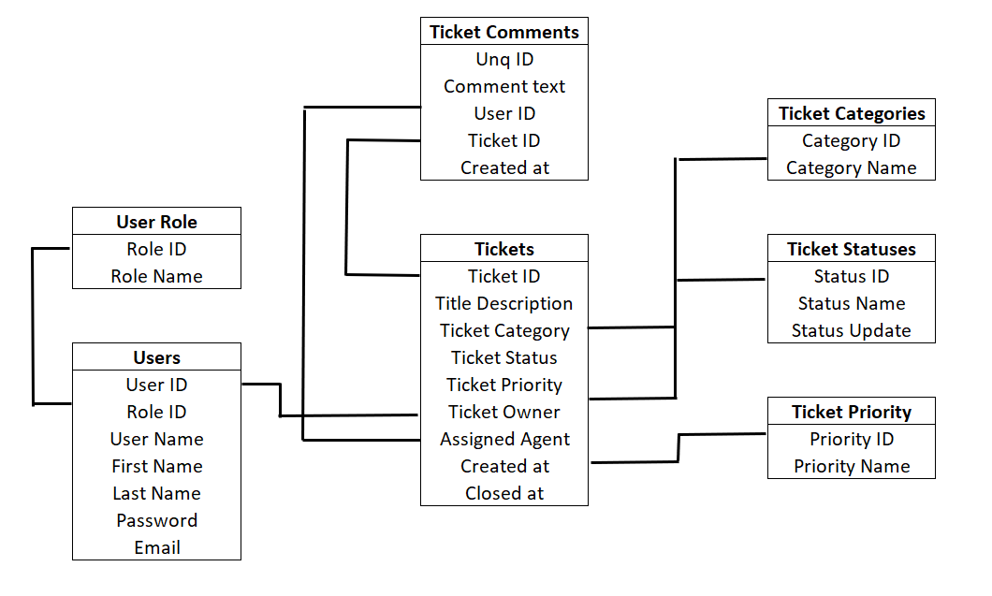

4. User story of shopping from ecommerce.

|  |  |  |  |
| --- | --- | --- | --- |
| User Story : 1 | Task : 1 | | Priority: High |
| AS A USER | | | |
| I WANT TO LOGIN TO ECOMMERCE STORE | | | |
| SO THAT USER CAN SEARCH AND BUY PRODUCTS | | | |
| BV : 300 | | CP : 1 | |
| **Acceptance Criteria:** | | | |
| User Name, Password, Forgot password Link, Signup option for new user | | | |

|  |  |  |  |
| --- | --- | --- | --- |
| User Story : 2 | Task : 2 | | Priority: High |
| AS A USER | | | |
| I WANT TO SIGNUP TO ECOMMERCE STORE | | | |
| SO THAT USER CAN LOGIN AND USE THEIR SERVICE | | | |
| BV : 100 | | CP : 2 | |
| **Acceptance Criteria:** | | | |
| User Name, First name, Last Name, email ID, mobile number, address, pin code, password | | | |

|  |  |  |  |
| --- | --- | --- | --- |
| User Story : 3 | Task : 3 | | Priority: High |
| AS A USER | | | |
| I WANT TO SEARCH FOR THE PRODUCT | | | |
| SO THAT USER CAN SEE AND BUY THE PRODUCT | | | |
| BV : 100 | | CP : 2 | |
| **Acceptance Criteria:** | | | |
| Searching the available product in the search bar, hit enter, can visualise the product below the search bar | | | |

|  |  |  |  |
| --- | --- | --- | --- |
| User Story : 4 | Task : 4 | | Priority: Medium |
| AS A USER | | | |
| I WANT TO READ THE DESCRIPTION OF THE PRODUCT | | | |
| SO THAT USER CAN UNDERSTAND THE PRODUCT BETTER AND BUY | | | |
| BV : 50 | | CP : 3 | |
| **Acceptance Criteria:** | | | |
| Searching the available product in the search bar, hit enter, can visualise the product below the search bar, click on read description for product details | | | |

|  |  |  |  |
| --- | --- | --- | --- |
| User Story : 5 | Task : 5 | | Priority: Medium |
| AS A USER | | | |
| I WANT TO ADDTHE PRODUCT TO THE CART | | | |
| SO THAT USER CAN PROCEED BUYING IT | | | |
| BV : 100 | | CP : 5 | |
| **Acceptance Criteria:** | | | |
| Searching the available product in the search bar, hit enter, can visualise the product below the search bar, click on read description for produt details, click on + button to add the product to the cart | | | |

|  |  |  |  |
| --- | --- | --- | --- |
| User Story : 6 | Task : 6 | | Priority: High |
| AS A USER | | | |
| I WANT TO ADD MUTIPLE COUNTS OF THE SAME PRODUCT | | | |
| SO THAT USER CAN BUY THE QUANTITIES THEY WANT | | | |
| BV : 50 | | CP : 1 | |
| **Acceptance Criteria:** | | | |
| Searching the available product in the search bar, hit enter, can visualise the product below the search bar, click on read description for product details, click on + button to add the product to the cart, click again on + to add the number of quantities | | | |

|  |  |  |  |
| --- | --- | --- | --- |
| User Story : 7 | Task : 7 | | Priority: Medium |
| AS A USER | | | |
| I WANT TO REMOVE MUTIPLE PRODUCT I ADDED AS I NEED | | | |
| SO THAT USER CAN REMOVE THE EXTRA ITEMS ADDED | | | |
| BV : 50 | | CP : 1 | |
| **Acceptance Criteria:** | | | |
| Searching the available product in the search bar, hit enter, can visualise the product below the search bar, click on read description for product details, click on + button to add the product to the cart, click again on + to add the number of quantities, Clock on - to remove the quantity one by one. | | | |

|  |  |  |  |
| --- | --- | --- | --- |
| User Story : 8 | Task : 8 | | Priority: Medium |
| AS A USER | | | |
| I WANT TO ADD ANOTHER ITEM TO THE CART | | | |
| SO THAT USER CAN BUY MULTIPLE DIFFERENT PRODUCT IN SAME ORDER | | | |
| BV : 200 | | CP : 5 | |
| **Acceptance Criteria:** | | | |
| Searching the available product in the search bar, hit enter, can visualise the product below the search bar | | | |

|  |  |  |  |
| --- | --- | --- | --- |
| User Story : 9 | Task : 9 | | Priority: Low |
| AS A USER | | | |
| I WANT TO SEE EXPAIRY DATE OF THE PRODUCT | | | |
| SO THAT USER CAN KNOW IT BETTER | | | |
| BV : 50 | | CP : 1 | |
| **Acceptance Criteria:** | | | |
| Searching the available product in the search bar, hit enter, can visualise the product below the search bar, click on read description for product details | | | |

|  |  |  |  |
| --- | --- | --- | --- |
| User Story : 10 | Task : 10 | | Priority: High |
| AS A USER | | | |
| I WANT TO VIEW THE CART | | | |
| SO THAT USER CAN SEE THE SUMMARY AND BUY THE PRODUCTS | | | |
| BV : 400 | | CP : 8 | |
| **Acceptance Criteria:** | | | |
| Click on go to cart, summary view of all the items in the cart along with the number of quantities and rates. | | | |

|  |  |  |  |
| --- | --- | --- | --- |
| User Story : 11 | Task : 11 | | Priority: High |
| AS A USER | | | |
| I WANT TO SEE OFFERS FOR THE PRODUCTS | | | |
| SO THAT USER CAN AVAIL ANY OFFERS GOING ON | | | |
| BV : 40 | | CP : 3 | |
| **Acceptance Criteria:** | | | |
| go to cart page, click on offers sections and view the wide verity of offers available | | | |

|  |  |  |  |
| --- | --- | --- | --- |
| User Story : 12 | Task : 12 | | Priority: Medium |
| AS A USER | | | |
| I WANT TO SELECT THE OFFER USER NEED | | | |
| SO THAT USER CAN OFFER CAN BE APPLIED AT THE TIME OF CHECKOUT | | | |
| BV : | | CP : | |
| **Acceptance Criteria:** | | | |
| go to cart page, click on offers sections and view the wide verity of offers available, choose the best offer applicable | | | |

|  |  |  |  |
| --- | --- | --- | --- |
| User Story : 13 | Task : 13 | | Priority: Medium |
| AS A USER | | | |
| I WANT TO BUY THE PRODUCTS FROM THE CART | | | |
| SO THAT USER CAN PROCEED WITH BUYING IT | | | |
| BV : 300 | | CP : 8 | |
| **Acceptance Criteria:** | | | |
| from the cart section, click on proceed to pay to proceed further in confirming the order | | | |

|  |  |  |  |
| --- | --- | --- | --- |
| User Story : 14 | Task : 14 | | Priority: Low |
| AS A USER | | | |
| I WANT TO CHOOSE THE MODE OF PAYMENT | | | |
| SO THAT USER CAN GET THE ORDER CONFIRM | | | |
| BV : 100 | | CP : 5 | |
| **Acceptance Criteria:** | | | |
| In Payment section tab, user can select any 1 mode of payment required like Net Banking, Credit card, UPI, COD | | | |

|  |  |  |  |
| --- | --- | --- | --- |
| User Story : 15 | Task : 15 | | Priority: High |
| AS A USER | | | |
| I WANT TO PROCEED FURTHER AFTER CHOOSING THE MODE OF PAYMENT | | | |
| SO THAT USER CAN PAY IT AND GET ORDER CONFIRMATION | | | |
| BV : 500 | | CP : 13 | |
| **Acceptance Criteria:** | | | |
| After choosing the payment method, click on proceed to pay. The respective payment gateway will be linked and user have to give their credentials to fulfil the payment. | | | |

|  |  |  |  |
| --- | --- | --- | --- |
| User Story : 16 | Task : 16 | | Priority: Medium |
| AS A USER | | | |
| I WANT TO GET THE ORDER CONFIRMATION | | | |
| SO THAT USER CAN SIT AND RELAX WHILE HIS/HER ORDER DELIVERs | | | |
| BV : 50 | | CP : 3 | |
| **Acceptance Criteria:** | | | |
| successful payment confirmation from the payment gateways, unq id generation, estimated delivery time | | | |

|  |  |  |  |
| --- | --- | --- | --- |
| User Story : 17 | Task : 17 | | Priority: Medium |
| AS A USER | | | |
| I WANT TO TRACK THE ORDER STATUS | | | |
| SO THAT USER CAN I CAN GET THE DETAILS UPDATED | | | |
| BV : 100 | | CP : 5 | |
| **Acceptance Criteria:** | | | |
| go to order summary, latest orders are updated at the top, click on track order and know the status | | | |

|  |  |  |  |
| --- | --- | --- | --- |
| User Story : 18 | Task : 18 | | Priority: Low |
| AS A USER | | | |
| I WANT TO UPDATE DELIVERY INFORMATION TO THE AGENT | | | |
| SO THAT USER CAN GET THE DELIVERY ACCORDINGLY | | | |
| BV : 50 | | CP : 1 | |
| **Acceptance Criteria:** | | | |
| go to order summary, latest orders are updated at the top, click on track order and know the status, click on add delivery notes and update the notes as required | | | |

|  |  |  |  |  |
| --- | --- | --- | --- | --- |
| User Story : 19 | Task : 19 | | Priority: Low |  |
| AS A USER | | | |  |
| I WANT TO CALL THE DELIVERY PERSON | | | |  |
| SO THAT USER CAN INSTRUCT HIM/HER ABOUT REACHING THE ADDRESS | | | |  |
| BV : 100 | | CP : 5 | |  |
| **Acceptance Criteria:** | | | |  |
| go to order summary, latest orders are updated at the top, click on track order and know the status, click on add delivery notes and click on call delivery agent | | | |  |

|  |  |  |  |
| --- | --- | --- | --- |
| User Story : 20 | Task : 20 | | Priority: Medium |
| AS A USER | | | |
| I WANT TO CANCEL THE CONFIRMED ORDER | | | |
| SO THAT USER CAN REVOKE THE ORDER | | | |
| BV : 300 | | CP : 13 | |
| **Acceptance Criteria:** | | | |
| go to order summary, latest orders are updated at the top, click on track order and know the status, click on add delivery notes and click on cancel the order. Order cancellation msg will be sent to customer as well as supply chain. | | | |

|  |  |  |  |
| --- | --- | --- | --- |
| User Story : 21 | Task : 21 | | Priority: Medium |
| AS A USER | | | |
| I WANT TO MAKE COD OPTION FOR MY ORDER | | | |
| SO THAT USER CAN SKIP PAYMENT GATEWAY AND DET ORDER CONFIRMATON DETAILS DIRECTLY | | | |
| BV : 30 | | CP : 3 | |
| **Acceptance Criteria:** | | | |
| If user choose COD, then the gateway page will be skipped and directly order confirmation with ID will be send to user | | | |

|  |  |  |  |
| --- | --- | --- | --- |
| User Story : 22 | Task : 22 | | Priority: Low |
| AS A USER | | | |
| I WANT TO REORDER SAME PRODUCT | | | |
| SO THAT USER CAN TAKE THE SAME PRODUCT FOR BUYING | | | |
| BV : 100 | | CP : 5 | |
| **Acceptance Criteria:** | | | |
| go to order summary, click on the previously ordered item, click on + or - sign with the number of quantities needed and click on add to cart | | | |

|  |  |  |  |
| --- | --- | --- | --- |
| User Story : 23 | Task : 23 | | Priority: Low |
| AS A USER | | | |
| I WANT TO LOGOUT APPLICATION | | | |
| SO THAT USER CAN RELOGIN WHEN REQUIRED | | | |
| BV : 10 | | CP : 1 | |
| **Acceptance Criteria:** | | | |
| Click on home page, click on signout button on the top right hand side corner | | | |

|  |  |  |  |
| --- | --- | --- | --- |
| User Story : 24 | Task : 24 | | Priority: High |
| AS A USER | | | |
| I WANT TO CLICK ON FORGOT PASSWORD LINK | | | |
| SO THAT USER CAN REGENERATE THE PASSWORD FOR THE APPLICATION | | | |
| BV : 100 | | CP : 5 | |
| **Acceptance Criteria:** | | | |
| in the login page, add user ID and click on forgot password link, email will be sent with reset link, click the reset link and enter the new password and submit. | | | |

|  |  |  |  |
| --- | --- | --- | --- |
| User Story : 25 | Task : 25 | | Priority: Low |
| AS A USER | | | |
| I WANT TO DELETE THE ACCOUNT | | | |
| SO THAT USER CAN NO LONGER USE THE APPLICATION | | | |
| BV : 50 | | CP : 5 | |
| **Acceptance Criteria:** | | | |
| go to account > settings > Deactivate account> confirm email ID and Password> click on submit. The account will be deleted and no longer can be used | | | |

|  |  |  |  |
| --- | --- | --- | --- |
| User Story : 26 | Task : 26 | | Priority: High |
| AS A USER | | | |
| I WANT TO DOWNLOAD THE SALES REPORT | | | |
| SO THAT USER CAN TAKE THE SALES TREND | | | |
| BV : 200 | | CP : 8 | |
| **Acceptance Criteria:** | | | |
| Admin user access, Sales reports, date range, city code wise, state wise and submit button | | | |

|  |  |  |  |
| --- | --- | --- | --- |
| User Story : 27 | Task : 27 | | Priority: High |
| AS A USER | | | |
| I WANT TO VIEW MY REFUND STATUS | | | |
| SO THAT USER CAN SEE WHEN WILL THEY GET THE REFUND | | | |
| BV : 200 | | CP : 5 | |
| **Acceptance Criteria:** | | | |
| Order summary page, click on the specific order refund is expected, click on refund status and submit | | | |

|  |  |  |  |
| --- | --- | --- | --- |
| User Story : 28 | Task : 28 | | Priority: Medium |
| AS A USER | | | |
| I WANT TO CHOOSE REFUND MODE | | | |
| SO THAT USER CAN EITHER GET THE REFUND AMOUNT OR VOUCHER | | | |
| BV : 200 | | CP : 13 | |
| **Acceptance Criteria:** | | | |
| Order summary, cancelled order, view cancellation status, Select refund mode, choose original payment method or voucher, submit button | | | |

|  |  |  |  |
| --- | --- | --- | --- |
| User Story : 29 | Task : 29 | | Priority: Low |
| AS A USER | | | |
| I WANT TO ASSIGN ADMIN ACCESS TO REGIONAL MANAGER | | | |
| SO THAT USER CAN MANAGE THE OPERATION FROM HIS/HER LOCATION | | | |
| BV : 50 | | CP : 5 | |
| **Acceptance Criteria:** | | | |
| Admin user> Home Page> delegate access screen> provide employee ID>submit for access to other admin users | | | |

|  |  |  |  |
| --- | --- | --- | --- |
| User Story : 30 | Task : 30 | | Priority: Low |
| AS A USER | | | |
| I WANT TO GENERATE TREND REPORT FOR ORDER CANCELLATION | | | |
| SO THAT USER CAN UNDERSTAND THE TOP REASONS FOR ORDER CANCELLATION AND INPROVE SERVICE | | | |
| BV : 200 | | CP : 13 | |
| **Acceptance Criteria:** | | | |
| Admin Login, Customer transaction report summary, order cancellation page, select date range, choose global or area wise, submit | | | |

|  |  |  |  |
| --- | --- | --- | --- |
| User Story : 31 | Task : 31 | | Priority: High |
| AS A USER | | | |
| I WANT TO VIEW OVERALL OPERATIONS DASHBOARD | | | |
| SO THAT USER CAN SEE THE OPERATIONS SALES OF THE COMPANY | | | |
| BV : 600 | | CP : 21 | |
| **Acceptance Criteria:** | | | |
| CEO/COO and TOP management of the company user login. Summary of overall sales, operations, financials, costs and other margin related dashboard view. | | | |

|  |  |  |  |
| --- | --- | --- | --- |
| User Story : 32 | Task : 32 | | Priority: High |
| AS A USER | | | |
| I WANT TO CONNECT TO AN AGENT ON AN ORDER | | | |
| SO THAT USER CAN CLARIFY THE DOUBT | | | |
| BV : 100 | | CP : 8 | |
| **Acceptance Criteria:** | | | |
| User can go to accounts sections, click on contact support, choose the recent lists of items they wanted to connect support, click on submit. Chat bot will open with real agents window and call option will be available. User can choose their mode of communications as required | | | |

|  |  |  |  |
| --- | --- | --- | --- |
| User Story : 33 | Task : 33 | | Priority: Medium |
| AS A USER | | | |
| I WANT TO CHANGE THE DELIVERY ADDRESS | | | |
| SO THAT USER CAN UPDATE THE HOME ADDRESS | | | |
| BV : 10 | | CP : 1 | |
| **Acceptance Criteria:** | | | |
| GO to accounts, Demographic changes, click on edit, update the new address correctly along with the pin code. pin the exact GPS location for delivery. And click submit | | | |

|  |  |  |  |
| --- | --- | --- | --- |
| User Story : 34 | Task : 34 | | Priority: Low |
| AS A USER | | | |
| I WANT TO ADD ANOTHER ADDRESS | | | |
| SO THAT USER CAN CHOOSE WHICH ADDRESS THEY NEED DELIVERY | | | |
| BV : 10 | | CP : 1 | |
| **Acceptance Criteria:** | | | |
| GO to accounts, Demographic changes, click on edit, click add another address, update the 2nd address correctly along with the pin code. pin the exact GPS location for delivery. And click submit | | | |

|  |  |  |  |
| --- | --- | --- | --- |
| User Story : 35 | Task : 35 | | Priority: Medium |
| AS A USER | | | |
| I WANT TO DELETE ADDRESS FROM THE ACCOUNT | | | |
| SO THAT USER CAN NO LONGER GET THAT ADDRESS SUGGESSTION | | | |
| BV : 20 | | CP : 2 | |
| **Acceptance Criteria:** | | | |
| GO to accounts, Demographic changes, click on address to delete, submit. Minimum 1 address is mandate to keep the account active | | | |

|  |  |  |  |
| --- | --- | --- | --- |
| User Story : 36 | Task : 36 | | Priority: High |
| AS A USER | | | |
| I WANT TO SAVE CREDIT CARD INFORMATION | | | |
| SO THAT USER CAN MAKE EASY TRACTION WHEN ORDER | | | |
| BV : 300 | | CP : 13 | |
| **Acceptance Criteria:** | | | |
| In the Payment mode selection, make CC payment and click on check BOX to save the credit card information. And proceed with the payment | | | |

|  |  |  |  |
| --- | --- | --- | --- |
| User Story : 37 | Task : 37 | | Priority: Low |
| AS A USER | | | |
| I WANT TO DELETE THE CREDIT CARD INFORMATION | | | |
| SO THAT USER CAN NO LONGER USE IT OR MANUALLY ENTER AT THE TIME OF ANY ORDERS | | | |
| BV : 100 | | CP : 5 | |
| **Acceptance Criteria:** | | | |
| Go to accounts, click saved credit card, choose the card that needs to be deleted, click ok to confirm and the credit card details will be removed | | | |

|  |  |  |  |
| --- | --- | --- | --- |
| User Story : 38 | Task : 38 | | Priority: Low |
| AS A USER | | | |
| I WANT TO UPDATE GST ID NUMBER | | | |
| SO THAT USER CAN GET THE OFFICIAL INVOICE COPY FOR THEIR COMPANY USEAGE | | | |
| BV : 200 | | CP : 13 | |
| **Acceptance Criteria:** | | | |
| In payment tab, add GST ID number and verify the business details. Submit the GST ID get OTP at business registered email ID to confirm and update | | | |

|  |  |  |  |
| --- | --- | --- | --- |
| User Story : 39 | Task : 39 | | Priority: Medium |
| AS A USER | | | |
| I WANT TO BUY NEWCREDIT CARD | | | |
| SO THAT USER CAN UTILIZE THE CREDITCARD FOR THE TRANSATION THEY DO IN THE PORTAL | | | |
| BV : 500 | | CP : 21 | |
| **Acceptance Criteria:** | | | |
| User login Home page, exclusive customer specific offer on Ecommerce based credit card, Customer can click on apply or get a call back to purchase the credit card and submit | | | |

|  |  |  |  |
| --- | --- | --- | --- |
| User Story : 40 | Task : 40 | | Priority: Low |
| AS A USER | | | |
| I WANT TO KNOW THE STATUS OF MY CREDIT CARD APPLICATION | | | |
| SO THAT USER CAN KNOW HIS/HER STATUS | | | |
| BV : 200 | | CP : 13 | |
| **Acceptance Criteria:** | | | |
| User login Home page, exclusive customer specific offer on Ecommerce based credit card, Customer can click know the status of application, provide application number and submit. Customer can see the approval status of credit card application | | | |