**Waterfall Project – Part 3rd**

**Document 6- Please prepare a use case diagram, activity diagram and a use case specification document.**

**The following actors and use cases are included in the project:**

**Actors:**

1. Primary Actors:
   * Customer (End-user)
   * Admin
2. Secondary Actors:
   * Payment Gateway System
   * Database System

**Use Cases:**

1. User Registration & Login
2. Browsing Product Catalogue
3. Adding Products to Cart
4. Processing Payment
5. Tracking Order
6. Managing Products (Admin)
7. Handling Change Requests (Admin)

**Use Case Diagram**

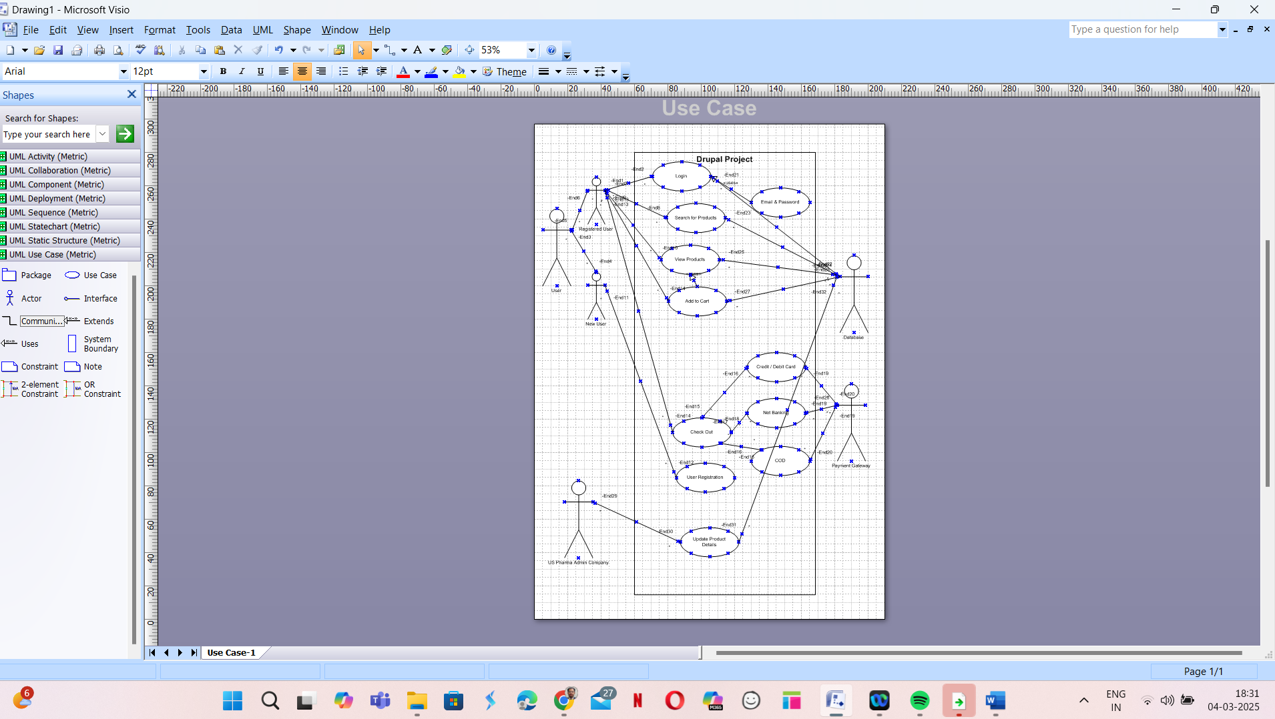

**Activity Diagram**

**User Registration**



**Search For Product**



**Making & Order**



**Order Tracking**



**Payments**



**Use Case Specification Document**

|  |  |
| --- | --- |
| **Use Case ID** | **US 001** |
| Use Case Name | Log IN |
| Created By | Manish Talreja (BA) |
| Created Date | 04/03/25 |
| Actors | user |
| Description | The user can login using the email id/ Mob No and password credentials |
| Precondition | User should have to register before login by using email and mobile number  User can log in by using email id and Password  User should have Internet connection |
| Post Condition | User can be routed to product catalogue |
| Flow | User can log in Pharma website using email and password for seeing Vets & Pets Products. |
| Alternative Flows | No |
| Exception | NA |
| Requirements | BR 001 |
|  |  |
| **Use Case ID** | **US 002** |
| Use Case Name | Search for Products |
| Created By | Manish Talreja (BA) |
| Created Date | 04/03/25 |
| Actors | User/ Pharma Admin |
| Description | By Using keyword user can search the Vets or Pets product |
| Precondition | User should have to register before login by using email and mobile number  User can log in by using email id and Password  User should have Internet connection  User should have to aware of the searching product, Name etc |
| Post Condition | User will be displayed about product catalogue. |
| Flow | User Log IN  User search for the product by keyword  Based on keyword product will be displayed  User will click the suitable product  Detailed product catalogue will be displayed  User can view the product |
| Alternative Flows | No |
| Exception | NA |
| Requirements | BR 004 |
|  |  |

|  |  |
| --- | --- |
| **Use Case ID** | **US 003** |
| Use Case Name | Add to Cart |
| Created By | Manish Talreja (BA) |
| Created Date | 04/03/25 |
| Actors | User |
| Description | Users can add products to the cart as per requirement |
| Precondition | User can log in by using email id and Password  User should have Internet connection |
| Post Condition | Products saved in cart; Number of products saved in card will be highlighted |
| Flow | User Log IN  User search for the product by keyword  Based on keyword product will be displayed  User will add the desired product to cart  Products saved in cart, Number of products saved in card will be highlighted |
| Alternative Flows | No |
| Exception | NA |
| Requirements | BR 006 |
|  |  |
| **Use Case ID** | **US 004** |
| Use Case Name | Payments |
| Created By | Manish Talreja (BA) |
| Created Date | 23/01/25 |
| Actors Involved | User |
| Use Case Description | After selecting all the products to cart, User will go for buy product and need to use payment option |
| Precondition | User can log in by using email id and Password  User should have Internet connection |
| Post Condition | Post payment, Order details will be displayed. |
| Basic Flow | User Log IN  User search for the product by keyword  Based on keyword product will be displayed  User will add the desired product to cart  Products saved in cart, Number of products saved in card will be highlighted  From cart user routed to buy option, where user routed to different payment methods  User will be paid using multiple payment options |
| Assumptions | User is registered I the website & also want to buy Vets & Pets product. |
| Alternative Flows | No |
| Exception | NA |
| Requirements | BR 007 |
|  |  |

**Document 8: Tools – Visio and Axure**

**Experience Using Visio and Axure:**

**Microsoft Visio:**

* Used for creating use case diagrams, activity diagrams, and process flows to illustrate system functionality.
* Helped in designing clear workflow diagrams for different modules in the project, making it easier for stakeholders to visualize the process.
* Utilized for preparing Requirement Traceability Matrix (RTM), ensuring all business requirements are mapped to system functionalities.
* Allowed seamless communication of design artifacts with developers and testers.

**Axure RP:**

* Used for creating interactive wireframes and mockups for the website.
* Designed clickable prototypes, enabling stakeholders to experience a simulated version of the system before development.
* Helped in UI/UX validation by allowing quick feedback on design elements and user experience.
* Ensured alignment with customer expectations by presenting realistic screen prototypes during JAD sessions.
* Streamlined collaboration between designers, developers, and business analysts by providing a visual representation of the end product.

**Document 9: Business Analyst (BA) Experience**

**1. Requirement Gathering:**

* Conducted stakeholder interviews and Joint Application Development (JAD) sessions to gather comprehensive requirements.
* Used MoSCoW prioritization technique to classify features into Must-have, Should-have, Could-have, and Won't-have.
* Documented requirements in Business Requirements Document (BRD) and Functional Specification Document (FSD).
* Collaborated with business stakeholders to define project scope and high-level objectives.
* Addressed requirement volatility by setting up structured requirement change control mechanisms.

**2. Requirement Analysis:**

* Created UML diagrams, use case diagrams, and activity diagrams to visually illustrate workflows.
* Conducted feasibility analysis for change requests (CRs) by evaluating impact, effort, and cost.
* Used FURPS technique (Functionality, Usability, Reliability, Performance, and Supportability) to validate requirements.
* Developed and maintained a Requirement Traceability Matrix (RTM) to track requirements from inception to completion.

**3. Design:**

* Worked with UI/UX teams to create wireframes and prototypes using Axure.
* Defined system architecture and design specifications to align with business goals.
* Collaborated with developers to ensure that technical feasibility was considered during the design phase.
* Documented all assumptions, constraints, and dependencies in the System Design Document (SDD).
* Ensured all business rules were enforced in the design to maintain data integrity and compliance.

**4. Development:**

* Acted as a bridge between business and technical teams to clarify doubts during development.
* Organized JAD sessions to resolve any development-related ambiguities.
* Conducted impact analysis of newly introduced features and modifications.
* Maintained alignment between customer expectations and development progress.
* Ensured adherence to the Waterfall methodology by tracking milestones and dependencies.

**5. Testing:**

* Created detailed test cases and test scenarios from use cases.
* Performed high-level functional testing before handing over to QA.
* Facilitated User Acceptance Testing (UAT) by preparing test scripts and coordinating with end-users.
* Ensured that all test cases were mapped in the RTM to validate requirement coverage.
* Collected feedback and documented defects and issues for resolution.

**6. Deployment:**

* Coordinated the deployment plan to ensure a smooth go-live process.
* Created and distributed user manuals and training materials for end-users.
* Conducted training sessions to help users adapt to the new system.
* Managed post-deployment support, handling issues and change requests efficiently.
* Ensured that the project met all SLA compliance requirements post-launch.