Online Agriculture Store Capstone Project 1 – Part 3

Q1) Identify minimum 20 functional requirements

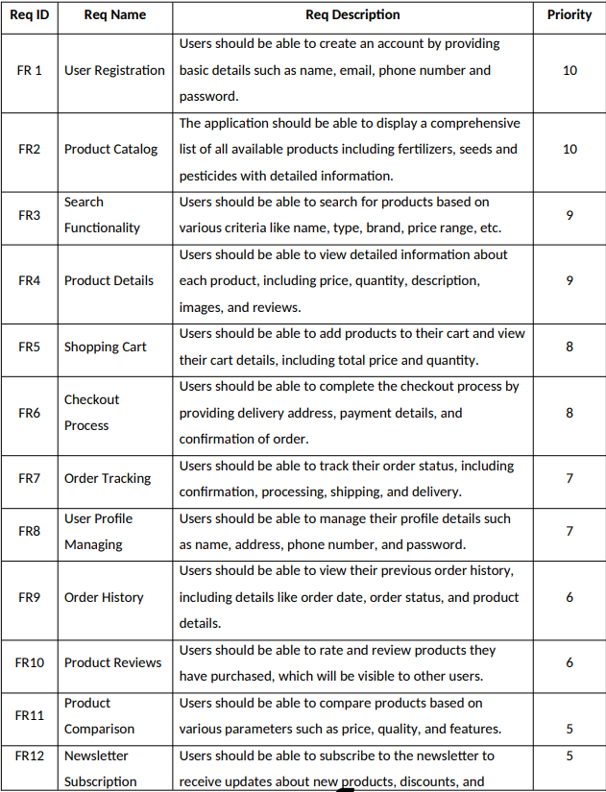

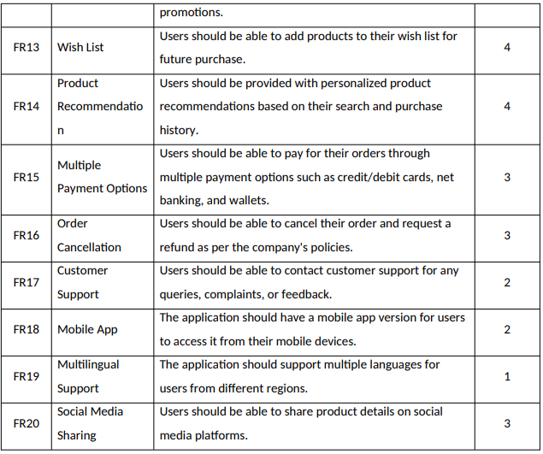

Question 2) Make wireframe and prototypes

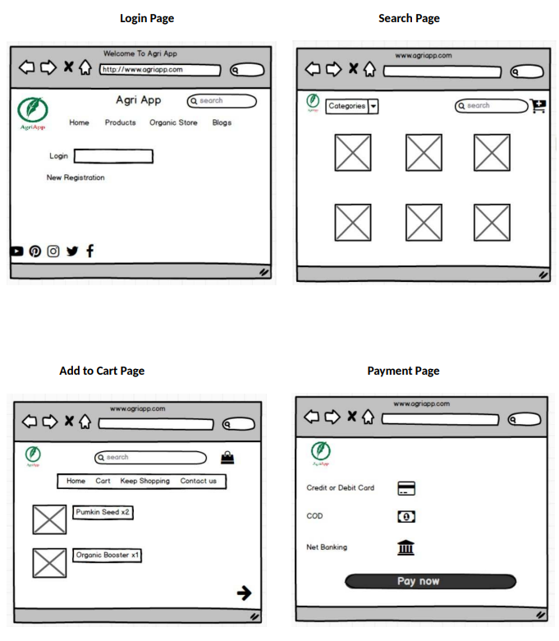

**Logout Page**

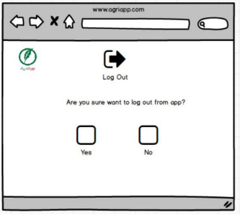

Question 3) Make a note of the Tools, which you are using for above concepts.

1. **Balsmiq:** Balsamiq is a popular wireframing tool used for creating low-fidelity prototypes. It focuses on simplicity and sketch-like designs to quickly visualize and communicate design ideas. With its drag-and-drop interface and pre-built UI elements, Balsamiq allows users to rapidly iterate and gather feedback on the basic structure and layout of a digital product.
2. **Microsoft Visio:** Microsoft Visio is a versatile diagramming tool that allows users to create a wide range of diagrams, including flowcharts, organizational charts, and network diagrams. With its extensive library of shapes and customization options, Visio enables users to visually represent complex information and processes. It offers collaboration features, data linking capabilities, and seamless integration with other Microsoft Office applications.

Question 4) A business analyst’s key responsibilities are to keep track of the requirements and make sure that no requirement is missed.

Answer) RTM requirement traceable Matrix plays a vital role as it showcases the progress and the status of the project; it contains high level documents which shows us the information on the project data

|  |  |  |  |  |  |  |  |  |  |  |  |
| --- | --- | --- | --- | --- | --- | --- | --- | --- | --- | --- | --- |
| **Req ID** | **Req Name** | **Req Description** | **Design** | **D1** | **D1_1** | **T1** | **T2** | **T3** | **T4** | **T4_1** | **UAT** |
| FR0001 | Farmer Registration | farmers should be able to register with their email id and mobile number | Completed | Yes | Yes | Yes | Yes | Yes | Yes | Yes | Completed |
| FR0002 | Login | Farmers should be able to login after registering | Completed | Yes | Yes | Yes | Yes | No | No | No | Pending |
| FR0003 | Search for products | Farmers should be able to search for required products | Completed | Yes | Yes | Yes | Yes | Yes | Yes | Yes | Completed |
| FR0004 | Add to cart | Farmers should be able to add required products to cart | Completed | Yes | Yes | Yes | Yes | Yes | No | No | Pending |
| FR0005 | View the cart | Farmers should be able to view the cart | Completed | Yes | Yes | No | No | No | No | No | Pending |
| FR0006 | Completing the order | Farmers should be able to complete the required order | Completed | Yes | Yes | Yes | Yes | Yes | Yes | Yes | Completed |
| FR0007 | Payment | Farmers should be able to view the payment options | Completed | Yes | Yes | Yes | No | Yes | Yes | Yes | Pending |
| FR0008 | Order confirmation | Farmers should be able to confirm the order | Completed | Yes | Yes | Yes | Yes | No | No | No | Pending |
| FR0008 | Order | Farmers should be able to | Completed | Yes | Yes | Yes | Yes | No | No | No | Pending |
| FR0009 | Status of order | Farmers should be able to see the status of order | Completed | Yes | Yes | Yes | Yes | Yes | No | No | Pending |
| FR0010 | Delivery tracking | Farmers should be able to view delivery tracking | Completed | Yes | Yes | Yes | No | No | No | No | Pending |

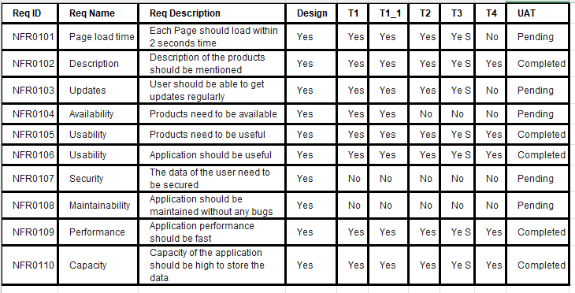

Question 5) Prepare 10 Test Case Documents

Test Case Documents are structured documents used in software testing to define and outline the specific conditions, steps, and expected results for verifying a particular feature or functionality of a software application. They are essential for ensuring that software meets its requirements and behaves as expected in different scenarios.

1. User registration:

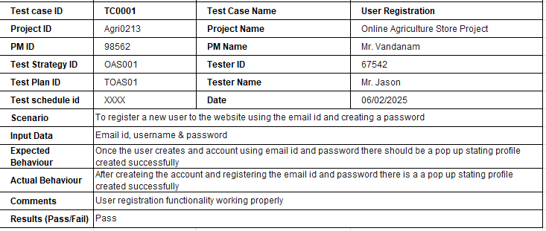

1. User login

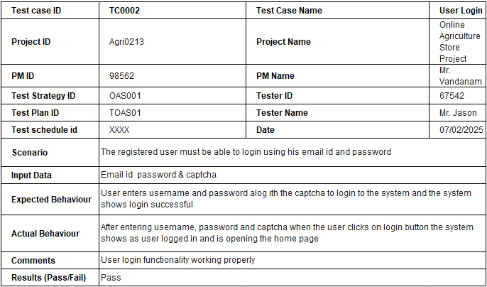

1. Add products to cart

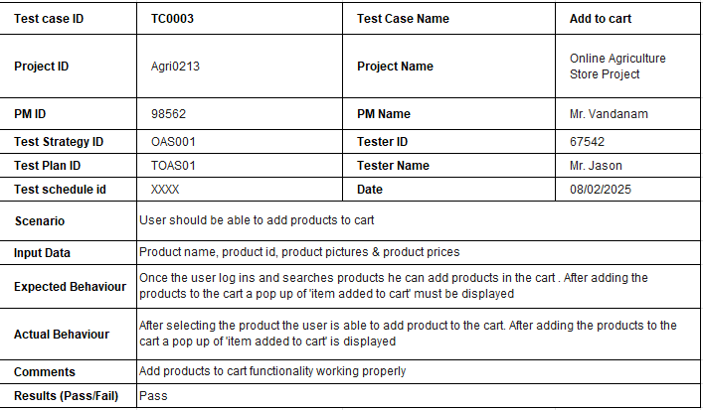

|  |  |  |  |
| --- | --- | --- | --- |
| 1. Search products |  |  |  |
| **Test case ID** | **TC0004** | **Test Case Name** | **Search for products** |
| **Project ID** | Agri0213 | **Project Name** | Online Agriculture Store Project |
| **PM ID** | 98562 | **PM Name** | Mr. Vandanam |
| **Test Strategy ID** | OAS001 | **Tester ID** | 67542 |
| **Test Plan ID** | TOAS01 | **Tester Name** | Mr. Jason |
| **Test schedule id** | XXXX | **Date** | 09/02/2025 |
| **Scenario** | User should be able to search for products using the search bar | | |
| **Input Data** | Product name, product id, product pictures & product prices | | |
| **Expected Behaviour** | Once the user log ins he should be able to search for products using the search bar. After entering the product name a list of all available products should be displayed | | |
| **Actual Behaviour** | After searching for products using the product name, a list of all available products from different manufacturers is displayed | | |
| **Comments** | Search Product functionality working properly | | |
| **Results (Pass/Fail)** | Pass |  |  |
|  |  |  |  |
| 1. **View cart** |  |  |  |
| **Test case ID** | **TC0005** | **Test Case Name** | **View cart** |
| **Project ID** | Agri0213 | **Project Name** | Online Agriculture Store Project |
| **PM ID** | 98562 | **PM Name** | Mr. Vandanam |
| **Test Strategy ID** | OAS001 | **Tester ID** | 67542 |
| **Test Plan ID** | TOAS01 | **Tester Name** | Mr. Jason |
| **Test schedule id** | XXXX | **Date** | 10/02/2025 |
| **Scenario** | User should be able to view cart before checking out | | |
| **Input Data** | Product name, product id, product pictures & product prices | | |
| **Expected Behaviour** | Once the user adds products to cart, he should be able to view the cart to verify all the products before checking out | | |
| **Actual Behaviour** | After adding the products to cart, user is able to view the cart | | |
| **Comments** | View cart functionality working properly | | |
| **Results (Pass/Fail)** | Pass |  |  |
|  |  |  |  |
|  |  |  |  |
| 1. **Payment** |  |  |  |
| **Test case ID** | **TC0006** | **Test Case Name** | **Payment** |
| **Project ID** | Agri0213 | **Project Name** | Online Agriculture Store Project |
| **PM ID** | 98562 | **PM Name** | Mr. Vandanam |
| **Test Strategy ID** | OAS001 | **Tester ID** | 67542 |
| **Test Plan ID** | TOAS01 | **Tester Name** | Ms. Alkeya |
| **Test schedule id** | XXXX | **Date** | 11/02/2025 |
| **Scenario** | User must be able to select a payment method and complete the payment | | |
| **Input Data** | UPI id, Card details, Payment Method | | |
| **Expected Behaviour** | User should be able to choose a payment method from UPI, card or COD | | |
| **Actual Behaviour** | After checking out the cart, the user is able to select from different payment methods like net banking, card, cash , UPI | | |
| **Comments** | Payment functionality working properly | | |
| **Results (Pass/Fail)** | Pass |  |  |
|  |  |  |  |
|  |  |  |  |
| 1. **Payment confirmation** |  |  |  |
| **Test case ID** | **TC0007** | **Test Case Name** | **Payment confirmation** |
| **Project ID** | Agri0213 | **Project Name** | Online Agriculture Store Project |
| **PM ID** | 98562 | **PM Name** | Mr. Vandanam |
| **Test Strategy ID** | OAS001 | **Tester ID** | 67542 |
| **Test Plan ID** | TOAS01 | **Tester Name** | Ms. Alkeya |
| **Test schedule id** | XXXX | **Date** | 12/02/2025 |
| **Scenario** | User should get a payment confirmation message on email and MPN | | |
| **Input Data** | Payment id and total price | | |
| **Expected Behaviour** | After completing the payment, the user should get a payment confirmation | | |
| **Actual Behaviour** | After completing the payment the user received a message on email id and MPN | | |
| **Comments** | NA | | |
| **Results (Pass/Fail)** | Pass |  |  |
|  |  |  |  |
|  |  |  |  |
| 1. Order confirmation |  |  |  |
|  |  |  |  |
| **Test case ID** | **TC0008** | **Test Case Name** | **Order confirmation** |
| **Project ID** | Agri0213 | **Project Name** | Online Agriculture Store Project |
| **PM ID** | 98562 | **PM Name** | Mr. Vandanam |
| **Test Strategy ID** | OAS001 | **Tester ID** | 67542 |
| **Test Plan ID** | TOAS01 | **Tester Name** | Mr. Jason |
| **Test schedule id** | XXXX | **Date** | 13/02/2025 |
| **Scenario** | User should get an order confirmation on email and MPN | | |
| **Input Data** | Product name, price and delivery date | | |
| **Expected Behaviour** | Once the order is placed, user should get a confirmation regarding the order on his registered email id and MPN | | |
| **Actual Behaviour** | As the order was paid and the payment was completed , the user received a order confirmation on the email and MPN with product names, quantity, price and expected delivery dates | | |
| **Comments** | NA | | |
| **Results (Pass/Fail)** | Pass |  |  |
| 1. Cancel order |  |  |  |
|  |  |  |  |
| **Test case ID** | **TC0009** | **Test Case Name** | **Cancel order** |
| **Project ID** | Agri0213 | **Project Name** | Online Agriculture Store Project |
| **PM ID** | 98562 | **PM Name** | Mr. Vandanam |
| **Test Strategy ID** | OAS001 | **Tester ID** | 67542 |
| **Test Plan ID** | TOAS01 | **Tester Name** | Miss Alkeya |
| **Test schedule id** | XXXX | **Date** | 14/02/2025 |
| **Scenario** | User should be able to cancel the order if wrongly ordered | | |
| **Input Data** | order id, product id | | |
| **Expected Behaviour** | User shold be able to cancel order or orders if wrongly placed from cancel order page | | |
| **Actual Behaviour** | User is able to cancel the order from the order cancel page | | |
| **Comments** | NA | | |
| **Results (Pass/Fail)** | Pass |  |  |
|  |  |  |  |
| 1. Track my order |  |  |  |
| **Test case ID** | **TC0010** | **Test Case Name** | **Track order** |
| **Project ID** | Agri0213 | **Project Name** | Online Agriculture Store Project |
| **PM ID** | 98562 | **PM Name** | Mr. Vandanam |
| **Test Strategy ID** | OAS001 | **Tester ID** | 67542 |
| **Test Plan ID** | TOAS01 | **Tester Name** | Miss Alkeya |
| **Test schedule id** | XXXX | **Date** | 15/02/2025 |
| **Scenario** | User should be able to track the status of the order | | |
| **Input Data** | order id, product id, delivery status | | |
| **Expected Behaviour** | User should be able to track the status of his order once the order is placed to understand about the delivery | | |
| **Actual Behaviour** | User is able to track the order under 'Track my order' option | | |
| **Comments** | NA | | |
| **Results (Pass/Fail)** | Pass |  |  |

Question 6) After the requirements are thoroughly explained to the entire project team by business analyst, the Database architects have decided to do the database design and to represent the in-flow and out-flow of data. Draw database schema and ER diagram

Answer) **DB Schema**: DB schema is the blueprint that describes the organisation, relationship and structure of the data in the database. Schema is at the core of the database and tells the database how to store data. A well-defined schema helps to store and retrieve data efficiently**. There are various symbols used to draw a DB schema;  A rectangle, for instance, represents a table; a line represents the relationship between two tables, and a diamond represents an entity**.

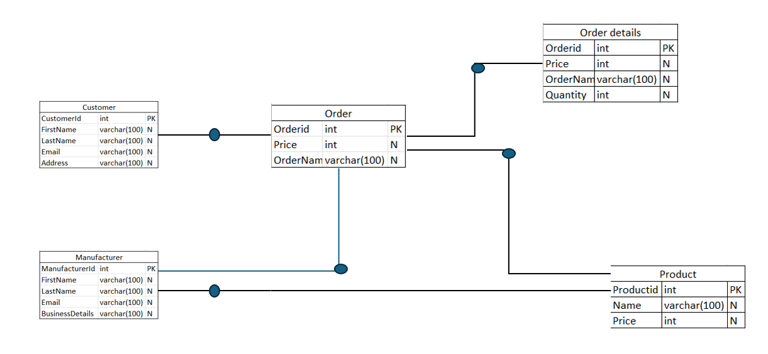

**ERD Diagram:** ERD stands for Entity Relation Diagram and descript relationship between entities like people, activities and things within a database. It also describes the attributes.

There are 3 levels of ERD , namely conceptual, logical and physical diagrams.

**Conceptual ERD: represents the highest level of abstraction giving a birds eye view of the system. It is helpful during the early stages of the diagram. It identifies the significant entities and relationships between them**DB Schema + ERD diagram = DB Design

**Logical ERD: Logical diagrams sit at the middle level of abstraction, providing a more detailed look at the system's structure. It includes all entities, relationships, and attributes, reflecting how they interact. Unlike the conceptual level, it provides a greater degree of specificity about data types, primary keys, and constraints.**

**Physical ERD:** represent the lowest level of abstraction, detailing exactly how the database will be implemented. It defines the tables, columns, data types, constraints, primary and foreign keys, indexes, triggers, and other database-specific elements. This level is often database-specific, incorporating the details and constraints of the particular database management system (DBMS) being used. It provides the blueprint for the database's construction and is typically developed by database administrators and developers right before the implementation phase.catalogue, order details

**ERD for Online Agriculture store:**

**Entities: Customer, Manufacturer, order, product, catalogue,order detail.**

**Relationships:** Manufacturer ‘updates’ products on the website, the customer ‘places order’ for the products , Order contains ‘Product’, Products belong to ‘ catalogue, order details’ order detail connects ‘order & product’.

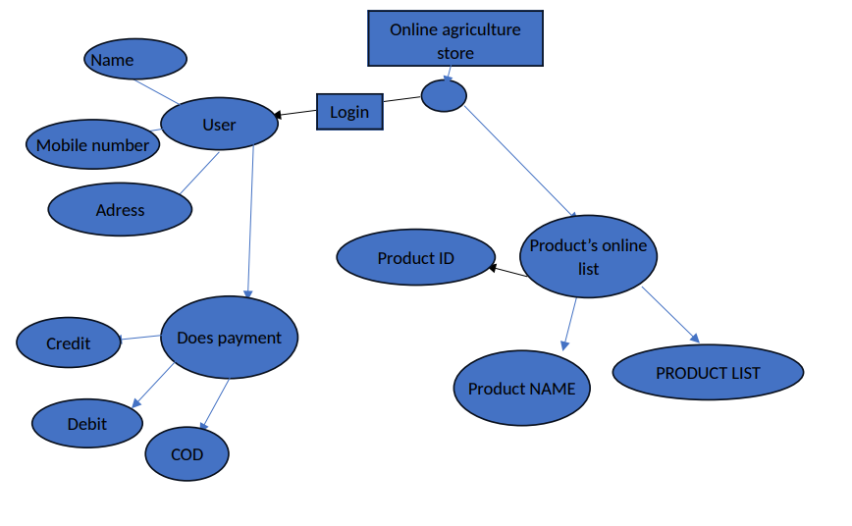

Question 7) What is a data flow diagram? Draw a data flow diagram to represent the in-flow and out-flow of data when a Farmer is placing an order for the product

A Data Flow Diagram (DFD) is a graphical representation of the flow of data within a system. It shows how data moves from one part of the system to another and how data is transformed, stored, and utilized within the system. DFDs are widely used in systems analysis and design to visualize data processes and the way information is handled, stored, and transmitted between different system components.

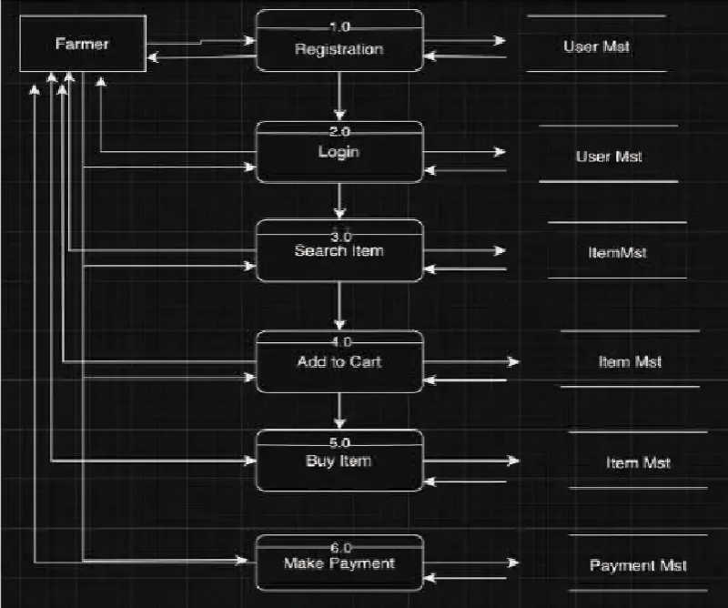

Question 8) Due to change in the Government Taxation structure. we should change the Tax structure How do you handle change requests in a project?

Answer) What is a **Change** **request** : Change requests are when a stakeholder, either a client or an internal team or department, requests a change to the processes or deliverables that had already been decided upon in the project scope.

However, in this scenario, this change request has come up due to change in the Govt. Taxation structure.

As a BA, I would analyse the request and clarify the stakeholders exactly what the request is asking us to do in the Online Agriculture Product Store. In a normal scenario, as a BA, I would first do the **Feasibility Test**, to check, how feasible it is to change the current ongoing project with the new change request. Post the feasibility Test, I will conduct **Impact analysis** and then **effort estimation.** However, in this case, Feasibility study is not required, as it’s a Govt structure which needs to be updated and followed. Therefore, as a BA the below steps to change the project as per the client’s requirements: -

o Document the Change request.

o Look for any Supporting materials to help in adding this Change.

o Need to assess, whether the Change is an Inside or Outside scope. As it’s an outside scope, the Budget and time will get impacted.

o BA and PM should ensure whether the change is a minor or a major change. Policy changes by Govts a major change request and we need to ensure that the change should be done according to the Govt. instruction.

o Fill the Change request Form (CRL) and get the approval from the Project Manager.

o We also need to ensure that our Team understands the priority of this change request.

o We also need to discuss the change with Change Control Board (CCB) who will recommend the necessary change on the Project.

o Once this change is approved, the project deliverables will need to be updated. This can include plans and schedules, business process documents, and the requirements documents.

o Once these updates have been made, the project manager can communicate the new course of action to everyone who will be impacted. Now you can delegate the necessary tasks to the people in charge of implementing these new changes

Question 9) As the project is in process, Ben and Kevin have contacted you. The reason is to inform you that they want the Farmers to sell their crop yields through this application i.e. Farmers should be able to add their crop yields or products and display to general public and should be able to sell them. They also want to introduce Auction system for their Crop yields. As a BA, what will be your response? Is this a change request or an enhancement???

**Answer) Change Request Vs an Enhancement**

A Change request (CR) is a formal proposal to modify a project, product, process or a system

An enhancement on the other hand refers to improvements to be made to the project, application or process after the initial release.

Enhancement means adding features to the agreed upon design and Change request may mean responding to changes that were outside the original agreed upon scope of the project.

The request from Ben and Kevin is an Enhancement request, as they want to add another feature in the Online store which acts as an application upgrade, which will also help the Farmers to sell the yields directly in the online store, apart from buying products. Hence my response would be a positive response to them. Therefore, as a BA, I should :

1. **Gather requirements:** I would meet Kevin, Ben & Peter to understand what features need to be added to meet the new functionalities.
2. **Feasibility studies**: I will conduct a feasibility study to understand if it is feasible for the changes to be made and also to find out alternate solutions to meet the requirements.
3. **Impact Analysis:** I would do an impact analysis to understand the impact these changes will have on the cost, budget, time &resources.
4. **Stakeholder analysis:** I will identify and involve relevant stakeholders and gather their perspective on the enhancement requests.
5. **Documentation:** I will document the requests so the same can be communicated to all the relevant stakeholders and also can be added to the project scope.
6. **Evaluate & Prioritize:** I will work with the project team to evaluate how will these enhancements impact the project scope and prioritize them on the basis of benefits, resources, budget and cost and map if these enhancements align to the business objectives.
7. **Planning and execution:** I should analyse the request and provide a project plan, requirement, design, an testing plans for this request. I must prepare an enhancement request form and decide how much manpower and man-hours required for this enhancement request

Question 10) Come up with estimations – How many Manhours required

**Answer –** **Estimation : -** Estimation in Software Development Life Cycle refers to the process of predicting the resources (time, cost, effort) required to complete asoftware development project or specific tasks within that project. Estimation is a critical part of the planning phase of SDLC, as it helps in setting realistic expectations, managing resources efficiently, and determining the project's feasibility.

Man-hours estimation in software development refers to the process of estimating the total amount of human effort required to complete a software development task, project, or feature. It is typically expressed in terms of the number of hours that a team or individual will spend working on the project. This estimation is crucial for planning, budgeting, and scheduling the project. It helps determine resource requirements, assess project timelines, and evaluate project feasibility.

Types of projects on the basis of Man-Hours:

1.Small project – Upto 500 Man-Hours

2.Medium project – 500 - 1000 Man-Hours

3.Large project – Greater than 1000 man-hours

Manhours Required= Total hours working per day x Total number of members x Total numbers of days worked over the specific period.

Number of Working Hours a day = 8 hours

Number of Resources = 12

Time period provided = 18 months = 547 days = 78 weeks (Including Weekends and Public Holidays)

Assuming Weekends = 156

Assuming Public Holidays = 10

Total = 166

547-166 = 381 working days

Hence, Estimated Manhours = 8 hours * 12 resources * 381 days = **36,576 manhours will be required.**

**Question 11)** Project has finally completed all the stages i.e., design, development, testing etc. Now, it is the role of a business analyst to contact the client for testing of the final product and have to successfully complete it. How are you going to handle this situation? And once it is done, what will be the process to close the project? Explain UAT Acceptance process

**Answer) User Acceptance Testing (UAT) :**

UAT (User Acceptance Testing) is a crucial phase in the software development life cycle where the intended users of the system validate the software by testing it in a real-world or production-like environment. The primary goal of UAT is to ensure that the software meets the business requirements, functions as expected and is ready for deployment to the end users. To handle the situation of testing the final product and successfully completing it, the business analyst can follow these steps:

1. UAT Planning: Prepare a plan for User Acceptance Testing (UAT) in consultation with the client. This plan should include the scope of testing, test scenarios, testdata, and timelines.

2. Test Environment Setup: Ensure that the required test environment is set up and available for the client to perform testing. This may include providing access to the testing environment, necessary test accounts, and any additional resources needed for testing.

3. Test Execution: Coordinate with the client to execute the planned test scenarios. Monitor the testing progress, provide support for any questions or issues that arise and track the test results.

4. Defect Management: If any defects are identified during UAT, work closely with the client to understand the issues, document them, and track their resolution. Collaborate with the development team to address the reported defects and verify their fixes.

5. UAT Sign-off: Once the client has completed testing and is satisfied with the product’s functionality, obtain their formal sign-off or approval which includes RTM and closure documents. This indicates that the client has accepted the final product and is ready to move forward with its deployment.

Question 12) Explain Project closure document

A project closure document is a document that summarizes the results of a project. It documents all phases of project management into one report. It includes the team’s accomplishments, lessons learned, and recommendations for improving upon future projects. A project closure document is created at the end of a project.

The purpose of this document is to ensure that the project is officially closed and that all stakeholders have agreed that the project has met its objectives. The Project Closure Document is typically prepared by the project manager or the project team and is presented to stakeholders, including the client, team members and management.

The project closure document typically includes the following sections:

**1. Project Overview**: This section provides an overview of the project, including its objectives, scope, and stakeholders involved. It summarizes the project’s purpose and sets the context for the closure report.

**2. Project Achievements:** Here, the document highlights the key achievements and deliverables of the project. It outlines the successful completion of milestones, tasks and any significant accomplishments that were achieved.

**3. Project Timeline and Budget:** This section provides an overview of the project timeline, highlighting the start and end dates, major phases, and milestones. It also includes information on the project's budget, including any significant deviations or changes.

**4. Lessons Learned:** The lessons learned section reflects on the project successes and challenges. It includes a comprehensive analysis of what worked well and what could have been improved. It highlights valuable insights and recommendations for future projects.

**5. Stakeholder Feedback:** This section gathers feedback from key stakeholders involved in the project. It includes their opinions, suggestions, and any concerns they may have expressed.

**6. Risks and Issues:** The closure document discusses the risks and issues encountered throughout the project. It outlines the actions taken to mitigate these risks and resolve any issues that arose during the project's lifecycle.

**7. Project Performance:** This section evaluates the project's performance against the defined objectives and success criteria. It assesses factors such as scope adherence, timeline adherence, budget performance, quality of deliverables, and customer satisfaction.

**8. Project Sign-off:** The closure document includes formal sign-off or approval from key stakeholders, indicating their acceptance and satisfaction with the project’s outcomes. This signifies the official closure of the project.