**Business Requirements Document (BRD)**

**Project Title**: Inventory and Delivery Management System for Dairy Products  
**Client**: Hatsun Agro Product Ltd  
**Prepared By**: Kumaran Dharmalingam  
**Date**: 03-04-2025

**Contents**

1. Document Revisions .............................................................................................................1

2. Approvals ............................................................................................................................. 2

3. RASCI Chart for This Document ............................................................................................ 3

Codes Used in RASCI Chart .............................................................................................4

RASCI Chart ...................................................................................................................5

4. Introduction .........................................................................................................................6

4.1. Business Goals ..............................................................................................................7

4.2. Business Objectives .......................................................................................................8

4.3. Business Rules ............................................................................................................. 8

4.4. Background ................................................................................................................. 9

4.5. Project Objective......................................................................................................... 10

4.6. Project Scope .............................................................................................................. 10

4.6.1. In Scope Functionality .......................................................................................... 10

4.6.2. Out Scope Functionality ....................................................................................... 10

5. Assumptions ...................................................................................................................... 10

6. Constraints ......................................................................................................................... 10

7. Risks ................................................................................................................................... 10

Technological Risks .................................................................................................... 11

Skills Risks ................................................................................................................. 11

Political Risks ............................................................................................................ 11

Business Risks ........................................................................................................... 11

Requirements Risks ................................................................................................... 11

Other Risks ................................................................................................................ 11

8. Business Process Overview ................................................................................................ 12

8.1. Legacy System (AS-IS) .................................................................................................. 13

8.2. Proposed Recommendations (TO-BE) ......................................................................... 14

9. Business Requirements ...................................................................................................... 15

10. Appendices ..................................................................................................................... 16

10.1. List of Acronyms ...................................................................................................... 17

10.2. Glossary of Terms .................................................................................................... 17

10.3. Related Documents ................................................................................................. 18

**1. Document Revisions**

|  |  |  |
| --- | --- | --- |
| **Date** | **Version Number** | **Document Changes** |
| 05/02/2025 | 0.1 | Initial Draft |
|  |  |  |

**2. Approvals**

|  |  |  |  |  |
| --- | --- | --- | --- | --- |
| **Role** | **Name** | **Title** | **Signature** | **Date** |
| Project Sponsor: Mr. Hendry | | | | |
| Business Owner: Mr. Hendry | | | | |
| Project Manager: Mr. Vandanam | | | | |
| **System Architect: ARUN** | | | | |
| **Development Lead:** Mr. Suresh | | | | |
| **User Experience Lead:** Mr. Gopi | | | | |
| **Quality Lead: Mr**. Mohan | | | | |
| **Content Lead:** Ms. Tamilselvi | | | | |

**3.RACI Chart**

|  |  |  |  |  |  |  |  |  |  |
| --- | --- | --- | --- | --- | --- | --- | --- | --- | --- |
| **Project Activity** | **Business Owner** | **Project Manager** | **Business Analyst** | **Developers** | **QA Team** | **IT Team** | **Warehouse Manager** | **End Users** | **Finance Team** |
| 1. Requirements Gathering | A | R | R | C | C | I | C | I | I |
| 2. Business Case Approval | A | R | C | I | I | I | I | I | C |
| 3. UI/UX Design | I | R | C | R | C | I | C | I | I |
| 4. Development | I | R | C | R | C | C | I | I | I |
| 5. Integration with ERP | I | R | C | R | C | R | I | I | C |
| 6. System Testing | I | R | C | I | R | I | I | I | I |
| 7. UAT (User Acceptance Testing) | I | R | C | I | R | I | R | R | I |
| 8. Deployment & Go-Live | I | R | C | R | R | R | I | I | I |
| 9. Training & Change Management | I | R | C | C | I | R | R | R | I |
| 10. Post-Go-Live Support | I | R | I | R | R | R | I | I | I |

**R-Responsible, A-Accountable, C-Consulted, I-Informed**

**Codes Used in RACI Chart**

R -Responsible: Responsible for creating this document.

A -Accountable: Accountable for accuracy of this document (for example, the project manager)

C- Consulted: Provides input (such as an interviewee).

I -Informed Must be informed of any changes.

**4. Introduction**

**4.1 Business Goals**

The Project aims to deliver a scalable, secure, and user-friendly system that enables businesses to manage their warehouses more effectively. The key objectives include:

* Improve Warehouse Efficiency & Productivity
* Enhance Inventory Accuracy & Visibility
* Optimize Order Processing & Reduce Errors
* Seamless Integration with ERP & Other Systems
* Improve Decision-Making with Analytics & Reporting
* Ensure Compliance & Data Security

**4.2 Business Objectives**

* Improve warehouse efficiency by 30% through automation.
* Reduce order processing time and minimize errors in stock management.
* Ensure real-time inventory tracking via barcode/RFID scanning.
* Enable seamless integration with ERP systems for data synchronization.
* Provide role-based access control for security and compliance.

**4.3 Business Rules**

Business rules define the operational guidelines, constraints, and policies that the Warehouse Management System (WMS) must follow to ensure efficiency, accuracy, and compliance. These rules govern inventory management, order processing, user access, reporting, and system integration.

**1. Inventory Management Rules**

Rule 1: Every item in the warehouse must have a unique SKU (Stock Keeping Unit) or barcode/RFID tag for identification.

Rule 2: The system must trigger a low-stock alert when inventory falls below a predefined reorder level.

Rule 3: FIFO (First In, First Out) or FEFO (First Expired, First Out) methods must be followed for perishable goods.

Rule 4: The system should restrict manual stock updates, allowing only authorized users (Warehouse Manager/Admin) to make inventory adjustments.

Rule 5: Damaged or defective stock must be quarantined, and a return/replacement request must be initiated before further action.

Rule 6: Stock movement (inbound and outbound) should be logged automatically, including timestamps and user details.

Rule 7: Physical stock audits must be conducted monthly/quarterly, and any discrepancies should be flagged for investigation.

**2. Order Processing & fulfilment Rules**

Rule 8: Orders must be processed only if inventory is available; partial fulfilment is allowed based on business policy.

Rule 9: Orders must be picked and packed according to the warehouse layout optimization strategy to reduce handling time.

Rule 10: The system must assign warehouse staff automatically to pick orders based on workload distribution.

Rule 11: The system must validate scanned items during picking to prevent order mismatches.

Rule 12: Orders must be shipped only after quality checks are completed.

Rule 13: The system should provide real-time shipment tracking for customers and warehouse staff.

Rule 14: Returns and refunds must follow a predefined approval workflow, requiring validation by the Warehouse Manager.

**3. User Roles & Access Control Rules**

Rule 15: Only authorized personnel (Warehouse Manager/Admin) can perform manual stock adjustments.

Rule 16: Warehouse staff can access only assigned tasks (picking, packing, stock checking, etc.) based on their role.

Rule 17: The system must implement Role-Based Access Control (RBAC) to restrict access to sensitive data.

Rule 18: Every system login and action must be logged for audit purposes, and logs must be retained for a minimum of 1 year.

Rule 19: Users must change passwords every 90 days, and passwords must meet security standards (minimum 8 characters, mix of uppercase, lowercase, numbers, special characters).

**4. Reporting & Analytics Rules**

Rule 20: Real-time reports must be generated for inventory levels, order status, warehouse efficiency, and sales trends.

Rule 21: Daily, weekly, and monthly performance reports must be automatically emailed to Warehouse Managers and Business Owners.

Rule 22: The system should provide dashboard analytics for quick decision-making.

Rule 23: Historical data must be archived after 3 years but should be accessible if needed.

**5. Integration & Compliance Rules**

Rule 24: The WMS must integrate seamlessly with ERP, CRM, and third-party logistics (3PL) providers through secure APIs.

Rule 25: The system must comply with ISO 27001 & GDPR to ensure data security and privacy.

Rule 26: All system data must be backed up daily to prevent data loss.

Rule 27: Data transmission between WMS and other systems must be encrypted (SSL/TLS) for security.

Rule 28: Any change request to modify business rules must go through a structured approval process before implementation.

**4.4 Background**

In today’s fast-paced logistics and supply chain environment, businesses require efficient warehouse management solutions to optimize inventory tracking, order fulfilment, and resource utilization. Traditional manual warehouse operations lead to delays, errors, and increased operational costs, which negatively impact business performance and customer satisfaction.

To overcome these challenges, this project focuses on developing a Warehouse Management System (WMS) to automate and streamline warehouse operations, ensuring real-time inventory control, faster order processing, and seamless integration with existing enterprise systems.

**Current Challenges in Warehouse Management**  
**Manual Stock Tracking:** Paper-based records and spreadsheets lead to inaccurate inventory data. **High Order Processing Time:** Inefficient picking and packing processes result in delayed deliveries.  
**Stock Discrepancies:** Mismatched stock levels lead to lost sales and overstocking issues.  
**Limited Visibility:** Lack of real-time insights into stock movements and warehouse performance.  
**Integration Issues:** Difficulty in synchronizing data with ERP, CRM, and logistics systems.

**4.5. Project Objective**

The WMS Development Project aims to deliver a scalable, secure, and user-friendly system that enables businesses to manage their warehouses more effectively. The key objectives include:

**Increase warehouse efficiency** by at least **30%** through process automation.  
 **Improve inventory accuracy** to **99.5%** with real-time tracking.  
 **Reduce order fulfilment time** by **40%** through optimized workflows.  
 **Enhance system interoperability** by integrating with ERP and logistics solutions.  
 **Provide robust analytics** for better decision-making.

**4.6. Project Scope**

**4.6.1 In Scope Functionality**

* Inventory Management
* Order Processing & fulfilment
* Warehouse Operations & Workflow Optimization
* System Integrations
* User Management & Security
* Reporting & Analytics
* Compliance & Data Security

**4.6.2 Out Scope Functionality**

* Warehouse robotics automation.
* Direct customer-facing e-commerce order processing.
* Hardware Procurement & Maintenance.
* Marketplace & E-Commerce Order Management.
* Non-Warehouse Logistics Operations.
* AI-based predictive analytics (Phase 2 development).

**5. Assumptions**

* The organization has stable internet connectivity for cloud-based WMS.
* Barcode/RFID scanning devices are available and compatible with the system.
* Users will receive training before system deployment.

**6.Constraints**

* The system must be developed within a **6-month timeframe**.
* The budget for development is **fixed** and cannot exceed [amount].
* Any additional feature requests will be **considered in future phases**.

**7.Risks**

A risk is something that could affect the success or failure of a project. Analyse risks regularly as the project progresses.

For each risk, I’ll note the likelihood of its occurrence, the cost to the project if it does occur, and the strategy for handling the risk. Strategies include I am the following for the Risk handling.

**Risk Analysis & Mitigation Plan**

|  |  |  |
| --- | --- | --- |
| **Risk** | **Impact** | **Mitigation Strategy** |
| Employee resistance to new system | High | Conduct training & change management programs. |
| System downtime affecting operations | High | Ensure cloud-based deployment with failover mechanisms. |
| Integration issues with ERP | Medium | Conduct API testing & pilot deployment before full rollout. |
| Data security concerns | High | Implement role-based access & encryption for sensitive data. |

**8.Business Process Overview**   
 Warehouse operations are crucial for ensuring efficient inventory management, order fulfilment, and seamless supply chain operations. However, the current (As-Is) warehouse management process relies on manual workflows, leading to delays, errors, and inefficiencies. This project focuses on developing a Warehouse Management System (WMS) to automate and optimize warehouse operations.

**8.1. Legacy System (AS-IS)**   
 The existing warehouse management process involves manual stock handling, outdated tracking methods, and inefficient order fulfilment, leading to:

* Stock discrepancies due to manual data entry.
* Slow order fulfilment with manual picking and packing.
* No real-time inventory visibility, causing stockouts or overstocking.
* High operational costs due to inefficient resource utilization.
* Limited reporting & decision-making due to reliance on spreadsheets.

**Process Flow Diagram (As-Is)  
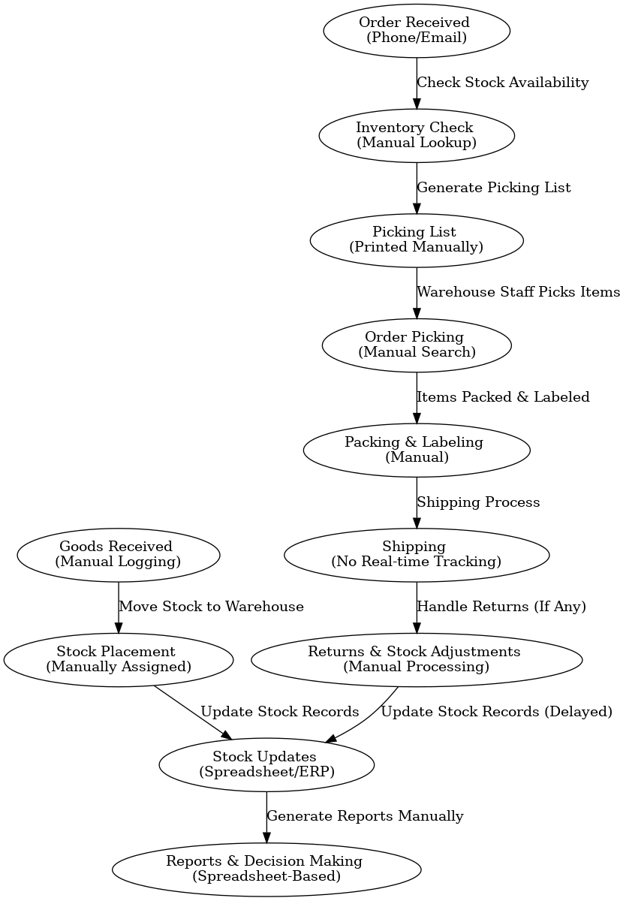**

**8.2. Proposed Recommendations (TO-BE)**

The new WMS-enabled process will introduce automation, real-time tracking, and system integration, leading to:

* Automated stock tracking with barcode/RFID scanning.
* Faster order fulfilment with optimized picking & packing.
* Real-time inventory visibility, preventing stockouts.
* Optimized warehouse layout for efficient storage.
* Automated reporting & analytics for better decision-making.

**Process Flow Diagram (To-Be)**

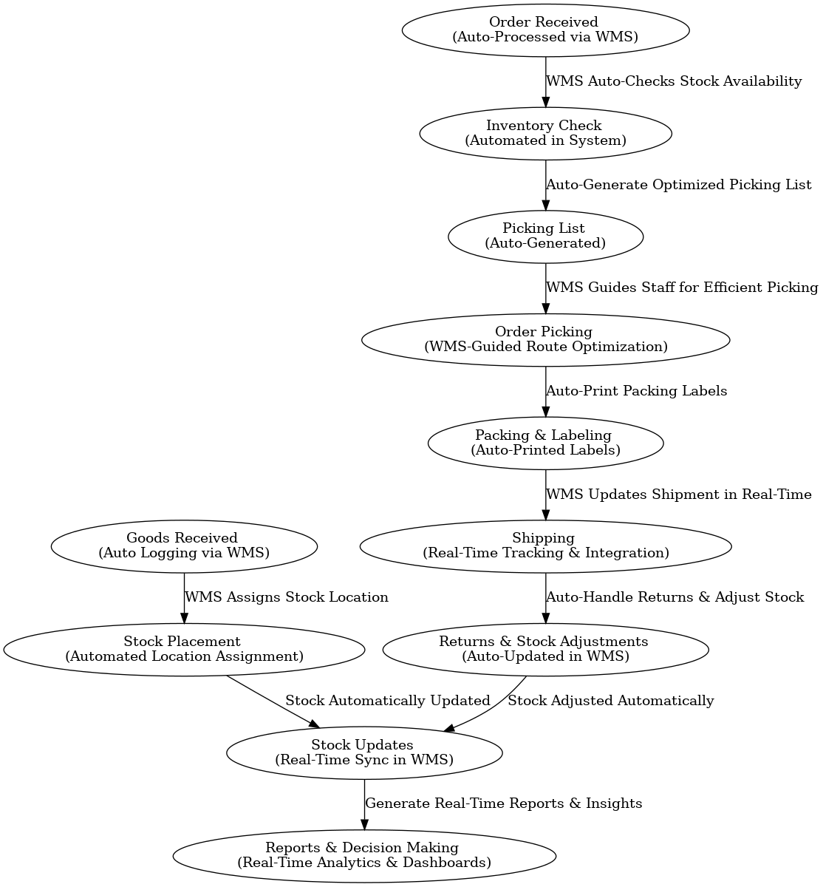

**9. Business Requirements**

The following are the key business requirements categorized into functional and non-functional needs:

|  |  |  |
| --- | --- | --- |
| **ID** | **Requirement** | **Description** |
| BR-01 | Goods Receiving Automation | Automate inbound stock logging using barcode/RFID scanning. |
| BR-02 | Inventory Tracking | Enable real-time stock tracking and movement updates. |
| BR-03 | Order Processing | Automate order verification and fulfilment workflows. |
| BR-04 | Picking & Packing Optimization | Provide system-guided picking routes and automatic packing label generation. |
| BR-05 | Shipping & Logistics | Integrate with carriers for real-time tracking and shipment status updates. |
| BR-06 | Returns Management | Automate returns processing and stock adjustments. |
| BR-07 | Reporting & Analytics | Generate real-time reports on inventory, order status, and warehouse performance. |

**9.1 Non-Functional Requirements**

|  |  |  |
| --- | --- | --- |
| **ID** | **Requirement** | **Description** |
| NFR-01 | System Performance | WMS should handle high transaction volumes with minimal latency. |
| NFR-02 | Security & Access Control | Implement role-based access and data encryption. |
| NFR-03 | System Integration | WMS must integrate with ERP, CRM, and logistics partners. |
| NFR-04 | Scalability | The system should support future expansion to multiple warehouse locations. |
| NFR-05 | User Experience | The interface must be user-friendly with minimal training required. |

**10. Appendices**

**10.1 List of Acronyms**

|  |  |
| --- | --- |
| **Acronym** | **Definition** |
| WMS | Warehouse Management System |
| ERP | Enterprise Resource Planning |
| RFID | Radio Frequency Identification |
| BRD | Business Requirements Document |
| FSD | Functional Specifications Document |
| SRS | System Requirement Specification |
| USD | Use case Document |
| UAT | User Acceptance Testing |
| KPI | Key Performance Indicator |
| SKU | Stock Keeping Unit |
| API | Application Programming Interface |
| SLA | Service Level Agreement |

**10.2 Glossary of Terms**

|  |  |
| --- | --- |
| **Term** | **Definition** |
| Warehouse Management System (WMS) | A software application that helps manage warehouse operations, including inventory tracking, order fulfilment, and shipping. |
| Order fulfilment | The process of receiving, processing, and delivering customer orders. |
| Inventory Tracking | The method used to monitor stock levels and movement within the warehouse. |
| Picking & Packing | The process of selecting items from inventory and preparing them for shipment. |
| Barcode Scanning | A technology used to quickly capture product details for tracking. |
| RFID | A technology that uses electromagnetic fields to automatically identify and track tags attached to objects. |
| ERP Integration | Connecting the WMS with an ERP system for seamless data exchange. |
| User Acceptance Testing (UAT) | The final phase of testing where end-users validate the system before deployment. |

**10.3 Related Documents**

* **Business Requirements Document (BRD)** – Defines business needs and high-level requirements.
* **Functional Specifications Document (FSD)** – Outlines detailed functional requirements and system design.
* **System Architecture Document** – Describes the technical architecture of the WMS application.
* **Test Plan & Test Cases** – Defines the testing strategy and cases for validating the system.
* **User Manual & Training Guide** – Provides instructions for warehouse staff on using the WMS.

**Process Flow Diagram for Inventory and Delivery Management System**

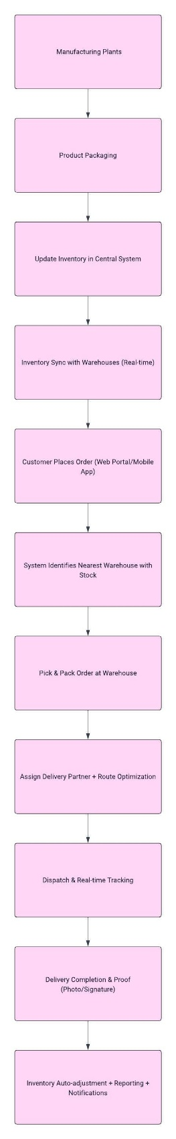

**Introduction Letter to a client to Understand the Business Process**

**Subject:** Introduction – Business Analyst Assigned to Your Project

Dear Arun(poc person),

I hope this message finds you well.

My name is Kumaran Dharmalingam, and I’m excited to introduce myself as the Business Analyst assigned to work with you and your team on the **Inventory and Delivery Management System** project. It’s a pleasure to be part of this engagement, and I’m looking forward to a productive collaboration.

As we begin this journey, my primary responsibility is to lead the **business understanding phase** — ensuring we gain a clear, in-depth view of your current operations around inventory management and delivery workflows. I’ll be working closely with your key stakeholders to gather requirements, identify operational pain points, and align our software solution with your long-term goals for efficiency, visibility, and customer satisfaction.

To kick things off, I’d like to propose a brief meeting where we can introduce teams, align on objectives, and map out the discovery process. This will also be a great opportunity for me to understand your priorities, expectations, and any existing systems or data you’d like us to consider.

Please feel free to suggest a convenient time for this discussion, or share any materials that would help us prepare ahead of time. I’m here to ensure this project runs smoothly and delivers real value to your operations.

Looking forward to working with you and your team.

Warm regards,  
Kumaran Dharmalingam  
Business Analyst  
Sagar Global systems  
+91-9281398375  
kumarandharmalingam@gmail.com

**Brief Business Requirements Document (BRD)** for **Online Store / eCommerce Platform**

**Business Requirements Document (BRD)**

**Project Title**: Online Store / eCommerce Platform  
**Prepared By**: Kumaran Dharmalingam  
**Date**: 04-04-2025

**1. Executive Summary**

This project aims to design and develop a scalable and user-friendly online store that allows customers to browse products, place orders, and make secure payments. The platform will support both desktop and mobile access, offering a seamless shopping experience. Vendors/admins will be able to manage product listings, inventory, and track sales from a centralized dashboard.

**2. Business Objectives**

* Enable customers to purchase products online with ease
* Offer a secure and reliable order and payment process
* Allow admin to manage product catalogue, orders, inventory, and promotions
* Provide sales insights and customer behaviour analytics for business growth
* Scale the platform to support new product categories and vendors

**3. Key Stakeholders**

|  |  |
| --- | --- |
| Role | Responsibility |
| Customers | Browse, purchase, track orders |
| Admin | Manage products, orders, inventory, and users |
| Vendors (optional) | Manage their own product listings and orders |
| Delivery Partners | Fulfil and deliver orders |

**4. High-Level Requirements**

* User registration, login, and profile management
* Product catalogue with categories, filters, and search
* Shopping cart and checkout process
* Secure payment gateway integration (e.g., Stripe, Razorpay)
* Order tracking and status updates
* Inventory and stock management
* Promotions and discount coupon engine
* Admin dashboard for product and order management
* Email/SMS notifications for order and delivery updates
* Optional: Multi-vendor support (Marketplace model)

**5. Assumptions & Constraints**

* Platform will support both web and mobile views
* Delivery logistics may be handled internally or via third-party APIs
* Product images and descriptions will be provided by the business team
* Payments must be PCI-DSS compliant

**6. Success Criteria**

* 95% of orders processed without support intervention
* Load time of less than 3 seconds per page
* 99.5% platform uptime
* Positive customer feedback and repeat orders within 3 months
* Increase in daily active users and monthly sales volume

**Software Requirements Specification (SRS)**

**Project Title**: Online Store / eCommerce Platform  
**Prepared By**: Kumaran Dharmalingam  
**Date**: 04-04-2025

**1. Introduction**

**1.1 Purpose**

This document outlines the functional and non-functional requirements for the development of a web-based **Online Store** that allows users to browse, purchase, and track products online while enabling admins to manage the backend operations efficiently.

**1.2 Scope**

The system will allow users to register, browse products, add items to their cart, make payments securely, and track orders. Admins can manage product listings, orders, inventory, and promotions. The system should be accessible via web browsers and optimized for mobile.

**1.3 Definitions**

* **SKU**: Stock Keeping Unit
* **Checkout**: Process of confirming and paying for products
* **Admin Panel**: Backend dashboard to manage the store

**2. Functional Requirements**

**2.1 User Module**

* Register and login using email, phone, or social logins
* View and edit user profile, address, and preferences
* Browse product categories and search by keyword or filter
* Add/remove items from the cart
* Apply coupon codes during checkout
* Make secure payments via integrated gateway
* View order history and track order status
* Rate and review purchased products

**2.2 Product & Catalogue Management (Admin)**

* Add, edit, delete product listings (name, image, price, stock)
* Assign products to categories and tags
* Manage SKUs and stock levels in real time
* Add promotional banners and homepage highlights

**2.3 Order Management**

* View all orders with status (Pending, Shipped, Delivered, Cancelled)
* Update order status and trigger notifications
* View customer invoices and delivery details

**2.4 Promotions & Coupons**

* Create and manage coupon codes (flat discount, percentage-based)
* Set expiry dates and usage limits

**2.5 Notifications**

* Email and SMS alerts for order placement, status updates, delivery
* Admin alerts for low stock and new orders

**2.6 Reports & Analytics**

* Sales reports by date/product/category
* Customer behaviour analytics
* Stock and inventory turnover reports

**3. Non-Functional Requirements**

|  |  |
| --- | --- |
| **Requirement** | **Description** |
| **Performance** | Page load time under 3 seconds |
| **Scalability** | System must support up to 10,000 concurrent users |
| **Availability** | 99.5% uptime expected |
| **Security** | Must comply with PCI-DSS for payment handling, use HTTPS, encrypted passwords |
| **Responsiveness** | Optimized for desktop, tablet, and mobile views |
| **Localization (optional)** | Multilingual and multi-currency support if needed in future |

**4. External Interfaces**

**4.1 Payment Gateway Integration**

* Integration with APIs like Phonepe,Gpay, Razorpay, or PayPal
* Handle transaction success/failure and update order status accordingly

**4.2 Delivery Partner Integration (Optional)**

* API to send shipment data and receive tracking info
* Auto-update order status from shipping API

**5. Assumptions & Constraints**

* Internet connection is required to use the platform
* Admin users must be assigned roles for controlled access
* Product content (images, descriptions) will be provided by the business team
* Initial deployment will be in a single region/language

**6. Future Enhancements *(Optional Section)***

* Wishlist and Save for Later functionality
* Chatbot for customer support
* Loyalty points and reward system
* Multi-vendor marketplace support

**ERD of Diagram for a support ticket/Ticketing life cycle**

|  |
| --- |
|  |

**User story of shopping from ecommerce.**

**1. User Registration & Login**

**As a** visitor,  
**I want to** register or log in to the eCommerce platform,  
**So that** I can access my profile, track orders, and shop securely.

*Acceptance Criteria*:

* User can register via email/phone/social login.
* User can log in and log out securely.
* Password reset functionality is available.

**2. Product Browsing & Search**

**As a** shopper,  
**I want to** browse or search for products by category, filters, or keywords,  
**So that** I can easily find what I’m looking for.

*Acceptance Criteria*:

* Categories and subcategories are clearly listed.
* Filter and sort options (e.g., price, brand, rating).
* Search bar supports autosuggestions.

**3. View Product Details**

**As a** shopper,  
**I want to** view detailed information about a product,  
**So that** I can decide whether to purchase it.

*Acceptance Criteria*:

* Product images, description, price, availability shown.
* Size/colour options (if applicable).
* Customer ratings and reviews displayed.

**4. Add to Cart**

**As a** shopper,  
**I want to** add products to my shopping cart,  
**So that** I can continue browsing and purchase multiple items together.

*Acceptance Criteria*:

* Product added to cart with correct quantity and variation.
* Cart icon updates in real-time.
* Cart is persistent across sessions.

**5. View and Modify Cart**

**As a** shopper,  
**I want to** view, update, or remove items from my cart,  
**So that** I can manage my purchase list before checkout.

*Acceptance Criteria*:

* User can increase/decrease quantity or remove items.
* Total amount reflects all changes.
* Option to apply coupons or promo codes.

**6. Checkout & Delivery Address**

**As a** shopper,  
**I want to** enter or select a delivery address during checkout,  
**So that** my order is shipped to the correct location.

*Acceptance Criteria*:

* Existing addresses shown.
* User can add/edit/delete addresses.
* Address validation is in place.

**7. Payment**

**As a** shopper,  
**I want to** pay for my order using secure and flexible payment options,  
**So that** I can complete the purchase securely.

*Acceptance Criteria*:

* Multiple options available (Card, UPI, Net Banking, COD).
* Payment gateway integration is secure.
* Payment success/failure is handled gracefully.

**8. Order Confirmation & Notification**

**As a** shopper,  
**I want to** receive an order confirmation,  
**So that** I know my order has been successfully placed.

*Acceptance Criteria*:

* Order summary displayed.
* Email/SMS confirmation sent.
* Order number generated.

**9. Order Tracking**

**As a** shopper,  
**I want to** track my order status,  
**So that** I know when to expect delivery.

*Acceptance Criteria*:

* Real-time status updates (Processing, Shipped, Out for Delivery, Delivered).
* Tracking number and courier link provided.

**10. Product Delivery**

**As a** shopper,  
**I want to** receive my product at my delivery address,  
**So that** I can start using it.

*Acceptance Criteria*:

* Delivery confirmation and signature (if required).
* Delivery status updated in user profile.