**AGILE DOCUMENTS**

**Document 1: Definition of Done**

The Agile definition of done is a collection of criteria that must be completed for a project to be considered as “done.” It is essentially a checklist used by Scrum teams to create a shared understanding of what is required to make a product releasable.

To fully understand the definition of done in the context of Scrum, we must first outline two of the key elements in Agile project management:

Product backlog item: This is a specific improvement that is made to a product. Items can include bug fixes, user stories, and specifications.

Product increment: This is what is produced at the end of a short development period or sprint. It combines all the product backlog items completed during this sprint.

In specific terms, the Scrum definition of done is a list of conditions that must be met to successfully mark a product increment as complete.

**Definition of done: Agile example**

In Agile project management, the definition of done is often employed when Scrum teams are creating a software product. Take the launch of a new mobile app as an example. Here, the definition of done in Agile could incorporate the following deliverables:

* Code has been written
* Code has been reviewed
* Build has been deployed for testing on mobile devices
* Tests have passed
* Google has approved the app for accessibility
* **Document 2- Product Vision**

|  |  |  |  |
| --- | --- | --- | --- |
| Scrum Project Name: | Lead Management System |  |  |
| Venue: | Pune |  |  |
| Date: | Start time:20/03/2025 | End time:20/9/2025 | Duration: 6 Months |
| Client: | Macrotech Developers Ltd.(LODHA) |  |  |
| **Stakeholder list:** |  | | |
| 1 | Mr. LODHA | | Owner-Sponsor |
| 2 | Mr. Anant | | Finance Head |
| 3 | Mr. Tikam | | CEO |
| 4 | Mr. Jaiswal | | Site Head |
| 5 | Ms. Payal | | Lodha Closing Head |
| 6 | Mr. Kishore | | Sourcing Head |
| 7 | Mr. Vikas | | Site MIS Team |
| 8 | Mr. Sudhanshu | | Marketing Head |
| Scrum Team | | | |
|  | Mr. Vaibhav | Scrum Master |  |
|  | SHIVAM | Product owner |  |
| Scrum Developer 1: | Mrs. Jaya | Sr. Java Developer |  |
| Scrum Developer 2: | Mr. Prashant | Jr. Java Developer |  |
| Scrum Developer 3: | Mr. Vibhor | Jr. Java Develpper |  |
| Scrum Developer 4: | Mr. Tutu | UI/UX designer |  |
| Scrum Developer 5: | Mr. Rakshit | Sr. NW. Admin |  |
| Scrum Developer 6 | Mr. Rohit | Sr. DB. Admin |  |
| Scrum Developer 7 | Mr. Vikas | Sr.Tester |  |
| Scrum Developer 8 | Mrs. Rohini | Jr.Tester |  |

|  |  |  |  |
| --- | --- | --- | --- |
| **Vision:** The purpose of the **Lead Management System (LMS)** is to automate streamline, organize, and optimize the process of capturing, tracking, and converting leads with user friendly interface in the real estate industry. | | | |
| **Target group**  Real Estate Industry /Company  **Customer/Users-**  All sales team members of LODHA involved in interaction with lead.  Management of LODHA involved in tracking performance and reports. | **Needs**  **What problem does the product solve?**  **1)**LMS solves lead capturing and tracking problem which resulted in delay in follow-ups and missed opportunities.  **2)**LMS will provide automation and mitigate manual handling of leads, leading to delays and inconsistencies.  **3)**LMS will provide clear visibility of lead progress, and increase efficiency of management to measure performance and track reports.  **4)** Duplicate leads and poor lead qualification will be solved by LMS which will increase efficiency of sales team and increase lead conversion.  **5)**LMS will automate the communication process as well so that there is timely follow-up and no delay in communication. | **Product**  **What product is it?**  End to end Lead Management System integrated with existing CRM  **What makes it desirable and special?**  All the manual work from lead capturing to lead management will be automated.  **Is it feasible to develop the product?**  Yes, it is | **Value**  **How is the product going to benefit the company?**  It will increase the sales and eventually revenue as all the processes will be automated and manual tracking of leads will be resolved. It will also help management to track the performance.  **What are the business goals?**  Purpose of this project is to provide an effective Lead Management System to the company so all the process from capturing lead to tracking leads can be automated which can increase sales.  **What is the business model?**  The Lead Management System aims to increase sales revenue and is developed using an Agile methodology with the SCRUM framework which providing automation for the lead capturing, tracking and management that severs as an opportunity for real estate industry. |

**Document 3: User stories**

|  |  |  |  |  |  |
| --- | --- | --- | --- | --- | --- |
| **User Story no.** | 1 | **Task:** | 2 | **Priority:** | Highest |
| AS A SALES MANAGER | | | | | |
| I WANT TO CAPTURE CUSTOMER DETAILS AND REQUIREMENT | | | | | |
| SO THAT EVERY CUSTOMER IS REGISTERED | | | | | |
| **BV:** | 1000 | | **CP:** | | 5 |
| **ACCEPTANCE CRITERIA** |  |  |  |  |  |
| CUSTOMER DETAILS REGISTRATION SCREEN | | | | | |
| ENTER CUSTOMER DETAILS | | | | | |
| SELECT DATE IN DD/MM/YY FORMAT | | | | | |
| CAPTURE TIME OF ENTRY | | | | | |
| CLICK ON SUBMIT BUTTON | | | | | |
|  |  |  |  |  |  |
| **User Story no.** | 2 | **Task:** | 1 | **Priority:** | Highest |
| AS A SALES MANAGER | | | | | |
| I WANT TO VIEW NEWLY ASSIGNED LEAD | | | | | |
| SO THAT I CAN CHECK DETAILS OF CUSTOMER AND HIS REQUIREMENT | | | | | |
| **BV:** | 500 | | **CP:** | | 5 |
| **ACCEPTANCE CRITERIA** |  |  |  |  |  |
| VIEW NEW ASSIGNED LEAD LIST | | | | | |
| CHECK CAPTURED CUSTOMER DETAILS AND REQUIREMENT | | | | | |
| CLICK ON VIEW LEADS | | | | | |
| SHOW SCREEN AS NEW CUSTOMER ALLOCATED | | | | | |
|  |  |  |  |  |  |
| **User Story no.** | 3 | **Task:** | 1 | **Priority:** | Highest |
| AS A CLOSING HEAD | | | | | |
| I WANT TO VIEW ALL PENDING LEADS ASSIGHNED TO SALES MANAGERS | | | | | |
| SO THAT I CAN CHECK REALLOT THEM TO SALES MANAGER | | | | | |
| **BV:** | 500 | | **CP:** | | 5 |
| **ACCEPTANCE CRITERIA** |  |  |  |  |  |
| VIEW PENDING LEADS | | | | | |
| OPTION TO REALLOT TO SALES MANAGER | | | | | |
|  |  |  |  |  |  |
| **User Story no.** | 4 | **Task:** | 1 | **Priority:** | Highest |
| AS A CLOSING HEAD | | | | | |
| I WANT TO VIEW THE STATUS OF THE LEADS ASSIGNED TO SALES MANAGER | | | | | |
| SO THAT I CAN GET THE PROSPECTS AND WORKABLE LEADS CLOSING MANAGER HAVE | | | | | |
| **BV:** | 500 | | **CP:** | | 4 |
| **ACCEPTANCE CRITERIA** |  |  |  |  |  |
| VIEW STATUS OF LEADS | | | | | |
| CHECK REMARKS | | | | | |
| CHECK FOR ANY PENDING FOLLOW-UP | | | | | |
| OPTION TO GIVE NOTIFICATION IF SOME PENDENCY IS OBESERVED | | | | | |
|  |  |  |  |  |  |
| **User Story no.** | 5 | **Task:** | 1 | **Priority:** | Highest |
| AS A SALES MANAGER | | | | | |
| I WANT TO SEND COMMUNICATION TO THE LEAD ASSIGNED | | | | | |
| SO THAT I CAN UPDATE REMARK AND CURRENT STATUS OF LEAD | | | | | |
| **BV:** | 500 | | **CP:** | | 5 |
| **ACCEPTANCE CRITERIA** |  |  |  |  |  |
| VIEW LIST OF CUSTOMERS ALLOCATED/HANDLED | | | | | |
| CLICK ON CALL/SEND COMMUNICATION | | | | | |
| OPTION TO UPDATE STATUS AND REMARK | | | | | |
|  |  |  |  |  |  |
| **User Story no.** | 6 | **Task:** | 1 | **Priority:** | Highest |
| AS A CLOSING HEAD | | | | | |
| I WANT TO VIEW REVENUE GENERATED BY CLOSING MANAGER | | | | | |
| SO THAT I CHECK IF ALL THE CLOSING MANAGERS ARE HANDING LEADS AND DRIVING CLOSURES | | | | | |
| **BV:** | 500 | | **CP:** | | 5 |
| **ACCEPTANCE CRITERIA** |  |  |  |  |  |
| CLICK ON REPORTS | | | | | |
| SELECT REVENUE GENERATED | | | | | |
| OPTION TO VIEW LEADS CLOSED | | | | | |
|  |  |  |  |  |  |
| **User Story no.** | 7 | **Task:** | 1 | **Priority:** | Highest |
| AS A SITE HEAD | | | | | |
| I WANT TO VIEW SOURCE OF LEAD GENERATED | | | | | |
| SO THAT I CHECK IF ALL THE SOURCING TOOLS ARE WORKING AND LEADS ARE GETTING QULIFIED INTO WALK-INS | | | | | |
| **BV:** | 500 | | **CP:** | | 5 |
| **ACCEPTANCE CRITERIA** |  |  |  |  |  |
| CLICK ON FILTER BY SOURCE | | | | | |
| SELECT SOURCE | | | | | |
| OPTION TO DOWNLOAD THE REPORT | | | | | |

**Document 4: Agile PO Experience**

**Responsibilities of PO in a project**

The product owner decides what needs to be in the project and will be responsible for how the product has to be. He will regularly interact with the customers and BA’s. this role can be played by BA or any person who worked for end users for a long time the or customer himself.

The product owner decides what needs to in the product and responsible the for entire progress of the project and reviews all stakeholders at end of each sprint

**Responsibilities:**

* Managing and prioritizing the product backlog. ...
* Translating product managers' strategies to tasks for development. ...
* Learning the market and customers' needs. ...
* Serving as a liaison between product and development. ...
* Staying accessible to development to answer questions.

**Meetings:**

* **Sprint Planning Meeting** – This meeting happens at the beginning each sprint

Deliverables – The team decides on what they will be delivering in the sprint

* **Daily Scrum Meeting** – This happens each day where team will just answer 3 questions

**What did u do today?**

**What will u do tomorrow?**

**Are there any impediments that is slowing or stopping u?**

* **Sprint Review Meeting** – This happens at the end of each sprint where team will demo completed stories to product owner and get it cleared
* **Sprint Retrospective Meeting** - At the end of the sprint where team will answer 3 questions

**What went well in the sprint?**

**What did not go well?**

**What are the improvement areas for next sprint**?

**Product Back Log:**

A product backlog is a prioritized list of work for the development team that is derived from the roadmap and its requirements. The most important items are shown at the top of the product backlog so the team knows what to deliver first. The development team doesn't work through the backlog at the product owner's pace and the product owner isn't pushing work to the development team. Instead, the development team pulls work from the product backlog.

**Document 5: Product and sprint backlog and product and sprint burndown charts**

**Product Back Log:**

A product backlog is a prioritized list of work for the development team that is derived from the roadmap and its requirements. The most important items are shown at the top of the product backlog so the team knows what to deliver first. The development team doesn't work through the backlog at the product owner's pace and the product owner isn't pushing work to the development team. Instead, the development team pulls work from the product backlog as there is capacity for it.

|  |  |  |  |  |  |  |
| --- | --- | --- | --- | --- | --- | --- |
| **User Story ID** | **User Story** | **Task** | **Priority** | **CP** | **BV** | **Sprint** |
| 1001 | AS A SALES MANAGER I WANT TO CAPTURE CUSTOMER DETAILS AND REQUIREMENT SO THAT EVERY CUSTOMER IS REGISTERED | 1 | High | 5 | 1000 | Sprint1 |
| 1002 | AS A SALES MANAGER I WANT TO VIEW NEWLY ASSIGNED LEAD SO THAT I CAN CHECK DETAILS OF CUSTOMER AND HIS REQUIREMENT | 1 | High | 5 | 500 | Sprint1 |
| 1003 | AS A CLOSING HEAD I WANT TO VIEW ALL PENDING LEADS ASSIGHNED TO SALES MANAGERS SO THAT I CAN CHECK REALLOT THEM TO SALES MANAGER | 1 | High | 5 | 500 | Sprint1 |
| 1004 | AS A CLOSING HEAD I WANT TO VIEW THE STATUS OF THE LEADS ASSIGNED TO SALES MANAGER SO THAT I CAN GET THE PROSPECTS AND WORKABLE LEADS CLOSING MANAGER HAVE | 1 | High | 4 | 500 | Sprint1 |
| 1005 | AS A SALES MANAGER I WANT TO SEND COMMUNICATION TO THE LEAD ASSIGHNED SO THAT I CAN UPDATE REMARK AND CURRENT STATUS OF LEAD | 1 | High | 5 | 500 | Sprint2 |
| 1006 | AS A CLOSING HEAD I WANT TO VIEW REVENUE GENERATED BY CLOSING MANAGER SO THAT I CHECK IF ALL THE CLOSING MANAGERS ARE HANDING LEADS AND DRIVING CLOSURES | 1 | High | 5 | 500 | Sprint2 |
| 1007 | AS A SITE HEAD I WANT TO VIEW SOURCE OF LEAD GENERATED SO THAT I CHECK IF ALL THE SOURCING TOOLS ARE WORKING AND LEADS ARE GETTING QULIFIED INTO WALK-INS | 1 | High | 5 | 500 | Sprint2 |

**Sprint Back Log:**

A sprint backlog is the set of items that a cross-functional product team selects from its product backlog to work on during the upcoming sprint. Typically, the team will agree on these items during its sprint planning session. In fact, the sprint backlog represents the primary output of sprint planning.

|  |  |  |  |  |  |
| --- | --- | --- | --- | --- | --- |
| **User Story ID** | **User Story** | **Task** | **Owner** | **Status** | **Estimated Effort In Days** |
| 1001 | AS A SALES MANAGER I WANT TO CAPTURE CUSTOMER DETAILS AND REQUIREMENT SO THAT EVERY CUSTOMER IS REGISTERED | 1 | Developer | completed | 5 |
| 1002 | AS A SALES MANAGER I WANT TO VIEW NEWLY ASSIGNED LEAD SO THAT I CAN CHECK DETAILS OF CUSTOMER AND HIS REQUIREMENT | 1 | Developer | completed | 4 |
| 1003 | AS A CLOSING HEAD I WANT TO VIEW ALL PENDING LEADS ASSIGHNED TO SALES MANAGERS SO THAT I CAN CHECK REALLOT THEM TO SALES MANAGER | 1 | Developer | completed | 5 |
| 1004 | AS A CLOSING HEAD I WANT TO VIEW THE STATUS OF THE LEADS ASSIGNED TO SALES MANAGER SO THAT I CAN GET THE PROSPECTS AND WORKABLE LEADS CLOSING MANAGER HAVE | 1 | Developer | completed | 3 |
| **User Story ID** | **User Story** | **Task** | **Owner** | **Status** | **Estimated Effort In Days** |
| 1005 | AS A SALES MANAGER I WANT TO SEND COMMUNICATION TO THE LEAD ASSIGHNED SO THAT I CAN UPDATE REMARK AND CURRENT STATUS OF LEAD | 1 | Developer | completed | 5 |
| 1006 | AS A CLOSING HEAD I WANT TO VIEW REVENUE GENERATED BY CLOSING MANAGER SO THAT I CHECK IF ALL THE CLOSING MANAGERS ARE HANDING LEADS AND DRIVING CLOSURES | 1 | Developer | completed | 4 |
| 1007 | AS A SITE HEAD I WANT TO VIEW SOURCE OF LEAD GENERATED SO THAT I CHECK IF ALL THE SOURCING TOOLS ARE WORKING AND LEADS ARE GETTING QULIFIED INTO WALK-INS | 1 | Developer | completed | 5 |

**Product Back Log chart:**

Product burn down chart it shows the graph of CP covered in daily basis.

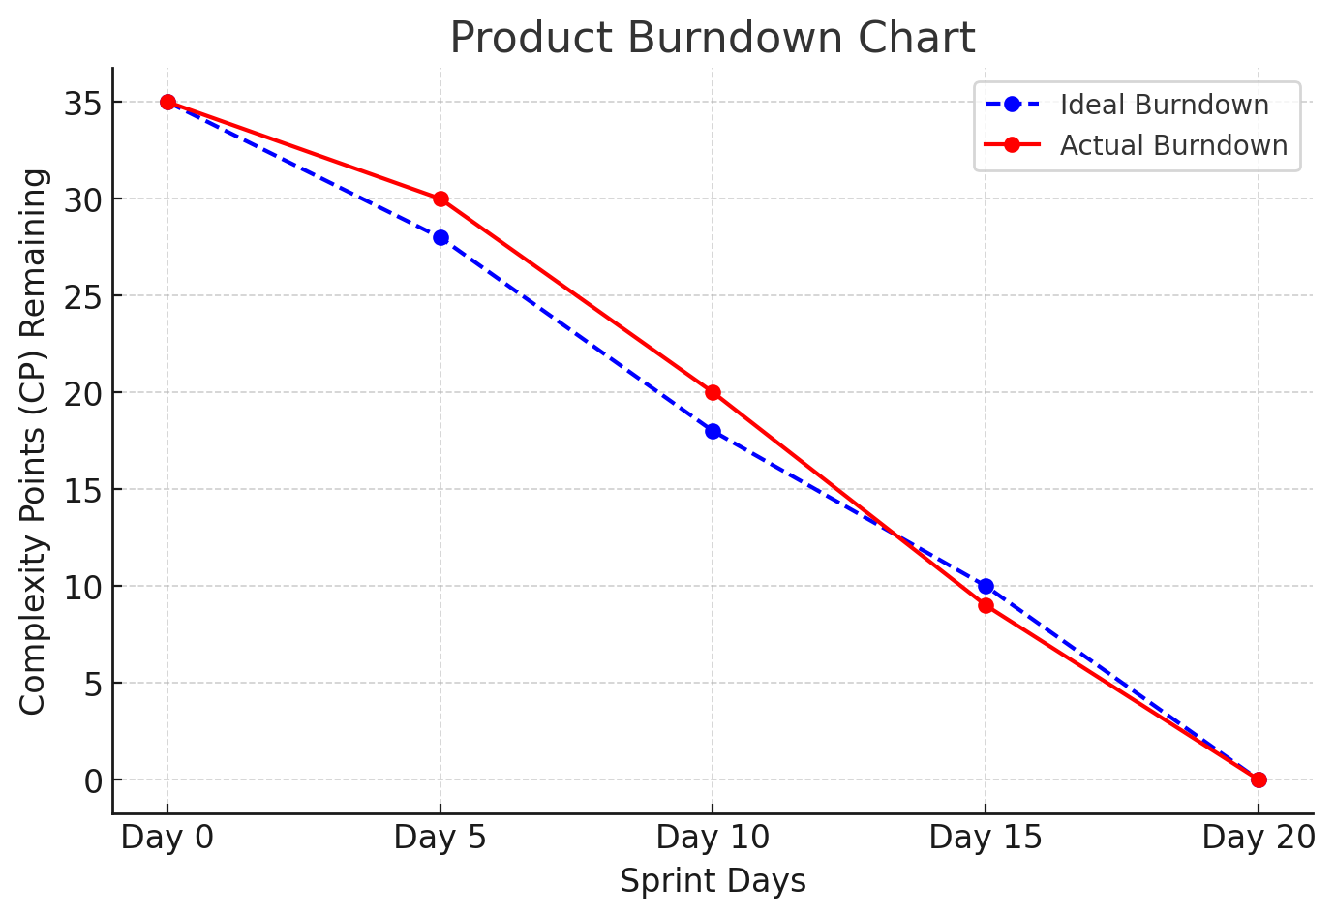

**Sprint Burn Down:**

Sprint burn down chart will always showcase us total number of CP covered in a sprint.

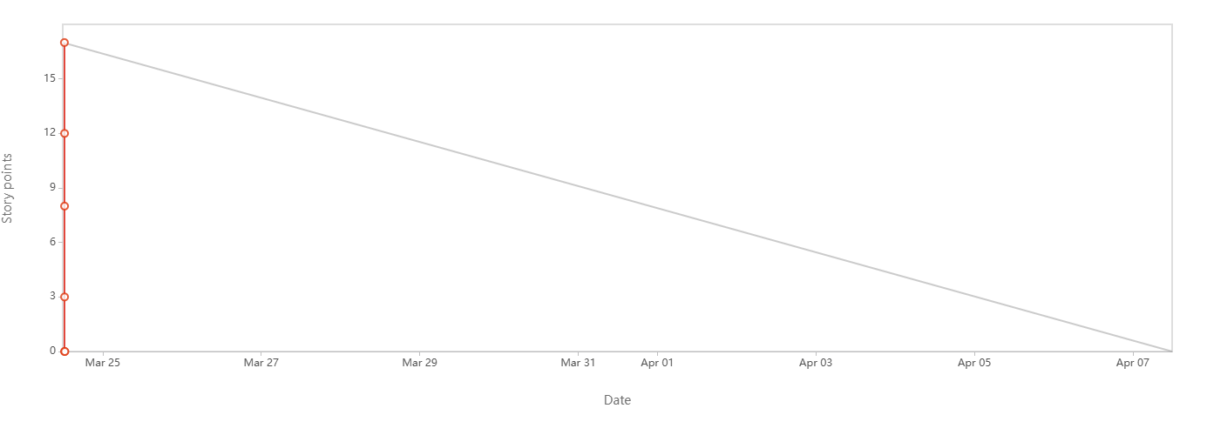

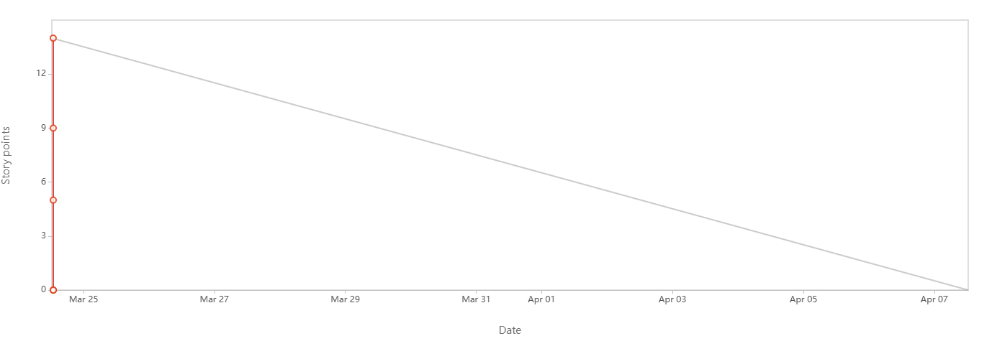

**Document 6: Sprint meetings**

**Sprint Planning Meeting:**

This happens at the beginning of each sprint and the team decides what they will be delivering in this sprint.

|  |  |  |
| --- | --- | --- |
| **Date** | 23.03.2025 |  |
| **Time** | 09.00 AM |  |
| **Location** | Pune |  |
| **Prepared By** | Mr. Shivam |  |
| **Attendees** | Mr. Vaibhav- Scrum Master  Mr. Jaya- Sr. Java developer  Mr. Prashant-Jr. Java developer  Mr. Vibhor-Jr. Java developer  Mr. Tutu-UI/UX Designer  Mr. Rakshit-Sr. NW. Admin  Mr. Rohit- Sr. DB Admin  Mr. Vikas- Sr. Tester  Ms. Rohini- Jr. Tester |  |

**Agenda Topics:**

|  |  |  |
| --- | --- | --- |
| **Topic** | **Presenter** | **Time Allocated** |
| Weekly Task completion | Mr. Shivam | 60 Min |
| Task Completed | Mr. Shivam | 60 Min |

**Other Information:**

|  |  |
| --- | --- |
| **Observers** | IT Team Design architect and Business Analyst |
| **Resource** | 3 Developers |
| **Speal Note** | Test cases for login process - Next review will be done 24th March 2025 |

**Daily Stand-up Meeting:**

|  |  |  |  |  |  |  |  |  |
| --- | --- | --- | --- | --- | --- | --- | --- | --- |
| **Question** | **Name/Role** | **Week “1” (from 24th March 2024 to 30th March. 2025)** | | | | | | |
| **Monday** | **Tuesday** | **Wednesday** | **Thursday** | **Friday** | **Saturday** | **Sunday** |
| **What did you do yesterday?** | |  | | --- | | **Developer 1** | | **Developer 2** | | **Developer 3** | | **Task 1  Task 2**  **Task 3** | **Task 4  Task 5**  **Task 6** | **Task 7  Task 8**  **Task 9** | **Task 13  Task 14**  **Task 15** | **Task16  Task17**  **Task18** |  |  |
| **What will you do today?** | |  | | --- | | **Developer 1** | | **Developer 2** | | **Developer 3** | | **Task 4   Task 5  Task 6** | **Task 7   Task 8  Task 9** | **Task 10   Task 11  Task 12** | **Task 16   Task 17**  **Task 18** | **Task19   Task20**  **Task21** |  |  |
| **What (if any) is blocking your progress?** | |  | | --- | | **Developer 1** | | **Developer 2** | | **Developer 3** | | **No   Change request  No** | **Change request   WIP  No** | **WIP   client meeting  DB issue** | **Client meeting   Sorted  No** | **Network    Network  Network** |  |  |

**Sprint Review Meeting:**

This happens at the end of the sprint where team will demo the completed stories to the product owner and get it cleared.

|  |  |
| --- | --- |
| **Date** | 7-03-2025 |
| **Time** | 10.30 AM |
| **Location** | Pune |
| **Prepared By** | Product Owner -Mr. Shivam |
| **Attendees** | Developers , Design architect and Team. |

|  |  |  |  |
| --- | --- | --- | --- |
| **Sprint Status** | **Demo** | **Quick Updates** | **What's Next** |
| Task Completed | AS A SALES MANAGER I WANT TO CAPTURE CUSTOMER DETAILS AND REQUIREMENT SO THAT EVERY CUSTOMER IS REGISTERED | Completed as desired by the customer. | get sign off |
| Task Completed | AS A SALES MANAGER I WANT TO VIEW NEWLY ASSIGNED LEAD SO THAT I CAN CHECK DETAILS OF CUSTOMER AND HIS REQUIREMENT | Completed as desired by the customer. | get sign off |
| Task Completed | AS A CLOSING HEAD I WANT TO VIEW ALL PENDING LEADS ASSIGHNED TO SALES MANAGERS SO THAT I CAN CHECK REALLOT THEM TO SALES MANAGER | Completed as desired by the customer. | get sign off |
| Task Completed | AS A CLOSING HEAD I WANT TO VIEW THE STATUS OF THE LEADS ASSIGNED TO SALES MANAGER SO THAT I CAN GET THE PROSPECTS AND WORKABLE LEADS CLOSING MANAGER HAVE | Completed as desired by the customer. | get sign off |

**Sprint Retrospective Meeting:**

This meeting happens at the end of the sprint where team will answer 3 questions.

a) what went will in the sprint

b) what did not go well

c) what are the required areas of improvement in the next sprint.

|  |  |  |  |  |
| --- | --- | --- | --- | --- |
| **Agenda** | **What went well** | **What did not go well** | **Questions** | **Reference** |
| Sprint tasks | All the deliverables planned for the current sprint went well |  | NO |  |
| Change request |  | Due to last minutes, change request could not be done |  | Speak to the client regarding this. |