Online Agriculture Products Store

Mr. Henry, after being successful as a businessman and has become one of the wealthiest persons in the city. Now, Mr. Henry wants to help others to fulfil their dreams. One day, Mr. Henry went to meet his childhood friends Peter, Kevin and Ben. They live in a remote village and do farming. Mr. Henry asked his friends if they are facing any difficulties in their day-to-day work. Peter told Mr. Henry that he is facing difficulties in procuring fertilizers which are very important for farm. Kevin said that he is also facing the same problem in-case of buying seeds for farming certain crops. Ben raised his concern on lack of pesticides which could help in greatly reducing pests in crops.

After listening to all his friends’ problems, Mr. Henry thought that this is a crucial problem faced not only by his friends but also by so many other farmers. So, Mr. Henry decided to make an online agriculture product store to facilitate remote area farmers to buy agriculture products. Through this Online Web / mobile Application, Farmers and Companies (Fertilizers, seeds and pesticides manufacturing Companies) can communicate directly with each other.

The main purpose to build this online store is to facilitate farmers to buy seeds, pesticides, and fertilizers from anywhere through internet connectivity. Since new users are involved, Application should be user friendly.

This new application should be able to accept the product (fertilizers, seeds, pesticides) details from the manufacturers and should be able to display them to the Farmers. Farmers will browse through these products and select the products what they need and request to buy them and deliver them to farmers location.

Mr. Henry has given this project through his Company SOONY. In SOONY Company, Mr Pandu is Financial Head and Mr Dooku is Project Coordinator. Mr. Henry , Mr Pandu , and Mr Dooku formed one Committee and gave this project to APT IT SOLUTIONS company for Budget 2 Crores INR and 18 months Duration under CSR initiative. Peter, Kevin and Ben are helping the Committee and can be considered as Stakeholders share requirements for the Project.

Mr Karthik is the Delivery Head in APT IT SOLUTIONS company and he reached out to Mr Henry through his connects and Bagged this project. APT IT SOLUTIONS company have Talent pool Available for this Project. Mr Vandanam is project Manager, Ms. Juhi is Senior Java Developer, Mr Teyson, Ms Lucie, Mr Tucker, Mr Bravo are Java Developers. Network Admin is Mr Mike and DB Admin is John. Mr Jason and Ms Alekya are the Tester. And you joined this team as a BA.

# Question 1 – Audits:

Audit is a process in which external team go thru all the project related documents to ensure that the required process and standards are followed by the concern person. The team may ask questions to the concern person, if needed.

During the project life cycle, BA audits can happen at below stages:

* Requirement Gathering
* Requirement Analysis
* Design
* Development
* Testing

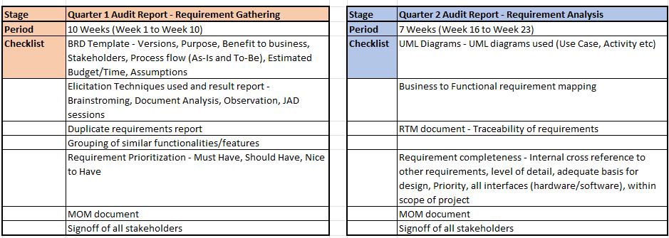

# Question 2 –: BA Approach Strategy

* What Elicitation Techniques to apply – There are many elicitation techniques available to gather the requirements from stakeholders. They are Brainstorming, Document Analysis, Reverse Engineering, Focus Groups, Observation, Workshops, JAD (Joint Application Development) session, Interview, Prototyping and Questionnaire.
* How to do Stakeholder Analysis – Stakeholder analysis can be done using RACI matrix. This involve identifying stakeholders, defining their roles and responsibilities in the project.

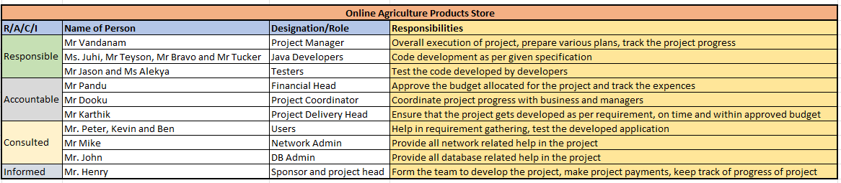

* What Documents to Write:
  + BRD – This contains high level requirements captured from stakeholders.
  + FRD – This contains the functional level requirements those are converted from business requirements.
  + Use Case Document – This contains use cases created for each functional requirement.
  + Test Case Document – This contains all test cases written to test the application
  + RTM – Requirement Trackability Matrix – This contains the mapping of each business requirement into functional requirements … then to use cases …then to test cases etc.
* What process to follow to Sign off on the Documents:
  + Sign off can be taken on documents like business requirement document, functional requirement document, System requirement specification, Test case document etc
  + Sign off can be taken either on email or as part of meeting MOM
* How to take Approvals from the Client:
  + Arrange a formal meeting with Client to discuss and take approval on required components.
  + If needed, approval can be taken on emails also.
* What Communication Channels to establish n implement:
  + Regular meetings – Weekly status, Bi-weekly sprint reviews, monthly stakeholder updates
  + Emails
* How to Handle Change Requests:
  + Get Change Request Form
  + Do impact analysis – What functionalities are impacted, time to implement the change, is change aligned and beneficial to the project.
  + Approval process – Get it approved from PM, Business etc
  + Document
* How to update the progress of the project to the Stakeholders:
  + Weekly status report
  + Monthly review meetings
  + Sprint review meetings
  + Email
* How to take signoff on the UAT:
  + Prepare UAT plan
  + Conduct UAT
  + Fix issues if any
  + Fill Acceptance Form
  + Final review meeting
  + Obtain sign-off

# Question 3 – 3 Tier Architecture

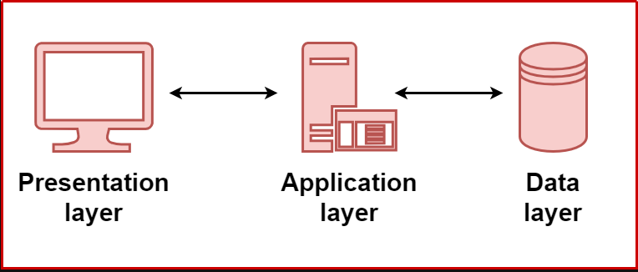

The application is divided into three logical layers:

* Presentation Layer
  + The presentation tier is the user interface and communication layer of the application, where the end user interacts with the application.
  + Its main purpose is to display information to and collect information from the user using screens/forms/pages.
  + This top-level tier can run on a web browser, as desktop application, or a graphical user interface (GUI).
  + Example - HTML, CSS, and JavaScript etc.
* Business Logic Layer
  + The application tier, also known as the logic tier or middle tier, is the heart of the application.
  + It acts as a bridge between Presentation layer and Database layer.
  + This contains the core logic of the application and contains all business rules.
  + Example – Application programs written in Python, Java etc.
* Database Layer
  + This layer is responsible for storing and retrieving the data from database.
  + Uses RDBMS like PostgreSQL, MySQL, Oracle, Db2 etc.

# Question 4 – BA Approach Strategy for Framing Questions

To get the requirement details from the stakeholders, BA needs to frame and ask the correct questions. Following techniques can be used to frame the questions:

* 5W1H – This framework is useful to gather the information and understand the situation by getting answers for questions about Who, What, When, Where, Why and How.
* SMART – The questions need to be Specific, Measurable, Attainable, Relevant and Timebound.
* RACI chart – This chart helps in defining roles and responsibilities within a team. So, using this chart BA would know whom and what questions to ask … based on roles and responsibilities.
* UML – Unified Modelling Language is a standard way of diagramming and modelling software systems that helps in design, development and communication between team members using Use cases, Activity diagrams etc.

# Question 5 – Elicitation Techniques

Elicitation Techniques are used to gather the requirements from stakeholders. There are many elicitation techniques to apply to dig out the information from stakeholders.

* **Brainstorming** – This can be done either individually or in groups. Ideas can be collected from users/stakeholders that they have seen or experience elsewhere.
* **Document Analysis** - Go through the available documentation of existing system that can help to build new system. Documentation includes interface details, user manuals, navigation etc.
* **Reverse Engineering** – If no documentation is available for current system, then go through the current application and code to understand what current system actually does. Mainly used for Migration projects.
* **Focus Groups** - If many people are needed for discussion, then groups are formed as per application area, technology, process etc. Typically focus group has 6-12 members and they discuss only about specific application area, technology or process.
* **Observation** – Observing. Shadowing users or doing part of there job can provide information about current process/application, inputs and outputs. Mainly used when no documentation is available, and no persons are available for discussions.
* **Workshops** – Workshops are mainly for defined duration rather than any outcome. Usually, workshops get repeated to get any outcome.
* **JAD (Joint Application Development) session** – JAD team is formed with participants having mixed skills and from various areas like Business owners, Managers, Client representatives, end users, Network and DB analyst, IT specialist, HR representatives, Trainers etc. In JAD session, large amount of information gets available that needs to be processed further.
* **Interview** – One to One discussion with Users and Stakeholders. During interview, relevant questions are asked, and responses are documented.
* **Prototyping** – Screen mocks ups can support requirement gathering process. Mock up help stakeholders to visualise the functionality of the system.
* **Questionnaire** – This can be useful to obtain the information from users/stakeholders. Questions needs to be framed correctly to get the right information.

# Question 6 – Elicitation Techniques suitable for this project

In the case study, since the requirements are not given in detail and there is no documentation available, as a BA, I would use below elicitation techniques:

* Brainstorming
* Focus Groups
* Workshops
* JAD sessions
* Interview
* Prototyping

# Question 7 – 10 Business Requirements

Business requirements are the high level needs that business wants to fulfil to achieve their business objectives.

* BR001 – User should be able to create a new account in the application by submitting their email ID and creating a secure password.
* BR002 – User should be able to login using their email id and password.
* BR003 – User should be able to browse through the products catalogue once they visit the website.
* BR004 – The new application needs to have a search option, so that user can search for any product they need.
* BR005 – User should be able to select any product they want and place it into the Cart.
* BR006 – User should be able to add/delete the products from their Cart.
* BR007 – Using Cart products, user should be able to place the order by giving the delivery address.
* BR008 – The new application should have various payment options available like Cash on Delivery, Debit/Credit cards and UPI etc.
* BR09 – User should be able to track their orders for the delivery status.
* BR010 – The new application should be easy to use and very user friendly.
* BR011 – The application should show the order history for the logged in user

# Question 8 – Assumptions

* Assumption 1 – User have a desktop/laptop or a mobile to use the application.
* Assumption 2 – User have a network access to use the application
* Assumption 3 – User has knowledge about farming products and its usage
* Assumption 4 – Online shopping trend will increase, and farmers will prefer online purchase of their products.
* Assumption 5 – The customer has online accounts for secure payment processing.
* Assumption 6 – The vendors will upload information about all their products in the application.

# Question 9 – This project Requirements Priority

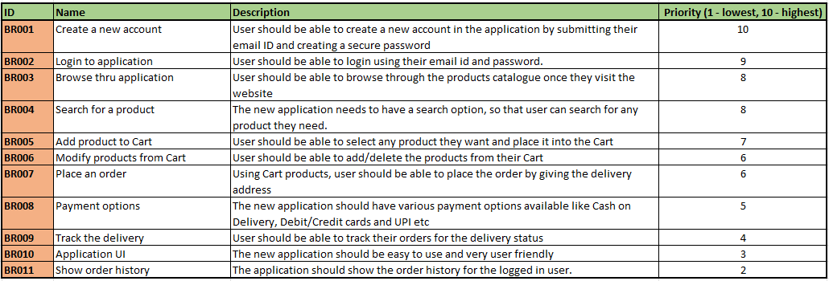

# Question 10 – Use Case Diagram:

Use case diagram is nothing but the visual interaction between User and the System. MS Visio.

Types of Use Cases - Essential and Supporting use case

Types of Relationships – Include/Use, Extend, Generalisation

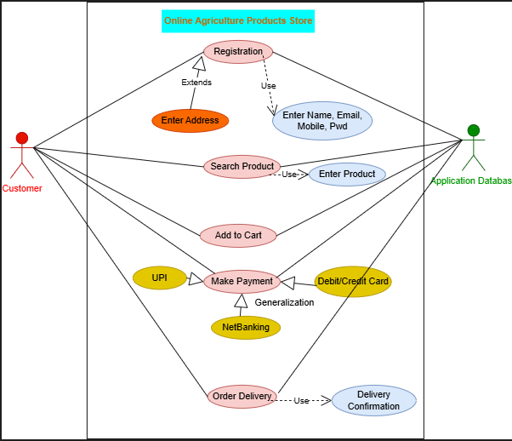

# Question 11 – Use Case Specifications

A use case specification document provides detail description of how user (actor) will interact with the system to achieve specific functionality.

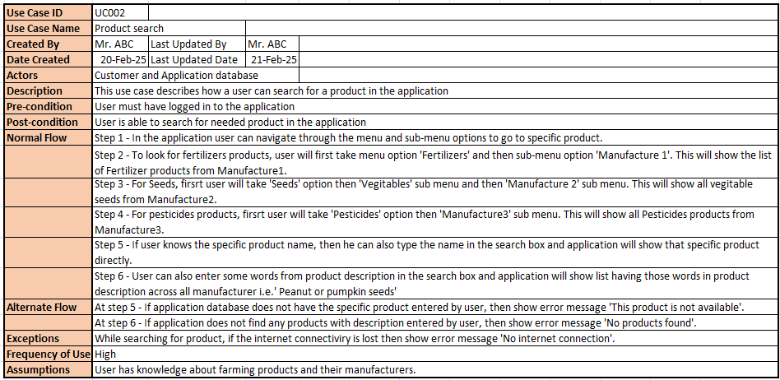

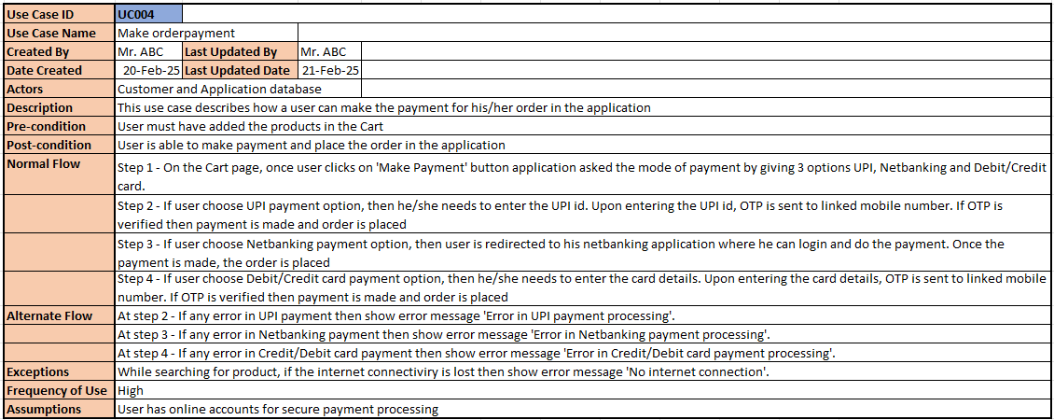

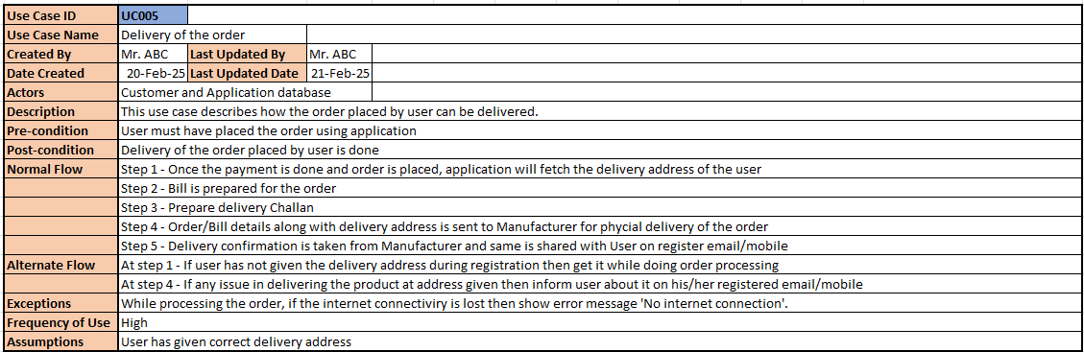

# Question 12 – Activity Diagrams

Activity diagram is a type of UML (Unified Modelling Language)) diagram that represents the flow of activities happening within the system.

Use case diagram represents interaction between User and System, whereas Activity diagram represents the flow of activities in the system.

Activity Diagrams are defined with Conditions like:

* Guard – Yes or No
* Fork and Join – Split and Merge flows
* Branch and Merge - conditions and parallel activities

**1) Activity Diagram for Use Case UC001: User Registration**

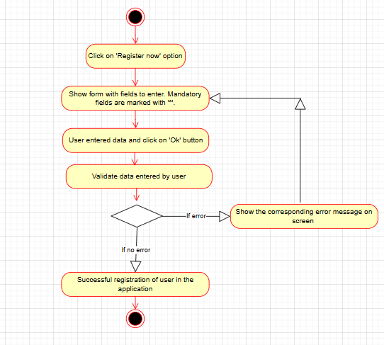

**2) Activity Diagram for Use Case UC002: Product search**

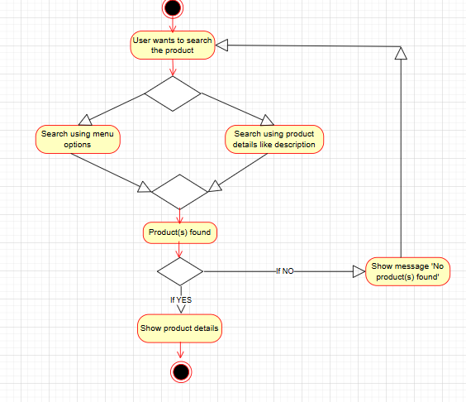

**3) Activity Diagram for Use Case UC003: Add product to Cart**

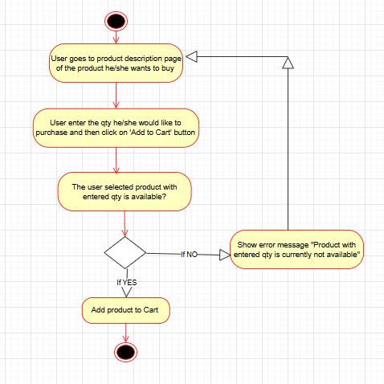

**4) Activity Diagram for Use Case UC004: Make order payment**

This diagram uses **Branch and merge** condition. Branches and merges are used to indicate conditions and parallel activities.

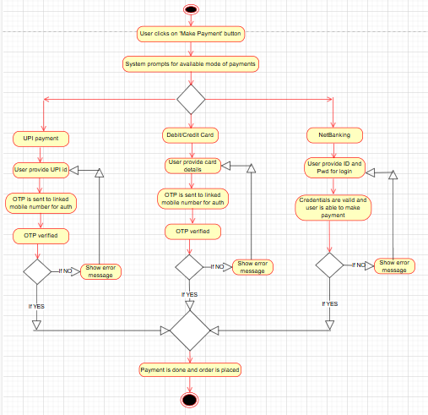

**5) Activity Diagram for Use Case UC005: Order Delivery**

This diagram uses ‘**Fork and Join**’ condition. A fork splits a single flow into multiple concurrent flows, while a join merges multiple concurrent flows into a single flow.

