**Question 1 – Write Agile Manifesto**

**Answer:**

Agile manifesto includes four main value and twelve principles of Agile Software.

**Four Main Values:**

1. Individuals & Interactions over Processes & Tools
2. Working Software over Comprehensive Documentation
3. Customer Collaboration over Contract Negotiation
4. Responding to Change Over following plan

**Twelve Principles:**

1. **Customer Satisfaction:** Satisfy customer through early and continuous delivery of software.
2. **Change in Requirements:** Welcome changing requirements, even late in development. Agile process harness change for customer’s competitive advantage.
3. **Frequent Delivery:** Deliver working software frequently from weeks to months with preference to timescale.
4. **Team Work:** Business people and developers must work together throughout project.
5. **Motivation:** Build projects around motivated individuals. Provide support they need & trust to get the job done.
6. **Face to Face Conversation:** The most convenient method to communicate information to development team is face to face conversation.
7. **Progress measure:** Working software is primary measure of progress.
8. **Constant Pace:** Agile process promotes continuous development. The sponsors, developers and users maintain constant pace.
9. **Excellence & Design:** Continuous attention to technical excellence and good design.
10. **Simplicity:** The art of maximizing amount of work not done is essential.
11. **Self-Organizing Teams:** The best architectures, requirements and design will emerge from self-organizing teams.
12. **Adjusting as per Environment:** After specific intervals, teams should reflect on how to become more effective & adjust behavior accordingly.

**Question 2 – User Stories- Acceptance Criteria-BV-CP**

**Answer:**

|  |  |  |  |
| --- | --- | --- | --- |
| **User story No.:** 1 | **Tasks:** Registration | | **Priority:**  Highest |
| AS A USER  I SHOULD BE ABLE TO DO REGISTRATION  SO THAT I CAN LOGIN | | | |
| **BV:** 500 | | **CP:** 5 | |
| **Acceptance Criteria:** | | | |

|  |  |  |  |
| --- | --- | --- | --- |
| **User story No.:** 2 | **Tasks: Login** | | **Priority:**  Highest |
| AS A RESTAURANT OWNER  I SHOULD BE ABLE TO DO REGISTRATION  SO THAT I CAN LOGIN | | | |
| **BV:** 500 | | **CP:** 5 | |
| **Acceptance Criteria:** | | | |

|  |  |  |  |
| --- | --- | --- | --- |
| **User story No.:** 3 | **Tasks:** Registration | | **Priority:**  Highest |
| AS A DELIVERY AGENT  I SHOULD BE ABLE TO DO REGISTRATION  SO THAT I CAN LOGIN | | | |
| **BV:** 500 | | **CP:** 5 | |
| **Acceptance Criteria:** | | | |

|  |  |  |  |
| --- | --- | --- | --- |
| **User story No.:** 4 | **Tasks:** Login | | **Priority:**  Highest |
| AS A USER  I SHOULD BE ABLE TO DO LOGIN  SO THAT I CAN SEE HOME PAGE | | | |
| **BV:** 500 | | **CP:** 5 | |
| **Acceptance Criteria:** | | | |

|  |  |  |  |
| --- | --- | --- | --- |
| **User story No.:** 5 | **Tasks:** Login | | **Priority:**  Highest |
| AS A RESTAURANT OWNER  I SHOULD BE ABLE TO DO LOGIN  SO THAT I CAN SEE HOME PAGE | | | |
| **BV:** 500 | | **CP:** 5 | |
| **Acceptance Criteria:** | | | |

|  |  |  |  |
| --- | --- | --- | --- |
| **User story No.:** 6 | **Tasks:** Login | | **Priority:**  Highest |
| AS A DELIVERY AGENT  I SHOULD BE ABLE TO DO LOGIN  SO THAT I CAN SEE HOME PAGE | | | |
| **BV:** 500 | | **CP:** 5 | |
| **Acceptance Criteria:** | | | |

|  |  |  |  |
| --- | --- | --- | --- |
| **User story No.:** 7 | **Tasks:** Registration | | **Priority:**  Highest |
| AS A ADMIN  I SHOULD BE ABLE TO DO REGISTRATION  SO THAT I CAN LOGIN | | | |
| **BV:** 500 | | **CP:** 5 | |
| **Acceptance Criteria:** | | | |

|  |  |  |  |
| --- | --- | --- | --- |
| **User story No.:** 8 | **Tasks:** Login | | **Priority:**  Highest |
| AS A ADMIN  I SHOULD BE ABLE TO DO LOGIN  SO THAT I CAN SEE HOME PAGE | | | |
| **BV:** 500 | | **CP:** 5 | |
| **Acceptance Criteria:** | | | |

|  |  |  |  |
| --- | --- | --- | --- |
| **User story No.:** 9 | **Tasks:** Search | | **Priority:**  Highest |
| AS A USER  I SHOULD BE ABLE TO SEARCH THE FOOD ITEM  SO THAT I CAN ORDER | | | |
| **BV:** 500 | | **CP:** 5 | |
| **Acceptance Criteria:** | | | |

|  |  |  |  |
| --- | --- | --- | --- |
| **User story No.:** 10 | **Tasks:** Add | | **Priority:**  Highest |
| AS A RESTARANT OWNER  I SHOULD BE ABLE TO ADD THE FOOD ITEMS OF MY RESTAURANT  SO THAT CUSTOMER CAN SEE THE ITEMS | | | |
| **BV:** 500 | | **CP:** 5 | |
| **Acceptance Criteria:** | | | |

|  |  |  |  |
| --- | --- | --- | --- |
| **User story No.:** 11 | **Tasks:** Add | | **Priority:**  Highest |
| AS A RESTARANT OWNER  I SHOULD BE ABLE TO ADD MY RESTAURANT  SO THAT PROVIDE FOOD ITEMS | | | |
| **BV:** 500 | | **CP:** 5 | |
| **Acceptance Criteria:** | | | |

|  |  |  |  |
| --- | --- | --- | --- |
| **User story No.:** 12 | **Tasks:** Add | | **Priority:**  Highest |
| AS A RESTAURANT OWNER  I SHOULD BE ABLE TO ADD IMAGE OF FOOD ITEMS  SO THAT CUSTOMER CAN GET MORE KNOWLEDGE ABOUT FOOD ITEM | | | |
| **BV:** 500 | | **CP:** 5 | |
| **Acceptance Criteria:** | | | |

|  |  |  |  |
| --- | --- | --- | --- |
| **User story No.:** 13 | **Tasks:** Add | | **Priority:**  Highest |
| AS A RESTAURANT OWNER  I SHOULD BE ABLE TO ADD FOOD SPECIFICATIONS  SO THAT CUSTOMER CAN GET MORE KNOWLEDGE ABOUT FOOD ITEM | | | |
| **BV:** 500 | | **CP:** 5 | |
| **Acceptance Criteria:** | | | |

|  |  |  |  |
| --- | --- | --- | --- |
| **User story No.:** 14 | **Tasks:** Add | | **Priority:**  Highest |
| AS A RESTAURANT OWNER  I SHOULD BE ABLE TO ADD PREPARATION TIME  SO THAT CUSTOMER CAN GET INFORMMATION ABOUT APPROXIMATE DELIVERY TIME. | | | |
| **BV:** 500 | | **CP:** 5 | |
| **Acceptance Criteria:** | | | |

|  |  |  |  |
| --- | --- | --- | --- |
| **User story No.:** 15 | **Tasks:** Add | | **Priority:**  Highest |
| AS A USER  I SHOULD BE ABLE TO CATEGORIZE FOOD INTO VEG AND NON-VEG  SO THAT I CAN ORDER VEG OR NON-VEG AS PER REQUIREMENT | | | |
| **BV:** 500 | | **CP:** 5 | |
| **Acceptance Criteria:** | | | |

|  |  |  |  |
| --- | --- | --- | --- |
| **User story No.:** 16 | **Tasks:** Add | | **Priority:**  Highest |
| AS A USER  I SHOULD BE ABLE TO ADD COOKING INSTRUCTION  SO THAT CUSTOMER CAN GET CUSTOMIZED FOOD. | | | |
| **BV:** 500 | | **CP:** 5 | |
| **Acceptance Criteria:** | | | |

|  |  |  |  |
| --- | --- | --- | --- |
| **User story No.:** 17 | **Tasks:** Location | | **Priority:**  Highest |
| AS A USER  I SHOULD BE ABLE TO GET MY LOCATION UPDATED  SO THAT CUSTOMER CAN FOOD FROM MY LOCALITY | | | |
| **BV:** 500 | | **CP:** 5 | |
| **Acceptance Criteria:** | | | |

|  |  |  |  |
| --- | --- | --- | --- |
| **User story No.:** 18 | **Tasks:** Location | | **Priority:**  Highest |
| AS A RESTAURANT OWNER  I SHOULD BE ABLE TO UPDATE LOCATION IN APP  SO THAT I CAN RECEIVE MAXIMUM ORDERS FROM LOCALITY. | | | |
| **BV:** 500 | | **CP:** 5 | |
| **Acceptance Criteria:** | | | |

|  |  |  |  |
| --- | --- | --- | --- |
| **User story No.:** 19 | **Tasks:** Location | | **Priority:**  Highest |
| AS A DELIVERY AGENT  I SHOULD BE ABLE TO UPDATE MY LOCATION  SO THAT CUSTOMER CAN PICK THE ORDERS FROM MY LOCALITY. | | | |
| **BV:** 500 | | **CP:** 5 | |
| **Acceptance Criteria:** | | | |

|  |  |  |  |
| --- | --- | --- | --- |
| **User story No.:** 20 | **Tasks:** Categorize | | **Priority:**  Highest |
| AS A RESTAURANT OWNER  I SHOULD BE ABLE TO CATEGORIZE FOOD INTO DIFFERENT TYPES LIKE BEVERAGES, DESSERTS, SPICY, SOUTHINDIAN, CHINESE, ETC  SO THAT CUSTOMER CAN EASILY ORDER. | | | |
| **BV:** 500 | | **CP:** 5 | |
| **Acceptance Criteria:** | | | |

|  |  |  |  |
| --- | --- | --- | --- |
| **User story No.:** 21 | **Tasks:** Categorize | | **Priority:**  Highest |
| AS A ADMIN  I SHOULD BE ABLE TO CATEGORIZE FOOD ITEMS FROM RESTAURANT INTO DIFFERENT TYPES LIKE BEVERAGES, DESSERTS, SPICY, SOUTHINDIAN, CHINESE, ETC  SO THAT CUSTOMER CAN EASILY ORDER. | | | |
| **BV:** 500 | | **CP:** 5 | |
| **Acceptance Criteria:** | | | |

|  |  |  |  |
| --- | --- | --- | --- |
| **User story No.:** 22 | **Tasks:** Offers | | **Priority:**  Highest |
| AS A RESTAURANT OWNER  I SHOULD BE ABLE TO ADD FESTIVE OFFERS FOR CUTOMER  SO THAT WE CAN INCREASE MY CUSTOMER BASE. | | | |
| **BV:** 500 | | **CP:** 5 | |
| **Acceptance Criteria:** | | | |

|  |  |  |  |
| --- | --- | --- | --- |
| **User story No.:** 23 | **Tasks:** Offers | | **Priority:**  Highest |
| AS A ADMIN  I SHOULD BE ABLE TO OFFERS FROM RESTAURANT  SO THAT CUSTOMER CAN GET BEST OFFER AS PER THEIR ORDER. | | | |
| **BV:** 500 | | **CP:** 5 | |
| **Acceptance Criteria:** | | | |

|  |  |  |  |
| --- | --- | --- | --- |
| **User story No.:** 24 | **Tasks:** Offers | | **Priority:**  Highest |
| AS A USER  I SHOULD BE ABLE TO GET BEST OFFER  SO THAT CUSTOMER CAN SAVE MY MONEY | | | |
| **BV:** 500 | | **CP:** 5 | |
| **Acceptance Criteria:** | | | |

|  |  |  |  |
| --- | --- | --- | --- |
| **User story No.:** 25 | **Tasks:** Feedback | | **Priority:**  Highest |
| AS A USER  I SHOULD BE ABLE TO ADD FEEDBACK FOR SPECIFIC PRODUCT  SO THAT EVERYONE ELSE WILL KNOW ABOUT FOOD ITEM | | | |
| **BV:** 500 | | **CP:** 5 | |
| **Acceptance Criteria:** | | | |

|  |  |  |  |
| --- | --- | --- | --- |
| **User story No.:** 26 | **Tasks:** Feedback | | **Priority:**  Highest |
| AS A RESTAURANT OWNER  I SHOULD BE ABLE TO GET FEEDBACK FROM CUSTOMERS  SO THAT WE CAN IMPROVE OUR PRODUCTS | | | |
| **BV:** 500 | | **CP:** 5 | |
| **Acceptance Criteria:** | | | |

|  |  |  |  |
| --- | --- | --- | --- |
| **User story No.:** 27 | **Tasks:** Rating | | **Priority:**  Highest |
| AS A USER  I SHOULD BE ABLE TO GIVE RATING FOR FOOD ITEM  SO THAT EVERYONE ELSE WILL KNOW ABOUT FOOD ITEM | | | |
| **BV:** 500 | | **CP:** 5 | |
| **Acceptance Criteria:** | | | |

|  |  |  |  |
| --- | --- | --- | --- |
| **User story No.:** 28 | **Tasks:** Misc | | **Priority:**  Highest |
| AS A USER  I SHOULD BE ABLE TO ADD DIFFERENT ADDRESSES  SO THAT I CAN ORDER FOOD FROM ALL PLACES | | | |
| **BV:** 500 | | **CP:** 5 | |
| **Acceptance Criteria:** | | | |

|  |  |  |  |
| --- | --- | --- | --- |
| **User story No.:** 29 | **Tasks:** Payment | | **Priority:**  Highest |
| AS A RESTAURANT OWNER  I SHOULD BE ABLE TO SEE PAYMENT STATUS  SO THAT I CAN ACCEPT THE ORDER | | | |
| **BV:** 500 | | **CP:** 5 | |
| **Acceptance Criteria:** | | | |

|  |  |  |  |
| --- | --- | --- | --- |
| **User story No.:** 30 | **Tasks:** Payment | | **Priority:**  Highest |
| AS A USER  I SHOULD BE ABLE TO MAKE PAYMENT  SO THAT I CAN DO PAYMENT | | | |
| **BV:** 500 | | **CP:** 5 | |
| **Acceptance Criteria:** | | | |

|  |  |  |  |
| --- | --- | --- | --- |
| **User story No.:** 31 | **Tasks:** Payment | | **Priority:**  Highest |
| AS A ADMIN  I SHOULD BE ABLE TO SEE PAYMENT STATUS  SO THAT I CAN ACCEPT OR DECLINE THE ORDER. | | | |
| **BV:** 500 | | **CP:** 5 | |
| **Acceptance Criteria:** | | | |

|  |  |  |  |
| --- | --- | --- | --- |
| **User story No.:** 32 | **Tasks:** History | | **Priority:**  Highest |
| AS A USER  I SHOULD BE ABLE TO | | | |
| **BV:** 500 | | **CP:** 5 | |
| **Acceptance Criteria:** | | | |

|  |  |  |  |
| --- | --- | --- | --- |
| **User story No.:** 33 | **Tasks:** History | | **Priority:**  Highest |
| AS A USER  I SHOULD BE ABLE TO SEE HISTORY  SO THAT I CAN REPEAT THE ORDER | | | |
| **BV:** 500 | | **CP:** 5 | |
| **Acceptance Criteria:** | | | |

|  |  |  |  |
| --- | --- | --- | --- |
| **User story No.:** 34 | **Tasks:** History | | **Priority:**  Highest |
| AS A USER  I SHOULD BE ABLE TO SEE HISTORY  SO THAT I CAN REPEAT THE ORDER | | | |
| **BV:** 500 | | **CP:** 5 | |
| **Acceptance Criteria:** | | | |

|  |  |  |  |
| --- | --- | --- | --- |
| **User story No.:** 35 | **Tasks:** History | | **Priority:**  Highest |
| AS A USER  I SHOULD BE ABLE TO SEE HISTORY  SO THAT I CAN REPEAT THE ORDER | | | |
| **BV:** 500 | | **CP:** 5 | |
| **Acceptance Criteria:** | | | |

|  |  |  |  |
| --- | --- | --- | --- |
| **User story No.:** 36 | **Tasks:** History | | **Priority:**  Highest |
| AS A USER  I SHOULD BE ABLE TO SEE HISTORY  SO THAT I CAN REPEAT THE ORDER | | | |
| **BV:** 500 | | **CP:** 5 | |
| **Acceptance Criteria:** | | | |

|  |  |  |  |
| --- | --- | --- | --- |
| **User Story No:** 37 | **Tasks:** Food tracking | | **Priority:** High |
| AS A CUSTOMER  I WANT TO TRACK MY FOOD  SO THAT I CAN TRACK MY ORDER STATUS | | | |
| **BV:** 500 | | **CP:** 5 | |
| Acceptance Criteria: status of delivery, location details, expected time for delivery | | | |

|  |  |  |  |
| --- | --- | --- | --- |
| **User story No.:** 38 | **Tasks:** History | | **Priority:**  Highest |
| AS A USER  I SHOULD BE ABLE TO SEE HISTORY  SO THAT I CAN REPEAT THE ORDER | | | |
| **BV:** 500 | | **CP:** 5 | |
| **Acceptance Criteria:** | | | |

**Q. 3 What is epic? Write 2 epics**

**Answer:**

Epic are the biggest user stories where you can divide into smaller parts. Epic can be set of small user stories to achieve one task.

Registration: As a customer I want to register in scrum food app so I can register myself.

Login: As a customer I am able to login in scrum food app.

Payment: As a customer I should be able to make payment.

Enhance order tracking feature.

Improve account security for users.

**Q.4 What is difference between BV and CP?**

**Answer:**

**BV:**

* BV is Business Value which are given as per importance of task.
* This shows how much benefit a task will bring to business.
* Business Value numbers are decided on business point of view.
* It is estimated by scrum currency notes. Ex. Rs. 10, Rs. 20, Rs. 50, Rs.100, Rs. 200, Rs. 500, Rs. 1000.

**CP:**

* CP is Complexity points which are given by developers as per efforts taken to complete task.
* This measures how difficult or time consuming a task is.
* Complexity points decided on basis of effort taken by developer team.
* The CP estimated by Poker Cards like 1,2,3,5,8,13,20,40,100, BIG.

**Q.5 Explain about Sprint.**

**Answer:**

A sprint is scrum based agile methodology concept which is similar to iteration. A sprint is time boxed to deliver a specific set of user stories and produce working features within set period time. During sprint planning, customer or product owner specifies priority of user story and development team commits to complete for given sprint. During sprint, user stories can be removed from sprint but new user stories cannot get added. Non addition of user stories can help developing team to get more focus on accomplishing goal.

Sprint can range from 2 weeks but it may extend up to 4 weeks. It could not go longer than a month. Sprint more focuses on delivering goal, determining right team size to get optimal sprint length.

What is sprint Duration: 2weeks to 4 weeks

Scrum is subunit of sprint.

**Q.6 Product backlog & Sprint Backlog**

**Answer:**

**Product backlog:**

* It is list of all item that need to complete so product can be developed.
* Product owner is responsible for product backlog items.
* Product backlog specific to entire goal of product.
* It not dependent on sprint backlog.
* Until new product developed, product backlog remains same i.e. unchanged.

Product backlog shows project tasks and user stories, their deadlines, who’s assigned to complete them priority level and completion percentage

**Sprint Backlog:**

* It is list of items taken from product backlog and completed to complete sprint.
* The developer is responsible for sprint backlog items.
* Sprint backlog specific for particular sprint.
* Sprint backlog dependent on product backlog.
* For every new sprint, a new sprint backlog prepared.

Sprint backlog is subset of product backlog. The complexity of project determines complexity of sprint. Sprint backlog remains unchanged during sprint period. It can be changed during Sprint Planning Meeting.

**Q.7 What is impediments log? Write 2 impediments**

**Answer:**

Impediments are blockers which prevent scrum team to complete work which impact velocity of team. Impediments are obstacles which are recorded in impediments log. They are preventing scrum team to complete work and recorded in impediments log. All challenges faced by scrum team recorded in impediments log.

Ex. Lack of system knowledge.

Lack of Management support.

Lack of skilled resources.

Unclear requirements

Frequent Changes.

Lack of collaboration.

Dependencies on third party vendors.

**Q. 8 Explain velocity of team.**

**Answer:**

Velocity is amount of work team can done during specific time.

It is used to set plans, improve efficiency and set expected goals.

Velocity = Total User story Points Completed / Number of Sprints.

**Q.9 Draw sprint burn charts & product burn down charts**

**Answer:**

Sprint Burn down Chart shows how much work needed to be completed to complete sprint while product burn down chart shows how much work is left to complete project.

**Product Burn down chart:**

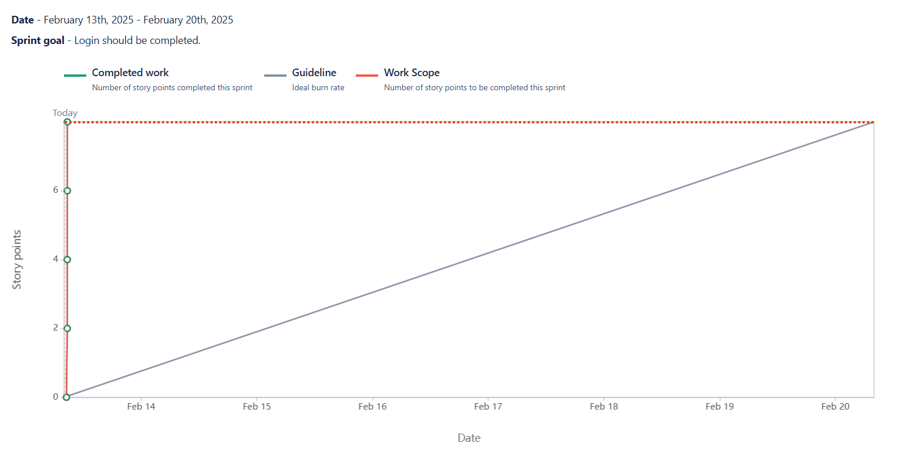

**Sprint burn down chart:**

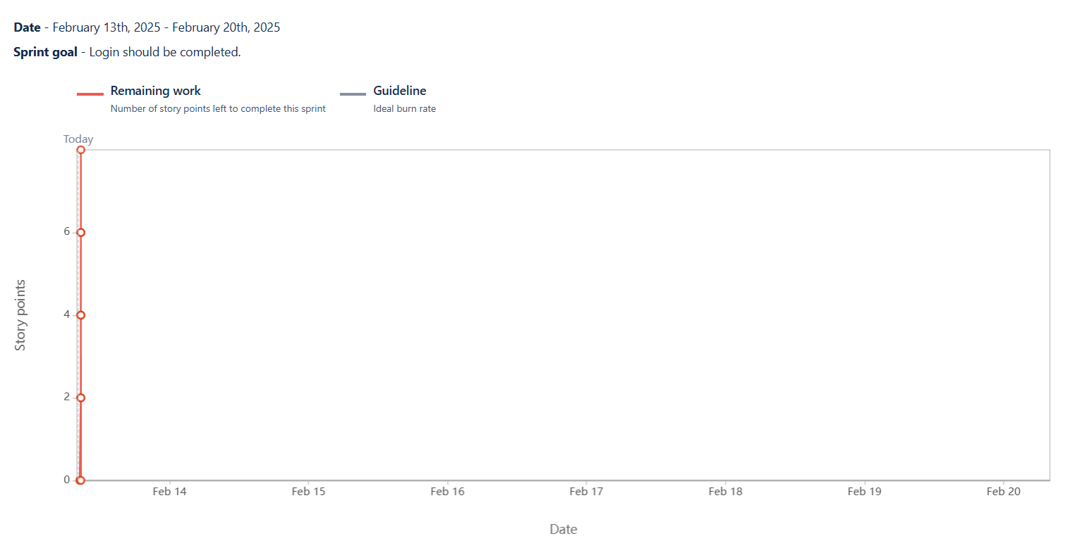

**Q.10 Explain about Product Grooming**

**Answer:**

Product grooming is a regular meeting where the product team reviews, updates and prioritizes backlog items to ensure that they are ready for future sprints.

In product grooming session the vision or goal of project is discussed and who will be target group in which market segment does product address.

What are the needs and solution does product required.

Product grooming helps to keep the backlog up to date and organized.

It also helps team to prepare for upcoming sprints.

It is process of planning project and understanding need of project. Similarly, product grooming requires to understand stakeholder requirement and addition to be done.

It generally happens once per sprint. It involves Product owner, Development Team and Scrum Master.

**Q.11 Explain roles of Scrum Master & Product Owner**

**Answer:**

Product owner is responsible for product completion. Main job of product owner is to ensure about meeting needs of stakeholders as per requirements. He is also responsible for:

* Product vision
* Requirements questions
* Stakeholders Interest
* He can decide whether to

-Accept project

-Reject the project increment

-Continue or discontinue with product development

-Deliver product or not

* Market analysis
* SWOT analysis
* Similar products availability in market

Scrum Master will facilitate scrum process by resolving issues, create environment for team self-organization and capture data to adjust forecast.

**Q.12 Explain all meetings conducted in scrum project.**

**Answer:**

In scrum there are four meetings conducted to get understanding of what is going on in project and is there any difficulty in project. The names of meetings are as below:

1. **Sprint Planning Meeting:** This meeting happens at the beginning of each project. In this meeting sprint team decides what will team is going to achieve during sprint.
2. **Daily Scrum Meeting:** Daily Scrum Meeting happen on daily basis to check –
   * + What did you today?
     + What will you do tomorrow?
     + Are there any impediments that are slowing you or stopping you?

3. **Sprint Review Meeting:** Sprint review meeting will conduct at the end of each sprint where team shows completed stories to product owner and get it cleared.

4. **Sprint Retrospective Meeting**: Sprint Retrospective Meeting happen at end of sprint where team will answer questions:

* + - What went well in the sprint?
    - What did not go well?
    - What are required areas of improvements in the next sprint?

**Q.13 Explain Sprint size and Scrum size.**

**Answer:**

**Sprint Size**

Sprint Size is the time period which team decides to achieve their outcomes. Normally, sprint period will be of 2 weeks but may be extend up to 4 weeks.

**Scrum Size**

Scrum size consists of BAs, Developers, Tester. Each scrum team will be average size of 7- 8 team members.

**Q.14 Explain DOD and DOR.**

**Answer:**

**DOR**:

-DOR is acronym for Definition of Ready.

-DOR is criteria where it shows user story is clear and ready for sprint.

-DOR ensures about right product working and team is prepared to work.

**DOD**:

-DOD is acronym for Definition of Done.

-DOD is criteria which shows product is complete and meets all the requirements.

-DOD ensures about consistency and quality of product.

**Q.15 Explain prioritization techniques and MVP.**

**Answer:**

Prioritize requirements are requirements which used to sort out as per priority of requirements. They help to get urgency of requirements and sort accordingly. Factors influenced for priority are: Risk, Cost, Time, Benefits and strategy.

**MoSCoW**

MoSCoW is a prioritization technique which includes Must do, Should do, Could do and would do requirements.

Must do – These are mandatory requirements to meet business/stakeholders need.

Should do – These are requirements where we can proceed for that but product is not dependent on them.

Could do – These are requirements where they will not affect anything in project.

Would do – These are requirements do proceed later, not necessary to deliver at the time of product delivery.

**MVP**

MVP is Minimum Viable Product is technique which shows product has enough features to satisfy early need of stakeholder and ask them to provide feedback for future product.

**Q.16 Difference – Business Analyst and Product Owner**

**Answer:**

Product owner is responsible for product completion. Main job of product owner is to ensure about meeting needs of stakeholders as per requirements. He is also responsible for:

1.Product vision

2.Requirements questions

3.Stakeholders Interest

4.He can decide whether to:

-Accept project

-Reject the project increment

-Continue or discontinue with product development

-Deliver product or not

* Market analysis
* SWOT analysis
* Similar products availability in market

Business Analyst are problem solvers, facilitators and communicator between stakeholders and scrum team. They get requirements from stakeholders by asking questions, accessing needs, find gaps and understand all requirements using elicitation techniques.

**Question 17 – Prepare a sample Resume of 3yrs exp Product Owner**

**Answer:**

Kalyani Babhulgaonkar,

[abc@gmail.com](mailto:abc@gmail.com)

91-9523647xxx

**Objective:**

Motivated and forward thinker with experience of 3 years. Always eager to support with leadership and guidance over wide range of product development efforts.

**Work Experience:**

Agile Product Owner

Badhiya Company, Surat.

* Acted as mediator between sales, business and IT teams to complete product and features as per market demands.
* Partnered with IT and product leadership to manage solution development process and ensure completion of project
* Collaborated with teams to get best solution in market provided by product team.
* Create and maintain solution vision, roadmap and backlog of work through project life cycle
* Translated features into user stories within team’s backlog and manage, rank and prioritize stakeholder’s requirements.

**Education**:

* B.E in Computer Science and Engineering

**Key Skills:**

* Conceptual Skills
* User centered design process
* Design quality standards
* Agile and scrum
* Conduct sprints
* Analytical skills
* Teamwork