Agile Part 2

Document 1: Definition of Done

It is described as the criteria that has to be achieved by a user story before considering it has been done.

The criteria to be met by user story to enter out from sprint.

It is defined at different levels throughout the project

Criteria:

Assumptions of user story are met

Unit tests are written checked and passed

Project is build without errors

Testing is passed

Changes documented

Documentation updated

Acceptance criteria verified

Wireframes designed

Bugs resolved

Document 2 Product vision

Target group: People around 18 to 60 age group. Who mostly look at their responsibility of wellbeing of loved ones to generate loans for their basic and excitement needs.

Need: To avail more than one loan in each kind and loan from all kinds parallely.

Multiple loans parallely to single customer.

Product: It is product which offers loans to customers as per their need and requirement.

It is possible for changes and enhancements as per requirement.

Value: It is going to increase strong customer retention rate and strong customer satisfaction rate.

Strong market expansion.

|  |  |  |  |  |  |
| --- | --- | --- | --- | --- | --- |
| **Product Vision** |  |  |  |  |  |
| **Scrum project** |  |  |  |  |  |
| **Name** | Check and Go | |  |  |  |
| **Venue** |  |  |  |  |  |
| **Date** | Start time | End time | Duration |  |  |
| **Client** | US Client |  |  |  |  |
| **Stakeholder list** |  | Bank employees | | Marketting and sales team head | |
|  |  | Bank employers | | Operations team head | |
| **Scrum Team** | | | | | |
| **Scrum master** |  |  | Veera venkata varaprasad | | |
| **Product owner** |  |  | Venkata veerendra | |  |
| **Scrum developer 1** |  |  | Rahul |  |  |
| **Scrum developer 2** |  |  | Ravi |  |  |
| **Scrum developer 3** |  |  | Radha |  |  |
| **Scrum developer 4** |  |  | Raghu |  |  |
| **Scrum developer 5** |  |  | Rama |  |  |

Document 3: User story and acceptance criteria

|  |  |  |
| --- | --- | --- |
| user story no.1 (Apply loan) | Tasks: 1 | Priority: 5 |
| User story statement: As a customer I want to apply loan so that I can get money for specific use |  |  |
| BV:500 | CP:5 |  |
| Acceptance Criteria: Given : As a valid customer When I click on apply loan  Then I should be able to view list of loans offered When I select partocular loan  Then I should see the terms and conditions of that particular loan When I select on checkbox Then i should get questionnare to be fioled for the loan When i fill the questionaree Then i should be able to click on submit When i click on submit Then i should see notification saying loan applied successfully. |  |  |

|  |  |  |
| --- | --- | --- |
| user story no.2(Edit loan) | Tasks: 2 | Priority: 5 |
| User story statement: As a customer I want to edit loan so that I can do modifications even after I submit loan |  |  |
| BV:500 | CP:5 |  |
| Acceptance Criteria: Given : As a valid customer When I click on edit loan  Then I should be able to view list of loans submitted and are pending for approval When I select partocular loan seeing loan number  Then I should see the terms and conditions of that particular loan for edit When I select on checkbox Then i should get questionnare that has been previously filled by methat has been previously filled by me  When i edit the questionaree Then i should be able to click on submit When i click on submit Then i should see notification saying loan editted successfully. |  |  |

|  |  |  |
| --- | --- | --- |
| user story no.3 (Cancel loan) | Tasks: 3 | Priority: 5 |
| User story statement: As a customer I want to cancel loan so that I can cancel if it is not required as of now |  |  |
| BV:200 | CP:1 |  |
| Acceptance Criteria: Given : As a valid customer When I click on cancel loan  Then I should be able to view list of loans applied When I select partocular loan  Then I should see the terms and conditions of that particular loan for cancellation When I select on checkbox Then i should get reason for cancellation to be filled  When i fill the reason Then i should be able to click on submit When i click on submit Then i should see notification saying loan cancelled successfully. |  |  |

|  |  |  |
| --- | --- | --- |
| user story no.4 (Check loan status) | Tasks: 4 | Priority: 5 |
| User story statement: As a customer I want to apply loan so that I can get money for specific use |  |  |
| BV:500 | CP:5 |  |
| Acceptance Criteria: Given : As a valid customer When I click on check loan status Then I should be able to view list of loans applied When I select partocular loan  Then I should see the status of the loan approved, pending, rejected  When the status is rejected Then it should show reason for rejection |  |  |

|  |  |  |
| --- | --- | --- |
| user story no. 5 (view loan) | Tasks: 5 | Priority: 5 |
| User story statement: As a employee I want to view applied loans so that I can see the details of loans applied |  |  |
| BV:200 | CP:2 |  |
| Acceptance Criteria: Given : As a valid Employee When I click on view loan  Then I should be able to view list of loans applied by a customer When I select particular loan  Then I should see furthur details of that loan  When I click on loan status  Then I should get status of loan rejected/approved. |  |  |

|  |  |  |
| --- | --- | --- |
| user story no.6(Repay loan) | Tasks: 4 | Priority: 5 |
| User story statement: As a customer I want to repay loan so that I can clear the loan taken. |  |  |
| BV:500 | CP:5 |  |
| Acceptance Criteria: Given : As a valid customer When I click on repay loan Then I should be able to view list of loans applied When I select particular loan  Then I should see the amount to be repaid till date  When I select pay Then it should display options for repayment  When I select a particular option  Then it should ask further details as per option  When I click on pay  Then amount should be debited from my account and get notification |  |  |

Document 4: My experience as product owner in Agile project

1. **Defining the product vision and road map:** I work closely with stakeholders to understand their needs and market requirements, then translate these into product reqiuiirements, then translate these into clear product vision and roadmap. This road map acts as a guide for the team to ensure we are delivering the most impactful features.
2. Managing the product backlog: I am responsible for creating and managing the product backlog. This involves breaking down features, stories and tasks and ensuring that they are well priotrised based on business value urgency and customer feedback.
3. Colloborate with development team: I work closely with development team during each sprint, ensuring they understand the requirements, and the “why” behind each feature. During sprint planning, I priotrise stories and answer any questions the team may have.
4. Sprint review and retrospective: After each sprint, I participate in the sprint review to assess the work done and gather feedback. In retrospective I reflect on what went well and what can be improved in future sprints, Contributing to culture of continuous improvent.
5. Ensuring stakeholder communication: A key part of my role is managing stakeholder expectations. I maintain the communication with stakeholder throughout the project to ensure that they are informen of progress, upcoming release and any challenges.
6. Handlling change requests: In Agile things evolve quickly, I have worked with stakeholders to accommodate, new insights and arket challenges, adjusting the backlog and sprint goals, when necessary while balancing scope.
7. User- centered focus: I always advocate for the end user needs, ensuring the future are not just technically sound but, also deliver tangible value to users.
8. Prioritization techniques: I use priotirization technique like MOSCOW. This ansures we are always working on right task at right time.
9. Managing product delivery: I oversee the overall progress of the project, ensuring the product is delivered on time and within the scope. I also track progress against, KPIs, ensuring that each sprint, contributes to meeting the product goals and user needs.

Documet 5: Product and sprint backlog

Product backlog

|  |  |  |  |  |  |  |
| --- | --- | --- | --- | --- | --- | --- |
| User story ID | User story | Task | Priority | BV | CP | Sprint |
| 1 | per day loan | To create option to apply for perday loan | High | 500 | 5 | 1 |
| 2 | repay loan | To create option to repay loan | High | 500 | 5 | 2 |
| 3 | cancel loan | To create option to cancel loan | Medium | 200 | 3 | 1 |
| 4 | view loan | To create option view loan | Medium | 200 | 3 | 1 |
| 5 | check loan status | To create option check loan status | Medium | 100 | 1 | 2 |

Sprint Backlog

|  |  |  |  |  |  |
| --- | --- | --- | --- | --- | --- |
| User story ID | User story | Task | Owner | Status | Estimated hours |
| 1 | per day loan | To create option to apply for perday loan | Ravi | IN progress | 20 hrs |
| 2 | repay loan | To create option to repay loan | Rahul | IN progress | 20 hrs |
| 3 | cancel loan | To create option to cancel loan | Rahul | Yet to start | 12 hrs |
| 4 | view loan | To create option view loan | Rama | IN progress | 12 hrs |
| 5 | check loan status | To create option check loan status | Ravi | Yet to start | 4 hrs |

Product burndown chart:

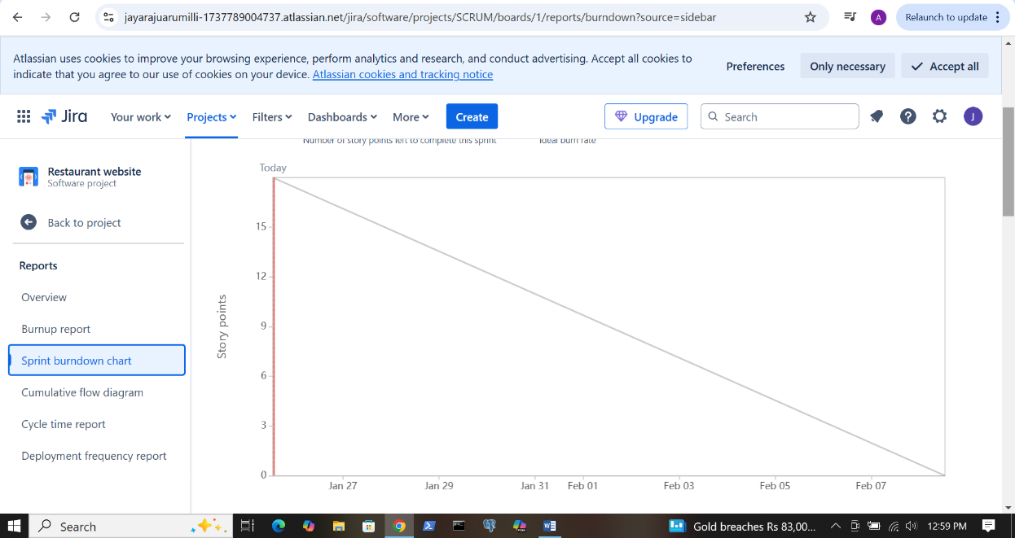

Burn up report

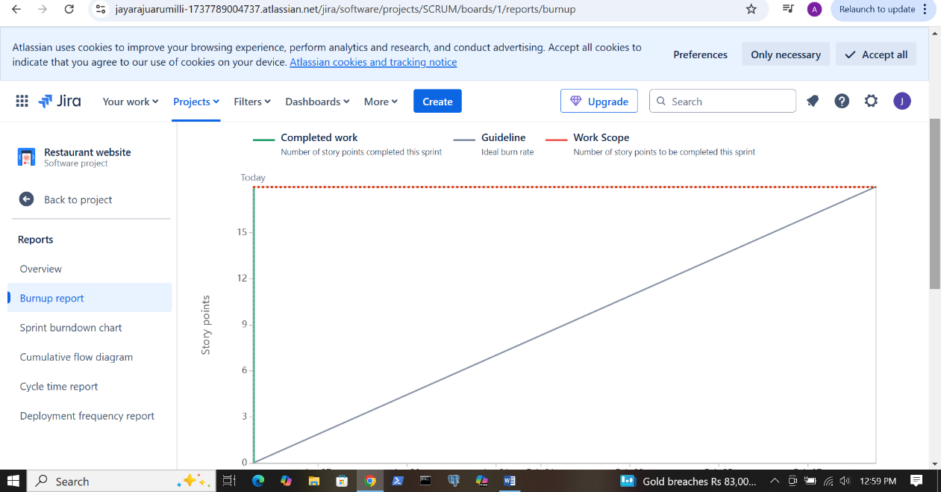

Document 6: sprint meetings

|  |  |  |
| --- | --- | --- |
| Sprint Planning meeting |  |  |
|  |  |  |
| Date | 10 deceber 2024 |  |
| Time | 10:00 AM |  |
| Location | Zoom - In office |  |
| Prepared by | Venkata |  |
| attendees | Rahul Ravi Radha Rama | |
| Agenda topics | To discuss about user stories to be worked in next sprint | |
|  |  |  |
| Topic | Presenter | Time allotted |
| Assigning user stories | Radha-Scrum master | 15 min |
| Giving inputs about functionality and acceptance criteria and flow | Radha and venkata(Product owner) | 2 hrs |

|  |  |
| --- | --- |
| Other information |  |
|  |  |
| Observer | Rasamber |
| Resources | Dec Team |
| Special notes | Assignend user stories to dev team |
|  | Given inputs |

Sprint review meeting

|  |  |  |  |
| --- | --- | --- | --- |
| **Sprint Status** | **Things to demo** | **Quick updates** | **Whats next** |
| Done | About user stories developed | Explain the functionality to client | About what we are going to do in next sprint |
|  |  |  |  |
|  |  |  |  |

|  |  |  |  |
| --- | --- | --- | --- |
| **Sprint retrospective meeting** | |  |  |
| **Date** | 25-Jan-25 |  |  |
| **Time** | 10:00 AM |  |  |
| **Location** | Zoom - In office |  |  |
| **Prepared by** | Venkata |  |  |
| **Attendees** | All internal team |  |  |
|  |  |  |  |
| **Sprint Status** | **Things to demo** | **Quick updates** | **Whats next** |
| Done | Internal feedback | Feedback of each and every individual | About next schedules |
|  |  |  |  |
|  |  |  |  |

Daily stand up meeting

|  |  |  |  |  |  |  |  |  |
| --- | --- | --- | --- | --- | --- | --- | --- | --- |
| Dailyn stand up meeting | Week 25 jan 31 jan | | | | | | | |
| Question | Name/Role | Monday | Tuesday | Wednesday | Thursday | Friday | Saturday | Sunday |
| What did you do yestarday? | Dev 1 | working on user story assigned | working on user story assigned | working on user story assigned | working on user story assigned | working on user story assigned | HOLIDAY | |
|  | Dev 2 | working on user story assigned | working on user story assigned | working on user story assigned | working on user story assigned | working on user story assigned |
|  | Dev 3 | working on user story assigned | working on user story assigned | working on user story assigned | working on user story assigned | working on user story assigned |
| What will you do today? | Dev 1 | will continue on user story assigned | will continue on user story assigned | will continue on user story assigned | will continue on user story assigned | will continue on user story assigned |
|  | Dev 2 | will continue on user story assigned | will continue on user story assigned | will continue on user story assigned | will continue on user story assigned | will continue on user story assigned |
|  | Dev 3 | will continue on user story assigned | will continue on user story assigned | will continue on user story assigned | will continue on user story assigned | will continue on user story assigned |
| What (if any) is blocking your progress? | Dev 1 | no issues | no issues | no issues | no issues | no issues |
|  | Dev 2 | no issues | no issues | no issues | no issues | no issues |
|  | Dev 3 | no issues | no issues | no issues | no issues | no issues |