Capstone Project Part-2:

Question 1 – Audits
Audit Phase | Focus | Activities Reviewed | BA Role
Q1 – Planning & Requirement Gathering Audit | Ensure all initial documentation is complete. | Elicitation techniques, stakeholder meetings, BRD initiation. | Provide documented minutes, stakeholder analysis, draft BRDs.
Q2 – Requirements Sign-off & Design Support Audit | Validate if requirements are properly analyzed, documented, and signed off. | Functional/Non-functional requirements, Use Cases, UI Mockups. | Present signed BRDs and traceability matrices.
Q3 – Development & Change Management Audit | Ensure requirements are implemented correctly and change requests are managed. | CR logs, updated traceability matrix, sprint reviews. | Document changes and confirm communication records.
Q4 – UAT & Project Closure Audit | Validate UAT and final delivery. | UAT test results, sign-off forms, retrospectives. | Provide UAT reports and final sign-off forms.
As a Business Analyst (BA), quarterly audits help ensure that business analysis activities are aligned with project goals, documentation is accurate, and stakeholder expectations are met. Here's how audits typically happen for a BA during each quarter:

Question 2 – BA Approach Strategy
Aspect | Details
Elicitation Techniques | Use BDRFOWJIPQU (e.g., Brainstorming with stakeholders, Document Analysis for CSR guidelines, Prototyping for UI feedback).
Stakeholder Analysis | Create a RACI matrix (Peter/Kevin/Ben as "Consulted," Mr. Henry as "Accountable").
Documentation | BRD (Business Requirements Document), SRS (System Requirements Specification), Use Case Diagrams/Specs.
Sign-off Process | Share drafts via email, conduct review meetings, obtain written approval.
Communication | Weekly updates via email/Teams; escalation to Mr. Karthik for blockers.
Change Requests | Log changes in a tracker, assess impact, seek committee approval.
UAT Sign-off | Coordinate testing with Mr. Jason/Ms. Alekya, obtain Client Project Acceptance Form post-UAT.

Question 3 – 3-Tier Architecture
3-tier architecture divides the system into three layers:
Tier | Description
Presentation Tier (UI) | Farmers/manufacturers interact with the web/mobile app (e.g., product search, login).
Application Tier (Logic) | Processes business rules (e.g., payment processing, order tracking).
Data Tier (Database) | Stores product details, user accounts (managed by DB Admin Mr. John).
This structure improves scalability, maintainability, and security.
Illustrated below:
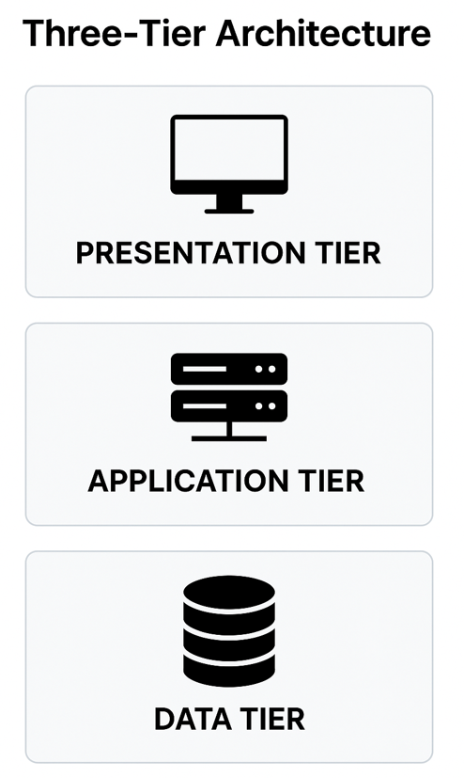

Question 4 – BA Approach Strategy for Framing Questions
Strategy | Description
5W 1H Framework | What (features), Who (stakeholders), Why (business need), Where (remote access), When (timeline), How (technical feasibility).
SMART Principle | Specific, Measurable, Achievable, Realistic, and Time-bound questioning ensures clarity.
RACI Consideration | Tailor questions based on whether a stakeholder is Responsible, Accountable, Consulted, or Informed.
3-Tier Architecture | Align questions to interface (Presentation Layer), logic (Application Layer), and data (Data Layer).
Use Case | Ask questions to build use cases, identify actors, preconditions, flows, page design, navigational flow, and field-level expectations.
As a Business Analyst, it is important to ask the right questions the right way to extract relevant, complete, and clear information from stakeholders. Before framing a question, a BA should keep the following strategies in mind:

Question 5 – Elicitation Techniques
As a Business Analyst, elicitation is the first step in gathering requirements from stakeholders. The following are key elicitation techniques remembered by the acronym BDRFOWJIPQU:
Code | Technique | Description
B | Brainstorming | Group discussion to quickly generate a wide range of creative ideas or solutions. Ideal for early-stage requirement gathering.
D | Document Analysis | Studying existing documentation (manuals, process flows, etc.) to understand current systems and gather requirements.
R | Reverse Engineering | Analyzing an existing system to uncover undocumented requirements, especially useful when documentation is missing or outdated.
F | Focus Groups | Sessions with selected users to gather opinions, expectations, and preferences. Useful for identifying shared or conflicting needs.
O | Observation | Watching users perform tasks to understand real workflows, challenges, and deviations from documented processes.
W | Workshops | Structured group meetings for detailed and collaborative requirement elicitation, validation, or prioritization.
J | Joint Application Development (JAD) | Facilitated sessions involving users, developers, and analysts to collaboratively define system requirements and foster consensus.
I | Interviews | One-on-one or small group meetings to deeply understand stakeholder needs, goals, and pain points.
P | Prototyping | Creating mockups or UI models to help stakeholders visualize and refine requirements. Helps reduce misunderstandings.
Q | Questionnaires/Surveys | Distributing structured questions to gather information or opinions from a large number of stakeholders efficiently.
U | Use Cases/User Stories | Narratives that describe user interactions with the system, focusing on what the user wants to achieve. Helps in defining functional requirements.
Each of these techniques is used based on the project’s context, user group, and type of information needed.

Question 6 – This Project: Elicitation Techniques
For the Online Agriculture Products Store project, the following elicitation techniques are most appropriate:
Technique | Description
Brainstorming | With farmers (Peter/Kevin/Ben) to list product features.
Prototyping | Mock-ups for UI feedback (e.g., payment gateway layout).
Document Analysis | Review CSR guidelines from SOONY.
Interviews | One-on-one with Mr. Henry for business goals.
Justification - Farmers are non-tech; visuals (prototypes) and discussions (brainstorming) ensure clarity.

Question 7 – 10 Business Requirements
Below are ten business requirements based on stakeholder needs and project assumptions:
BR Code | Business Requirement
BR001 | Farmers should be able to search for available products in fertilizers, seeds, and pesticides.
BR002 | Manufacturers should be able to upload and display their products in the application.
BR003 | The application should allow users (farmers and manufacturers) to create and manage accounts.
BR004 | Farmers should be able to view detailed product information including price, description, and manufacturer details.
BR005 | The system should include a secure login and authentication mechanism.
BR006 | Farmers should be able to add products to a cart or save for later.
BR007 | The application should support multiple payment options (COD, Credit/Debit card, UPI).
BR008 | An email confirmation should be sent to users after placing an order.
BR009 | Farmers should be able to track their order status in real-time.
BR010 | The application should be mobile-responsive or include a mobile app for accessibility.

Question 8 – Assumptions
When preparing business requirements, the following assumptions are made to proceed with clarity and reduce ambiguity:
1. Farmers have basic internet access.
2. Manufacturers can upload product details digitally.
3. Budget (2Cr INR) covers payment gateway integration.
4. 18-month timeline includes UAT.
5. Stakeholders (Peter/Kevin/Ben) represent all farmer needs.

Question 9 – Requirements Priority
BR Code | Business Requirement | Priority (1–10)
BR001 | Farmer Search for Products | 10
BR002 | Manufacturers Upload Products | 9
BR003 | User Registration & Login | 10
BR004 | View Product Details | 9
BR005 | Secure Authentication | 10
BR006 | Add to Cart or Buy Later | 8
BR007 | Multiple Payment Options | 9
BR008 | Email Confirmation | 7
BR009 | Order Delivery Tracking | 8
BR010 | Mobile Accessibility | 6

Question 10 – Use Case Diagram
The Use Case Diagram for the Online Agriculture Products Store identifies key system functionalities and actors. It illustrates the interactions between users (Farmers, Manufacturers, Admin) and the system.
Primary Actors:
- Farmer
- Manufacturer
- Admin
Secondary Actor:
- DB Manager
Use Cases for Farmer:
- Register/Login
- Search Products
- View Product Details
- Add to Cart
- Make Payment
- Track Order
- Receive Email Confirmation
Use Cases for Manufacturer:
- Register/Login
- Upload Product
- Manage Profile
Use Cases for Admin:
- Manage Users
- Monitor Platform Activities

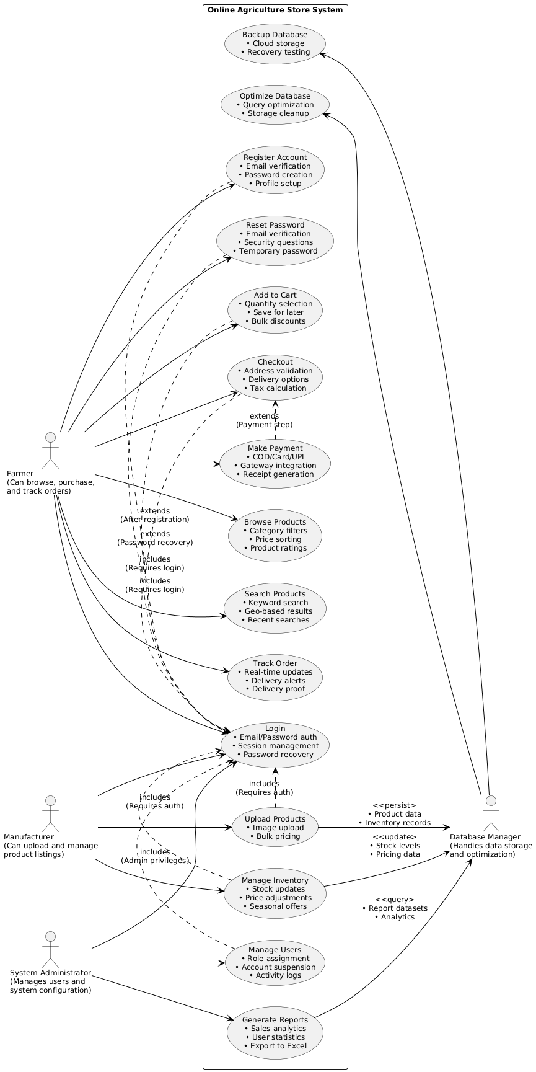

Question 11 – Use Case Specifications
Below are Use Case Specifications for five key system functions:
1. Use Case: User Registration
- Use Case ID: UC001
- Actor: Farmer/Manufacturer
- Description: Allows new users (farmers or manufacturers) to create an account.
- Preconditions: User is not logged in.
- Postconditions: User account is created, and credentials are stored in the database.
- Basic Flow:
  - User selects "Register."
  - System displays registration form (email, password, user type, contact details).
  - User fills in details and submits.
  - System validates data and creates an account.
  - System sends a confirmation email.
- Alternative Flow:
  - If email already exists, system prompts user to log in or use another email.
- Exceptions:
  - Invalid email format: System displays an error message.

2. Use Case: Product Search
- Use Case ID: UC002
- Actor: Farmer
- Description: Enables farmers to search for products (fertilizers, seeds, pesticides).
- Preconditions: User is logged in (optional for browsing).
- Postconditions: Search results are displayed.
- Basic Flow:
  - User enters keywords in the search bar.
  - System fetches matching products from the database.
  - System displays results with filters (category, price range).
- Alternative Flow:
  - No results found: System suggests similar products.
- Exceptions:
  - Database error: System shows "Try again later."

3. Use Case: Add Product to Cart
- Use Case ID: UC003
- Actor: Farmer
- Description: Farmer adds products to the cart for purchase.
- Preconditions: User is logged in; product is available.
- Postconditions: Cart is updated.
- Basic Flow:
  - User selects a product.
  - User clicks "Add to Cart."
  - System updates cart quantity and total.
- Alternative Flow:
  - Out-of-stock: System notifies the user.
- Exceptions:
  - Session timeout: System redirects to login.

4. Use Case: Checkout and Payment
- Use Case ID: UC004
- Actor: Farmer
- Description: Completes the order with payment.
- Preconditions: Cart is not empty; user is logged in.
- Postconditions: Order is confirmed; payment is processed.
- Basic Flow:
  - User proceeds to checkout.
  - System shows order summary and delivery options.
  - User selects payment method (COD, Card, UPI).
  - System processes payment and confirms the order.
- Alternative Flow:
  - Payment fails: System retries or suggests another method.
- Exceptions:
  - Network issue: System saves the order as "Pending."

5. Use Case: Upload Product (Manufacturer)
- Use Case ID: UC005
- Actor: Manufacturer
- Description: Manufacturers upload product details to the catalog.
- Preconditions: Manufacturer is logged in.
- Postconditions: Product is listed in the catalog.
- Basic Flow:
  - Manufacturer selects "Add Product."
  - System displays a form (name, category, price, description, image).
  - Manufacturer submits the form.
  - System validates and adds the product to the database.
- Alternative Flow:
  - Invalid data: System highlights errors.
- Exceptions:
  - Duplicate product: System alerts the manufacturer.

Question 12 – Activity Diagrams
Below are five Activity Diagrams representing user flows in the Online Agriculture Products Store:
1. User Registration (With Email verification Fork & Join)
- Start → Click Register → Fill form → Submit → Validate → Create Account → Show Confirmation → End
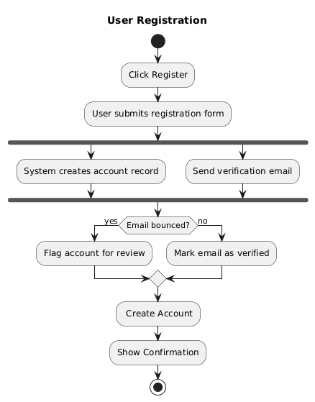

2 . Search and View Products
- Start → Enter Keywords → Fetch Results → Apply Filters → Display Results → End
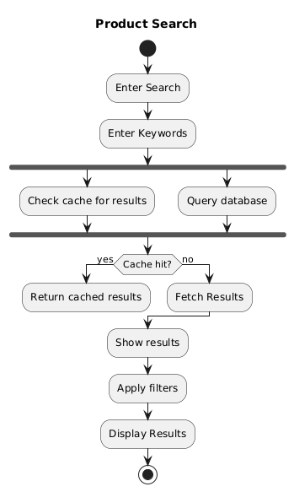

3. Add to Cart and Checkout
- Start → Select Product → Add to Cart → Proceed to Checkout → Choose Payment → Process Payment → Success? → Yes → Confirm Order → End
No → Cancel
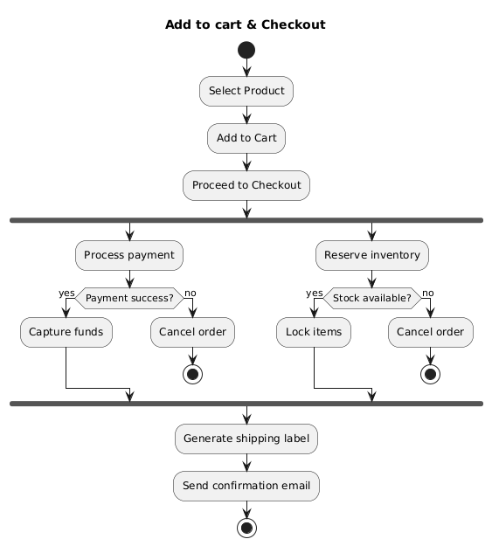

4. Upload Product along with Product approval workflow (Manufacturer)
- Start → Login → Navigate to Upload → Fill Product Details → Submit → Validate → Success or Error → End
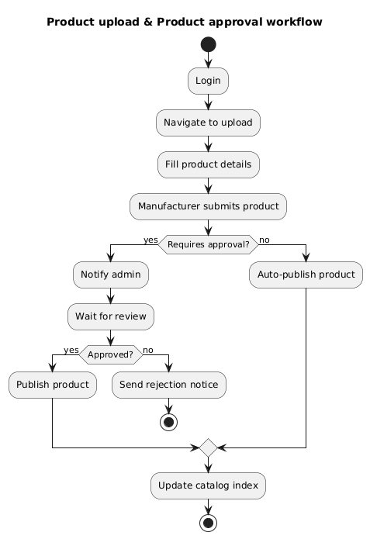

5. Track Delivery (Farmer tracks it)
Start → Login → View Orders → Select Order → Fetch Tracking → Display Status → End
