PROJECT 3 PART 2

Q1)What is the difference between JAD and Brain storming.
Brainstorming is a free-form technique for generating a large quantity of diverse ideas in a judgment-free environment, JAD is a structured, collaborative method for system requirements and making joint decisions , involving both business and technical experts to produce a unified requirements document. The key difference is that brainstorming is focused on broad idea generation, whereas JAD is a formal, facilitator-led process for detailed requirement gathering and consensus building.
Brainstorming
- Purpose:
To generate a wide range of ideas, solutions, or concepts for a specific problem or project in a creative, uncritical way.
- Process:
Participants freely share ideas without immediate evaluation or criticism, with a focus on the quantity and diversity of ideas.
- Structure:
Can be unstructured or semi-structured, allowing for a free flow of ideas.
- Outcome:
A large number of potential solutions, concepts, or alternatives that can help address a problem or inject new insights into a project.
Joint Application Development (JAD)
- Purpose:
To collaboratively define system requirements, scope, and design by bringing together business and technical experts to make joint decisions and solve problems.
- Process:
A structured process facilitated by a leader, involving detailed agendas, objective discussions, and the assignment of action items.
- Structure:
Highly structured and often involves a series of meetings (workshops) with significant preparation, including defined objectives and detailed agendas.
- Outcome:
Consolidated, consensus-based system requirements documented in a single, unified document, leading to accelerated development and higher quality products.
Key Differences Summarized
- Focus:
Brainstorming focuses on generating creative ideas, while JAD focuses on extracting and agreeing on detailed system requirements.
- Structure:
Brainstorming is largely unstructured, whereas JAD is a highly structured, facilitated process.
- Participants:
Brainstorming can involve various groups, while JAD specifically brings together business and technical stakeholders to discuss and decide on requirements.
- Application:
Brainstorming is a versatile tool for innovation and problem-solving, while JAD is a specific methodology primarily used during the requirements and design phases of software development.

Q2)Why document analysis is one of the compulsory technique we use in a project.Justify.
Document analysis is a compulsory technique in projects because it provides foundational knowledge, establishes a historical and contextual understanding, helps identify gaps and inconsistencies, ensures compliance with regulations, and offers a cost-effective and efficient means of gathering information that can complement other elicitation methods. It allows teams to understand the "as-is" state, build a strong base for requirements, and lay the groundwork for successful project development by leveraging existing data.
Justification for Document Analysis
- Establishes Foundational Knowledge:
Analyzing existing documents, such as project charters, business cases, and previous project reports, provides crucial background information and context for the current project. This helps the project team get up to speed quickly without having to start from scratch.
- Historical and Contextual Insights:
Documents offer a historical perspective on past events, decisions, and trends related to the project's domain, which is vital for understanding the problem space and making informed decisions.
- Identifies Gaps and Inconsistencies:
By systematically reviewing existing documentation, teams can uncover potential gaps, ambiguities, or inconsistencies in requirements or processes. This proactive identification allows for problem-solving and clarification before significant resources are invested.
- Ensures Compliance:
Projects must often adhere to various legal, regulatory, and contractual requirements. Document analysis ensures that these obligations are understood and integrated into the project plan, minimizing risks of non-compliance.
- Cost-Effective and Efficient:
Document analysis is a cost-effective data collection method because the information already exists, saving time and resources compared to primary data collection methods. It is also efficient, allowing for a broad understanding before engaging in more targeted elicitation like interviews.
- Complements Other Elicitation Techniques:
Document analysis serves as an excellent first step before conducting stakeholder interviews, workshops, or surveys. It ensures that the team enters these sessions with a solid understanding of the project's landscape, allowing for more focused and productive discussions.

Q3 In Which Context we will use Reverse Engineering? - 3 Marks
Reverse engineering is used to understand a product's design and functionality, primarily for recreating lost or unavailable parts, improving existing products, enhancing security by analyzing malware, and ensuring compatibility between systems. Other contexts include competitor analysis, creating digital archives of designs, and extracting reusable components from existing systems.
Key Contexts for Using Reverse Engineering
- Product Repair and Replacement:
  - Legacy Parts Replacement: When original parts for old machinery are no longer available, reverse engineering can be used to recreate them.
  - Product Improvement: To enhance a product's performance, durability, or cost-efficiency, reverse engineering can provide insights for improvement.
- Security and Analysis:
  - Malware Analysis: Security professionals use reverse engineering to understand the workings of malicious software to develop defenses against it.
  - Vulnerability Discovery: It helps identify security flaws and weaknesses in software or hardware so they can be fixed or patched.
  - Competitor Analysis: Companies use reverse engineering to understand how competitor products work, which helps in product development and innovation.
- Design and Development:
  - Understanding Complex Systems: Reverse engineering helps in deconstructing complex products to understand their design, materials, and how components are assembled.
  - Creating Digital Models: It is used to generate digital 3D models of physical objects, creating a virtual record for future reference and development.
- Software and Compatibility:
  - Software Re-engineering: When source code is lost, reverse engineering can reconstruct it to fix bugs, improve functionality, or add new features.
  - Interoperability: It can be used to create new versions of software that are compatible with older systems or to integrate new components with existing infrastructure.

Brainstorming focuses on generating as many creative ideas as possible for a problem, while focus groups aim to gather deep qualitative insights from a small group of participants about a specific topic, product, or service. The key difference lies in their primary objectives: brainstorming is for idea generation, and focus groups are for insight collection and understanding perceptions, often involving structured conversations and moderated discussions.
Brainstorming
- Objective:
To generate a wide range of innovative and unconventional ideas in a judgment-free environment.
- Process:
Typically unstructured or semi-structured, emphasizing open thinking and creative output from participants.
- Outcome:
A large pool of potential solutions, options, or ideas.
- Setting:
Can be a more informal setting, with a focus on free-flowing thought and diverse input.
Focus Groups
- Objective:
To uncover nuanced insights into participants' feelings, experiences, and opinions on a specific subject.
- Process:
A structured conversation facilitated by a moderator to guide the discussion and ensure all voices are heard.
- Outcome:
A deeper understanding of customer needs, behaviors, and perspectives related to a product, service, or topic.
- Setting:
A more formal, controlled environment where participants discuss a pre-identified topic, sometimes presenting options for their feedback.

Q5. Observation Technique – Explain both Active and Passive approaches - 3 Marks

In the observation technique, the Passive approach involves an observer watching a subject or activity without any interaction, allowing for natural behavior observation and later follow-up questions. In contrast, the Active approach includes the observer asking questions or participating in the activity as it happens, influencing the event and potentially providing immediate clarification but risking altering natural behavior.
Passive Observation
- Description:
The observer acts as an unobtrusive onlooker, simply watching and taking notes on the subject's behavior or activity.
- Interaction:
There is no interaction with the person or group being observed during the observation period.
- Data Collection:
Notes are taken during the session, and follow-up questions may be asked after the observation is complete to clarify what was seen.
- Pros:
Allows for observation of natural, unaltered behavior, making it useful for understanding processes in their natural flow.
- Cons:
Deeper understanding requires follow-up, as direct interaction to clarify immediate questions is not possible.
Active Observation
- Description:
The observer interacts with the subject, asking questions or even participating in the activity to gain a deeper understanding.
- Interaction:
The observer engages with the person or group, potentially interrupting the activity to ask questions or seek clarification.
- Data Collection:
Information is gathered through direct observation, asking questions, and participating, leading to immediate feedback and understanding.
- Pros:
Provides immediate insights, context, and clarification, which can be invaluable for understanding complex processes.
- Cons:
The observer's presence and interaction can influence or alter the natural behavior of the subjects, potentially leading to less authentic data.

To conduct a successful requirements workshop, first plan the workshop by defining its goals, selecting attendees, and creating a detailed agenda with pre-work materials. During the workshop, a facilitator should guide discussions using techniques like brainstorming and process mapping to define current states, identify pain points, and elicit requirements. Key steps include documenting gathered requirements, assigning actions, and following up by circulating the documentation for review and approval.
1. Pre-Workshop Planning
- Define Purpose and Goals:
Clearly state what the workshop aims to achieve and what decisions need to be made.
- Identify and Invite Stakeholders:
Include all relevant parties, such as the project sponsor, decision-makers, subject matter experts, and impacted users.
- Create a Detailed Agenda:
Develop a logical, time-boxed agenda that covers context setting, discovery, elicitation, validation, and next steps.
- Assign Roles:
Designate a facilitator, scribe (to take notes), and a timekeeper to ensure the workshop stays on track.
- Prepare Pre-Work Materials:
Send attendees the workshop objectives, agenda, background information, existing documentation, and specific questions to review beforehand.
- Tidy Up Initial Requirements:
Prepare and send a list of known requirements to attendees for review to streamline the session.

Q7. In which context, Interview Technique can be conducted by a BA ? How may approaches are there in conducting Interviews? (Structured – Unstructured) Explain them. Explain the difference between Open Ended Questions and Closed ended Questions –

A Business Analyst (BA) uses the interview technique in a variety of contexts to gather detailed business requirements, build stakeholder relationships, and increase involvement and support for solutions. There are three main approaches to conducting interviews: structured, semi-structured, and unstructured. A structured interview uses a fixed set of questions in a specific order, while an unstructured interview is more like a free-flowing conversation with no predetermined questions. Open-ended questions encourage detailed, free-form answers, whereas closed-ended questions limit responses to a specific, often short, choice.
Context for a BA Conducting Interviews
A BA conducts interviews to:
- Gather Requirements: To understand business needs, user workflows, and pain points from stakeholders and end-users.
- Build Relationships: To establish trust and rapport with stakeholders.
- Increase Stakeholder Involvement: To ensure key individuals feel heard and engaged in the project.
- Gain Support for Solutions: To build consensus and buy-in for proposed solutions by understanding the needs of the people who will be affected by them.
- Explore Ideas: To uncover new insights, creativity, and innovative solutions to business problems.
Approaches to Conducting Interviews
There are three main approaches to conducting interviews:
- Structured Interviews:
  - What they are: Interviews that use a pre-set list of questions, asked in the same order and format to every participant.
  - When to use: Best for gathering specific information, especially when comparing different candidates or groups on predefined metrics.
  - Pros: Consistent data collection, easy to compare responses, and ensures all key topics are covered.
  - Cons: Can be rigid, may miss unexpected but important insights, and can feel less conversational.
- Semi-Structured Interviews:
  - What they are: A combination of both structured and unstructured approaches, featuring a list of predetermined topics or questions, but also allowing for flexibility to ask follow-up questions and explore unexpected areas.
  - When to use: To get a balance of specific information and deeper insights, providing a framework but allowing for spontaneous conversation.
- Unstructured Interviews:
  - What they are: Also known as informal or in-depth interviews, they do not have a specific set of predetermined questions. The interviewer typically has a general topic in mind and lets the conversation flow naturally, similar to an informal conversation.
  - When to use: Ideal for exploring topics in detail, understanding complex issues, and eliciting creative ideas.
  - Pros: Highly flexible, can uncover new and unexpected information, and fosters a more open dialogue.
  - Cons: Can be time-consuming to analyze, may go off-topic, and relies heavily on the interviewer's skill to guide the conversation effectively.
Open-Ended vs. Closed-Ended Questions
- Open-Ended Questions:
  - Definition: Questions that cannot be answered with a simple "yes," "no," or a single word.
  - Purpose: To encourage detailed, thoughtful responses and gather rich information about opinions, experiences, and ideas.
  - Examples: "Can you describe your process for handling customer complaints?" or "What are your main challenges with the current system?"
- Closed-Ended Questions:
  - Definition: Questions that offer a fixed set of responses, such as multiple-choice options, a rating scale, or a simple "yes" or "no".
  - Purpose: To gather specific, quantifiable data and to quickly and efficiently collect facts or opinions on a limited set of choices.
  - Examples: "Are you satisfied with the new feature?" (Yes/No) or "On a scale of 1 to 5, how easy is the new software to use?"

The questionnaire technique is used to systematically collect data on attitudes, experiences, knowledge, opinions, beliefs, and behaviors from a large number of respondents, often in fields like market research, social sciences, and health sciences. They are particularly useful when researchers cannot be present to coordinate data collection personally. An example is a Customer Satisfaction (CSAT) questionnaire, used by a restaurant to understand customer experiences, identify areas for service improvement, and gauge overall satisfaction with the dining experience.
Questionnaires are employed in various contexts to gather information for decision-making and research:
- Market Research: To understand consumer preferences, product usage, and market trends.
- Social Sciences: To study public opinions, attitudes, and beliefs on various social issues.
- Health Sciences: To collect data on health-related behaviors, experiences, and knowledge among individuals.
- Business: To evaluate customer satisfaction, assess the effectiveness of communications, and improve services or products.
- Education: To assess student satisfaction, learning outcomes, or program effectiveness.
Example: Customer Satisfaction Questionnaire
- Scenario:
A new restaurant owner wants to understand what customers think about their food, service, and overall dining experience.
- Purpose:
To identify strengths, weaknesses, and areas for improvement in the restaurant's operations.
- How it's used:
After a customer dines, they are given a questionnaire with closed-ended questions.
- Example Questions:
  - "On a scale of 1 to 5 (where 1 is 'very dissatisfied' and 5 is 'very satisfied'), how satisfied were you with the quality of food?" (Likert scale)
  - "Did our staff provide excellent customer service? (Yes/No)" (Dichotomous question)
  - "Please provide any additional comments about your experience." (Open-ended question)
- Outcome:
The collected responses provide quantifiable data that helps the owner make informed decisions to enhance the customer experience and improve overall business performance.

Requirements can be sorted for a project by prioritizing them based on factors like importance, urgency, or stakeholder value, using techniques such as MOSCOW (Must have, Should have, Could have, Won't have). Sorting requirements is crucial during methods and requirement analysis and management phases of a project to effectively plan development, allocate resources, and ensure that the most valuable features are delivered first. An example is sorting user requirements for a new mobile banking app, where "ability to transfer money" would be a "Must have," while "biometric login" might be a "Should have" if it's a highly requested but not essential feature at launch.
Where Requirements Are Sorted
Requirements sorting occurs during the requirements management process, specifically in the analysis and prioritization stages. This is essential for:
- Project Planning:
To decide which requirements to implement first and to create a realistic project roadmap.
- Resource Allocation:
To ensure that the most critical requirements receive the necessary development time and resources.
- Risk Management:
To address high-risk requirements or dependencies early in the development cycle.
Methods for Sorting Requirements
Several methods can be used to sort requirements:
- MoSCoW Method:
A popular prioritization technique categorizing requirements into "Must have," "Should have," "Could have," and "Won't have".
- Kano Model:
Groups requirements into basic (expected), performance (satisfaction), and delighters (excitement).
- Weighted Scoring:
Assigns a score to each requirement based on predefined criteria (e.g., business value, cost, risk) and then sorts them by their total score.
- Dependency Mapping:
Identifies requirements that depend on one another, ensuring that dependent items are addressed in the correct order.
Example: Mobile Banking App
Consider a project to develop a new mobile banking app.
- Must Have:
  - User must be able to log in securely.
  - User must be able to view account balances.
  - User must be able to transfer funds between their own accounts.
- Should Have:
  - User should be able to make payments to other bank accounts.
  - User should be able to use biometric login (fingerprint/face ID).
- Could Have:
  - User could potentially set up recurring payments.
  - User could potentially receive personalized financial advice.
- Won't Have (for the initial release):
  - Integration with cryptocurrency wallets.
  - A feature for negotiating loans directly within the app.
In this example, the "Must have" requirements are prioritized for the initial launch, while "Should have" and "Could have" features would be considered for future updates based on available resources and market demand.

Requirements prioritization is the process of ranking software features by their importance to a project's goals and stakeholders, often using techniques like the MoSCoW Method (Must have, Should have, Could have, Won't have), voting, or a prioritization matrix. For example, in a mobile banking app, a "Must have" requirement would be "secure login," a "Should have" might be "biometric login," and a "Could have" could be "dark mode".
Why Prioritize Requirements?
- Budget & Resource Allocation:
Ensures limited budgets and resources are focused on features that deliver the most value.
- Project Success:
Helps identify and implement essential features, increasing the likelihood of the project's success.
- Transparency & Informed Decisions:
Provides clarity to stakeholders about project scope and helps them make informed decisions.
Where Requirements Prioritization is Used
Requirements prioritization is used in various stages of software development and project management:
- Agile Development:
Business analysts and product owners continuously prioritize backlog items for iterative development cycles.
- Project Planning:
To define the scope of a project and make decisions about what features to include in the initial release.
- Stakeholder Management:
To get buy-in and manage expectations from different stakeholders by understanding what is most important to them.
Example: Mobile Banking App
Let's apply the MoSCoW method to a new mobile banking app:
- Must Have:
  - Secure User Login: Essential for accessing the account and ensuring data security.
  - View Account Balance: A core function of any banking app.
  - Initiate Fund Transfers: A fundamental banking operation.
- Should Have:
  - Biometric Login: Adds convenience and an enhanced user experience but isn't strictly necessary for basic function.
  - Transaction History: Allows users to track their spending, adding significant value but not being essential for initial launch.
- Could Have:
  - Dark Mode: A cosmetic feature that enhances user experience but is non-essential.
  - Investment Tracking: A desirable feature for some users but not a core banking need.
- Won't Have (for now):
  - International Fund Transfers: This may be deferred to a later release or added to a separate product.
By using this prioritization, the development team can focus on building the core "Must have" features first, followed by "Should have" and "Could have" features as resources allow, ensuring the most critical functionalities are delivered.

To drive weekly status reporting, establish a consistent reporting rhythm with clear objectives, define the necessary metrics and KPIs to track progress, and utilize a standardized template for easy data collection and comparison. Foster open communication by highlighting accomplishments, identifying challenges and solutions, and proactively outlining next steps and potential risks to maintain alignment, productivity, and informed decision-making across the team and stakeholders.
1. Establish a Clear Reporting Framework
- Consistent Rhythm and Deadlines:
Set a regular, predictable time for reports to be submitted and reviewed, such as every Friday, to build a consistent workflow.
- Define Objectives:
Be clear about the purpose of the weekly report, whether it's to track progress, assess performance, or ensure alignment with project goals.
- Standardized Template:
Use a consistent template to ensure that all team members provide the same essential information, making reports easier to read and compare.
2. Focus on Key Information
- Report Summary:
Begin with a concise overview of the week's main achievements, key issues, and any unexpected risks.
- Accomplishments & In-Progress Tasks:
Detail completed tasks, ongoing activities, and progress made toward project milestones.
- Challenges & Solutions:
Clearly identify any blockers, issues, or risks encountered and include proposed or implemented solutions to overcome them.
- Future Outlook:
Outline planned tasks, next steps, and any potential challenges for the upcoming week to provide a forward-looking view.
3. Foster Communication and Collaboration
- Team Input:
Encourage all team members to provide their input and collaborate on report content to ensure everyone is informed and engaged.
- Open Communication Channels:
Use the report as a tool to open a dialogue about challenges and encourage team members to suggest solutions and improvements.
- Link to Resources:
Include links to relevant documents or resources within the report to provide context and allow stakeholders to delve deeper into specific areas.
4. Drive Actionable Outcomes
- Metrics & KPIs:
Track and report on key performance indicators (KPIs) relevant to project success to measure progress and identify trends.
- Informed Decision-Making:
Use the consolidated information in the reports to make timely and informed decisions regarding resource allocation, risk management, and strategic adjustments.
- Accountability:
Hold individuals and teams accountable by tracking progress against their stated goals and commitments, using the report as a basis for performance assessment.

Q12. Meeting Minutes Document – prepare one Sample -5 Marks
Meeting Minutes Template:
- Organization Name.
- Meeting Minutes.
- Date:
- Opening: The meeting was called to order at [Time] by [Name] at [Location].
- Present: [List of all present members]
- Absent: [List of any members who were not present]
- Approval of Agenda: The agenda was reviewed and approved.
- Approval of Minutes:

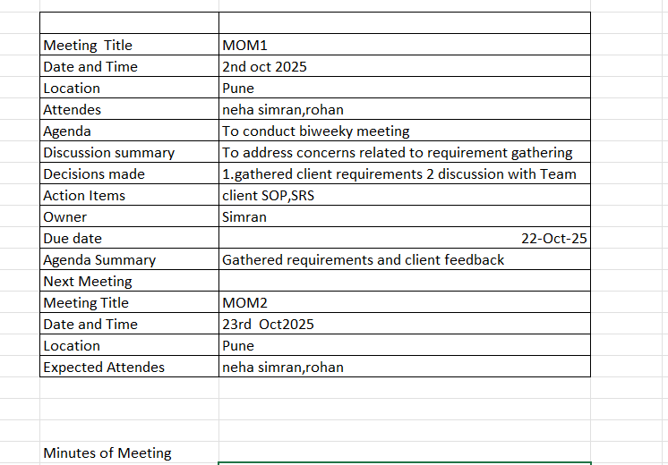

Q13. Change Tracker – Document - – prepare one Sample
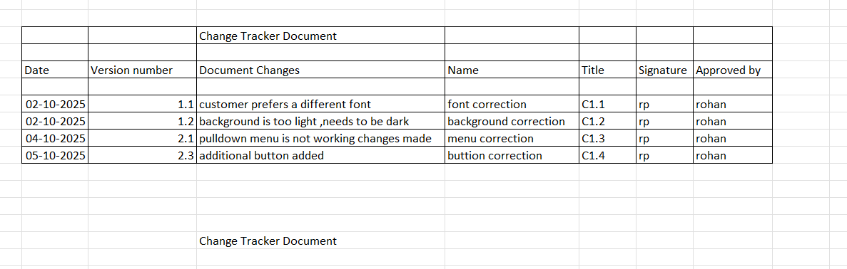

Q14. Difference between Traditional Development Model and Agile Development Models
Traditional (Waterfall) development is a sequential, plan-driven model with fixed requirements and one large delivery at the end, while Agile is an iterative, adaptive model that delivers software in small, frequent increments, allowing for flexibility and early customer feedback. The key differences lie in their approach to requirements, project phases, customer involvement, and delivery structure, making Agile better suited for projects with evolving needs.
Here's a breakdown of the differences:
Traditional Development (e.g., Waterfall Model)
- Linear & Sequential:
Phases (requirements, design, coding, testing) follow a strict, non-overlapping order.
- Fixed Requirements:
All project requirements must be fully defined and documented upfront, making changes difficult and costly.
- "Big Bang" Delivery:
The complete software product is delivered only once, at the end of the entire project lifecycle.
- Limited Customer Interaction:
Customer feedback is often limited to the initial phase, with less involvement during the later development stages.
- Documentation-Focused:
Progress is measured by completed and reviewed artifacts like design documents and test plans.
- Predictable Outcome (if successful):
Offers a clear understanding of project progress and predictable outcomes, but struggles with market dynamism.
Agile Development Models
- Iterative & Incremental:
The project is developed in small, time-boxed cycles or "sprints," delivering working software incrementally.
- Adaptive Requirements:
Agile is built to accommodate changing requirements, allowing for flexibility and adaptation throughout the project.
- Frequent, Early Delivery:
Working versions of the software are delivered to the customer at the end of each sprint, providing early value and feedback.
- Continuous Customer Collaboration:
Customers and stakeholders are actively involved throughout the development process, providing ongoing feedback and approvals.
- Focus on Working Software:
Q15. Explain Brainstorming Technique – Where to use? 5 Marks Progress is measured by the delivery of functional, valuable software features.
- High Adaptability:
Responds quickly to changing market demands and allows for early course correction, reducing overall project risk.
When to Use Which Model
- Traditional:
Best for projects with very clear, unchanging requirements, such as building a skyscraper, where the final result is well-defined.
- Agile:
Ideal for projects where requirements are expected to evolve, the market is dynamic, and early, frequent delivery of value is crucial for success.

Q15. Explain Brainstorming Technique – Where to use? 5 Marks

Brainstorming is a creative problem-solving method where individuals or groups generate a high volume of ideas in a judgment-free environment to solve a specific challenge or develop new concepts. It fosters collaboration and diverse perspectives, enabling participants to build on each other's ideas to spark innovative and practical solutions. Brainstorming is used across various sectors, including business, design, marketing, education, and strategic planning, to unlock creativity for new products, processes, or solutions.
Where to Use Brainstorming
- Business & Marketing: Develop new products, improve marketing campaigns, and find innovative solutions to business challenges.
- Product Design: Create user-centered designs and explore new features for existing products.
- Strategic Planning: Generate innovative ideas for adaptive and agile strategic planning processes.
- Problem Solving: Address and resolve complex or uncertain problems in various contexts.
- Education & Training: Facilitate creative thinking and collaborative problem-solving among students and trainees.
- Innovation & R&D: Foster new ideas and drive innovation in research and development efforts.
- Team Building: Encourage teamwork and a sense of collective ownership in finding solutions.
Key Principles of Brainstorming
- Focus on Volume:
Aim to generate as many ideas as possible, even seemingly impractical ones, to explore a wide range of possibilities.
- Defer Judgment:
Postpone criticism and evaluation of ideas to create a safe space for free-thinking and prevent inhibiting creativity.
- Encourage Wild Ideas:
Welcome unconventional or "out-of-the-box" ideas, as they can lead to unique and innovative solutions.
- Build on Others' Ideas:
Foster a collaborative environment where participants can combine, modify, or expand on the ideas suggested by others.
- Stay Focused on the Problem:
Ensure the brainstorming session is centered around a clear and well-defined problem statement.

Q16 TO Q20
CASE STUDY…….

Q16
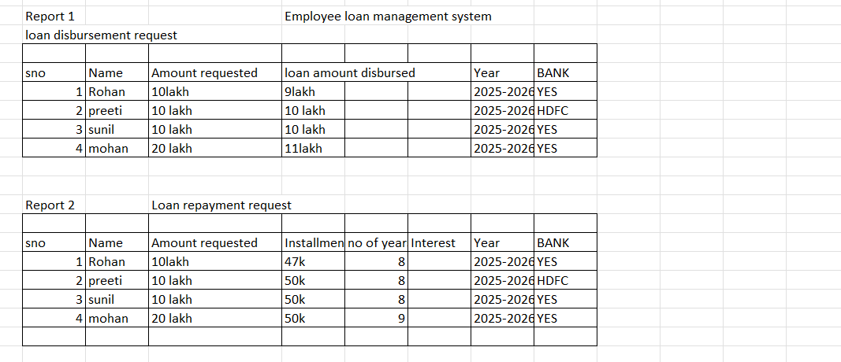

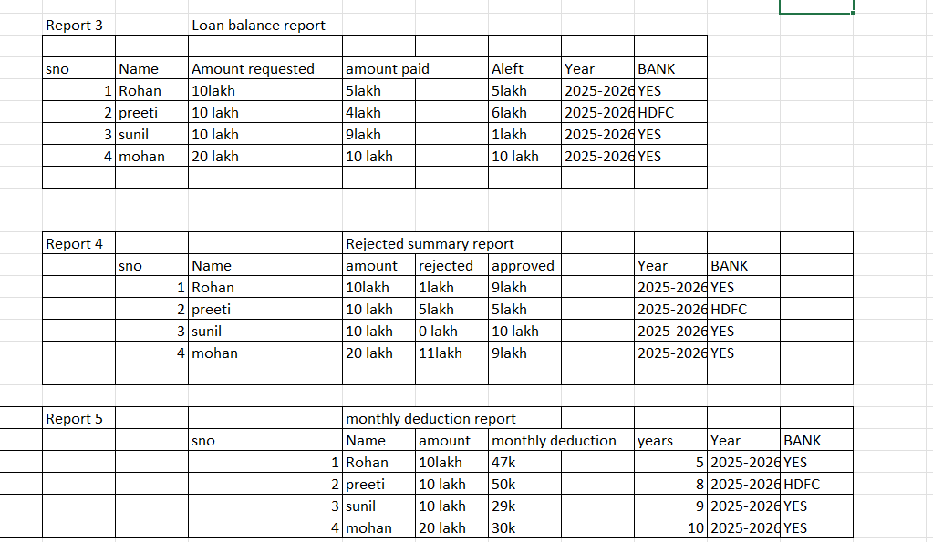

Q17)
Hi Rohan,
Subject:-Request approved regarding loan
This is regarding your request for approval of loan.We looked into your request regarding education loan.We found it a legitimate demand and we consulted with our loan department.As you’re a good employee we wish to grant your request to get loan.
Kindly treat this is an approval of loan from our side.
Thanks and regards
Murali mohan
HR department.

Q18)
Hi Rohan,
Subject:-Request Rejected regarding loan
This is regarding your request for approval of loan.We looked into your request regarding education loan.We found it a legitimate demand and we consulted with our loan department.But because in the past you have already taken a loan we wish to not grant your request.
Kindly treat this is a rejection of loan from our side.
Thanks and regards
Murali mohan
HR department.

Q19)
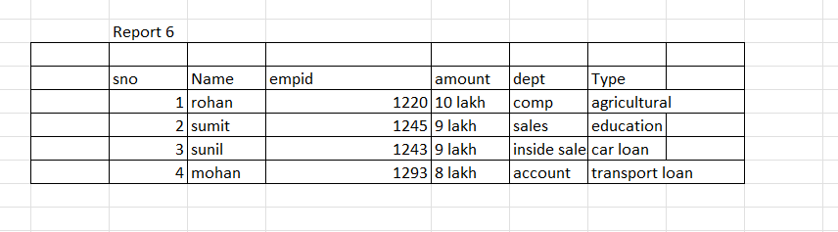

Q20)
We use Power BI ,Tableau tools to generate reports.

