Capstone Project 1 – Part 2/3

**Online Agriculture Product Store**

Decoding the Case Study:

* Project Idea: To create an Online Agriculture Product Store where farmers can buy the products (pesticides, seeds, fertilizers) directly from the manufacturers easily using their mobile/computer.
* Current needs: The farmers need a user-friendly platform to buy agriculture products, internet access
* Overview of the Project: This is an e-commerce project aiming to create a digital marketplace that connects farmers with agriculture products manufacturers.
* Current Problems: Farmers are finding it difficult to get seeds, pesticides and fertilizers for their crops due to remote location.

Stakeholders involved in the Project:

* Farmers (Stakeholders) – Peter, Kevin, Ben
* Mr. Henry (a successful businessman) initiated this project through SOONY Company:
  + - Mr. Pandu – Financial Head (Soony company)
    - Mr. Dooku – Project Co-Ordinator (Soony Company)
  + Mr. Henry gives the project to APT IT SOLUTIONS:
    - Mr. Karthik – Delivery Head
    - Mr. Vandanam – Project Manager
    - Ms. Juhi – Sr. Java Developer
    - Mr. Teyson, Ms. Lucie, Mr. Tucker, Mr. Bravo – Java Developers
    - Mr. Mike – Network Admin
    - John – Database Admin
    - Mr. Jayson and Ms. Alekya – Testers
    - Me – Business Analyst

Question 1 – Audits

4 Quarterly Audits are planned Q1 , Q2, Q3, Q4 for this Project What is your

knowledge on how these Audits will happen for a BA ?

Answer 1 –

* Audits are done to evaluate the work done by BA.
* It helps to ensure that the project progress is as per planned and the BA is actively involved in working on requirements, conducting meetings, MOM, documentation and co-ordination with stakeholders.

Below are the sample quarterly audit reports of a BA for this project:

|  |  |
| --- | --- |
| Quarter 1 Audit Report | |
| Stage | Requirement Gathering & Analysis Phase |
| Completed | 3-4 months |
| Checklist | BRD Template |
|  | Elicitation result report |
|  | Grouping of functionalities/features |
|  | Email communications - To,CC,BCC |
|  | UML Diagrams |
|  | Function Requirement Specification (Functional & Technical requirements) |
|  | RTM document |
|  | Client sign-off |

|  |  |
| --- | --- |
| Quarter 2 Audit Report | |
| Stage | Design & Development Phase |
| Completed | 5-9 month |
| Checklist | Design Document |
|  | Solution Document |
|  | Utilization of tools |
|  | First phase of UAT planned |
|  | Stakeholder MOM |
|  | Documented evidence on client communication |
|  | RTM document |
|  | Client sign-off |

|  |  |
| --- | --- |
| Quarter 3 Audit Report | |
| Stage | Development & Testing Phase |
| Completed | 10-15 months |
| Checklist | JAD Report |
|  | End user manual document |
|  | Test documents |
|  | BA and Developers MOM |
|  | RTM document |
|  | Email communications - To,CC,BCC |
|  | Client sign-off |

|  |  |
| --- | --- |
| Quarter 4 Audit Report | |
| Stage | UAT and Deployment |
| Completed | 16-18 months |
| Checklist | Test case summary |
|  | Project closure document |
|  | Training report to end users |
|  | Lessons learned document |
|  | Email communications - To,CC,BCC |

Question 2 – BA Approach Strategy

Before the Project is going to Kick Start, The Committee asked Mr Karthik to submit BA Approach Strategy

Write BA Approach strategy (As a business analyst, what are the steps that you would need to follow to complete a project – What Elicitation Techniques to apply, how to do Stakeholder Analysis RACI/ILS, What Documents to Write, what process to follow to Sign off on the Documents, how to take Approvals from the Client, What Communication Channels to establish n implement, how to Handle Change Requests, how to update the progress of the project to the Stakeholders, how to take signoff on the UAT- Client Project Acceptance Form)

Answer 2 -

**BA Approach strategy for Online Agriculture Product Store**

* What Elicitation Techniques to apply?

As a BA, to gather requirements effectively I will follow these elicitation techniques: -

* Interviews – Meeting with the key stakeholders of this project like Farmers, Mr. Henry, agriculture products manufacturing companies, Subject matter experts, project team.
* Survey & Questionnaire – Prepare a survey of open and closed ended questions to gather inputs from farmers and manufacturing companies.
* Observation – Observe & understand how farmers and suppliers currently operate.
* Workshops – Conduct meetings to gather, define and prioritize requirements.
* Prototyping – Use mock-ups/wireframes to visualize requirements
* How to do Stakeholder Analysis?

Stakeholder analysis can be done by using RACI Matrix (Responsible, Accountable, Consulted and Informed). It includes identifying stakeholders, listing them, define roles and responsibilities in the project.

* Responsible – Project Manager, Developers, Testers, BA, NW Admin, DB admin.
* Accountable – Project Manager, Delivery Head
* Consulted – Farmers (Stakeholders), BA, SMEs, Manufacturers
* Informed – Mr. Henry (Project Sponsor)
* What Documents to Write?
* Business Requirement Document (BRD) – high-level business needs and objective
* Functional Requirement Document (FRD) – System functionalities
* Non-functional Requirement Document (NFRD) – Performance, Scalability, security
* Use Case Documents – how different users interact with the system, detailed description about each task.
* Test Case Documents – test case scenarios are prepared from use cases for further testing
* Process flow diagrams – Visual representation of process workflow
* What process to follow to Sign off on the Documents?
* Sign-off is taken on SRS from the client before design phase.
* Sign-off from client is also taken on the Project acceptance form.
* It is taken through formal confirmation via E-mail from the client (Mr. Henry and Committee).
* How to take Approvals from the Client?
* Approval from the Client (Mr. Henry and Committee) is taken through formal meetings, status review meetings. Feedback is also taken.
* What Communication Channels to establish and implement?
* Weekly/monthly review meetings, status meetings, demo sessions
* Communication tools – Microsoft teams, email, slack, etc
* Tracking tools – Jira for project progress
* How to Handle Change Requests?
* BA documents the change request.
* BA analyses is the change is real or defect.
* Project manager gives initial approval for further analysis
* Decision depends on whether it is a major or minor change
* Complex changes expand scope of project and delivery time
* BA helps the stakeholders understand the impact
* Change management requires clear communication & justifications.
* BA must manage changes effectively
* How to update the progress of the project to the Stakeholders?
* Through daily standup meetings, weekly status reports, monthly review meetings we can update the progress of the project to the Stakeholders.
* How to take signoff on the UAT- Client Project Acceptance Form
* Prepare UAT plan with test cases
* Conduct UAT sessions with stakeholders and farmers
* Gather feedback, fix issues
* Final review meeting with client
* Take sign off from client on Client Project Acceptance Form before deployment.

Question 3 –

Explain and illustrate 3-tier architecture?

Answer 3 –

The 3-tier architecture divides the application into three logical layers:

1. **Application layer** – It is also called presentation layer. It handles User interface pages such as screens/pages. It is the front-end layer where users interact with the system.

* Example – Farmers access the application and browse products.

1. **Business logic layer** – It acts as intermediary between application layer and data layer. It contains core logic of the application. It processes the data.

* Example – When farmer places an order, this layer validates the request and forwards it to database.

1. **Database Layer** - It is responsible for storing and retrieving data securely.

* Example – Stores farmer profiles, product details, manufacturer data.

Application Layer

(User Interface)

React, HTML, CSS, JS

Database Layer

(Stores Data)

MySQL, PostgreSQL

Business Logic Layer

(Processing and rules)

Java, Spring Boot

Question 4 – BA Approach Strategy for Framing Questions

Business Analyst should keep What points in his/her mind before he frames a Question to ask to the Stakeholder

(5W 1H – SMART – RACI – 3 Tier Architecture – Use Cases, Use case Specs, Activity Diagrams, Models, Page designs)

Answer 4 –

* **5W 1H**: -

The 5W 1H framework is a useful tool for gathering information by answering questions about who, what, where, when, why and how.

**What?** – What are the business requirements? What features are included?

**Why?** – Why is this project important? Why do we need this feature?

**Who?** – Who are the stakeholders? Who are the users?

**When?** – When will this project complete?

**Where?** – Where will the system be used?

**How?** – How will the system function?

* **SMART: -**

This principle can help in validating questions.

**Specific:** What is the objective of this feature?

**Measurable:** How will the project success be tracked?

**Achievable:** Can this feature be implemented within time and budget?

**Relevant:** Is it practical to implement? Does it align with the goal?

**Time-bound:** What is the expected completion time?

* **RACI: -**

RACI helps in clarifying roles and responsibilities within a team by outlining who is responsible, accountable, consulted and informed.

**Responsible**: Who is actively working on this task?

**Accountable**: Who approves the work?

**Consulted**: Who is giving expert opinion?

**Informed**: Who needs to be given updates?

* **3 Tier Architecture: -**

Questions should cover all the three layers:

**Application Layer –** How should the UI be designed?

**Business Logic Layer –** What rules should be applied for ordering and payments?

**Database layer-** What data needs to be stored? How will it be secured?

* **Use Cases, Use case Specs, Activity Diagrams, Models, Page designs: -**

**Use Cases –**

Example of a use case – “Farmer places an order”

Questions – What steps should the farmer follow to buy a product? What payment method should be supported?

**Use case Specifications-**

Example – Condition: If order is above 2000, should free delivery apply?

**Activity Diagrams-** What are the process flows?

**Models-** ER diagrams, flowcharts, wireframes.

**Page designs –** How will the UI look? How should the product categories be displayed?Where should be the search and filter option?

Question 5 – Elicitation Techniques

As a Business Analyst, What Elicitation Techniques you are aware of? (BDRFOWJIPQU)

Answer 5 –

1. **Brainstorming** –

* Generating ideas individually or in groups to define requirements is called brainstorming.
* It is an open forum discussion
* Steps:
* Prepare: Define goals, set a time limit for discussion, select participants, set evaluation criteria for generated ideas.
* Conduct: Share new ideas, encourage participants to generate ideas, record the ideas.
* Wrap-up: The ideas collected can be evaluated, analysed and included where relevant.

1. **Document analysis** –

* This is one of the compulsory elicitation techniques for any project.
* In this, the existing documents are reviewed for system requirements. (It can be interface details, user manuals, software vendor manuals)
* Steps:
* Prepare: Identify and locate project folder, pick latest version document for analysis, evaluate which documents are relevant and appropriate to study.
* Conduct: Read the documents, prepare query log, set up meeting with SME, record answers in the log.
* Wrap-up: Prepare understanding document (process flow/use cases) and publish document to all responsible stakeholders.

1. **Reverse engineering**-

* Extracting system requirements from existing software when documentation is lacking is called reverse engineering.
* It is generally done for migration projects.
* Two types of Reverse engineering –
* Black-box reverse engineering: System is studied without examining its internal structure.
* White-box reverse engineering: The inner logic and code of the system is studied.

1. **Focus groups** –

* Interactive meetings with 6-7 participants to elicit ideas about specific product/service.
* Participants share their ideas, preferences and needs guided by a moderator.
* Homogenous focus groups - Individuals of similar characteristics/backgrounds, and of similar perspective.
* Heterogenous focus groups – Individuals with different backgrounds and perspectives (may differ from others resulting in low quality data collection).

1. **Observation** –

* Watching/shadowing users performing task to understand existing processes, inputs and outputs.
* Two types of observations:
* Active – In this approach, BA may ask questions to the worker during the process and take notes.
* Passive – In this approach, BA observes the SME through his business routine but not ask questions.

1. **Workshops** –

* A structured group session of 6-10 or more users to gather and define requirements.
* It is faster than group interviews for obtaining system wide requirements.
* Steps:
* Prepare: Identify critical stakeholders to participate in workshop, set objective, define agenda, schedule and arrange room logistics, conduct pre-workshop interviews with participants.
* Conduct: Elicit, analyse, document requirements, resolve conflicts, maintain professionalism and keep team on track, ask questions and analyse information being provided, document business requirements
* Wrap-up: Follow up on action items recorded at the workshop, complete the documentation and distribute it among participants.

1. **Prototyping** –

* Using mock-ups/sample screens to visualize requirements is called prototyping.
* It can support the requirement gathering process when introduced at the right time.

1. **Joint Application Development (JAD)** –

* This is an extended workshop involving all stakeholders and analysts to identify needs in a concentrated and focused effort.
* This is a detailed requirement gathering technique producing large amount of high-quality information in less time.
* Steps:
* Prepare: Define scope and objective of JAD session, identify and invite appropriate stakeholders, schedule session, research and prepare materials, visual aids, develop realistic agenda and prepare a meeting room.
* Conduct: Follow agenda to gather and document project requirements.
* Wrap-up: Prepare formal documents, analyse information, issues discovered through sessions is resolved and final document is returned to stakeholders for review and validation.

1. **Interviews** –

* Conducting interview of users and stakeholders is a systematic approach to elicit information in a formal or informal setting.
* The interviewee asks relevant questions and documents responses.
* Easy technique as it requires less planning and scheduling effort.
* Does not work well in large projects where many stakeholders are involved as it may be a time-consuming process.

1. **Questionnaire** –

* Questionnaires are surveys that are conducted in structured forms and sent to users to gather inputs.
* This technique can be useful for obtaining limited system requirement details from users/stakeholders who have minor inputs or are geographically remote.
* Open ended questions: asking descriptive and detailed questions.
* Closed ended questions: asking yes/no based questions.

1. **Use Case Specification –**

* Use case specs help to gather detailed functional requirements by focusing on interactions between users and system
* Makes it easier for stakeholders to visualize real-world usage.
* It helps to understand, document and explain what the system should do in a simple and complete way.

Question 6 – This project Elicitation Techniques

Which Elicitation Techniques can be used in this Project and Justify your selection of Elicitation Techniques?

Prototyping, Use case Specs, Document Analysis, Brainstorming

Answer 6 –

* Brainstorming
* This technique will help in generating ideas with key stakeholders like farmers, manufacturers and Mr. Henry who will have multiple ideas about the project.
* A group brainstorming session may help identifying hidden or extra requirements that may be missed out in interviews.
* It can help gather creative ideas and solve problems together.
* Document Analysis
* BA can review existing documents if any, CSR policies, reference documents shared by Mr. Henry’s Soony company
* Document analysis helps gather initial understanding of requirements, all the legal aspects and technical feasibility.
* It saves time and effort by using already available information.
* Prototyping
* As the farmers and committee members are not from technical background, prototyping will help them visualize how the app will look.
* Sample screen design helps in gaining quick feedback and clarity of requirements.
* Use case Specs
* It will help to understand how farmers and sellers will interact with the system step by step.
* It will be easy to understand functional behaviour of system.
* With this technique all the normal flows and alternate flows like payment failure or product unavailability will also be clear.

Question 7 – 10 Business Requirements

Make suitable Assumptions and identify at least 10 Business Requirements.

Answer 7 –

BR001 – Farmers should be able to search for available products in fertilizers, seeds, pesticides

BR002 – Manufacturers should be able to upload and display their products in the application

BR003 – Manufacturers should be able to update their profile details (business name, contact info), seller license

BR004 – Farmers should be able to add products to Wishlist in order to revisit and buy them later

BR005 – For registration, new user should be able to create a new account by submitting their email ID and creating a secure password.

BR006 – Farmers need to have an easy-to-use payment gateway which should include cash-on-delivery (COD), Credit/Debit card and UPI options

BR007 - Farmers should get an email confirmation regarding their order status

BR008 – Farmers should be able to browse through the product catalogue

BR009 – Farmers should be able to see seller information for verification

BR010 – Farmers should be able to rate and review the purchased product

BR011 – Farmers should be able to search products using their voice without typing

BR012 – Farmers should be able to track the whereabouts of their order

Question 8 –Assumptions

List your assumptions

Answer –

Assumptions:

1. Farmers will have internet access at their location to use the website/application.
2. Farmers/manufacturers will have basic knowledge on how to browse, click and fill forms.
3. There will be logistic partners available to deliver products in rural areas.
4. The project will be completed within set budget and timeline
5. Manufacturers will regularly update the products listing
6. Resources (Project team) will be available throughout the project duration.
7. Proper co-ordination and support will be provided by all the stakeholders of the project
8. Trust of farmers and manufacturers will be built more due to smooth and secure user experience
9. Farmers can choose and make payments securely without any issue
10. Farmers will have their bank account and access to internet banking
11. Customer support/ helpdesk team will help farmers to solve their queries
12. Only genuine and approved manufacturers will be allowed to register and sell their products on the platform.
13. Farmers will prefer buying products online instead of physically visiting stores

Question 9 – This project Requirements

Give Priority 1 to 10 numbers (1 being low priority – 10 being high priority) to these Requirements after discussions with the stakeholders

Answer 9 –

|  |  |  |  |
| --- | --- | --- | --- |
| **Req ID** | **Req Name** | **Req Description** | **Priority** |
| BR005 | User create Login | For registration, new user should be able to create a new account by submitting their email ID and creating a secure password. | 10 |
| BR006 | Easy payment gateway | Farmers need to have an easy-to-use payment gateway which should include cash-on-delivery (COD), Credit/Debit card and UPI options | 9 |
| BR001 | Farmer Search for Products | Farmers should be able to search for available products in fertilizers, seeds, pesticides | 8 |
| BR002 | Manufacturer upload their Products | Manufacturers should be able to upload and display their products in the application | 8 |
| BR008 | Browse product catalogue | Farmers should be able to browse through the product catalogue | 8 |
| BR009 | View seller information | Farmers should be able to see seller information for verification | 7 |
| BR007 | Email confirmation for order status | Farmers should get an email confirmation regarding their order status | 7 |
| BR012 | Order tracking | Farmers should be able to track the whereabouts of their order | 7 |
| BR003 | Manufacturers upload their profile | Manufacturers should be able to update their profile details (business name, contact info), seller license | 6 |
| BR004 | Add products to Wishlist | Farmers should be able to add products to Wishlist in order to revisit and buy them later | 5 |
| BR010 | Rate/review product | Farmers should be able to rate and review the purchased product | 4 |
| BR011 | Search product using voice | Farmers should be able to search products using their voice without typing | 3 |

Question 10 – Use Case Diagram

Draw use case diagram

Answer 10 –

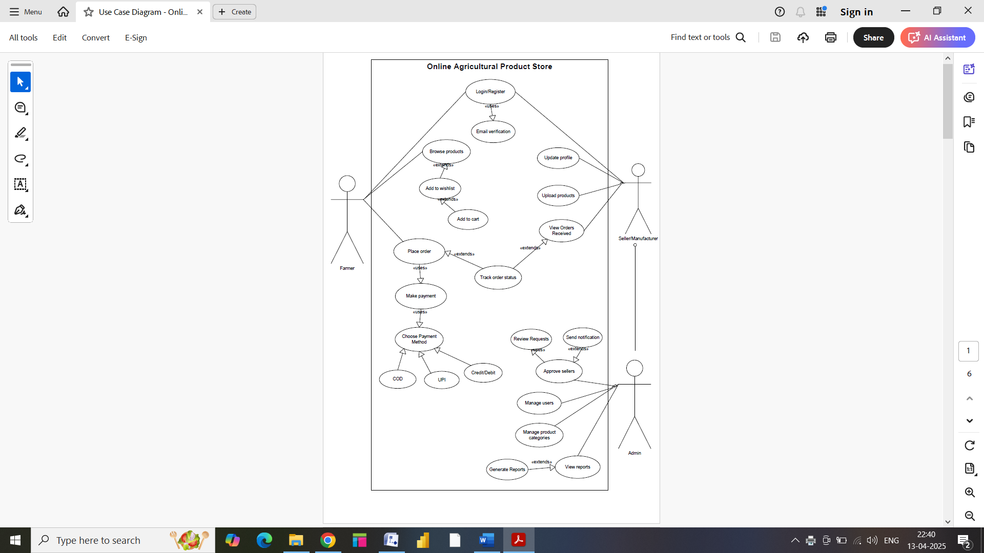

Question 11 – (minimum 5) Use Case Specs

Prepare use case specs for all use cases

Answer 11 –

1. **Login**

* Use Case Name – Login
* Use Case Description – Farmers/Sellers can login to access their account
* Actors –
* Primary Actor: Farmer
* Secondary Actor: Seller/Manufacturer
* Preconditions –
* Farmers/Sellers must have registered and created an account
* Basic Flow –
* Farmers/Sellers open the website/application
* Enters username and password
* Clicks on login
* System verifies credentials
* Login successful
* Alternate flow –
* Credentials not verified
* Show error
* Retry Option
* Postconditions – Farmer/Seller is logged in

1. **Register**

* Use Case Name – Register
* Use Case Description – Farmers/Sellers can register to create a new account
* Actors –
* Primary Actor: Farmer
* Secondary Actor: Seller/Manufacturer
* Preconditions –
* Farmers/Sellers must have an email ID/mobile no.
* Users must have active internet
* Basic Flow –
* User opens the application/webpage
* User fills registration details (contact info, name, email ID)
* Verification email is sent to verify details
* Authentication successful
* Registration completed
* Alternate flow –
* Send email verification
* Email not verified
* Show error
* Resend link
* Postconditions – A new user account is created

1. **Browse Products**

* Use Case Name – Browse Products
* Use Case Description – Farmers can view list of available products
* Actors – Farmer (Customer)
* Preconditions –
* Farmers must have been logged in
* System must have an active product catalogue
* Basic Flow –
* Farmers select product category (seeds, fertilizers, pesticides)
* Farmers apply filter to search desired product
* System displays list of products with details
* Farmers browse the listed products
* Farmers select a product to view details
* Farmer decides to add product to cart
* Farmer views cart
* Farmer proceeds to checkout
* Alternate Flow –
* Farmers do not add product to cart and returns to the product listing page
* Farmers continue browsing products again
* Postconditions –
* Farmers can add products to Wishlist
* Farmers can proceed with buying and checkout

1. **Place Order**

* Use Case Name – Place Order
* Use Case Description – Farmers selects desired product and places order to buy the item
* Actors – Farmer
* Preconditions –
* Farmers must be logged in
* Farmers must have items in cart
* Basic Flow –
* Farmers select the product to buy
* Clicks on “buy now”
* Farmer reviews the cart for price details
* Farmer chooses payment method
* System confirms payment
* Farmer enters delivery details
* System confirms order
* Farmer can track order status
* Postconditions –
* Order is placed
* Farmer receives order confirmation via email

1. **Make Payment**

* Use Case Name – Make payment
* Use Case Description – Farmer makes payment for confirmed order.
* Actors – Farmer
* Preconditions – Order must be placed and ready for payment
* Basic Flow –
* Farmer chooses payment mode (UPI, net banking, COD, Debit/credit)
* Enters required account details
* System processes the payment
* Completes payment transaction
* Alternate flow –
* Payment fails due to network issue/ invalid card or insufficient balance
* System displays error message
* Farmer can retry payment or select different payment method
* Postconditions –
* Payment is confirmed
* Invoice is generated

1. **Update Profile**

* Use Case Name – Update profile
* Use Case Description – Seller registers/updates his business name and contact information
* Actors – Manufacturer/Seller
* Preconditions – Seller must be logged in
* Basic Flow –
* Seller clicks on update profile under “My profile”
* Seller edits/updates business details (address, contact info, name)
* System validates and updates the profile information.
* A confirmation is displayed
* Postconditions – Uploaded profiled is saved in the system

1. **Upload Products**

* Use Case Name – Upload products
* Use Case Description – Seller adds new products on the website to sell
* Actors – Seller
* Preconditions – Seller must be verified and approved by admin
* Basic Flow –
* Seller clicks on “Upload Product”
* Enters product details (name, price, description, image, stock availability)
* Submits for review
* Postconditions –
* Product details are saved
* Reviewed product is displayed on the website for sell

1. **Approve Sellers**

* Use Case Name – Approve sellers
* Use Case Description – Admin reviews and approves new seller request
* Actors – Admin
* Preconditions –
* Sellers must have agreed to terms and conditions
* Seller’s license is verified
* Seller must have applied for registration
* Basic Flow –
* Admin login to system
* Select Pending seller requests
* List of new seller registration is displayed
* Admin selects seller to view full details
* Review Submitted documents
* Approve seller on document verification
* System updates seller information in database
* Approval email notification is sent to seller
* Alternate flow –
* Reject seller if documents invalid
* System updates seller information in database
* Rejection email notification is sent to seller
* Postconditions – Seller gets activated or declined status

1. **Manage Users**

* Use Case Name – Manage Users
* Use Case Description – Allow admin to view, edit, activate/deactivate or delete farmer and seller user accounts
* Actors – Admin
* Preconditions –
* Admin must be logged in
* Admin must have access to user dashboard
* Basic Flow –
* Admin selects manage user’s option
* System displays list of all registered farmers and sellers
* Admin views details of specific users
* Admin edits/activates/deactivates user account
* Postconditions – User status is updated as per admin’s action

1. **Add to Wishlist**

* Use Case Name – Add to Wishlist
* Use Case Description – Allows the farmer to save a product to Wishlist to buy later
* Actors – Farmer
* Preconditions – Farmer must be logged in
* Basic Flow –
* Farmer browses product list
* Selects a product they are interested in
* Clicks on “add to Wishlist” option
* Postconditions – Product is saved to Wishlist

1. **Track Order**

* Use Case Name – Track Order
* Use Case Description – Allows farmers to check the delivery status of their ordered product
* Actors – Farmer
* Preconditions – Farmer must have placed an order
* Basic Flow –
* Farmer logs in and selects “My Orders”.
* Chooses a specific order to track
* Systems fetch current delivery status (processing, shipped, out for delivery, delivered)
* Postconditions – Tracking status is displayed

1. **Manage Product Categories**

* Use Case Name – Manage product categories
* Use Case Description – Admin can create, edit, update, delete and view product categories to organize the products
* Actors – Admin
* Preconditions – Admin must be logged in to the system
* Basic Flow –
* Admin selects “Manage Categories” on the dashboard
* Admin choose categories to view the product details
* Admin edits, organizes, adds or deletes categories
* System validates inputs and updates category list
* Postconditions – Category list is updated and reflected in product listing

1. **View Reports**

* Use Case Name – View reports
* Use Case Description – Admin can view system reports like product sales, user activity, seller performance, order status.
* Actors – Admin
* Preconditions –
* Admin must be logged in
* Basic Flow –
* Admin navigates through “Reports” section
* Admin selects the report type (sales report, order summary, etc)
* Admin applies filter to date, category, seller, product, etc
* System generates and displays the report
* Postconditions – Admin can export the report

Question 12 – (minimum 5) Activity Diagrams

Activity diagram

Answer 12 –

1. **Register**

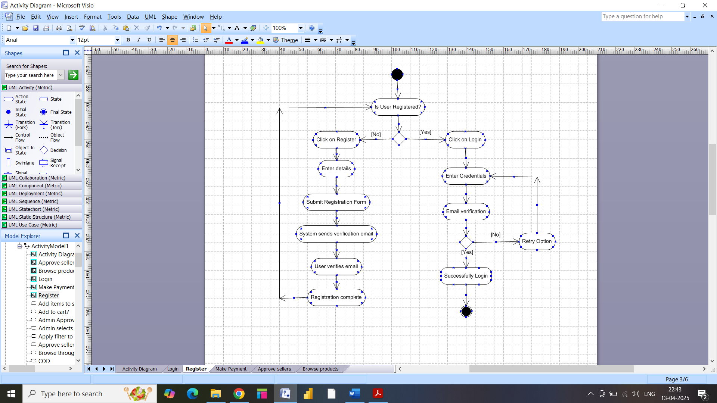

1. **Login**

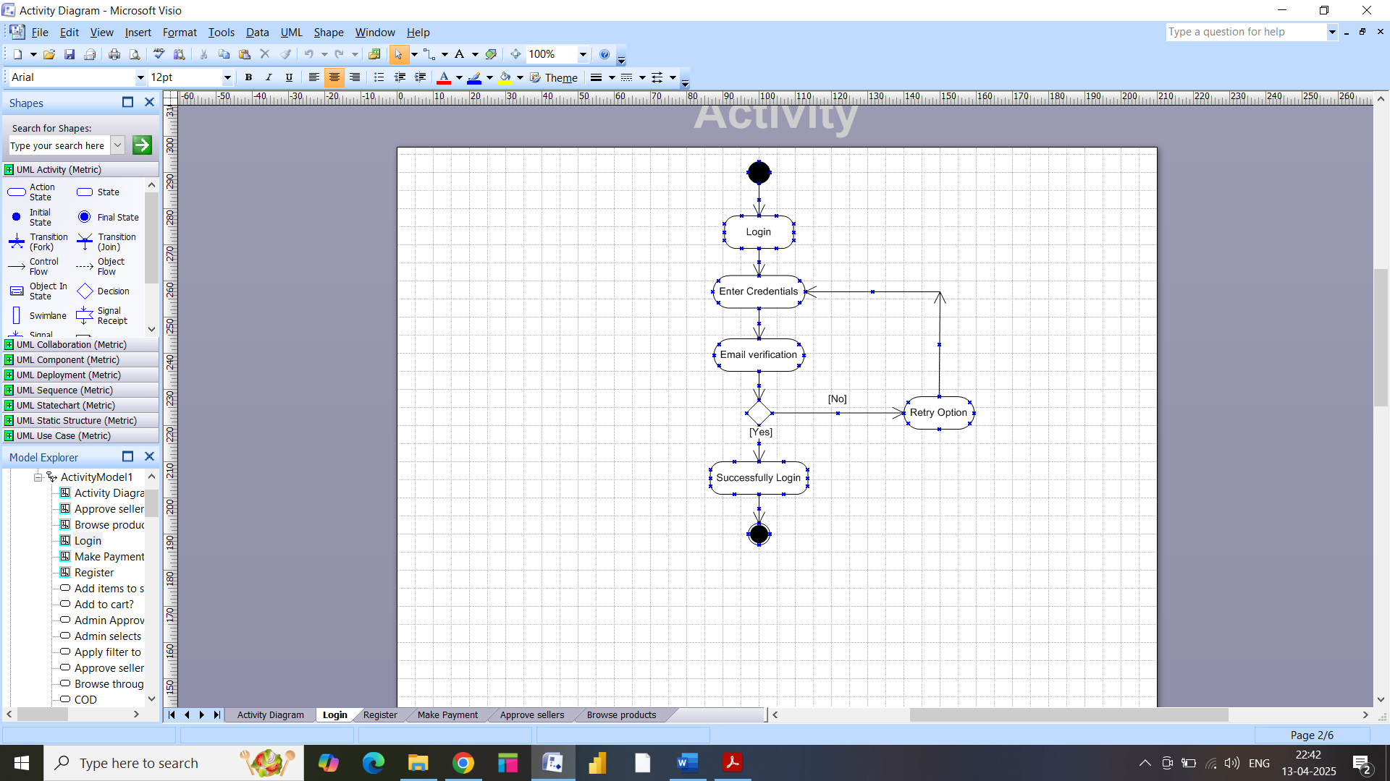

1. **Make Payment**

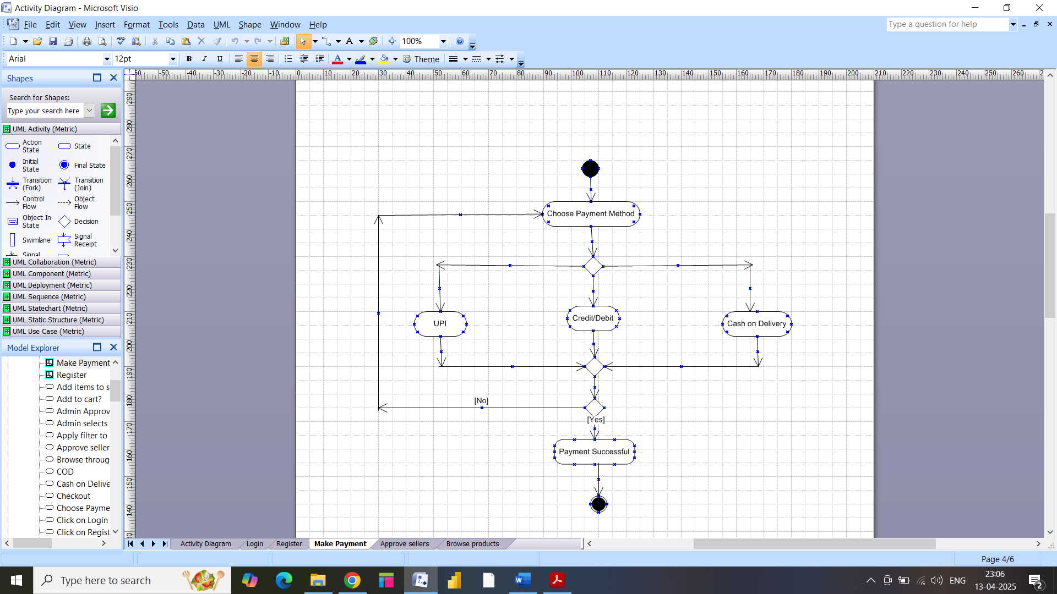

1. **Browse Products**

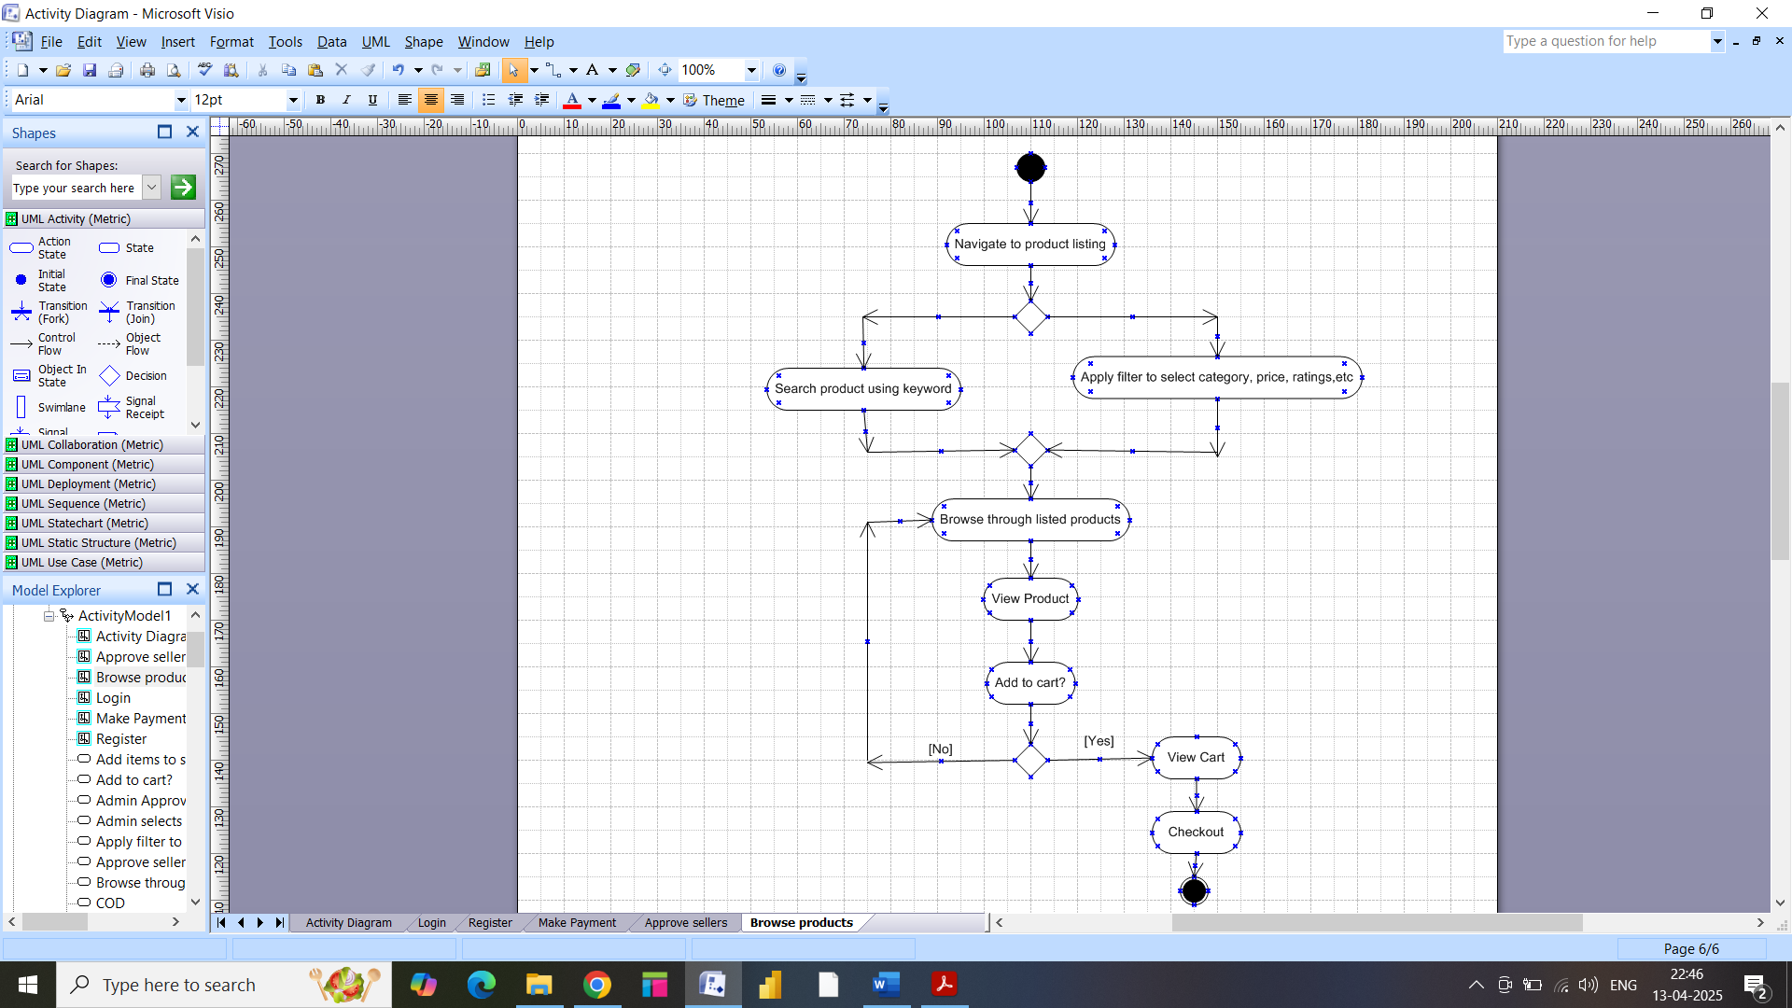

1. **Approve Sellers**

