**Nurturing Process - Capstone Project 1 – Part 2/3**

Online Agriculture Product Store

**Question 1 Audits**

4 Quarterly Audits are planned Q1, Q2, Q3, Q4 for this Project What is your knowledge on how these Audits will happen for a BA?

**Answer**

|  |  |  |  |
| --- | --- | --- | --- |
| **Stage** | **Quarter 1 Audit Report**  **Requirement Gathering Phase** | **Stage** | **Quarter 2 Audit Report Requirement Analysis Phase** |
| **Completed** | 10 Weeks (Week 1 to Week 10) | **Completed** | 7 Weeks (Week 16 to Week 23) |
| **Check list** | BRD template | **Check list** | UML Diagrams |
|  | Elicitation results report |  | Business to functional requirements mapping |
|  | Duplicate requirements report |  | Client sign off- documents |
|  | Grouping of functionalities/features- client sign off |  | RTM document version control |
|  | Email communication- TO, CC, BCC |  | Email communication- TO, CC, BCC |
|  |  |  |  |

|  |  |  |  |
| --- | --- | --- | --- |
| **Stage** | **Quarter 3 Audit Report**  **Design** | **Stage** | **Quarter 4 Audit Report**  **Development** |
| **Completed** | 7 Weeks (Week 30 to Week 37) | **Completed** | 20 Weeks (Week 40 to Week 60) |
| **Check list** | Utilisation of tools | **Check list** | JAD session report |
|  | Documented evidence on client communication |  | End user manual preparation document |
|  | Stakeholder MOM |  | BA and developer MOM |
|  | Email communication- TO, CC, BCC |  | Email communication- TO, CC, BCC |
|  |  |  |  |

**Question 2 BA approach strategy**

Write BA Approach strategy (As a business analyst, what are the steps that you would need to follow to complete a project – What Elicitation Techniques to apply, how to do Stakeholder Analysis RACI/ILS, What Documents to Write, What process to follow to Sign off on the Documents, How to take Approvals from the Client, What Communication Channels to establish n implement, How to Handle Change Requests, How to update the progress of the project to the Stakeholders, How to take signoff on the UAT- Client Project Acceptance Form)

**Answer**

- What elicitation techniques to apply?

Techniques that can be used to create a comprehensive document of requirements that are further used throughout the software development process. This include:

Brainstorming is a creative technique that involves generating ideas and solving problems by encouraging free thinking. It can be done by a group or an individual.

Document analysis is a method of examining documents to gain insights and information about a business.

Reverse engineering allows businesses to explore existing designs and find ways to adapt them for new uses and applications.

Focus groups are a form of qualitative research in which a group of people are asked about their attitude and/or feelings towards a product, service, concept, advertisement, or idea.

Observation is an excellent elicitation technique that helps understand requirements based on observations related to process flows and work environments of stakeholders.

Workshop has collaborative sessions which bring multiple stakeholders together to discuss requirements, resolve conflicts, and reach consensus.

JAD (Joint Application Development) sessions holds structured workshops where users, developers, and analysts work together intensively to define requirements. These sessions promote collaboration and help reduce miscommunication.

Interviews allow direct interaction with stakeholders to understand their needs, concerns, and expectations.

Prototyping creates mock-ups or working models helps stakeholders visualize the solution and provide feedback early.

Questionnaires and Surveys help gather requirements from a large number of stakeholders efficiently.

- How to do stakeholder analysis?

Identify all relevant stakeholders and project tasks, then assign each stakeholder a role for each task using the RACI categories: "Responsible," "Accountable," "Consulted," and "Informed," ensuring each task has a clear responsible party and only one accountable party; finally, review and communicate the matrix with stakeholders to ensure clarity on roles and responsibilities.

- What documents to write?

BRD: A Business Requirements Document (BRD) is a document that outlines a business's goals and needs for a project. It's a high-level document that's usually the first document created for a project.

FRD: A Functional Requirements Document (FRD) is a document that outlines the features and capabilities of a software application. It's used in business analysis to ensure that the software meets the needs of the users.

Use case documentation: A use case document is a detailed description of how a user interacts with a product or system. It is a methodology used in system analysis to identify and organize system requirements.

Test case documents: A test case document is a set of steps to test a specific feature or functionality in software testing. It's the smallest unit of a testing plan.

- What process to follow to sign off on the documents?

Sign off should be done on SRS, a Software Requirements Specification document is a detailed description of how a software product should be built and function. Sign off can be done by E-mail confirmation from client.

- How to take approvals from the client?

Establish a formal meeting with the clients to keep them informed and get continuous feedback.

- What communication channels to establish and implement?

Regular meetings which included weekly status meetings, bi-weekly sprint reviews, and monthly stakeholder updates.

- How to handle change requests?

Fill change request form then perform impact analysis, go through approval process and do documentation.

- How to update the progress of the project to the stakeholders?

Through weekly status reports and monthly review meetings.

- How to take sign off on the UAT client project acceptance form?

Prepare UAT, conduct UAT, fix issues, fill acceptance form, go through final review meeting, and obtain sign off.

**Question 3 3-Tier Architecture**

Explain and illustrate 3-tier architecture

**Answer**

3-tier architecture refers to a software application design that separates the system into three distinct layers: the application layer, the business logic layer, and the database layer, allowing each layer to be developed, updated, and scaled independently, improving maintainability and flexibility within a system.

1. Application layer: This is the user interface where users interact with the system, including web pages, mobile apps, or desktop applications. It handles user input, displays data, and sends requests to the application logic layer.

2. Business logic layer: This middle layer contains the core business logic, processing user requests, performing calculations, and retrieving data from the database based on the rules defined by the business.

3. Database layer: This layer handles data storage and retrieval, interacting directly with the database to store, update, and retrieve information.

**Question 4 BA approach strategy for framing questions**

Business Analyst should keep What points in his/her mind before he frames a Question to ask to the Stakeholder

(5W 1H – SMART – RACI – 3 Tier Architecture – Use Cases, Use case Specs, Activity

Diagrams, Models, Page designs)

**Answer**

- 5W 1H: A problem-solving method that uses a set of questions to help understand a situation, identify problems, and develop solutions. The acronym 5W1H stands for "what", "who", "where", "when", "why", and "how".

Who: Identify the individuals or groups involved.

What: Define the specific issue or event.

Where: Determine the location or context where the problem occurs.

When: Specify the timeframe or frequency of the problem.

Why: Understand the underlying causes or reasons behind the issue.

How: Explore potential solutions or actions to address the problem.

- SMART: SMART is an acronym that stands for Specific, Measurable, Achievable, Relevant, and Time-bound. It is a widely used tool to create effective and meaningful objectives for any project, task, or activity.

- RACI: A RACI matrix is a tool that defines roles and responsibilities for a project or process. RACI stands for Responsible, Accountable, Consulted, and Informed.

Responsible: The person or team that does the work

Accountable: The person or team that is ultimately responsible for the outcome

Consulted: The person or team that provides input and advice

Informed: The person or team that is kept up to date on the progress

- 3 tier architecture: Three-tier architecture is a software development model that organizes an application into three logical tiers: the application tier, the business logic tier, and the database tier. It's a popular implementation of multi-tier architecture.

- Use cases: A use case is a description of how a user interacts with a product, service, or system to achieve a goal. Use cases are used in software and systems engineering, and are a methodology for identifying and organizing system requirements.

- Use case specs: A use case specification is a document that describes a use case in detail. It's a key step in creating a use case diagram. Use case specifications are often created during the analysis and design phase of a project.

- Activity Diagrams: An activity diagram is an extension of the workflow diagram, visually depicting the flow of system operations as a sequence of actions.

- Models: Visual representations or frameworks used to understand and analyse complex business processes, systems, and situations.

- Page designs: The process of visually structuring and presenting information gathered during analysis, typically using diagrams, charts, tables, and other graphical elements.

**Question 5 Elicitation techniques**

As a Business Analyst, What Elicitation Techniques you are aware of? (BDRFOWJIPQU)

**Answer**

- Brainstorming: a creative technique that involves generating ideas and solving problems by encouraging free thinking. It can be done by a group or an individual.

- Document Analysis: a method of examining documents to gain insights and information about a business.

- Reversing Engineering: allows businesses to explore existing designs and find ways to adapt them for new uses and applications.

- Focus Groups: a form of qualitative research in which a group of people are asked about their attitude and/or feelings towards a product, service, concept, advertisement, or idea.

- Observation: an excellent elicitation technique that helps understand requirements based on observations related to process flows and work environments of stakeholders.

- Workshops: has collaborative sessions which bring multiple stakeholders together to discuss requirements, resolve conflicts, and reach consensus.

- JAD: (Joint Application Development) sessions holds structured workshops where users, developers, and analysts work together intensively to define requirements. These sessions promote collaboration and help reduce miscommunication.

- Interview: allow direct interaction with stakeholders to understand their needs, concerns, and expectations.

- Prototype: creates mock-ups or working models helps stakeholders visualize the solution and provide feedback early.

- Questionnaire: help gather requirements from a large number of stakeholders efficiently.

- Use case specs: a document that describes a use case in detail. It's a key step in creating a use case diagram.

**Question 6 This project elicitation techniques**

Which Elicitation Techniques can be used in this Project and Justify your selection of Elicitation Techniques?

**Answer**

- Prototyping

Since the application needs to be user-friendly for farmers who may not be tech-savvy, creating prototypes will help validate the interface design early. It can also help visualize the product catalogue, search functionality, and payment gateway interfaces

- Use case Specs

* Helps detail the core functionalities like product search, user registration, order placement, and delivery tracking.
* Can clearly document the interaction flow between farmers and manufacturers.
* Essential for capturing complex processes like the payment gateway integration.
* Useful for developers to understand the exact system behaviour expected.

- Document Analysis

* Need to analyse existing product documentation from manufacturers for fertilizers, seeds, and pesticides.
* Review any existing e-commerce documentation to understand best practices.
* Study payment gateway documentation and delivery tracking systems.
* Analyse regulatory requirements around agricultural product sales.

- Brainstorming

* Valuable for generating ideas with Peter, Kevin and Ben who understand farmer pain points.
* Can help identify additional features that would benefit farmers.
* Useful for exploring different approaches to make the platform user-friendly.
* Good for gathering input on search parameters and product categorization.

**Answer**

**Question 7 10 Business Requirements**

Make suitable Assumptions and identify at least 10 Business Requirements.

**Answer**

Business requirements are the specific needs or conditions that a business must meet to achieve its objectives.

BR001- Users should be able to search fertilizers, seeds, and pesticides.

BR002- Users should be able to browse through the product catalogue.

BR003- If the user is a new user then he should create the login ID and password first.

BR004- Manufacturers should be able to upload and display their products in the application.

BR005- Users should be able to add products to cart for immediate purchase.

BR006-The application should support "buy later" wish list functionality.

BR007- The application should have multiple payment options including COD, Credit/Debit cards and UPI.

BR008- The users must get real-time tracking of order delivery status.

BR009- Products should be properly categorized and organized.

BR010- The application should include product details, pricing, and availability information.

**Question 8 Assumptions**

List your assumptions

**Answer**

Assumption 1: The application will work with low bandwidth connections.

Assumption 2: A user can login using google account.

Assumption 3: Users can perform basic operations like login, search, and payment.

Assumption 4: Products will be available in various quantities to suit different farm sizes.

Assumption 5: Delivery partners can reach remote farming locations.

Assumption 6: Regular security audits will be conducted.

Assumption 7: Return/refund policies will be clearly defined.

**Question 9 This project requirement priorities**

Give Priority 1 to 10 numbers (1 being low priority – 10 being high priority) to these Requirements after discussions with the stakeholders

**Answer**

|  |  |  |  |
| --- | --- | --- | --- |
| Requirement ID | Requirement Name | Requirement Description | Priority |
|  |  |  |  |
| BR001 | Farmer Search for Products | Farmers should be able to search for available products in fertilizers, seeds, pesticides. | 8 |
| BR002 | Manufacturers Product Upload | Manufacturers should be able to upload and display their products in the application. | 8 |
| BR003 | User Authentication | Users must be able to login using email and password, with option to create new account. | 10 |
| BR004 | Product Catalogue | System must maintain and display comprehensive catalogue of fertilizers, seeds, and pesticides. | 9 |
| BR005 | Payment Gateway Integration | Multiple payment options including COD, Credit/Debit cards, and UPI must be available. | 9 |
| BR006 | Order Tracking | Users should be able to track their order status and delivery progress. | 7 |
| BR007 | Email Notifications | Farmers should be able to save products to a buy-later list for future purchase. | 6 |
| BR008 | Buy Later List | Farmers should be able to save products to a buy-later list for future purchase. | 5 |
| BR009 | User Profile Management | Users should be able to manage their profile and delivery information. | 7 |
| BR010 | Product Management | Manufacturers should be able to manage (add/edit/remove) their product listings. | 8 |

**Question 10 Use Case Diagram**

Draw use case diagram

**Answer**

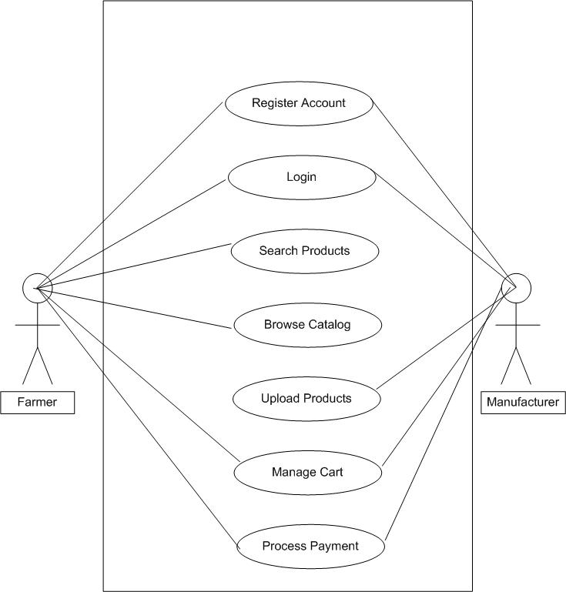

**Question 11 Use Case Specs**

Prepare use case specs for all use cases

**Answer**

Use Case Specification

This use case describes the basic functionality of the application.

|  |  |  |  |
| --- | --- | --- | --- |
| Use Case | Register New User | Search Products | Upload products |
| Actor | Farmer/Manufacturer | Farmer | Manufacturer |
| Description | Allows new users to create an account in the system | Allows farmers to search for agricultural products | Allows manufacturers to add new products to the catalogue |
| Pre-conditions | -User has internet access  -User is not already registered | -User has access to the application  -Product catalogue exists | -Manufacturer is logged in  -Manufacturer account is verified |
| Basic flow | -User selects "Create New Account" option  -System displays registration form  -User enters required information:  -Email ID  -Password  -User Type (Farmer/Manufacturer)  -Personal Details  -System validates the information  -System creates new account  -System sends verification email  -System displays success message | -User enters search criteria  -System displays search options:  -Product type (Seeds/Fertilizers/Pesticides)  -Product name  -Brand  -User selects search parameters  -System displays matching products  -User can filter results by:  -Price range  -Availability  -Rating | -Manufacturer selects "Add New Product"  -System displays product upload form  -Manufacturer enters product details:  -Product name  -Category  -Description  -Price  -Available quantity  -Images  -System validates information  -System adds product to catalogue  -System confirms successful upload |
| Alternative flow | -Email already exists  -System displays error message  -User enters different email  -Invalid information  -System highlights invalid fields  -User corrects information | -No results found  -System displays "No matching products" message  -Suggests alternative search terms | -Invalid product information  -System highlights errors  -Manufacturer corrects information |
| Post conditions | -New user account is created  -User can login to the system | -Search results are displayed  -User can select products for purchase | -New product is added to catalogue  -Product is available for search |

|  |  |  |
| --- | --- | --- |
| Use Case | Process Payment | Track Order |
| Actor | Farmer | Farmer |
| Description | Handles payment processing for product purchases | Allows farmers to track their order status |
| Pre-conditions | -User is logged in  -Products are in cart  -Total amount is calculated | -User is logged in  -Order is placed |
| Basic flow | -User selects "Checkout"  -System displays payment options:  -COD  -Credit/Debit Card  -UPI  -User selects payment method  -System processes payment  -System generates order confirmation  -System sends email confirmation | -User selects "Track Order"  -System displays order history  -User selects specific order  -System shows:  -Order status  -Estimated delivery date  -Current location  -Delivery updates  -User can opt for notifications |
| Alternative flow | Payment failure  -System displays error message  -Offers retry option  -Insufficient funds  -System notifies user  -Suggests alternative payment method | -Order not found  -System displays error message  -Provides customer support contact |
| Post condition | -Payment is processed  -Order is confirmed  -Delivery process initiates | -User can view order status  -User receives delivery updates |

**Question 12 Activity diagrams**

Activity diagrams

**Answer**

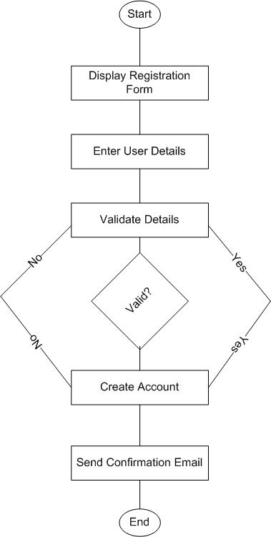

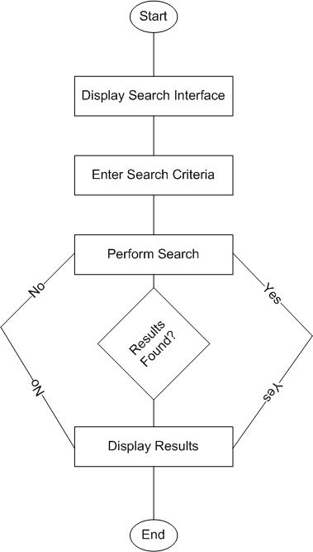

1. User Registration

2. Search Products

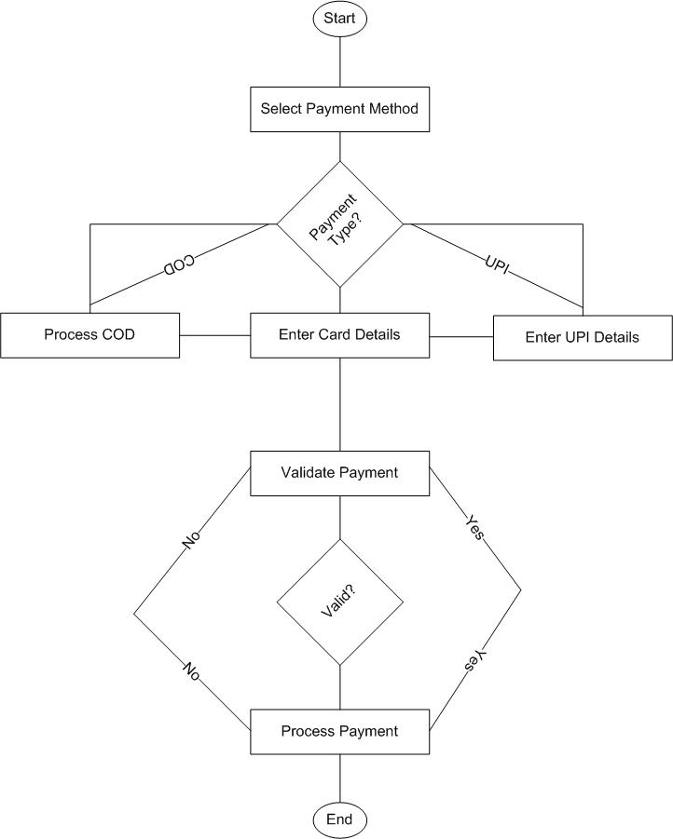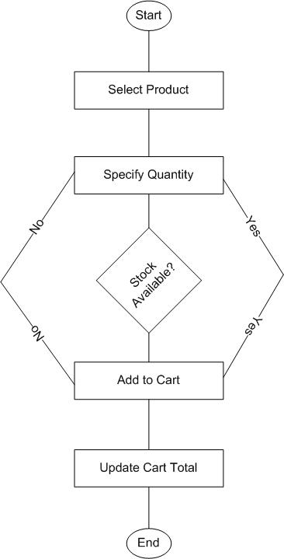

4. Making a payment

3. Add products to the cart

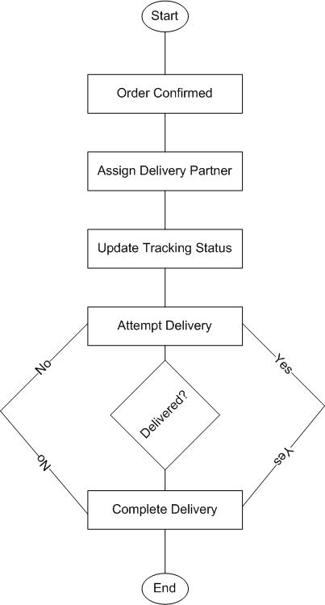

5. Delivery