**Question 1: Identify Minimum 20 functional requirements.**

|  |  |  |
| --- | --- | --- |
| **Req Id** | **Req Name** | **Req Description** |
| **FR001** | User Registration | Farmers and Manufacturers should be able to register using email address and phone number. |
| **FR002** | User login | Users able to login using their registered email address and password. |
| **FR003** | Reset Password | User able to reset password using registered email address. |
| **FR004** | Add Product | Manufacturers able to list their products with details. |
| **FR005** | Product Catalogue | Manufacturers should be able to list their products category wise. |
| **FR006** | Search Product | Farmers should be able to search any product using search option. |
| **FR007** | Browse Product | Farmers should be able to scroll and browse through categories to look for products. |
| **FR008** | Add to wish list | Add to wish list option should be available for the farmers, if they want to buy products later. |
| **FR009** | Add to Cart | Add to cart option to add selected products to cart. |
| **FR010** | Enter Address | Farmers should be able to enter and save delivery address. |
| **FR011** | Select Address | Farmers should be able to select delivery address from already saved address. |
| **FR012** | Select CC Payment | Farmers should be able to select CC to make payment. |
| **FR013** | Select Debit Card | Farmers should be able to select Debit Card option to make payment. |
| **FR014** | Select Bank Transfer | Farmers should be able to select bank transfer to make payment. |
| **FR015** | Payment Confirmation email | Farmers should get an email receipt and SMS on payment confirmation. |
| **FR016** | COD | Farmers should be able to select Cash on Delivery as payment option. |
| **FR017** | Order Confirmation email and SMS | Farmers should get email confirmation and SMS on order status. |
| **FR018** | Delivery details in email and SMS | Farmers should get delivery partner details such as name and consignment number in email and SMS. |
| **FR019** | Track delivery real-time | Farmers should be able to track their orders using consignment number in app and website. |
| **FR020** | Delivery message and email. | Farmers should get Delivery update in email and SMS. |

**Question 2. Make Wire Frame and Prototypes. (Minimum 5-page designs).**

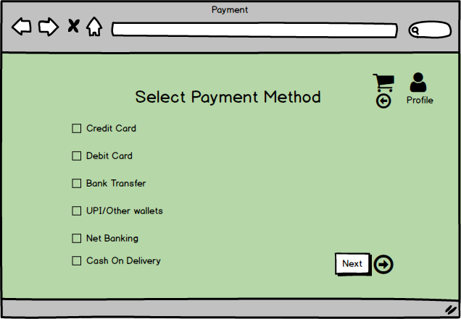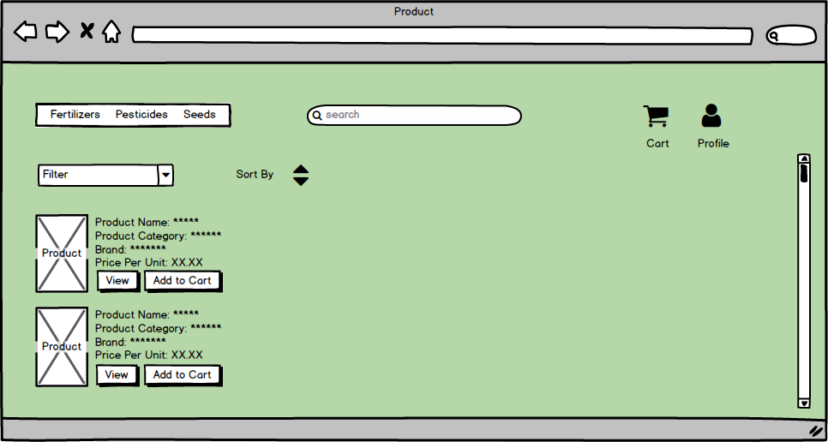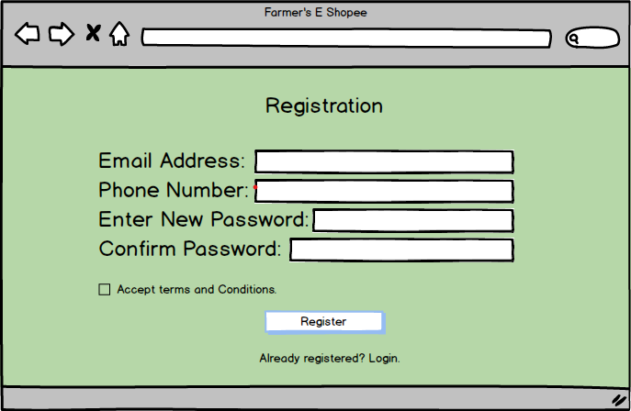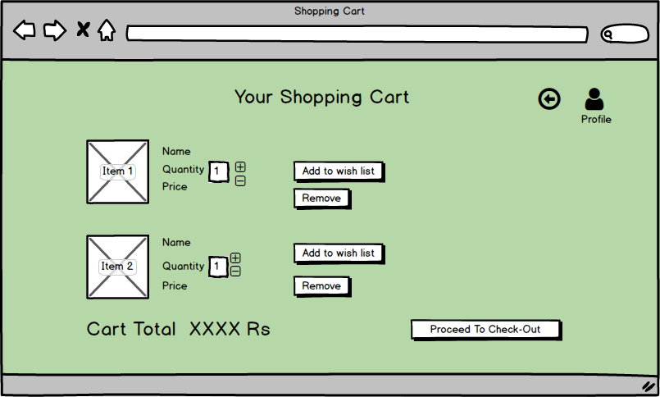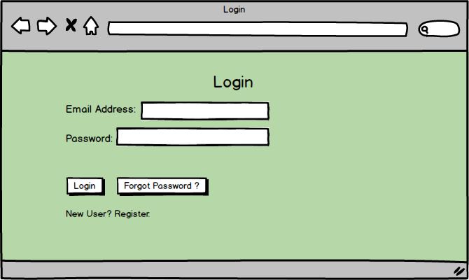

**Question 3. Make a note of tools, which you are using for above concepts. (Visio, Balsamiq)**

* **Microsoft Visio**: It is a diagraming tool used to create flow charts, activity diagrams, sequence diagrams, etc. and is used for visual representations of complex processes. I used MS visio to create activity diagram and Use-case diagrams for this project.

Key features of MS Visio are:

* + Templates: Provides pre-built templates for various diagram types (e.g., flowcharts, UML diagrams, network diagrams).
  + Shapes and Symbols: Extensive library of shapes and symbols for creating complex diagrams.
  + Integration: Easily integrates with other Microsoft Office tools like Excel, PowerPoint, and Word.
  + Collaboration: Allows real-time collaboration on diagrams.
  + Customization: Offers a high level of customization for shapes, styles, and data-driven diagrams.
* **Balsamiq**: It is a Mockup tool and used to create wireframes, mockups and prototypes for the upcoming solution. It is used for creating low fidelity, sketch like mockups of websites and applications. I used Balsamiq to create wireframes for this agricultural project. Key features of Balsamiq are:
  + Drag-and-drop Interface: Simple and intuitive interface to create wireframes quickly.
  + Pre-designed Components: Offers a wide range of UI elements like buttons, menus, text fields, and navigation elements.
  + Low-Fidelity Focus: Emphasizes early-stage design and concept validation rather than polished visuals.
  + Collaboration: Easy to share wireframes with team members and stakeholders for feedback.

**Question 4. RTM**

|  |  |  |  |  |  |  |  |  |  |  |  |  |
| --- | --- | --- | --- | --- | --- | --- | --- | --- | --- | --- | --- | --- |
| **Req Id** | **Req Name** | **Req Description** | **Design** | **D1** | **T1** | **D2** | **T2** | **D3** | **T3** | **D4** | **T4** | **UAT** |
| **FR001** | User Registration | Farmers and Manufacturers should be able to register using email address and phone number. | Complete | Complete | Complete | Complete | Complete | Complete | Complete | Complete | Incomplete | Incomplete |
| **FR002** | User login | Users able to login using their registered email address and password. | Complete | Complete | Complete | Complete | Complete | Complete | Complete | Complete | Incomplete | Incomplete |
| **FR003** | Reset Password | User able to reset password using registered email address. | Complete | Complete | Complete | Complete | Complete | Complete | Complete | Complete | Incomplete | Incomplete |
| **FR004** | Add Product | Manufacturers able to list their products with details. | Complete | Complete | Complete | Complete | Complete | Complete | Complete | Complete | Incomplete | Incomplete |
| **FR005** | Product Catalogue | Manufacturers should be able to list their products category wise. | Complete | Complete | Complete | Complete | Complete | Complete | Complete | Complete | Incomplete | Incomplete |
| **FR006** | Search Product | Farmers should be able to search any product using search option. | Complete | Complete | Complete | Complete | Complete | Complete | Complete | Complete | Incomplete | Incomplete |
| **FR007** | Browse Product | Farmers should be able to scroll and browse through categories to look for products. | Complete | Complete | Complete | Complete | Complete | Complete | Complete | Complete | Incomplete | Incomplete |
| **FR008** | Add to wish list | Add to wish list option should be available for the farmers, if they want to buy products later. | Complete | Complete | Complete | Complete | Complete | Complete | Complete | Complete | Incomplete | Incomplete |
| **FR009** | Add to Cart | Add to cart option to add selected products to cart. | Complete | Complete | Complete | Complete | Complete | Complete | Complete | Complete | Incomplete | Incomplete |
| **FR010** | Enter Address | Farmers should be able to enter and save delivery address. | Complete | Complete | Complete | Complete | Complete | Complete | Complete | Complete | Incomplete | Incomplete |
| **FR011** | Select Address | Farmers should be able to select delivery address from already saved address. | Complete | Complete | Complete | Complete | Complete | Complete | Complete | Complete | Incomplete | Incomplete |
| **FR012** | Select CC Payment | Farmers should be able to select CC to make payment. | Complete | Complete | Complete | Complete | Complete | Complete | Complete | Complete | Incomplete | Incomplete |
| **FR013** | Select Debit Card | Farmers should be able to select Debit Card option to make payment. | Complete | Complete | Complete | Complete | Complete | Complete | Complete | Complete | Incomplete | Incomplete |
| **FR014** | Select Bank Transfer | Farmers should be able to select bank transfer to make payment. | Complete | Complete | Complete | Complete | Complete | Complete | Complete | Complete | Incomplete | Incomplete |
| **FR015** | Payment Confirmation email | Farmers should get an email receipt and SMS on payment confirmation. | Complete | Complete | Complete | Complete | Complete | Complete | Complete | Complete | Incomplete | Incomplete |
| **FR016** | COD | Farmers should be able to select Cash on Delivery as payment option. | Complete | Complete | Complete | Complete | Complete | Complete | Complete | Complete | Incomplete | Incomplete |
| **FR017** | Order Confirmation email and SMS | Farmers should get email confirmation and SMS on order status. | Complete | Complete | Complete | Complete | Complete | Complete | Complete | Complete | Incomplete | Incomplete |
| **FR018** | Delivery details in email and SMS | Farmers should get delivery partner details such as name and consignment number in email and SMS. | Complete | Complete | Complete | Complete | Complete | Complete | Complete | Complete | Incomplete | Incomplete |
| **FR019** | Track delivery real-time | Farmers should be able to track their orders using consignment number in app and website. | Complete | Complete | Complete | Complete | Complete | Complete | Complete | Complete | Incomplete | Incomplete |
| **FR020** | Delivery message and email. | Farmers should get Delivery update in email and SMS. | Complete | Complete | Complete | Complete | Complete | Complete | Complete | Complete | Incomplete | Incomplete |

**Question 5: Prepare 10 Test Case documents.**

|  |  |  |  |
| --- | --- | --- | --- |
| **Test Case ID** | **T001** | **Test Case Name** |  |
| **Project ID** |  | **Project Name** |  |
| **PM ID** |  | **PM Name** |  |
| **Test Strategy ID** |  | **Tester ID** |  |
| **Test Plan ID** |  | **Tester Name** |  |
| **Test Schedule ID** |  | **Date of Test** |  |
| **Scenario** |  | | |
| **Page Link** |  | | |
| **Input Data** | **Email Address and Phone Number for registration** | | |
| **Expected Behavior** |  | | |
| **Actual Behavior** |  | | |
| **Comments** |  | | |
| **Result (Pass/Fail)** |  | | |

|  |  |  |  |  |
| --- | --- | --- | --- | --- |
| **Test Case ID** | **T002** | **Test Case Name** | |  |
| **Project ID** |  | **Project Name** | |  |
| **PM ID** |  | **PM Name** | |  |
| **Test Strategy ID** |  | **Tester ID** | |  |
| **Test Plan ID** |  | **Tester Name** | |  |
| **Test Schedule ID** |  | **Date of Test** | |  |
| **Scenario** | **Login.** | | | |
| **Page Link** |  | | | |
| **Input Data** | **Set 1: Login using Registered email and Password** | | **Set 2. Forgot Password** | |
| **Expected Behavior** |  | |  | |
| **Actual Behavior** |  | |  | |
| **Comments** |  | |  | |
| **Result (Pass/Fail)** |  | |  | |
| **Test Case ID** | **T003** | **Test Case Name** | |  |
| **Project ID** |  | **Project Name** | |  |
| **PM ID** |  | **PM Name** | |  |
| **Test Strategy ID** |  | **Tester ID** | |  |
| **Test Plan ID** |  | **Tester Name** | |  |
| **Test Schedule ID** |  | **Date of Test** | |  |
| **Scenario** | **Search Product** | | | |
| **Page Link** |  | | | |
| **Input Data** | **Search product using search bar.** | | | |
| **Expected Behavior** |  | | | |
| **Actual Behavior** |  | | | |
| **Comments** |  | | | |
| **Result (Pass/Fail)** |  | | | |

|  |  |  |  |
| --- | --- | --- | --- |
| **Test Case ID** | **T004** | **Test Case Name** |  |
| **Project ID** |  | **Project Name** |  |
| **PM ID** |  | **PM Name** |  |
| **Test Strategy ID** |  | **Tester ID** |  |
| **Test Plan ID** |  | **Tester Name** |  |
| **Test Schedule ID** |  | **Date of Test** |  |
| **Scenario** | **Product Catalogue** | | |
| **Page Link** |  | | |
| **Input Data** | **Navigate through Product categories** | | |
| **Expected Behavior** |  | | |
| **Actual Behavior** |  | | |
| **Comments** |  | | |
| **Result (Pass/Fail)** |  | | |

|  |  |  |  |
| --- | --- | --- | --- |
| **Test Case ID** | **T005** | **Test Case Name** |  |
| **Project ID** |  | **Project Name** |  |
| **PM ID** |  | **PM Name** |  |
| **Test Strategy ID** |  | **Tester ID** |  |
| **Test Plan ID** |  | **Tester Name** |  |
| **Test Schedule ID** |  | **Date of Test** |  |
| **Scenario** | **Add to Cart** | | |
| **Page Link** |  | | |
| **Input Data** | **Add items to cart.** | | |
| **Expected Behavior** |  | | |
| **Actual Behavior** |  | | |
| **Comments** |  | | |
| **Result (Pass/Fail)** |  | | |

|  |  |  |  |
| --- | --- | --- | --- |
| **Test Case ID** | **T006** | **Test Case Name** |  |
| **Project ID** |  | **Project Name** |  |
| **PM ID** |  | **PM Name** |  |
| **Test Strategy ID** |  | **Tester ID** |  |
| **Test Plan ID** |  | **Tester Name** |  |
| **Test Schedule ID** |  | **Date of Test** |  |
| **Scenario** | **Delivery Address** | | |
| **Page Link** |  | | |
| **Input Data** | **Enter and save delivery address.** | | |
| **Expected Behavior** |  | | |
| **Actual Behavior** |  | | |
| **Comments** |  | | |
| **Result (Pass/Fail)** |  | | |

|  |  |  |  |
| --- | --- | --- | --- |
| **Test Case ID** | **T007** | **Test Case Name** |  |
| **Project ID** |  | **Project Name** |  |
| **PM ID** |  | **PM Name** |  |
| **Test Strategy ID** |  | **Tester ID** |  |
| **Test Plan ID** |  | **Tester Name** |  |
| **Test Schedule ID** |  | **Date of Test** |  |
| **Scenario** | **Select Payment Method** | | |
| **Page Link** |  | | |
| **Input Data** | **Any of the payment method provided in option.** | | |
| **Expected Behavior** |  | | |
| **Actual Behavior** |  | | |
| **Comments** |  | | |
| **Result (Pass/Fail)** |  | | |

|  |  |  |  |
| --- | --- | --- | --- |
| **Test Case ID** | **T008** | **Test Case Name** |  |
| **Project ID** |  | **Project Name** |  |
| **PM ID** |  | **PM Name** |  |
| **Test Strategy ID** |  | **Tester ID** |  |
| **Test Plan ID** |  | **Tester Name** |  |
| **Test Schedule ID** |  | **Date of Test** |  |
| **Scenario** | **Delivery Status.** | | |
| **Page Link** |  | | |
| **Input Data** | **Tracking Number and delivery service provider details.** | | |
| **Expected Behavior** |  | | |
| **Actual Behavior** |  | | |
| **Comments** |  | | |
| **Result (Pass/Fail)** |  | | |

|  |  |  |  |
| --- | --- | --- | --- |
| **Test Case ID** | **T009** | **Test Case Name** |  |
| **Project ID** |  | **Project Name** |  |
| **PM ID** |  | **PM Name** |  |
| **Test Strategy ID** |  | **Tester ID** |  |
| **Test Plan ID** |  | **Tester Name** |  |
| **Test Schedule ID** |  | **Date of Test** |  |
| **Scenario** | **Cash On delivery** | | |
| **Page Link** |  | | |
| **Input Data** | **Choose Cash on delivery option.** | | |
| **Expected Behavior** |  | | |
| **Actual Behavior** |  | | |
| **Comments** |  | | |
| **Result (Pass/Fail)** |  | | |

|  |  |  |  |
| --- | --- | --- | --- |
| **Test Case ID** | **T010** | **Test Case Name** |  |
| **Project ID** |  | **Project Name** |  |
| **PM ID** |  | **PM Name** |  |
| **Test Strategy ID** |  | **Tester ID** |  |
| **Test Plan ID** |  | **Tester Name** |  |
| **Test Schedule ID** |  | **Date of Test** |  |
| **Scenario** | **Order Confirmation** | | |
| **Page Link** |  | | |
| **Input Data** | **Payment Confirmation Or COD, Valid Address.** | | |
| **Expected Behavior** |  | | |
| **Actual Behavior** |  | | |
| **Comments** |  | | |
| **Result (Pass/Fail)** |  | | |

**Question 6: DB Design**

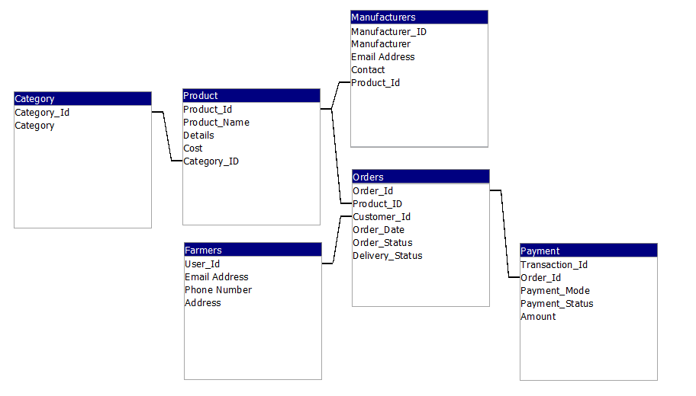

**Question 7: Data Flow Diagram**

A Data flow Diagram is a graphical representation of flow of data within a system. It shows how a data will move from one process to another.

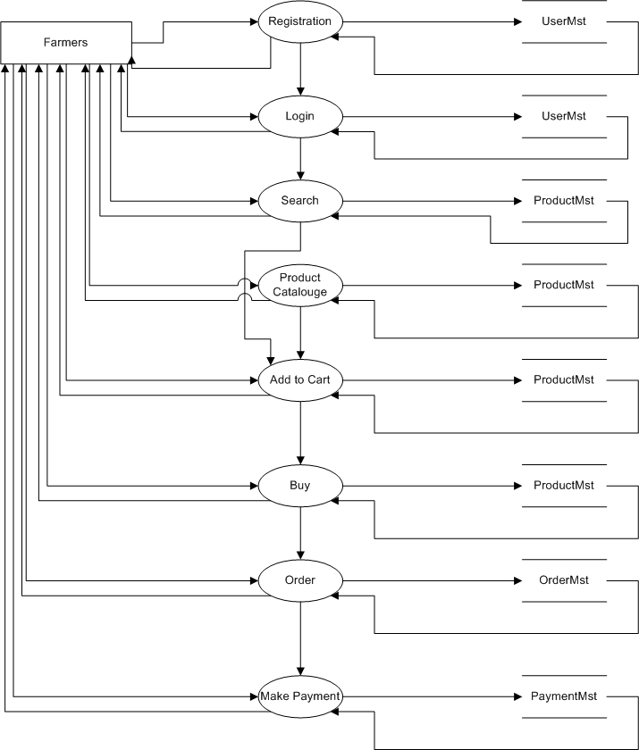

**Question 8: Change Request**

To Handle a change request:

* We should first understand the differences in previous and current Tax structure and document the change request.
* Do Impact Analysis.
* Prioritize the change request based on its impact on project and budget.
* Seek approval from sponsors.
* Communicate the impact and importance of change request to stakeholders and project team.
* Implement the request.

**Question 9: Change Request Vs an Enhancement**

* A change request is a formal proposal to make changes in an existing software or product. It is requested due to reasons like Defects or bugs, change in requirement, changes in regulations, etc. It addresses the components that are either not working as expected or needs to be modified as per change in scenarios.
* Enhancement on the other hand is a proposal to add new features beyond the scope. It aims to improve overall value, performance or usability of the product or software.

In this project, the stakeholders have requested to add a feature where farmers could display and sell their crops to general public. As this was not the part of original requirement, I would consider it as an Enhancement.

**Question 10: Estimations – Man Hours.**

A project sizes are measured in Man-hours. There are 3 sizes of projects:

* Small Projects: Up to 500 Man-Hours
* Medium Projects: 500 – 1000 Man-Hours
* Large Projects: Above 1000 Man-Hours

Our Project is of 18 Months and includes 11 team members. Therefore, this is a large-scale project.

**Question 11: UAT**

User Acceptance Testing is a phase in SDLC. In this phase, stakeholders test the software and its functionalities to ensure that the requirement is met before the deployment of project.

UAT acceptance process is a structured approach to ensure that the system meets the requirement before it is released to production. The steps are:

* Planning:
  + Define Acceptance Criteria
  + Develop UAT plan.
  + Create Test Case and Scenarios.
  + Prepare test data and environment.
* UAT Execution:
  + Conduct Testing
  + Record and track defects.
* Evaluation and Sign-off:
  + Analyze test results
  + Defect resolution
  + Obtain User Sign-off
  + Documentation

**Question 12. Project Closure Document**

The Project Closure document, also known as a Project Closure Report, is a formal record that signifies the completion of a project. It serves as a final assessment, summarizing the project's performance and officially closing it. Its key aspects are:

* Project Overview
* Project Performance
* Deliverable’s review
* Financial Summary
* Lesson learned
* Administrative Closure
* Stakeholder Sign-offs
* Recommendations