***Question 1: Audits – 5 marks***

Four quarterly audits are planned Q1, Q2, Q3, and Q4 for this project. What is your knowledge on how these audits will happen for a BA?

|  |  |
| --- | --- |
| Stage | Quarter 1 – requirement validation and documentation review |
| Completed | Week 1 to Week 20 |
| Checklist | * Business requirement document (BRD) * System requirement specifications (SRS) * UML Diagrams * Business to functional requirements mapping * Email communication list: To, CC and BCC * Client sign off documents * RTM document version control * Email communications – To, CC and BCC |
| BA Responsibilities | * Ensure all requirements are well documented. * Align with SOONY and development team. * Identify missing requirements or risks. |

|  |  |
| --- | --- |
| Stage | Quarter 2 – design and initial development audit |
| Completed | Week 30 to Week 37 |
| Checklist | * Utilization of tools * Documented evidence on client communication * Stakeholder MOM * UI / UX design compliance * Data flow and process flow audit * Development milestone check * Review changes and impact analysis |
| BA Responsibilities | * Validate process models and wireframes. * Ensure developers align with the requirements. * Monitor scope changes. * Update traceability matrix. |

|  |  |
| --- | --- |
| Stage | Quarter 3 – development and testing compliance audit |
| Completed | Week 40 to Week 60 |
| Checklist | * JAD Sessions report * End user-manual preparation * BA and developer MOM * Code review and compliance with requirements * Functional and integration testing review * Defect management and risk assessment |
| BA Responsibilities | * Track requirement to test case coverage * Verify defect resolution alignment with requirements * Assess system performance and usability issues. |

|  |  |
| --- | --- |
| Stage | Quarter 4 – UAT & Deployment Readiness Audit |
| Completed | Week 58 to Week 78 |
| Checklist | * User Acceptance Testing (UAT) Report * Stakeholder Feedback Review * Final Documentation Review * Deployment & Post-Launch Plan Verification |
| BA Responsibilities | * Ensure all UAT feedback is addressed * Validate training materials for farmers/suppliers * Prepare business impact analysis for SOONY |

***Question 2: BA Approach Strategy – 6 marks***

What elicitation techniques to apply in this project?

|  |  |
| --- | --- |
| Technique | Why to use? |
| Interviews | Directly gather insights from key stakeholders on project goals, expectations, and pain points. |
| Workshops | Collaborative discussions to refine system workflows, payment processes, and logistics. |
| Observation | Understand how farmers currently procure products and the challenges they face. |
| Surveys & Questionnaires | Collect large-scale feedback from farmers on digital platform usability, preferences, and features. |
| Focus Groups | Gather qualitative feedback from select farmers and suppliers on pricing, order processing, and ease of use. |
| Document Analysis | Study existing procurement policies, government agricultural schemes, and competitor platforms. |
| Prototyping | Provide a mock-up of the online store to validate usability before development. |
| Brainstorming | Generate new ideas for platform features and business model innovations. |

How to do stakeholder analysis RACI?

|  |  |  |  |  |  |  |  |  |
| --- | --- | --- | --- | --- | --- | --- | --- | --- |
| Project Activity | Sponsor (Mr. Henry) | SOONY Finance (Mr. Pandu) | Project Manager | BA | Developers | Testers | Farmers & Suppliers | Customer Support |
| Requirement Gathering | A | C | R | R | I | I | C | I |
| Business Model Finalization | A | R | C | C | I | I | C | I |
| System Design & Architecture | I | I | A | R | R | I | C | I |
| Development | I | I | A | C | R | I | I | I |
| Testing & Quality Assurance | I | I | A | C | C | R | C | I |
| User Acceptance Testing (UAT) | I | I | A | R | C | R | C | I |
| Deployment & Go-Live | A | I | R | C | R | C | I | C |
| Post-Launch Support & Maintenance | I | I | A | C | R | R | I | R |

What documents to write?

1. Business Case Document: Justifies why the project is initiated (problem, solution, benefits, ROI, risks).
2. Project Charter: Defines project scope, objectives, stakeholders, budget, and timeline.
3. Stakeholder Analysis & RACI Matrix: Identifies key stakeholders and assigns roles/responsibilities.
4. Requirement Elicitation Report: Summarizes findings from interviews, surveys, and workshops.
5. Business Requirements Document (BRD): Defines business needs, goals, and high-level requirements.
6. Software Requirements Specification (SRS): Detailed functional & non-functional system requirements.
7. Use Case Document: Describes system interactions between users and the platform.
8. Process Flow Diagrams (UML, BPMN): Visualizes workflows for purchasing, payment, order tracking, etc.
9. Data Flow Diagrams (DFD): Shows how data moves within the system (users, products, transactions).
10. User Interface Wireframes & Prototypes: Initial screen designs to validate UI/UX before development.
11. Functional Specification Document (FSD): Maps functional requirements to system design.
12. Technical Specification Document (TSD): Defines architecture, database, APIs, and security standards.
13. Traceability Matrix (RTM): Links requirements to test cases for validation.
14. Test Plan & Test Cases: Defines testing strategy, test cases, expected results.
15. Defect Log: Tracks and documents bugs/issues found during testing.
16. User Acceptance Testing (UAT) Plan: Defines UAT process, participants, and success criteria.
17. Training Manuals & User Guides: Guides for farmers, suppliers, and support teams.
18. Deployment Plan: Steps for migrating system from test to production.
19. Change Management Plan: Handles process transitions & minimizes user resistance.
20. Post-Launch Support Plan: Defines issue resolution, monitoring, and system updates.
21. Quarterly Audit Reports (Q1, Q2, Q3, Q4): Ensures compliance, tracks issues, and process improvements.
22. Lessons Learned Document: Captures successes, failures, and recommendations for future projects.

What process to follow to sign off on documents?

* Step 1: Identify Required Signatories
  + Determine who must approve the document based on the RACI Matrix.
  + Common signatories include:
    - Business Sponsor (Mr. Henry)
    - Financial Head (Mr. Pandu)
    - Project Manager (Mr. Vandanam)
    - Developers (for technical documents)
    - Testers (for QA-related documents)
    - End-Users (Farmers & Suppliers for UAT documents)
* Step 2: Draft & Review the Document
  + Prepare the first draft based on stakeholder requirements.
  + Conduct internal reviews with relevant teams (e.g., Developers, Testers, Architects).
  + Address feedback before sending it for formal approval
* Step 3: Distribute for Review & Approval
  + Send the document to all stakeholders for review.
  + Use email, document management tools (SharePoint, Confluence, Google Docs), or project management software (JIRA, Trello).
  + Set a deadline for review and response.
* Step 4: Address Feedback & Make Revisions
  + Gather feedback via meetings, email comments, or collaborative tools.
  + Make necessary changes and update the document version.
  + Maintain a version history to track updates.
* Step 5: Formal Approval & Sign-Off
  + Once all feedback is incorporated, request final approval.
  + Obtain written confirmation via email or digital signatures (DocuSign, Adobe Sign).
  + Store the approved version in a centralized repository for future reference.
* Step 6: Communicate Final Sign-Off
  + Inform all relevant stakeholders that the document is finalized and approved.
  + Update the traceability matrix to ensure alignment with project phases.
  + Restrict further edits unless a formal change request is raised.

How to take approvals from the client?

Identify What Needs Approval:

* Key documents include BRD, SRS, Design Prototypes, UAT Results, and Deployment Plan.

Prepare & Share the Document:

* Ensure clarity, accuracy, and completeness.
* Send via email, project management tools (JIRA, SharePoint), or cloud storage (Google Drive).
* Specify approval deadline and key highlights for easy review.

Conduct a Review Meeting (If Needed):

* Walk the client (Mr. Henry & SOONY team) through the document.
* Address questions, concerns, and requested changes.

Revise & Finalize:

* Incorporate feedback and maintain version control.
* Send the final version for confirmation.

Obtain Formal Approval:

* Request written approval via email or digital signature (DocuSign, Adobe Sign).
* Store signed copies for future reference.

What communication channels to establish?

Emails & Official Documents – For approvals, formal updates, and sign-offs.  
Meetings (Zoom, MS Teams, Google Meet) – For stakeholder discussions, requirement gathering, and status updates.  
Project Management Tools (JIRA, Trello, Asana) – For task tracking and issue management.  
Instant Messaging (Slack, Microsoft Teams, WhatsApp Groups) – For quick clarifications and team coordination.  
Shared Repositories (Google Drive, SharePoint, Confluence) – For document storage and version control.

How to handle change requests?

Receive & Document: Capture requests via emails, meetings, or JIRA, detailing the reason and urgency.  
Analyse Impact: Assess effects on scope, timeline, budget, and resources with developers and testers.  
Seek Approval: Present impact analysis to SOONY leadership for decision-making.  
Implement & Test: Update requirements, modify the system, and conduct regression testing to ensure stability.  
Communicate & Document: Inform stakeholders of changes and update the traceability matrix.

How to update project progress to stakeholders?

To update project progress to stakeholders:

* Send regular emails and official documents for approvals, formal updates, and sign-offs.
* Schedule meetings via Zoom, MS Teams, or Google Meet for stakeholder discussions, requirement gathering, and status updates.
* Utilize project management tools like JIRA, Trello, or Asana for task tracking and issue management.
* Use instant messaging platforms such as Slack, Microsoft Teams, or WhatsApp Groups for quick clarifications and team coordination.
* Regularly update shared repositories like Google Drive, SharePoint, or Confluence with the latest project documents and version control records.

How to take sign off on the UAT – client project acceptance form?

Step 1: Conduct UAT Sessions

* Facilitate hands-on testing with the client (Mr. Henry & SOONY team).
* Document test results, feedback, and defects.

Step 2: Resolve Issues

* Fix critical bugs and conduct retesting.
* Ensure the system meets agreed requirements.

Step 3: Present UAT Report & Acceptance Form

* Share UAT summary, defect resolutions, and final test results.
* Attach the Client Project Acceptance Form for approval.

Step 4: Obtain Formal Sign-Off

* Request written approval via email or digital signature (DocuSign, Adobe Sign).
* Store signed forms for compliance and future reference.

***Question 3: explain and illustrate 3 tier architecture***

Application layer: Top most layer of the application, also called as the presentation layer – it handles the user interface (UI) components such as screens and pages.

Business Logic Layer: Middle layer of the architecture – acts as the intermediatory between presentation layer and the data storage layer. This layer contains the core logic of the application.

Database Layer: Bottom most layer of the architecture – responsible for storing and retrieving data.



***Application Layer***  
UI Components displayed in the client computers are handled here.



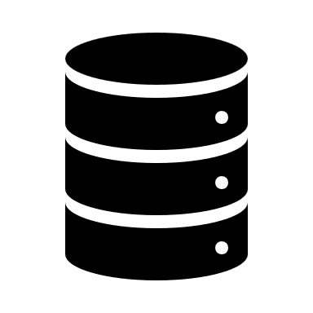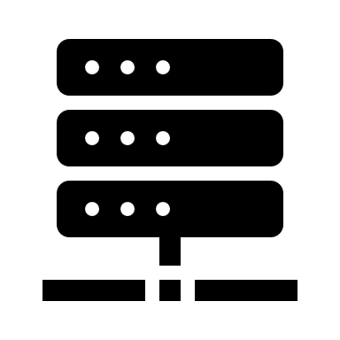

***Database Layer***Responsible for storing and retrieving data

***Business Logic Layer***  
Core logic of the application is stored in the application servers here.

***Question 4 – BA Approach Strategy for Framing Questions***

1. 5W 1H (Who, What, When, Where, Why, How)

* Who will use the system? (Farmers, suppliers, SOONY team)
* What are the key pain points and expectations?
* When should each feature be available? (Timelines)
* Where will the platform be accessed? (Web/Mobile)
* Why is the requirement necessary? (Business impact)
* How will it be implemented? (Technical feasibility)

2. SMART Approach *(Specific, Measurable, Achievable, Relevant, Time-bound)*

* Questions should be specific & measurable (e.g., "How many suppliers should be onboarded initially?")
* Requirements should be achievable & relevant to business needs.
* Ensure a time-bound scope to avoid delays.

3. RACI Framework (Responsible, Accountable, Consulted, Informed)

* Identify which stakeholders are Responsible (R), Accountable (A), Consulted (C), and Informed (I) before questioning.
* Example: Farmers & suppliers consulted on usability, while SOONY’s finance team is accountable for pricing models.

4. 3-Tier Architecture Awareness

* Ensure clarity on UI (Frontend), Business Logic (Backend), and Database (Data Storage).
* Example: "How should product categories be structured for easy navigation?"

5. Use Cases, Models & Diagrams

* Frame questions around Use Cases, Use Case Specs, Activity Diagrams, and UI Page Designs.
* Example: “What happens if a farmer cancels an order? Should refunds be automated?”

***Question 5 – Elicitation Techniques - 6 Marks***

As a Business Analyst, What Elicitation Techniques you are aware of?

|  |  |
| --- | --- |
| Technique | Definition |
| Brainstorming | A group discussion technique to generate innovative ideas and solutions. |
| Document Analysis | Reviewing existing documents to gather system requirements and business rules. |
| Reverse Engineering | Analysing an existing system to understand its functionality and derive requirements. |
| Focus Groups | A guided discussion with selected stakeholders to gather feedback and insights. |
| Observation | Watching users interact with a system or process to understand workflows and challenges. |
| Workshops | Interactive sessions with stakeholders to collaboratively define requirements and solutions. |
| JAD (Joint Application Development) | A structured workshop involving users, developers, and business teams for rapid requirement gathering. |
| Interview | A one-on-one or group discussion to collect detailed stakeholder requirements. |
| Prototype | A visual or interactive mock-up of a system to validate requirements before development. |
| Questionnaire | A structured set of questions to collect quantitative or qualitative data from stakeholders. |
| Use Case Specs | Detailed descriptions of system interactions between users and functionalities. |

***Question 6 – This project Elicitation Techniques - 5 Marks***

1. Interviews*(For Stakeholder Alignment)*

Why?

* Helps gather detailed business requirements from Mr. Henry, SOONY’s leadership, farmers, and suppliers.
* Allows one-on-one discussions to understand key pain points and expectations.

2. Workshops *(For Requirement Finalization & Consensus)*

Why?

* Facilitates collaborative requirement gathering among stakeholders.
* Ensures faster decision-making for system workflows and pricing models.

3. Document Analysis *(For Understanding Existing Processes & Compliance)*

Why?

* Helps analyse government agricultural policies, existing procurement methods, and competitor platforms.
* Ensures legal and regulatory compliance in the platform’s design.

4. Prototyping *(For UI/UX Validation & User Experience Testing)*

Why?

* Helps stakeholders visualize the platform (order placement, payments, delivery tracking).
* Ensures usability before full-scale development.

5. Observation (Job Shadowing) *(For Understanding Farmer Challenges)*

Why?

* Provides real-world insights into how farmers currently purchase seeds, fertilizers, and pesticides.
* Helps design a user-friendly digital experience for first-time users.

6. Focus Groups *(For Gathering User Preferences & Expectations)*

Why?

* Engages multiple farmers/suppliers in a structured discussion about product selection, pricing, and payment options.
* Helps understand common challenges and feature priorities.

7. Questionnaires & Surveys *(For Large-Scale Input Collection)*

Why?

* Helps collect quantitative & qualitative feedback from farmers on preferred payment modes, order volumes, and logistics expectations.
* Useful for assessing digital literacy levels of end-users.

***Question 7 – 10 Business Requirements- 10 Marks***

BR001: The system shall allow farmers to browse and purchase agricultural products (fertilizers, seeds, pesticides) from multiple suppliers.

BR002: The platform shall support multiple payment methods, including UPI, debit/credit cards, net banking, and cash on delivery (COD).

BR003: The system shall enable order tracking functionality, allowing farmers to check delivery status in real time.

BR004: Suppliers shall be able to list, update, and manage their products, inventory, and pricing dynamically.

BR005: The platform shall provide multilingual support (English, Hindi, and regional languages) to accommodate farmers across different regions.

BR006: The system shall allow farmers to rate and review products to enhance transparency and trust.

BR007: The platform shall include a dashboard for SOONY and suppliers to track sales, revenue, and customer orders.

BR008: The system shall integrate with logistics partners for delivery management, including estimated delivery timelines and tracking.

BR009: The platform shall comply with government agricultural regulations and allow for subsidy-based pricing when applicable.

BR010: The system shall provide customer support via live chat, email, and phone assistance to help farmers navigate the platform.

***Question 8 –Assumptions- 5 Marks***

Target Users: The platform will primarily serve farmers in remote areas and agricultural suppliers (fertilizer, seed, pesticide manufacturers).

Platform Accessibility: The system will be available on both web and mobile (Android & iOS) for ease of access.

User Digital Literacy: Farmers may have limited technical knowledge, so the platform must be user-friendly with simple navigation and multilingual support.

Payment Methods: The platform will support UPI, debit/credit cards, net banking, and cash-on-delivery (COD).

Order Management: Farmers should be able to track orders in real time, and suppliers should manage inventory and product availability dynamically.

Product Transparency: Product ratings and reviews will be available for farmers to make informed decisions.

Logistics & Delivery: The system will integrate with third-party delivery partners for seamless transportation of goods.

Government Regulations: The platform must comply with agricultural and e-commerce regulations, including potential subsidy integrations for farmers.

Customer Support: Farmers and suppliers will have access to live chat, email, and phone support for issue resolution.

Performance & Scalability: The system must handle a large number of concurrent users and scale as adoption increases.

***Question 9 – This project Requirements Priority - 8 Marks***

|  |  |  |  |
| --- | --- | --- | --- |
| Req ID | Req Name | Req Description | Priority (1-10) |
| BR001 | Product Browsing & Purchase | The system shall allow farmers to browse and purchase agricultural products (fertilizers, seeds, pesticides) from multiple suppliers. | 10 |
| BR002 | Payment Methods Integration | The platform shall support multiple payment methods, including UPI, debit/credit cards, net banking, and cash on delivery (COD). | 9 |
| BR003 | Order Tracking | The system shall enable order tracking functionality, allowing farmers to check delivery status in real time. | 8 |
| BR004 | Supplier Product Management | Suppliers shall be able to list, update, and manage their products, inventory, and pricing dynamically. | 9 |
| BR005 | Multilingual Support | The platform shall provide multilingual support (English, Hindi, and regional languages) to accommodate farmers across different regions. | 8 |
| BR006 | Product Reviews & Ratings | The system shall allow farmers to rate and review products to enhance transparency and trust. | 7 |
| BR007 | Sales & Order Dashboard | The platform shall include a dashboard for SOONY and suppliers to track sales, revenue, and customer orders. | 8 |
| BR008 | Logistics & Delivery Integration | The system shall integrate with logistics partners for delivery management, including estimated delivery timelines and tracking. | 9 |
| BR009 | Government Compliance & Subsidy Integration | The platform shall comply with government agricultural regulations and allow for subsidy-based pricing when applicable. | 7 |
| BR010 | Customer Support Services | The system shall provide customer support via live chat, email, and phone assistance to help farmers navigate the platform. | 9 |

***Question 10 – Use Case Diagram - 10 Marks***

***Question 11 – (minimum 5) Use Case Specs - 15 Marks***

Use Case: Browse & Select Products

|  |  |
| --- | --- |
| Use Case ID | UC001 |
| Use Case Name | Browse & Select Products |
| Actors | Farmer |
| Preconditions | The farmer must be logged in. |
| Postconditions | Products are added to the shopping cart. |
| Flow of Events | 1. Farmer searches for products. |
|  | 2. System displays results. |
|  | 3. Farmer selects a product. |
|  | 4. System shows details and reviews. |
|  | 5. Farmer adds the product to the cart. |
| Exceptions | - If no products match the search, an error message is shown. |
|  | - If an item is out of stock, a notification is displayed. |

Use Case: Place an Order

|  |  |
| --- | --- |
| Use Case ID | UC002 |
| Use Case Name | Place an Order |
| Actors | Farmer |
| Preconditions | Farmer has products in the shopping cart. |
| Postconditions | Order is placed, and a confirmation is sent. |
| Flow of Events | 1. Farmer goes to the cart and clicks “Checkout.” |
|  | 2. System asks for a delivery address. |
|  | 3. Farmer selects a payment method. |
|  | 4. System validates the order and stock. |
|  | 5. System processes the order and generates an order ID. |
|  | 6. Farmer receives an order confirmation. |
| Exceptions | - Payment fails → Prompt the farmer to retry. |
|  | - Item out of stock → Notify the farmer. |

Use Case: Make Payment

|  |  |
| --- | --- |
| Use Case ID | UC003 |
| Use Case Name | Make Payment |
| Actors | Farmer, Payment Gateway |
| Preconditions | The order must be confirmed. |
| Postconditions | Payment is completed, and the order is processed. |
| Flow of Events | 1. Farmer selects a payment method. |
|  | 2. System redirects to the Payment Gateway. |
|  | 3. Farmer enters payment details. |
|  | 4. Payment Gateway validates the transaction. |
|  | 5. System updates payment status. |
|  | 6. Order confirmation is sent. |
| Exceptions | - Payment fails → System prompts the farmer to retry or select another method. |

Use Case: Track Order

|  |  |
| --- | --- |
| Use Case ID | UC004 |
| Use Case Name | Track Order |
| Actors | Farmer, Logistics Partner |
| Preconditions | The order must be shipped. |
| Postconditions | The farmer receives real-time updates. |
| Flow of Events | 1. Farmer logs in and navigates to "My Orders." |
|  | 2. System fetches order details. |
|  | 3. Logistics partner updates status (Dispatched, In Transit, Delivered). |
|  | 4. System displays tracking details. |
| Exceptions | - Tracking system unavailable → Show the last known order status. |

Use Case: Supplier Manages Inventory

|  |  |
| --- | --- |
| Use Case ID | UC005 |
| Use Case Name | Supplier Manages Inventory |
| Actors | Supplier |
| Preconditions | Supplier must be logged in. |
| Postconditions | Product stock is updated in real time. |
| Flow of Events | 1. Supplier logs in. |
|  | 2. Navigates to the product catalog. |
|  | 3. Selects a product to update stock. |
|  | 4. System updates the stock and reflects changes to buyers. |
| Exceptions | - If the update fails, an error message is displayed. |

Use Case: Supplier Processes Orders

|  |  |
| --- | --- |
| Use Case ID | UC006 |
| Use Case Name | Supplier Processes Orders |
| Actors | Supplier |
| Preconditions | Orders must be placed by farmers. |
| Postconditions | Orders are shipped. |
| Flow of Events | 1. Supplier logs in. |
|  | 2. Navigates to "Orders." |
|  | 3. Accepts and prepares the order. |
|  | 4. Marks the order as "Ready for Pickup." |
|  | 5. Logistics partner picks up the order. |
| Exceptions | - If logistics fails to pick up, an alert is sent. |

Use Case: SOONY Admin Manages Users

|  |  |
| --- | --- |
| Use Case ID | UC007 |
| Use Case Name | SOONY Admin Manages Users |
| Actors | SOONY Admin |
| Preconditions | Admin must be logged in. |
| Postconditions | Users are approved, deactivated, or managed. |
| Flow of Events | 1. Admin logs in. |
|  | 2. Views a list of farmers and suppliers. |
|  | 3. Approves or deactivates accounts. |
|  | 4. Updates user roles if needed. |
| Exceptions | - If admin access fails, system prompts for re-authentication. |

Use Case: Customer Support Handling Complaints

|  |  |
| --- | --- |
| Use Case ID | UC008 |
| Use Case Name | Customer Support Handling Complaints |
| Actors | Farmer, SOONY Support Team |
| Preconditions | Farmer must have an issue related to an order or product. |
| Postconditions | Complaint is registered and resolved. |
| Flow of Events | 1. Farmer logs in and submits a complaint. |
|  | 2. System assigns a ticket ID. |
|  | 3. Support team reviews and resolves the issue. |
|  | 4. Farmer receives resolution notification. |
| Exceptions | - If no response is received, escalate the issue. |

Use Case: Product Reviews & Ratings

|  |  |
| --- | --- |
| Use Case ID | UC009 |
| Use Case Name | Product Reviews & Ratings |
| Actors | Farmer |
| Preconditions | The order must be marked as "Delivered." |
| Postconditions | Review is published for other buyers to see. |
| Flow of Events | 1. Farmer logs in and navigates to "My Orders." |
|  | 2. Selects an order to review. |
|  | 3. Provides a star rating and feedback. |
|  | 4. System updates the product rating. |
| Exceptions | - If a review violates platform policies, it is flagged. |

Use Case: Generate Sales & Order Reports

|  |  |
| --- | --- |
| Use Case ID | UC010 |
| Use Case Name | Generate Sales & Order Reports |
| Actors | SOONY Admin, Suppliers |
| Preconditions | Sales and order data must be available. |
| Postconditions | A sales report is generated and stored. |
| Flow of Events | 1. Admin logs in and selects "Reports." |
|  | 2. Chooses a date range and report type. |
|  | 3. System fetches and generates the report. |
|  | 4. Report is available for download. |
| Exceptions | - If no data is found, system displays "No records available." |

***Question 12 – (minimum 5) Activity Diagrams - 15 Marks***

Activity – farmer buying process:

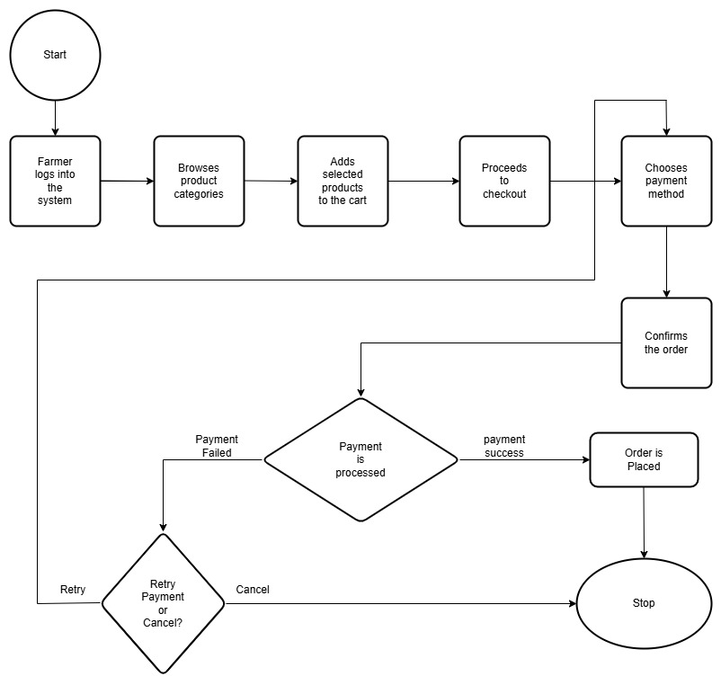

Activity – Order Processing by Supplier

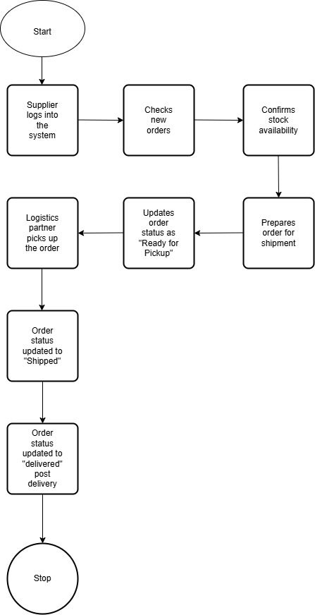

Activity Diagram: Order Tracking

Activity Diagram: Customer Support Request

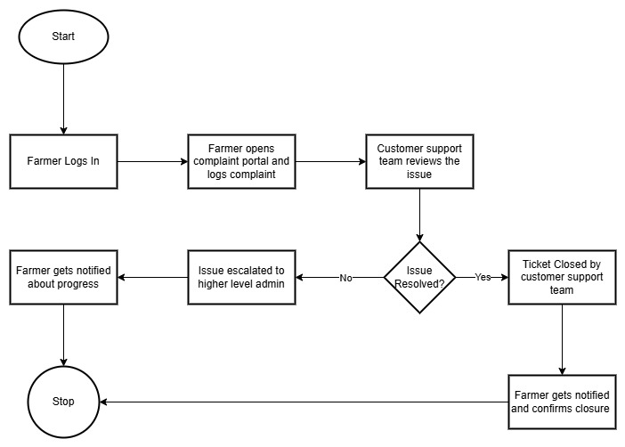

Activity Diagram: Product information request

