Q.1. Write Agile Manifesto.
Ans. Agile Manifesto
Four Main Values:
- Individuals and interactions over processes and tools
- Working software over comprehensive documentation
- Customer collaboration over contract negotiation
- Responding to change over following a plan
Twelve Principles of Agile Software:
- Satisfy the customer through early and continuous delivery of valuable software.
- Welcome changing requirements, even late in development. Agile processes harness change for the customer's competitive advantage.
- Deliver working software frequently, from a couple of weeks to a couple of months, with a preference to the shorter timescale.
- Business people and developers must work together daily throughout the project.
- Build projects around motivated individuals. Give them the environment and support they need, and trust them to get the job done.
- The most efficient and effective method of conveying information to and within a development team is face-to-face conversation.
- Working software is the primary measure of progress.
- Agile processes promote sustainable development. The sponsors, developers, and users should be able to maintain a constant pace indefinitely.
- Continuous attention to technical excellence and good design enhances agility.
- Simplicity — the art of maximizing the amount of work not done — is essential.
- The best architectures, requirements, and designs emerge from self-organizing teams.
- At regular intervals, the team reflects on how to become more effective, then tunes and adjusts its behaviour accordingly.
Q.2. Write minimum 40 User stories and their Acceptance Criteria along with their BV and CP.
User Story No: 1 | Tasks: 02 | Priority: High
As a customer,
I want to register,
so that I can order food online.
BV: 500 | CP: 02
Acceptance Criteria:

Fields for Name, Email, Mobile, Address, and Password; Register button; Input validation; Success message
Ans.

User Story No: 2 | Tasks: 02 | Priority: High
As a customer,
I want to login,
so that I can access my profile and order history.
BV: 500 | CP: 02
Acceptance Criteria:

Login screen with Email and Password fields; Login button; Success and error responses

User Story No: 3 | Tasks: 02 | Priority: High
As a customer,
I want to search for restaurants by cuisine,
so that I can find food I like.
BV: 500 | CP: 03
Acceptance Criteria:

Search bar; Cuisine filter dropdown; Search results listing matching restaurants

User Story No: 4 | Tasks: 02 | Priority: High
As a customer,
I want to view restaurant menus,
so that I can choose what to order.
BV: 500 | CP: 02
Acceptance Criteria:

Restaurant menu listing; Sectioned by category; Prices displayed

User Story No: 5 | Tasks: 02 | Priority: High
As a customer,
I want to add items to cart,
so that I can place a bulk order.
BV: 500 | CP: 02
Acceptance Criteria:

“Add to cart” button on menu items; Quantity adjuster; Cart page showing selected items

User Story No: 6 | Tasks: 02 | Priority: Medium
As a customer,
I want to apply coupon codes,
so that I can get discounts.
BV: 200 | CP: 03
Acceptance Criteria:

Input box for coupon code; Apply button; Real-time discount update; Error for invalid codes

User Story No: 7 | Tasks: 02 | Priority: High
As a customer,
I want to select delivery address,
so that I can receive the order at a specific location.
BV: 500 | CP: 02
Acceptance Criteria:

Address selection screen; Add new address form with validation; Save button

User Story No: 8 | Tasks: 02 | Priority: High
As a customer,
I want to choose a payment mode,
so that I can pay conveniently.
BV: 500 | CP: 03
Acceptance Criteria:

Radio buttons for payment options; Pay button; Success/failure notification

User Story No: 9 | Tasks: 03 | Priority: High
As a customer,
I want to have real-time order tracking,
so that I know delivery progress.
BV: 1000 | CP: 05
Acceptance Criteria:

Radio buttons for payment options; Pay button; Success/failure notification

User Story No: 10 | Tasks: 02 | Priority: Medium
As a customer,
I want to rate the order,
so that I can share my experience.
BV: 200 | CP: 02
Acceptance Criteria:

Star rating selection; Comment box; Submit button; Confirmation message

User Story No: 11 | Tasks: 02 | Priority: High
As a Delivery Boy,
I want to register,
so that I can join the platform.
BV: 500 | CP: 02
Acceptance Criteria:

Form fields, ID upload, Register button, confirmation notification

User Story No: 12 | Tasks: 02 | Priority: Medium
As a Delivery Boy,
I want to login,
so that I can access my dashboard.
BV: 200 | CP: 01
Acceptance Criteria:

Mobile/Email login, authentication, error messages

User Story No: 13 | Tasks: 02 | Priority: High
As a Delivery Boy,
I want to view available orders,
so that I can accept them.
BV: 500 | CP: 03
Acceptance Criteria:

Order list view, accept/reject buttons, auto-refresh

User Story No: 14 | Tasks: 02 | Priority: High
As a Delivery Boy,
I want to update the delivery status,
so that I can inform the customers.
BV: 500 | CP: 03
Acceptance Criteria:

Status stages, update button, timestamped

User Story No: 15 | Tasks: 02 | Priority: Medium
As a Delivery Boy,
I want to view delivery history,
so that I can track past tasks.
BV: 200 | CP: 02
Acceptance Criteria:

Filter by date, order list, export option

User Story No: 16 | Tasks: 02 | Priority: Medium
As a Delivery Boy,
I want to raise issues,
so that support can resolve them.
BV: 100 | CP: 02
Acceptance Criteria:

Issue form, optional image upload, submit, confirmation

User Story No: 17 | Tasks: 02 | Priority: High
As a Restaurant Owner,
I want to register,
so that I can list my kitchen.
BV: 500 | CP: 03
Acceptance Criteria:

Business details, license upload, confirm submission

User Story No: 18 | Tasks: 02 | Priority: Medium
As a Restaurant Owner,
I want to update my menu,
so that it’s always current.
BV: 200 | CP: 02
Acceptance Criteria:

Add/Edit/Delete items, price/availability updates

User Story No: 19 | Tasks: 02 | Priority: High
As a Restaurant Owner,
I want to view orders,
so that I can prepare them.
BV: 500 | CP: 02
Acceptance Criteria:

Live order feed, filters, details view

User Story No: 20 | Tasks: 02 | Priority: High
As a Restaurant Owner,
I want to assign delivery boys,
so that orders are dispatched quickly.
BV: 500 | CP: 03
Acceptance Criteria:

Assign dropdown, confirm button, notification

User Story No: 21 | Tasks: 02 | Priority: High
As a Regional Admin,
I want to track restaurant performance,
so that I can optimize business.
BV: 300 | CP: 03
Acceptance Criteria:

Restaurant list; performance metrics; exportable Excel report

User Story No: 22 | Tasks: 02 | Priority: High
As a Regional Admin,
I want to track delivery performance,
so that I can monitor SLAs.
BV: 300 | CP: 03
Acceptance Criteria:

Dashboard with filters by delivery boy/date; summary and trend data

User Story No: 23 | Tasks: 02 | Priority: Medium
As a Regional Admin,
I want to handle complaints,
so that regional disputes are managed.
BV: 200 | CP: 02
Acceptance Criteria:

View complaint tickets; respond/comment; change status to resolved

User Story No: 24 | Tasks: 02 | Priority: High
As an Admin,
I want to approve restaurants,
so that quality control is ensured
BV: 500 | CP: 03
Acceptance Criteria:

Pending registrations list; document view; approve/reject action; notification

User Story No: 25 | Tasks: 02 | Priority: High
As an Admin,
I want to manage user accounts,
so that platform integrity is maintained.
BV: 500 | CP: 03
Acceptance Criteria:

User list; search; suspend/reactivate options; system-generated alerts

User Story No: 26 | Tasks: 02 | Priority: Medium
As a customer,
I want to reorder past meals,
so that I can save time.
BV: 200 | CP: 02
Acceptance Criteria:

Order history view; reorder button; confirmation and auto-cart update

User Story No: 27 | Tasks: 02 | Priority: Medium
As a customer,
I want to schedule an order,
so that food arrives when I want it.
BV: 200 | CP: 03
Acceptance Criteria:

Select date/time; modify window; automated reminder or alert

User Story No: 28 | Tasks: 02 | Priority: High
As a customer,
I want to have support access,
so that I can get help.
BV: 500 | CP: 03
Acceptance Criteria:

Live chat window; support ticket creation; response history

User Story No: 29 | Tasks: 02 | Priority: Medium
As a Restaurant Owner,
I want to view earnings,
so that I can analyse income.
BV: 300 | CP: 03
Acceptance Criteria:

Date filter; earnings summary; PDF/Excel download option

User Story No: 30 | Tasks: 02 | Priority: Medium
As a Delivery Boy,
I want to view earnings,
so that I can track payouts.
BV: 300 | CP: 02
Acceptance Criteria:

Weekly payment summary; order-level breakdown; invoice option

User Story No: 31 | Tasks: 02 | Priority: High
As a Business Owner,
I want to view KPIs,
so that I can track overall platform health.
BV: 1000 | CP: 04
Acceptance Criteria:

Dashboard showing orders, users, income, growth, charts

User Story No: 32 | Tasks: 02 | Priority: Medium
As a Business Owner,
I want to manage promotional banners,
so that I can highlight deals.
BV: 300 | CP: 03
Acceptance Criteria:

Upload image; schedule visibility; deactivate options

User Story No: 33 | Tasks: 02 | Priority: Medium
As a customer,
I want to filter dishes by dietary preferences,
so that I can choose suitable meals.
BV: 200 | CP: 03
Acceptance Criteria:

Filters for veg, vegan, gluten-free, etc.; tag-based sorting

User Story No: 34 | Tasks: 02 | Priority: High
As a customer,
I want to see estimated delivery time,
so that I can make informed decisions.
BV: 200 | CP: 02
Acceptance Criteria:

ETA displayed next to each restaurant; auto-update based on distance

User Story No: 35 | Tasks: 02 | Priority: High
As an Admin,
I want to generate platform reports,
so that stakeholders get insights.
BV: 300 | CP: 03
Acceptance Criteria:

Report filters; automatic summary; download in PDF/Excel

User Story No: 36 | Tasks: 02 | Priority: Medium
As a Delivery Boy,
I want to get order notifications,
so that I don’t miss tasks.
BV: 200 | CP: 02
Acceptance Criteria:

Push alerts on dashboard and mobile; vibration setting; acknowledgment

User Story No: 37 | Tasks: 02 | Priority: Low
As a customer,
I want to mark favourite restaurants,
so that I can order from them often.
BV: 200 | CP: 02
Acceptance Criteria:

Heart icon on listings; favourites tab for easy access

User Story No: 38 | Tasks: 02 | Priority: High
As a customer,
I want to cancel an order before it's accepted,
so that I avoid wrong charges.
BV: 300 | CP: 03
Acceptance Criteria:

Cancel option visible until restaurant confirmation; refund process initiated

User Story No: 39 | Tasks: 02 | Priority: Medium
As a Regional Admin,
I want to track refund requests,
so that I can take corrective actions.
BV: 200 | CP: 03
Acceptance Criteria:

Filter by complaint/refund reason; status update; download option

User Story No: 40 | Tasks: 02 | Priority: High
As a customer,
I want to get SMS/email alerts,
so that I am updated on each stage.
BV: 300 | CP: 03
Acceptance Criteria:

Order confirmed, packed, dispatched, delivered; message templates

Q.3. What is epic? Write 2 epics.
Ans. An Epic is a large user story that cannot be completed in a single sprint. It’s broken down into smaller user stories or grouped into themes.
Examples of Epic:
Epic 1: Customer Onboarding and Food Ordering Flow
- Includes registration, searching restaurants, viewing menus, adding to cart, payment, tracking orders.
Epic 2: Restaurant Management & Order Processing
- Includes receiving orders, confirming availability, delivery assignment, revenue tracking, and feedback handling.

Q.4. What is the difference between BV and CP?
Ans.
Aspect | BV (Business Value) | CP (Complexity Points)
Who estimates it? | Stakeholders/clients | Scrum developers
What does it measure? | Value delivered to business | Efforts and technical complexity involved in development
Basis of estimation | Importance of feature to end users | Time, difficulty and risk of implementation

Q.5. Explain about Sprint.
Ans. A Sprint is a short, time-boxed development cycle in the Agile Scrum framework where a team works to deliver a usable product increment. It allows the team to plan, build, inspect, and adapt to continuously improving the product.
Step-by-Step Flow of a Sprint:
Step 1: Sprint Planning
- The sprint planning meeting is conducted at the start of the sprint before development begins. Product owner, scrum master and the whole scrum team attends sprint planning meeting.
- In this meeting, sprint goal and objective is defined. User Stories from product backlog are selected based on team capacity. The selected stories are then broken into tasks and further moved to product backlog items to sprint backlog.
Step 2: Task Allocation
- Tasks are assigned to developers based on their expertise and workload
- Tasks are small enough to be completed within a single Scrum (daily cycle)
Step 3: Start the Sprint
- Team begins working on tasks listed in the Sprint Backlog
- Sprint duration is usually 2 weeks
Step 4: Daily Scrum (Stand-Up Meeting)
- The scrum meeting is conducted on a daily basis for a maximum of 15 minutes
- Scrum Developers and Scrum Master participate in this meeting
- Each developer has to answer some questions:
  - What did you do today?
  - What will you do tomorrow?
  - Are there any impediments or challenges blocking you?
Step 5: Ongoing Development and Tracking
- Work progresses with status moving across columns: To Do → WIP (Work In Progress) → Done
- Track progress using:
  - Sprint Burndown Chart (measures work completed vs. time)
  - Impediment Log (logs any blockers)
Step 6: Sprint Review
- The sprint review takes place at the end of the sprint
- Scrum team, product owner, scrum master, client/stakeholders and anybody interested in sprint can participate in sprint review
- In this meeting, the goal is to demonstrate the shippable product increment.
- In the meeting, few points are discussed as:
  - What was completed
  - Feedback from stakeholders
  - Updated Product Backlog for next sprint
Step 7: Sprint Retrospective
- Only scrum team only can attend sprint retrospective meet while the scrum Master being optional.
- In this meeting, the team reflects on what went well and what did not, identify lessons learned and plan process improvements for next sprint.
The Cycle Then Repeats
- Learnings from the Retrospective are used during the next Sprint Planning
- New PBIs are selected, and a new Sprint begins
Key Deliverables from Each Sprint
- A working product increment
- Updated burndown charts
- Retrospective action points
- Feedback incorporated into the backlog
Q.6. Explain product backlog and sprint back log.
Ans. Product Backlog

The Product backlog is a dynamic, prioritized list of Product Backlog Items (PBIs) that represent all the features, enhancements, bug fixes and technical work needed to build the complete product. It is owned and maintained by the product owner.
Key Characteristics:
- Contains user stories which are often grouped under epics or themes
- Each PBI includes:
  - Business Value (BV) – assigned by stakeholders
  - Complexity Points (CP) – estimated by Scrum developers
- Prioritized using techniques like MoSCoW, Kano, or Business Value ranking
- Continuously refined during Product Grooming sessions
Sprint Backlog
The sprint backlog is a subset of the product backlog that includes all the user stories selected for the current sprint, broken down into tasks that the scrum developers will work on.
Key Characteristics:
- Created during Sprint Planning Meeting
- Includes:
  - Selected PBIs/User Stories
  - Estimated Tasks per user story
  - Movement tracking: To Do → WIP → Done
- Owned and updated by the Scrum Team
- Fixed during the Sprint (but tasks may evolve)
Sprint Backlog Lifecycle:
- Product Owner presents prioritized backlog
- Team selects stories they can deliver based on sprint velocity
- Tasks are prepared and assigned
- During development, updates are made to task status
- At Sprint end: PBIs that are “Done” contribute to Product Increment
Q.7. What is impediments log? write 2 impediments.
Ans. An impediments log is a centralized document or tracking system used in Agile scrum to record, monitor and manage all the challenges, obstacles or blockers faced by the scrum team during a sprint.
It helps the scrum master and team identify anything that is slowing progress so that quick resolutions can be implemented helping ensure smooth sprint delivery.
Characteristics:
- Maintained by the Scrum Master
- Reviewed in Daily Scrum meetings

- May include: date, description, priority, owner, resolution status
Example: Two Sample Impediments
- Impediment 1: Description: “Payment gateway API is unavailable due to vendor outage” Impact: Blocks backend integration task in Sprint 1 Owner: Scrum Master (to coordinate with vendor support) Status: In Progress
- Impediment 2: Description: “Restaurant profile page design not finalized by Product Owner” Impact: Front-end developers are idle for that module Owner: Product Owner (to confirm wireframe approval) Status: Resolved
Q.8. How many CP is covered in this sprint
Ans. In sprint 1 of the scrum foods application, a total of 10 MVP user stories were selected for development. Each of these stories was assigned Complexity Points (CP) based on estimation sessions with the scrum developers using planning poker.
In total, the sprint covered 21 CPs which defines the team's velocity for this initial cycle. This baseline will help in planning and forecasting capacity for upcoming sprints.
Q.9. Draw Sprint Burn Down Charts and Product Burn Down Charts.
Ans. Sprint Burn Down Chart
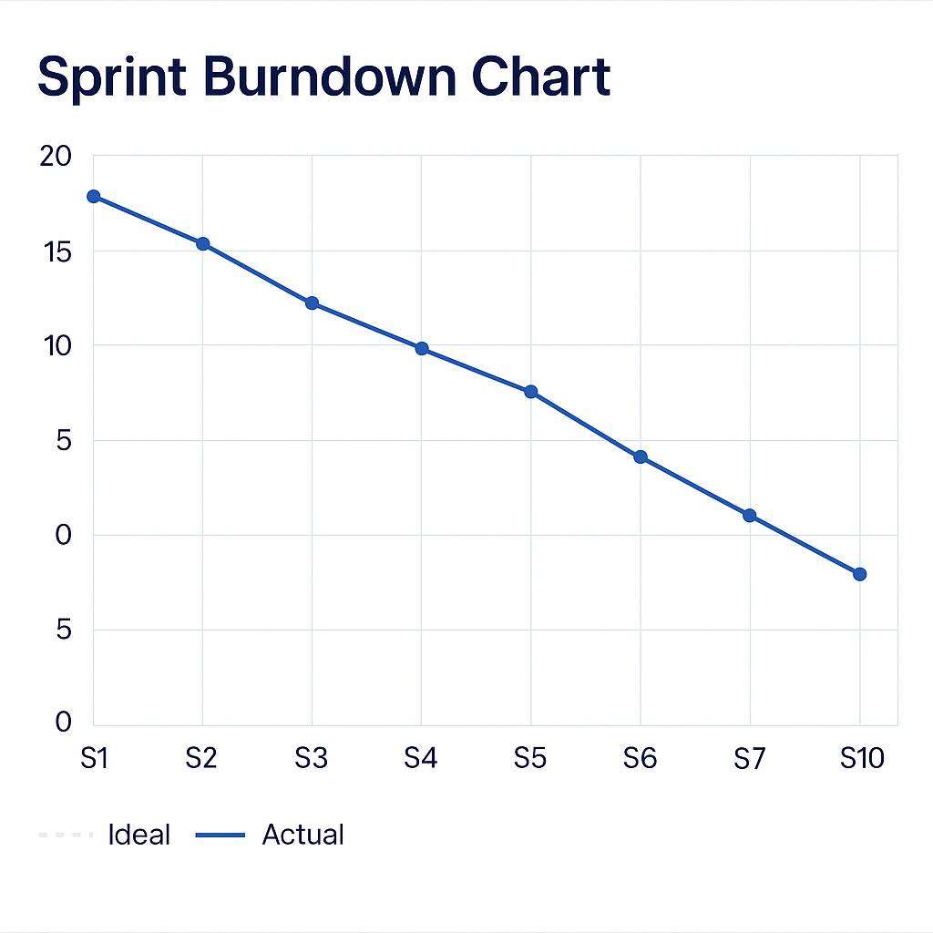
Product Burn Down Chart
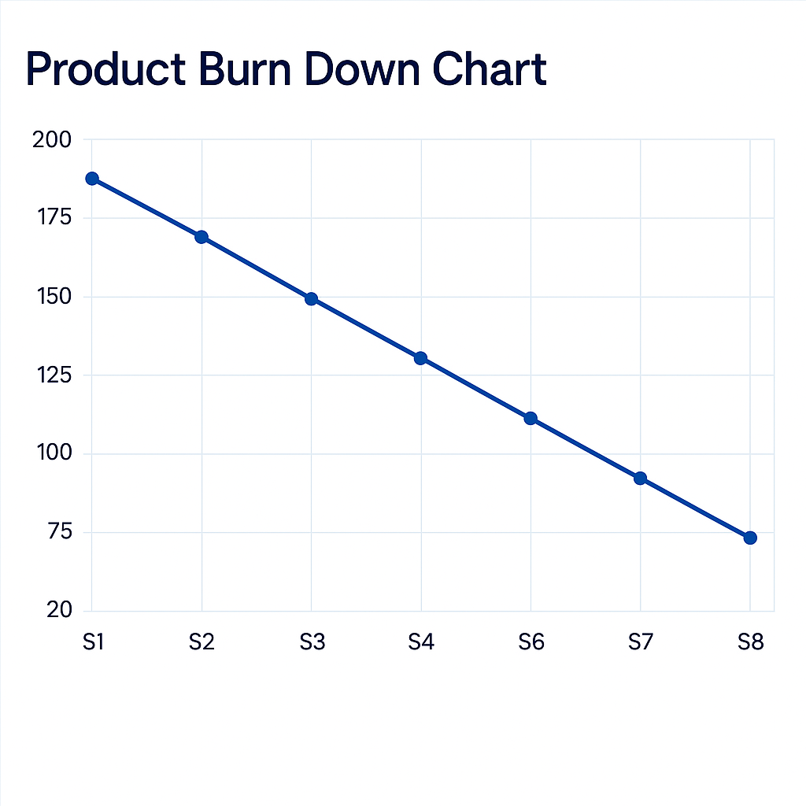
Q.10. Explain about Product Grooming.
Ans. Product grooming also known as backlog refinement is an ongoing scrum activity where the product owner along with the scrum team; reviews, revises and prioritizes items in the product backlog to ensure that it's always up to date, well-defined and ready for upcoming sprint planning meetings.
It’s not a formal Scrum ceremony, but a crucial Agile practice that improves team clarity and Sprint success.
Q.11. Team Experiences with Sprint 1.
Ans. Role of the Scrum Master – Satya Rathnakar
The Scrum Master’s guidance was instrumental in facilitating a smooth workflow. His responsibilities included:
- Sprint Planning Facilitation: Guided all 8 Scrum Developers in understanding the Sprint Goal, sizing the stories, and distributing tasks efficiently.
- Daily Scrum Coordination: Ensured the 15-minute stand-ups were prompt and to the point. Developers answered the three guiding questions—what they did, plan to do, and any blockers.
- Impediments Handling: Two major blockers were quickly addressed:
  - A third-party payment API delay
  - UI wireframe confirmation lag for the address module He logged both in the Impediments Log and followed up proactively to minimize disruption.
- Team Morale & Discipline: Maintained a positive team environment and upheld Agile discipline throughout the sprint.
Role of the Product Owner – Me (Isha)
As the acting Product Owner, I played a pivotal role in ensuring alignment between stakeholder expectations and team delivery:
- Product Backlog Ownership:
  - Created a clear, prioritized backlog of 40 user stories
  - Helped estimate Business Value (BV) and ensured stories were investment-worthy
  - Identified 10 high-priority MVP stories for Sprint 1
- Clarity During Sprint Planning:
  - Clearly articulated the Sprint Goal to the team
  - Collaborated with developers to ensure acceptance criteria were precise and testable
- Stakeholder Collaboration:
  - Represented end-user needs and business value during backlog grooming and Sprint Review
  - Captured stakeholder feedback post-review and translated insights into refined backlog items
- Availability & Decision-Making:

  - Was available throughout the sprint to clarify doubts and approve changes
  - Helped accelerate decision-making when the team faced ambiguity
Final Outcome
- Sprint 1 concluded with a working product increment that included customer login, restaurant discovery, cart setup, address and payment logic, and admin approval features.
- The Sprint Review session highlighted customer satisfaction as a core strength of the app, while the Sprint Retrospective yielded improvements around internal dependencies and pre-approval of assets before development.
- The coordinated effort between the Scrum Master and the Product Owner ensured that blockers were removed quickly and that the development stayed focused and value-driven.
Q.12. Explain all Meetings Conducted in Scrum Project.
Ans. 1. Sprint Planning Meeting:
- The meeting is conducted at the beginning of each sprint
- Product owner, scrum master, scrum developers participate in this meeting
- The purpose of the meeting is to define the sprint goal, select product backlog items (PBIs) to work on and break PBIs into tasks and assign them
2. Daily Scrum (Stand-up Meeting)
- It is conducted every day during the sprint (timeboxed to 15 minutes)
- Scrum developers, facilitated by the scrum master participate in this meeting
- The purpose of the meeting is to synchronize work and discuss progress, identify blockers and answer 3 questions:
    - What did I work on yesterday?
    - What will I work on today?
    - Are there any impediments?
3. Sprint Review Meeting
- The meeting is conducted at the end of each sprint
- Scrum team, product owner, client/stakeholders participate in this meeting
- The purpose of the meeting is to demonstrate the product increment, collect feedback from stakeholders and discuss what was done vs. not done
4. Sprint Retrospective Meeting
- The meeting is conducted after the sprint review before next sprint planning
- Scrum Developers participate in this meeting (Product owner may attend if invited)
- The purpose of the meeting is to reflect on the sprint process, identify what went well, what did not, create action items for improvement
5. Product Grooming (Backlog Refinement)
- The meeting is conducted during the mid-sprint, recurring

- Product owner, scrum developers, optionally scrum master participate in this meeting
- The purpose of this meeting is to refine and prioritize the product backlog, update user stories, define acceptance criteria and estimate business value and complexity points
Q.13. Explain Sprint Size and Scrum Size.
Ans. Sprint Size (Duration of a Sprint)
A sprint is a timeboxed iteration in scrum during which a specific set of tasks is completed to produce a shippable product increment.
- In our project, the sprint size is 2 weeks.
- This means the team had 10 business days to complete the selected MVP user stories.
- The duration is fixed and does not change once the sprint begins, ensuring predictability and focus.
- Work is planned based on team velocity—for example, our sprint 1 delivered 21 CP (Complexity Points) worth of user stories in a 2 week window.
Purpose of Sprint Size:
- Enables rhythm and cadence for planning, feedback and reflection.
- Helps measure velocity for future forecasting.

Scrum Size (Duration of a Scrum)
A scrum refers to the daily scrum or daily stand-up meeting held within the sprint.
- The scrum size is typically 15 minutes, but conceptually, our document describes it more broadly as a 1 day delivery unit.
- You can think of your Sprint (2 weeks) being made up of multiple scrums—one per day—each measuring progress toward sprint goals.
In our project:
- There were 10 Scrums (1 per working day in the 2-week Sprint).
- After each scrum, tasks are updated on the sprint board: To Do → WIP → Done.
- Developers answer:
  - What they completed in the last Scrum
  - What they’ll tackle in the current Scrum
  - Any blockers or impediments
Q.14. Explain DOR and DOD.
Ans. Definition of Ready (DoR)
The Definition of Ready refers to a checklist that ensures a User Story is fully prepared to be picked up for development. It’s like a green signal: only stories meeting the DoR criteria can be pulled into a Sprint. The purpose of DoR is to avoid ambiguity and rework by making sure the story is truly "ready to start."
Definition of Done (DoD)
The Definition of Done outlines what it means for a User Story or feature to be considered completely finished—not just "coded", but delivered with quality. The purpose of DoD is to ensure that each feature delivers real value and meets quality standards—ready to go live or demo.
Concept | When applied | Focuses on | Metaphor
DoR | Before the work begins | Preparedness | Packing bags before trip
DoD | After the work is complete | Quality and completeness | Arriving at your destination with everything in place

Q.15. Explain Prioritization Techniques and MVP.
Ans. Prioritization Techniques
  - MoSCoW Method
- Must Have
- Should Have
- Could Have
- Won’t Have (this time)
  - Kano Model
- Classifies features into:
  - Basic Needs
  - Performance Needs
  - Excitement Features
- Helps balance user satisfaction
  - Business Value vs. Complexity Matrix
- Choose high value, low complexity stories first
- Plot user stories on a 2×2 grid (High/Low: Value vs. Complexity)
  - WSJF (Weighted Shortest Job First)
- Used in SAFe Agile
- Prioritize based on the formula: WSJF = Cost of Delay/Job Duration
MVP – Minimum Viable Product
Definition: The smallest set of features that allows a product to be deployed and deliver value to early users while enabling feedback.
In your project: > You selected 10 high-value, low-complexity user stories for Sprint 1 as your MVP, allowing stakeholders to experience core app functionality like registration, login, restaurant browsing, ordering, and payments.
Benefits:
- Early value delivery

- Faster feedback cycles
- Reduced time-to-market
- Basis for future iterations
Q.16. Difference between Business Analyst n Product Owner.
Ans.
Sr. No. | Aspect | Business Analyst (BA) | Product Owner (PO)
1. | Role focus | Gathers, analyses, and documents business requirements | Owns the product vision and defines the Product Backlog
2. | Customer representation | Acts as a liaison between stakeholders and technical teams | Represents the customer's voice within the Scrum Team
3. | Decision authority | Recommends solutions, but typically doesn’t make final product decisions | Has authority to accept/reject features and prioritize backlog items
4. | Scope of work | Often works across multiple departments or domains | Focuses on a single product or feature set
5. | Involvement in scrum | Optional role in Scrum (more common in hybrid models) | A core, mandatory role within the Scrum framework
6. | Requirements handling | Creates detailed BRDs, use cases, and process diagrams | Captures high-level Epics and User Stories in the Product Backlog

Q.17. Prepare a sample Resume of 3yrs exp Product Owner.
Ans.
Product Owner (3 Years Experience)
Ananya Mehta 📍 Bengaluru, India | 📱 +91-98765-43210 | 📧 ananya.mehta@email.com 🔗 LinkedIn: linkedin.com/in/ananyamehta | 🔗 Portfolio: www.ananyamehta.io
🧭 Professional Summary
Dynamic and user-focused Product Owner with 3+ years of experience driving agile product development, gathering stakeholder insights, and delivering scalable digital solutions. Proven ability to translate business vision into actionable product roadmaps, manage cross-functional teams, and launch features that enhance customer experience. Adept in backlog grooming, sprint planning, and leading high-performing Scrum teams.
🛠️ Core Competencies
- Agile / Scrum / Kanban
- Product Backlog Management
- Sprint Planning & Execution

- Wireframing (Balsamiq, Figma)
- Stakeholder Engagement
- Data-Driven Decision Making
- JIRA, Confluence, Trello
- MVP Definition & Release Strategy
- User Stories & Acceptance Criteria
💼 Professional Experience
Product Owner ABC Tech Solutions, Mumbai July 2022 – Present
- Owned roadmap and delivery for B2B logistics platform used by 25+ enterprise clients, achieving a 28% YoY reduction in delivery SLA violations
- Led cross-functional Scrum team (developers, QA, UX) through 12+ sprints; improved delivery predictability using sprint velocity tracking
- Defined user stories, created acceptance criteria, and maintained prioritized backlog of 70+ PBIs
- Collaborated with UI/UX team to wireframe intuitive dashboards using Figma and Balsamiq
- Facilitated sprint ceremonies, stakeholder demos, and retrospectives to drive continuous improvement
Associate Product Owner InnoApps Digital, Pune June 2021 – June 2022
- Contributed to the product strategy of an ed-tech platform, increasing monthly active users by 45% in 6 months
- Translated product vision into release plans and aligned with engineering on delivery milestones
- Conducted competitor benchmarking and prioritized features using MoSCoW and Kano models
- Introduced structured backlog grooming sessions, reducing spillovers by 30% per sprint
🎓 Education
Bachelor of Engineering – Information Technology University of Mumbai, 2017 – 2021
📈 Certifications
- Certified Scrum Product Owner (CSPO) – Scrum Alliance
- Product Management Bootcamp – Pragmatic Institute
💡 Projects & Highlights
- 🛍️ MVP for Grocery Delivery App: Defined and launched MVP within 6 weeks, including user registration, cart management, and payment integration
- 📊 KPI Dashboard for Logistics Admins: Delivered analytics module with real-time tracking and customizable filters

