A company is having manufacturing plants and warehouses in various parts of the country. They manufacture ice-cream and milk products.

They want to build software to achieve two goals.

• Manage the inventory

• Quickest delivery to the customers

Assignment 1:

1. Please make a BRD which can be presented to the client along with complete development and resource plan.

Answer :

**Business Requirement Document (BRD)**

Project Name : Supply chain management at AMUL, Pune

Project ID : SPM321

Version ID : 002

Author : Monika Malpe

Contents

1. Document Revisions ............................................................................................................05

2. Approvals............................................................................................................................. 05

3. RASCI Chart for This Document ............................................................................................06

Codes Used in RASCI Chart ...........................................................................................06

RASCI Chart ................................................................................................................. 06

4. Introduction ..........................................................................................................................07

4.1. Business Goals ...................................................................................................................07

4.2. Business Objectives ...........................................................................................................07

4.3. Business Rules ................................................................................................................ 08

4.4. Background .......................................................................................................................09

4.5. Project Objective ............................................................................................................ 09

4.6. Project Scope .................................................................................................................. 11

4.6.1. In Scope Functionality .............................................................................................….. 11

4.6.2. Out Scope Functionality .......................................................................................... …..11

5. Assumptions .......................................................................................................................11

6. Constraints ..........................................................................................................................11

7. Risks .....................................................................................................................................12 Technological Risks ..................................................................................................................12

Skills Risks ................................................................................................................................12

Political Risks ............................................................................................................................12

Business Risks ...........................................................................................................................12 Requirements Risks ................................................................................................................. 13

Other Risks .............................................................................................................................. 13

8. Business Process Overview ................................................................................................. 14

8.1. Legacy System (AS-IS) ...................................................................................................... 15

8.2. Proposed Recommendations (TO-BE) ...............................................................................16

9. Business Requirements .........................................................................................................17

10. Appendices .........................................................................................................................18

10.1. List of Acronyms ..............................................................................................................18

10.2. Glossary of Terms ............................................................................................................19

10.3. Related Documents ........................................................................................................ 19

1. Document Revisions

|  |  |  |
| --- | --- | --- |
| Date | Version number | Changes |
| 01/01/2025 | 0.2 | Initial draft |
|  |  |  |
|  |  |  |
|  |  |  |
|  |  |  |
|  |  |  |
|  |  |  |
|  |  |  |

2. Approvals

|  |  |  |  |  |
| --- | --- | --- | --- | --- |
| Role | Name | Title | Signature | Date |
| Project Sponsor | Mr. Deshmukh | BRD |  | 15/01/2025 |
| Business Owner | Mr. Raut | BRD |  | 15/01/2025 |
| Project Manager | Mr. Chaudhari | FRD & NFRD |  | 13/01/2025 |
| System Architect | Mrs. Ohol | HDD, ADD |  | 10/01/2025 |
| Development Lead | Ms. Rama | LDD/CDD |  | 11/01/2025 |
| User Experience Lead | Ms. Chaitali | User accessibility |  | 11/01/2025 |
| Quality Lead | Mr. Patil | App quality |  | 09/01/2025 |
| Content Lead | Mr. Ravi | Content |  | 09/01/2025 |

1. RACI Chart for This Document

Codes Used in RACI Chart

* Authorize document ultimate signing authority for any changes to the document

R Responsible Has Responsible for creating this document.

A Accountable Accountable for accuracy (for example, the project manager) of this documents

S Supports Provides supporting services in the production of this document

C Consulted Provides input (such as an interviewee).

I Informed Must be informed of any changes.

RACI Chart

|  |  |  |  |  |  |  |  |
| --- | --- | --- | --- | --- | --- | --- | --- |
| Name | Position | * | R | A | S | C | I |
| Mr. Deskmukh | Store Dept head |  |  |  |  |  |  |
| Mr. Sanjay | Project coordinator |  |  |  |  |  |  |
| Mr Chaudhari | Project Manager |  |  |  |  |  |  |
| Ms. Rama | Sr. Java Developer |  |  |  |  |  |  |
| Mr Patil, , | Java Developer |  |  |  |  |  |  |
| Ms Swati | Java Developer |  |  |  |  |  |  |
| Mr Raghavam, | Java Developer |  |  |  |  |  |  |
| Mrs Shrushti | Java Developer |  |  |  |  |  |  |
| Mr Raju | Network Admin |  |  |  |  |  |  |
| Mr Sameer | DB Admin |  |  |  |  |  |  |
| Mr Saroj | Tester |  |  |  |  |  |  |
| Ms Kavya | Tester |  |  |  |  |  |  |
| Ms. Monika | BA |  |  |  |  |  |  |
| Mrs. Ohol | System Architect |  |  |  |  |  |  |
| Ms. Chaitali | User Experience Lead |  |  |  |  |  |  |
| Mr. Patil | Quality Lead |  |  |  |  |  |  |
| Mr. Ravi | Content Lead |  |  |  |  |  |  |
| Mr. Kartik | Delivery head |  |  |  |  |  |  |

4. Introduction

4.1. Business Goals

1. Efficient invetory management for cost reduction

2. Improve customer experience by quickest develiry

3. Increase scalabilty for bussines growth

4. Data driven analytics and decision.

* 1. Business Objectives

1. **Efficient Inventory management** by real data visibility and tracking of stock level across manufacturing plants and warehouses, auto alerts for stock level and product batch tracking for expiry data management
2. **Optimize product delivery** by route optimization, GPS integration for real time location tracking.
3. **Compliance** –with industry standards for food industry
4. **Data analytics-** Real time inventory data for decision and strategic planning
5. **Cost saving –** save investor’s money due to product overstock or expired products causes wastage of invested money and delayed product delivery lead to pay for compensation.

4.3. Business Rules

**1. Organization Policies**

Policies are high-level statements that outline an organization's intentions and directions. They serve as guiding principles for decision-making and behavior. Common policies include:

* **Code of Conduct:** Expected behavior and ethical guidelines for employees.
* **Anti-Discrimination Policy:** Commitment to equal opportunity and prohibition of discrimination.
* **Data Protection and Privacy Policy:** Guidelines for handling and protecting personal and sensitive information.
* **Health and Safety Policy:** Measures to ensure a safe and healthy working environment.
* **Leave Policy:** Guidelines for different types of leave (sick leave, vacation, etc.).
* **Workplace Violence Policy:** Procedures and measures to prevent and address workplace violence.

**2. Procedures**

Procedures are detailed, step-by-step instructions on how to implement policies and accomplish specific tasks. They ensure consistency and efficiency in operations. Examples include:

* **Onboarding Procedure:** Steps for integrating new employees into the organization.
* **Expense Reimbursement Procedure:** Process for submitting and approving expense claims.
* **Incident Reporting Procedure:** How to report and manage workplace incidents or accidents.
* **IT Support Procedure:** Steps for requesting and resolving IT issues.
* **Hiring Procedure:** Steps for recruiting, interviewing, and selecting candidates.

**3. Rules**

Rules are specific directives that govern individual behavior and actions. They are usually straightforward and enforceable. Examples include:

* **Attendance Rule:** Expectations for punctuality and attendance.
* **Dress Code Rule:** Guidelines for appropriate workplace attire.
* **Internet and Email Usage Rule:** Limits on personal use of company resources.
* **Substance Abuse Rule:** Prohibitions against drug and alcohol use at work.
* **Conflict of Interest Rule:** Restrictions on situations where personal interests may conflict with job responsibilities.

**4. Regulations**

Regulations are legally binding rules imposed by external authorities or governing bodies. Organizations must comply with these to avoid legal issues. Common regulations include:

* **Occupational Safety and Health Administration (OSHA) Regulations:** Standards for workplace safety and health.
* **General Data Protection Regulation (GDPR):** European Union regulations on data protection and privacy.
* **Health Insurance Portability and Accountability Act (HIPAA):** U.S. regulations for handling medical information.
* **Equal Employment Opportunity (EEO) Regulations:** Laws ensuring fair employment practices.
* **Environmental Regulations:** Laws governing the impact of business activities on the environment.

4.4. Background

1. The manufacturing company has production of dairy and frozen products containing ice-cream and milk products which are perishable in nature and needs effective inventory management and quick distribution of products to deliver quality to customer

2. Company has manufacturing plant and warehouses across the country to deliver the product to customers as per regional demand which need synchronization to optimize supply chain efficiently.

3. Current inventory tracking is done manually leading to inaccurate stock levels and discrepancies in report.

4. Company is facing challenges like lack of real time data visibility of product movement at plant and warehouses leading to overstocking causing wastage or stock shortage causing delay for fulfilling customer orders

5. Product delivery planning is done manually leading to lack of real time product & vehicle location tracking, long delivery route selection may increase transportation cost and time, delayed delivery or inaccurate delivery times cause poor customer satisfaction.

6. risk of product quality standard and compliance.

4.5. Project Objective

1. Integrated inventory management system

* Enable Real time tracking of raw material and finished goods across all manufacturing plants and warehouses
* Implement a centralized database for inventory visibility and synchronization across locations.
* Reduce product wastage and automate inventory replenishment to ensure optimal stock level and avoid overstocking or stock shortage.
* Effective reporting tools for inventory analysis and forecasting

2. Implementation of product delivery optimization solution

* Delivery route optimizations to reduce delivery lead time and accurate delivery time estimation
* Real time vehicle tracking for product delivery visibility
* Automate order assignment to delivery vehicles based on vehicle capacity, lead time and route optimization

3. Data driven Decision making

* Real time inventory data enable to monitor inventory trends, delivery performance and customer satisfaction.
* Enable demand forecasting to align production and inventory with market demand

4. Improve operational efficiency

* Process automation will help to reduce human error and improve workflow speed
* Integrate production with Supply chain management application for seamless operations
* Increase operational scalability for business expansion and growth.

5. Increase customer satisfaction

* Increase product inclusion across all the region of country
* Delivery fresh and quality products to customer on time

6. Compliance with industry standard

* Ensure product & process comply with industry standards.

4.6. Project Scope

Development of application for Inventory management and delivery optimization to increase customer satisfaction

* + 1. In Scope Functionality
* Development of application for Inventory management and delivery optimization
* Real time integration with IoT devices for stock and vehicle tracking
* Real time data monitoring of product stock levels
* Role based access to admin, plant managers, warehouse staff and delivery personnel.

4.6.2. Out Scope Functionality

* Hardware procurement for IoT devices or GPS systems.
* End User interfaces of company e.g. mobile app.

**5. Assumptions**

* All necessary hardware – basic IT infrastructure are available at all plants and warehouses
* Internet connectivity is available at all locations to enable real time data synchronization.
* All third party systems (like payment gateways, route optimization tools, GPS ) are accessible and functional
* Business processes are same and standard across all the location

**6. Constraints**

* The system should comply with food industry regulations & quality standards
* Limited budget & timelines for the development & deployment
* No GPS system in transportation vehicles.
* End user resistance for use & implementation of software

**7. Risks**

A risk is something that could affect the success or failure of a project.

Strategies include the following:

• Avoid: Do something to eliminate the risk.

• Mitigate: Do something to reduce damage if risk materializes.

• Transfer: Pass the risk up or out to another entity.

• Accept: Do nothing about the risk. Accept the consequences.

Technological Risks :

* Integration challenges with existing systems causing project delays
* Technology obsolescence due to choosing out dated or soon to be absolute technology leading to higher maintenance cost & need for early upgrades
* Data security risk due to breaches casing loss of sensitive data
* Performance issues due to higher loads

Skills Risks :

* Unskilled resources
* Lack of training & certification

Political Risks :

* Taxation changes
* Employment laws
* Safety standard
* Trade agreements

Business Risks

* Business loss due to cancellation of project in aspects of resources, time, money

Requirements Risks :

* Incomplete or ambiguous requirements that do not meet business needs
* Scope creep due uncontrolled changes causing delays, increased cost, quality impact

Other Risks :

* Timeline delays causing missed deadlines
* Communication breakdown between team causing error
* Change resistance from end users causing delay in implementation

Manufacturing disruption due to implementation/testing of application

8. Business Process Overview

The company manufactures milk products and Ice-cream which are perishable in nature and need efficient supply chain management.

The key business processes are like

1. **Manufacturing:**

* Milk products and ice-cream are produced at multiple plants.

1. **Inventory Management:**

* Raw material and finished goods are stored manufacturing plants and warehouses.
* Inventory level tracking is done to ensure optimal stock

1. **Order Completion:**

* Receive customer order and allocate it to nearest plant or warehouses

1. **Delivery:**

* Product Order delivery is done to customer

**Challenges with current System:**

* **Manual Processes:** Raw material and finished good stock tracking & stock report generation is done manually may lead to inaccurate or inefficient reports.
* **Data Management:** scattered data of every plant and warehouses in different sheet so data integration and data analytics is difficult.
* **Difficulties in planning & forecasting:** Lack of Real time inventory data visibility causing difficulties in Material planning and forecasting which also lead to products overstocking or stock shortage
* **Delayed product delivery:** no standard process or no route optimization tools leading delayed product delivery affecting product quality and customer dissatisfaction.
* **Inconsistent Reporting:** Reporting may be inconsistent and time-consuming, affecting the ability to make data-driven decisions.
* **Lack of technology** for business growth
* **Higher costing of transportations and wastage of perished products**

8.1. Legacy System (AS-IS)

1. **Manual Inventory management** :

* Raw material and finished goods stock tracking is done manually causing inaccurate and inefficient reporting,
* lack of real time data visibility
* high products wastage due to overstocking of perishable products
* Stock shortage causes delayed in product delivery

1. **Manual Delivery Management** :

* Delivery route and persons are planned manually
* Delayed delivery due to inefficient route planning
* No real time tracking of delivery and vehicle
* Higher transportation cost of delivery

1. **Poor Order management :**

* Orders are received and processed through basic system without integration with inventory
* Slow processing time
* Difficult to prioritize orders based on delivery location and timelines.

1. **Technology :** Lack of integrated technology
2. **Customer Dissatisfaction:** Delayed product delivery leading to lowering the quality of products and fumes up the customer dissatisfaction.

8.2. Proposed Recommendations (TO-BE)

1. **Integrated Inventory Management System :**

* Real time inventory tracking across all plants and warehouses
* Automated stock shortage alert to refill the stock
* Automated stock replenishment alert to reduce product wastage
* FIFO (First In – First Out) system for perishable products
* Centralized database for inventory visibility and reporting for stock availability and forecasting

1. **Delivery Optimization System :**

* Route optimization for faster and cost effective deliveries
* Real time delivery vehicle tracking using GPS system
* Integration of inventory and order system for order allocation and scheduling
* Delivery proof feature as customer’s signature and confirmation from customer of product delivery in mobile app

1. **Automated Order Management :**

* Centralized order processing linked to inventory and delivery systems for better alignment between demand supply.
* Automated order assignment to nearest warehouse
* Real time order updates to customer of order status and delivery times.

1. **Enhanced data analytic and reporting :**

* Real time data visibility for inventory, customer orders and deliveries
* Support to material planning and demand forecasting
* Data driven decision-making for operational efficiency.
  1. Business Requirements

|  |  |  |  |
| --- | --- | --- | --- |
| Sr No | Business Requirements | Functionality | Priority |
| BR0001 | Provide real time updates on inventory levels at all manufacturing plants and warehouses | Inventory status | 10 |
| BR0002 | Track stock movements between plants to warehouses | Stock movement tracking | 8 |
| BR0003 | Implement system to monitor expiry dates of perishable products ensure FIFO | FIFO system | 9 |
| BR0004 | Send alert for products nearing to expiration to minimize wastage | Expiry alert | 9 |
| BR0005 | Send alert for stock replenishment if stock falls below predefined safety stock | stock replenishment alert | 9 |
| BR0006 | Integrate procurement system for seamless material replenishment | Procurement integration | 8 |
| BR0007 | Create centralized database for all locations to ensure consistency and accuracy | Centralized DB | 9 |
| BR0008 | Create reports on stock levels, wastage, expiring products, sales turnover, product wise sales quantity | Report generation | 8 |
| BR0009 | Prediction of inventory requirements based on historical data and demand trends | Inventory forecasting | 9 |
| BR0010 | Automatically assignment of customer orders to nearest warehouse or plants based on stock availability and location | Order assignment | 8 |
| BR0011 | Receive real time updates on order status to customer and internal team | Order updates | 7 |
| BR0012 | Use route optimization tool to minimize delivery times and transportation costs | Delivery route optimization | 9 |
| BR0013 | Adjust delivery routes based on circumstances such as traffic, weather forecast | Circumstantial route adjustment | 7 |
| BR0014 | Real time GPS tracking of delivery vehicles to monitor location and progress | Vehicle GPS tracking | 9 |
| BR0015 | Provide live update to customer regarding delivery status and estimated delivery rime | Delivery live update | 8 |
| BR0016 | Allow customer to select preferred delivery time slot during order placement | Select delivery time slot | 6 |
| BR0017 | Automate scheduling to ensure efficient fleet utilization | Order scheduling | 8 |
| BR0018 | Capture customer’s digital signature as proof of successful delivery | Delivery signature proof | 7 |
| BR0019 | Delivery confirmation by customer on application | Delivery confirmation | 8 |
| BR0020 | Collect real time feedback from customer regarding product quality and delivery time. | Order feedback | 7 |
| BR0021 | Ensure products delivery within timeline to maintain customer satisfaction | Timely product delivery | 6 |
| BR0022 | Ensure product quality during storage and delivery through temperature monitoring quick transit time. | Maintain product quality | 8 |
| BR0023 | Send automated notification to customer regarding order confirmation, dispatch and delivery status | Order status notification | 6 |
| BR0024 | Integrate software with existing ERP system for seamless data exchange | ERP integration | 7 |
| BR0025 | Integrate software with existing CRM system to manage customer preferences and feedback | CRM integration | 7 |
| BR0026 | Design the software for future expansion in manufacturing plants and warehouses and delivery | Design for future growth | 6 |
| BR0027 | Ensure compliance with Food Safety and transportation regulations for perishable goods. | Regulatory compliance | 9 |
| BR0028 | Adhere to data protection laws for customer and company data | Data security | 10 |
| BR0029 | Ensure role based access control to protect sensitive data | System security | 9 |
| BR0030 | Use encryption to protect data I transit and at rest | Data encapsulation | 9 |

* 1. Appendices

1. **Appendix A : stakeholder involved**

Internal stockholders :

* Supply chain & logistic team
* Manufacturing plant mangers
* Warehouse managers and staff
* Delivery team
* IT team
* Finance and procurement team

External stakeholder :

* Customers (retailers, distributors, end consumers)
* Third party logistic provider
* Regulatory authorities

10.1. List of Acronyms

* **FIFO** – First In – First Out
* **ERP** – enterprise resource planning
* **CRM** – customer relationship management
* **GPS** – Global positioning system

10.2. Glossary of Terms

* **Inventory Management:** process of tracking the material storage , uses, movement and replenishment of stocks.
* **Perishable products:** Products that have limited shelf life, requires specialized storage conditions such as dairy products and Ice-cream.
* **Replenishment of product:** re-filling the product stock which is being used.
* **Route optimization:** the process of determining the most efficient delivery route to minimize delivery time and transportation cost
* **Real time tracking:** monitoring the actual location and status of delivery vehicles or inventory level.
* **Demand forecasting:** the practice of using historical data to predict future customer demand
* **Centralized database:** the customized system for storing and accessing inventory, order, delivery data across all all locations
* **Proof of delivery :** confirmation document i.e. sign of customer that product order is successfully delivered to customer.

10.3. Related Documents

* 1. **Current process document:** Detailed records of existing inventory management and delivery workflows
  2. **IT infrastructure assessment :** a report containing company’s existing hardware and software capabilities.
  3. **Regulatory compliance guidelines:** Standardized documents detailing legal requirements on food safety, transportation and data protection
  4. **Vendor contracts:** agreement with third party vendors like logistic providers, IT service providers.
  5. **Customer feedback report :** document insight from past customer surveys or customer complaints regarding order and delivery timeliness .
  6. **Training Materials:** Documents and resources used for training employees on software usage and handling.

Product development :

Phase 1 : Requirement gathering & analysis (Week1-week 12)

* Stakeholder analysis using ILS & RACI matrix
* Requirement elicitation by using Interview, workshop, document analysis, observation techniques
* Requirement sorting
* Requirement prioritization using MOSCOW technique
* Requirement Validation using FURPS technique
* Requirement analysis includes use case diagram & activity diagram
* Create FRD and all architect provide SSD to create SRS.

Phase 2 : Design (Week 13-week 21)

* Create detailed system architecture and database design which includes HDD, ADD and DB schema
* Prepare test cases, mock ups & screens
* Prepare RTM

Phase 3 : Coding & development (Week 22-week 44)

* Conduct JAD session to clarify queries of development team to develop code
* Prepare end user manual and update RTM

Phase 4 : Integration and testing (Week 45-week 51)

* Prepare test cases and do high level testing
* Prepare client for UAT
* Updsate RTM & user manual

Phase 5 : Deployment & Implementation (Week 52-week 53)

* Complete deployment and prepare project closure document
* Conduct training session for end users.

**Resource plan** :

1. Project Team :

* Project Manager - Mr Chaudhari
* Senior Java Developer - Ms. Rama
* Java Developers - Mr Patil, Ms Swati, Mr Raghavam, Mrs Shrushti
* Network Admin - Mr Raju
* DB Admin - Mr Sameer.
* Testers - Mr Saroj and Ms Kavya
* BA – Ms. Monika

Business stakeholders :

* Dept head – Mr. Deshmukh
* Project coordinator – Mr. Sanjay

Project Duration: 12 months (53 weeks)

2

7

23

12

12

9

Project Budget : Rs. 2 crore

|  |  |
| --- | --- |
| Aspects | Distribution |
| Requirement analysis | 2 lacs |
| Design | 5 lacs |
| Production | 12 lacs |
| Hardware | 7 lacs |
| Software | 25 lacs |
| Manpower | 30 lacs |
| Infrastructure | 15 lacs |
| Reserve | 30 lacs |
| Taxes | 20 lacs |
| **Revenue produced** | **54 lacs** |

* **Hardware**
* Server - multi core processor , RAM (32GB+), redundant Array of Independent Disk (RAID) storage solution, robust network connectivity
* Network connections & infrastructure – VPNs, routers, switches, firewall
* Physical computer resources – 12 nos of High resolution monitor, at least 16 GB RAM, SSD storage
* Backup systems – disk-to-disk to cloud (D2D2C) , disk-to-disk to tape (D2D2T)
* **Software**
* Language : Java

Workflow software :

* Design : MS-visio & Axure RP for UI/UX.
* Development : IntelliJ IDEA for writing backend code
* Database : PostgreSQL DB for open source relational Database
* Testing : Selenium for automated testing and Jmeter for performance testing
* Deployment : Docker for containerizing the app for easy deployment across multiple environment & Kubernetes for managing containerized app at scale on AWS (Amazon web Services ) for deploying app in the cloud which provides Computing power (EC2), storage (S3) and databases (RDS, DynamoDB)
* Documentation tools

Technical tools:

* Confluence : allows team to documents processes, technical details and quality standards
* Microsoft word & Google docs – for simple documentation and sharing
* MS Excel for making reports of production quality with trends

Issue tracking & project management :

* Jira : for tracking S/w bugs , QC issues and team collaboration

1. Prepare process flow diagram using your imagination

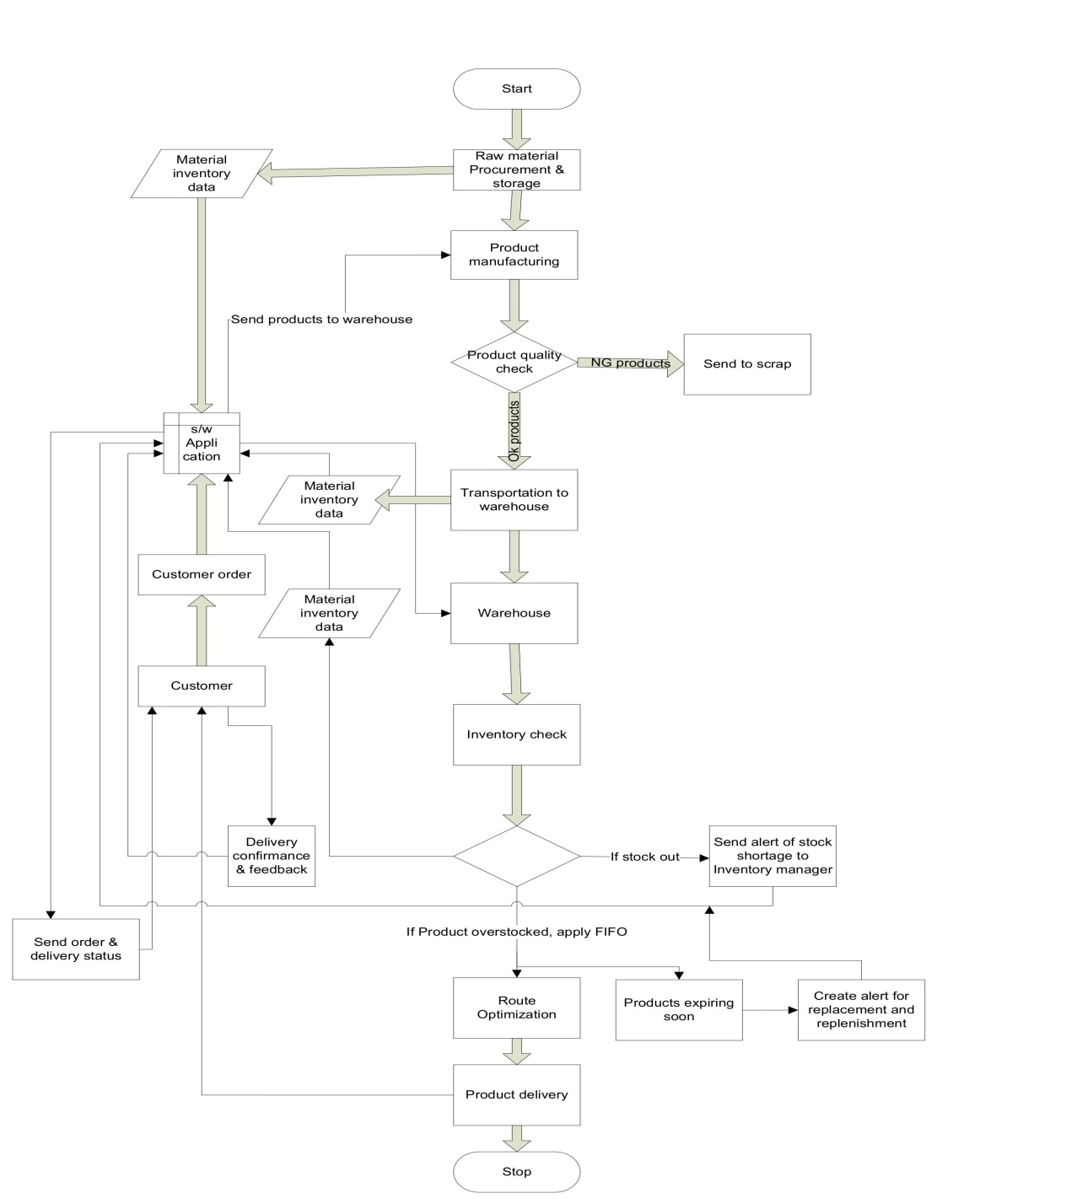

**Assessment 2 :**

1. Write an introduction letter to a client introducing yourself as a business analyst in charge of working with the client and his team to start the business understanding process.

Ans :

From,

Monika Malpe

Business analyst

monika.malpe@gmail.com

Opt IT solution Pvt ltd, Pune

Date : 04/01/2025

To,

Mr. Raut,

CEO,

AMUL India Pvt Ltd, Pune

Dear Mr. Raut,

Good day! My name is Monika Malpe and I am pleased to introduce you myself as a Business analyst assigned to collaborate with you and your team on the Supply chain Management, I am primary point of contact for this project and my role will focus on understanding your business needs, aligning objectives and ensure seamless transition from planning to execution.

I have working experience of 5.6 years as a Business analyst. Till date I have worked on 5 projects including waterfall scrum models and assisted to successfully transit the requirement into working software. I am certified Business analysis professional from IIBA.

Following was my key Responsibilities:

We gathered and documented detailed business requirements using tools like JIRA, confluence and Excel.

We conducted stakeholder interviews, workshops, document analysis, questionnaire, brainstorming and other elicitation techniques to identify & extract requirements from stakeholders.

Developed Business Requirement documents (BRD) & functional requirements (FRS)

Developed User stories, use case specifications and acceptance criteria in agile or waterfall projects

Designed process flow diagrams, use case diagram and activity diagrams using MS-Visio tool and wireframe and prototypes using Balsemique and Azure RP tools.

Collaborated with cross functional team including developers, testers and project managers.

Analyzed data trends using SQL and visualization tools like Tableau and Power BI.

Thorough study of Enterprise analysis and recommended process improvements.

Led and participated in daily stand ups, sprint planning, review, retrospective meetings.

Prepared presentations and reports for executive stakeholders.

As a Business Analyst, my primary goal is to ensure that our collaboration leads to clear & comprehensive understanding of your business objectives, requirements and expectations. In the upcoming weeks, I will be working with you to

Identify and document your business needs and goals.

Analyze current processes and any legacy system in place and define clear & actionable requirements for proposed solution

Address potential challenges and constraints to ensure a seamless implementation.

To start, I propose scheduling an initial meeting to discuss your vision, priorities and preliminary information you’d like to share. This helps us to set a clear direction for project and structure our next step in our collaborations.

Thank you for this opportunity, I am excited to work with you and your team and I am committed to make this journey both productive and rewarding.

Please feel free to contact me at [monika.malpe@gmail.com](mailto:monika.malpe@gmail.com) or contact no – 9321935717 at your earliest convenience to arrange our first meeting or to address any queries.

Thank you for entrusting us with this opportunity. I look forward to contribute to success of your project.

Regards,

Monika Malpe

Business Analyst

Opt Solution Pvt Ltd

2. Prepare a brief BRD and SRS for a project- Grocery online store.

**Business Requirement Document (BRD)**

Project Name : BigBasket -Online store of grocery products

Project ID : OGP321

Version ID : 001

Author : Monika Malpe

Contents

1. Document Revisions .............................................................................................................29

2. Approvals ............................................................................................................................. 29

3. RASCI Chart for This Document ..............................................................................................29

Codes Used in RASCI Chart ........................................................................................... 29

RASCI Chart ....................................................................................................................30

4. Introduction ...........................................................................................................................31

4.1. Business Goals .....................................................................................................................31

4.2. Business Objectives .............................................................................................................31

4.3. Business Rules ..................................................................................................................…32

4.4. Background .........................................................................................................................33

4.5. Project Objective ................................................................................................................33

4.6. Project Scope ......................................................................................................................35

4.6.1. In Scope Functionality ................................................................................................…..35

4.6.2. Out Scope Functionality .............................................................................................…..35

5. Assumptions .........................................................................................................................35

6. Constraints ......................................................................................................................... 35

7. Risks ......................................................................................................................................36 Technological Risks ...................................................................................................................36

Skills Risks .................................................................................................................................36

Political Risks ............................................................................................................................36

Business Risks ...........................................................................................................................36 Requirements Risks ..................................................................................................................37

Other Risks ...............................................................................................................................37

8. Business Process Overview ..................................................................................................38

8.1. Legacy System (AS-IS) ...................................................................................................... 39

8.2. Proposed Recommendations (TO-BE) ...............................................................................41

9. Business Requirements .........................................................................................................41

10. Appendices ..........................................................................................................................42

10.1. List of Acronyms ...............................................................................................................42

10.2. Glossary of Terms ........................................................................................................... 43

10.3. Related Documents ........................................................................................................ 43

1. Document Revisions

|  |  |  |
| --- | --- | --- |
| Date | Version number | Changes |
| 03/01/2025 | 0.1 | Initial draft |
|  |  |  |
|  |  |  |
|  |  |  |
|  |  |  |
|  |  |  |
|  |  |  |
|  |  |  |

2. Approvals

|  |  |  |  |  |
| --- | --- | --- | --- | --- |
| Role | Name | Title | Signature | Date |
| Project Sponsor | Mr. Patil | BRD |  | 18/01/2025 |
| Business Owner | Mr. Sharma | BRD |  | 18/01/2025 |
| Project Manager | Mr. Chaudhari | FRD & NFRD |  | 16/01/2025 |
| System Architect | Mrs. Ohol | HDD, ADD |  | 11/01/2025 |
| Development Lead | Ms. Rama | LDD/CDD |  | 09/01/2025 |
| User Experience Lead | Ms. Chaitali | User accessibility |  | 09/01/2025 |
| Quality Lead | Mr. Patil | App quality |  | 08/01/2025 |
| Content Lead | Mr. Ravi | Content |  | 08/01/2025 |

1. RACI Chart for This Document

Codes Used in RACI Chart

* Authorize document ultimate signing authority for any changes to the document

R Responsible Has Responsible for creating this document.

A Accountable Accountable for accuracy (for example, the project manager) of this documents

S Supports Provides supporting services in the production of this document

C Consulted Provides input (such as an interviewee).

I Informed Must be informed of any changes.

RACI Chart

|  |  |  |  |  |  |  |  |
| --- | --- | --- | --- | --- | --- | --- | --- |
| Name | Position | * | R | A | S | C | I |
| Mr. Patil | Store Dept head |  |  |  |  |  |  |
| Mr. Sanjiv | Project coordinator |  |  |  |  |  |  |
| Mr Chaudhari | Project Manager |  |  |  |  |  |  |
| Ms. Rama | Sr. Java Developer |  |  |  |  |  |  |
| Mr Patil, , | Java Developer |  |  |  |  |  |  |
| Ms Swati | Java Developer |  |  |  |  |  |  |
| Mr Raghavam, | Java Developer |  |  |  |  |  |  |
| Mrs Shrushti | Java Developer |  |  |  |  |  |  |
| Mr Raju | Network Admin |  |  |  |  |  |  |
| Mr Sameer | DB Admin |  |  |  |  |  |  |
| Mr Saroj | Tester |  |  |  |  |  |  |
| Ms Kavya | Tester |  |  |  |  |  |  |
| Ms. Monika | BA |  |  |  |  |  |  |
| Mrs. Ohol | System Architect |  |  |  |  |  |  |
| Ms. Chaitali | User Experience Lead |  |  |  |  |  |  |
| Mr. Patil | Quality Lead |  |  |  |  |  |  |
| Mr. Ravi | Content Lead |  |  |  |  |  |  |
| Mr. Kartik | Delivery head |  |  |  |  |  |  |

4. Introduction

4.1. Business Goals

1. Revenue generation through online grocery store

2. Acquire the customer and retain them through market penetration

3. Increase scalabilty for bussines growth

4. Use friendly interface for ease of order processing & increase operational efficiency.

* 1. Business Objectives
  2. Provide a user friendly interface to customer to browse the products, select the needed products and will request to buy and deliver it at desired location.
  3. Enable efficient order processing and inventory management
  4. Ensure timely delivery of product with order tracking details
  5. Enhance customer satisfaction with 24X7 customer support and personalized features.

4.3. Business Rules

**1. Organization Policies**

Policies are high-level statements that outline an organization's intentions and directions. They serve as guiding principles for decision-making and behavior. Common policies include:

* **Customer service policy:** respond to customer within 24 hrs, resolve the complaints or issues within 5 business days.
* **Workforce policy:** Employees and delivery personnel should undergo training for system use and customer satisfaction. Ensure fair working hours and compensation for employees.
* **Sustainability policy:** use eco friendly packaging materials, minimize food wastage by partnering with charities for unsold items
* **Ethical sourcing policies:** prioritizing local supply and ensure ethical sourcing of products, ensure transparency in supply chain management

**2. Procedures**

Procedures are detailed, step-by-step instructions on how to implement policies and accomplish specific tasks. They ensure consistency and efficiency in operations. Examples include:

* **On boarding Procedure:** Steps for integrating new employees into the organization.
* **Expense Reimbursement Procedure:** Process for submitting and approving expense claims.
* **Incident Reporting Procedure:** How to report and manage workplace incidents or accidents.
* **IT Support Procedure:** Steps for requesting and resolving IT issues.
* **Hiring Procedure:** Steps for recruiting, interviewing, and selecting candidates.
* **Order placement & processing:** customer place order via web or application by processing payment, system send order confirmation and store admin receive order and prepare items for dispatch
* **Inventory management:** Update stock levels In real time as items are sold or restocked, conduct audit regularly to ensure accuracy and inventory records.
* **Delivery process:** Assign order to delivery person based on availability and distance, delivery person must follow predefined route and adhere to delivery slots.
* **Return and refunds:** Customer initiate return via web or app, items is picked by delivery person or delivered at a designated location and refund is processed after verifying the condition of the returned items.

**3. Rules & regulation**

Rules are specific directives that govern individual behavior and actions. They are usually straightforward and enforceable.

Regulations are legally binding rules imposed by external authorities or governing bodies. Organizations must comply with these to avoid legal issues. Common regulations include:

* **Customer regulations:** Customer provide accurate contact and delivery information, any misuse of promotional codes or discount will results in account suspension.
* **Employee regulations:** Employee must adhere to company policies and code of conduct, misuse of company resources or breaches of confidential information will lead to disciplinary action.
* **Delivery personnel regulations:** Delivery person must ensure safe handling of items during transit, any failure to deliver within assigned time must be reported immediately.
* **Compliance with law:** adhere to local taxation laws, including GST or VAT, comply with food safety regulation and ensure proper labeling of products..
* **Consumer Protection Act, 2019**: Compliance with consumer rights and e-commerce guidelines.
* **Data Protection Regulations**: Follow guidelines for user data privacy and protection and conduct regular security audits to protect against cyber threats.
* **Payment and security regulation** : follow industry standards for secure payment processing like PCI DSS Compliance

4.4. Background

1. Grocery Market has significant business growth as it provides services online at customer’s convenience and get it delivered at door step, it offers much discount on products

2. With evolving customer preferences, a robust online grocery store can be address the growing demand for hassle free shopping experiences.

3. This projects aims to create a digital platform for purchasing groceries, ensuring product quality, efficient service at competitive pricing.

4. This platform will cater to wide audiences from working professionals, senior citizens, disabled people to homemaker providing features like fast/standard delivery, personalized recommendations and source to payment of your choice.

5. Product delivery planning is done manually leading to lack of real time product & vehicle location tracking, long delivery route selection may increase transportation cost and time, delayed delivery or inaccurate delivery times cause poor customer satisfaction.

6. risk of product quality standard and compliance.

4.5. Project Objective

1. Support to Customer

* Provide seamless shopping experience through a user friendly website or mobile application
* Enable customer to search, browse, purchase and receive groceries at door step without visiting to physical grocery store.

2. Operational efficiency

* Streamline order processing, inventory management and delivery logistics.
* Minimize manual error through automated system

3. Market penetration

* Capture a large share of grocery market by offering competitive pricing and promotions.
* Attract a diverse customers base through target marketing campaigns.

4. Revenue growth

* Increase sales volume by offering subscription, discount and bundles deals.
* Encourage repeat purchases through loyalty programs and personalized recommendations.

5. Sustainability

* Practice eco friendly packaging for sustainability and partnering with local suppliers.
* Minimize food wastage by optimizing inventory and offering unsold items to charities.

6. Compliance with industry standard

* Ensure product & process comply with industry standards.

4.6. Project Scope

Development of application for Inventory management and delivery optimization to increase customer satisfaction

* + 1. In Scope Functionality
* User registration and login for customer
* Browsing and searching for grocery items
* Managing the shopping cart and order placement
* Secure payment gateway integration
* Order tracking for customers
* Inventory management for store admin
* Delivery management for personnel

4.6.2. Out Scope Functionality

* Hardware procurement for company
* Physical store integration
* Third party logistics.

**5. Assumptions**

* Customer will have access to the internet connectivity and desktop/ mobile phone.
* Sufficient staff and resources to manage inventory and delivery.

**6. Constraints**

* Device compatibility of platform with wide range of devices and browsers which can lead to increase in development and testing time
* Limited budget & timelines for the development & deployment
* Dependency on third party services such as payment gateways, inventory management tools, delivery partners may create integration limitations.
* Platform should be able to handle peak trafficking during festival seasons or promotional sales but initial infrastructure may have limited capacity.
* Perishable items need to manage efficiently to minimize wastage.
* Compliance with industry standard for data security (PCI DSS, SSL) may restrict the certain functionalities and ad to development complexity.
* Training will be compulsory to new/ unskilled personnel.
* Existing competitor cal limit market penetration

**7. Risks**

A risk is something that could affect the success or failure of a project.

Strategies include the following:

• Avoid: Do something to eliminate the risk.

• Mitigate: Do something to reduce damage if risk materializes.

• Transfer: Pass the risk up or out to another entity.

• Accept: Do nothing about the risk. Accept the consequences.

Technological Risks :

* High traffic during peak hours or festival seasons, promotional sales may affect system performance
* Integration challenges with existing systems causing project delays
* Technology obsolescence due to choosing out dated or soon to be absolute technology leading to higher maintenance cost & need for early upgrades
* Data security risk due to breaches casing loss of sensitive data
* Performance issues due to higher loads
* Delay in delivery due to external factors such as weather, logistics.

Skills Risks :

* Unskilled resources
* Lack of training & certification

Political Risks :

* Taxation changes
* Employment laws
* Safety standard
* Trade agreements

Business Risks

* Business loss due to cancellation of project in aspects of resources, time, money

Requirements Risks :

* Incomplete or ambiguous requirements that do not meet business needs
* Scope creep due uncontrolled changes causing delays, increased cost, quality impact

Other Risks :

* Timeline delays causing missed deadlines
* Communication breakdown between team causing error
* Change resistance from end users causing delay in implementation
* Manufacturing disruption due to implementation/testing of application

8. Business Process Overview

The online business grocery store business process involves many interconnected activities to provide a seamless shopping experience.

The key business processes are like

1. **Process for Customer :**

* Customer registration and login to the platform
* Browse or search specific product using filters and categories.
* Add items to cart and proceed to check out and buy.
* Select Payment mode, deliver slots, provide delivery address and complete payment
* Track order and receive delivery

1. **Store Operation:**

* Manage inventory by tracking stock levels and adding new products
* Process orders by preparing items for dispatch
* Handle customer support requests regarding orders, returns and refunds.

1. **Delivery management:**

* Assign delivery personnel based on location and order size.
* Ensure on time delivery with real time tracking and route optimization
* Update order status such as dispatches, shipped, in transit or delivered.

**Challenges with current System:**

* **Customer challenges:** Limited delivery zone exclude some customers, items stock-outs of popular items specially during peak hours and High delivery charges
* **Operation Management:** Inefficient inventory management leads to overstocking or stock-outs, errors in order processing such as wrong items, missed delivery, High logistic costs due to inefficient routing or delivery failures.
* **Technical issues:** System downtime during high traffic hours, lack of robust data analytics to predict demand and supply, security concern regarding customer data and payment details.
* **Market challenges:** no High competition from existing players offering attractive discounts and offers on items along with faster delivery and resistance from customer used to traditional grocery shopping.

8.1. Legacy System (AS-IS)

Current state :

* Manual inventory tracking leading to delay in stock updates, human errors
* Limited online presence with basic website functionality
* No integration with payment gateways, COD (Cash on Delivery) was the only option
* Minimal delivery tracking features relying on phone based updates.
* Many working personnel find difficulty to buy grocery due their busy work schedule
* Disable personnel can visit store personally for their need
* Sometimes condition arises where customer needs grocery items urgently but can’t get it

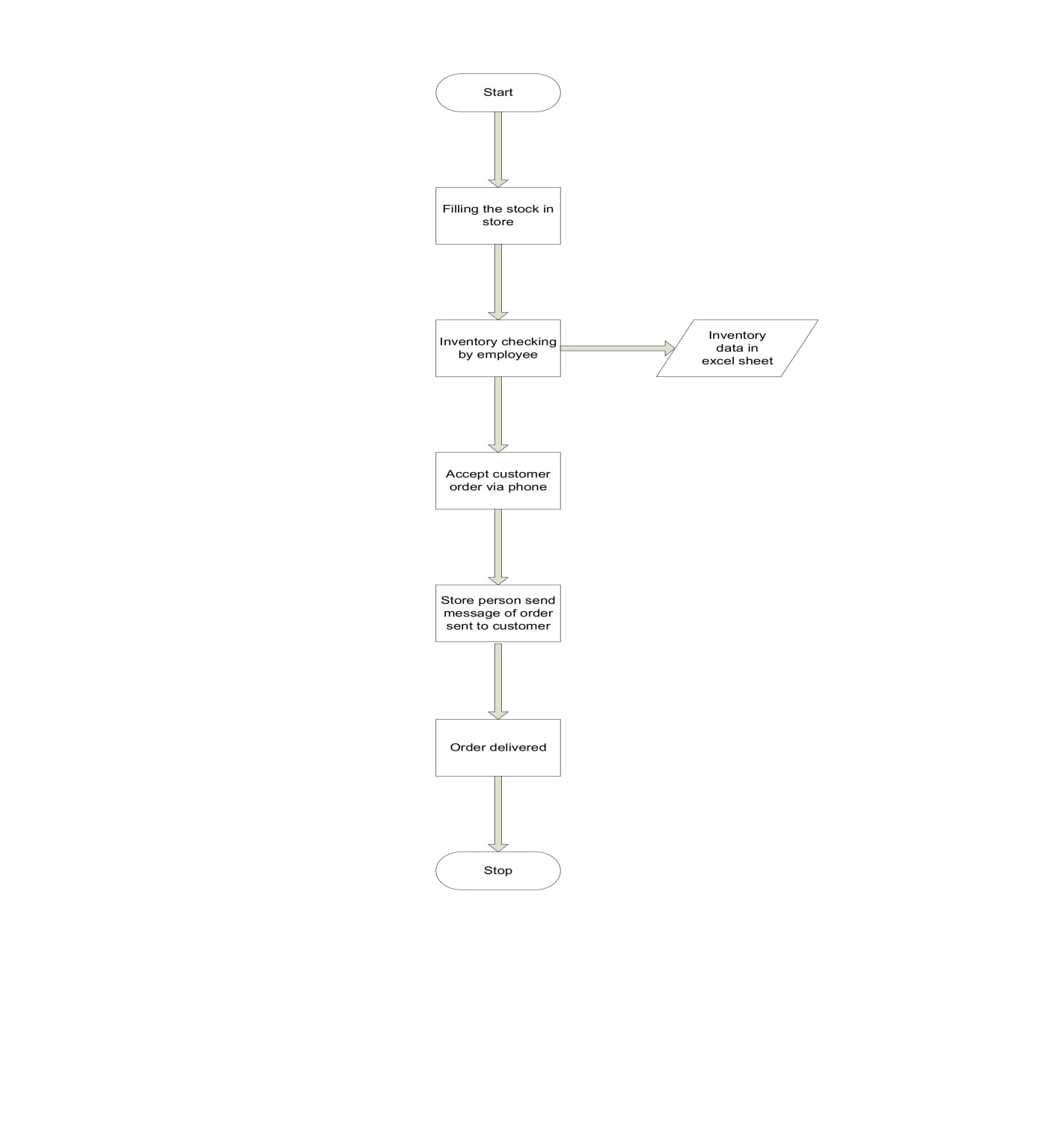

8.2. Proposed Recommendations (TO-BE)

* 1. **Enhance Customer experience :**
* Develop user friendly website or mobile app with advanced search and filtering options
* Offer multiple secure payment options including wallets and UPIs.
* Implement loyalty program to repeat purchase
  1. **Operational improvements :**
* Automate inventory management with real time updates and low stock alerts
* Implement order processing with barcode scanning and order verification
* Use data analytics to forecast demand and optimize inventory.
  1. **Delivery Optimization :**
* Practice real time delivery tracking for customers and administrators
* Optimize delivery routes using GPS and traffic data
* Partner with third party logistics providers to expand delivery zones
  1. **Enhanced Technology :**
* Use cloud based infrastructure to ensure scalability and reliability
* Integrate AI powered recommendations engines foe personalized customer experiences.
* Strengthen security with encryption with data protection laws such as GDPR, PCI DSS.
  1. **Market strategy**
* Introduce subscription models for recurring deliveries.
* Offer promotions like free deliveries, first time users or order above a threshold value.
* Partner with local suppliers to differentiate with fresh and local sourced products.

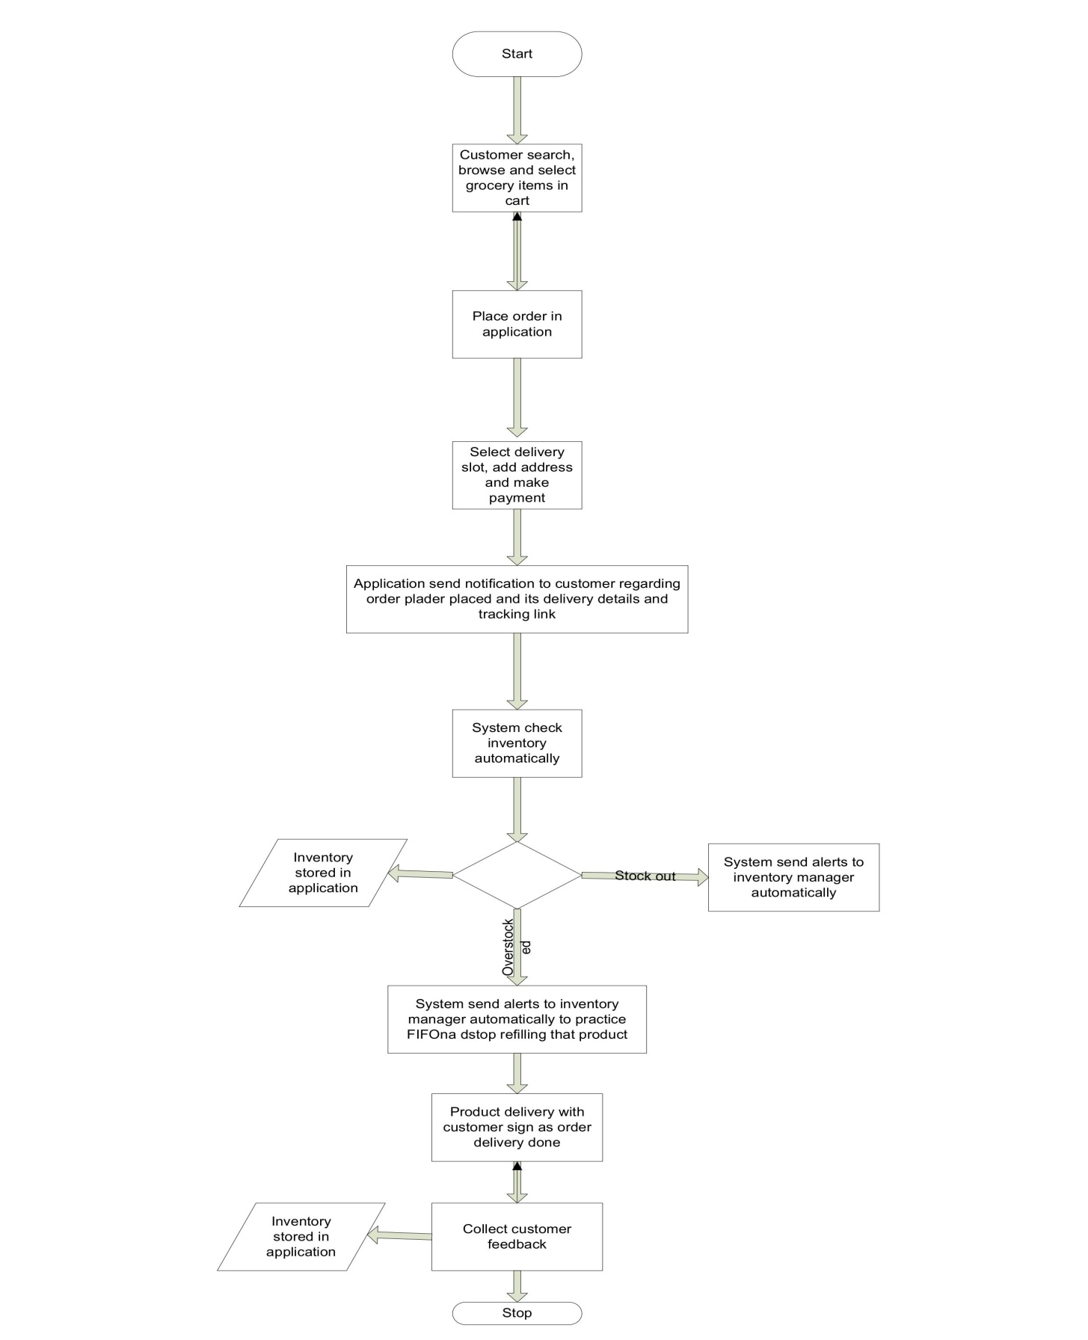

* 1. Business Requirements

|  |  |  |  |
| --- | --- | --- | --- |
| Sr No | Business Requirements | Functionality | Priority |
| BR0001 | Provide seamless platform for customers to browse, select and purchase groceries online | Platform development | 10 |
| BR0002 | Ensure timely and reliable delivery f fresh and high quality products | Grocery delivery | 9 |
| BR0003 | Provide a wide range of products ,including fresh products, packaged goods and specialty items. | Diversify products | 8 |
| BR0004 | Enhance customer engagement through promotion, loyalty programs or personalized recommendation | Engage customers | 9 |
| BR0005 | Ensure competitive pricing to attract and retain customers | Competitive pricing | 8 |
| BR0006 | Streamline inventory management to maintain optimal stock levels and minimize wastage | Inventory management | 9 |
| BR0007 | Automate order processing and delivery assignment for efficiency | Order processing | 9 |
| BR0008 | Implement a diverse and secure payment options including digital wallets and COD | Payment processing | 9 |
| BR0009 | Real time order tracking for both customer and delivery personnel | Order tracking | 9 |
| BR0010 | Scale up operations t expand delivery zones and cater to larger community | Operation scaling | 7 |
| BR0011 | Comply with local as well as international regulations for food safety, data privacy and taxation. | Regulation compliance | 8 |
| BR0012 | Practice sustainability for eco friendly packaging | Sustainability | 9 |
| BR0013 | Adjust delivery routes based on circumstances such as traffic, weather forecast | Circumstantial route adjustment | 7 |
| BR0014 | Real time GPS tracking of delivery vehicles to monitor location and progress | Vehicle GPS tracking | 9 |
| BR0015 | Provide live update to customer regarding delivery status and estimated delivery rime | Delivery live update | 8 |
| BR0016 | Allow customer to select preferred delivery time slot during order placement | Select delivery time slot | 6 |
| BR0017 | Automate scheduling to ensure efficient fleet utilization | Order scheduling | 8 |
| BR0018 | Capture customer’s digital signature as proof of successful delivery | Delivery signature proof | 7 |
| BR0019 | Delivery confirmation by customer on application | Delivery confirmation | 8 |
| BR0020 | Collect real time feedback from customer regarding product quality and delivery time. | Order feedback | 7 |
| BR0021 | Ensure products delivery within timeline to maintain customer satisfaction | Timely product delivery | 6 |
| BR0022 | Ensure product quality during storage and delivery through temperature monitoring quick transit time. | Maintain product quality | 8 |
| BR0023 | Send automated notification to customer regarding order confirmation, dispatch and delivery status | Order status notification | 6 |

10. Appendices

**Appendix A : stakeholder involved**

Stockholders :

* Customers
* Store admin
* Delivery personnel
* Business owner

Appendix B : implementation timeline

* Detailed schedule of key mile stonnes and deliverables

10.1. List of Acronyms

* **CRM** – Customer Relationship Management
* **GDPR** – General Data Protection Regulations
* **PCI DSS** – Payment Card Industry Data Security Standard
* **GPS** – Global positioning system
* **OTP** – One Time Password
* **API –** Application Programming Interface

10.2. Glossary of Terms

* **Inventory Management:** process of tracking the material storage , uses, movement and replenishment of stocks.
* **Perishable products:** Products that have limited shelf life, requires specialized storage conditions such as dairy products and Ice-cream.
* **Customer profile:** a detailed collection of customer data including name, contact details and order history.
* **Route optimization:** the process of determining the most efficient delivery route to minimize delivery time and transportation cost
* **Real time tracking:** monitoring the actual location and status of delivery vehicles or inventory level.
* **Order fulfillment :** the complete process from receiving an order to delivering it to the customer
* **Payment Gateway:** the service that securely processes online payment
* **Proof of delivery :** confirmation document i.e. sign of customer that product order is successfully delivered to customer.
* **Delivery slot :** a pre-determined time window for delivering order to customers
* **Loyalty program :** A system of rewards for frequent customers to encourage repeat purchases
* **Eco friendly packaging :** packing materials that are biodegradable or recyclable to reduce environmental impact
* **Subscription models –** a service where customer can schedule recurring deliveries for convenience

10.3. Related Documents

* 1. **Current process document:** Detailed records of existing inventory management and delivery workflows
  2. **IT infrastructure assessment:** a report containing company’s existing hardware and software capabilities.
  3. **Regulatory compliance guidelines & check sheets:** Standardized documents detailing legal requirements on food safety, transportation and data protection
  4. **Customer feedback report :** document insight from past customer surveys or customer complaints regarding order and delivery timeliness .
  5. **Training Materials:** Documents and resources used for training employees on software usage and handling.
  6. **Market plan :** strategies to promote the platform and attracting customers

**SRS document**

A **Software Requirement Specification** (**SRS**) is a comprehensive document that structures the functional and Non-functional requirements of the software system. It acts as contract between stockholders to ensure everyone understands the systems scope, purpose and functionalities.

**Introduction :**

* Grocery Market has significant business growth as it provides services online at customer’s convenience and get it delivered at door step, it offers much discount on products
* With evolving customer preferences, a robust online grocery store can be address the growing demand for hassle free shopping experiences.
* This projects aims to create a digital platform for purchasing groceries, ensuring product quality, efficient service at competitive pricing.
* This platform will cater to wide audiences from working professionals, senior citizens, disabled people to homemaker providing features like fast/standard delivery, personalized recommendations and source to payment of your choice.

**Project Goal :**

To create a user friendly, secure and scalable online grocery platform that offers customer a seamless shopping experience with a wide variety of fresh and packaged products, flexible delivery slot selection options and personalized recommendations while maintaining the operational efficiency and scalability.

**Project Objective** :

1. Support to Customer

* Provide seamless shopping experience through a user friendly website or mobile application
* Enable customer to search, browse, purchase and receive groceries at door step without visiting to physical grocery store.

2. Operational efficiency

* Streamline order processing, inventory management and delivery logistics.
* Minimize manual error through automated system

3. Market penetration

* Capture a large share of grocery market by offering competitive pricing and promotions.
* Attract a diverse customers base through target marketing campaigns.

4. Revenue growth

* Increase sales volume by offering subscription, discount and bundles deals.
* Encourage repeat purchases through loyalty programs and personalized recommendations.

5. Sustainability

* Practice eco friendly packaging for sustainability and partnering with local suppliers.
* Minimize food wastage by optimizing inventory and offering unsold items to charities.

6. Compliance with industry standard

* Ensure product & process comply with industry standards.

Use case Diagram :

Ans :

• A Use case is a high level diagram.

• The main purpose of the diagram is to identify the requirement.

• A use case diagram is an actor specific.

• A use case diagrams are designed to explain how an external user is interacting with the system.

•if end user can use application with easily & comfortably then work is successful

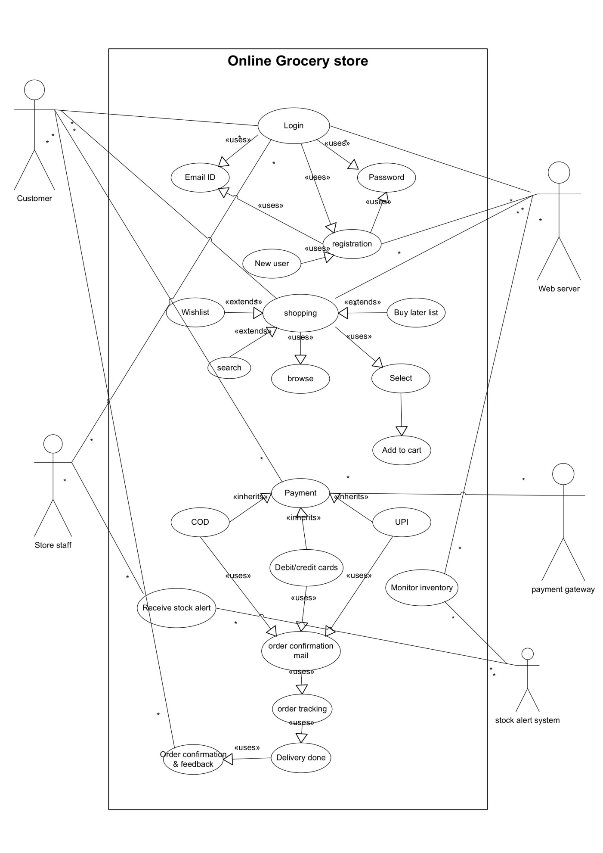Prepare use case specs for all use cases

Answer :

|  |  |
| --- | --- |
| Use case ID : UC001 | Use case Name : User registration |
| Created by : BA | References : |
| Date of creation : 06/01/25 | Revision date: 06/01/25 |
| 1. Use case description | New Customer, Store staff can create new account & register |
| 1. Actor | Customer, Store staff, Web server |
| 1. Pre-condition | User should have internet connection & mobile/desktop |
| 1. Basic flow | 1. User open the website/app for registration 2. User will provide name, email ID & create password 3. System Validate the details provided with email. 4. User is registered |
| 1. Alternative flow | 1. If email is not received for authentication from system, recheck the email ID provided 2. If not, then re-register the user |
| 1. Exceptional flow |  |
| 1. Post – condition | User is authenticated and successfully created account. |
| 1. scenario | 1. Customer and store staff as a user enters the details to register with website 2. Server saves the data and creates account for user, message to user that registration is complete, account is created. |
| 1. special requirements | NA |

|  |  |
| --- | --- |
| Use case ID : UC002 | Use case Name : User login |
| Created by : BA | References : |
| Date of creation : 06/01/25 | Revision date: 06/01/25 |
| 1. Use case description | User (Customer & Store staff) can log into their account |
| 1. Actor | Customer, Store staff, Web server |
| 1. Pre-condition | User should have internet connection & mobile/desktop |
| 1. Basic flow | 1. System provide the Login page to users 2. User enters Email ID and password as login credentials 3. If entered credentials are correct, user will log in successfully |
| 1. Alternative flow | 1. If email ID or password is incorrect, system will show incorrect credential message. 2. System message to user as please enter correct credentials 3. If password is incorrect, system message please enter correct password. 4. If user forgot the password, system provide forgot password link to reset password using email ID. 5. Reset the password, then again log in with new password. |
| 1. Exceptional flow | NA |
| 1. Post – condition | User is authenticated and successfully logged in. |
| 1. scenario | 1. User enters the credentials and logs in. 2. If credentials are incorrect, server pop up message to user to enter correct credential and re – attempt the login 3. If User forgot password, server help & send mail to reset password via email link. |
| 1. special requirements | NA |

|  |  |
| --- | --- |
| Use case ID : UC003 | Use case Name : products browsing |
| Created by : BA | References : |
| Date of creation : 06/01/25 | Revision date: 06/01/25 |
| 1. Use case description | Customer can browse catalog of grocery products |
| 1. Actor | Customer, Web server |
| 1. Pre-condition | - User should have internet connection & mobile/desktop  - Customer is logged in |
| 1. Basic flow | 1. System displays a list of available products 2. User can filter the products by category, price, etc 3. System update the products according to user’s interest |
| 1. Alternative flow | 1. If there is no product available then system will give message of no record found 2. If user is not logged in, then system will redirect the user to login page |
| 1. Exceptional flow | NA |
| 1. Post – condition | Products catalog is displayed. |
| 1. scenario | 1. User browse the products available in the catalog 2. Filter the product as per price, location, content, manufacturer etc. 3. Server shows all possible products to user 4. User checks its product details in description box and its availability 5. If product is out of stock, ask customer service for that specific product. 6. Customer server checks the stock with store and gives the notification to farmer as products gets back in stock. 7. If product is out of stock, user leave website/app and later will keep checking it for stock updating. |
| 1. special requirements | NA |

|  |  |
| --- | --- |
| Use case ID : UC004 | Use case Name : Search products |
| Created by : BA | References : |
| Date of creation : 06/01/25 | Revision date: 06/01/25 |
| 1. Use case description | Customer can search for specific products within catalog |
| 1. Actor | Customer, Web server |
| 1. Pre-condition | - User should have internet connection & mobile/desktop  - Customer is logged in  -product catalog is displayed |
| 1. Basic flow | 1. User search specific product in search bar. 2. System shows list of available products matching to search query. 3. User can filter the products by category, price, content 4. System recommend the products according to user’s interest, matching content of query products |
| 1. Alternative flow | 1. If there is no product available then system will give message of no record found 2. If user is not logged in, then system will redirect the user to login page |
| 1. Exceptional flow | NA |
| 1. Post – condition | Search results shows matching products asked in query |
| 1. scenario | 1. User search the specific products in the catalog 2. Filter the product as per price, location, content, manufacturer etc. 3. Server shows all possible products to user 4. User checks its product details in description box and its availability 5. If product is out of stock, ask customer service for that specific product. 6. Customer server checks the stock with Store and gives the notification to farmer as products gets back in stock. 7. If product is out of stock, user leave website/app and later will keep checking it for stock updating. |
| 1. special requirements | 1. Add the filter category as content so that Customer can search the products using products ingredients/ contents. |

|  |  |
| --- | --- |
| Use case ID : UC005 | Use case Name : purchase products |
| Created by : BA | References : |
| Date of creation : 06/07/25 | Revision date: 06/01/25 |
| 1. Use case description | Customer can purchase the selected products |
| 1. Actor | Customer, Web server |
| 1. Pre-condition | - User should have internet connection & mobile/desktop  - Customer is logged in  -product catalog is displayed |
| 1. Basic flow | 1. After browsing, user select the products to purchase 2. And add it to cart 3. User buys the products by placing order & proceeds forward for payment options. |
| 1. Alternative flow | 1. If there is no product available then system will give message of no record found 2. If user is not logged in, then system will redirect the user to login page 3. If user didn’t purchase products, then user add it to wish list or buy later list |
| 1. Exceptional flow | NA |
| 1. Post – condition | Customer completed the purchase process |
| 1. scenario | 1. User browse the product, check its details in description and select the product 2. A server provides product details to users and provides add to cart tab to collect all selected products and to proceed further for placing the order. 3. User adds the selected product/products in cart and check the availability, if product is in stock then press Buy now tab to place order. 4. If product is out of stock, ask customer service for that specific product. 5. Customer server checks the stock with store and gives the notification to Customer as products gets back in stock. 6. If product is out of stock, user leave website/app and later will keep checking it for stock updating. |
| 1. special requirements | NA |

Functional requirements :

|  |  |  |  |
| --- | --- | --- | --- |
| Req ID | Req Name | Req Description | Priority |
| FR0001 | Customer Registration | Customer should able to register with the application | 8 |
| FR0002 | Customer login | Customer should able to login into the application for purchasing the products | 9 |
| FR0003 | Customer search for products | Customer should able to Search for the products available on application | 8 |
| FR0004 | Check catalog for products | Customer should able to browse & check the products available in the products catalog along with all details like manufacturer, ingredients, formulations, etc. | 9 |
| FR0005 | Home page | Customer should be able to see homepage where all basic information about the app can be seen along with key option | 7 |
| FR0006 | Buy option | Customer should able to buy the products with buy now option | 8 |
| FR0007 | Add to cart | Customer should be able to add the selected products into the cart with Add to cart option | 7 |
| FR0008 | Buy later list | Customer should be able to add the products in the buy later list for future purchasing | 6 |
| FR0009 | Wish list | Customer should be able to add the selected products in the wish list for future purchasing or reference. | 6 |
| FR0010 | User account | Customer account has to be created where user’s address, order history, tracking information, payment details, Wish list, rewards received can be seen. | 5 |
| FR0011 | Cart editing | User should be able to add, update or remove items from the cart | 4 |
| FR0012 | Payment gateways | Customer should be able to access multiple payment gateways as per users convenience like COD, UPI, Credit/debit card, Internet banking, EMI | 9 |
| FR0013 | Order confirmation | Once after placing the order, an Email should be received by customer for order confirmation. | 7 |
| FR0014 | Order cancelation | Customer should be able to cancel the order if product is not required | 5 |
| FR0015 | Track delivery of product | After placing the order, Customer should be able to track the product’s current location. | 5 |
| FR0016 | Delivery options | Application should provide 2 types of delivery – normal and fast track delivery. | 4 |
| FR0017 | Delivery confirmation | A facility for product delivery confirmation as product is been delivered to the farmer. | 3 |
| FR0018 | Product restock notification | Customer should receive a notification if stock out product gets restocks to continue shopping | 10 |
| FR0019 | Return and refunds | Customer should be able to return or get refunded easily with simple process and clear policies. | 9 |
| FR0020 | Inventory Management | Automated stock level updates alerts for low stocks. | 9 |
| FR0021 | Order management | Admin should be able to view, update and track all the customer order | 8 |
| FR0022 | Customer support | Manage customer queries and complaints efficiently | 7 |
| FR0023 | Help center | Customer can ask for help from application for queries if any via call/chat with customer care executives. | 7 |
| FR0024 | Promotion management | Create and manage the discounts, coupons and special offers | 6 |
| FR0025 | Add review | Customer should be able to reviews and feedback on the purchased products. | 5 |
| FR0026 | Print Packing slip | Once the order is fulfilled, local printer shall print the packing slip. | 6 |
| FR0027 | Delivery assignment | Assign delivery personnel to orders based on location and availability | 8 |
| FR0028 | Route optimization | Provide optimized route and real time updates foe delivery personnel | 8 |
| Non-Functional requirements | | | |
| NFR0001 | Page loading time | Each page should load within 2 sec under normal condition | 9 |
| NFR0002 | WCAG 2.1 | The system must meet Web Content Accessibility Guidelines WCAG 2.1. | 8 |
| NFR0003 | System security | System should able to deal with malware and authorized access. | 9 |
| NFR0004 | scalability | System should be able to handle atleast 10,000 users simultaneously without down time | 7 |
| NFR0005 | compatibility | Web app should be compatible with various version of iOS and iPhone devises | 6 |
| NFR0006 | Language change | User should allow user to change the language of app for great user experience. | 3 |
| NFR0007 | Print packing slip | Packing slips shall be printed on both sides of 4”x 6” white paper, the standard size for packing slips used by local printers. | 6 |
| NFR0008 | Time limit for OTP | OTP validation time should be max 5 minutes for login and registration | 6 |
| NFR0009 | Stock availability & alert | System should check stock availability and if stock goes below stock limit, system should send alert to manufacturer | 7 |
| NFR0010 | Logout system | If page is not accessed for more than 5 minutes, page will automatically redirected to logout | 6 |
| NFR0011 | Scalability | System should scale to accommodate peak demands during festivals or promotional campaigns | 7 |
| NFR0012 | Data security | Encrypt sensitive user data and payment data | 10 |
| NFR0013 | Data security | Ensure compliance with PCI DCC, GDPR and other relevant data protection standards | 9 |
| NFR0014 | Availability | Guarantee 99.9% uptime with failover and disaster recovery mechanisms. | 8 |
| NFR0015 | Usability | The platform should be user friendly with an intuitive interface for both web and mobile users | 9 |
| NFR0016 | Maintainability | Ensure easy updates for products catalogs, promotions and content through an admin portal. | 7 |
| NFR0017 | Maintainability | Implement modular code for efficient and debugging and updates | 8 |
| NFR0018 | sustainability | Use cloud infrastructure to reduce physical server dependencies and Environmental impact. | 7 |

3. Make an ERD of creating a support ticket/Ticketing life cycle.

* Railway ticketing system

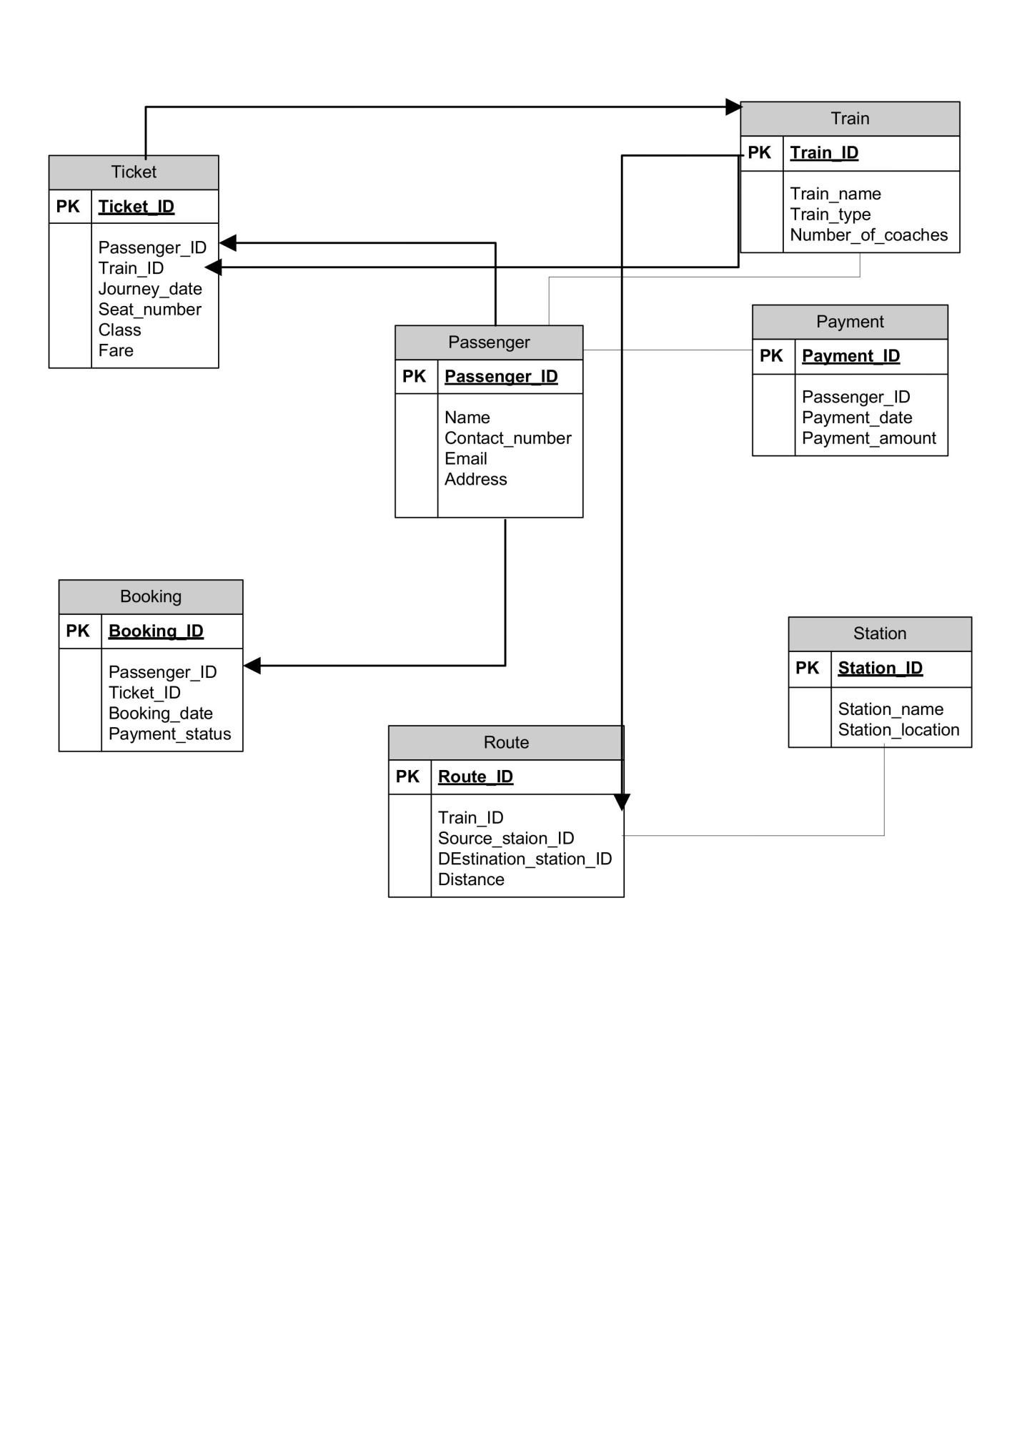

4. User story of shopping from ecommerce BigBasket

|  |  |  |  |
| --- | --- | --- | --- |
| User Story No: 1 | Tasks: 2 | | Priority: HIGHEST |
| AS A CUSTOMER  I WANT TO REGISTER IN BIGBASKET  SO THAT I CAN CREATE MY ACCOUNT | | | |
| BV: 500 | | CP: 03 | |
| ACCEPTANCE CRITERIA   1. Registration Screen Text Boxes for User Name, Password, Nation ID, Mobile No, Email, Address, Phone Number. 2. Click on Register Button. 3. Send Successful Notification to the user | | | |

|  |  |  |  |
| --- | --- | --- | --- |
| User Story No:2 | Tasks: 2 | | Priority: HIGHEST |
| AS A CUSTOMER  I WANT TO LOGIN IN BIGBASKET  SO THAT I CAN ORDER THE PRODUCT FROM BIGBASKET | | | |
| BV: 500 | | CP: 03 | |
| ACCEPTANCE CRITERIA   1. Login Screen Text Boxes for User Name, Password, captcha code. 2. Click on Login Button. | | | |

|  |  |  |  |
| --- | --- | --- | --- |
| User Story No: 3 | Tasks: 2 | | Priority: HIGHEST |
| AS A CUSTOMER  I WANT TO SEARCH & VIEW PRODUCTS IN BIGBASKET  SO THAT I CAN ORDER THE PRODUCT FROM BIGBASKET | | | |
| BV: 500 | | CP: 05 | |
| ACCEPTANCE CRITERIA   1. Insert search bar to search products in BigBasket 2. Product displays its name, price, rating stars, delivery time, distance from address. | | | |

|  |  |  |  |
| --- | --- | --- | --- |
| User Story No: 4 | Tasks: 2 | | Priority: HIGHEST |
| AS A CUSTOMER  I WANT TO VIEW PRODUCT DESCRIPTION IN BIGBASKET  SO THAT I CAN CHECK & ORDER THE PRODUCT FROM BIGBASKET | | | |
| BV: 100 | | CP: 08 | |
| ACCEPTANCE CRITERIA   1. Description includes ingredients, manufacturing date, expiry date, special features of product, production batch no, manufacturer’s name, uses. | | | |

|  |  |  |  |
| --- | --- | --- | --- |
| User Story No: 5 | Tasks: 1 | | Priority: MEDIUM |
| AS A CUSTOMER  I WANT TO BROWSE FOR SPECIFIC PRODUCT  SO THAT I CAN ORDER REQUIRED PRODUCT FROM BIGBASKET | | | |
| BV: 100 | | CP: 03 | |
| ACCEPTANCE CRITERIA   1. App displays relevant grocery products matching to query 2. Grocery shop is open or close to accepts the order. 3. Mention the left stock if product is about to stockout. | | | |

|  |  |  |  |
| --- | --- | --- | --- |
| User Story No: 6 | Tasks: 1 | | Priority: HIGH |
| AS A CUSTOMER  I WANT ADD ITEMS IN CART & ORDER PRODUCT IN BIGBASKET  SO THAT I CAN ORDER THE FOOD FROM BIGBASKET | | | |
| BV: 500 | | CP: 03 | |
| ACCEPTANCE CRITERIA   1. App display text box of add item to cart and item quantity to select and add it in cart. 2. Display text box of place the order to confirm the order placement | | | |

|  |  |  |  |
| --- | --- | --- | --- |
| User Story No: 7 | Tasks: 1 | | Priority: MEDIUM |
| AS A CUSTOMER  I WANT TO SEE THE PRICE  SO THAT I CAN ORDER THE PRODUCT | | | |
| BV: 50 | | CP: 01 | |
| ACCEPTANCE CRITERIA   1. Display price in the menu list of items | | | |

|  |  |  |  |
| --- | --- | --- | --- |
| User Story No: 8 | Tasks: 2 | | Priority: HIGHEST |
| AS A CUSTOMER  I WANT TO SELECT PAYMENT MODE IN BIGBASKET  SO THAT I CAN MAKE PAYMENT OF MY CHOICE | | | |
| BV: 500 | | CP: 08 | |
| ACCEPTANCE CRITERIA   1. Display payment modes, radio buttons to select payment modes, payment button   Business rule - can select only one payment mode | | | |

|  |  |  |  |
| --- | --- | --- | --- |
| User Story No: 9 | Tasks: 2 | | Priority: HIGHEST |
| AS A CUSTOMER  I WANT TO ADD ADRRESS  SO THAT ORDER GET DELIVERED TO MY ADDRESS | | | |
| BV: 500 | | CP: 02 | |
| ACCEPTANCE CRITERIA   1. Text box to enter the address   Business rule – within radius of 5 km | | | |

|  |  |  |  |
| --- | --- | --- | --- |
| User Story No: 10 | Tasks: 2 | | Priority: MEDIUM |
| AS A CUSTOMER  I WANT TO TRACK MY ORDER  SO THAT I CAN KNOW EXACT LOCATION OF ORDERS | | | |
| BV: 100 | | CP: 05 | |
| ACCEPTANCE CRITERIA   1. Text button to track order 2. Expected delivery time display on tracking details 3. Shoe exact location of order on map | | | |

|  |  |  |  |
| --- | --- | --- | --- |
| User Story No: 11 | Tasks: 1 | | Priority: HIGH |
| AS A CUSTOMER  I WANT TO CANCEL MY ORDER  SO THAT I CAN CANCEL MY ORDERS IF NOT REQUIRED | | | |
| BV: 100 | | CP: 03 | |
| ACCEPTANCE CRITERIA   1. Screen Text Boxes for cancel order& confirm cancellation buttons. 2. Send cancellation Successful Notification to the user   Business rule – cancel order within 60 seconds | | | |

|  |  |  |  |
| --- | --- | --- | --- |
| User Story No: 12 | Tasks: 2 | | Priority: MEDIUM |
| AS A CUSTOMER  I WANT TO SHARE FEEDBACK & RATING  SO THAT I CAN SHARE FEEDBACK & RATING ON MY ORDERED ITEMS | | | |
| BV: 100 | | CP: 02 | |
| ACCEPTANCE CRITERIA   1. After order delivery confirmation, display the text box for share your feedback and review. 2. rating star for every item, review tab for every item & delivery feedback button. 3. submit review button | | | |
|  | | | |
| User Story No: 13 | Tasks: 2 | | Priority: Low |
| AS A CUSTOMER  I WANT TO VIEW THE CONTACT NUMBER OF DELIVERY BOY  SO THAT I CAN CONTACT DELIVERY BOY FOR THE STATUS | | | |
| BV: 50 | | CP: 01 | |
| ACCEPTANCE CRITERIA  1. Display delivery boy mobile number  2. Display delivery boy name in tracking field  3. Display delivery boy picture | | | |

|  |  |  |  |
| --- | --- | --- | --- |
| User Story No: 14 | Tasks: 2 | | Priority: high |
| AS A CUSTOMER  I WANT TO CHAT WITH REG ADMIN  SO THAT I CAN REQUEST FOR REFUND | | | |
| BV: 200 | | CP: 08 | |
| ACCEPTANCE CRITERIA  1)BR-ALL MANDATORY  2) TEXT BOX FIELDS  3)DISPLAY ORDER ID  4) TEXT BOX,FOR DESCRIPTION  5) SUBMIT BUTTON  6)GENERATE ISSUE ID  7)DISPLAY SUCCESSFUL | | | |

|  |  |  |  |
| --- | --- | --- | --- |
| User Story No: 15 | Tasks: 1 | | Priority: HIGHEST |
| AS A CUSTOMER  I WANT TO LOG OUT  SO THAT I CAN SIGN OFF AND LEAVE THE APP | | | |
| BV: 500 | | CP: 03 | |
| ACCEPTANCE CRITERIA  Display button for Log out.  Business rule – Ask user “are you sure you want to log out?” with yes or no buttons on screen. | | | |

|  |  |  |  |
| --- | --- | --- | --- |
| User Story No: 16 | Tasks: 2 | | Priority: HIGHEST |
| AS A DELIVERY BOY  I WANT TO LOGIN IN BIGBASKET  SO THAT I CAN DELIVER ORDERS | | | |
| BV: 500 | | CP: 02 | |
| ACCEPTANCE CRITERIA   1. Login Screen Text Boxes for User Name, Password, captcha code. 2. Click on Login Button. | | | |

|  |  |  |  |
| --- | --- | --- | --- |
| User Story No: 17 | Tasks: 1 | | Priority: HIGH |
| AS A DELIVERY BOY  I WANT TO VIEW ORDERS IN BIGBASKET  SO THAT I CAN VIEW & ACCCEPT ORDERS | | | |
| BV: 100 | | CP: 02 | |
| ACCEPTANCE CRITERIA   1. App Screen displays Text Boxes for view order. 2. Order visibility 3. Real time updates 4. Order details 5. Order map view 6. Order navigation 7. Order completion & confirmation | | | |

|  |  |  |  |
| --- | --- | --- | --- |
| User Story No: 18 | Tasks: 2 | | Priority: MEDIUM |
| AS A DELIVERY BOY  I WANT TO RAISE ISSUE IN BIGBASKET  SO THAT I REGISTER ISSUE WITH BIGBASKET | | | |
| BV: 100 | | CP: 02 | |
| ACCEPTANCE CRITERIA  App Screen display Text Boxes raise issue, issue details & submit buttons  Send issue raised Notification to the delivery boy. | | | |

|  |  |  |  |
| --- | --- | --- | --- |
| User Story No: 19 | Tasks: 2 | | Priority: HIGH |
| AS A DELIVERY BOY  I WANT TO COLLECT PAYMENT(COD)  SO THAT I CAN ACCEPT & COLLECT COD PAYMENT | | | |
| BV: 500 | | CP: 05 | |
| ACCEPTANCE CRITERIA :  Screen Text Boxes for collect payment, Radio button for payment modes, confirm payment.  Send Successful payment Notification to the customer  Business rule – can select only one payment mode | | | |

|  |  |  |  |
| --- | --- | --- | --- |
| User Story No: 20 | Tasks: 2 | | Priority: HIGHEST |
| AS A GROCERY SHOP OWNER  I WANT TO LOGIN IN BIGBASKET  SO THAT I CAN TAKE ORDERS | | | |
| BV: 500 | | CP: 02 | |
| ACCEPTANCE CRITERIA  login Screen Text Boxes for User Name, Password, captcha code.  Click on login Button.  Send Successful Notification to the restaurant owner. | | | |

|  |  |  |  |
| --- | --- | --- | --- |
| User Story No: 21 | Tasks: 1 | | Priority: HIGHEST |
| AS A GROCERY SHOP OWNER  I WANT TO VIEW ORDERS IN BIGBASKET  SO THAT I CAN VIEW THE LIST OF ITEMS IN ORDER | | | |
| BV: 500 | | CP: 02 | |
| ACCEPTANCE CRITERIA  App Screen display Text Boxes for view order & list of menu items in tabular form along with its quantity. | | | |

|  |  |  |  |
| --- | --- | --- | --- |
| User Story No: 22 | Tasks: 2 | | Priority: HIGH |
| AS A GROCERY SHOP OWNER  I WANT TO KNOW THE DELIVERY BOY  SO THAT I CAN VERIFY DELIVERY BOY | | | |
| BV:100 | | CP: 04 | |
| ACCEPTANCE CRITERIA   1. Display screen shows ID proof 2. Punctuality 3. Reliability | | | |

|  |  |  |  |
| --- | --- | --- | --- |
| User Story No: 23 | Tasks: 2 | | Priority: MEDIUM |
| AS A GROCERY SHOP OWNER  I WANT TO PROVIDE TIME SLOTS  SO THAT CUSTOMER CAN CHECK OPENING AND CLOSING HOURS | | | |
| BV: 50 | | CP: 02 | |
| Acceptance Criteria:  1. Click on grocery shop dashboard  2. Add from time to time  3. Click on submit  4. Display updated successfully | | | |

|  |  |  |  |
| --- | --- | --- | --- |
| User Story No: 24 | Tasks: 2 | | Priority: HIGH |
| AS A GROCERY SHOP OWNER  I WANT TO VIEW PAYMENT  SO THAT I CAN GET PAYMENT CONFIRMATION | | | |
| BV: 500 | | CP: 02 | |
| ACCEPTANCE CRITERIA  App Screen display Text Box for payment details | | | |

|  |  |  |  |
| --- | --- | --- | --- |
| User Story No: 25 | Tasks: 1 | | Priority: LOW |
| AS A GROCERY SHOP OWNER  I WANT TO VIEW FEEDBACK  SO THAT I CAN GET CUSTOMER REVIEW | | | |
| BV: 50 | | CP: 02 | |
| ACCEPTANCE CRITERIA   1. Access to feedback system 2. Feedback visibility 3. Feedback sorting and filtering 4. Response mechanism 5. User support | | | |

|  |  |  |  |
| --- | --- | --- | --- |
| User Story No: 26 | Tasks: 3 | | Priority: HIGH |
| AS A GROCERY SHOP OWNER  I WANT TO VIEW REVENUE GENERATED  SO THAT I CAN VIEW GROCERY SHOP’S REVENUE | | | |
| BV: 100 | | CP: 04 | |
| ACCEPTANCE CRITERIA   1. Select reports 2. Select revenue reports 3. Select to and from date 4. Generate report 5. Download & save report | | | |

|  |  |  |  |
| --- | --- | --- | --- |
| User Story No: 27 | Tasks: 3 | | Priority: LOW |
| AS A REG ADMIN  I WANT TO MANAGE REGIONAL GROCERY SHOPS  SO THAT I CAN TRACK THE PERFORMANCE OF REGIONAL GROCERY SHOP | | | |
| BV: 100 | | CP: 03 | |
| Acceptance Criteria :   1. CLICK ON PERFORMANCE OF GROCERY SHOPS 2. SELECT FROM DATE TO DATE 3. CLICK ON GENERATE REPORT WHICH INCLUSES GROCERY SHOPS ID, NAME, REVENUE 4. CLICK ON DOWNLOAD REPORT SHOULD BE IN EXCEL | | | |

|  |  |  |  |
| --- | --- | --- | --- |
| User Story No: 28 | Tasks: 2 | | Priority: MEDIUM |
| AS A REG ADMIN  I WANT TO VIEW CUSTOMER FEEDBACK  SO THAT I CAN KNOW ABOUT CUSTOMER REVIEWS | | | |
| BV: 50 | | CP: 03 | |
| ACCEPTANCE CRITERIA   1. Access to feedback system 2. User support 3. Feedback sorting and filtering 4. Response mechanism | | | |

|  |  |  |  |
| --- | --- | --- | --- |
| User Story No: 29 | Tasks: 2 | | Priority: MEDIUM |
| AS A REG ADMIN  I WANT TO VIEW BIG BASKET APPLICATION  SO THAT I CAN MANAGE REGIONAL DELIVERY BOYS & GROCERY SHOPS | | | |
| BV: 500 | | CP: 02 | |
| ACCEPTANCE CRITERIA   1. CLICK ON LIST OF GROCERY SHOPS IN REGION 2. CLICK ON & CHECK APPROVED AND NOT APPROVED GROCERY SHOPS LIST 3. CLICK ON DELIVERY BOYS & CHECK NO OF DELIVERY BOYS AVAILABLE IN REGION | | | |

|  |  |  |  |
| --- | --- | --- | --- |
| User Story No: 30 | Tasks: 2 | | Priority: MEDIUM |
| AS A REG ADMIN  I WANT TO VIEW REVENUE GENERATED  SO THAT I CAN VIEW REGIONAL REVENUE | | | |
| BV: 100 | | CP: 03 | |
| ACCEPTANCE CRITERIA   1. Select reports 2. Select revenue reports 3. Select to and from date 4. Generate report 5. Download & save report | | | |

|  |  |  |  |
| --- | --- | --- | --- |
| User Story No: 31 | Tasks: 3 | | Priority: LOW |
| AS A REG ADMIN  I WANT TO CHECK REFUNDS  SO THAT I CAN MANAGE THE CUSTOMER GRIEVANCES & REFUND | | | |
| BV: 50 | | CP: 03 | |
| ACCEPTANCE CRITERIA   1. Select help 2. Click on customer refunds 3. Check refunds with reasons of refund 4. Talk to grocery shop for reason 5. Click on refund to customer | | | |

|  |  |  |  |
| --- | --- | --- | --- |
| User Story No: 32 | Tasks: 2 | | Priority: MEDIUM |
| AS A REG ADMIN  I WANT TO VIEW PAYMENT  SO THAT I CAN MANAGE REGIONAL GROCERY SHOPS PAYMENT | | | |
| BV: 100 | | CP: 02 | |
| ACCEPTANCE CRITERIA   1. CLICK ON PAYMENT 2. CLICK ON GROCERY SHOPS PAYMENT 3. CLICK ON RADIO BUTTONS FOR PAYMENT DONE AND NOT DONE 4. GENERATE PAYMENT SHEET 5. GROCERY SHOPS GET NOTIFICATION OF PAYMENT RECEIVED | | | |

|  |  |  |  |
| --- | --- | --- | --- |
| User Story No: 33 | Tasks: 2 | | Priority: MEDIUM |
| AS A REG ADMIN  I WANT TO VIEW PAYMENT  SO THAT I CAN MANAGE REGIONAL DELIVERY BOY’S PAYMENT | | | |
| BV: 100 | | CP: 02 | |
| ACCEPTANCE CRITERIA   1. CLICK ON PAYMENT 2. CLICK ON DELIVERY BOY PAYMENT 3. CLICK ON RADIO BUTTONS FOR PAYMENT DONE AND NOT DONE 4. GENERATE PAYMENT SHEET 5. DELIVERY BOY GET NOTIFICATION OF PAYMENT RECEIVED | | | |

|  |  |  |  |
| --- | --- | --- | --- |
| User Story No: 34 | Tasks: 3 | | Priority: HIGHEST |
| AS A ADMIN  I WANT TO LOGIN IN BIG BASKET  SO THAT I CAN MANAGE ALL GROCERY SHOPS S AND DELIVERY BOYS | | | |
| BV: 500 | | CP: 02 | |
| ACCEPTANCE CRITERIA   1. Login Screen Text Boxes for User Name, Password, captcha code. 2. Click on login Button. 3. Send Successful Notification to the Admin | | | |

|  |  |  |  |
| --- | --- | --- | --- |
| User Story No: 35 | Tasks: 3 | | Priority: MEDIUM |
| AS A ADMIN  I WANT TO VIEW REGIONAL ADMINS  SO THAT I CAN MANAGE ALL REGIONAL ADMINS | | | |
| BV: 100 | | CP: 05 | |
| ACCEPTANCE CRITERIA   1. CLICK ON REGIONAL ADMIN BUTTON 2. CLICK ON DROP DOWN BOTTON CONTAINING DIFERENT REGIONS 3. SELECT REQUIRED REGION 4. CHECK REQUEST/ISSUE RAISED FROM REGIONAL ADMIN IF ANY | | | |

|  |  |  |  |
| --- | --- | --- | --- |
| User Story No: 36 | Tasks: 2 | | Priority: HIGH |
| AS A ADMIN  I WANT TO VIEW GROCERY SHOPS  SO THAT I CAN APPRAVE THEIR REGISTRATION | | | |
| BV: 500 | | CP: 02 | |
| ACCEPTANCE CRITERIA   1. REGISTER IN PLATFORM WITH THE DETAILS | | | |

|  |  |  |  |
| --- | --- | --- | --- |
| User Story No: 37 | Tasks: 2 | | Priority: MEDIUM |
| AS A ADMIN  I WANT TO SEE THE REGIONAL REVENUE REPORTS  SO THAT I CAN VIEW THE REGIONAL PERFORMANCE | | | |
| BV: 50 | | CP: 03 | |
| Acceptance Criteria :   1. Select regional dropdown 2. View performance of each rest of that region in tabular form which includes rest name, revenue generated 3. Download in excel or PDF | | | |

|  |  |  |  |
| --- | --- | --- | --- |
| User Story No: 38 | Tasks: 2 | | Priority: LOW |
| AS A ADMIN  I WANT TO SEE PRIVILEGES  SO THAT I CAN APPROVE/REJECT PRIVILEGES ON GROCERY SHOPS & DELIVERY BOYS | | | |
| BV: 20 | | CP: 03 | |
| ACCEPTANCE CRITERIA   1. SELECT PRIVILEGES 2. SELECT RADIO BUTTONS FOR GROCERY SHOPS / DELIVERY BOYS 3. SELECT ONE GROCERY SHOPS /DELIVERY BOY TO SEE ITS PERFORMANCE 4. SELECT TEXT BOX FOR APPRAVE OR REJECT 5. SEND THE NOTIFICATION TO GROCERY SHOPS / DELIVERY BOYS.   BUSINESS NOTE – CAN EITHER APPROVE OR REJECT PRIVILEGES | | | |

|  |  |  |  |
| --- | --- | --- | --- |
| User Story No: 39 | Tasks: 2 | | Priority: MEDIUM |
| AS A ADMIN  I WANT TO SEE REQUEST  SO THAT I CAN VIEW REQUEST BY GROCERY SHOPS & REGIONAL ADMINS | | | |
| BV: 100 | | CP: 02 | |
| ACCEPTANCE CRITERIA   1. SELECT REQUEST 2. SELECT RADIO BUTTONS REQUEST FROM EITHER GROCERY SHOPS OR REG ADMIN 3. SELECT ONE GROCERY SHOPS OR REG ADMIN TO SEE ITS REQUEST 4. SELECT TEXT BOX FOR ANSWERING 5. CLICK SUBMIT BUTTON 6. SEND THE NOTIFICATION TO GROCERY SHOPS OR REG ADMIN | | | |

|  |  |  |  |
| --- | --- | --- | --- |
| User Story No: 40 | Tasks: 2 | | Priority: HIGHEST |
| AS A BUSINESS OWNER  I WANT TO VIEW GROCERY SHOPS REVENUE REPORT  SO THAT I CAN VIEW THE GROCERY SHOPS’S REVENUE | | | |
| BV: 100 | | CP: 03 | |
| ACCEPTANCE CRITERIA   1. Select Reports 2. Select Revenue Reports 3. Select to and from date 4. Select Region (can select all) 5. Generate Report 6. Download Report in EXCEL | | | |

|  |  |  |  |
| --- | --- | --- | --- |
| User Story No: 41 | Tasks: 2 | | Priority: MEDIUM |
| AS A BUSINESS OWNER  I WANT TO MANAGE PAYMENT  SO THAT I CAN UPDATE THE PAYMENT OF GROCERY SHOPS & DELIVERY BOYS | | | |
| BV: 100 | | CP: 05 | |
| ACCEPTANCE CRITERIA   1. SELECT PAYMENT 2. SELECT RADIO BUTTON FOR PAYMENT OF GROCERY SHOPS & DELIVERY BOYS 3. SELECT PAYMENT STATUS OF GROCERY SHOPS /DELIVERY BOYS 4. CLICK UPDATE PAYMENT 5. SEND NOTIFICATION TO USERS | | | |